MSC certification of Guyana’s industrial seabob fishery

Report 2: Mapping of benthic habitats on the Guyana shelf

Sustainable Fisheries

Cefas Document Control

|  |  |
| --- | --- |
| Submitted to: | Ed McManus |
| Date submitted: | 30/04/2018 |
| Project Manager: | Lyn Elvin |
| Report compiled by: | Anna Downie |
| Quality control by: | Stephen Mangi |
| Approved by and date: | Ed McManus 30/04/2018 |
| Version: | 3 |

Version Control History

|  |  |  |  |
| --- | --- | --- | --- |
| **Author** | **Date** | **Comment** | **Version** |
| Anna Downie | 26/04/2018 | Initial version | 1 |
| Stephen Mangi | 27/04/2018 | Edits | 2 |
| Ed McManus | 30/04/2018 | Sign off report | 3 |

# Executive Summary

For a fishery to achieve Marine Stewardship Council (MSC) certification, it needs to be underpinned by rigorous and scientifically credible data and information. Local stakeholders in Guyana have requested technical support from Cefas towards completing specific analyses and producing reports on stock assessment, habitat and ecosystem impacts, and training in the setting up and running of an observer programme. The Seabob Working Group (our main local stakeholder group/research partner) has indicated that it intends to include these reports in their application for MSC certification. Report 1 in this CME Project presents findings from exploratory analyses on Guyana’s commercial sampling scheme and the results of a stock assessment that was done on three key commercial species. Report 2 (this report) is focused on vessel monitoring system (VMS) data analysis and habitat mapping of seabed within the seabob trawl zone along with sampling of seabed communities and their structure in trawled and less trawled areas. It builds on the habitat mapping exercise that formed part of the training provided by Cefas to the Guyana Fisheries Department in CME Year I. It lays out the steps taken to produce a basic physical habitat map using only spatial data that are freely available for download and use on the internet and ground truth data consisting of sediment grain size and taxon biomass and/or abundance. It further demonstrates a quick assessment of the amount of each habitat currently impacted by the Seabob fishery. It is concluded that although there are some observations of sensitive species occurring on the edges of the fishing footprint, they do not overlap with the main fished area.

Contents

Executive Summary 3

1. Scope 5

2. The Marine Stewardship Council (MSC) certification process 6

3. Input datasets 9

3.1 GIS Layers 9

3.2 Field observations 11

4. Bottom sediment type classification and map 13

4.1 Sediment types 13

4.2 Sediment grain size fractions 16

5. Habitats and species 17

5.1 Basic benthic habitat map 17

5.2 Biological relevance of the habitat map 19

5.3 Sensitive taxa 23

6. Seabob fishery impact on habitats 26

6.1 Distribution of fishing activity 26

6.2 Area of habitat types fished 27

6.3 Sensitive taxa and the fishing footprint 28

7. Next steps 28

References 29

# 1. Scope

Seabob, a short-lived shallow water shrimp found in the western central Atlantic, is Guyana’s most valuable seafood export and ranks fifth among exports overall. Almost all seabob harvested by the industrial fishery is exported to the US with a value of ~ US$45 million annually. Increasingly, customers of Guyana’s seabob are demanding Marine Stewardship Council (MSC) certification. The MSC is an international non-profit organisation established to address the problem of unsustainable fishing and safeguard seafood supplies for the future. It runs a certification and eco-labelling program for wild-capture fisheries. For a fishery to attain MSC certification, it must meet the MSC Fisheries Standard, which is based upon the United Nations Food and Agriculture Organization (FAO) Code of Conduct for Responsible Fisheries.

In Year I of the Commonwealth Marine Economies (CME) Programme, Cefas i) provided an expert external review of key documents required for MSC certification; ii) reviewed existing data for key by-catch species and habitats (for both by-catch species and seabob) and their suitability for stock assessment; and iii) provided general and specialist training to Fisheries Department personnel in stock assessment, habitat mapping and other key science areas in fisheries management. Building on this initial assessment, reviews and training, work in Year II focused on completing specific analyses and producing reports on stock assessment, habitat and ecosystem impacts, and training in the setting up and running of an observer programme. The Seabob Working Group (our main local stakeholder group/research partner) has indicated that it intends to include these in their application for MSC certification.

The main objective of this work is to provide expert technical support to Guyana towards attaining MSC certification for the seabob trawl fishery and in the process build the Fisheries Department’s capacity for more efficient independent future progress on the ongoing fisheries improvement project (FIP) and in fisheries management.

Specifically, the project focuses on three main areas:

* Ecosystems and habitat mapping. Technical support is being provided towards vessel monitoring system (VMS) data analysis and habitat mapping of seabed within the seabob trawl zone along with sampling of seabed communities and their structure in trawled and less trawled areas.
* Stock assessment. Length-based stock assessment (suitable for data poor stocks) is being carried out on the key bycatch species (Bangamary, Seatrout and Butterfish) using datasets that Cefas helped the Fisheries Department clean, sort and prepare last year.
* Observer programme. To support the Fisheries Department (FD) in Guyana develop and run an observer programme for trawlers targeting seabob to demonstrate awareness of impacts of their fishery on ecosystems including levels of by-catch/discards. This information is needed to achieve MSC certification of the Industrial Seabob Fishery.

# 2. The Marine Stewardship Council (MSC) certification process

Ecolabels (seals of approval) are a growing feature of international fish trade and marketing. They are recognised by consumers, producers and suppliers who use them to indicate that they are purchasing / selling a seafood product that originates from a sustainable source. A range of ecolabelling and certification schemes exists in the fisheries sector, with each scheme having its own criteria, assessment processes, levels of transparency and sponsors. For instance, the

* Dolphin Safe was developed by the Non-Governmental Organisation (NGO) Earth Island Institute in 1990 and is concerned mainly with Dolphin bycatch.
* Friend of the Sea (FoS), was also developed by the Earth Island Institute in 2006. It covers both wild and farmed fish and its criteria also include requirements related to carbon footprint and “social accountability”.
* The MSC was set up by the World Wild Fund for Nature (WWF) and Unilever in 1997 but is independent of them now. The MSC is arguably the most comprehensive fisheries certification scheme in that it covers a range of species and deals with all aspects of the management of a fishery (Sainsbury, 2010). It is an international non-profit organisation established to address the problem of unsustainable fishing and safeguard seafood supplies for the future. For a fishery to attain MSC certification, it must meet the MSC Fisheries Standard which is based upon the Food and Agriculture Organization (FAO) Code of Conduct for Responsible Fisheries. The MSC Fisheries Standard has three core principles: sustainable fish stocks; minimising environmental impact; and effective management, (Table 1). MSC therefore, certifies the fishery as being both sustainable and sustainably managed.

Table 1: Principles that make up the MSC Fisheries Standard

|  |  |  |
| --- | --- | --- |
| Principle 1 | Sustainable fish stocks | Fisheries must operate in a way that allows fishing to continue indefinitely, without over exploiting the resources |
| Principle 2 | Minimising environmental impacts | Fishing operations need to be managed to maintain the structure, productivity, function and diversity of the ecosystem upon which the fishery depends, including other species and habitats. |
| Principle 3 | Effective management | All fisheries need to meet all local, national and international laws and have an effective management system in place. |

The MSC Fisheries Standard is comprised of twenty-eight performance indicators (PI) as illustrated in Figure 1.



Figure 1: The three principles and relevant 28 performance indicators that make up the MSC Fisheries Standard.

Usually an accredited third-party certification body is used to independently score each fishery against the 28 PIs. The fishery will be assigned a score for each PI where 60 for each of the 28 PIs is the minimum acceptable performance, 80 is global best practice and 100 is near perfect performance. If a fishery scores between 60 and 79 for any PI, it will be required to take appropriate action to improve performance against the indicator so that it scores 80 or above within a predetermined timeframe (typically five years).

The following key steps are used -

1. Deciding on the Unit of Assessment (UoA)

The UoA defines what is being assessed during the certification process and includes:

* Target stock(s);
* Fishing method or gear;
* The fleets, vessels, individual fishing operators and other eligible fishers pursuing that stock.

The UoA could cover anything from a handful of local vessels to a full national fleet. Once it has been defined, only seafood from that specific unit will later be able to carry the MSC ecolabel in the marketplace.

2. Preparing the information

A fishery assessment is based on expert analysis of information. This information can take many forms, including:

* Data on fish stocks;
* Data on landings;
* Interviews with stakeholders;
* Scientific papers and reports.

Without this information the assessment team will not be able to make a thorough evaluation of the fishery. If the fishery is data limited, the assessment team could use the MSC’s Risk-Based Framework, which is built into the MSC fisheries certification requirements.

3. Gaining the support of stakeholders

In the MSC assessment process, the burden of proof is on the fishery. The assessment team may only consider information that is also available to the public and it is the fishery stakeholder’s (fishing industry, the Government and fisheries scientists) responsibility to assemble an information package for the assessment team. The MSC assessment process is also a public process where the public is invited to engage in contributing to the assessment. Relevant stakeholders therefore need to be made aware at the very beginning of the assessment process to build trust, reduce the likelihood of any unforeseen setbacks and help make sure the assessment goes smoothly. Input and involvement of stakeholders is used to ensure that the assessment is fair, credible and robust.

There is an objections procedure, in case an objection is raised during the 15-working day period of ‘intent to object’ after the final report is published. This provides a mechanism for any disagreement with the assessment of the fishery to be resolved by an independent adjudicator. Following appropriate consultations, the adjudicator will decide on whether the objection should be upheld.

# 3. Input datasets

## 3.1 GIS Layers

The spatial data layers used in the habitat map for the Guyanese shelf are all based on open source data freely available online. Bathymetry was derived from the 30 arc second GEBCO grid (The GEBCO_2014 Grid, version 20150318, www.gebco.net). The bathymetry raster was then used to produce a coastline and bathymetric contours as line vector data (Fig. 1).

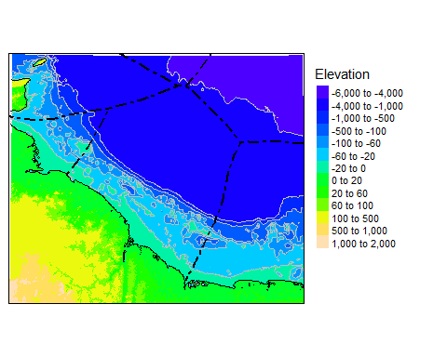

Figure 1 GEBCO bathymetry of the coast of Guyana, with the boundaries of the surrounding countries Exclusive Economic Zones (EEZ).

Data were clipped to <200m depth, to represent the Guyanese shelf seas. The environmental datasets are provided along with this report. The bathymetry raster was used to calculate slope (degrees) and the Bathymetric Position Index (BPI, Lundblad et al., 2006), where positive values indicate bathymetric elevations (the raster has a higher elevation than the mean of a surrounding neighbourhood of cells), whilst negative values indicate bathymetric depressions (Figure 2). Slope was calculated using the ‘Slope’ tool in ArcGIS Spatial Analyst. BPI was calculated using the ‘Benthic Terrain Modeller’ ArcGIS extension (Walbridge et al., 2018, available at <http://www.arcgis.com/home/item.html?id=b0d0be66fd33440d97e8c83d220e7926>), using an annulus with an inner distance of 3 cells and outer distance of 50 cells.

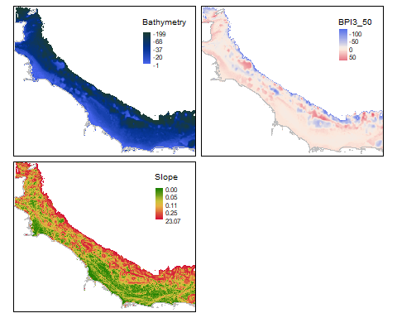

Figure 2 Bathymetry and derivative topographic variables.

Oceanographic data comprising salinity, surface and bottom water temperatures and current velocity for 2015 were extracted from a physical oceanographic model of daily means by Mercator Ocean (<http://opendap-glo.mercator-ocean.fr:8080/thredds/dodsC/global-analysis-forecast-phy-001-024>“). Ocean colour data, including turbidity (absorption by particulate matter, BBP443), chlorophyll-a and the light attenuation coefficient (KD2), were extracted from data products created from MODIS-Aqua satellite imagery, provided by ACRI (BBP443, <http://cmems.isac.cnr.it:8080/thredds/dodsC/dataset-oc-glo-opt-multi-l4-bbp443_4km_monthly-rt-v01>) and Plymouth Marine Laboratory (KD2 and Chlorophyll-a, <http://www.esa-oceancolour-cci.org/>). For all oceanographic and ocean colour data, the daily or monthly means in the original datasets were averaged to an annual mean and interpolated to the same raster cell size as the GEBCO bathymetry (Fig. 3) using the Inverse Distance Weighed tool in ArcGIS.

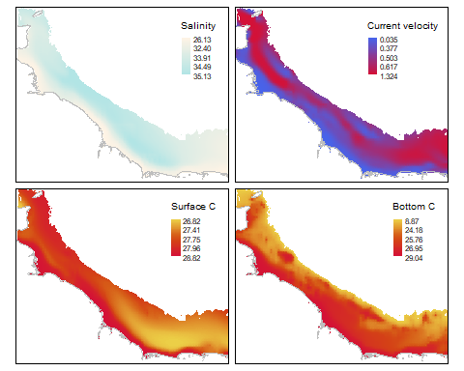

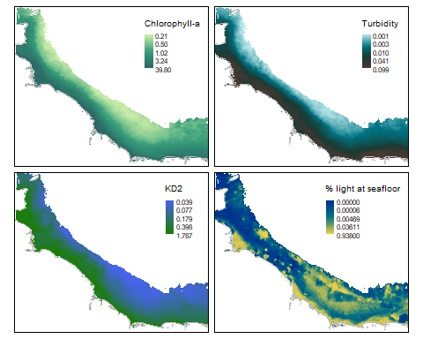

Figure 3 Oceanographic model and satellite imagery derived variables.

## 3.2 Field observations

Field observations used in this report are derived from Van veen grab sampling and epibenthic trawl surveys conducted at 38 locations across the Guyanese shelf as reported in Willems (2018). Particle size analysis results were used to create a bottom sediment type map. Biomass of epibenthic fauna from the trawls was used to test the biological relevance of assigned habitat classes. Grain size composition from the Van Veen grab samples was presented as percentages per sample of sand (grain size 62.5 - 2000 µm), silt (3.9 - 62.5 µm) and clay (<3.9 µm). The abundance and biomass data on epibenthic taxa from the trawl surveys provided by T. Willems (A consultant working with the Guyana Association of Trawler Owners and Seafood Processors (GATOSP)), was plotted in ArcGIS and intersected with the environmental raster layers to extract values at the known locations. These GIS point layers are provided along with the report.

Data on the occurrence of taxa that are especially sensitive to trawling impact was downloaded from the OBIS online repository (<http://www.iobis.org/>). The OBIS dataset was collected by and is provided with the permission of the National Museum of Natural History, Smithsonian Institution, 10th and Constitution Ave. N.W., Washington, DC 20560-0193. (<https://www.nmnh.si.edu/>).

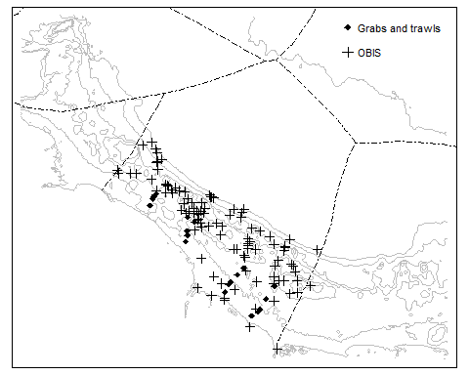

Figure 4 Map showing locations of ground truth data.

# 

# 4. Bottom sediment type classification and map

## 4.1 Sediment types

The range of sediment types in the Van veen grab samples was investigated using ternary plots and cluster analysis of the sediment grain size fractions. A ternary plot of the sediment fractions indicates there is a ‘sandier’ group of stations and a ‘muddier’ group of stations (Fig. 5).

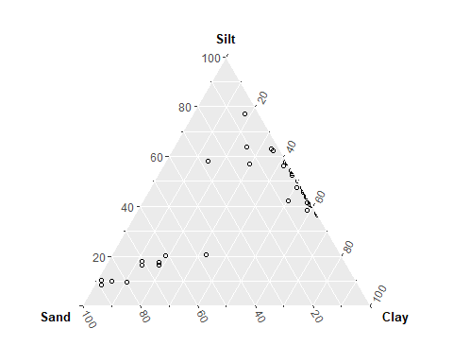

Figure 5 Ternary plot of sediment fractions in grab samples.

K- means clustering was used to split the stations into groups of different sediment types. The optimal number of groups was identified using metrics applied in the NbClust and fviz_nbclust functions in “factoextra” and “NbClust” packages in R statistical software (R Core Team, 2017). Figure 6 shows examples of three commonly used individual methods for determining the optimal number of groups: the Elbow method, the silhouette method and the gap statistic (Kaufman and Rousseeuw, 1990). Each method identifies a different number of groups. The NbClust function uses 30 different indices of group unity, determining the optimal number of clusters by majority vote (Charrad et al. 2014). The majority vote indicated by the optimum number of sediment cluster groups was two (10/30 indices, Fig. 7). Grab data were clustered into 2 sediment classes according to the ‘best partition’ output from the NbClust analysis. These clusters were interpreted to correspond to ‘sand’ and ‘mud’.

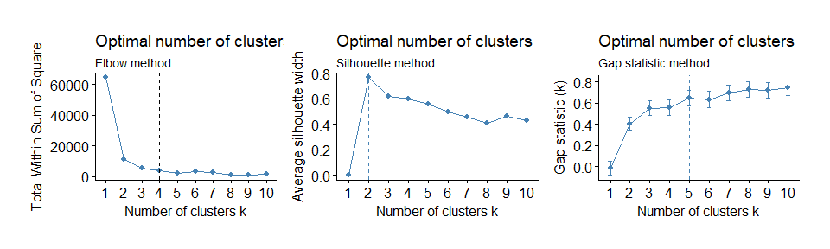

Figure 6 Examples of different methods for determining the optimal number of clusters.

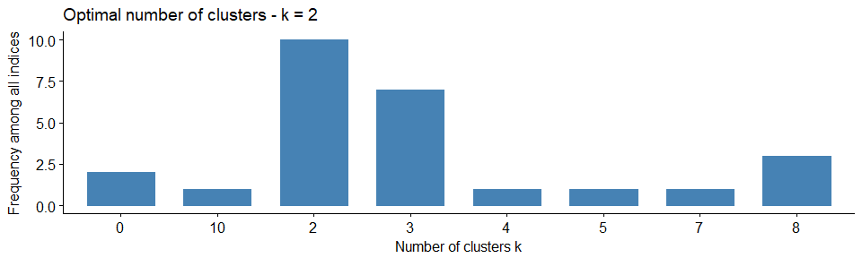

Figure 7 Result of the NBClust analysis to determine the optimal number of cluster groups.

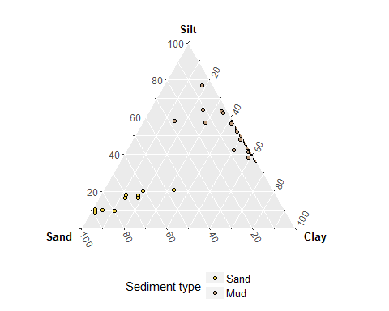

Figure 8 Cluster groups for 'sand and 'mud' illustrated on the ternary diagram.

A conditional inference (CI) tree model (Hothorn et al., 2006) was used to identify the best environmental predictors and their associated cut-off values for predicting the distribution of the sediment classes in geographical space. The light attenuation coefficient (KD2) was found to best separate the sediments (Fig. 9). Sand (class 1) is most likely to occur where KD2 ≤ 0.3 and Mud (class 2) where KD2 > 0.3. The CI model was used to predict sediment class across the shelf (Fig. 10).

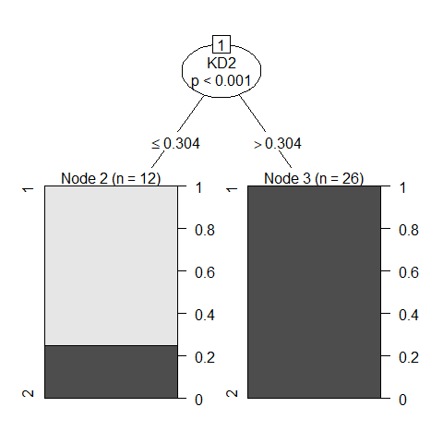

Figure 9 The result of the conditional inference tree analysis on the two sediment classes identified through cluster analysis. Class 1 = ‘sand’, and class 2 = ‘mud’.

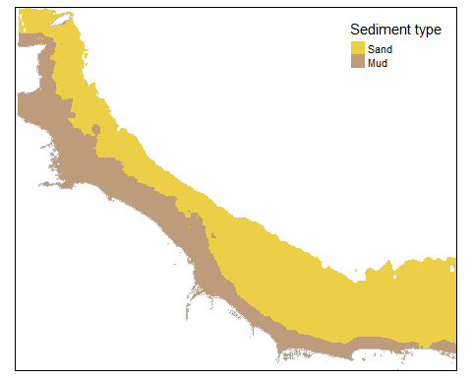

Figure 10 Spatial prediction of the two sediment classes.

## 4.2 Sediment grain size fractions

The spatial distribution for the sand, silt and clay sediment fractions was modelled using the random Forest function in the ‘random Forest’ package in R (Liaw and Wiener, 2002). For each variable, potential predictor variables were first investigated using the boruta algorithm in the ‘Boruta’ package (Kursa and Rudnicki, 2010). The most important variables for model performance were the light attenuation coefficient (KD2), % light at the bottom and the BPI. After inspection of response curves for models the % light at the bottom variable was dropped from the final models because of a response curve that did not seem realistic. Each random forest model was run with the default settings with 250 threes.

The models fit data well. It was not possible to do independent validation on the models because of the low number of samples. Table 1 shows the out of bag (OOB) estimates of root mean squared error (RMSE) and variance explained (R2) by the random forest model for each sediment fraction.

Sand content was highest in clear waters with low light attenuation and flat or low-lying topography. Both clay and silt content increased with increasing turbidity. Clay was most prominent in elevated topographies (Fig. 11).

Table 1 Internal validation results for random forest models.

|  |  |  |
| --- | --- | --- |
| Sediment fraction | RMSE | R2 |
| Sand | 12.145849 | 0.8319984 |
| Silt | 8.811425 | 0.7276541 |
| Clay | 9.662982 | 0.7265095 |
|  |  |  |

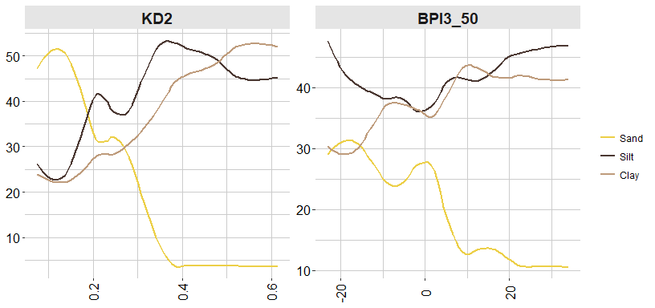

Figure 11 Response curves for the Random Forest models for sand, silt and clay.

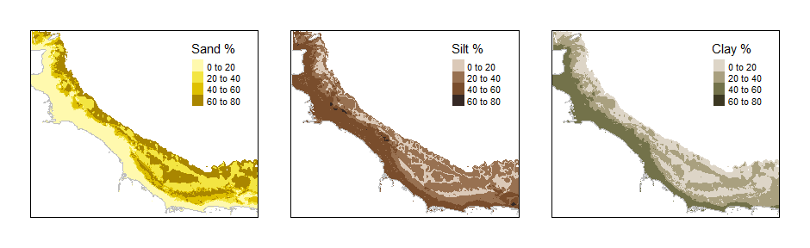

Figure 12 Spatial predictions for sediment fractions.

# 5. Habitats and species

## 5.1 Basic benthic habitat map

The most basic form of a habitat map is often called a seascape or a benthoscape. This is where we use environmental layers, without any additional biological information to describe the physical benthic habitat. Layers that are included are usually variables that are known to influence benthic communities, such as sediment type, light availability and current speed and/or wave energy. Additional variables can include e.g. salinity (where a gradient from estuarine brackish conditions to fully marine is present) or bioregion.

For the basis of this habitat map, we used the sediment type map created earlier, which splits habitats into sandy and muddy sediments. In addition, we split habitats into the infralittoral (photic zone, where a minimum of 1% of the surface light is present) and circalittoral (too dark to allow vegetation). Salinity was used to separate brackish (0.5-30 ppt) from fully marine conditions (>30 ppt) (Fig. 13).

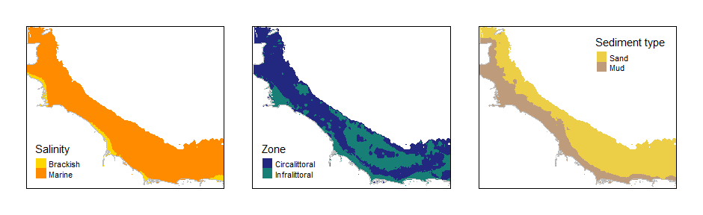

Figure 13 Environmental input layers making up the habitat map.

The three layers were intersected to make up eight basic habitat classes for the Guyanese coast:

* Brackish infralittoral sand
* Brackish circalittoral sand
* Brackish infralittoral mud
* Brackish circalittoral sand
* Marine infralittoral sand
* Marine circalittoral sand
* Marine infralittoral mud
* Marine circalittoral sand

The resulting habitat map is shown in Fig. 14.

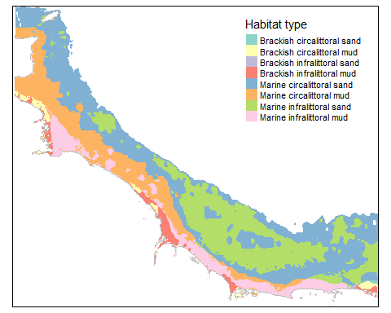

Figure 14 Basic habitat map for the Guyanese shelf.

## 

## 5.2 Biological relevance of the habitat map

Biomass data on the faunal community from the epibenthic trawls were used to investigate the biological relevance of the physical habitat (‘benthoscape’) classes. The aim was to examine if the physical class boundaries correspond to differences in the biological communities observed. Only the fully marine habitat types have been sampled by trawl (Fig. 15). Habitat labels in the following section have been simplified to reflect this, by replacing ‘marine’ with ‘sublittoral’.

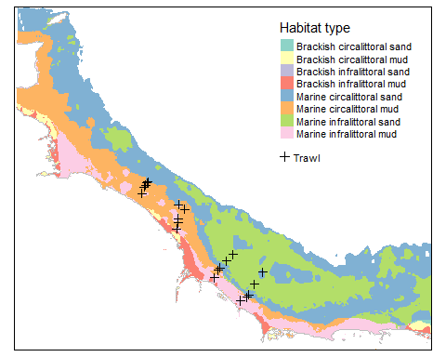

Figure 15 Location of benthic trawls in relation to mapped habitats.

Circalittoral mud was found to host the lowest number of taxa, and infralittoral sand the highest number of taxa. Both had on average a lower abundance of individuals than circalittoral sand and infralittoral mud (Fig. 16). The species composition of epibenthic communities, however, does not seem to differ between the infralittoral and circalittoral (Fig. 17). The infra/circalittoral split is more relevant to vegetation as the lack of distinctive communities is not unexpected, when just dealing with fauna. The most relevant habitat split in this case is the sediment type. Consequently, the biological analysis is repeated below for just sublittoral sand and sublittoral mud.

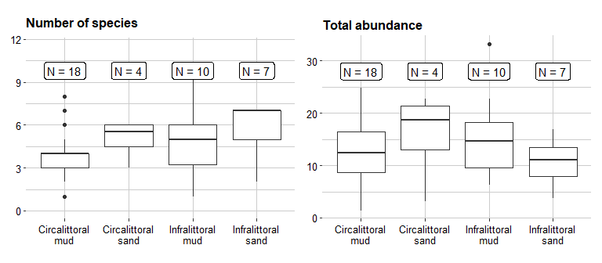

Figure 16 *Number of taxa and total abundance observed in trawl samples from each habitat type.*

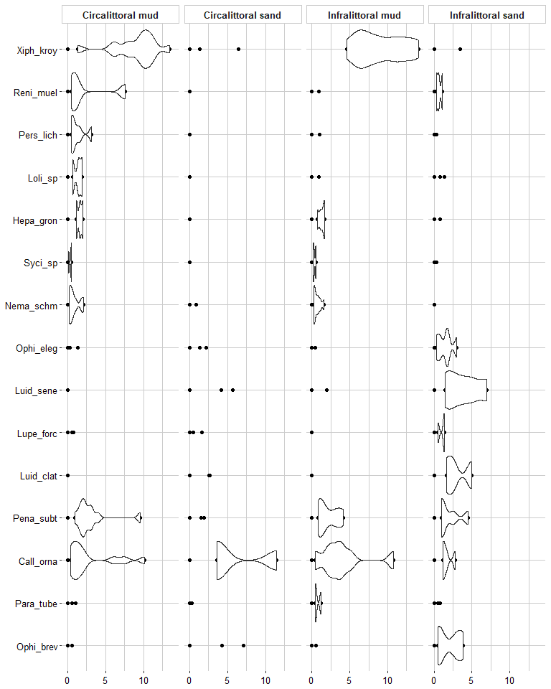

Figure 17 The relative density plots of biomass for the epibenthic taxa across habitat types.

Results show that sand habitats had on average a higher number of taxa, whilst abundance varied across both sediment types (Fig. 18). Many species, such as the sea pansy (*Renilla muelleri*), Southern brown shrimp (*Penaeus subtilis*), and the crabs *Callinectes ornatus* and *Paradasygyius tuberculatus* were common to both sediment types. There were, however, some taxa highlighted by an indicator species analysis for sand and mud. The analysis calculates the indicator value of a species as the product of the relative frequency and relative average abundance in a given group (Dufrene and Legendre, 1997). Mud was characterized by the Whitebelly prawn (*Nematopalaemon schmitti*) and Atlantic seabob (*Xiphopenaeus kroyeri*). Seabob is also present on sand but is found in much higher biomass in mud. The Tweezer crab (*Lupella forceps*), Lined seastar (*Luidia clathrata),* Nine-armed seastar (*Luidia senegalensis*) and Short-spined brittlestar (*Ophioderma brevispina*) are specific to the sand habitat and the Elegant brittlestar (*Ophiolepis elegans*) is present in higher abundance (Table 2, Fig. 19).

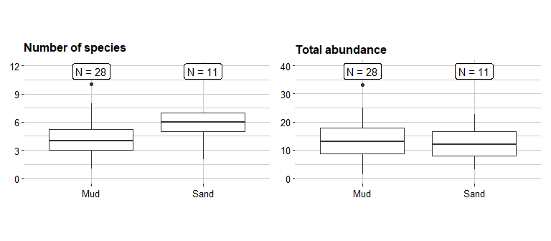

Figure 18 Number of taxa and total abundance observed in trawl samples from each sediment type. Indicator values range 0-1.

Table 2 Results of the indicator species analysis.

|  |  |  |  |
| --- | --- | --- | --- |
| Sediment type | Indicator species | Indicator value | p-value |
| Mud | *Nematopalaemon schmitti* | 0.52 | 0.025 |
| Mud | *Xiphopenaeus kroyeri* | 0.76 | 0.001 |
| Sand | *Lupella forceps* | 0.41 | 0.004 |
| Sand | *Luidia clathrata* | 0.45 | 0.001 |
| Sand | *Ophioderma brevispina* | 0.53 | 0.002 |
| Sand | *Ophiolepis elegans* | 0.59 | 0.001 |
| Sand | *Luidia senegalensis* | 0.62 | 0.001 |

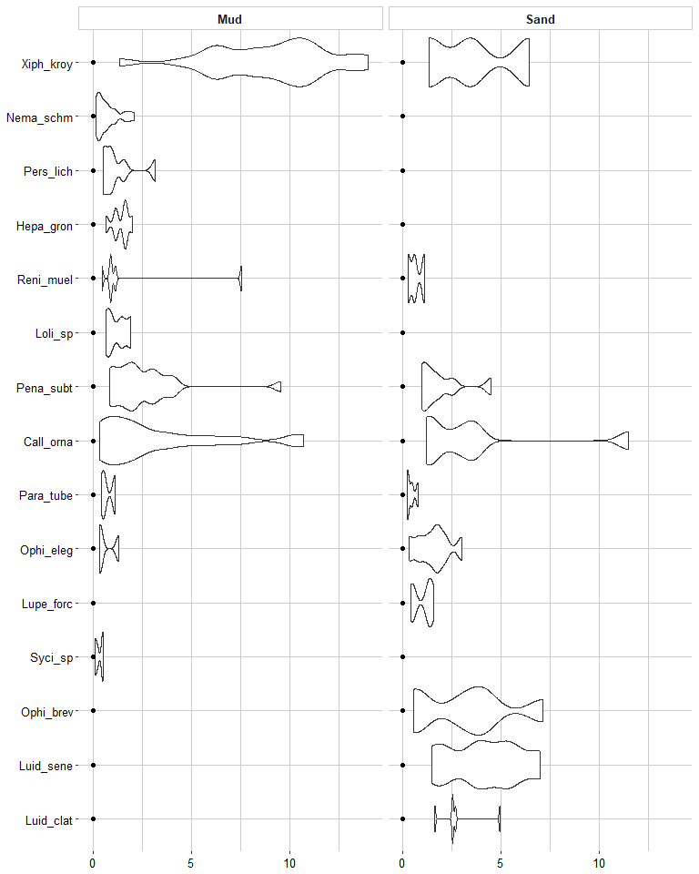

Figure 19 The relative density plots of biomass for the epibenthic taxa across sediment types.

## 

## 5.3 Sensitive taxa

The OBIS data was used to identify any known locations on the Guyanese shelf with sensitive taxa that could indicate the presence of vulnerable habitats. The following taxa were included in the dataset:

* Alcyonacea - soft corals
* Scleractinia - hard corals
* Pennatulacea - sea pens

Several species in each group have been identified at locations across the Guyanese shelf (Table 3, Figure 20).

Table 3 Number of locations with observations, and the constituent genera for Alcyonacea, Pennatulacea and Scleractinia.

|  |  |  |  |  |  |
| --- | --- | --- | --- | --- | --- |
| Order | No. locations | No. families | Family | Genus | Data collected |
| Alcyonacea | 16 | 11 | Acanthogorgiidae | *Acanthogorgia* | 1968 |
|  |  |  | Alcyoniidae | *Anthomastus* | 1968 |
|  |  |  | Chrysogorgiidae | *Chrysogorgia* | 1968 |
|  |  |  | Clavulariidae | *Carijoa* | 1958 |
|  |  |  |  | *Telesto* | 1963, 1968 |
|  |  |  |  | *Scleranthelia* | 1958, 1963, 1968 |
|  |  |  | Coralliidae | *Corallium* | 1968 |
|  |  |  | Ellisellidae | *Nicella* | 1968 |
|  |  |  |  | *Ellisella* | 1968 |
|  |  |  |  | *Ctenocella* | 1968 |
|  |  |  | Gorgoniidae | *Leptogorgia* | 1958, 1968 |
|  |  |  | Isididae | *Acanella* | 1968 |
|  |  |  |  | *Keratoisis* | 1968 |
|  |  |  | Plexauridae | *Paramuricea* | 1968, 1969 |
|  |  |  |  | *Muricea* | 1968 |
|  |  |  |  | *Villogorgia* | 1968 |
|  |  |  |  | *Swiftia* | 1968 |
|  |  |  |  | *Bebryce* | 1968 |
|  |  |  |  | *Scleracis* | 1968 |
|  |  |  | Primnoidae | *Thouarella* | 1968 |
|  |  |  | Spongiodermidae | *Diodogorgia* | 1968 |
| Pennatulacea | 5 | 4 | Kophobelemnidae | *Sclerobelemnon* | 1968 |
|  |  |  | Renillidae | *Renilla* | 1958, 1968, 1969 |
|  |  |  | Umbellulidae | *Umbellula* | 1968 |
|  |  |  | Virgulariidae | *Virgularia* | 1968 |
| Scleractinia | 20 | 10 | Agariciidae | *Helioseris* | 1963 |
|  |  |  |  | *Agaricia* | 1963 |
|  |  |  | Astrocoeniidae | *Madracis* | 1963, 1964, 1968 |
|  |  |  | Caryophylliidae | *Paracyathus* | 1963 |
|  |  |  |  | *Stephanocyathus* | 1968 |
|  |  |  |  | *Polycyathus* | 1963, 1968 |
|  |  |  |  | *Caryophyllia* | 1957, 1963, 1968, 1969 |
|  |  |  |  | *Trochocyathus* | 1969 |
|  |  |  |  | *Phacelocyathus* | 1957 |
|  |  |  |  | *Coenosmilia* | 1969 |
|  |  |  |  | *Oxysmilia* | 1963 |
|  |  |  |  | *Solenosmilia* | 1957, 1969 |
|  |  |  | Deltocyathidae | *Deltocyathus* | 1963 |
|  |  |  | Dendrophylliidae | *Balanophyllia* | 1963, 1968 |
|  |  |  |  | *Dendrophyllia* | 1957 |
|  |  |  | Flabellidae | *Javania* | 1963 |
|  |  |  | Guyniidae | *Guynia* | 1963 |
|  |  |  | Oculinidae | *Madrepora* | 1968 |
|  |  |  | Rhizangiidae | *Astrangia* | 1963, 1968 |
|  |  |  | Turbinoliidae | *Sphenotrochus* | 1963, 1968 |

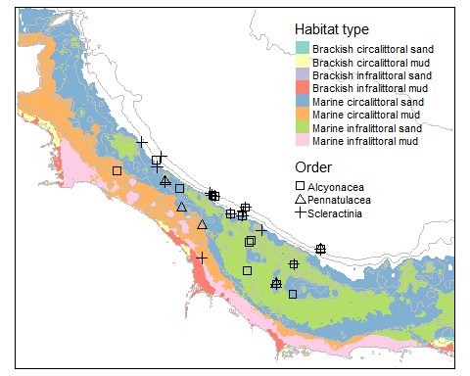

Figure Reported locations of observations for the three main sensitive taxonomic groups in OBIS.

It must be noted that many of these observations are decades old and their position information is consequently not precise. For example, the observation of Scleractinia near the coast, where the seafloor is likely to be muddy is potentially a positioning error. The observations of Alcyonacea and Scleractinia further towards the shelf edge, where elevation data indicates shallower more variable bathymetry, and hence potentially harder substrata, are more likely to be accurate. Dedicated survey effort would be required to confirm the continued presence of the taxa and whether they occur in abundances that would correspond to a vulnerable habitat. The data are presented here as an indication only, to allow planning for future investigations to be targeted, should they be required.

# 6. Seabob fishery impact on habitats

## 6.1 Distribution of fishing activity

The area that is currently being fished was estimated from the accumulated Vessel Monitoring System (VMS) pings from 2015 (Fig. 21a). Individual pings were filtered to those most likely to represent actual fishing activity by removing all records with no information on vessel speed or a recorded speed above 4 knots. The remaining pings were plotted on the habitat map. The distribution of fishing effort was generalised into a raster layer using the density function from the ‘spatstat’ package (Baddeley et al. 2015) which computes a kernel smoothed intensity function from a user provided point pattern. The function was run using the default settings with a gaussian smoother and the sigma value for the kernel set at 2000 m.

The density raster was further reclassified into four levels of intensity of fishing effort, by using the quartiles of observed ping density (0-25%, 25-50%, 50-75%, 75-100%). Fishing is evenly distributed across the fishing footprint, which covers a clearly defined area (Fig. 21b).

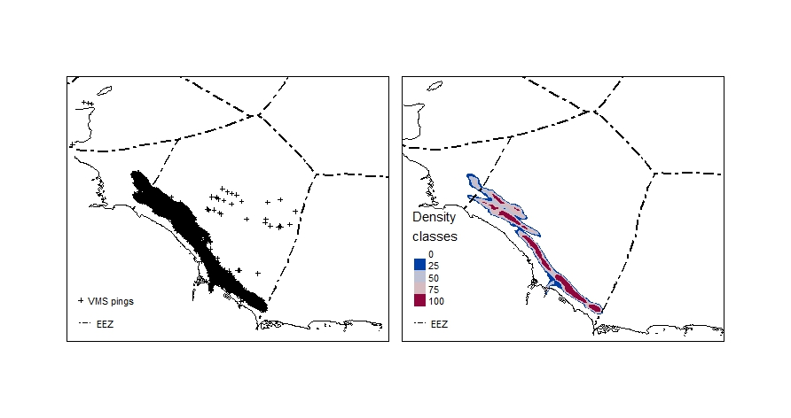

Figure 21 VMS pings from 2015 (a) and the kernel density raster (b) plotted using quartiles.

## 6.2 Area of habitat types fished

The habitat map and fishing footprint were cropped to the extent of the shelf waters within the Guyanese Exclusive Economic Zone (EEZ) to calculate the area of each habitat and sediment type, and the percentage of each overlapping the fishing footprint. Figure 22 shows the fishing footprint overlaid on the distribution of the eight physical habitat types (a) and the sediment types (b). Majority of the fishing effort is concentrated over ‘Marine circalittoral sand’ and ‘Marine circalittoral mud’, with some over ‘Marine infralittoral mud’ (Table 4 and Table 5).

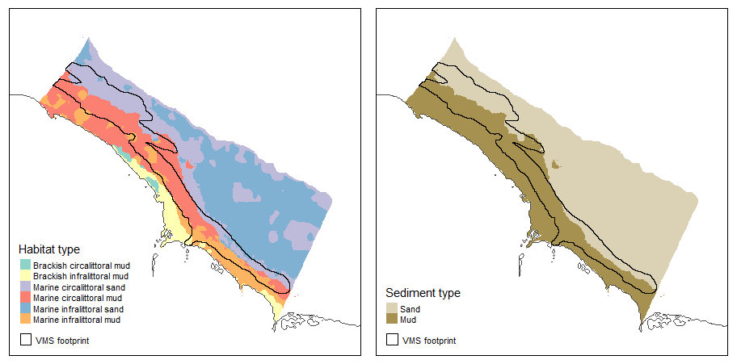

Figure 22 Fishing footprint in relation to the basic habitat types (a), and sediment type (b)

Table 4 Total and fished area of each habitat type on the Guyanese shelf, with the percent of area fished.

|  |  |  |  |
| --- | --- | --- | --- |
| Habitat type | Total area km2 | Fished area km2 | % area fished |
| Brackish circalittoral mud | 387 | 0 | 0 |
| Brackish infralittoral mud | 2625 | 72 | 3 |
| Marine circalittoral sand | 13818 | 4212 | 30 |
| Marine circalittoral mud | 10355 | 6358 | 61 |
| Marine infralittoral sand | 18043 | 378 | 2 |
| Marine infralittoral mud | 4921 | 2022 | 41 |

Table 5 Total and fished area of each habitat class on the shelf of Guyana, with the percent of area fished.

|  |  |  |  |
| --- | --- | --- | --- |
| Sediment type | Total area km2 | Fished area km2 | % area fished |
| Sand | 31861 | 4590 | 14 |
| Mud | 18288 | 8452 | 46 |

## 6.3 Sensitive taxa and the fishing footprint

Although some of the observations of sensitive species obtained from the OBIS database occur on the edges of the fishing footprint, they do not overlap with the main fished area (Fig. 23). The one location, with a Scleractinian observation inside the footprint occurs in habitat unlikely for the reef forming hard corals of the genus Madracis, which is recorded, and is very likely a result of a position error.

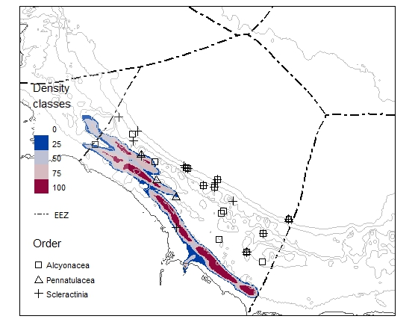

Figure 23 Location of observed sensitive taxa in relation to the fishing footprint.

# 

# 7. Next steps

To continue to provide expert technical support to Guyana towards attaining MSC certification for their trawl industrial fishery for seabob. Project activities to focus on data collection and sampling protocols in particular:

* Developing/modifying their sampling programme in light of the explanatory analyses that we have done in Year II
* Environmental and socio-economic impact assessments
* Strategic planning and operational management of an observer programme for the seabob fishery.

# References

Baddeley A., Rubak E. and Turner R. (2015). Spatial Point Patterns: Methodology and Applications with R. Chapman and Hall/CRC Press.

Charrad, Malika, Nadia Ghazzali, Véronique Boiteau, and Azam Niknafs. 2014. “NbClust: An R Package for Determining the Relevant Number of Clusters in a Data Set.” Journal of Statistical Software 61: 1-36. http://www.jstatsoft.org/v61/i06/paper.

Dufrene, M. and Legendre, P. 1997. Species assemblages and indicator species: the need for a flexible asymmetrical approach. Ecol. Monogr. 67(3):345-366.

Hothorn, T., Hornik, K. and Zeileis, A. (2006). Unbiased recursive partitioning: A conditional inference framework. Journal of Computational and Graphical statistics 15, 651-674.

Kaufman, Leonard, and Peter Rousseeuw. 1990. Finding Groups in Data: An Introduction to Cluster Analysis.

Lundblad, E. R., Wright, D. J., Miller, J., Larkin, E. M., Rinehart, R., Naar, D. F., Donahue, B. T., Anderson, S. M. and Battista, T. (2006). A benthic terrain classification scheme for American Samoa. Marine Geodesy 29, 89-111.

R Development Core Team (2017). R: A language and environment for statistical computing. R Foundation for Statistical Computing. Vienna, Austria. URL http://www.R-project.org

Walbridge, S.; Slocum, N.; Pobuda, M.; Wright, D.J. Unified Geomorphological Analysis Workflows with Benthic Terrain Modeler. Geosciences 2018, 8, 94. doi:10.3390/geosciences8030094

Willems, Tomas (2018). Impact of Guyana seabob trawl fishery on marine habitats and ecosystems: A preliminary assessment. A Report prepared for the Guyana Association of Trawler Owners & Seafood Processors (GATO&SP) Jackson Street Republic Park, East Bank Demerara, Guyana.