Consequence Spatial Analysis (CSA) Report

Background

An assessment of Marine Stewardship Council (MSC) Principle 2 (P2) targets was conducted by a private consultant (Dr. G Gaudian) in February 2018. In order to pass the MSC assessment, a minimum average score of 80 is required. The assessment highlighted that a number of targets within P2 failed to score the required 80 needed to pass. Gaudian stated that there is a need for details on the distribution of Vulnerable Marine Ecosystems (VMEs). It is suggested to conduct an Risk Based Framework (RBF) on habitat outcome through a Consequence Spatial Analysis (CSA).

A preliminary CSA was conducted on the Guyana Seabob Industry using the Marine Stewardship Council (MSC) Guide lines scoring. The CSA is conducted using a scoring system ranging from 1-3 where by 1 being of the best score and 3 the worse. The overall CSA score was obtained by determining the scores for each of the consequence attributes and spatial attributes.

The Consequences attributes included:
- Habitat productivity
- Regeneration of biota
- Natural disturbance
- Gear habitat interaction
- Gear footprint
- Removability of biota
- Removability of substratum
- Substratum hardness
- Ruggedness of habitat type
- Seabed slope

While the Spatial attributes included:
- General depth range
- Depth zone and feature type
- Habitat rareness

Regeneration of biota
This was scored base the rate of recovery of biota associated with the habitat type, using information on age, growth, recolonization of fauna and flora where applicable. Due to the absence of data a surrogate was used to determine a score with the depth also being considered.
A score of one (1) was given due to no evidence of fauna in the fishing area (Willems 2018) and the area under studied lay with in the inner shelf.

Natural disturbance
This attribute was scored based on the occurrence of natural disturbance that occurred in the particular depth zone in which the habitat and fishing activity occurs. A score of one (1) are given the communities that are highly disturbed (in the context of water currents) and three for communities where no natural disturbance occurs.
Due to the irregularity and moderate natural disturbance within this fisheries (McConnel 1960, Cefas 2018) a score of two (2) was given.

Ruggedness of Substratum
This is based on the concept that the access of the gear to the habitat is influenced by the substratum ruggedness. A rugged substratum is less accessible to mobile gear and this would receive a good score (1). With Guyana sea bed being smooth and flat a score of three (3) was given for this category (Cefas 2018).

Removability of Biota
Removability of biota is influenced by the size, flexibility, structural complexity, etc. of the attached biota. Due to the habitat under study and the low incidence of attached fauna and flora, a score of one (1) was given (Willems 2018).

Removability of Substratum
This measures how susceptible the substratum is to erosion by the gear. A hard substratum would be more resistant, while a soft substratum like the one in question would be degraded by the contact gear. A score of three (3) was given.

Seabed slope
Due to the seabed being flat with little to no slope in the habitat under study a score of three (3) was given. Because of the flat seabed, the gear would have heavy contact with the sea bed.

Substratum hardness
The substratum of the habitat under study is composing of a mixture of clay, sand and silt mainly (Cefas 2018). Due to this composition it is quite soft and easily eroded so a score of three (3) was given.

Gear Footprint
This area measures the level and intensity of gear disturbance on the habitat. This score was determined using Table 3 in Appendix 1 of the CSA Guideline. The otter trawl gear was given a score of three (3).

Spatial overlap And Encounter ability
Referencing the mapping of benthic habitats on the Guyana shelf report (Cefas 2018) sensitive taxa do not overlap the main fishing area and encounter of the a very low. A score of one (1) was given for both category.

CSA Result
The subsequent CSA score indicated that a MSC score of ≥ 80 (85) would be achieved.

Recommendation
There is an absence of data in some of respective data fields of the CSA scoring. It is recommended a Productivity Susceptibility Analysis (PSA) be conducted on Seabob Fisheries.

Conclusion
In conclusion, the result of the CSA for the habitat obtained pass score of ≥ 80 and along with the analysis of Cefas and Willems improve the overall information on the seabob fishery in P2.

Reference
- Cefas, “MSC certification of Guyana’s industrial Seabob fishery Report 2: Mapping of benthic habitats on the Guyana shelf,” 2018.
- Willems T., “Impact of Guyana seabob trawl fishery on marine habitats and ecosystems: A preliminary assessment,” 2018.
- McConnell H., “The Trawl Survey Carried out by The R’V” Cape St. Mary Off British Guiana 1957-1959,” 1960.

Appendix 1

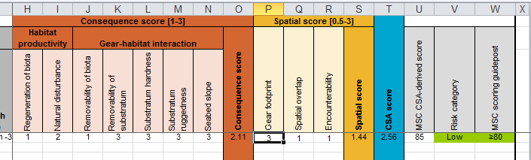

Table 1: Consequence Spatial Analysis Spreadsheet

