Indian Ocean tuna - purse seine (SIOTI) FIP

Three (six)-Year Audit Report
Version 1.2, September 2021

FIP Information
Target species scientific name(s) and common name(s) | Skipjack – Eastern stock (Katsuwonus pelamis)  Yellowfin (Thunnus albacares)  Bigeye (Thunnus obesus)
Fishery location | Area 51 (Indian Ocean, Pacific, Western)  Area 57 (Indian Ocean, Eastern)
Gear type(s) | Purse seine
Estimated FIP Landings (weight in tons) | 188,310 tons (2022)
Vessel type(s) and size(s) | Large (>60 m) purse seine vessels
Number of vessels | 29 purse seine vessels
Management authority | Indian Ocean Tuna Commission (IOTC) – Management of tuna stocks (RFMO)  National management authorities (Country flag of the vessels – Seychelles, Mauritius, France, Spain, Italy; areas of operation of the fishery – Seychelles, France (overseas territories), Mauritius, Mozambique, Madagascar, The Comoros, Kenya and the United Republic of Tanzania)
Auditor name(s) | Jose Peiro Crespo
Auditor Organization/Affiliation | Naunet Fisheries Consultants
Date of report completion | 25/06/2023

FIP Background (Optional)
The fishery targets three species of tuna: skipjack tuna (Katsuwonus pelamis), yellowfin (Thunnus albacares) and bigeye (Thunnus obesus) It is currently carried out by 29 purse seines (down from around 40 vessels at the beginning of the FIP). The total catch of tuna species of the vessels in 2022 was 188,310 t (SKJ accounts for 65% of the total catch, with YFT and BET representing ~25% and ~10% respectively). This FIP includes both the Free-schools and associated sets/FAD components of the stock. Two partners of the SIOTI are MSC certified (Echebastar, CFTO, or are in process of being certified (ANABAC, SAPMER) for skipjack. The SIOTI FIP requested a one year extension in order to enable a greater prospect of completion of all indicators.
Stakeholder Consultation & Meetings

Name | Affiliation | Date and Subjects Discussed
Jan Robinson | FIP manager | 17th May 2023  Introductory call  - Scope of the FIP (are of operation of the fleet, number of vessels, target species, catch volume, etc.).  - Main stakeholders involved in the fishery and their roles.  - Scope of the audit, preparation of the stakeholder meeting/s, deadlines, etc.  - Main issues identified in the fishery.  - Principle 1, 2 and 3 activities (stock assessment, data collection, Code of good practices, etc).
Nekane Alzorriz | Scientific adviser ANABAC | 1st June 2023  - Scope of the FIP (number of vessels, flags, MSC certified fleets, etc).  - Principle 1 progress (IOTC’s new stock assessment reports/HS/ HCR developments, etc).  - Bycatch species management strategies (observer coverage/ETP species handling).  - Code of good practices.  - Recent developments in FAD management in the area of operation of the fishery. Other FAD related initiatives.  - Compliance of the fleet with IOTC and EU regulations.  - Other related issues (scientific research, relevant publications, etc).
Maria Jose Juan-Jorda | Scientific researcher - Spanish Institute of Oceanography IEO-CSIC | 9th June 2023  - Role, work conducted for the SIOTI.  - Clarification on the ecosystem impact of the fishery (impacts and information).  - Other related issues (scientific research, recent publications, etc).
Sophie Des Clers | Principle 3 expert | Contacted by email  - Clarifications on some Principle 3 issues for recent MSC certifications (CFTO).
Dan Fu | Stock assessment expert - Indian Ocean Tuna Commission (IOTC) | Contacted by email  - Projections of bigeye tuna based on different catch scenarios.
Laurent Pinault  Christopher Naminzo  Armelle Denoize | SAPMER Sustainability Director  Fisheries and Environment Certification assistant  Resources and Environmental Policy group manager. | Contacted by email  - SAPMER Code of good practices.  - SAPMER public policies on sustainability.  - ISSF Compliance report.  - Compliance of the fleet with IOTC and EU regulations.  - Other issues
Christopher O'Brien | Executive Secretary - Indian Ocean Tuna Commission (IOTC) | Contacted by email  - Clarifications on the performance review of the key elements within the IOTC.

Summary of Findings and Recommendations
This report presents the findings of the six-year audit of the Indian Ocean tuna - purse seine (SIOTI) FIP. This FIP started in 2017 and the target end date was June 2022. However, the FIP requested an extension of 1 year in order to complete some of the activities in the FIP. This extension was granted by FisheryProgress and the new due date set to June 2023. Two of the companies involved in the FIP are already MSC certified for skipjack (Echebastar, CFTO) or are in process of being certified for that species (ANABAC, a scope extension of CFTO certification for SAPMER vessels). A new FIP is being developed for YFT and BET and will be launched after this one is finished with the objective of addressing remaining issues (stock status, P2 and P3 issues).
In regard to Principle 1, recent stock assessments have been conducted for SKJ, YFT and BET). The most recent stock assessments for YFT and BET, conducted in 2021 and 2022 respectively, indicated that the biomass of those species was below the SSB_{MSY} (SB_{2020 YFT/}SB_{MSY} = 0.87 and SB_{2021 BET/}SB_{MSY} = 0.90).
In the case of SKJ, a stock assessment was started in 2023. The results of the 2020 assessment indicated that SB_{2019 SKJ}/ SB_{MSY} = 1.99. Resolution 21/03 On Harvest Control Rules for Skipjack Tuna were adopted in 2021 and a Management Procedure for bigeye tuna was adopted in 2022. An interim plan for rebuilding the Indian Ocean yellowfin tuna stock (Resolution 21/01) is also in place. But some issues persist with catches above the defined HCR limits for both SKJ and YFT. Management measures for BET were adopted in 2022 (IOTC Res. 22/03).
The score for 1.1.2 Stock rebuilding for YFT was increased by the FIP during Year 4 based on the implementation of Resolution 21/01 but the auditor disagrees with that change and based on the regular over-catch of the stock and the recent projections conducted by Urtizberea et al., 2021, this score has been reduced again to <60 (for more information see the relevant P.I. and annex 1).
Recently the FIP has commissioned a number of studies to improve the management of the three species (Merino et al., 2020, Merino et al., 2022, Sauer & Bova 2022).
In regard to Principle 2, a number of issues were identified during the pre-assessment or in further FIP reviews: data collection on primary, secondary and ETP species, habitat impacts of the FAD component and ecosystem impacts. A number of studies and activities have been conducted by the FIP in order to address those issues. A Code of Good Practices was implemented by the fleet, which has recently been harmonized and is updated when necessary. Non-entangling FADs are now being used by all the fleet, and a FAD Watch project was launched to reduce the impact of lost FADs on VMEs (coral communities) in the Seychelles.
A review of the ecosystem impact and the interpretations and scores given by the auditors of 2.5 in the different MSC certifications was also conducted by a consultant (Juan-Jordá 2022). The combination of these activities has resulted in the scores being raised for some performance indicators (2.4.1, 2.4.2, 2.5.1, 2.5.2), although more progress needs to be made on the information component (2.3.3 ETP, 2.4.3. Habitat, 2.5.3 Ecosystem) of those elements. The impact on primary and secondary species has been assessed and it seems to be relatively low.
A comprehensive strategy to manage the impact of the fishery on silky sharks, the main ETP bycatch species in the fishery, has not been developed although several projects have been implemented to assess the scope and nature of the interaction of that species with the purse seine tuna fishery and inform a potential strategic approach.
In regard to Principle 3, a number of activities have been undertaken by the FIP to improve the management of the target tuna stocks at the regional (IOTC) and national level (EU, Spain, France, Seychelles and Mauritius).
The FIP pre-assessment identified the need to address the legislative gaps that exist at national level to ensure the IOTC Contracting Party and Cooperating Non-Contracting Party (CPCs) comply with IOTC Conservation and Management Measures (CMMs). These issues are being addressed in collaboration of a legal expert and some progress has been made for specific countries (Seychelles, Mauritius, Kenya). There is also a need to strengthen compliance in implementing CMMs at the national level and ensure a more robust reporting and sanctions approach to non-compliance. It means that SG80 is not reached for a number of national authorities. Compliance issues have also been raised concerning the nominal catch records of the EU fleet during the year 2018 (being solved), the irregular use of AIS in the fishery and the non-compliance with the EU catch declaration margin (which have resulted in conditions for 3.2.3. being set for the ANABAC and CFTO certifications respectively). Several P.I. are now scored as >80 (3.1.2. Consultation, Roles and Responsibilities and 3.2.1 Fishery Specific Objectives), although some of them have been downgraded to 60-79 (3.1.2 Decision-making processes and 3.1.1 Legal framework).
As indicated above, progress has been made in recent years under the FIP, mainly for Principle 2 but also for Principle 1 issues (data collection, FAD impact and management, HCR for SKJ, a MP for BET), but some important issues still remain for P1 (overcatch of SKJ and YFT, lack of appropriate HS and well defined HCR for several species) and for P3 (cooperation among parties and compliance within the EU fleet (AIS use, EU catch declaration margin). These are very important problems which should be addressed as a matter of urgency by the FIP. Therefore, although progress has been made, more efforts must be taken to address those remaining issues.

Summary of MSC Performance Indicator Scores
Note: scores for all target species have been provided in the table below. It is understood this information will help to track progress for each species.

Principle | Component | Performance Indicator |  | Previous Score  2022 | Current Score  2023 | Rationale or Key Points
1 (UoA1: SKJ) | Outcome | 1.1.1 | Stock status | >80 | >80 | A new stock assessment is being conducted in 2023 so existing advice is based on the 2020 assessment using Stock Synthesis with data up to 2019. The outcome of the 2020 stock assessment model does not differ substantially from the previous assessment (2017) despite the large catches recorded in the period 2018-2019, which exceeded the catch limits established in 2017 for this period.  The final overall estimate of stock status indicates that the stock is above the adopted target for this stock and that the current exploitation rate is just below the target. Also, the models estimate that the spawning biomass remains above its SB_{MSY} and the fishing mortality remains below E_{MSY} with very high probability. Over the history of the fishery, biomass has been well above the adopted limit reference point (0.2*SB0). The recent catches have been within the range of estimated target yield (see C40%SB0). The current spawning biomass relative to unexploited levels is estimated at 45%. Thus, on the weight-of-evidence available in 2020, the skipjack tuna stock is determined to be: (i) above the adopted biomass target reference point; (ii) not overfished (SB2019>SB40%SB0); (iii) with fishing mortality below the adopted target fishing mortality, and (iv) not subject to overfishing (E2019<E40%SB0). SG80 is met.
 |  | 1.1.2 | Stock rebuilding | NA | NA | NA
 | Management | 1.2.1 | Harvest Strategy | <60 | 60-79 | A harvest control rule and reference points for Indian Ocean skipjack are defined by IOTC Res. 16/02 (superseded by Res. 21/03).  Total catches in recent years have been larger than the resulting catch limit from the skipjack HCR for the period 2018-2020 (470,029 t), which raised concern as reaching the management objectives defined in Res. 21/03 requires that the catch limits adopted by the skipjack HCR are implemented effectively. Due to its specific life history attributes, skipjack can respond quickly to ambient foraging conditions driven by ocean productivity, which seem to have been favorable in recent years.  Management tools in place aimed to reduce the catch or the effort on tuna species in the IOTC area (Res. 21/01, rebuilding YFT; Res. 18/08, FAD use restrictions) are not specifically aimed to SKJ and in some cases they have resulted in increases in the catch of this species.  Within the SIOTI, a number of studies have been undertaken to assess how to better manage the stock (multispecies catch limits, etc) (Merino et al., 2020; Merino et al., 2022; Sauer & Bova 2022).  Therefore, there are not pre-agreed tools in place aimed to reduce the catch of SKJ when it surpasses the level set by the HCR and it cannot be considered that the harvest strategy is responsive to the state of the stock (1.2.1a). It is also unclear if the harvest strategy is achieving its objectives (1.2.2b). SG80 is not met. Harmonized with the Echebastar, CFTO and ANABAC assessments.
 |  | 1.2.2 | Harvest control rules and tools | <60 | 60-79 | MSC Fisheries Standard v2.01 stipulates two conditions for acceptance of HCR being ‘available’ instead of being in place to justify scoring at the SG60 level. The first is through SA2.5.2a where the guidance indicates that teams shall accept ‘available’ HCRs in cases where, “…Stock biomass has not previously been reduced below the MSY level or has been maintained at that level for a recent period of time that is at least longer than 2 generation times of the species and is not predicted to be reduced below BMSY within the next 5 years”  The second condition is through SA2.5.3b where the guidance indicates that teams shall recognize HCRs as being available if “an agreement or framework is in place that requires the management body to adopt HCRs before the stock declines below BMSY”.  Resolution 21-03, which superseded 16/02 established a biomass limit reference point of 20% of unfished spawning biomass, a biomass target reference point of 40% of unfished spawning biomass (MSY proxy), and a harvest control rule whereby the exploitation rate is proportionally reduced as biomass declines from 0.4B0 to 0.1B0. The HCR is now well defined and is clearly intended to maintain the stock at target levels. The annual catch limit was set at 513,572t for the period 2021-2023. However, the tools in use are not effective in achieving the exploitation levels required under the HCRs (In the first 4 years of applying the skipjack catch limit (2018-2021), skipjack catch overshot the limit in the range 116-130%), SG80 is not met. Harmonized with the Echebastar, CFTO and ANABAC assessments.
 |  | 1.2.3 | Information and monitoring | >80 | >80 | IOTC-2023-WPTT25(DP)-07.2_Rev2 summarizes the standing of a range of data and statistics received by the IOTC Secretariat for skipjack. Although a number of issues on catch reporting from different coastal countries and gears are highlighted in the report (inadequate information on discards, uncertainties in catch and effort data for some countries (Indonesia, Iran, Sri Lanka)), the main issue identified for the purse seine fishery covered by this FIP (discrepancies in the reported catch data for 2018) has been resolved, resulting in a decrease of almost 2,400 t in catches of skipjack tuna recorded for that year. Data on CPUE, fish size, age trends, etc. seem to be adequately covered for the industrial fleets. SG80 is met.
 |  | 1.2.4 | Assessment of stock status | >80 | >80 | As indicated above, the most recent stock assessment for skipjack was conducted in 2022 using Stock Synthesis v3 with data up to 2019. It incorporates multiple fisheries, gears, selectivity models and spatial variability. SG80 is met.
1 (UoA2: YFT) | Outcome | 1.1.1 | Stock status | 60-79 | 60-79 | A new stock assessment was carried out for yellowfin tuna in 2021 using Stock Synthesis III (SS3), a fully integrated model that is currently used to provide scientific advice for the three tropical tunas stocks in the Indian Ocean. Overall stock status estimates do not differ substantially from the previous assessment. Spawning biomass in 2020 was estimated to be 31% on average of the unfished (1950) levels. Biomass estimates have been generally declining over time and particularly since 2011. Spawning biomass in 2020 was estimated to be 87% of the level that supports the maximum sustainable yield (SB₂₀₂₀/ SB_{MSY} = 0.87). Current fishing mortality is estimated to be 32% higher than F_{MSY} (F₂₀₂₀/ F_{MSY} = 1.32). The probability of the stock being in the red Kobe quadrant in 2020 is estimated to be 68%. The WPTT (IOTC-2021-WPTT23-R) and Scientific Committee noted that many of the issues undermining the previous assessment in 2018 had been resolved and improved levels of certainty in the results, including the projections of status in relation to future catch levels. On the weight-of-evidence available since 2018, the yellowfin tuna stock is determined to remain overfished and subject to overfishing. Based on this information, the stock of YFT is not above the MSY level. SG80 is not met.
 |  | 1.1.2 | Stock rebuilding | 60-79 | <60 | Assuming a natural mortality of 0.35 - 0.8 yr-1, the yellowfin generation time should be around 3.75 – 5.9 years, and 2 generation times 8-12 years (GSA2.2.4: Goodyear 1995). Catches of the stock have decreased in the most recent years, from 442,205 t and 450,788 t caught in 2018 and 2019 respectively to 427,156 t and 416,614 t in 2020 and 2021 respectively but they are not yet enough to rebuild the stock (Resolution 21/01 requires reductions in 2022 catches based on 2014 catch levels, which, if fully implemented, will achieve a reduction to around 400,000). Reductions need to be achieved by CPCs and vary by fleet from 0% to 21%. Bearing in mind at least a two-year delay before reductions occurs and probably, based on the resolutions, a 10% reduction in practice will be achieved (i.e., 80% projected catches compared to current levels), there would be approximately >70% probability B2023<BMSY after 3 years and >50% probability B2030<BMSY after 10 years (Urtizberea et al. 2021, see figure 3 in Annex 1).  Catch reported for 2021 remained above the catch limitation specified in the rebuilding plan and requiring substantial reduction to give more confidence that the stock can be rebuilt. The Working Party on Tropical Tunas continued to express concern that increases in catches by some CPCs and objections by other CPCs are offsetting the reductions achieved by compliant CPCs (IOTC-2022-WPTT24R). SIOTI flag states continue to comply with the catch limit allocations. Based on the implementation of Resolution 2021/01, the score for this P.I. was increased from <60 to 60-79 but it is important to note that some countries with significant yellowfin catches are not bound to this latest resolution and catches have not been decreased enough yet. Therefore, the auditor considers that SG60 is not met.
 | Management | 1.2.1 | Harvest Strategy | <60 | 60-79 | The IOTC’s harvest strategy objective is to maintain stock levels at or above the biomass which would produce MSY. This was established as an interim threshold reference point under 15-10. Scientific advice has been formulated relative to a harvest strategy relative to MSY reference points and is responsive to that state of the stock and to limit and target reference points commonly used for yellowfin and other tropical tunas. Resolutions 16/01, 17/01, 18/01, 19/01 and 21/01 established interim plans for rebuilding the Indian Ocean yellowfin tuna stock in the IOTC area of competence. However, the effectivity of the strategy is unclear as a number of provisions, like well-defined catch limits, are still in development and have not been implemented yet. As indicated above, catches have regularly exceeded the estimated MSY since 2012. The 2021 estimate of MSY was 349,000 t while the average catch 2016-2020 = 434,569 t, suggesting that the current strategy is not working well (enforcement is lacking). SG80 is not met.
 |  | 1.2.2 | Harvest control rules and tools | <60 | <60 | As indicated previously, MSC Fisheries Standard v2.01 stipulates two conditions for acceptance of HCR being ‘available’ instead of being in place to justify scoring at the SG60 level. The first is through SA2.5.2a where the guidance indicates that teams shall accept ‘available’ HCRs in cases where, “…Stock biomass has not previously been reduced below the MSY level or has been maintained at that level for a recent period of time that is at least longer than 2 generation times of the species and is not predicted to be reduced below BMSY within the next 5 years”.  The second condition is through SA2.5.3b where the guidance indicates that teams shall recognize HCRs as being available if “an agreement or framework is in place that requires the management body to adopt HCRs before the stock declines below BMSY”.  In the case of yellowfin, the stock has declined and based on projections in the assessments before 2015 was likely to fall below its target point. The most recent assessments confirmed that this indeed had happened.  Based on resolutions 16-01/17-01/18-01/19-01/21-01 a number of tools for controlling catches were adopted including percent reductions in purse seine, gillnet and other gear catch and reduction in FADs. Catches have been broadly reduced in some fleets subject to the controls, albeit the reduction has not yet met the target level over the last 5 years. Fleets exempt from such requirements have increased their catch, and the overall catch has therefore increased in 2020 to around the 2016 level and has remained significantly higher than the target. Resolution 19/01 threatens overages to catch limits be carried forward to 2021 and resolution 21/01 has increased the catch reductions. Several countries have objected to Res. 19/01 and to Res. 21/01.  As CPCs are unwilling or unable to apply the catch limits being set out in resolutions, there is no evidence indicating that the tools in use are appropriate and effective in achieving the exploitation levels required under the HCRs. SG60 is not met.
 |  | 1.2.3 | Information and monitoring | >80 | >80 | The IOTC-2023-WPTT25(DP)-07.1_Rev1 summarizes the standing of a range of data and statistics received by the IOTC Secretariat for tropical tunas. Data available includes information on catches, geo-referenced catch and effort data, size frequency data, tagging data, socio-economic data. A scoring system has been implemented to assess the quality of the retained catch, catch-effort, and size-frequency data available at the Secretariat for all IOTC species. Overall, the reporting quality for industrial fisheries covered by this FIP is better than artisanal fisheries, mostly because larger vessels are generally monitored with logbooks and recording systems at landing. Some issues were identified for the reporting of YFT and BET in the EU fleet but it is considered that the available information is broadly adequate to assess the status of both stocks. SG80 is met.
 |  | 1.2.4 | Assessment of stock status | >80 | >80 | The most recent full assessment of YFT was carried out in 2021 using Stock Synthesis III (SS3), a fully integrated model that is currently used to provide scientific advice for the three tropical tunas stocks in the Indian Ocean. The model used in 2021 is based on the model developed in 2018 with a series of revisions that were noted during the WPTT in 2018, 2019 and 2020. The model uses four types of data: catch, size frequency, tagging and CPUE indices. The proposed final assessment model options correspond to a combination of model configurations, including alternative assumptions about the spatial structure (2 options), longline CPUE catchability (2 options on the effect of piracy), weighting of the tagging dataset (lambda = 0.1 or 1), steepness values (0.7, 0.8, and 0.9), natural mortality values (2 options), and growth parameters (2 options). The model ensemble (a total of 96 models) encompasses a range of stock dynamics. SG80 is met.
1 (UoA3: BET) | Outcome | 1.1.1 | Stock status | >80 | 60-79 | In 2022 a new stock assessment was carried out for bigeye tuna in the IOTC area of competence to update the stock assessment undertaken in 2019. Two models were applied to the bigeye stock (Statistical Catch at Size (SCAS) and Stock Synthesis (SS3)), with the SS3 stock assessment selected to provide scientific advice. Spawning biomass in 2021 was estimated to be 25% (80% CI: 23-27%) of the unfished levels in 2021 and 90% (75-105%) of the level that can support MSY. Fishing mortality was estimated at 1.43 (1.1-1.77) times the F_{MSY} level. Considering the characterized uncertainty, the assessment indicates that SB₂₀₂₁ is below SB_{MSY} and that F2021 is above F_{MSY} (79%). On the weight-of-evidence available in 2022, the bigeye tuna stock is determined to be overfished and subject to overfishing. SG80 is not met.
 |  | 1.1.2 | Stock rebuilding | NA | 60-79 | Given the life history characteristics of bigeye, it seems that the stock has the potential to recover relatively quickly (within a 5–10-year period) with appropriate management measures (Medley et al., 2023). The TAC recommended from the application of the MP specified in Resolution 22/03 is 80,583 t/year for the period 2024-2025, a 15% below the 2021 catch. The management procedure approved for the species is designed to achieve: a 60% probability that the bigeye tuna spawning stock biomass achieves the target reference point of SB_{MSY} by 2034-2038 (12 years). The rebuilding time frame of 2034 is within the 20 years or 2 times the approximate generation time. However, the projections shown in annex 1 indicate a 60% probability of violating the MSY target point for 2028 with catch levels similar to the one set by Resolution 23/04 for the period 2024-2025 (see explanation below). Moreover, catch limits set for other tuna species (SKJ, YFT) in the IOTC have not been complied with by the CPCs and it is unclear how this catch limit will be enforced for BET. Therefore, on that basis it is considered that SG80 is not met.
 | Management | 1.2.1 | Harvest Strategy | <60 | 60-79 | The adopted management objectives of the Commission set out in Resolution 15/10 are to:  1) maintain the biomass at or above levels required to produce MSY or its proxy,  2) maintain the fishing mortality rate at or below FMSY or its proxy, and  3) avoid the biomass being below B_{LIM} and the fishing mortality rate being above F_{LIM.}  This basic harvest strategy is understood and is expected to achieve stock management objectives consistent with BMSY. The strategy consists of periodic stock assessment updates (every three years) providing management advice. Current management resolutions being applied consist of managing FADs (Res. 19/02), maintaining a list of authorised vessels (Res. 19/04), banning discarding (Res. 19/05) and managing transshipment (Res. 19/06). Indirect effects of limiting yellowfin catches (Res. 19/01) and the use of FADs (Res. 19/02) may also help limit exploitation on bigeye.  In 2022, IOTC adopted a Management Procedure (MP) for bigeye in Resolution 22/03 (known as MP1 Harvest) for setting a TAC for the species for the period 2024-2025. The management procedure is designed to achieve:  a) a 60% probability that the bigeye tuna spawning stock biomass achieves the target reference point of SB_{MSY} by 2034-2038;  b) the bigeye tuna spawning stock biomass avoids breaching the interim limit reference point specified in Resolution 15/10 with a high probability;  and operates with the following constraint:  c) the maximum increase or decrease in the TAC shall be 15% relative to the previous TAC.  Based on that resolution it is considered that SG60 is met. The IOTC Commission adopted a management procedure for bigeye tuna at its 26th session in 2022 (IOTC-2022-S26-RE). The TAC for 2024 and 2025 were set under Resolution 23/04 by the IOTC Commission in May 2023. But due to the recent implementation of the TAC, no evidence exists that it is achieving its objectives yet (1.2.1.b), SG80 is not met.
 |  | 1.2.2 | Harvest control rules and tools | <60 | <60 | As indicated above, in 2022 IOTC adopted a Management Procedure (MP) for bigeye in Resolution 22/03 (known as MP1 Harvest) for setting a TAC for the species for the period 2024-2025. A 80,583 t/year TAC has been set for the period 2024-2025. After 2025, the TAC will be applied in each of the subsequent three years following the year it is set by the Commission (ISSF 2023).  Resolution 23/04 adopted at the 27th commission adopted a TAC for BET for the years 2024 and 2025 but no specific restrictions are set in the resolution to reduce fishing effort. Other measures in place in the area are Resolution 21/01 on yellowfin request CPCs to gradually reduce supply vessels by 31 December 2022. Resolution 19/05 establishes a ban on discards of bigeye, skipjack and yellowfin tuna by purse seine vessels. Resolution 19/02 established procedures on a FADs management plan, including a limit of 300 operational buoys at sea at any one time per vessel. It is understood that those measures would help to reduce the catch of bigeye, although their effectiveness so far is unknown.  However, there is no available evidence indicating that the tools in use are appropriate and effective in achieving the exploitation levels required under the HCRs (the IOTC has struggled to enforce catch limits for YFT and SKJ). SG60 is not met.
 |  | 1.2.3 | Information and monitoring | >80 | >80 | The IOTC-2023-WPTT25(DP)-07.1_Rev1 summarizes the standing of a range of data and statistics received by the IOTC Secretariat for tropical tunas. Data available includes information on catches, geo-referenced catch and effort data, size frequency data, tagging data, socio-economic data. A scoring system has been implemented to assess the quality of the retained catch, catch-effort, and size-frequency data available at the Secretariat for all IOTC species. Overall, the reporting quality for industrial fisheries covered by this FIP is better than artisanal fisheries, mostly because larger vessels are generally monitored with logbooks and recording systems at landing. Some issues were identified for the reporting of YFT and BET in the EU fleet but it is considered that the available information is broadly adequate to assess the status of both stocks and support the harvest strategy. SG80 is met.
 |  | 1.2.4 | Assessment of stock status | >80 | >80 | In 2022 a new stock assessment was carried out for bigeye tuna in the IOTC area of competence to update the stock assessment undertaken in 2019. Two models were applied to the bigeye stock (Statistical Catch at Size (SCAS) and Stock Synthesis (SS3)), with the SS3 stock assessment selected to provide scientific advice. The reported stock status is based on a grid of 24 model configurations designed to capture the uncertainty on stock recruitment relationship, longline selectivity, growth and natural mortality. SG80 is met.
2 | Primary species | 2.1.1 | Outcome | >80 | >80 | No primary species were identified during the pre-assessment. However, skipjack, Yellowfin and bigeye must be considered primary main under the UoAs which they are not the target species. According to the information presented in P1, for the three species it is highly likely (80th percentile) that the stocks are above the PRI. SG80 is met.
 |  | 2.1.2 | Management strategy | >80 | >80 | A number of measures in the IO are aimed at managing the main tuna stocks including inter alia.  • Resolution 23/04 On Establishing Catch Limits for Bigeye Tuna in the IOTC Area of Competence  • Resolution 22/03 On a Management Procedure for Bigeye Tuna in the IOTC Area of Competence  • Resolution 21/01 On an interim plan for rebuilding the Indian Ocean Yellowfin tuna stock in the IOTC Area of Competence which sets out separate catch limits (expressed as reductions from 2014 levels) for purse seine, gill net, longline and other gear fisheries.  • Resolution 16/02. Resolution 21-03 established a biomass limit reference point of 20% of unfished spawning biomass, a biomass target reference point of 40% of unfished spawning biomass (MSY proxy)  • Resolution 22/04 On a Regional Observer Scheme  • Resolution 15/01 On the recording of catch and effort by fishing vessels in the IOTC area of competence  • Resolution 15/02 Mandatory statistical reporting requirements for IOTC Contracting Parties and Cooperating Non-Contracting Parties (CPC’s)  • Resolution 15/06 On a ban on discards of bigeye tuna, skipjack tuna, yellowfin tuna and a recommendation for non-targeted species caught by purse seine vessels in the  • Resolution 15/10 On target and limit reference points and a decision framework  • Resolution 15/11 on the implementation of a limitation of fishing capacity of Contracting Parties and Cooperating Non-Contracting Parties  • Resolution 14/02 for the conservation and management of tropical tunas stocks in the IOTC area of competence.  • Resolution 14/05 concerning a record of licensed foreign vessels fishing for IOTC species in the IOTC area of competence and access agreement information  • Resolution 10/08 concerning a record of active vessels fishing for tunas and swordfish in the IOTC area  The three stocks are highly likely to be above the PRI. As such, it is considered that there is a partial strategy in place that is expected to maintain or to not hinder rebuilding of the main primary species at/to levels which are highly likely to be above the PRI. SG80 is met.
 |  | 2.1.3 | Information | >80 | >80 | There is quantitative information for the catch of ‘main’ and ‘minor’ primary species (landings and discards) from a range of fishery dependent (logbooks) and independent sources. IOTC Resolution 22/04 requires CPCs to ensure that all fishing vessels of 24 meters length overall (LOA) and above and under 24 meters, if they operate outside the exclusive economic zone (EEZ) of the flag CPC and in the IOTC area of competence, comply with the minimum observer coverage of 5% as defined by the number of operations/sets.  Under the SIOTI FIP, 100% observer coverage (by onboard or electronic observers) should be guaranteed by SIOTI member fleets. However, when translating this coverage to data availability, this percentage usually decreases due to a lack of recovery the trip data or the no compliance with the standard quality required for the data to be included in the database (according to the MSC assessment reports consulted, the number of observed sets is lower (for example in the Echebastar fishery 70% and 38% in the FADs and FSC sets were observed in 2020 (Scarcella & Rios 2022) or in the ANABAC fishery the observed coverage in recent years reaches a 53% on average for the years 2016-2020 (Scarcella et al., 2023). Anyway, the Echebastar, CFTO and ANABAC MSC assessments, provide unconditional passes to both primary and secondary species information PIs. Therefore, it is considered the collected information (through logbooks and observers) is adequate to assess the impact of the fishery on those species. SG80 is met.
 | Secondary species | 2.2.1 | Outcome | >80 | >80 | Three secondary main species were defined during the pre-assessment: blue marlin (BUM), rainbow runner (RRU) & dolphinfish (DOL) (silky shark was also defined as secondary but later moved to ETP following a harmonization with Echebastar). No main secondary species have been identified in most recent reports (Scarcella et al., 2023, Sieben & des Clers 2023). SG80 is met.
 |  | 2.2.2 | Management strategy | >80 | >80 | A Code of Good Practices has been implemented by the SIOTI fleet. They are harmonized through the fleet and updated when necessary. It is understood this will help to reduce the impact of the fishery on secondary species. . Shark finning does not take place in the fleet. SG80 is met.
 |  | 2.2.3 | Information | >80 | >80 | As in 2.1.3. SG80 is met.
 | ETP species | 2.3.1 | Outcome | >80 | >80 | As indicated above, the fleet has observers aboard. A number of ETP species interacting with the fishery have been considered, including cetaceans (false killer whale, minke whale, Brydes whale, pygmy sperm whale, pigmy killer whale, fin whale, sei whales, short-finned pilot whales and spinner dolphins; elasmobranchs (oceanic whitetip sharks, silky shark, South Pacific blue shark, whale sharks, mobula rays and pelagic stingray). Interactions with marine mammals, sea turtles and seabirds are low. Catches of sharks have been recently reviewed (ANABAC, SAPMER) and were found to be relatively low. The fishery uses non-entangling FAD and has a Code of Good Practice to reduce the bycatch of those species. SG80 is met.
 |  | 2.3.2 | Management strategy | 60-79 | 60-79 | The IOTC has a series of conservation and management measures in place to address ETP species:  • Resolution 23/06 On the conservation of cetaceans  • Resolution 15/01 on the recording of catch and effort by fishing vessels in the IOTC area of competence sets out the minimum logbook requirements, including sharks.  • Resolution 15/02 Mandatory statistical requirements for IOTC Members and Cooperating Non-Contracting Parties (CPC’s) indicated that the provisions, applicable to tuna and tuna-like species, are applicable to shark species.  • Resolution 13/02 prohibits deliberate purse seine sets around cetaceans and requires reporting of interactions. However, “CPCs having national and state legislation for protecting these species shall be exempt from reporting to IOTC but are encouraged to provide data for the IOTC Scientific Committee consideration.”  • Resolution 13/06 on a scientific and management framework on the conservation of shark species caught in association with IOTC managed fisheries prohibits, as an interim pilot measure, the retention onboard, transshipment, landing or storing any part or whole carcass of oceanic whitetip sharks.  • Resolution 11/04 on a Regional Observer Scheme requires data on shark interactions to be recorded by observers and reported to the IOTC within 150 days.  • Resolution 12-04 (which supersedes various prior measures) is specific to the conservation of sea turtles, and requires a range of measures including, to the extent practicable to avoid the encirclement of turtles and to safely release all turtles, including those observed entangled in FADs and to provide data on turtle bycatch to the SC.  • Resolution 17/05 Concerning the conservation of sharks caught in association with fisheries managed by IOTC includes minimum reporting requirements for sharks, calls for full utilization of sharks and includes a ratio of fin-to-body weight for shark fins retained onboard a vessel.  • Resolution 19/03 on the conservation of mobulid species caught in association with fisheries in the IOTC was adopted. This resolution prohibits all vessels from intentionally setting any gear type for targeted fishing of mobulid rays and retaining onboard, transhipping, landing, storing, any part or whole carcass of mobulid rays caught in the IOTC Area of Competence.  The SIOTI members have signed Good Practice Codes and have implemented NE FAD policies that ensure that entangling FADs are not used and to promote the use of biodegradable FADs (which have an impact on ETP species) (ANABAC CoP, BVC 2020, MRAG 2018, MRAG 2019). Therefore, it is understood that there is a strategy in place for managing the UoA’s impact on ETP species.  Shark finning does not take place in the SIOTI fleet as confirmed by a report commissioned by the group.  However, a management strategy for silky shark, which together with ocean white tip shark, are the main ETP species affected by the fishery in the Indian Ocean is not in place. Therefore, it is considered that SG80 is not met.
 |  | 2.3.3 | Information | 60-79 | 60-79 | An overview of data requirements for bycatch species is given in IOTC-2022-WPEB18-07_Rev1 (see figure 5 in annex 1).  Resolution 11/04 on a Regional Observer Scheme requires 5% observer coverage for vessels operating in the IOTC convention area, as calculated by the number of operations/sets for each gear type by the fleet of each CPC. All SIOTI vessels have 100% observer coverage. However, when translating this coverage to data availability, CFTO ACDR and Echebastar reports indicate observer coverages of 77% and 90% respectively (CUP 2019) (BV 2020). Observer coverage in the ANABAC fishery seems to be lower, of around 53% on average for the years 2016-2020. IOTC-2022-WPEB18-07_Rev1 summarizes the statistical data available for IOTC bycatch species. The ROS regional database includes a total of 84,100 interactions with bycatch species for the purse seine, 98% affecting sharks. SIOTI has worked with the IOTC Secretariat to review the improvement in primary, secondary and ETP species information available in the Regional Observer Scheme database. However, according to the IOTC secretariat only limited data on bycatch is reported by the both the Spanish and French PS fleet due to several reasons and issues have been highlighted about the quality of that data which has resulted in conditions being set for this P.I. for two out of the three certified fisheries within the SIOTI (CFTO and ANABAC, this condition was closed for Echebastar at the 3rd surveillance visit (Scarcella & Rios 2022). Therefore, it is considered that SG80 is not met.
 | Habitats | 2.4.1 | Outcome | 60-79 | >80 | The purse seine gear in this fishery is pelagic, and therefore the fishing operation itself does not impact on benthic habitats. The only impact to be considered here is that of the risk of lost or abandoned drifting FADs beaching onto coastlines and causing damage to coral reefs VMEs. The likelihood of beaching events has been calculated by Davies et al. (2017), Maufroy et al. (2015) and Zudaire et al. (2018) with estimates ranging from 32.3% to 0.5%. The use of non-entangling FADs is already implemented, while the use of BioFADs is being implemented by the SIOTI fleet which reduces the possibility of ghost fishing interacting with coastal areas. A FAD watch project operating in Seychelles waters was launched by the fleet to respond to this issue and FADWATCH 2 will shortly start to develop the approach. A pilot study to assess the impact of lost FADs on coral reefs has been recently finished. The UoA has made efforts to reduce the impact of drifting FADs and the impact of lost FADs seems to be relatively small and localized. SG80 is met. Harmonized with the ANABAC assessment.
 |  | 2.4.2 | Management strategy | 60-79 | >80 | At the IOTC level a number of resolutions have been approved in order to reduce the impact of FADs, including:  • Resolution 19/02 established procedures on a FADs management plan, including a limit of 300 operational buoys at sea at any one time per vessel; and a limit of 500 instrumented buoys in stock at any time and 500 instrumented buoys to be acquired annually by each fishing vessel. Moreover, this resolution requests CPC vessels to use non-entangling FADs constructed without netting material and encourage to use biodegradable FADs and remove from the water, retain onboard and only dispose of in port, all traditional FADs encountered (e.g. those made of entangling materials or designs) from 1 January 2022.  • Resolution 11/04: Resolution on a regional observer scheme requiring observer coverage of at least 5% of the number of operations/sets for each gear type by the fleet of each CPC. Through this observer scheme, compliance with the types of FADs deployed is monitored.  • Resolution 03/01: Resolution on the limitation of fishing capacity of contracting parties and cooperating non-contracting parties for CPCs which have more than 50 vessels on the 2003  As indicated above the SIOTI fleet has also implemented a number of measures to reduce the risk of dFADs beaching. Therefore, it is considered that SG80 is met. Harmonized with ANABAC.
 |  | 2.4.3 | Information | 60-79 | 60-79 | Despite the studies conducted in recent years, for VMEs the scale of the problem of the lost FADs and their impacts is not completely understood. More data is necessary about the number of FADs lost, impacts, etc. SG80 is not met.
 | Ecosystem | 2.5.1 | Outcome | >80 | >80 | The impacts of tuna fishing on the ecosystem are complex and not fully understood. Tuna are high trophic level predators so there is some concern their removal could lead to trophic cascades, negatively impacting the ecosystem. A range of models of the structure and functioning of the pelagic ecosystems have been developed that support the main tuna fisheries and their responses to fishing and climate change (e.g. Allain et al. 2007, Allain et al. 2015, Kitchell et al. 1999, Lehodey et al. 2013, Leroy et al. 2013, Sibert et al. 2006, ee references in Anhalzer et al., 2022).  Two issues are considered under this PI: dFADs acting as ecological traps and t the ecosystem effect of fishery removals. In the first case, networks of thousands of artificial drifting and anchored FADs possibly act as ‘ecological traps’ of pelagic species by altering their natural spatial and temporal distributions, habitat associations, migration patterns, and residence times (Marsac et al. 2000, Hallier & Gartner 2008, Dagorn et al. 2013). dFADs may transport tunas away from their traditional forage areas to areas of low productivity, thus resulting in reduced growth and condition, lower fitness, and increased natural mortality. Indeed, the rate of empty stomachs is very high for the tunas caught under drifting FADs (74% vs. 13% for unassociated schools for skipjack tuna, and 49% vs. 7% for YFT) (Hallier & Gaertner 2008). However, the Ecological trap hypothesis is seen as controversial among scientists (for a review, see Dagorn et al 2013). Although this subject has received considerable research attention, it is difficult to evaluate the impacts of FADs on the ecology of tunas, largely due to uncertainty on how tunas interact with floating objects (e.g. length of association, reasons for joining/leaving an object). Consequently, the ecological trap hypothesis remains open to discussion (Leroy et al. 2013, Davies et al. 2014).  In recent years, SIOTI commissioned a consultant to better understand this issue. Juan- Jorda (2022) took into consideration several issues (not all of them covered by the different certification reports) and reviewed the scores given for this issue by the different MSC certifications. A number of issues remain poorly understood (the effects of the increasing number of dFADs and FAD densities on the behaviour and movement patterns of tunas, the ecological impact that FAD may have on the genetic, biology and ecology of the non-targeted tunas (e.g., sharks), etc).  A Code of Good Practices and FADs reduction plans have been implemented by the SIOTI fleet.  Several recent certifications in the area have considered that the impact of those fisheries on the ecosystem (assessed at the UoA level) is highly unlikely to disrupt the key elements underlying ecosystem structure and function to a point where there would be a serious or irreversible harm and have received a 80 score for this issue. Measures on FADs continue to be adopted to strengthen the management and reduce the activity on dFADs (over 45% reduction in the maximum number of active buoys and 55% reduction in the permissible number acquired anually since Resolution 15/08). Therefore, a >80 score is given in line with those assessments.
 |  | 2.5.2 | Management strategy | >80 | >80 | A number of resolutions have been implemented in the Indian Ocean to improve knowledge and reduce the impact of the fishery on the ecosystem. Resolution 18/08 requires a limitation on the number of FADs; Resolution 19/02 requires that all CPCs prepare annual management plans for FADs, and requires the use of non-entangling FADs and biodegradable FADs; Resolution 17/04 banned discards of tuna and non-targeted species caught by PS vessels in the IOTC area of competence; and Resolution 11/04 defined a regional observer scheme.  Code of good practices and FADs reduction plans have been or are being implemented by this fleet. Therefore, there is a partial strategy in place which is expected to restrain impacts of the UoA on the ecosystem. Harmonized with Echebastar, CFTO and ANABAC. SG80 is met.
 |  | 2.5.3 | Information | 60 – 79 | 60 – 79 | In 2018, the WPEB developed and refined its Program of Work for 2020–2024 to align with the requests and directives from the Commission and Scientific Committee (IOTC–2018–WPEB14–10). It includes priority topics for obtaining the information necessary to develop stock status indicators for bycatch in the Indian Ocean, such as a reporting framework to monitor the full range of interactions between IOTC fisheries, review bycatch monitoring measures for sharks, seabirds, marine turtles and marine mammals, etc. It also includes the development of a plan for Ecosystem Based Fisheries Management (EBFM) approaches in the IOTC, in conjunction with the Common Oceans Tuna Project and the development and testing of ecosystem report cards aimed to provide stronger links between ecosystem science and fisheries management to support the implementation of the EBFM. To support the IOTC ecosystem report card, Andonegi et al., 2019 estimated several indicators which could be used to measure progress towards monitoring the impacts of IOTC fisheries on and the state of the “Food web/Trophic relationships” ecosystem component. They examined the potential ecological effects of this fishery on the food web structure and functioning of this ecosystem.  The SIOTI commissioned a consultant to conduct a review of the ecosystem impact and the scores given for this P.I. in the different certification reports (Juan-Jordá, M-J, 2022). This paper considers several impacts of the fishery at the ecosystem level. According to this study, the available information is enough to identify and describe what are the main ecological impacts of the fishery and what ecosystem elements and attributes need to be monitored to assess those impacts, although more efforts need to be done to integrate all the available information. However, it is considered that more information is necessary to completely understand some of the ecosystem impacts created by the wide use of FADs in the IO. Ecosystem models in the IO have not been developed yet either (the development of these models in the IO is behind than in other areas, such as the Atlantic/ICCAT or the Pacific/WCPFC). Therefore, it is considered that SG80 is not met. Harmonized with ANABAC, Echebastar and the CFTO certification reports (note: in the first SA of the CFTO certification conducted in 2022 this condition was scored ahead of target with the following rational: “The assessment team believes that the Dupaix et al. (2022) findings are a significant step towards closing out this condition. However, at this stage the paper has not been peer reviewed, which would provide additional confidence in the robustness of this study”. It is understood that article was peer reviewed in 2023)
3 | Governance and Policy | 3.1.1 | Legal and customary framework | >80 | 60-79 | Fishing for tuna and tuna like species in the area of the assessment, both on the high seas and in zones of national jurisdiction, is governed by the Indian Ocean Tuna Commission (IOTC). IOTC provides an organized and effective international cooperation framework regarding scientific data collection and sharing, stock assessment and the development of scientific advice and well as monitoring and control. IOTC conservation measures are adopted as resolutions to deliver management outcomes consistent with Principles 1 and 2. Those CMM are binding at national levels on all CPCs that do not object to them. Recently, the implementation of IOTC Resolution 23/02 which included a phased reduction in the number of drifting FADs permitted per vessel, from 300 to 250 in the first year and to 200 in 2025; and would put in place a 72-day closure period for drifting FADs in the Indian Ocean was adopted by the Commission at its 6th Special Session (held in Kenya from 3 to 5 February 2023). However, several CPCs (including the EU) objected to the resolution, and as this number reached more than one third of members (11 objections out of 30), it has not been finally adopted (IOTC CIRCULAR 2023–51).  Cooperation of all parties within the IOTC is not mandatory. However, the guidepost in 3.3.1a indicates: “There is an effective national legal system and organized and effective cooperation with other parties, where necessary, to deliver management outcomes consistent with MSC Principles 1 and 2.” As indicated above, it is possible within the IOTC framework for an individual IOTC CPC to object to an otherwise binding IOTC resolution that is key to the fishery’s management. However, the increasing number of CPCs objecting to the different resolutions (1 to Res. 19/01. 6 to Res. 21/01, 11 to Res. 23/02, including the EU) seems to indicate that cooperation between the parties in the IOTC is not being effective. Therefore, the auditor consider that SG80 is not met. Downgraded from the previous score.
 |  | 3.1.2 | Consultation, roles and responsibilities | 60-79 | >80 | At the regional level, organizations and individuals involved in the management process have been identified. IOTC Rules of Procedure specify consultation processes and roles and responsibilities. According to the Echebastar assessment report evidence indicated the limited input of local stakeholders in the Seychelles decision making process (DeAlteris et al., 2018) but the condition set for this assessment was closed at the third annual audit (Scarcella & Rios 2022).  The Government of Seychelles has recently published the ‘Seychelles Fisheries Sector Policy and Strategy 2019’ (MFAg 2019a) and a Fisheries Comprehensive Plan’ (MFAg 2019b). The policy indicates that the “The Seychelles Government is committed to working with all stakeholders to improve the management and development of sustainable fisheries and aquaculture industry”. Seychelles is currently implementing the Fisheries Transparency Initiative (FiTI), a national multi-stakeholder group (NMSG) has been created and information on the 12 FiTI’s transparency requirements is regularly published and assessed by the MSG.A tuna FMP which includes an extensive stakeholder consultation is also being drafted. Therefore, it is understood transparency and consultation has improved in the country.  The recent ACDR report for the CFTO/SAPMER does not highlight any problem with consultation processes in Mauritius either. Therefore, based on that information, it is considered that SG80 is met.
 |  | 3.1.3 | Long term objectives | >80 | >80 | The IOTC was established in 1996 under Article XIV of the FAO Constitution. It manages 16 tuna and tuna-like species in the Indian Ocean based on the scientific advice provided by the Scientific Committee (SC). The IOTC’s primary objective is the conservation and optimum utilization of the stocks for long-term sustainability (ISSF 2018). IOTC Resolution 12-01 requires “To apply the precautionary approach, in accordance with relevant internationally agreed standards”. It further indicates “In applying the precautionary approach, the Commission shall adopt: […] stock-specific reference points (including, but not necessarily limited to, target and limit reference points), relative to fishing mortality and biomass, and associated harvest control rules, that is, management actions to be taken as the reference points for stock status are approached or if they are breached”. An clarifies: “Reference points and harvest control rules shall be determined so that, according to the best available science, the risk of a negative impact on the sustainability of Indian Ocean resources of tuna and tuna-like species is minimized”.  The EU Common Fisheries Policy (Regulation (EU) No 1380/2013) also indicates in its objectives:  ” 1. The CFP shall ensure that fishing and aquaculture activities are environmentally sustainable in the long-term and are managed in a way that is consistent with the objectives of achieving economic, social and employment benefits, and of contributing to the availability of food supplies.  2. The CFP shall apply the precautionary approach to fisheries management, and shall aim to ensure that exploitation of living marine biological resources restores and maintains populations of harvested species above levels which can produce the maximum sustainable yield. In order to reach the objective of progressively restoring and maintaining populations of fish stocks above biomass levels capable of producing maximum sustainable yield, the maximum sustainable yield exploitation rate shall be achieved by 2015 where possible and, on a progressive, incremental basis at the latest by 2020 for all stocks.  3. The CFP shall implement the ecosystem-based approach to fisheries management so as to ensure that negative impacts of fishing activities on the marine ecosystem are minimised, and shall endeavour to ensure that aquaculture and fisheries activities avoid the degradation of the marine environment”.  Assessed as >80 at the pre-assessment. No issues have been identified by any of the MSC assessments conducted in recent years. SG80 is met.
 | Fishery specific management system | 3.2.1 | Fishery specific objectives | 60-79 | >80 | This PI seeks information about specific management objectives designed to achieve outcomes expressed in MSC’s Principles 1 and 2; and whether these objectives are implicit, explicit and/or well defined and measurable.  A number of IOTC resolutions cover short- and long-term strategies/actions like scientific and statistical reporting, registration of vessels, FAD management, limit reference targets, fleet capacity, compliance and IUU, port inspections, etc (Poseidon 2015). A condition in place for the Echebastar fishery was closed in 2022 (Scarcella & Rios 2022). And no issues with this P.I. were identified in the recent scope extension for the CFTO/SAPMER fleet (Sieben et al., 2023 and Sieben & des Clers 2023). Therefore, it is understood this issue has been addressed and SG80 is met.
 |  | 3.2.2 | Decision making processes | >80 | 60-79 | Within the IOTC, there are well-established decision-making process (IOTC rules of procedures) that result in measures and strategies to achieve the fishery-specific objectives. The process is adaptive through the Working Parties meeting agenda setting and with the possibility for the Commission to establish a Technical Committee when a need for action is identified. The wider implications of decisions are examined by IOTC’s subsidiary bodies, CPCs (including the EU) and meetings observers, who inform or are informed of the issues ahead-of-time, and contribute and inform decisions on all serious issues (CUP 2019). However, there is an issue with decision-making processes regarding SKJ stock management. Specifically, the SKJ catch has been in excess of the annual catch limit corresponding to the HCR (IOTC-Res. 16/02 and Res. 21/03) in recent times (this limit was exceeded in the last four years) which has led to a condition for the three certified fisheries included in the SIOTI (Echebastar, CFTO and ANABAC). Also catches of YFT have been above the defined limit. Thus while (SG60) Decision-making processes respond to serious issues identified in relevant research, monitoring, evaluation and consultation, in a transparent, timely and adaptive manner and take some account of the wider implications of decisions they do not (SG80) respond to serious and other important issues identified in relevant research, monitoring, evaluation and consultation, in a transparent, timely and adaptive manner and take account of the wider implications of decisions. SG80 is not met.
 |  | 3.2.3 | Compliance and enforcement | 60-79 | 60-79 | A number of issues have been identified during the different SA conducted for the MSC certified fisheries resulting in a condition being set for the different fisheries for this PI. In the case of the AGAC and Echebastar fishery is related to the use of the AIS. The team assessing the CFTO also set a condition on 3.2.3 based on the use of the AIS and on the sanctions recently imposed to the French fleet for breaching the 10% tolerance margin allowed in the prior notifications. Furthermore, during the 19th session of the IOTC’s compliance committee in May 2022 it was indicated that there were low levels of compliance with Resolution 15/02, covering mandatory statistical reporting requirements, and Resolution 17/05, covering the conservation of sharks caught in association with fisheries managed by IOTC. Therefore, SG80 is not met.
 |  | 3.2.4 | Management performance evaluation | >80 | >80 | IOTC has in place mechanisms to evaluate all parts of the management system. This is demonstrated by the various committees and working groups that meet regularly and report their findings to the Commission. The performance of the management system was last reviewed in 2015 (IOTC–2016–PRIOTC02–R[E]). The review noted that lack of data continued to hamper the work of the IOTC, in particular the Scientific Committee. Although progress has been made concerning data collection and sharing requirements as well as capacity building, there is still a problem with many non-compliant CPCs. Other issues identified that needed further work were those related to capacity management, catch limitations including their allocations, MCS and follow-up on infringements. A Performance Review of the IOTC is scheduled to take place every 5 years, but it seems that the 2020 review was not conducted, the reasons are unclear. Technically, the commission and its subsidiary bodies annually review progress made in implementing each of the recommendations arising from the Performance Review and updates are included in the commission reports. At the national level, some of the countries involved, such as Seychelles, Madagascar and Mauritius are joining the Fisheries Transparency Initiative (FiTI) to which they have to submit annual reports. At EU level, the CFP is reviewed every 10 years, the EU-SFPA protocols are usually in force for 5 years and an evaluation ex-post and ex-ante is conducted prior to any renewal (Goulding et al., 2019). This issue was already assessed as >80 during the pre-assessment and no issues have been identified in recent years. P.I scores >80.

Environmental Workplan Results
Result | Related Action on FisheryProgress | Related MSC Performance Indicator | Explanation
Recent stock assessments have been conducted for all the main target tuna species (SKJ, YFT and BET) | Regularly assess the stock status of yellowfin | 1.1.1 | The SIOTI supported a study to explore alternative assessment models and presented it at the 21st Session of the Working Party of Tropical Tunas (IOTC-2019-WPTT21-48) and has participated as a member in all the recent WPTT meetings. Stock assessments were conducted for YFT in 2021 and BET in 2022. A new SKJ assessment is currently in progress. A peer-review of the YFT stock assessment is being conducted.
Resolution 21/01 On an interim plan for rebuilding the Indian Ocean yellowfin tuna stock in the IOTC Area of competence was adopted at the 25th Session of the Commission. | Rebuilding of tuna stocks in the Indian Ocean | 1.1.2 | In 2020, SIOTI submitted a position paper to the 24th session of the Commission in 2020 that urged the members to improve the rebuilding strategy for Indian Ocean yellowfin tuna. Resolution 21/01 On an interim plan for rebuilding the IO YFT stock was adopted but catches of YFT are still over the limit. Proposed amendments to the plan were not adopted.
Resolution 21/03 On Harvest Control Rules for Skipjack Tuna were adopted in 2021 and a Management Procedure for bigeye tuna was adopted in 2022. | Define harvest strategy for target species (SKJ, YFT and BET) | 1.2.1 | The main objective of this action is to implement a robust harvest strategy for all target tunas. A number of relevant activities have been conducted by the FIP since the last audit was conducted:  In 2020, SIOTI submitted a position paper to the 24th session of the Commission in 2020 that stressed the urgency of progressing with harvest strategy development (IOTC-2020-S24-INF09).  In 2022, SIOTI also presented a report to the 13th Session of the Working Party on Methods on the potential benefits of multispecies catch limits in harvest strategies (IOTC-2022-WPM13-13). Recommendations for improving the model were made.  SIOTI is also participating as a key stakeholder in the preparation of a Seychelles’ national tuna fishery management plan.
A number of studies on HCR have been commissioned by SIOTI. Resolution 21/03 On HCR for SKJ adopted | Put in place well defined and effective harvest control rules (HCRs). | 1.2.2 | As indicated above, SIOTI submitted a position paper to the 24th session of the Commission in 2020 that stressed the urgency of progressing with harvest strategy development (IOTC-2020-S24-INF09).  SIOTI also commissioned a report to review the impact of recent high catches of skipjack and recommend options for revising the HCRs for SKJ (and other tropical tunas) (Final report_IO_SKJ_HCR_Update_2019 catch). Resolution 21/03 On Harvest Control Rules for Skipjack Tuna in the IOTC Area of competence was adopted at the 25th Session of the Commission.  The efficacy of the skipjack HCR and associated or potential control tools has also been examined in a consultancy commissioned by SIOTI in 2022, but this report is not available yet. Skipjack catches are still above the catch limit.
No relevant activities, score harmonized with Echebastar. | Improve information and monitoring of Indian Ocean tropical tuna. | 1.2.3 | The main objective of this activity was to ensure that relevant information is collected to support the harvest strategies for the Indian Ocean tropical tuna stocks. The action is considered to be closed. No relevant activities have been conducted since the last audit as this P.I. was scored at 80 following harmonization with Echebastar.
Completed in 2019 | Assess impact of fishery on Secondary species. | 2.2.1 | Completed in 2019
SIOTI partners have made progress on an exercise on harmonise data collection and reporting on the fate of released bycatch (including ETP species). | Collect primary and secondary species Information | 2.1.3, 2.2.3 and 2.3.3 | SIOTI supported an Echebastar study to understand and quantify the post-release survival of silky sharks caught by PS. The findings indicated higher post release survival rates (43%) than previous studies, especially when best practice in handling and release are applied (Onandia et al. 2021).  Echebastar, with SIOTI support, conducted a second phase of the project to better understand the migratory patterns of silky shark (Grande et al., 2022).  SIOTI have completed an infographics-based report summarizing how Codes of Practice are harmonized across SIOTI fleets (SIOTI, 2021).
Code of Practices for ETP and secondary species implemented across the SIOTI fleet | Assess impact of fishery on Secondary species | 2.2.1 | In 2019, SIOTI commissioned a team of consultants to draft a study to harmonize and improve codes of practice for ETP and secondary species across the SIOTI fleet (Poisson et al., 2019b).  A code of good practices for ETP species has been implemented in the fleet and it is updated when necessary (ANABAC pers. Comm.)
A shark finning risk assessment confirmed that the risk of shark fining in the fleet was low. Code of good practices harmonized through the SIOTI fleet. | Improve secondary species management | 2.2.2 | The objective of this activity is to implement a strategy for the management of secondary species, and to assess the risk of shark finning occurring aboard the fleet.  SIOTI commissioned an independent shark finning risk assessment and management strategy which indicated a very low risk of shark finning within the UoA (Bräutigam and Fowler 2019). No new relevant measures have been undertaken during the second three-year period apart from harmonizing the code of good practices. Action completed.
Better knowledge about the fate of released sharks and migration patterns in silky sharks. | Improved knowledge of interaction of purse seiners with ETP species | 2.3.3 | The goal of this action is to ensure that information is adequate for the assessment of impacts on ETP species and their management.  Activities as explained in 2.1.3, 2.2.3 and 2.3.3 above.
Recommendations for improving FAD monitoring, reporting and management in the fleet provided. A monitoring program on the impact of FADs on the ecosystem launched. And a report on the impact of lost FADs on coral reefs commissioned. | Review habitat outcome, management and information | 2.4.1, 2.4.2, 2.4.3 | In 2019, a consultant undertook a study of FADs to identify deficiencies in the FAD data collection, reporting, and transmission process and provide recommendations to improve the data collection, data harmonization, and data flow between RFMOs, CPCs, and SIOTI partners enhancing transparency and compliance with FAD Management Plans and IOTC resolutions (IOTC-2019-WPEB15-37).  A FAD Watch project, a multi-partner initiative, aimed to monitor and mitigate the effects of beached FADs (Nieblas 2019) has been implemented in 13 islands in the Seychelles (the local partners are now receiving FAD positions that move into their area from all SIOTI vessels to allow real time monitoring and recovery of FADs that enter sensitive shallow marine habitats). Echebastar commissioned AZTI to undertake a research project to quantify the risks of FAD beaching and levels of coral mortality caused by beached FADs (in partnership with the Save Our Seas Foundation at D'Arros and St Joseph atoll). FADWATCH2 will shortly be implemented.
The impacts of tuna fisheries on the ecosystem were reviewed and P.I. 2.5.1 and 2.5.3 reassessed based on the available information | Improve ecosystem outcome, management and information | 2.5.1, 2.5.2, 2.5.3 | The main objective of this activity is to gather adequate information to have effective management that reduces serious or irreversible harm to the key elements of ecosystem structure and function.  In 2019, SIOTI commissioned a consultant to examine the core requirements of an ecosystem approach to fisheries management (EAFM) resulting from the impacts of tuna PS fishing in the Indian Ocean (Juan-Jorda 2019). That study summarized the current progress of IOTC in implementing the EAFM and proposed several research avenues and options to facilitate its operationalization; and reviewed the key risk areas associated with the ecosystem impact of PS fisheries on the foodweb structure and function, and identified potential options to improve fisheries management that explicitly accounts for ecosystem impacts (IOTC-2019-WPEB15-31).  Building on the findings of the previous report, in 2021 the same consultant (Juan-Jorda 2021) conducted a review of the scores given by the different certification reports for 2.5.1 and 2.5.3 and re-assessed them based on the available new information.
Legislative gaps identified in several coastal states, domestication of IOTC CMMs into the fisheries legislation of Seychelles, NPOA-IUU finalized in Kenya | Legal and customary framework | 3.1.1 | The objective of this activity is to implement a management system to exist within an appropriate and effective legal and/or customary framework. It was mainly aimed at closing legislative gaps in coastal states (in Seychelles, Mauritius, Tanzania and Kenya). SIOTI hired a legal expert to assist with this activity resulting (with some problems: COVID, elections, etc) in progress in the area (NPOA-IUU finalized in Kenya, domestication of IOTC CMMs into the fisheries legislation of Seychelles). The activity is considered closed.
Not relevant progress since the previous audit | Improve compliance and enforcement of best management practices. | 3.2.3 | No relevant activities since the last audit. The EU provided an update on its nominal catch records for 2018 but the IOTC’s has not reviewed it yet.

Supporting References (all the references and other supporting documents can be found in the profile of the SIOTI purse seine tuna FIP on the FisheryProgress website).
Andonegi, E., Juan-Jordá, M.J., Murua, H., Ruiz, J., Ramos, M.L., Baez, J.C., Sabarros, P.S., Abascal, F. and Bach, P. (2019). In support of the IOTC ecosystem report card: three ecosystem indicators to monitor the ecological impacts of purse seine fisheries operating in the Indian Ocean. IOTC-2019-WPEB15-26_Rev1. IOTC.
Andrés, M de., A. Iriondo, G. Merino, H. Murua & J. Santiago (2018). Consultation with the purse seine industry regarding the process of adoption of Harvest Strategies and Harvest Control Rules for IOTC’s tropical tunas. IOTC-2018-WPTT20-31. Prepared by AZTI 23 pp.
AZTI (2020). Harvest Control Rules for the Indian Ocean Skipjack Fishery. Draft Final Report for Sustainable Indian Ocean Tuna Initiative. 62 pp.
AZTI (2022). Study on Options for Integrating Multispecies Catch Limits in Harvest Strategies for Indian Ocean Tropical Tunas. 50 pp.
Baez, J. & Ramos, M.L. (2019). Free school fishery trends for Spanish tropical purse seiners in the Indian Ocean. IOTC-2019-WPTT21-12. 20 pp.
Bräutigam, A., & S. Fowler (2019). Shark Finning Risk Assessment - Final Report. October 2019. 31 pp.
Bureau Veritas Certification (2020). Echebastar Indian Ocean Skipjack Tuna Purse Seine Fishery. 1st Surveillance Report, Feb 2020. 77 pp.
Garcia, A., & Herrera, M. (2018). Assessing the Contribution of Purse Seine Fisheries to Overall Levels of Bycatch in the Indian Ocean. IOTC-2018-WPDCS14-26_Rev1. 95 pp.
Control Union Pesca (2019). Marine Stewardship Council (MSC) Announcement Comment Draft Report (ACDR) for the CFTO Indian Ocean Purse Seine Skipjack fishery. Prepared on behalf of Compagnie Française du Thon Océanique S.A.S. (CFTO). December 2019. 178 pp.
Dagorn, L., Holland, K. N., Restrepo, V., & Moreno, G. (2013). Is it good or bad to fish with FADs? What are the real impacts of the use of drifting FADs on pelagic marine ecosystems? Fish and fisheries, 14(3), 391-415.
DeAlteris, J., Stokes, K. & Scott, I. (2018). Echebastar Indian Ocean Skipjack Tuna Purse Seine Fishery. Public Certification Report. MSC sustainable fisheries certification 578 pp.
Dupaix, A., Dagorn, L., Duparc, A., Guillou, A., Deneubourg, J.-L. & Capello, M. (2022). Assessing an ecological trap using longterm condition data: case study on yellowfin tuna and Drifting Fish Aggregating Devices (DFADs).
Fu, D., Merino, G. & Winker, H. (2022). Preliminary indian ocean bigeye tuna stock assessment 1950-2021 (stock synthesis). Published 02 October 2022. IOTC–2022–WPTT24–10.
Hallier, J.P. & Gaertner, D. (2008) Drifting fish aggregation devices could act as an ecological trap for tropical tuna species. Marine Ecology Progress Series. Vol. 353: 255–264.
Hosch, G. (2018). Approaches for Increasing Compliance with Conservation and Management Measures of the Indian Ocean Tuna Commission. SIOTI Position paper 01. IOTC-2018-S22-INF07. 4 pp.
Grande, M., Onandia, I., Erauskin-Extramiana, M., Cabello, M., Uranga, J., Ruiz, J., Murua, J. & Santiago, J. (2022). Study of the migratory pattern and habitat of the silky shark (Carchahinus falciformis) in the Indian Ocean. 38 pp.
IOTC CIRCULAR 2023–51. Status of Resolution 2023-02 Adopted by the IOTC at its 6th Special Session. 2 pp.
IOTC-2023-WPTT25(DP)-07.2_Rev2. Review of Indian Ocean skipjack tuna statistical data. 43 pp.
IOTC-2023-WPTT25(DP)-07.1_Rev1. Overview of Indian Ocean tropical tuna fisheries. 26 pp.
IOTC 2021. Report of the 18th Session of the Compliance Committee. By Videoconference, 30 May to 1 June 2021. IOTC–2021–CoC18–R[E], 55 pp
IOTC-2019-S23-INF15. SIOTI1 Position Paper 02. SIOTI Position on Indian Ocean Yellowfin Tuna Rebuilding. 2 pp.
IOTC-2019-S23-INF17. SIOTI and OPAGAC Joint FIP letter. 2 pp.
IOTC–2019–WPEB15–10. Revision of the WPEB program of work (2020–2024). 18 pp.
IOTC–2019–WPICMM02–05b. Improve Monitoring Control and Surveillance scheme. Monitoring Control and Surveillance study. 7 pp.
IOTC-2022-WPEB18-07_Rev1. Review of the statistical data available for IOTC bycatch species. 47 pp.
IOTC-2019-SC22-ES02. Draft resource stock status summary – Bigeye tuna. Status of the Indian Ocean bigeye tuna (BET: Thunnus obesus) resource. 5 pp.
IOTC (2022a). Appendix 2 Executive Summary: Bigeye tuna (2022)
IOTC (2022b). Appendix 3 Executive Summary: Skipjack tuna (2022)
IOTC (2022c). Appendix 4 Executive Summary: Yellowfin tuna (2022)
ISSF (2023). Status of the world fisheries for tuna. Mar. 2023. ISSF Technical Report 2023-01. International Seafood Sustainability Foundation,
Pittsburgh, PA, USA. 119 pp.
2018 ISSF stock assessment workshop: “Review of Current t-RFMO Practice in Stock Status Determinations”. ISSF Technical Report 2018-15.
Juan-Jordá, M-J. (2019). Support for the development of an ecosystem approach to fisheries management for Indian Ocean tuna fisheries. IOTC-2019-
WPEB15-31. 53 pp.
Juan- Jordá,, M.J., (2022). Analysis of the interaction of the purse seine tuna fishery in the Indian Ocean with the ecosystem as defined by the MSC Standard for Sustainable Fisheries (Component 2.5). AZTI/SIOTI.
KAIROS,
Kell, L., & R. Sharma (2019). Alternative Assessment for the Indian Ocean Yellowfin Tuna Stock; with Generic Goodness of Fit Diagnostics. IOTC-2019-WPTT21-48. 10 pp.
Laborda, A., Urtizberea, A. & Merino, G. (2022). Options for Multispecies Catch Limits in Harvest Strategies for Indian Ocean Tropical Tunas. IOTC-2022-WPM13-13. 14 pp.
Lenel, S. (2023). Compliance Assessment in the Tuna Regional Fisheries Management Organizations (RFMOs) - A Comparative Review. IMCS Network
Marsac, F., Fonteneau, A. & Ménard, F. (2000). Drifting FADs used in tuna fisheries: an ecological trap? In: Le Gall JY, Cayré P, Taquet M (eds). Pêche thonière et dispositifs de concentration de poisons. Actes Colloques-IFREMER 28: 537–552.
Maufroy, A., Chassot, E., Joo, R., & Kaplan, D. (2015). Large-Scale Examination of Spatio-Temporal Patterns of Drifting Fish Aggregating Devices (dFADs) from Tropical Tuna Fisheries of the Indian and Atlantic Oceans. PLOS ONE. 10. e0128023. 10.1371/journal.pone.0128023.
Medley, P.A.H. & Gascoigne, J. (2023). An Evaluation of the Sustainability of Global Tuna Stocks Relative to Marine Stewardship Council Criteria (Version 10). ISSF Technical Report 2023-02. International Seafood Sustainability Foundation, Pittsburgh, PA, USA. 429 pp.
Merino et al., 2020. Harvest Control Rules for the Indian Ocean Skipjack Fishery. Final Report for- Sustainable Indian Ocean Tuna Initiative, 10 June 2020.
Merino et al., 2022. Study on Options for Integrating Multispecies Catch Limits in Harvest Strategies for Indian Ocean Tropical Tunas. Draft Final Report for- Sustainable Indian Ocean Tuna Initiative 30 April 2022.
MRAG 2023. ISSF Participating Company Compliance. Audit Checklist. Version 2022/3. SAPMER. 25 pp.
Nieblas, A-E. 2019. Towards improvement in monitoring, reporting and management of Fish Aggregating Devices in the Indian Ocean Purse Seine Tuna Fishery. IOTC-2019-WPEB15-37. 26 pp.
Onandia, I., M. Grande, J M Galaz, J. Uranga, N. Lezama-Ochoa, J. Murua, J. Ruiz, I. Arregui, H. Murua & J. Santiago (2021). New assessment on accidentally captured silky shark post-release survival in the Indian Ocean tuna purse seine fishery. IOTC-2021-WPEB17(DP)-13_Rev1.
Poisson F., Vernet A. L., Séret B. & Dagorn L. 2012. Good practices to reduce the mortality of sharks and rays caught incidentally by the tropical tuna purse seiners. EU FP7 project #210496 MADE, Deliverable 6.2., 30pp.
Poisson, F., Gilman, E., Seret, B. & Fowler, S. 2019. Reviews of bycatch species caught by the SIOTI fleet, codes of practice and other guidance for reducing bycatch mortality. 54 pp.
Poseidon (2015). Confidential pre-assessment report to the Seychelles Fisheries Authority. Marine Stewardship Council (MSC. Pre-Assessment of the Seychelles flagged tuna purse seine fishery. 128 pp.
Poseidon (2023). The Sustainable Indian Ocean Tuna Initiative (SIOTI)’ s action plan. 6-year review. 19 pp.
Preece, A.L., Williams, A. (2022) Consideration of Exceptional Circumstances for the Bigeye Tuna MP 2022. CSIRO, Australia.
Regulation (EU) No 1380/2013 of the European Parliament and of the Council of 11 December 2013 on the Common Fisheries Policy, amending Council Regulations (EC) No 1954/2003 and (EC) No 1224/2009 and repealing Council Regulations (EC) No 2371/2002 and (EC) No 639/2004 and Council Decision 2004/585/EC.
Resolution 12/01 On the implementation of the precautionary approach. 2 pp.
Resolution 19/01 On an interim plan for rebuilding the Indian Ocean yellowfin tuna stock in the IOTC area of competence. 5 pp.
IOTC-2022-S26-PropM&J_Rev1[E]. On an interim plan for rebuilding the indian ocean yellowfin tuna stock in the IOTC area of competence. Submitted by: Maldives. 8 pp.
Resolution 15/10 on target and limit reference points and a decision framework. 4 pp.
Resolution 16/02 on Harvest Control Rules for Skipjack Tuna in the IOTC Area of Competence IOTC Area of Competence. 6 pp.
Resolution 21/03 On harvest control rules for skipjack tuna in the IOTC area of competence. 7 pp.
Resolution 23-04 On establishing catch limits for bigeye tuna in the IOTC area of competence. 5 pp.
Ruiz, J., Bach, P., Krug, I., Murua, H., Robinson, J. & Shearlock, C. (2018). SIOTI support for improving information on bycatch for management of the Indian Ocean purse seine tuna fishery. IOTC–2018–WPEB14–19.
Ruiz, J., Abascal, F.J., Bach, P., Baez, J.C., Cauquil, P. et al., (2018). Bycatch of the European, and associated flag, purse-seine tuna fishery in the Indian Ocean for the period 2008-2017. IOTC-2018-WPEB14-15.
Sauer, W. & Bova, C. 2022. A Review of The Options For Harvest Control Tools For Indian Ocean Tuna Fisheries And Recommendations For Consideration By Sioti. Prepared For the Sustainable Indian Ocean Tuna Initiative Fishery Improvement Programme. Final Report – 20th June 2022.
Scarcella, G. & Ríos, J. (2022). Echebastar Indian Ocean Skipjack Tuna Purse Seine. Third Surveillance Report. Prepared by Bureau Veritas. October 2022. 106 pp.
Scarcella, G., Ambrosio, L., Solé, D. & Ríos, J. (2023). ANABAC Indian Ocean purse seine skipjack tuna fishery. Public Comment Draft Report. Prepared by Bureau Veritas Certification Holding SAS. June 2023. 309 pp.
Sieben, C. & des Clers, S. (2023). CFTO and SAPMER Indian Ocean Purse Seine Skipjack fishery Scope extension for the addition of SAPMER GROUP vessels and new fishing areas. Annoncement Comment Draft Report. Compagnie Française du Thon Océanique S.A.S. (CFTO) and SAPMER SA. Prepared by Control Union (UK) Limited. May 2023. 208 pp.
Sieben, C., des Clers, S. & McLoughlin, K. (2023). CFTO Indian Ocean Purse Seine Skipjack fishery. Compagnie Française du Thon Océanique S.A.S. (CFTO). Prepared by Control Union (UK) Limited. January 2023. 105 pp.
SIOTI 2020. Position Paper for the 24th Session of the IOTC. IOTC-2020-S24-INF09. 3 pp.
SIOTI (2021). SIOTI Member fleets - Code for Responsible Tropical Tuna Purse Seine Fisheries. February 2021. 10 pp.
Swan, J. (2019). Draft Act and Regulations - Legal Assistance to Seychelles to Transpose IOTC Resolutions into Domestic Fisheries Legal Instruments. Report to SWIOFish Regional & SWIOFish2. 243 pp.
Urtizberea, A., Fu, D., Schirripa, M., Methot, R., Cardinale, M., Hoyle, S., Merino, G. (2021). Indian Ocean Yellowfin Tuna SS3 Model Projections. IOTC–2021–SC24-INF08.
Zudaire, I., Santiago, J., Grande, M., Murua, H., Adam, P-A, Nogués, P., Collier, T., Morgan, M. et al., (2018). FAD Watch: a collaborative initiative to minimize the impact of FADs in coastal ecosystems. IOTC-2018-WPEB14-12.

Annex 1: Supporting tables and figures.
Stock status target species
Skipjack tuna (SKJ)
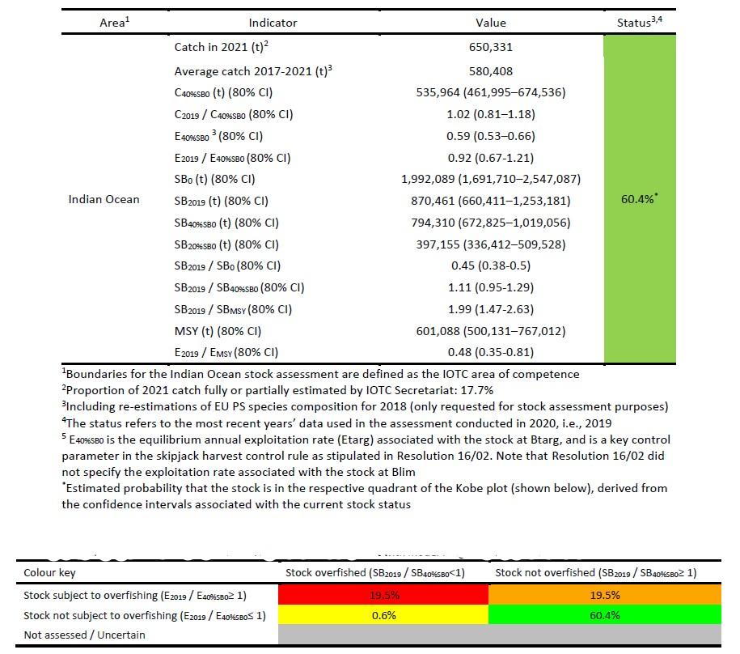
Figure 1 Status of skipjack tuna in the Indian Ocean and Probability of stock status with respect to each of four quadrants of the Kobe plot (Source: adapted from IOTC 2022b)

Yellowfin tuna (YFT)
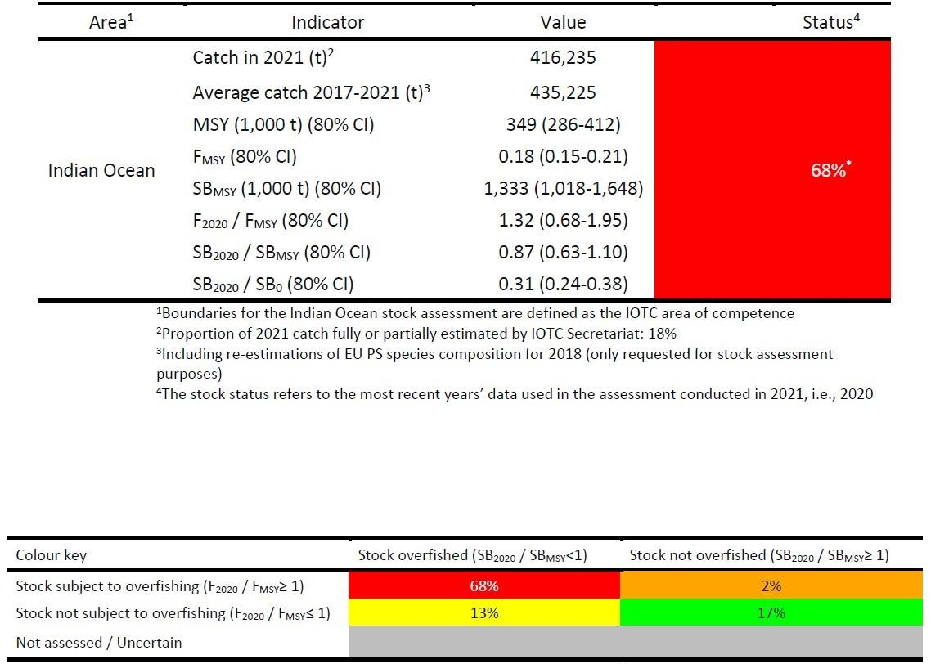
Figure 2 Status of yellowfin tuna in the Indian Ocean and Probability of stock status with respect to each of four quadrants of the Kobe plot (Source: adapted from IOTC 2022c)

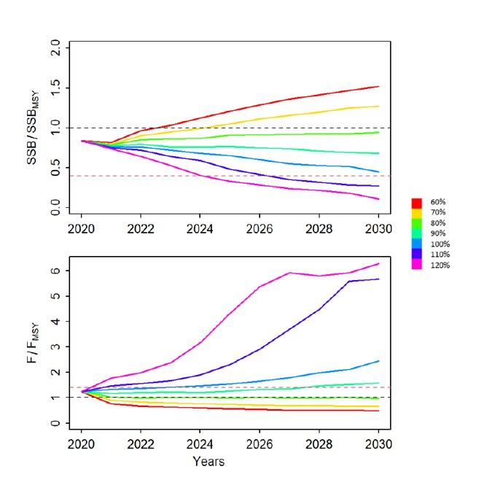
Figure 3 Average trajectories of relative biomass (SSB/SSBmsy) and fishing mortality (F/Fmsy) for yellowfin tuna (Source: Urtizberea et al., 2021)

Bigeye tuna (BET)
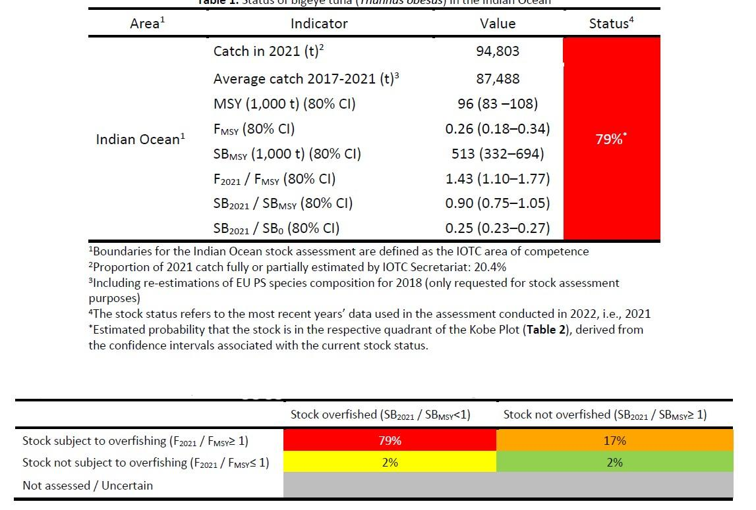
Figure 4 Status of bigeye tuna in the Indian Ocean and Probability of stock status with respect to each of four quadrants of the Kobe plot (Source: adapted from IOTC 2022a)

Table 1 Bigeye tuna: Stock Synthesis base case Indian Ocean assessment Kobe II Strategy Matrix. Probability (percentage) of violating the MSY-based target (top) and limit (bottom) reference points for constant catch projections (relative to average catch level from 2018 (81,413 t); -10%, -20%, -30%, -40%) projected for 3 and 10 years (Source: IOTC-2019-SC22-ES02)
Reference point and projection timeframe | Alternative catch projections (relative to the catch level from 2018) and weighted probability (%) scenarios that violate reference point
 | 60%  (48,848t) | 70%  (56,990t) | 80%  (65,130t) | 90%  (73,272t) | 100%  (81,413t)
B₂₀₂₁ < B_{MSY} | 51.1 | 53.3 | 54.2 | 57.1 | 58.9
F₂₀₂₁ > F_{MSY} | 7.3 | 17.8 | 32 | 47.9 | 62.8
B₂₀₂₈ < B_{MSY} | 8 | 19.5 | 35.1 | 49.1 | 60.8
F₂₀₂₈ > F_{MSY} | 1.1 | 6.9 | 19.8 | 37.7 | 55.6
Reference point and projection timeframe | Alternative catch projections (relative to the catch level from 2018) and probability (%) of violating MSY-based limit reference points  (B_{lim} = 0.5 B_{MSY}; F_{Lim} = 1.3 F_{MSY})
 | 60%  (48,848t) | 70%  (56,990t) | 80%  (65,130t) | 90%  (73,272t) | 100%  (81,413t)
B₂₀₂₁ < B_{LIM} | 0 | 0 | 0 | 0 | 0
F₂₀₂₁ > F_{LIM} | 6.0 | 11.0 | 17.0 | 28.0 | 39.0
B₂₀₂₈ < B_{LIM} | 0.0 | 0.0 | 6.0 | 11.0 | 22.0
F₂₀₂₈ > F_{LIM} | 0.0 | 6.0 | 17.0 | 22.0 | 39.0

IOTC Data requirements
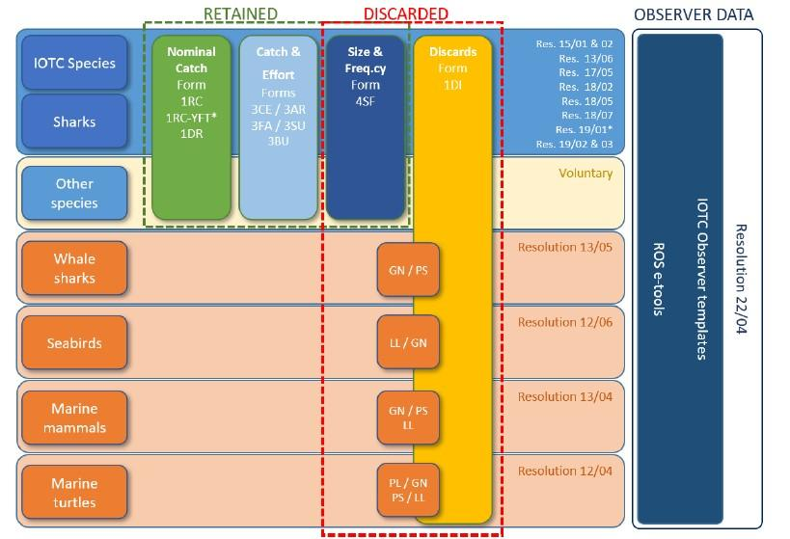
Figure 5 Overview of the data reporting requirements, including IOTC reporting forms and tools, and Resolutions for the 16 IOTC species and bycatch species caught or interacted with by fisheries for tuna and tuna-like species in the IOTC area of competence. BB = Baitboat; GN = Gillnet; LL = Longline; PS = Purse seine. * applies to CPCs that have objected to Res. 21/01 (Source: IOTC-2022-WPEB18-07_Rev1)

Scores in P1 for skipjack tuna and bigeye are the scores given at the time of the pre-assessment (Poseidon 2015) as the Fisheryprogress.org profile only allows for the tracking of the most threatened species (yellowfin) and scores for 2022 are only given for this last species.

