By receiving the report from the public and under the supervision of MARA (Ministry of Agriculture and Rural Affairs), the provincial fishery administration dispatched a working group to investigate the illegal fishing in Nan'ao Island, and recalled all the illegal fishing vessels in cooperation with the local government.
On August 14, the Nan’ao County Party Committee and the county government held a “three no” (no vessel name and number, no vessel certificate, no port of registry) fishing vessel disassembling event where 13 “three-no” fishing boats were dismantled. So far, 18 fishing vessels have been canceled their fishing licenses, 27 fishing vessels that violated fishing regulations have been punished, and 38 suspected illegal fishing boats have been detained.
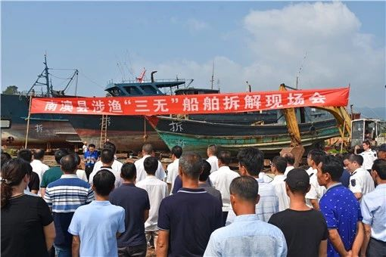
Illegal fishing boat disassembling event

Link：https://mp.weixin.qq.com/s/4jw0xVXSHmmZJZuJojWCjw
https://mp.weixin.qq.com/s/C7OOFd45SRCPBH5WXDaF8A

