Review of alternative measures to encourage the development and implementation of technologies and operational methods that minimise mortality of unwanted catch or ETP species
William Lart, Cameron Moffat, David Parker and Mike Mitchell

Introduction
The MSC Fisheries Assessment Methodology requires that fisheries adequately take into account the MSC Principles & Criteria, in relation to gear selectivity, namely that fisheries should “make use of fishing gear and practices designed to avoid the capture of non-target species (and non-target size, age, and/or sex of the target species); minimise mortality of this catch where it cannot be avoided, and reduce discards of what cannot be released alive” (Criterion 3B.12).In addition, FAO (1995), states that “selective and environmentally safe fishing gear and practices should be further developed and applied, to the extent practicable, in order to maintain biodiversity and to conserve the population structure and aquatic ecosystems and protect fish quality. Where proper selective and environmentally safe fishing gear and practices exist, they should be recognized and accorded a priority in establishing conservation and management measures for fisheries.”

To ensure this, the MSC has recently added a “Review of alternative measures” to several performance indicators to encourage the development and implementation of technologies and operational methods that minimise mortality of unwanted catch or ETP species”, the desired outcomes being:

- To motivate fishers to continually “think smart” about their impact on the environment (species and habitats); both in delivering the sustainable impact most efficiently, and continuing to reduce their impact beyond that.

- To balance this desire with efficiency by not spending a lot of money and time generating only marginal improvements.

To achieve this for species, the scoring issue has been added to the P1 Harvest Strategy (PI 1.2.1) and P2 Species Management PIs (PI 2.1.2, 2.2.2, 2.3.2) requiring fisheries to continually review alternative measures to encourage the development and implementation of technologies and operational methods that minimise mortality of unwanted catch or ETP species, taking into account the practicality of the measures, their potential impact on other species and habitats and on the overall cost of implementing the measures.

Fisheries need to either review alternative measures that are shown to minimise mortality of the species or species group in question. Fisheries also need to consider alternative measures to reduce impacts on habitats. Fisheries should also take account of the potential for both positive and negative impacts of alternative measures on species and habitats when considering whether such measures should be implemented.

Alternative measures should avoid capture of the species in the first place or increase its survivability if released. Alternatively, in the case of in-scope species, they could utilise the unwanted catch in some way so that it would no longer be ‘unwanted’. If there are no unwanted species, the scoring issue on reviewing alternative measures does not need to be scored in that PI.

Alternative Measures Definition: Fishing gear and practices that have been shown to minimise the rate of incidental mortality of the species or species type to the lowest achievable levels.

Alternative Measures Scoring Guideposts
SG 60 There has been a review of the potential effectiveness and practicality of alternative measures to minimise UoA-related mortality of unwanted catch of the target stock/secondary species/ ETP Species.
SG 80 There is a regular review of the potential effectiveness and practicality of alternative measures to minimise UoA-related mortality of unwanted catch of the target stock/secondary species/ ETP Species and they are implemented as appropriate.
SG 100 There is a biannual (biennial?) review of the potential effectiveness and practicality of alternative measures to minimise UoA-related mortality of unwanted catch of the target stock/secondary species/ ETP Species., and they are implemented, as appropriate.

Fishery Management measures
These are divided into input controls and output controls.
Input controls can be designed to regulate the quantity and type of fishing ‘effort’, often quantified in terms of vessel, size, power and time at sea. Days at sea regulations, where vessels of a given power and gear type are restricted to a certain number of days at sea in a given time period, are input controls. Technical measures can be considered a subset of input controls as they directly control the design and deployment of the gear, including selectivity devices and mesh sizes and also seasonal and area closures.
Output controls are designed to control the quantity and composition of the catch and include Minimum Landing Sizes (now described as Minimum Conservation Reference Sizes), Total Allowable Catches (TACs), which may be shared into quotas for individual nations or fishers, and so-called ‘bag limits’ which limit the quantity of fish a fisher can remove in a day.

Technical Conservation Measures
Currently European fisheries regulations are in flux with a new set of technical conservation regulations being discussed as well as the landing obligation being phased in.
The links for recent documents are at;
- Technical Conservation measures http://data.consilium.europa.eu/doc/document/ST-8151-2017-INIT/en/pdf
- Discard plan for North Sea https://ec.europa.eu/transparency/regdoc/rep/3/2018/EN/C-2018-6793-F1-EN-MAIN-PART-1.PDF
The European Parliament (EP) adopted their position on the proposal back in January. Trilogue negotiations are taking place– where they try to arrive at a compromise proposal taking both Council and EP positions into account – those are due to take place during this month (April; need an update from Defra).
From the Technical Conservation Regulations Article 4 states that
1) Technical measures shall aim to ensure;
(a) that catches of marine species below minimum conservation reference sizes are reduced as far as possible in accordance with Article 2(2) and Article 15 of Regulation (EU) No 1380/2013
(b) that bycatches of marine mammals, marine reptiles, seabirds and other non-commercially exploited species do not exceed levels provided for in Union legislation and international agreements that are binding on the Union.
(c) ensure that the environmental impacts of fishing activities on seabed habitats are in line with Article 2 (5) (j) of Regulation (EU) No 1380/2013
2)The extent to which these targets have been achieved shall be reviewed as part of the reporting process set out in Article 34.

Article 34
1)By the end of [2020 and every third year] thereafter, and on the basis of information supplied by Member States and the relevant Advisory Councils and following evaluation by the STECF, the Commission shall submit a report to the European Parliament and to the Council on the implementation of this Regulation. This report shall assess the extent to which technical measures both regionally and at Union level have contributed to achieving the objectives set out in Article 3 and in reaching the targets set out in Article 4.
2) On the basis of that report, where at regional level there is evidence that the objectives and targets have not been met, within six twelve months after the submission of the report as referred to in paragraph 1 Member States within that region shall submit a plan setting out the corrective actions to be taken to ensure those objectives and targets can be met.
3) The Commission may also propose to the European Parliament and to the Council any necessary amendments to this Regulation on the basis of that report.

Implications in relation to technical conservation measures
So these two articles imply that for the European fisheries as a whole the effectiveness of the technical conservation regulation is reviewed every three years and a plan setting out corrective action is implemented. As far as the discard plan under the landing obligation is concerned, there will be survivability and de minimus exemptions for a number of species fisheries including plaice and skates and rays, which are to be reviewed by STECF during 2019.
There is scope for examining how the new technical conservation and landings obligation regime is likely to affect the catches and discarding practices in relation to commercial requirements of the supply chain. The Appendix outlines some of the information available which could be used to make this assessment.

Output controls
Under the North Sea Multi Annual Plan TACs are set for the main resource species caught within mixed demersal fisheries cod, haddock, saithe, whiting and plaice are set so that the fishing mortality within the F_{MSY} range implying a maximum decrease in long term yield of -5% compared with maximum sustainable yield. The aim is to set the TACs to avoid these species becoming a choke species in North Sea fisheries.
These assessments are carried out annually http://ices.dk/sites/pub/Publication%20Reports/Advice/2018/2018/mix-ns.pdf to advise the annual TAC setting process during the EU December council. Although the mixed fisheries advice has been available annually for a number of years, the MAP has been implemented in 2018, so 2019 is the first year these assessments will be available for TAC setting under this plan.
Lemon sole is not included in the ICES mixed fishery assessments, however ICES report that some discarding does take place (recorded between 2013-16) and further interrogation of ICES catch data and landings information is required to improve the understanding of this aspect. Seafish analysis so far (Motova and Catchpole, 2018) suggests that lemon sole is currently at low risk of becoming a choke species at least for UK fleets http://www.seafish.org/media/1744388/dag_feb2018_ukloanalysis_seafish.pdf

Implications in relation to output controls
The use of F_{MSY} ranges by under the MAP implies that the TAC levels set under the plan will be designed to minimise catches of unwanted resource species. The plan is to utilise the approach to set TACs annually implying annual review.

Endangered Threatened and Protected (ETP) species
Under the Technical Conservation Measures Article 4 quoted above these species are expected to be managed by technical conservation measures. ETP species present in geographic area include allis shad, porbeagle, spurdog, common skate, starry ray and grey seal. The porbeagle, common skate and starry ray are on the EU prohibited species list (COUNCIL REGULATION (EU) 2018/120). These conservation measures rely on deterring fishers from targeting of these species, and returning to the sea alive those fish which are caught as by catch. Spurdog is subject to zero TAC over most of the Northeast Atlantic but not Sub area 4 and division 3a. Methods for spurdog bycatch avoidance including the southern North Sea are being developed under the UK shark, skate and ray conservation plan. http://randd.defra.gov.uk/Default.aspx?Module=More&Location=None&ProjectID=19725.
For grey seals in Scotland, the SMRU advice (annual) includes an assessment of seal bycatch in commercial fisheries (mainly in static net fisheries); they have a unit dedicated to monitoring and evaluating bycatch of all marine mammal species in fisheries.

Industry initiatives on ETP
Two industry initiatives are in progress which are of relevance.
SFSAG Northern Demersal stocks
Quoted from (Jones and Honneland 2018) Client action plan described in SFSAG Northern Demersal Stocks 2rd Surveillance report – Jun 18
Action plan for conditions 2, 3 and 4: Ensure data collection requirements are met under current PET observer programme. Also continue distribution of skate and ray identification cards, to member vessels and request interactions with starry ray and common skate to be logged so that the rate of interactions can be adequately assessed. On the basis of the recorded data, the fishery impact on those species will be assessed and appropriate management actions will be reviewed and implemented as required.
• Year 1: continue distribution of skate and ray identification cards and reporting instructions. Review data collection requirements to assess fishery impacts on common skate and starry ray and put in place additional data collection measures as required.
• Year 2: Data collection and provisional review of fishery impact
• Year 3: Data collection and assessment of fishery impact. Review of management options to reduce fishery impact on starry ray and common skate as required. Determine which management options can provide objective basis for confidence that the strategy – if required - will work.
• Year 4: Data collection and implementation of management strategy.
• Year 5: Data collection and final review of impacts and effectiveness management strategy.
Data collection still on-going, we would need to integrate the finding at a later date
Osprey trawler’s Starry Ray Impacts;
Quoted from Andrews and Milner (2018) surveillance report on Trawlers North Sea twin-rigged plaice certification report
This information shows that the fishery overlaps with the starry ray distribution in the central
North Sea, and that the starry ray range extends considerably further north, beyond the
extent of the twin-rig trawl fishery.

The conclusion of this assessment is that the direct effect of this fishery (the capture of
around 70t of starry rays in just part of the species overall range) is unlikely to hinder the recovery of rebuilding of starry rays in the North Sea, meeting the SG60 requirements.
The level of certainty of this assessment is not sufficient to warrant a higher score than this
however. The evidence presented at this surveillance audit demonstrates that there is a research plan in place to gather information about the catch of starry ray by Ekofish Group vessels, and to estimate the impact that the Ekofish Group fishery may have on starry ray.

Implications in relation to technical conservation measures
Conservation of most of the ETP species is reliant on technical measures which are reviewed every three years and a plan setting out corrective action is implemented. Spurdog is assessed biennially and seal stocks are assessed every year. There are also new industry measures for improving visibility of skates and rays catches in relevant fisheries as discussed above.

Appendix 1 Implications of new tech cons measures
From the new technical conservation measures as of April 2018;
Whole of North Sea, Skagerrak and Kattegat >120 mm mesh in all demersal trawls with the exception of;
- North Sea south of 57º30'N (approx. latitude of Peterhead) Directed fishing for plaice and sole (minimum of 50% of catch) with otter trawls and seines to use a minimum of 100mm. A square mesh panel of at least 90mm shall be fitted.
- Nephrops targeted (more than 20% of catch) > 80 mm mesh use of sorting grid or with a maximum bar spacing of 35mm or equivalent selectivity device shall be fitted or 120 mm SMP compulsory
- Div 4c only; Sole targeted otter trawls (min 15%) and pulse/beam (sole targeted) > 80 mm mesh. SMP required for sole targeted otter trawls
- Directed fishing for species not covered by catch limits (40%) > 80 mm. A square mesh panel of at least 80mm shall be fitted.
- Directed fishing for skates and rays (70%) > 80mm
- Small meshed fisheries for Crangon crangon are proposed to continue use technical measures in the form of sorting grid sieve or other device to reduce bycatch.
Spatial measures
• Plaice box to be retained with vessels of < 221 kw permitted and similar rules within UK 12 mile limit.

Relevance to plaice and lemon sole
Issues which could affect discarded bycatch levels are
- Selectivity of the gear and length distributions of the fish encountered
- Commercial demand for certain size groups
- Other species caught in a mixed fishery
- Landing obligation requirements

Selectivity of the gear and length distributions encountered
L₅₀s are provisional and actual discards levels would depend on populations encountered
Table 1 Approximate L₅₀s in cm for several North Sea species based on Herrman et al (2008)
 | Mesh Size mm |  |  | North Sea MCRS (cm)
Species | 100 | 120 | 140
Plaice | 25 | 26-27 | 32 | 27
Lemon sole | 24-25 | 29 | 34
Cod | 24-33 | 28-38 | 32-44 | 35
Haddock | 22-30 | 26-36 | 30-42 | 30

- Relevance to plaice; 120 mm mesh approximately equivalent to L₅₀ = 26-27 cm compared with MCRS of 27 cm for plaice, compared with 100 mm which is approximately equivalent L₅₀ of 22 cm. Smaller mesh (80 mm) Nephrops beam and pulse trawls would continue to catch small plaice.
- Relevance to lemon sole; 120 mm mesh approximately equivalent to L₅₀ = 29 cm and 100 mm approx. L₅₀ 24 cm which indicates a lower proportion of small lemon soles would be caught in this mesh.

Length-frequency distributions

Shetland length frequency data from 2013-2015 one trip per month on Shetland vessels
From Macdonald et al 2017 Data Limited Fish Stocks in the Northern North Sea (pdf)
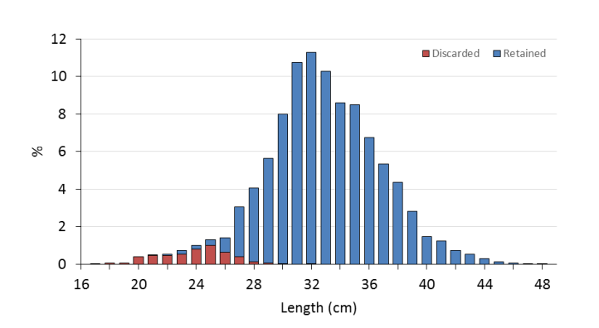
Figure 1 Raised length frequency distribution of the overall discarded and retained portion
of the lemon sole catch (n=7,467), should be 120 mm minimum mesh cod end
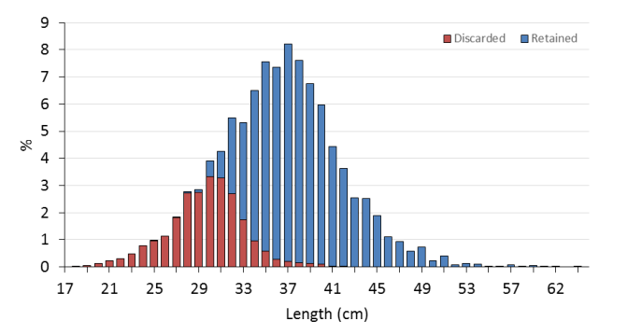
Figure 2 Raised length frequency distribution of the overall discarded and retained portion of the plaice catch (n=12,913) should be 120 mm minimum mesh cod end

Central – Western North Sea; Cefas Fisheries Science partnership data 2005-6 (Armstrong et al 2006)
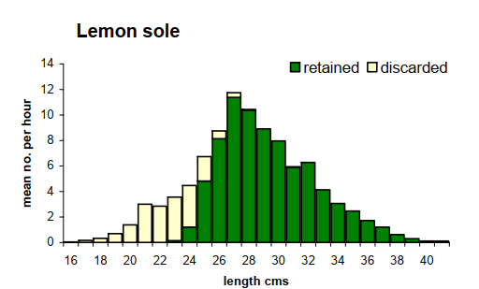
Figure 3 Lemon sole Length-frequency distributions central North Sea FSP survey July 2005 twin rig trawling 100 mm mesh
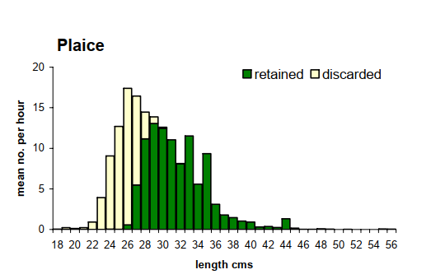
Figure 4 Plaice Length-frequency distributions central North Sea FSP survey July 2005 twin rig trawling 100 mm mesh

Central – Western North Sea; Cefas Fisheries Science partnership data 2005-6 (Parker-Humphreys, etal, 2008)
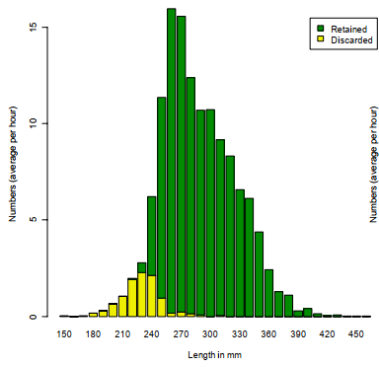
Figure 5 Lemon sole Length-frequency distributions central North Sea FSP survey June-July 2006 twin rig trawling 100 mm mesh

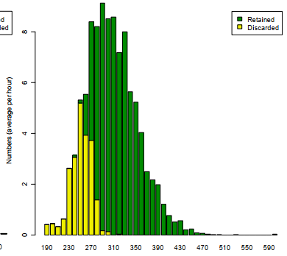
Figure 6 Plaice Length-frequency distributions central North Sea FSP survey June- July 2006 twin rig trawling 100 mm mesh

Central eastern North Sea; Osprey Trawlers North Sea twin-rigged plaice certification report (Andrews et al, 2016)
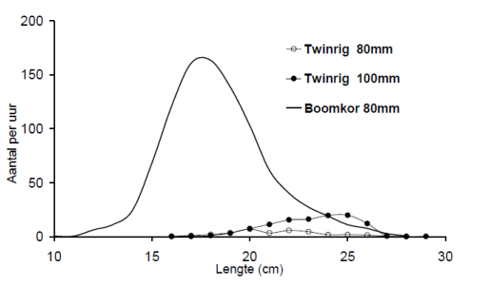
Figure 7 Length distribution of plaice discards from 80mm and 100mm twinrig trawl fisheries and 80mm beam trawls (“Boomkor”) from before 2004 data (shown in Andrews, et al 2016)

Length-weight relationships

Figure 8 Length-weight relationship for lemon sole from Macdonald et al (2017)
Figure 9 Length-weight relationship for plaice from Macdonald et al (2017)

References
Andrews J, Millner R, Cappell R (2016) Public Certification Report Osprey Trawlers North Sea Twin Rigged Plaice
https://fisheries.msc.org/en/fisheries/osprey-trawlers-north-sea-twin-rigged-plaice/@@assessments
Andrews, J and R. Milner 2018 Marine Stewardship Council 2nd Surveillance Report Osprey Group North Sea twin rigged plaice fishery, prepared by Acoura Marine
https://cert.msc.org/FileLoader/FileLinkDownload.asmx/GetFile?encryptedKey=a+hX5LhmZka94dLRxAEaOSjUY4ycQGBXtrUCBlZ4F8rBSYKCiQjwbJxHIMVJNcBl
Armstrong, M., Dann, J., Keable J., and Ashworth, J (2005) Fisheries Science Partnership: 2005/06 Final Report (1st draft for industry comment) Programme 4: North Sea lemon sole
https://webarchive.nationalarchives.gov.uk/20150204060540/http://www.cefas.defra.gov.uk/publications-and-data/scientific-series/fisheries-science-partnership-reports.aspx
Herrmann, B., L. A. Krag, R. P. Frandsen, B. Lundgren, N. Madsen and K-J Stæhr (2008) Simulering af selektiviteti fiskeredskaber Del 1: Hovedrapport Udarbejdet af: DTU Aqua
Macdonald P et al (2017) NAFC Marine Centre Data Limited Fish Stocks in the Northern North Sea
Jones, H., and G. Honneland (2018) Marine Stewardship Council (MSC) 2nd Annual Surveillance Report SFSAG North Sea haddock On behalf of SFSAG Prepared by ME Certification Ltd
https://fisheries.msc.org/en/fisheries/sfsag-northern-demersal-stocks/@@assessment-documentsets?documentset_name=Surveillance+report&phase_name=Ongoing+surveillance&start_date=2018-03-08&title=Surveillance+Audit

Parker-Humphreys, M Velterop M R and Bush R (2007) Fisheries Science Partnership: 2006/07 Final Report. Programme 11: North Sea lemon sole and plaice
https://webarchive.nationalarchives.gov.uk/20150204060540/http://www.cefas.defra.gov.uk/publications-and-data/scientific-series/fisheries-science-partnership-reports.aspx

