Summary of Bait Use in the 2J3KL Cod Stewardship Fishery

Performance indicators 2.1.1 (outcome), 2.1.2 (management strategy), 2.1.3 (information)
Under the MSC Standard (2.01), bait species are tested and subject to scoring the same as main species. Bait species that are obtained outside of the UoA are still examined as a proportion of total catch of the UoA rather than examined as a proportion relative to the fishery that the bait is obtained from. MSC requires that rationale is provided to show all facets of the fishery are sustainable, including purchased bait sources (MSC Standard 2.01, p. 57).
MSC guidelines concerning “designation of main species” (GSA 3.4.2) place the goalposts at 2 or 5 percent bait relative to overall landings to consider bait as a main species and thus to be scored under primary species. Consequently, the FIP Workplan for the 2J3KL cod stewardship fishery identified a need for information on the types and quantities of bait used in the 2J3KL cod stewardship fishery for the handline and longline (line-trawl) Units of Assessments (UoAs). Such information is needed to meet the requirements for a Scoring Guidepost >80 (TFC Inc 2016, p. 19).

Annual landing from this cod fishery have ranged from 3,929 t to 12,276 t since 2015, with 10,164 t landed in the 2019 fishery (Table 1). Since 2015, most (>80%) of landings were from gillnet, with baited gear accounting for a maximum of 27% of annual landings in 2016. Landings for specific gear types in the 2019 fishery will be provided at the upcoming 2J3KL assessment. Therefore, if bait usage is greater than 2 or 5 percent of landings for the handline and longline UoAs, or a maximum of 130.2t [based on the higher landing by baited gear types in 2016], the bait fisheries would need to be assessed under Performance indicators 2.1.1, 2.1.2 and 2.1.3.

Table 1. Landings 2015-19*
Year | TAC (t)
2015 | 3,929
2016 | 9,646
2017 | 12,276
2018 | 8,954
2019 | 10,164
*Source: Annual landings data from http://www.nfl.dfo-mpo.gc.ca/NL/Species-Quota-Reports.
Data retrieved 27/02/2020.

Main bait types
CPUE data gathered from logbooks and presented at the 2019 assessment illustrate, and confirm, that the majority of gear used in the 2J3KL cod fishery is unbaited gillnet. Logbook return rates have been consistently high, indicating that estimates of the amount of baited gear fished is well-documented.
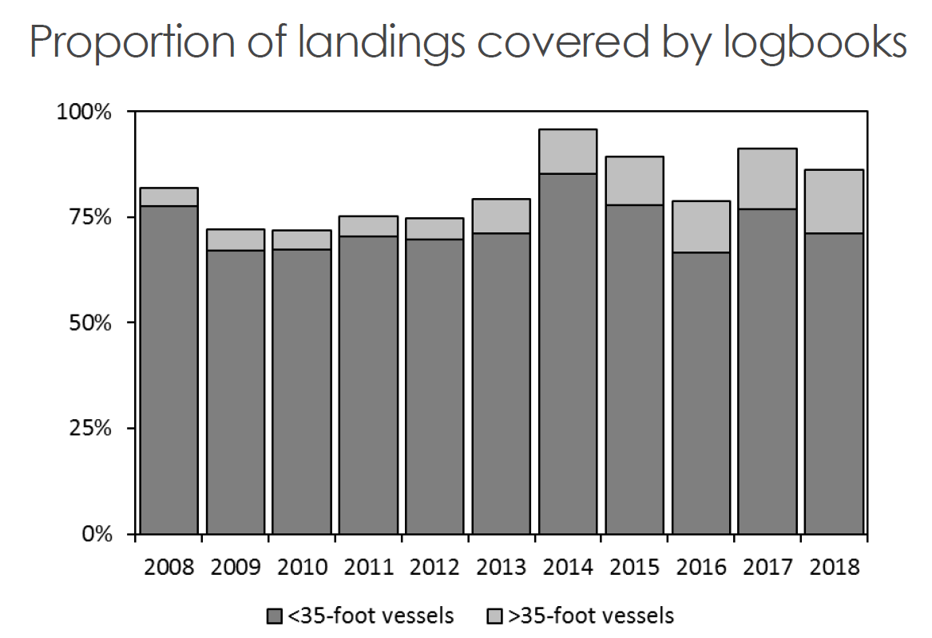
Figure 1. Proportion of inshore landings covered by logbooks. DFO unpublished data.

For vessels that fished baited gear, information on the types and amounts of bait used were compiled from the annual FFAW telephone survey (e.g., Stansbury 2017), from reports of harvesters participating in the cod quality program and based on estimates of total baited gear use. Information from both the cod quality project in 2019 and the annual telephone survey indicate that the most common bait used is squid, with only one out of 34 harvesters who replied to the phone survey indicating he used a small amount of herring while also using squid(Stansbury 2017).

During 2018-2019 harvesters who participated in the Cod Quality project provided information on bait use. Such information will be requested in future data sheets for this ongoing program. In 2018-19, harvesters participating in FFAW’s cod quality project reported the following bait use:

Bait used
Squid | 42 (82.4%)
Mackerel | 1 (2%)
Herring | 8 (15.7%)

These are the same baits used in the Newfoundland and Labrador snow crab fishery which is MSC certified.
In the most recent MSC reassessment of snow crab (2017), the Association of Seafood Producers indicates that primary bait used in the crab fishery is 90 percent squid, consistent with the northern cod fishery. Squid is sourced from the SW Atlantic. A small amount of herring is also used. Bait use is estimated at 1.5 kg per trap haul, or approximately 7,154 t, broken down into 6,438 t of squid and 644 t of herring. This amounts to squid being 9.4 percent of total catch volume and herring making up 1 percent (p. 53).

The cod fishery is at a level of < 12,000 t (compared to 28,000 t of snow crab in 2018) and the main gear type is gillnet which are unbaited. Data from the Department of Fisheries and Oceans previously stated here are consistent with FFAW’s cod quality project. Of 157 harvesters, 126 (86.4 percent) of harvesters used gillnets.

Harvesters who used handline and longline in the cod quality project indicated bait use ranging from 1/6 of a herring to ½ a squid per hook. The maximum amount of hooks permitted to be onboard per trip is 5,000, as per the CHP. Given that estimates of the weight of herring per hook was estimated to be approximately 500 g (DFO 2019), based on a half herring per hook in the longline survey for halibut, we estimate that the maximum amount of bait used per set would be 2,500 kg or 5,511 lbs. In 2018, for example, there were 178 longline sets fished, which would result in an estimate a maximum of 44 t used for this UoA in 2018. Noting that not all harvesters fishing longline will have fished the maximum number of hooks per set. Nonetheless, the maximum estimate of bait use is 9.63% of the landings for that gear type. Consequently, bait species would not be considered a “main species”. Similar estimations for handline, will be calculated based on numbers of hooks fished, once those data are available. Additionally, these estimates will be revised for longline as more data becomes available. It remains however, that bait use is well below the threshold for consideration as a main species.

References
Bourne, C., F. Mowbray, B. Squires, and J. Croft. 2013. Assessment of Newfoundland East and South Coast Herring Stocks to the Spring of 2011. DFO Can. Sci. Advis. Sec. Res. Doc. 2013/039. v + 109 p
Department of Fisheries and Oceans. 2019. Atlantic Halibut Survey Program Fishery Observers’ & Participants’ Manual.
Dwyer, K.S., Healey, B.P., Ings, D.W., Mello, L, Morgan, M.J., Regular, P, Rideout, R.M., Robertson, G, Rogers, R & Wheeland, L. 2019. Working Paper on the Assessment of the Northern Cod (Gadus morhua) stock in NAFO Divisions 2J3KL in 2019. Department of Fisheries and Oceans. In press.
Marine Stewardship Council. 2018. MSC Standard 2.0.
SAI Global. 2018. Marine Stewardship Council 1st Re-assessment Public Certification Report forNewfoundland & Labrador snow crab.
Stansbury, D. 2017. 2J3KL Cod Stewardship Fishery Bait Survey: Analysis of the Post-season Telephone Survey as it Relates to MSC Certification. Prepared for WWF Canada.

