Robin Cook
University of Strathclyde
A Review of the assessment of the southern stock of Sardine, Sardina pilchardus, in Moroccan waters

Summary

The XSA assessment of sardine is reviewed and compared to the results of a state-space assessment model (ALD). Both approaches give similar results. The ALD model suggests that natural mortality is 0.54, well above the value of 0.2 used in the XSA assessment. Estimates of MSY reference points are highly sensitive to the value of M and the fitted stock recruitment relationship. Recruitment is highly auto-correlated making the estimation of the stock-recruitment function difficult. In view of the uncertainty in the reference points, an escapement biomass method is suggested as a possible management approach. There is scope for improving estimates of natural mortality and steepness in the stock-recruitment model based on meta-analyses.

Introduction

This document reviews a stock assessment of sardine (Sardina pilchardus) in the southern zone of Moroccan waters as reported in INRH/DP (2017). The assessment involves three models including Biodyn COPACE, ASPIC (Prager 1994) and XSA (Shepherd 1999). This review is limited to the XSA assessment and the stock reference points derived from that analysis. The review is motivated by the observation that the relative magnitude of the F_{0.1} to F_{MSY} is sensitive the value of natural mortality, M, used in XSA. In particular, it was noted that if M was not set at 0.2, estimates of F_{0.1} exceeded the value of F_{MSY}, and this was considered unrealistic. The value M=0.2 was therefore chosen on this basis.

As part of the review an alternative stock assessment model has been applied to the data as used in the XSA assessment and provided by INRH/DP. The alternative assessment is used to estimate standard fishery reference points and compared to the XSA derived values.

Comments on XSA

Extended Survivors Analysis (XSA) was developed in the 1990s as a robust assessment tool and became the standard method of assessment in ICES for age structured data. The method uses one or more surveys to calibrate what is essentially a VPA calculation. Statistically it assumes measurement errors in the survey data but not in the catch at age data. This means that if there are measurement errors in the catch data these will be translated into the estimates of fishing mortality and population numbers. It is of particular importance to recognise that the values of fishing mortality in the most recent year of the assessment will be subject to this error. These values are also the ones used for projecting the stock forward and consequently may lead to error prone forecasts. XSA overcomes this problem to some degree by “shrinking” the final year F estimates towards the mean F over some recent period. Shrinkage potentially improves the precision of the values but may introduce bias. The bias will be worst if the mean F used for shrinkage is not representative of current F values. In the assessment presented in INRH/DP weak shrinkage has been adopted and this appears appropriate because of the large change in F over recent years. Stronger shrinkage is likely to introduce significant bias.

While XSA is a robust tool, it is a method that is now used less in ICES assessments due to the development of more statistically rigorous approaches that can more adequately account for observation error in both the survey and catch data. Increasingly ICES uses state space models such as SAM (Nielsen and Berg, 2014), TSA (Gudmundsson, 1994) and AAP (Arts and Poos, 2009). Although these methods are statistically more rigorous, they are far more complex and require considerable user expertise in order to fit them. Thus they may not necessarily outperform XSA.

Exploratory Analyses: Methods

In order to investigate the assessment, a new model (ALD) described in Cook (2019a, 2019b) was fit to data as used in the XSA assessment reported in INRH/DP (2018). This model is similar to SAM, TSA and AAP in estimating observation error in the catches. The model differs from XSA in parameterising fishing mortality, F, into an age and year effect. These effects are smoothed using a time series model. This reduces the effect of noise in the observations and allows measurement error to be accounted for in the population and mortality estimates. While it is not routinely done in ICES assessments, models of this class can potentially estimate natural mortality. Assessments done on west coast of the USA often make this estimation within the model using Stock Synthesis (Methot and Wetzel 2013).

In view of the issues raised about natural mortality in the XSA assessment, the ALD model was run in two versions, one where M was fixed at 0.2 and another where M was estimated by the model. Unlike the XSA assessment, in fitting ALD, data on 0 group fish were included in the analysis. The results were then used to calculate, deterministically, standard reference points such as F_{0.1} and F_{MSY} based on a Beverton-Holt stock-recruitment curve.

The Beverton Holt curve is often parameterised in terms of “steepness”, h, and recruitment at virgin biomass, R₀. Here steepness is a measure of the slope of the stock-recruitment curve near the origin and takes a value between 0.2 and 1. High values of h imply a steep slope near the origin and will be associated with high values of F_{crash}, the fishing mortality leading to stock collapse. Since stock recruitment data are often very scattered, estimating h is subject to large uncertainty and it is common to fix the value based on prior knowledge. For illustration in the analyses presented here estimates of MSY reference points were based on a Beverton-Holt curve fitted without fixing h (i.e. estimated freely) and with h fixed at a value of 0.4. This is a purely arbitrary value chosen to illustrate some of the issues in the estimation of MSY reference points.

Exploratory Analyses: Results

A summary of the assessment using ALD when M is fixed at 0.2 is shown in Figure 1. The trends in SSB and fishing mortality are very similar to the XSA assessment, as is the shape of selectivity of the fishery. The fits to the catch at age data and survey data are shown in Figure 2 and 3. As might be expected the catch data are fitted well but the survey data are subject to much larger errors.

Figure 4 shows the summary for the ALD assessment when M is estimated within the model. The trends are again very similar to the XSA assessment and the ALD M=0.2 assessment. Figures 5 and 6 shows the fit the data, and has the same qualities as the M=0.2 assessment. The model estimates M=0.54 which is substantially higher than the assumed value. The posterior distribution of the estimate in shown in Figure 7. It is clear that the estimate has a defined mode but very wide credible intervals. This suggests there is some information in the data on natural mortality but there is still considerable uncertainty. The M estimate is close the values quoted in the INRH/DP report when using the various Hoenig methods for the northern zone (INRH/DP page 39).

One important point to notice is that the time series of recruitment data (see Figures 1 and 4) show that recruitment is highly auto-correlated. This means the amount of information in the data about the relationship between stock size and recruitment is limited because the effective sample size is very small. The best predictor of recruitment at time T is recruitment at time T-1. As a result, the estimation of a reliable stock-recruitment model is extremely difficult and this will adversely affect the calculation of MSY reference points.

Table 1 and Figures 8-10 show the estimates of key reference points from the ALD assessment results. As would be expected, with the high value of M from the ALD estimate, values of F_{0.1} and F_{MSY} are much higher that when M=0.2. Both assessments give estimates of F_{crash} that are implausibly high as is also seen in the XSA assessment. These values imply an almost infinite exploitation rate is required to cause stock collapse. These estimates of reference points are derived from stock-recruitment models where steepness is estimated at values of 0.6 and 0.9 respectively. However, when h is fixed at 0.4 (Figure 8 and Table 1) F_{crash} is substantially lower. Note also that the value of F_{0.1} now exceeds the value of F_{MSY}, a problem first referred to the INRH/DP report. It shows that the relative magnitudes of F_{0.1} and F_{MSY} are affected by the fit of the stock-recruitment function.

Discussion

Comparing the results of the XSA assessment to the ALD assessments does not reveal any major discrepancies. It suggests that the trends in F and SSB are insensitive to the choice of assessment model, though the scale of both SSB and F is different. When M is estimated, the resulting value is much larger than the conventional value used in XSA. However, the error bounds on this estimate are large and include the value M=0.2. Thus while there is some evidence that M is larger than 0.2, there is a high degree of uncertainty. These assessments show the stock status to be the same as the XSA assessment with current fishing mortality below F_{MSY} regardless of the value of M. However, in relation to F_{0.1}, the M=0.2 assessment implies the stock is over-fished with the high value of M implies that current F is below F_{0.1}.

The estimation of reference points illustrates two major problems. Firstly, the value of M has a profound effect on both F_{0.1} and F_{MSY}. Secondly, the uncertainty in the stock-recruitment model makes the estimation of MSY values extremely difficult, to the extent that at present they are probably not usefully estimable. However, the choice of M=0.2 on the basis that it gives values of F_{0.1} lower that F_{MSY} is not a sound reason since this phenomenon is dependent on the stock-recruitment curve that itself is very unclear.

One area worth consideration is whether the use of MSY or similar proxies is appropriate for this stock. Sardine is species at a low trophic level in the ecosystem and is a forage fish for many predators. Given their role in supporting the ecosystem, an alternative approach would be to consider managing the stock to allow a fixed escapement of biomass. So for example, one might choose an absolute amount of biomass that should be left in the sea after the fishery catch is removed. While a detailed analysis would be required to determine the level, one might as an example set a limit of 1 million tonnes of SSB as the lower limit to be left in the sea. The stock assessment would then be used to estimate current biomass and the catch for the next year that would keep the SSB at 1 million tonnes or above. This would avoid the need to estimate reliable MSY reference points. It would still require an accurate stock assessment but the availability of the survey is a major advantage in determining the biomass.

Although the escapement approach is worth considering, the underlying issues of the appropriate level of M and the stock recruitment function remain and should be addressed. With regard to M, I would suggest that further analysis is done to derive an estimate. A useful paper by Hamel (2015) provides an overview of the various empirical methods that can be used to estimate M based on life history traits. These can be used to derive a prior distribution of M that could be used in a stock assessment. Similarly there are a number of analyses that address the issue of steepness in the stock-recruitment relationship (He, et al, 2006) that might assist in fitting a more reliable model to the data and hence derive more robust values of reference points.

Finally some thought should be given to the choice of assessment model for this stock. As has been mentioned before, XSA is a robust method but which has been superseded by more advanced statistical approaches. The results from XSA appear to compare well with the ALD approach so there is no reason to abandon it. Newer models do, however provide better estimates of uncertainty and offer other advantages in flexibility in the model assumptions that may prove useful.

References

Aarts, G., and Poos, J. J. (2009). Comprehensive discard reconstruction and abundance estimation using flexible selectivity functions. ICES Journal of Marine Science, 66, 763–771.

Cook, R.M. (2019a). Stock collapse or stock recovery? Contrasting perceptions of a depleted cod stock. ICES Journal of Marine Science (2019), https://doi.org/10.1093/icesjms/fsy190

Cook, R. M. (2019b). Inclusion of discards on stock assessment models. Fish and Fisheries.
https://doi.org/10.1111/faf.12408

Gudmundsson, G. (1994). Time series analysis of catch-at-age observations. Journal of the Royal Statistical Society: Series C (Applied Statistics), 43,117–126.

Hamel, Owen S. (2015). A method for calculating a meta-analytical prior for the natural mortality rate using multiple life history correlates, ICES Journal of Marine Science, Volume 72, Issue 1, January 2015, Pages 62–69, https://doi.org/10.1093/icesjms/fsu131

He, Xi and Mangel , Marc and MacCall , Alec (2006) A prior for steepness in stock-recruitment relationships, based on an evolutionary persistence principle. Fishery Bulletin, 104(3), pp. 428-433.

INRH/DP (2018). Rapport annuel de l'etat des stocks et les pêcheries Morocain, 2017. Institut Nationale de recherche Haliuetique, Casablanca (Maroc) ISSN:2509 1727.

Methot Jr., R. D. and Wetzel, C.R. (2013). Stock synthesis: A biological and statistical framework for fish stock assessment and fishery management. Fisheries Research, 142, 86-99.

Nielsen, A. and Berg, C. W. (2014). Estimation of time-varying selectivity in stock assessments using state-space models, Fisheries Research, 158, 96–101.

Prager, M. H. (1994). A suite of extensions to a non-equilibrium surplus-production model. Fishery Bulletin 92: 374–389.

Shepherd, J. G. (1999). Extended survivors analysis: An improved method for the analysis of catch-at-age data and abundance indices, ICES Journal of Marine Science, 56, 584–591, https://doi.org/10.1006/jmsc.1999.0498

Table 1. Estimates of reference point values from three model variants.

Quantity | ALD M estimated,  h estimated | ALD M=0.2  h estimated | ALD M estimated,  h=0.4
M | 0.54 | 0.2(fixed) | 0.54
Steepness | 0.59 | 0.9 | 0.4 (fixed)
F0.1 | 0.84 | 0.28 | 0.84
Fmsy | 1.67 | 0.76 | 0.48
Fcrash | 9.07 | 8.37 | 2.27
Fmax | NA | 2.25 | NA
MSY | 433549 | 360270 | 252232
Bmsy | 628596 | 592988 | 810199
B0 | 2140609 | 3293360 | 2140609
B2018 | 1529608 | 897361 | 1529608
F2018 | 0.51 | 0.64 | 0.51
B/BMSY | 2.43 | 1.51 | 1.88
F/FMSY | 0.31 | 0.84 | 1.06

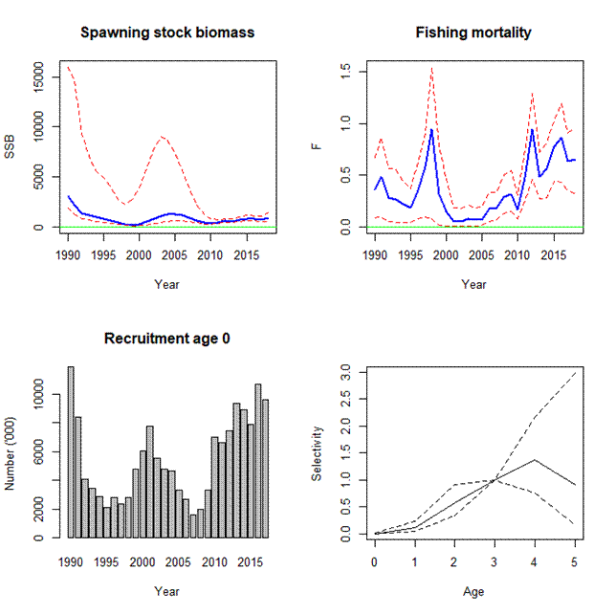
Figure 1. ALD assessment assuming M=0.2. Trends in SSB and mean fishing mortality are shown with associated 95% CIs. Selectivity is shown for 2018 relative to age 3 (hence zero CI). 95% CIs are shown as dashed lines.

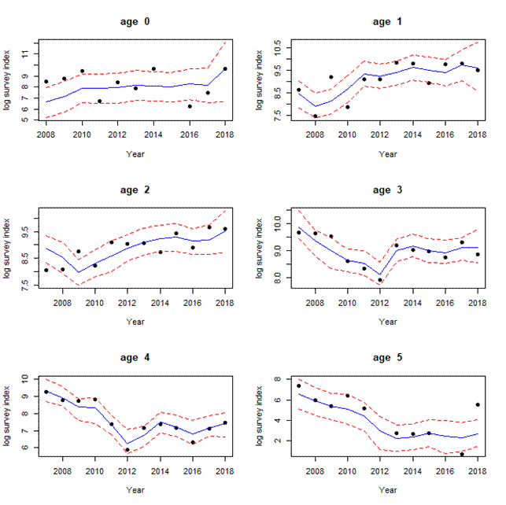
Figure 2. ALD assessment assuming M=0.2. Fits to the survey index with 95% CI.

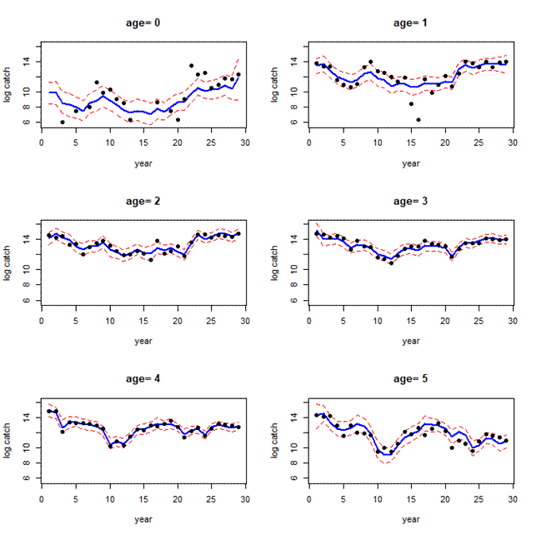
Figure 3. ALD assessment assuming M=0.2. Fits to the catch data with 95% CI.

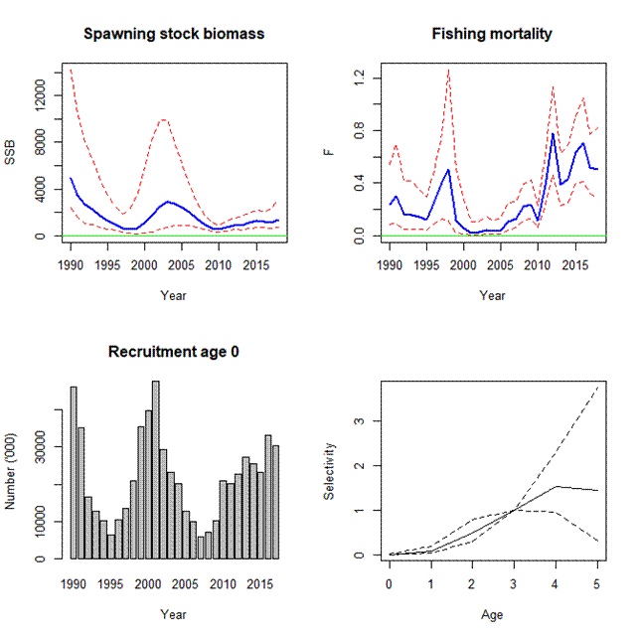
Figure 4ALD assessment with M estimated in the model. Trends in SSB and mean fishing mortality are shown with associated 95% CIs. Selectivity is shown for 2018 relative to age 3 (hence zero CI). 95% CIs are shown as dashed lines.

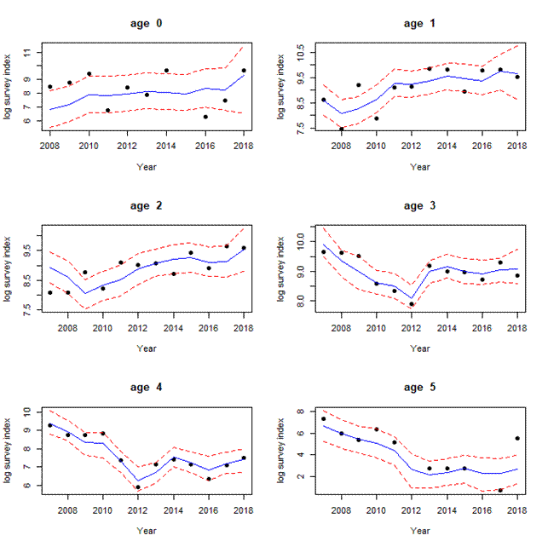
Figure 5. ALD assessment with M estimated in the model. Fits to the survey index with 95% CI.

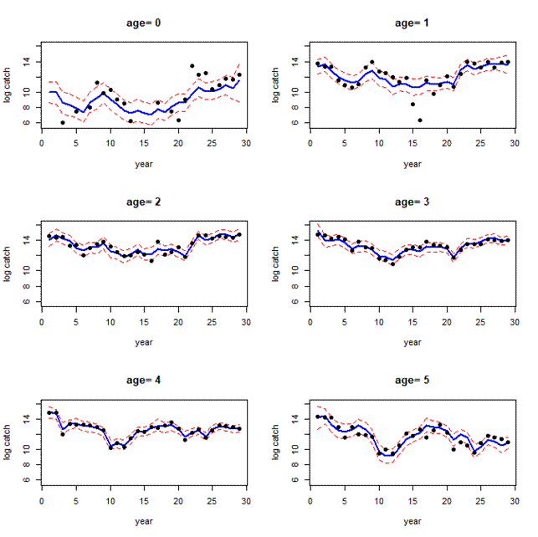
Figure 6. ALD assessment with M estimated in the model. Fits to the catch data with 95% CI.

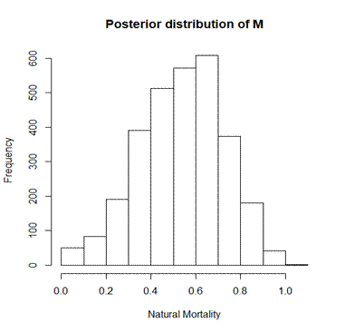
Figure 7. ALD assessment where M is estimated. Posterior distribution of M.

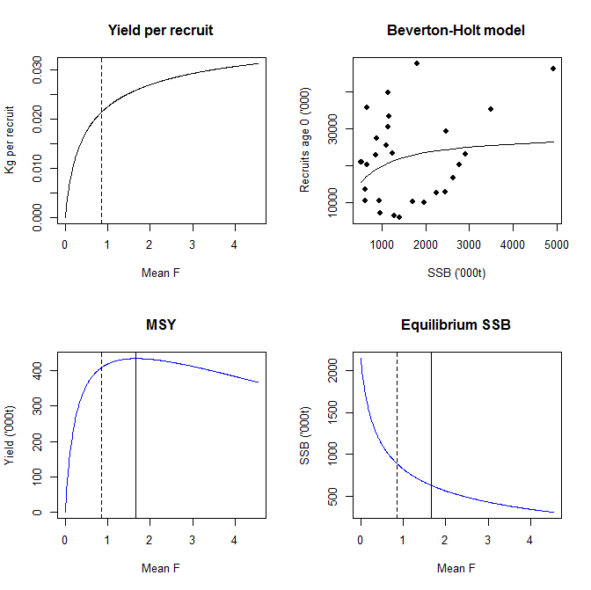
Figure 8. Reference points estimated using ALD output with M estimated. Dashed vertical lines show F_{0.1}. Solid vertical lines in lower two panels show F_{MSY.} In the stock-recrtuiment plot, both the parameters of the Beverton-Holt model are estimated.

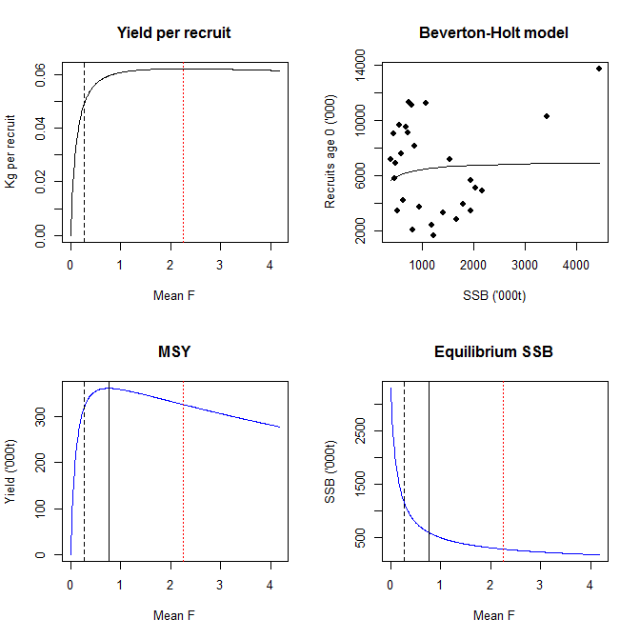
Figure 9. Reference points estimated using ALD output with M=0.2. Dashed vertical lines show F_{0.1}. Solid vertical lines in lower two panels show F_{MSY}. Dotted vertical red lines show F_{MAX}. In the stock-recruitment plot both the parameters of the Beverton-Holt model are estimated.

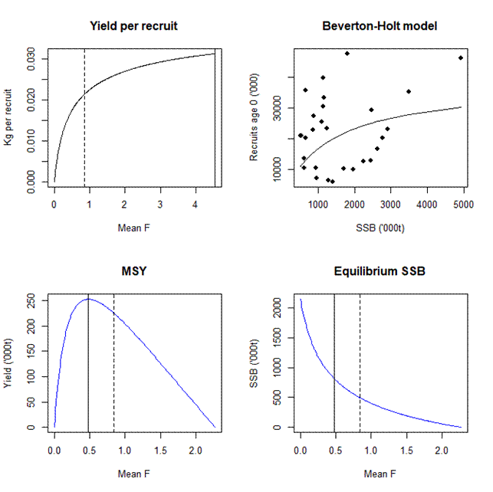
Figure 10. Reference points estimated using ALD output with M. Dashed vertical lines show F_{0.1}. Solid vertical lines in lower two panels show F_{MSY}. In the stock-recruitment plot the steepness of the Beverton-Holt model is fixed at 0.4.

