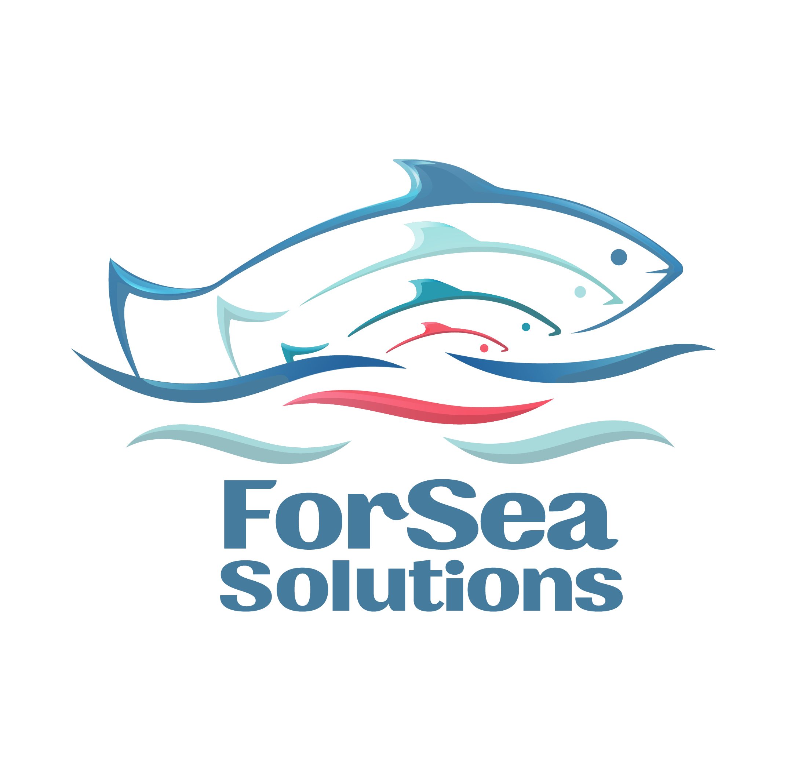
Goal #6 Results and management of artificial reproduction
Objective of the goal: to demonstrate the existence of effective fisheries optimization strategies aimed at eliminating the consequences of impacts of artificial reproduction activities on wild populations.

General characteristics of the activities of the Lagunnoye Lake Salmon Hatchery

Activities on artificial reproduction of salmon on Kunashir Island is carried out at the Lagunnoye Lake Salmon Hatchery, which is owned by the PCF Yuzhno-Kurilsky Ryibokombinat Co., Ltd. The plant plays a key role in maintaining the Chum Salmon population, performing compensatory and restorative functions in years when the number of returns is small. The own broodstock has been created: since 2023, 100% of the egg planting have been performed from the own broodstock, which significantly reduces dependence on natural spawners and ensures the sustainability of the reproductive cycle [7].
In 2025, the release of juvenile Chum Salmon amounted to 12.37 million fish, the average weight of juveniles was 1.206 g. All individuals of this generation were tagged with otolith tags of the 3n,4nH type [5]. In previous years, the release of juveniles also went along with tagging: 27.0 million in 2024 (tag 5H), 3.4 million in 2023 (4.2H), and 2.4 million in 2022 (1.3n, 1H). Thus, annual tagging provides the ability to trace the origin of spawners and to assess the hatchery's contribution to stock replenishment.

Analysis and identification of spawners

Field and laboratory work on the identification of otolith tags is carried out by T.G. Tochilina under contracts for 2024–2026 [2], [4]. In 2024, 600 otolith samples of the Chum Salmon collected at the plant and at sea were analyzed. Two characteristic tags from the 2022 batch (1,3n,1H) were detected, confirming the return of hatchery fish to spawn in the area of release [4]. The obtained data serve as confirmation of the effectiveness of the artificial reproduction program and the company's participation in the international NPAFC otolith tagging program.
As part of its work to improve artificial reproduction management, the company is considering the possibility of using a method for identifying hatchery-bred Chum and Pink Salmon based on microchemical analysis of otoliths. This approach was successfully applied in studies of Amur salmon and allowed to reliably differentiate the origin of fish (wild or hatchery-bred) based on the ratio of microelements (Sr:Ca) [6]. This approach could become an additional tool for confirming the origin of fish, especially in years when tagging is not carried out to the full extent.
International experience confirms that, if technological standards are met, fish hatcheries have minimal impact on wild populations and can effectively perform stock replenishment functions [8]. The application of scientific support principles, continuous quality control of tags, and open reporting within the framework of NPAFC demonstrate the transparency and scientific validity of the Lagunnoye Lake Salmon Hatchery's activities.

Conclusion

The complex of artificial reproduction measures implemented at the Lagunnoye Lake Salmon Hatchery confirms the existence of effective management strategies aimed at eliminating the potential impact of artificial breeding on wild populations.
The key elements of this system are:
- switching to the own broodstock (100 %);
- regular participation in the international otolith tagging program;
- scientific support from SakhNIRO and constant quality control of the tags;
- annual reporting under the international NPAFC program.
The combination of these measures ensures sustainable interaction between artificial reproduction and natural salmon populations, minimizing risks and strengthening the scientific basis for fishery management on Kunashir Island.

Reference and documents list

1. ENG_Official letter to SakhNIRO (Otolith Marking)_2025.docx – the letter from the Director of the YKRK regarding the inclusion of the tagging program in the Russian NPAFC plan
2. ENG_Tochilina_technical assignment.docx –technical assignment for the collection of biomaterial and analysis of the Chum Salmon otoliths.
3. ENG_Terms of Reference_SakhNIRO.docx –SakhNIRO technical specifications for scientific support of tagging in 2025.
4. ENG_T.Tochilina_Kunashir Chum Salmon Identification 2024–2025 Report.docx –report on the results of the otoliths analysis from fish returned in 2024.
5. ENG_Pastukhov D. Information on Juvenile Release.docx – information on the release of the Chum Salmon juveniles from 2020 to 2025.
6. ENG_P. Mikheev et al., Identification of hatchery and natural origin chum salmon by Otolith microchemistry, 2023. Aquaculture and Fisheries 8 (2023) 341–350
www.keaipublishing.com/en/journals/aquaculture-and-fisheries
7. ENG_Protocol_Meeting_with A. Gurov_okt2025.odt –minutes of the meeting with A. Gurov (YKRK) regarding 100% egg planting from the own broodstock.
8.ENG_Researchers-conclude-b-c-salmon-farms-pose-minimal-risk-to-wild-salmon-populations.pdf – an international review of research on the minimal impact of fish hatcheries on wild populations.
9. RUS_СахНИРО_Рекомендации по маркированию_2025 - tagging Guidelines 2025.

Liudmila Konstantinovna Fedorova
Expert Fisheries Consultant

Oct 09, 2025

