Workshop and training on MSC's 3rd principle of management and policy
On March 5-6, 2025, the Southern Institute of Marine Research - Institute of Marine Research in collaboration with the Marine Stewardship Council (MSC) organized a workshop and training course to evaluate the 3rd principle of management and policy of MSC, with the advice and support of international experts.
The workshop and training were attended by representatives of MSC, representatives of the Department of Fisheries and Fisheries Control - Ministry of Agriculture and Environment and 74 participants who are representatives of fisheries management units from the Department of Fisheries of Ba Ria - Vung Tau province, the Department of Fisheries of Binh Thuan province, the Department of Fisheries of Ben Tre province, the Vietnam Tuna Association; enterprises such as Ba Ria - Vung Tau Seafood Import-Export Processing Joint Stock Company, Tu Hai Seafood Export Supply Company Limited, Con Dao Import-Export Company; CP Vietnam Livestock Joint Stock Company, Grobest Vietnam Joint Stock Company; Representatives of fishmeal production companies in Ba Ria - Vung Tau province such as: Phuc Loc Vung Tau Company Limited, Tan Tien Company Limited, Dong Hai Company Limited, Phong Thinh Company Limited, Tan Long Company Limited... and clam farming cooperatives in Ben Tre such as Dong Tam Aquatic Products Cooperative, Tan Thuy Aquatic Products Cooperative, Bao Thuan Aquatic Products Cooperative, Thanh Loi Aquatic Products Cooperative, Rang Dong Aquatic Products Cooperative.
The training course combined online and face-to-face learning, which helped students easily get acquainted with the content and documents of MSC, and at the same time, they could ask questions/concerns and discuss their misunderstandings when participating in face-to-face learning. Through lectures and typical exercises, under the guidance of MSC experts, lively discussions and comments helped students further improve their knowledge related to MSC's assessment principles on Management and Policy.

Through the training course, Lead FIP Vung Tau and members better understood FIP as well as the requirements for Vung Tau trawling. In addition, FIP Vung Tau also understood better the advantages, difficulties and challenges in implementing FIP trawling according to MSC and needed a long process to complete and upgrade.

PARTICIPANTS LIST
No | Participant | Notes
1 | Department of Fisheries and Fisheries Control - Ministry of Agriculture and Environment
2 | Department of Fisheries of Ba Ria - Vung Tau province
3 | Department of Fisheries of Binh Thuan province
4 | Department of Fisheries of Ben Tre province | MSC Clam Ben Tre
5 | Dong Tam Aquatic Products Cooperative | MSC Clam Ben Tre
6 | Bao Thuan Aquatic Products Cooperative, | MSC Clam Ben Tre
7 | Tan Thuy Aquatic Products Cooperative | MSC Clam Ben Tre
8 | Thanh Loi Aquatic Products Cooperative, | MSC Clam Ben Tre
9 | Rang Dong Aquatic Products Cooperative. | MSC Clam Ben Tre
10 | Vietnam Tuna Association | FIP Yellow Fin Tuna
11 | Ba Ria - Vung Tau Seafood Import-Export Processing Joint Stock Company
12 | Tu Hai Seafood Export Supply Company Limited,
13 | Con Dao Import-Export Company
14 | CP Vietnam Livestock Joint Stock Company | Member of FIP Vung Tau
15 | Grobest Vietnam Joint Stock Company
16 | Phuc Loc Vung Tau Company Limited | Member of FIP Vung Tau
17 | Tan Tien Company Limited | Member of FIP Vung Tau
18 | Dong Hai Company Limited | Member of FIP Vung Tau
19 | Phong Thinh Company Limited | Member of FIP Vung Tau
20 | Tan Long Company Limited | Member of FIP Vung Tau
21 | Southern Institute of Marine Research - Institute of Marine Research | Lead of FIP Vung Tau
22 | Fishmeal and Fish Oil Association of Ba Ria Vung Tau Province | Lead of FIP Vung Tau
23 | MSC Organization Representative

PROGRAM
Training Course “MSC Principle 3 - Management and Policy”
- Time: March 5-6, 2025
- Location:
+ Training at the Southern Institute of Seafood Research, 3/2 Street, Ward 11, Vung Tau City - Ba Ria - Vung Tau Province.
+ Visit: Fishmeal Factory - Phuc Loc Company Limited; Seafood Processing Factory - Tu Hai Company Limited; Seafood Processing Factory - BASEAFOOD Company.
Time | Contents | Notes
March 5, 2025
08:00 - 08:30 | Register | MSC & SORESIMF
08:30 - 09:15 | Opening | MSC & SORESIMF
09:15 - 10:15 | Overview of the MSC Fisheries Program | MSC
10:15 - 11:15 | Fisheries Management Conditions (MSC Principle 3) for Vietnam's Fisheries | MSC
11:15 - 12:00 | MSC Principle 3 Live Discussion Session:  - Principle 3 Overview and QnA;  - Group Case Study Exercise. | Amanda
12:00 - 13:00 | Lunch | Participants
13:00 - 15:30 | MSC Principle 3 Live Discussion Session:  - Principle 3 Overview and QnA;  - Group Case Study Exercise.. | Amanda
15:30 - 15:45 | coffee break | Participants
15:45 - 16:40 | MSC Principle 3 Live Discussion:  - Overview of Principle 3 and QnA;  - Explanation of questions, discussion. | Amanda
16:45 - 17:00 | Close | MSC & SORESIMF
March 6, 2025
08:00 - 9:15 | The delegation moved from the Institute to visit the Fishmeal Factory - Phuc Loc Company Limited. Address: Lang Cat Road, Tan Hai Commune, Phu My Town, Ba Ria - Vung Tau Province | Participants
09:15 - 10:15 | The delegation continued to visit the Seafood Processing Factory - Tu Hai Company Limited. Address: Coastal Road (78 Phuoc Thang Street), Ward 12, Vung Tau City, Ba Ria - Vung Tau Province | Participants
10:15 - 11:30 | The delegation continued to visit the seafood processing factory - BASEAFOOD Company. Address: Loc An Industrial Park, Dat Do District, Ba Ria - Vung Tau Province. | Participants

PHOTOS OF TRAINING
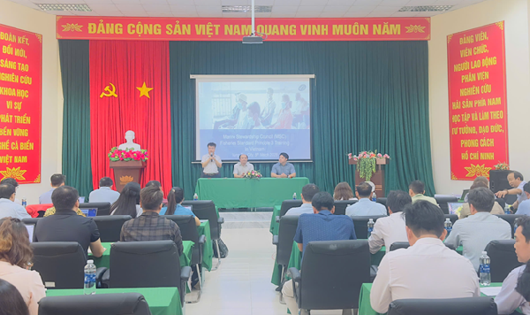 | 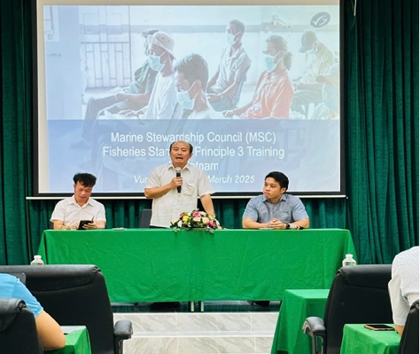
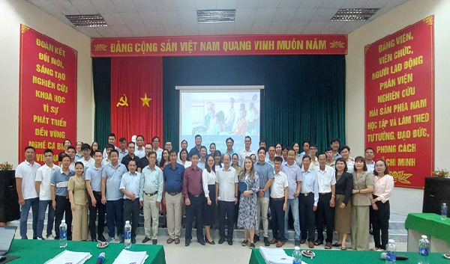 | 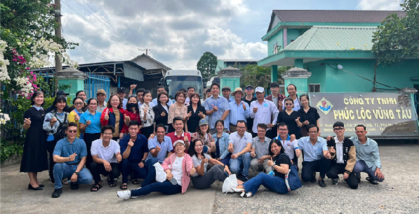
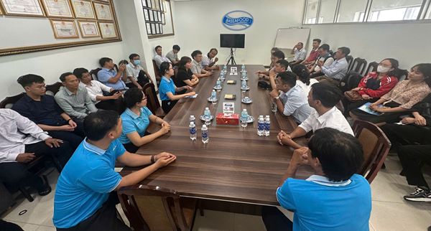 | 