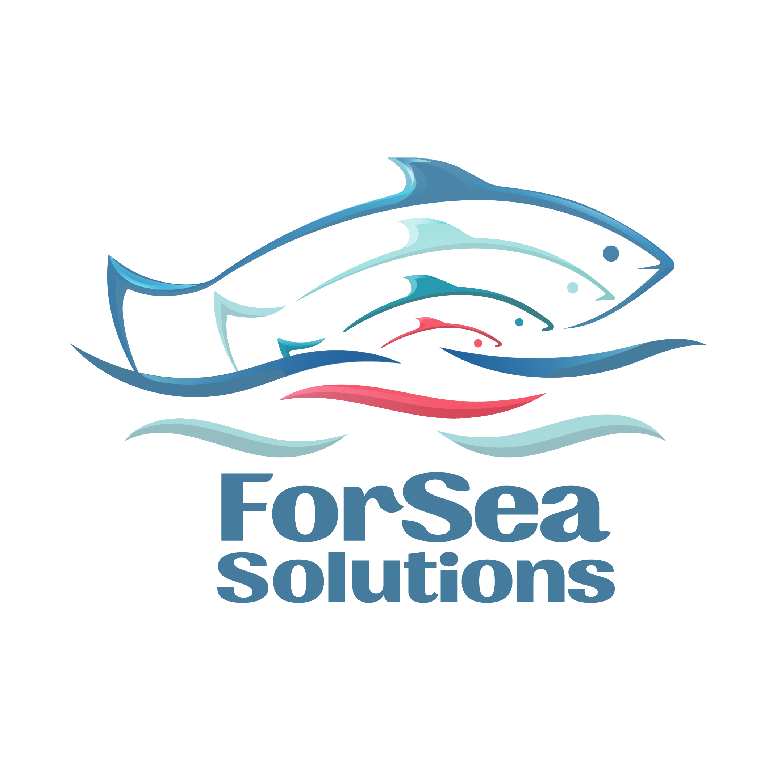

Action #5 Assessment of Stock Status

Action Objective: Demonstrate that there is an adequate assessment of the stock status.
PI 1.2.4

1. General Description of the Stock Assessment System

Assessment of Pacific salmon stock status in the Russian Far East is carried out on the basis of a comprehensive system of scientific observations and forecast models, combining spawning river monitoring data, fishery biostatistical information, and the results of marine expedition research. The primary role in the development of scientific forecasts is played by regional fisheries research institutes within the system of the Russian Federal Research Institute of Fisheries and Oceanography (VNIRO), including the Sakhalin branch of VNIRO (SakhNIRO).
A key element of stock assessment is the collection of long-term data on the abundance of spawners utilizing spawning grounds and on population reproduction parameters. Such research accounts for spawning ground escapement levels, egg and juvenile survival, and the abundance of outmigrating juveniles. Additionally, biological characteristics of spawners are analyzed, including size-weight structure, age composition, and fecundity.
The data obtained are used to build generation dynamics models that allow the relationship between parental and offspring generations to be assessed. In Russian Pacific salmon forecasting practice, the stock-recruitment model based on the Ricker equation is widely applied; it allows the potential abundance of future generations to be estimated and permissible harvest volumes to be calculated.
The scientific monitoring system covers both the freshwater and marine periods of the salmon life cycle. Observations in freshwater ecosystems are supplemented by studies of marine life stages, including analysis of the distribution and condition of juveniles and immature fish feeding in the Sea of Okhotsk and Bering Sea. Both traditional methods (trawl surveys, hydrobiological observations) and modern monitoring technologies are employed in these studies.
The analysis of environmental factors, including oceanological and climatic parameters, plays an important role in modern stock assessment. Scientific research shows that ocean temperature conditions, particularly during winter in salmon feeding areas, have a significant influence on food availability, migration processes, and fish survival at various life cycle stages [4]. Accordingly, sea surface temperature and other oceanological parameter data are increasingly used as additional predictors in salmon population abundance forecasting.
Substantial volumes of information for stock status assessment are provided by large-scale marine expedition research. For example, results of the trawl survey of aquatic biological resources in the Sea of Okhotsk in spring 2025 showed that the total abundance of aquatic organisms in the surveyed area was approximately 34 billion fish with a total biomass of approximately 10.2 million metric tons. Such data are used in the development of scientific forecasts and allow understanding of ecosystem structure and fish food base conditions to be refined [5].
An important feature of the modern stock assessment system is its multi-level scientific review. Forecasts prepared by regional scientific organizations (including SakhNIRO) are discussed and approved at institute academic councils, then reviewed at the headquarters institute VNIRO, and subsequently submitted for discussion at the Far Eastern Scientific and Fisheries Council (DVNPS). This procedure provides additional verification of the models and source data used, and allows scientific assessments to be aligned with fishery management decisions.
An additional element ensuring the reliability of assessments is the openness of scientific information and regular publication of research results. Operational data on the progress of the salmon fishing season, scientific recommendations, and forecast revisions are posted on the official websites of scientific organizations and industry information resources. According to fishery science data, more than 36,000 biological samples were collected, 23 meetings of the scientific headquarters were held, and more than 200 scientific recommendations were prepared for forecast adjustment and fishery regulation during scientific support of the 2025 salmon fishing season [8].
Thus, the Pacific salmon stock assessment system in the Russian Far East constitutes a comprehensive scientific and management structure based on long-term monitoring data, modern analytical methods, and extensive use of field research results. The existence of this system enables timely identification of changes in salmon population dynamics and the adoption of justified decisions on fishery regulation and resource conservation.

2. International Scientific Monitoring of Pacific Salmon (NPAFC)

Since Pacific salmon are a transboundary species, in addition to the national scientific monitoring system, international cooperation among North Pacific countries plays an important role in stock assessment. One of the key organizations coordinating such research is the North Pacific Anadromous Fish Commission (NPAFC).
Within the framework of NPAFC activities, scientific programs of regional countries are coordinated, including Russia, the USA, Canada, Japan, and the Republic of Korea. The Commission's primary objectives are the exchange of scientific information on the status of Pacific salmon populations, analysis of factors affecting their abundance, and the development of recommendations for the conservation and rational use of these resources. The Commission's scientific materials are regularly published as analytical reports, bulletins, and scientific compilations containing the results of international research on stock dynamics and environmental factors.
International monitoring programs include oceanographic expeditions, collection of biological samples, analysis of population genetic structure, and satellite monitoring of oceanological parameters. The results of such research allow a more complete picture of the distribution and status of Pacific salmon throughout their marine feeding range to be developed.
Particular attention in international research is paid to studying the influence of climatic and oceanological processes on salmon population status. In recent decades, the North Pacific has seen increasing climatic variability, including rising sea surface temperatures, changes in water mass circulation, and increased frequency of so-called "marine heat waves". These processes have a significant impact on the food base, distribution, and survival of Pacific salmon during the marine stage of their life cycle [7].
NPAFC scientific publications note that salmon population dynamics are increasingly determined by a combination of oceanological and climatic factors. In particular, forecasts of salmon population development through 2030 indicate the need to account for changes in ocean temperature regime, the structure of food communities, and interspecific interactions in North Pacific ecosystems [6].

Participation in NPAFC programs is important for Russian scientific organizations, as many Pacific salmon populations spend a significant part of their life cycle outside national waters. Information exchange and joint data analysis allow international observations to be incorporated into the preparation of national abundance and catch forecasts. A significant advantage of this system is the ability to compare regional data with research results from other parts of the North Pacific. This allows large-scale ecosystem changes affecting salmon population productivity to be identified and scientific forecasts to be adjusted in a timely manner.
Thus, international scientific monitoring within NPAFC complements national research and forms an important element of the modern Pacific salmon stock assessment system. The combination of national monitoring programs and international scientific research provides higher reliability in stock status assessments and promotes the development of adaptive approaches to fishery management.

3. Scientific Research on the Marine Stage of the Salmon Life Cycle

An important element of the Pacific salmon stock assessment system is research on the marine stage of their life cycle. A significant part of these fish' lives is spent in the ocean, where the conditions for their growth, feeding, and survival are formed. Therefore, data from marine expedition research are of great importance for preparing reliable forecasts of salmon returns to spawning rivers.
Russian scientific organizations, primarily VNIRO system institutes, regularly conduct large-scale expeditions in the Sea of Okhotsk and Bering Sea, as well as in adjacent areas of the North Pacific. These studies aim to investigate the distribution of juvenile and feeding Pacific salmon, to assess food base conditions, and to analyze the spatial structure of marine ecosystems.
Trawl surveys of aquatic biological resources are one important source of information. In spring 2025, a comprehensive VNIRO expedition was conducted in the Sea of Okhotsk, during which the abundance and biomass of nekton were assessed, including Pacific salmon stocks. Based on the results of this research, the total abundance of aquatic organisms in the surveyed area was approximately 34 billion fish, and their total biomass was approximately 34 billion fish, with a total biomass of 10.2 million metric tons [5].
The data obtained allow the spatial distribution of various groups of marine organisms to be analyzed and the food base for feeding salmon to be assessed. Such research is of great importance for understanding population abundance formation processes, as marine feeding conditions largely determine juvenile survival success and future commercial harvest volumes.
In addition to assessing marine community structure, scientific research pays great attention to studying the influence of oceanological factors. Modern scientific work shows that ocean temperature regime is one of the key factors influencing Pacific salmon population dynamics [4]. In particular, analysis of long-term data has revealed a relationship between sea surface temperature in the winter period and Pacific salmon catch volumes in the Russian Far East [4].
Thus, marine expedition research is an important part of the scientific system for assessing Pacific salmon stocks. It provides data on marine ecosystem status, distribution and biological characteristics of feeding fish, and allows the influence of oceanological factors on population abundance formation to be taken into account. In combination with freshwater monitoring data, such research provides a comprehensive scientific approach to stock assessment and fishery forecasting.

4. Forecast Verification and Scientific Review System

The preparation of Pacific salmon abundance forecasts and stock status assessment is accompanied by a multi-stage scientific review system. This system enables verification of the data and models used at various levels and increases the reliability of forecasts, which are subsequently used for fishery regulation.
At the first stage, scientific assessments and forecasts are developed by regional scientific organizations within the VNIRO system, in particular the Sakhalin branch of VNIRO (SakhNIRO). The prepared materials are reviewed at institute academic council meetings, where specialists analyze the assessment methods used, the monitoring data employed, and the validity of the results obtained.
At the next stage, the forecast assessments are reviewed at the headquarters institute — the Russian Federal Research Institute of Fisheries and Oceanography (VNIRO). Here, additional analysis of the results obtained and their comparison with data from other Far Eastern regions is conducted. This procedure allows large-scale changes in salmon stock dynamics to be taken into account and improves the consistency of scientific forecasts.
Final discussion of forecasts and harvest strategies takes place at meetings of the Far Eastern Scientific and Fisheries Council (DVNPS). Representatives of scientific organizations, state management bodies, and industry enterprises participate in the Council's work. Based on the scientific data presented, decisions are made on recommended harvest volumes, fishing season timing, and additional regulatory measures.
An additional tool for scientific forecast verification is the analysis of actual fishing season results and their comparison with previously calculated forecast indicators. This work is conducted annually after the completion of the salmon fishing season and allows the population abundance assessment models used to be refined.
The scientific fishery support system operates continuously throughout the entire season. Within this framework, biostatistical data are collected, fishery progress is analyzed, and operational harvest regulation recommendations are prepared.
According to VNIRO data, during scientific support of the 2025 salmon fishing season, more than 36,000 biological samples were collected, 23 meetings of the scientific headquarters were held, and 206 scientific recommendations and 33 scientific justifications were prepared for catch forecast adjustment [8]. [8].
The data collected allow timely assessment of changes in return abundance and, where necessary, revision of initial forecasts. In some cases, such revisions may lead to increases or decreases in projected harvest volumes depending on actual return dynamics.

5. Openness of Scientific Information and Transparency of the Monitoring System

An important feature of the scientific review system is its openness. Information on the progress of the salmon fishing season, scientific recommendations, and changes to forecast assessments is regularly published on the official websites of scientific organizations and industry information resources. This ensures transparency in the stock assessment and management decision-making processes.
One of the main sources of operational information on stock status and the salmon fishing season is the VNIRO website, where analytical materials, scientific recommendations, and updated data on the progress of the fishing season are regularly posted. During scientific support of the salmon fishing season, specialists from VNIRO system institutes continuously collect biostatistical information and analyze salmon return dynamics. According to fishery science data, during scientific support of the 2025 salmon fishing season, more than 36,000 biological samples were collected, 23 meetings of the Scientific Headquarters were held, and 206 scientific recommendations and 33 scientific justifications were prepared for catch forecast adjustment [8].
The openness of scientific information is also evident in the regular publication of Pacific salmon return forecasts for future years. For example, in February 2026, the Sakhalin Fisheries Council meeting presented a preliminary salmon return forecast according to which total catch in the Russian Far East could amount to approximately approximately 260,000 mt under an optimistic scenario and approximately 204,000 mt under a pessimistic scenario [9]. The presentation of multiple forecast scenarios reflects the existing uncertainty in the abundance dynamics of individual populations, primarily pink salmon, and demonstrates the application of an adaptive approach to fishery management. In particular, scientific organizations may recommend additional regulatory measures, including changes to fishing season timing or temporary closure of fishing in individual areas.
The transparency of the scientific monitoring system is also maintained at the state level. As part of the development of fishery science, the Russian Ministry of Agriculture and Rosrybolovstvo regularly publish information on scientific programs and priority research directions. According to the Russian Ministry of Agriculture, VNIRO system scientific organizations annually conduct approximately 900 expeditions, including marine and oceanic research aimed at studying the status of aquatic biological resources and their habitat [10].
Thus, the system of scientific fishery support and Pacific salmon stock status assessment is characterized by a high degree of transparency and openness of information. Regular publication of scientific data, forecasts, and analytical materials ensures access to information for the scientific community, management bodies, and stakeholders, and contributes to increased confidence in the management decisions adopted.

6. Conclusion: Existence of an Adequate Stock Assessment System

Analysis of the existing scientific research and monitoring system shows that Pacific salmon stock status assessment in the Russian Far East is based on a comprehensive scientific foundation and a multi-level system of data collection and analysis.
Population abundance assessment is formed on the basis of long-term observations of spawning rivers, fishery biostatistical data, marine expedition research results, and environmental factor analysis. The scientific methods used include stock-recruitment population dynamics models, size-age structure analysis of stocks, juvenile survival assessment, and study of marine feeding conditions. Research on oceanological and climatic factors influencing the food base and salmon survival during the marine life cycle stage plays a substantial role in refining forecasts [4].
The scientific research system covers both the freshwater and marine life cycle stages of salmon fish. Marine expedition research provides data on marine ecosystem status, distribution and biological characteristics of feeding fish, and allows the influence of oceanological factors on population abundance formation to be taken into account [5].
An additional element of reliability in the stock assessment system is the participation of Russian scientific organizations in international Pacific salmon monitoring programs. Within the framework of the North Pacific Anadromous Fish Commission (NPAFC), scientific information is exchanged between regional countries, including Russia, the USA, Canada, Japan, and the Republic of Korea. International research allows large-scale oceanological processes and ecosystem changes affecting salmon population productivity to be taken into account, thereby enhancing the reliability of national stock status assessments.
The reliability of scientific forecasts is ensured by a multi-stage review system. Forecast assessments prepared by regional scientific organizations are discussed at institute academic councils, then reviewed at the VNIRO headquarters institute, and subsequently submitted to meetings of the Far Eastern Scientific and Fisheries Council. This procedure enables additional verification of the models and source data used and alignment of scientific assessments with fishery regulation decisions.
An important element of the system is also ongoing scientific fishery support. During the salmon fishing season, biological data are collected, fish return dynamics are analyzed, and operational harvest regulation recommendations are prepared [8].
An additional factor enhancing confidence in the stock assessment system is the openness of scientific information. Research results, fish return forecasts, and scientific support materials are regularly published on the official resources of scientific organizations and industry information platforms. For example, preliminary Pacific salmon return forecasts for 2026 were presented at a regional fisheries council meeting and published in open sources, where both optimistic and pessimistic scenarios of the fishing situation were presented [9].
The importance of scientific support for fisheries activities is also emphasized at the state level [10].
Thus, the existing Pacific salmon stock assessment system in Russia is based on a combination of long-term large-scale scientific research, international cooperation, multi-stage forecast review, and continuous analysis of actual fishery results. This model enables timely identification of changes in population dynamics and the adoption of scientifically justified decisions on harvest regulation and resource conservation.
Consequently, it can be concluded that at present for Pacific salmon of the Russian Far East, including populations of Kunashir Island, an adequate, scientifically justified, and regularly updated stock status assessment system exists, meeting modern requirements for sustainable fishery resource management.

References

[1] Bulletin No. 19 on Pacific Salmon Studies in the Russian Far East. Vladivostok, 2025.
[2] Bugaev A.V. et al. The influence of climatic factors on pink salmon forecasting for Kamchatka. 2025.
[3] Belonenko T.V. et al. The influence of cold waters on salmon dynamics. 2025.
[4] Vanyushin G.P. et al. The influence of winter temperature factors on Pacific salmon catches. Voprosy Rybolovstva (Fisheries Issues), 2025.
[5] Sheibak A.Yu., Kuznetsova E.N., Antonov N.P. Results of the trawl survey of aquatic biological resources in the Sea of Okhotsk, spring 2025. Trudy VNIRO (VNIRO Proceedings), 2025.
[6] NPAFC. Salmon in a Changing World: 2030 Outlook. 2025.
[7] NPAFC. Climate impacts on Pacific salmon populations. 2025.
[8] VNIRO. Scientific support for the salmon fishing season in the Russian Far East, 2025.
[9] Fishnews. Preliminary salmon forecast for 2026.
[10] Russian Ministry of Agriculture. Priority directions of scientific work for the fisheries sector.

Liudmila Konstantinovna Fedorova
Fisheries Expert and Consultant

March 16, 2026

