6 months Progress Report: Eastern Pacific Ocean Swordfish -Longline (Taiwan, Panama, Vanuatu)
Fishery Progress through June 2025
- This fishery catches swordfish by longline gear in the South Pacific where swordfish are not overfished and not undergoing overfishing at this time, according to the latest update in December 2024 (WCPFC21-2024-27 p22). Swordfish are managed by the IATTC and WCPFC and the stock assessed by the WCPFC.
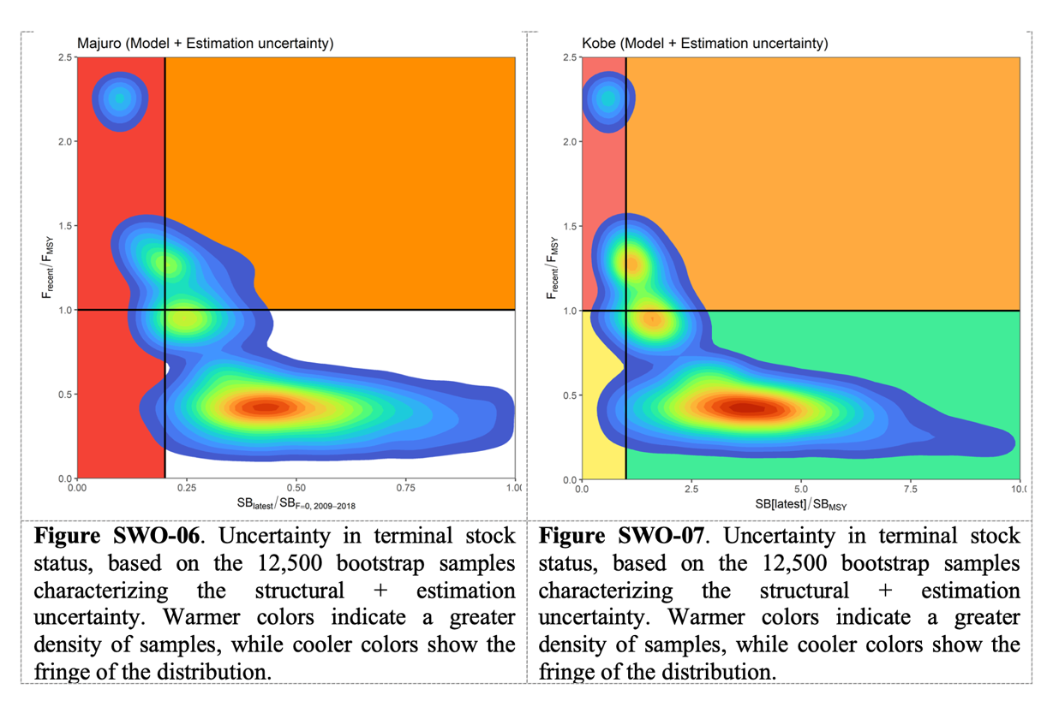
- A new stock assessment is underway in 2025.
- A breakthrough is underway in science-based management. The Western and Central Pacific Fisheries Commission agreed to develop a management strategy evaluation framework following the 2025 SWP swordfish stock assessment currently underway. The results will greatly improve the likelihood of success for the Harvest Strategy in the South Pacific by raising the standard for governance and science to a level commensurate with the major tunas. Candidate management procedures for southwest Pacific swordfish are also being identified through the management strategy evaluation. These decisions were formalized at the 21st Regular Session of the Commission, held 28 November to 3 December in Suva and when realized will raise the fishery's standing relative to the Marine Stewardship Council standard.
- The Commission took several decisions at WCPFC21 on future work to incorporate climate change considerations into its conservation and management framework and adopted a workplan.
- Improvements were achieved over the past 6 months also in the management of non-target species in this fishery.
- A conservation and management measures for cetaceans (2024-07) was enacted at the 21st meeting, with new consideration of longline fishing interactions, making it very pertinent to the fishery and FIP.
- Another is being updated for seabirds (2018-03) in a consultative process for updating the science (key working paper: SC20-EB-WP-06 and proposal document: WCPFC21-2024-21). The Commission is also enhancing compliance with seabird bycatch mitigation measures by ensuring that vessels operating south of 30°S, like the FIP fishery, are properly equipped and follow the mitigation protocols. This new oversight by the WCPFC will help to normalize the seabird mitigation techniques that the FIP has already introduced to participating vessels (using the US NOAA training materials, translated with permission).
- The Inter-American Tropical Tuna Commission is wrapping up Project H.7.e - South EPO swordfish monitoring and research, although progress has not been posted since 3/24.
- In addition to improvements in governance, the FIP has made progress by assisting the participating vessels to reduce fishing impacts on endangered, threatened or protected species with monitoring, avoidance techniques and ongoing crew training for safe release.
- Captains and crew working on vessels added in 2024 were onboarded with the monitoring spreadsheet (with species ID) and training package for safe release and handling of seabirds, sea turtles, cetaceans and rays and avoidance of striped marlin and overfished sharks.
- The FIP assisted the participating vessels to take up the new longline-specific guidance for conservation and mitigation of cetaceans found in WCPFC CMM 2024-07, newly adopted in December 2024 by the WCPFC, becoming effective July 1 2025 (replacing 2011-03) (https://cmm.wcpfc.int/measure/cmm-2024-07).
- For longline vessels, landing cetaceans is prohibited and vessel crew are required to release cetaceans hooked on the gear within their best ability while operating safely. The new measure further requires vessels to apply the Commission’s Best Practices for the Safe Handling and Release of Cetaceans (addressed in previous updates).
- This action involved a review of the measure for any additional requirements needed by the vessels to conform with CMM 2024-07 beyond the safe handling and release practices introduced to the vessels by the project from the US-NOAA training materials in 2023 and 2024. A review was performed of the CMM and Commission best practices and an update was prepared and distributed to participating vessels containing the specifics (in English and Chinese).
- The FIP is supporting the role of fishers in the fishery with rights training and crew enumeration and by tracking workforce characteristics (addressed under the social progress reporting for this project).

