ACTIVITY REPORT

Agenda : Stakeholder Meeting
Date : 10 Februari 2025
Venue : Banjarbaru
Participant(s) : Fishermen of Kotabaru, Ministry of Marine and Fisheries (SDI), South Kalimantan Provincial Department of Marine and Fisheries, Central Java Provincial Department of Marine and Fisheries, Kotabaru District Department of Marine and Fisheries, Outreach Officer of Kotabaru, Port Officer, Lambung Mangkurat University, Brawijaya University, PT. Sekar Laut, PT. Sahabat Laut Lestari, PT. Cassanatama, PT. Karya Kencana, MSC Consultant
Session(s) :
- Discussion on the Formation of the Working Group (POKJA) for the Development of the Kotabaru Shrimp Fisheries Management Plan.
- Convey related measura ble for fishing policy on WPP 713 and sustainable fisheries and marine resources monitoring policy
- Describe a study on catch composition (primary, by catch, ETP species) done by Brawijaya University in Kotabaru.
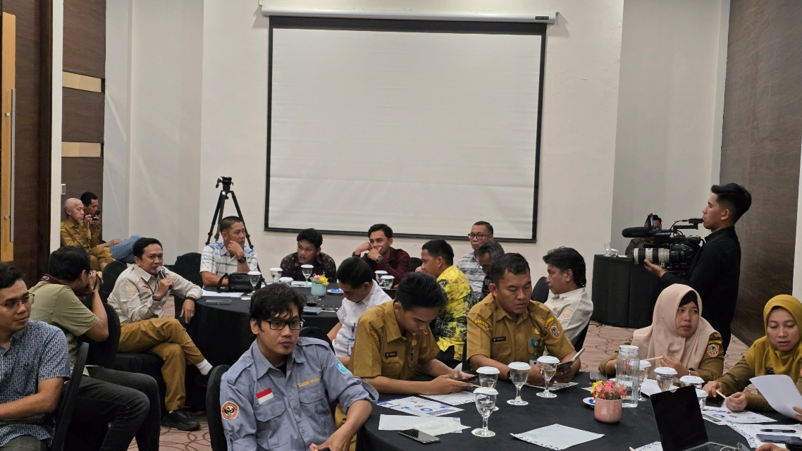

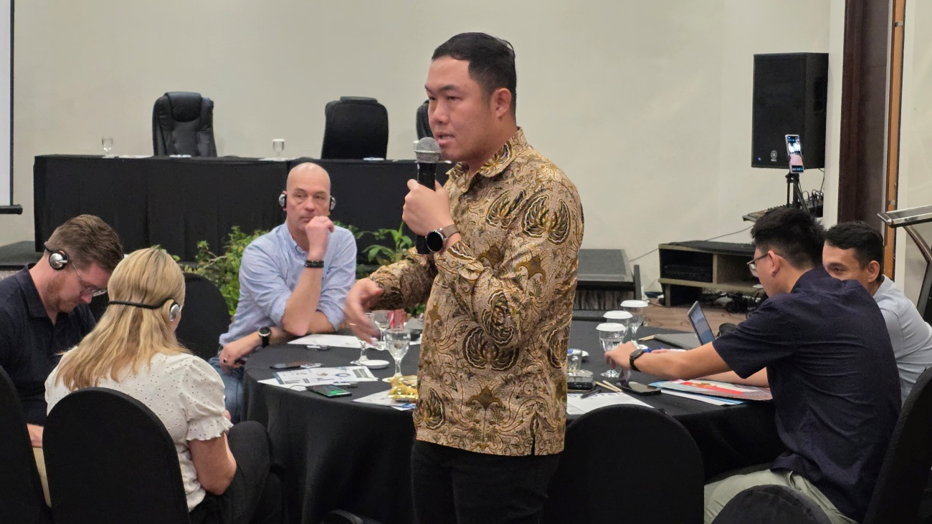

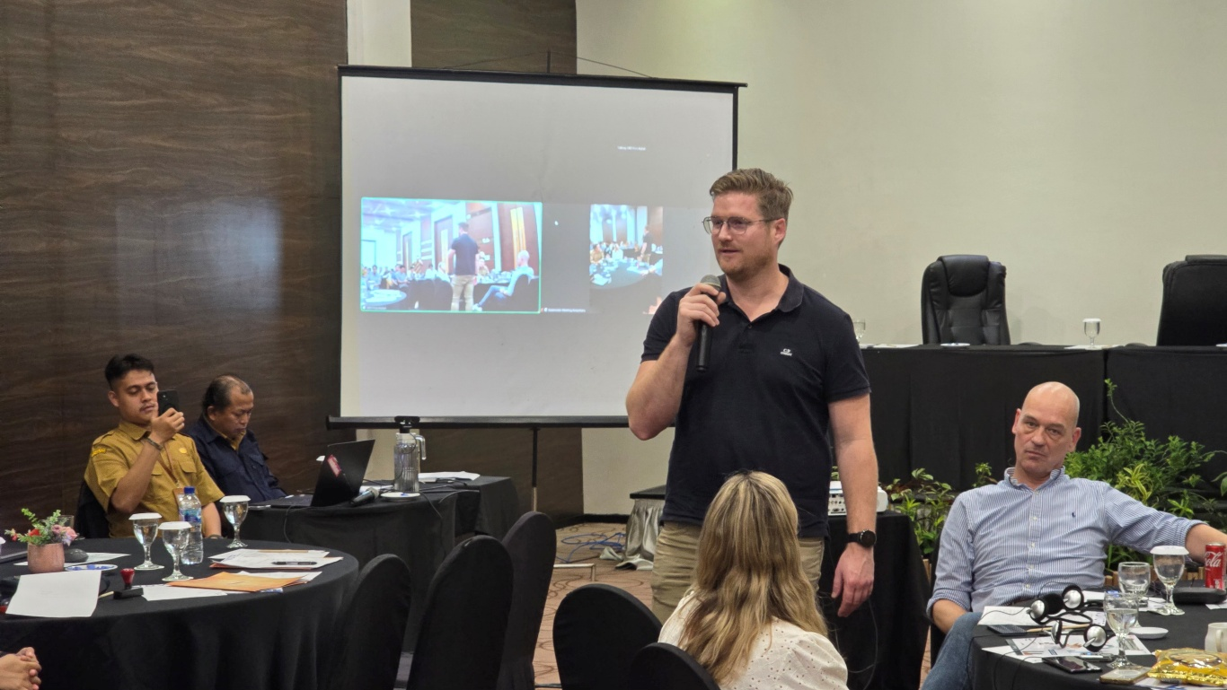

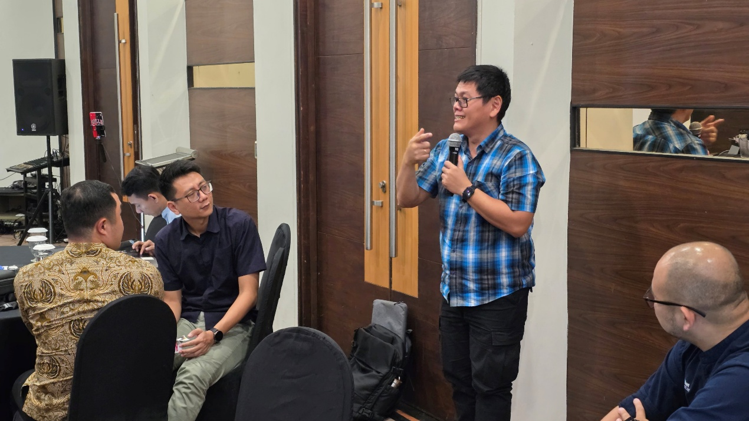

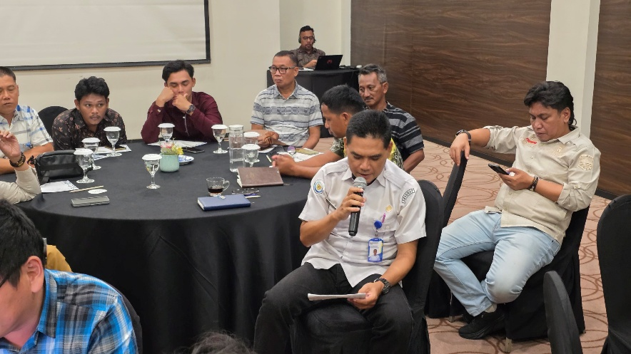
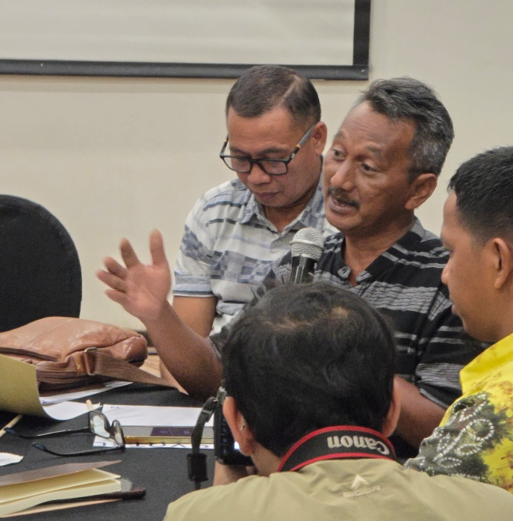

Agenda : Monitoring, Evaluation perahuapp – perahudata & Financial Literacy
Date : 11 – 13 Februari 2025
Venue : Kotabaru
Participant(s) : Fishermen of Kotabaru, Outreach Officer of Kotabaru, PT. Sahabat Laut Lestari, PT. Sekar Laut, Customer of Sekar Laut, MDPI
Session(s) :
- Visit from Sekar Laut Customers to the Kotabaru Fishermen Group.
- Monitoring and evaluation the issues encountered in data collection utilizing the perahuapp & perahudata.
- Update the information and software on the perahuapp & perahudata.
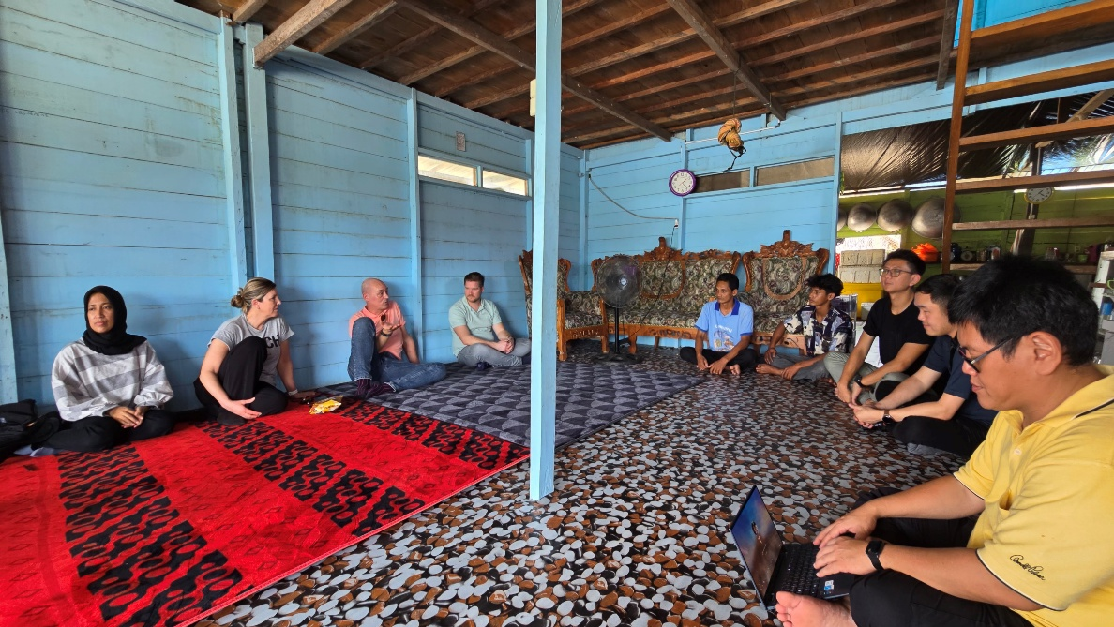
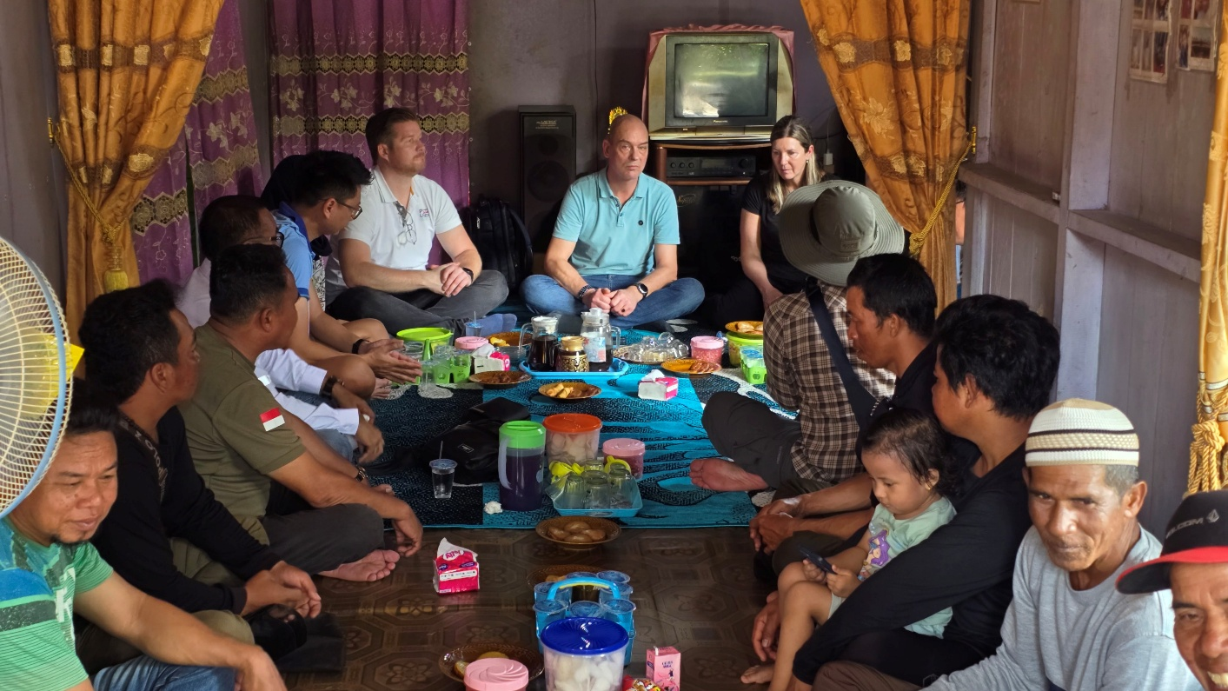
- Financial Literacy for Kotabaru Fishermen, best practices in household financial management

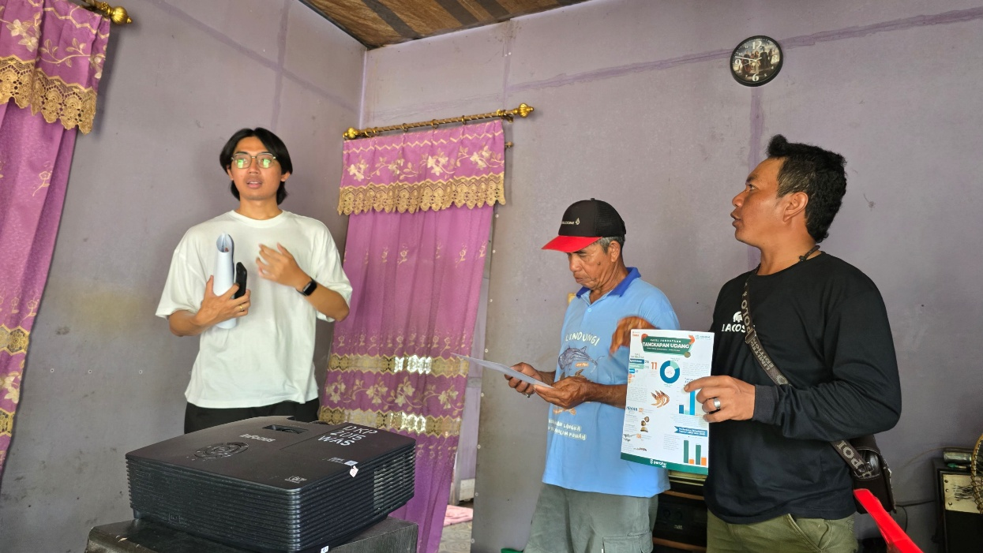
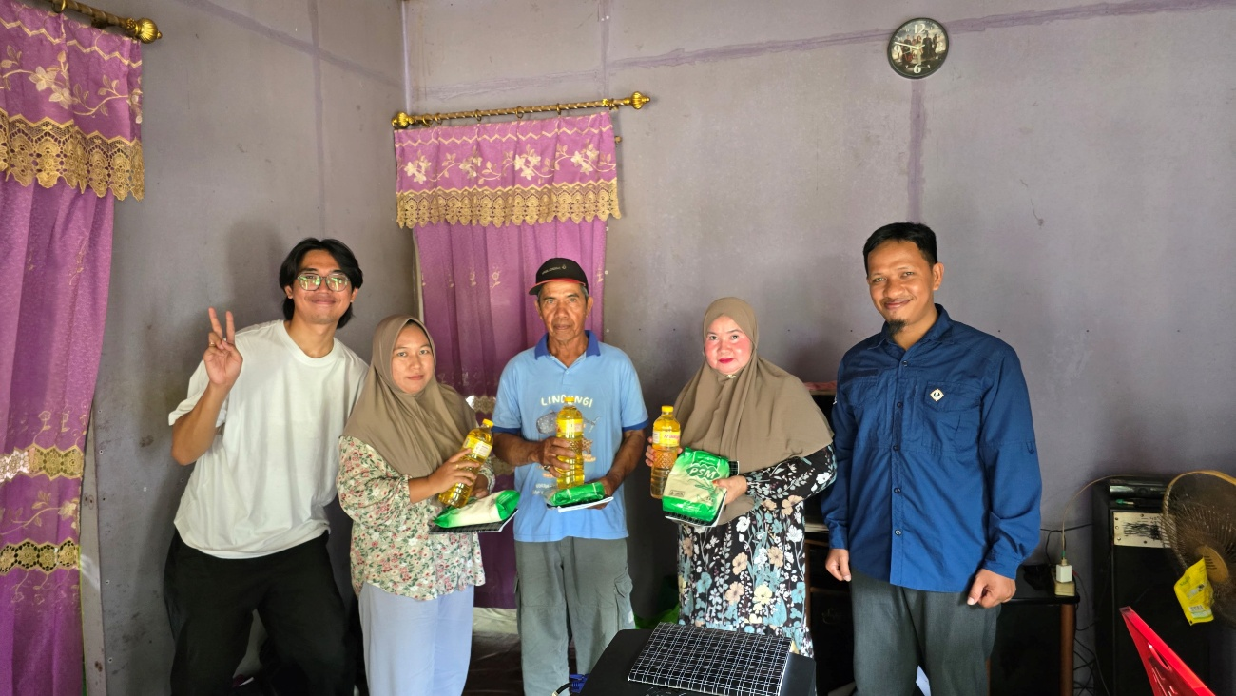
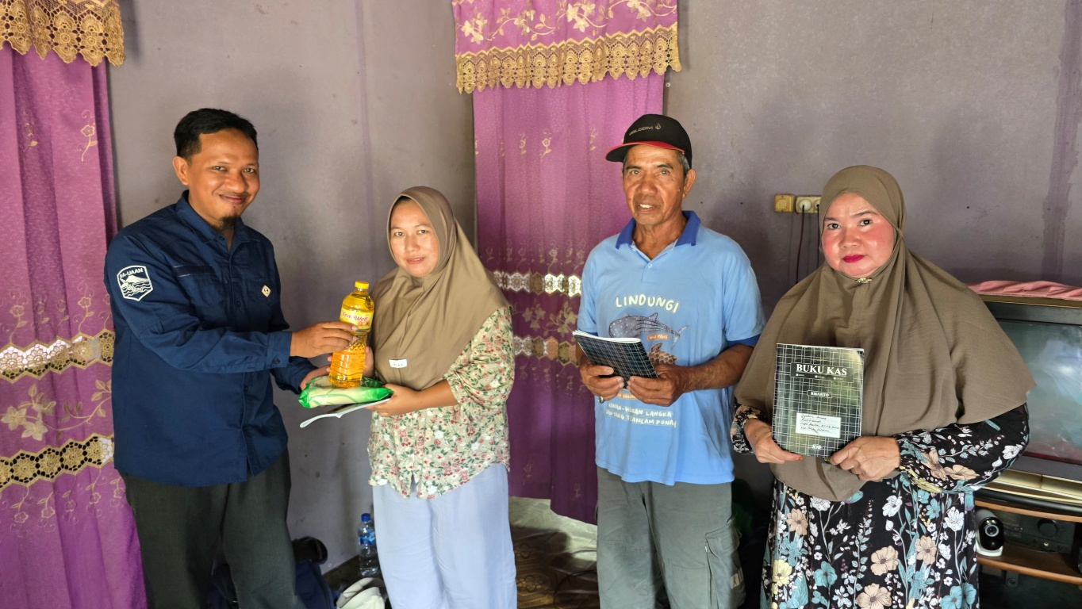

Agenda : Monitoring, Evaluation perahuapp – perahudata & Financial Literacy
Date : 17 – 19 June 2025
Venue : Kotabaru
Participant(s) : Fishermen of Kotabaru, DKP Province, Outreach Officer of Kotabaru, PT. Sahabat Laut Lestari, PT. Sekar Laut, MSC Consultant
Session(s) :
- Follow-up discussion regarding the draft Working Group (POKJA) and the Fisheries Management Plan that has been submitted to the Provincial Marine and Fisheries Agency
- Visit by the Provincial Marine and Fisheries Office to the fishermen group.
- Monitoring and evaluation the issues encountered in data collection utilizing the perahuapp & perahudata.
- Update the information and software on the perahuapp & perahudata.
- Financial Literacy for Kotabaru Fishermen, best practices in household financial management
