Assessing Shark Bycatch Risk Through Interactions Between Habitat Use and Fishing Pressure
Roshin Syahdan¹*, Mohammad Mukhlis Kamal², Fery Kurniawan², Rahmat Kurnia²
- Coastal and Marine Resources Management Study Program, Faculty of Fisheries and Marine Sciences, IPB University (Bogor Agricultural University), Kampus IPB Dramaga, Jl. Agatis, Bogor 16680, Indonesia
- Department of Aquatic Resources Management, Faculty of Fisheries and Marine Sciences, IPB University (Bogor Agricultural University), Kampus IPB Dramaga, Jl. Agatis, Bogor 16680, Indonesia
Correspondence: Roshin Syahdan, Coastal and Marine Resources Management Study Program, Faculty of Fisheries and Marine Sciences, IPB University (Bogor Agricultural University)
Email: novaturientsyahdan@apps.ipb.ac.id

Abstract
Bycatch is a major issue in global fisheries, particularly for vulnerable species like sharks. This study analyzes bycatch risk for three species: silky shark (Carcharhinus falciformis), blacktip reef shark (Carcharhinus melanopterus), and whitetip reef shark (Triaenodon obesus) in Langkai and Lanjukang waters, Spermonde Archipelago, Indonesia. MaxEnt modeling combined species occurrence data with environmental variables (salinity, temperature, bathymetry) to estimate habitat suitability. Results showed distinct habitat preferences for each species. By integrating habitat predictions with spatial data on demersal fishing effort, high-risk bycatch areas were identified. Findings highlight species-specific bycatch risks shaped by ecological traits and fishing gear overlap. The resulting probability maps provide a spatial framework for conservation prioritization and ecologically informed fisheries management.

Keywords: Sharks, Bycatch, Fishing Effort, Species Distribution Modelling, Spatial Risk Mapping.
- Introduction
Demersal fisheries play a crucial role in supporting coastal livelihoods and seafood supply chains, yet they also contribute substantially to unintentional catches of non-target species (Lucchetti et al., 2019). Bycatch has been widely recognized as a major conservation and management challenge, particularly for vulnerable taxa such as sharks, which exhibit slow growth, low fecundity, and high susceptibility to fishing pressure (Faure et al., 2025). Interactions between demersal fishing gears and shark populations can lead to declines in local abundance, disrupt ecological roles, and affect ecosystem imbalances (Crespo et al., 2024).
Addressing bycatch requires a clear understanding of the species spatial distribution, fishing effort dynamics, and the environmental factors that shape fisheries interactions. Risk-based approaches are increasingly used to quantify the likelihood of bycatch events and to inform targeted mitigation strategies that minimize ecological impacts while maintaining fishery productivity (Gullestad et al., 2014; Molina & Cooke, 2012). Bycatch assessments are therefore essential to support evidence-based decision-making, guide gear modifications, prioritize conservation actions, and enhance sustainable fisheries governance.
Bycatch refers to the unintentional capture of non-target species or organisms outside the target species size range by non-selective fishing gear (Crowder & Murawski, 1998; Hall, 1996). Species with low resilience to capture are heavily impacted by bycatch, leading to serious conservation issues within ecosystems (Molina & Cooke, 2012). Discarded catch is often undocumented, making bycatch evaluation more challenging and complicating efforts to manage it (Barker & Schluessel, 2005). Bycatch needs to be managed as it directly reduces megafauna populations and indirectly alters trophic dynamics in marine systems (Komoroske & Lewison, 2015). Bycatch is a significant threat to sharks, with 66.9% of shark species listed by IUCN facing conservation threats (Molina & Cooke, 2012). Furthermore, the decline of shark populations as apex predators may disrupt food web dynamics and ecosystem functions (Komoroske & Lewison, 2015).
Sharks play a vital role as top predators and ecological regulators in marine ecosystems. However, their populations are increasingly threatened by overfishing, particularly through bycatch (Mopay et al., 2021). This vulnerability is amplified by their biological traits where sharks typically grow slowly, mature late, and only begin reproducing at around 12 to 15 years of age (Dulvy et al., 2008). In demersal fisheries, shark bycatch often occurs because sharks naturally prey on many of the commercially valuable fish species targeted by fishermen (Pickens et al., 2022; Simeon et al., 2015). Gear types such as bottom longlines, gillnets, and trawls are frequently associated with high shark bycatch rates (White et al., 2006). The situation is further complicated by the demand for shark products, which discourages discarding and increases fishing pressure (Davies et al., 2009; Iffah, 2021; Mopay et al., 2021). All the factors of slow life history, frequent capture as bycatch, and economic exploitation made shark populations particularly prone to decline.
Species distribution models (SDM) connect species occurrence points with environmental variables to predict potential, impact, and distribution patterns (Briscoe et al., 2019). SDM identify the environmental variables that influence the species and produce heatmap distributions showing the probability of shark presence (Burns et al., 2023; Pickens et al., 2022). Bycatch probability can be assessed by overlaying fishing operation heatmaps with shark occurrence heatmaps, guiding effective management strategies to reduce shark bycatch (Chi-Chan et al., 2021; Pet-Soede, 2000; Pickens et al., 2022).
Global bycatch rates of sharks and rays in both artisanal and industrial fisheries have increased in recent decades, driven by rising fishing pressure and limited regulatory frameworks (Crespo et al., 2024; Doherty et al., 2014). The capture of sharks in fishing gear can result in physical injury and may lead to either immediate mortality or delayed post-release death, highlighting the importance of minimizing interactions between sharks and fishing activities. Such risks are strongly influenced by the spatiotemporal overlap between critical shark habitats and fishing activities (Lopes et al., 2016; Zollett & Swimmer, 2019). Recent studies further suggest that artisanal fisheries, particularly in developing nations where data availability is limited, exert significant negative impacts on shark populations (J. E. Moore et al., 2010; Pauly, 2006). Although shark bycatch has been widely studied, most research has focused either on single fishing gears (Doherty et al., 2014; McAuley et al., 2003; Morey et al., 2006) or on broad regional scales using coarse-resolution environmental data (Cao et al., 2013; Chi-Chan et al., 2021; Lezama-Ochoa et al., 2016). To address this gap, our study develops fine-scale bycatch risk maps for sharks in multi-gear demersal fisheries, providing a novel tool to formulate management strategies and mitigation scenarios in artisanal contexts spatially. This approach is particularly suited for data-limited regions with complex environments (Elith & Leathwick, 2009; Phillips, 2017), as it requires only species occurrence points and fishing effort distributions, which are relatively accessible. Thus, the objectives of this study are to predict the potential distribution of the three shark species and estimate the spatial extent of demersal fishing effort using MaxEnt, and quantify the spatial overlap between shark habitats and fishing activities to identify areas of high bycatch probability.
- Methods

2.1 Study Area
The study area encompasses the waters surrounding Langkai and Lanjukang Islands, situated in the outer zone of the Spermonde Archipelago (Fig. 1) (Faizal, 2023). This region is characterized by low nutrient levels, clear oceanic waters, and benthic habitats dominated by algal turf and coral reef structures that borders shallow sea and deep sea area (Faizal, 2023). The outer Spermonde zone serves as an important habitat for various reef-associated species, including sharks, due to its relatively undisturbed condition and structural complexity. The area was selected for this study because it represents a critical interface between biodiversity-rich marine ecosystems and active small-scale demersal fisheries, where spatial interactions between shark habitats and fishing effort are likely to occur and can be effectively assessed (Faizal, 2023; A. Moore et al., 2025).

Data Collections
Preliminary studies indicated that three shark species were most frequently caught either as bycatch or as target species for consumption and shark finning. These species included whitetip reef shark (Triaenodon obesus), blacktip reef shark (Carcharhinus melanopterus), and silky shark (Carcharhinus falciformis). Underwater census using camera (Bilodeau et al. 2022), participatory surveys, and interviews were utilized to collect presence-only data on each shark species and fishing gears (Istijanto, 2005; Zikmund et al., 2002). Respondent selection was conducted using the snowball sampling method to identify individuals with relevant knowledge and experience (Taylor & Bogdan, 1984).
The survey was conducted by accompanying demersal fishermen during fishing trips and directly observing shark presence. Chosen fishing gears were considered likely to catch sharks due to their operational characteristics, either by directly targeting large fish species including sharks or by unintentionally capturing sharks as bycatch through the capture of their prey (Broadhurst et al., 2014; Burns et al., 2023; McAuley et al., 2003; Morey et al., 2006; Sepulveda et al., 2015).
Environmental variables are essential in MaxEnt modeling as they define the ecological constraints that shape species distributions. By correlating species presence data with biophysical variable, the result will allow the model to infer habitat suitability across unsampled areas (Phillips et al., 2006). Sea surface temperature, salinity, and bathymetry were selected based on literature identifying key factors influencing shark species distribution and available data. Seasonal variation was not considered due to the limitation of how presence-only data were gathered; thus, resulting maps are integrated static images that show no temporal variations (Chi-Chan et al., 2021; Guisan & Zimmermann, 2000).
Sea surface temperature and salinity variables were derived from Landsat 9-L2SP satellite imagery of South Sulawesi waters in July 2024. These datasets were freely available and obtained through the Earth Explorer platform, providing accessible environmental data for marine studies. Sea surface temperature and salinity layers were validated against in-situ measurements, yielding acceptable RMSE values, ensuring reliability for habitat modeling (Bonansea et al., 2024).

Data Analysis
Maximum Entropy (MaxEnt) application was used to conduct Model development and mapping to predict species habitat and fishing gear distributions based on occurrence points and environmental variable (Phillips & Dudík, 2008). MaxEnt provides estimated species and fishing gear distributions representing the likelihood of the presence and area based on environmental input variables.
The area under the curve (AUC) matrix from the receiver operating characteristic (ROC) curve evaluates model fit to the occurrence data (Phillips, 2017). AUC and accuracy values range in both cases between 0.5 (random sorting) and 1 (perfect discrimination). Values of < 0.7 are considered acceptable, whilst values of <0.95 might indicate overfitting (Lezama-Ochoa et al., 2016). Cross-validation is used as a method for resampling the training and testing models. The data were divided into a smaller number in k-fold cross validation, in this case, ten subsets (Lezama-Ochoa et al., 2016). Model performance was evaluated using a k-fold cross-validation approach, where each subset of the data is successively omitted, the model is re-trained on the remaining data, and then used to predict the omitted portion (Elith & Leathwick, 2009). In this study, a 10-fold partitioning method (k = 10) was employed to divide the occurrence records into training data (80%) and testing data (20%). MaxEnt was run ten times using this k-fold approach, and the average prediction across these ten runs was calculated. Additionally, the coefficient of variation was computed to assess the variability among the predictions (Lezama-Ochoa et al., 2016).
Overlay analysis using weighted sum method was applied to integrate the spatial distribution of all fishing gears into a composite total fishing effort layer. This method was subsequently applied to combine the total fishing effort with each shark distribution models to produce bycatch probability maps (Adininggar et al., 2016; Prahasta, 2009).
- Results and Discussions
  - Sharks Distribution
A total of 90 occurrence points were found for Whitetip reef sharks, 60 occurrence points for Blacktip reef sharks, and 57 occurrence points for Silky sharks. The spatial distribution of silky shark (Fig. 5A) in the Langkai–Lanjukang region is characterized by a strong association with deeper offshore habitats. The 57 occurrence points recorded in this study were predominantly concentrated along the outer reef slopes, particularly in areas where bathymetry transitions sharply from shallow coral platforms to deeper pelagic zones. This pattern indicates that silky sharks prefer mesophotic and deeper reef-edge environments rather than shallow lagoonal or nearshore areas.
The distribution of blacktip reefshark (Fig. 5B) in the Langkai–Lanjukang region exhibits a strong affinity for shallow reef environments, as reflected by the clustering of 60 occurrence points around coral reef surrounding the island and lagoonal reef flats. High suitability values were concentrated along the shallow reef crests and island fringes, indicating that blacktip reef sharks primarily utilize structurally complex, high-productivity habitats where demersal fishes gather for food and protection. This spatial pattern is consistent with their ecological behavior as reef-resident sharks that rely on sheltered coastal areas for foraging and juvenile development. The limited presence of occurrence points in deeper offshore areas further emphasizes the species’ dependence on shallow reef systems, which also places them in proximity to fishing gears that commonly operate along island margins and reef slopes.
The spatial distribution of whitetip reefshark (Fig. 5C) in the Langkai–Lanjukang waters shows a pronounced concentration along the extensive reef slopes and outer coral ridges, consistent with the species behavior as a sedentary, reef-associated predator. The 90 occurrence points cluster densely along the western reef barrier and the linear reef structures south of Langkai, where complex benthic formations provide both resting sites and nocturnal foraging grounds. High suitability zones aligned closely with steep reef walls and deeper fore-reef habitats, reflecting the whitetip reef shark’s preference for structurally complex environments compared to other reef sharks. This distribution pattern places the species in frequent contact with demersal and stationary gears that operate along reef margins, exposing its vulnerability to bycatch in these ecologically critical habitats.
  - Fishing Gear Distribution and Total Fishing Effort
There are a lot of fishing gears that operate around Langkai – Lanjukang waters, but only 5 caught sharks, which is set gillnet (53 points), demersal longline (40 points), large fish longline (49 points), trammel net (61 points), and set buoy gear (41 points). The spatial distribution of fishing gears (Fig. 3) across the Spermonde Archipelago demonstrates a heterogeneous pattern, with certain gear types concentrated near reef structures and others extending into deeper offshore areas. The model performance of set gillnet, demersal longline, large fish longline, trammel net, set buoy gear have AUC of 0.789, 0.870, 0.917, 0.872, and 0.853 respectively. The result of set gillnet shows fair ability, demersal longline shows excellent ability, while the rest show good prediction probability (Phillips et al., 2006).
Large fish longline (Fig. 3A), used to target high-value individuals, and is operated around deeper offshore zones. Their configuration and hook depth also present bycatch concerns for both pelagic and demersal shark species (Broadhurst et al., 2014). Demersal longline (Fig. 3B) were commonly set on the reefs around the islands. These gears, which rest near the seafloor, pose a high bycatch risk for benthic-associated species such as the whitetip reef shark (Triaenodon obesus) (McAuley et al., 2003). Set buoy gear (Fig. 3C), although less common, was concentrated in reef areas around the islands with deeper waters. Characterized by vertical hook suspensions, this gear type targets huge fishes which includes sharks (Sepulveda et al., 2015). Set gillnet (Fig. 3D) are predominantly operated along reef slopes and sandy bottoms at intermediate depths. Their spatial coverage is more limited, these gears are associated with a higher risk of capturing non-target species, including juvenile reef sharks (He, 2006). Trammel nets (Fig. 3E) were widely distributed in shallower reef-associated waters. Their stationary nature and fine mesh sizes can entangle a broad range of species, including juveniles and non-target species like shark (Morey et al., 2006).
The spatial distribution of total fishing effort (Fig. 3F) across the Spermonde Archipelago reveals concentrated activity in several key zones. High-effort hotspots are visually identifiable as darker red regions on the effort intensity map, primarily clustered around the central reef complexes and nearshore areas of major islands. Notably, elevated fishing pressure is evident in the mid-western and southeastern sectors of the waters, where multiple fishing operations converge. These zones correspond to areas with higher fish abundance, ease of operation, and traditional fishing grounds (Ernaningsih et al., 2023; Faizal, 2023; Nababan & Dewita, 2017). The clustering of effort near reef slopes and lagoon edges suggests a preference for habitats that support diverse and abundant fish communities, but also coincide with critical shark habitats. In contrast, outer reef fronts and offshore zones exhibit lower fishing effort, indicated by lighter coloration, likely due to operational limitations.
  - Shark Habitats
The model performance of blacktip reef shark, whitetip reef shark, and silky shark has an AUC of 0.876, 0.828, and 0.824, respectively. This result indicates a good prediction probability (Phillips et al., 2006). This result also indicates that the model performs better than expected by chance, as the number is higher than 0.5, which is random. Bathymetry influenced whitetip and blacktip reef sharks by their preferences of shallow depths, while silky sharks prefers depths up to 500 meters (Amir et al., 2020; Becerril-Garcia et al., 2018; Mopay et al., 2021). Sea surface temperature and salinity influence shark distribution patterns through physiological tolerance limits and prey availability in marine environments (Last & Stevens, 2009).
The MaxEnt model predicted silky shark potential habitat (Fig. 2A) is distributed in deep water nearby the sea cliff close to the island. Relative percent contributions shows that bathymetry is the most contributing factor (85.8) followed by sea surface temperature (12) and salinity (2.2). The response curve shows performance and contributions of each environmental variable to model fit. Peak suitability is around –150 to –50 meters depth. Suitability drops at shallower (< –50 m) waters. Silky shark is commonly found close to the shelf edges, oceanic waters, reef areas, and sometimes in coastal waters (Forselledo et al., 2022). Optimal temperature is between 26.4°C to 27.8°C, with suitability declining beyond that range. This species has a higher probability to be found in temperatures between 24°C to 30°C (Forselledo et al., 2022). Salinity shows a range of 30.0 to 30.9 PSU, with decreasing suitability as salinity approaches 31.3 PSU. The modeled habitat pattern of the silky shark indicates a strong suitability for deeper offshore zones adjacent to steep reef slopes, which aligns with its known ecology as a semi-pelagic species frequently associated with shelf edges and oceanic habitats. Silky shark also prefers for slope and oceanic habitats because it reflects the distribution of mesopelagic prey communities, as silky sharks are mid-trophic predators that frequently forage along productivity gradients associated with shelf breaks.
The MaxEnt model predicted whitetip reef shark potential habitat (Fig. 2B) is distributed in between and around the islands, especially in areas with coral reef. Relative percent contributions shows that salinity is the most contributing factor (56.6) followed by sea surface temperature (25.2) and bathymetry (18.2). The response curve shows performance and contributions of each environmental variable to model fit. Salinity with the highest predicted presence between 29.9 to 30.5 PSU, suitability decreases beyond 30.5 PSU. Sea surface temperature suitability peaks between 26.3°C to ~27.5°C, then sharply decreases after that. The whitetip reef shark as tropical shark is commonly found at ambient temperatures above 26 °C (Duffy et al., 2017). Bathymetry shows increasing suitability toward shallower waters indicating preference for shallow reef-associated habitats. The whitetip reef shark usually inhabits shallow coral reef lagoons and outer reef slopes from the intertidal zone to at least 330 m depth (Duffy et al., 2017). These results shows that whitetip reef shark lives on the bottom of shallow reef-associated habitats with warm temperature and optimal salinity, which are influenced by prey availability from demersal fishes, protection from predators, also resting places by hiding behind the reef crevices. Whitetip reef sharks typically rest in reef crevices or shallow lagoons during the day and actively forage at night. The preference for structurally complex, shallow habitats not only provides shelter during daylight hours but also supports nocturnal hunting, as these areas harbor abundant prey such as small fish and invertebrates.
The MaxEnt model predicted that the blacktip reef shark's potential habitat (Fig. 2C) is in shallow ocean floor around the islands and reefs (Papastamatiou et al., 2010). This finding is in line with how blacktip reef shark ecology as reef species where the juvenile grows, find foods and shelter nearshore. Relative percent contributions show that salinity is the most contributing factor (63.7), followed by sea surface temperature (24.3) and bathymetry (12). The response curve shows performance and contributions of each environmental variable to model fit. Suitability is highest at low salinity (29.7 PSU), drops around 30 PSU, then rises again at higher salinities (31+ PSU), showing a bimodal response. The strong influence of salinity in the model likely reflects the species’ sensitivity to fine-scale coastal salinity gradients, which are shaped by tidal mixing, runoff, lagoon exchange, and reef hydrodynamics. Sea surface temperature suitability peaks between 27°C and 28°C, then sharply decreases after 28.5°. The temperature response aligns with the species preference for warm, stable tropical waters and avoidance of higher temperatures that can induce thermal stress. Blacktip reef shark is commonly found in around 28°C, and avoids 31°C temperature (Bouyoucos et al., 2020). Bathymetry shows increasing suitability toward shallower waters around the islands. Bathymetry’s relatively smaller contribution reflects the shark’s overall reliance on shallow habitats, though the increased suitability toward island-adjacent shallows is consistent with tendency to occupy reef crest and lagoon systems (Myers, 1999). Ecologically, these patterns means that blacktip reef sharks inhabit a narrow but dynamic environmental niche shaped by coastal oceanography and reef structure.
  - Shark Bycatch Probability
    - Silky Shark
The bycatch probability map for silky shark (Fig. 4A) reveals a distinct pattern, with the highest overlap occurring along the western margin of the archipelago and offshore slope regions. These areas exhibit deeper waters and aligned with the species broader habitat range, which spans reef edges to pelagic zones (Forselledo et al., 2022). Because silky sharks have relatively slow growth rates and low reproductive output, even moderate levels of bycatch in slope-associated fisheries may have disproportionate demographic impacts compared to more resilient coastal species.
The bycatch probability map for silky shark revealed values ranging from 0 to 0.8 indicated a very high risk of bycatch, but it’s concentrated in deeper area. The bycatch risk here is driven by high fishing effort concentrated in deeper zones, likely associated with large fish longlines and set gillnets, both of which are targeting pelagic and semi-pelagic fishes frequented by silky shark. Furthermore, this shark species has a high market value in the local market, which made them a main target for fishermen. Although silky sharks occupy deeper waters compared with reef-associated species, their vertical movements and attraction to prey concentrated near shelf breaks bring them into frequent contact with pelagic and demersal fishing activities operating at similar depths, as high value target are usually present. Their slow growth, long gestation, and moderate fecundity make even low levels of incidental capture impact their population, especially in regions with high cumulative fishing pressure. The bycatch probability is therefore shaped by a combination of depth-specific habitat suitability, foraging behavior near productive shelf edges, and gear interaction patterns that increase the likelihood of hooking or entanglement.
    - Whitetip Reef Shark
The bycatch probability map for whitetip reef shark (Fig. 4B) indicates areas of overlap between suitable habitat and intense fishing activity, primarily in between Langkai – Lanjukang island and the reefs around them. High-probability zones (darker red) are concentrated around the reefs north of Lanjukang island, around Langkai island, and reefs on the south which is common fishing ground for fishermen in coral reef structure, suggesting these areas as potential bycatch hotspots. Fishing efforts particularly from demersal longlines and trammel nets appears to elevate the bycatch risk, even though whitetip reef shark is typically more nocturnal and reef-bound (Fitzpatrick et al., 2011). This suggests that even relatively stationary species can face significant bycatch threats when their habitats intersect with fixed and passive gear types.
The bycatch probability map for whitetip reef shark reveals values ranging from 0 to 0.9, indicating a very high risk of bycatch across the study area. This species experiences strong spatial overlap with areas of intense fishing activity, and that the fishing gears commonly used in high-effort zones are more likely to incidentally capture it. This is because most of the fishing gear was operated in reef areas around the islands whilst whitetip reef shark also prefers reef areas especially reef structure as their habitat (Fitzpatrick et al., 2011). This overlap is ecologically significant because whitetip reef sharks are slow-growing, late-maturing, and have low reproductive output, meaning even moderate levels of incidental capture may reduce local population stability. Additionally, the species nocturnal foraging behavior coincides with peak nighttime fishing operations in many small-scale fisheries, as they tend to steal the catch of fishermen as well. These spatial patterns suggest that bycatch risk is driven not only by the proximity of fishing effort to suitable habitat but also by behavioral traits that increases susceptibility to demersal fishing gear.
    - Blacktip Reef Shark
The bycatch probability map for blacktip reef shark (Fig. 4C) indicates areas of overlap between suitable habitat and fishing activity, primarily around the reefs of Langkai – Lanjukang island. High-probability zones (darker red) are concentrated around the reefs north of Lanjukang island which is common fishing ground of fishermen, suggesting these areas as potential bycatch hotspots.
The bycatch probability map for blacktip reef shark revealed values ranging from 0 to 0.6, indicating a relatively moderate risk of bycatch across the study area. The absence of high-probability zones (i.e., >0.7) suggests that this species does not experience strong spatial overlap with areas of intense fishing activity, or that the fishing gears commonly used in high-effort zones are less likely to incidentally capture it. Their low bycatch risk is likely because of how they are staying very close to the shore of the island, where most gear cannot operate (Amir et al., 2020; Papastamatiou et al., 2010). The model’s indication of high suitability in shallow, nearshore areas further align with blacktip reef shark ecology, where individuals utilize these habitats for foraging, nursery functions, and predator avoidance (Papastamatiou et al., 2010). These habitats also act as fishing hotspots due to high prey abundance, placing sharks at increased risk of entanglement or hooking. Given their relatively small habitat ranges and strong dependence, repeated interactions with fishing gear in these confined areas may increase bycatch impacts. Although from a fisheries perspective, their strong association with shallow, nearshore waters decrease the likelihood of spatial overlap with most fishing gears because they cannot be fully operated on shallow water and might risk damaging the equipment.

Conclusion
Results of the present study provides approximation of the spatial risk of shark bycatch in the Spermonde Archipelago. Shallow reef habitats were shown to be most suitable for blacktip reef shark (Carcharhinus melanopterus) and whitetip reef shark (Triaenodon obesus), while deeper offshore slopes were more favorable for silky shark (Carcharhinus falciformis). The highest fishing effort overlapped with reef-associated habitats, particularly increasing the risk for whitetip reef shark, which exhibited the strongest interaction with reef-based gears. In contrast, silky shark showed a lower degree of overlap due to its pelagic preference, although targeted fishing pressure was still evident.
Acknowledgment
The author would like to thank the Indonesian Demersal Association (ADI) for financial support and field assistance throughout the research. This support has been invaluable in advancing academic development and contributing to the field of science.

References
Adininggar, F. W., Suprayogi, A., & Wijaya, A. P. (2016). Pembuatan Peta Potensi Lahan Berdasarkan Kondisi Fisik Lahan Menggunakan Metode Weighted Overlay. Jurnal Geodesi Undip, 5(2), Article 2. https://doi.org/10.14710/jgundip.2016.11530
Amir, F., Mallawa, A., & Tresnati, J. (2020). Size Structure and Sex Ratio of Black Tip Reef Shark (Carcharhinus melanopterus) Landed in the TPI Paotere of Makassar City and TPI Beba of Takalar Regency, Province South Sulawesi. Agrikan: Jurnal Agribisnis Perikanan, 13(2), 232–237. https://doi.org/10.29239/j.agrikan.13.2.232-237
Barker, M. J., & Schluessel, V. (2005). Managing global shark fisheries: Suggestions for prioritizing management strategies. Aquatic Conservation: Marine and Freshwater Ecosystems, 15(4), 325–347. https://doi.org/10.1002/aqc.660
Becerril-Garcia, E. E., Cota-Lucero, T. C., & Galvan-Magana, F. (2018). Northernmost Record of Triaenodon obesus (Rüppell, 1837) in the Eastern Tropical Pacific. Turkish Journal of Fisheries and Aquatic Sciences, 18(6). https://doi.org/10.4194/1303-2712-v18_6_10
Bonansea, M., Gutierrez, S., Correa, M., Pana, S., Gauto, V., Nemiña, F., Germán, A., Beltramone, G., Pinotti, L., & Ferral, A. (2024). Comparison of water surface temperature retrieval methods from Landsat 9 satellite data. The International Archives of the Photogrammetry, Remote Sensing and Spatial Information Sciences, XLVIII-2/W6-2024, 1–6. https://doi.org/10.5194/isprs-archives-XLVIII-2-W6-2024-1-2024
Bouyoucos, I. A., Morrison, P. R., Weideli, O. C., Jacquesson, E., Planes, S., Simpfendorfer, C. A., Brauner, C. J., & Rummer, J. L. (2020). Thermal tolerance and hypoxia tolerance are associated in blacktip reef shark ( Carcharhinus melanopterus ) neonates. Journal of Experimental Biology, 223(14), jeb221937. https://doi.org/10.1242/jeb.221937
Briscoe, N. J., Elith, J., Salguero‐Gómez, R., Lahoz‐Monfort, J. J., Camac, J. S., Giljohann, K. M., Holden, M. H., Hradsky, B. A., Kearney, M. R., McMahon, S. M., Phillips, B. L., Regan, T. J., Rhodes, J. R., Vesk, P. A., Wintle, B. A., Yen, J. D. L., & Guillera‐Arroita, G. (2019). Forecasting species range dynamics with process‐explicit models: Matching methods to applications. Ecology Letters, 22(11), 1940–1956. https://doi.org/10.1111/ele.13348
Broadhurst, M. K., Butcher, P. A., Millar, R. B., Marshall, J. E., & Peddemors, V. M. (2014). Temporal hooking variability among sharks on south-eastern Australian demersal longlines and implications for their management. Global Ecology and Conservation, 2, 181–189. https://doi.org/10.1016/j.gecco.2014.09.005
Burns, E. S., Bradley, D., & Thomas, L. R. (2023). Global hotspots of shark interactions with industrial longline fisheries. Frontiers in Marine Science, 9, 1062447. https://doi.org/10.3389/fmars.2022.1062447
Cao, Y., DeWalt, R. E., Robinson, J. L., Tweddale, T., Hinz, L., & Pessino, M. (2013). Using Maxent to model the historic distributions of stonefly species in Illinois streams: The effects of regularization and threshold selections. Ecological Modelling, 259, 30–39. https://doi.org/10.1016/j.ecolmodel.2013.03.012
Chi-Chan, M. Y., Sosa-Nishizaki, O., & Pérez-Jiménez, J. C. (2021). Potential distribution of critically endangered hammerhead sharks and overlap with the small-scale fishing fleet in the southern Gulf of Mexico. Regional Studies in Marine Science, 46, 101900. https://doi.org/10.1016/j.rsma.2021.101900
Crespo, G. O., Griffiths, S., Murua, H., Österblom, H., & Lopez, J. (2024). Adaptive spatiotemporal management to reduce shark bycatch in tuna fisheries. Conservation Biology, 38(4), e14324. https://doi.org/10.1111/cobi.14324
Crowder, L. B., & Murawski, S. A. (1998). Fisheries Bycatch: Implications for Management. Fisheries, 23(6), 8–17. https://doi.org/10.1577/1548-8446(1998)023%253C0008:FBIFM%253E2.0.CO;2
Davies, R. W. D., Cripps, S. J., Nickson, A., & Porter, G. (2009). Defining and estimating global marine fisheries bycatch. Marine Policy, 33(4), 661–672. https://doi.org/10.1016/j.marpol.2009.01.003
Doherty, P. D., Alfaro‐Shigueto, J., Hodgson, D. J., Mangel, J. C., Witt, M. J., & Godley, B. J. (2014). Big catch, little sharks: Insight into Peruvian small‐scale longline fisheries. Ecology and Evolution, 4(12), 2375–2383. https://doi.org/10.1002/ece3.1104
Duffy, C. A. J., Forrester, N. D., Gibson, T. K., & Hathaway, S. (2017). Occurrence of the whitetip reef shark Triaenodon obesus at the Kermadec Islands, Southwest Pacific Ocean. New Zealand Journal of Zoology, 44(4), 354–360. https://doi.org/10.1080/03014223.2017.1340312
Dulvy, N. K., Baum, J. K., Clarke, S., Compagno, L. J. V., Cortés, E., Domingo, A., Fordham, S., Fowler, S., Francis, M. P., Gibson, C., Martínez, J., Musick, J. A., Soldo, A., Stevens, J. D., & Valenti, S. (2008). You can swim but you can’t hide: The global status and conservation of oceanic pelagic sharks and rays. Aquatic Conservation: Marine and Freshwater Ecosystems, 18(5), 459–482. https://doi.org/10.1002/aqc.975
Elith, J., & Leathwick, J. R. (2009). Species Distribution Models: Ecological Explanation and Prediction Across Space and Time. Annual Review of Ecology, Evolution, and Systematics, 40(1), 677–697. https://doi.org/10.1146/annurev.ecolsys.110308.120159
Ernaningsih, Asni, A., Jamal, M., Hasnidar, & Kasmawati. (2023). Karakteristik Biologis Ikan Kakap Merah (Lutjanus Gibbus) Yang Tertangkap Di Kepulauan Spermonde Sulawesi Selatan. BAWAL, 15(3), 163–171.
Faizal, A. (2023). Zonation of The Waters of Spermonde Archipelago Base on Nutrient Concentration and Its Impact to Coral Reef Ecosystem. Torani Journal of Fisheries and Marine Science, 126–137. https://doi.org/10.35911/torani.v6i2.27205
Faure, J., Péron, C., Jones, R., Grima, M., Appert, C., Gasco, N., Lamb, T., Ziegler, P., & Cleeland, J. (2025). Condition assessment and best-practice handling guidelines for skate (Rajiformes) bycatch: Lessons from demersal longline fisheries in the Southern Indian Ocean. Fisheries Research, 285, 107357. https://doi.org/10.1016/j.fishres.2025.107357
Fitzpatrick, R., Abrantes, K. G., Seymour, J., & Barnett, A. (2011). Variation in depth of whitetip reef sharks: Does provisioning ecotourism change their behaviour? Coral Reefs, 30(3), 569–577. https://doi.org/10.1007/s00338-011-0769-8
Forselledo, R., Domingo, A., Mas, F., & Miller, P. (2022). Silky shark.
Guisan, A., & Zimmermann, N. E. (2000). Predictive habitat distribution models in ecology. Ecological Modelling, 135(2–3), 147–186. https://doi.org/10.1016/S0304-3800(00)00354-9
Gullestad, P., Aglen, A., Bjordal, Å., Blom, G., Johansen, S., Krog, J., Misund, O. A., & Røttingen, I. (2014). Changing attitudes 1970–2012: Evolution of the Norwegian management framework to prevent overfishing and to secure long-term sustainability. Ices Journal of Marine Science, 71, 173–182.
Hall, M. A. (1996). On bycatches. Reviews in Fish Biology and Fisheries, 6(3), 319–352. https://doi.org/10.1007/BF00122585
He, P. (2006). Gillnets: Gear Design, Fishing Performance and Conservation Challenges. Marine Technology Society Journal, 40(3), 12–19. https://doi.org/10.4031/002533206787353187
Iffah, A. A. D. (2021). Penilaian Pengelolaan Perikanan Hiu di Kepulauan Spermonde Dengan Pendekatan Ekosistem (EAFM) [Tesis]. Universitas Hasanuddin.
Istijanto. (2005). Riset Sumber Daya Manusia. Gramedia Pustaka Utama.
Komoroske, L. M., & Lewison, R. L. (2015). Addressing fisheries bycatch in a changing world. Frontiers in Marine Science, 2. https://doi.org/10.3389/fmars.2015.00083
Last, P. R., & Stevens, J. D. (2009). Sharks and rays of Australia (2. edition, 1. publ). CSIRO Publishing.
Lezama-Ochoa, N., Murua, H., Chust, G., Van Loon, E., Ruiz, J., Hall, M., Chavance, P., Delgado De Molina, A., & Villarino, E. (2016). Present and Future Potential Habitat Distribution of Carcharhinus falciformis and Canthidermis maculata By-Catch Species in the Tropical Tuna Purse-Seine Fishery under Climate Change. Frontiers in Marine Science, 3. https://doi.org/10.3389/fmars.2016.00034
Lopes, K., Passos, L., Rodrigues, J. G., Koenen, F., Stiebens, V., Székely, T., & Dutra, A. (2016). Sea Turtle, Shark, and Dolphin Bycatch Rates by Artisanal and Semi-Industrial Fishers in Maio Island, Cape Verde. Chelonian Conservation and Biology, 15(2), 279–288. https://doi.org/10.2744/CB-1213.1
Lucchetti, A., Bargione, G., Petetta, A., Vasapollo, C., & Virgili, M. (2019). Reducing Sea Turtle Bycatch in the Mediterranean Mixed Demersal Fisheries. Frontiers in Marine Science, 6, 387. https://doi.org/10.3389/fmars.2019.00387
McAuley, R., Fisheries, W. A. D. of, & Simpfendorfer, C. A. (2003). Catch Composition of the Western Australian Temperate Demersal Gillnet and Demersal Longline Fisheries, 1994 to 1999. Department of Fisheries, Government of Western Australia. https://books.google.co.id/books?id=NU34twAACAAJ
Molina, J. M., & Cooke, S. J. (2012). Trends in shark bycatch research: Current status and research needs. Reviews in Fish Biology and Fisheries, 22(3), 719–737. https://doi.org/10.1007/s11160-012-9269-3
Moore, A., Rafiq, M., Idrus, M., Tresnati, J., Tuwo, A., & Rukamana, D. (2025). Condition of Octopus Fishery Resources with Ecosystem Approach to Fisheries Managament Assessment on Langkai and Lanjukang Islands, Makassar City. Egyptian Journal of Aquatic Biology and Fisheries, 29, 287–296. https://doi.org/10.21608/ejabf.2025.404169
Moore, J. E., Cox, T. M., Lewison, R. L., Read, A. J., Bjorkland, R., McDonald, S. L., Crowder, L. B., Aruna, E., Ayissi, I., Espeut, P., Joynson-Hicks, C., Pilcher, N., Poonian, C. N. S., Solarin, B., & Kiszka, J. (2010). An interview-based approach to assess marine mammal and sea turtle captures in artisanal fisheries. Biological Conservation, 143(3), 795–805. https://doi.org/10.1016/j.biocon.2009.12.023
Mopay, M., Wullur, S.-, Onibala, H.-, Ginting, E. L., Rumengan, I. F. M., Sondak, C. F. A., & Sumilat, D. A. (2021). Molecular Identification And Conservation Status Of Sharks From The Fins Trade In Manado City North Sulawesi. Jurnal Ilmiah PLATAX, 9(2), 347. https://doi.org/10.35800/jip.v9i2.36016
Morey, G., Moranta, J., Riera, F., Grau, A., & Morales-Nin, B. (2006). Elasmobranchs in trammel net fishery associated to marine reserves in the Balearic Islands (NW Mediterranean). Cybium, 30, 125–132.
Myers, R. F. (1999). Micronesian reef fishes: A field guide for divers and aquarists. Coral Graphics.
Nababan, B., & Dewita, Y. (2017). Optimasi Pemanfaatan Sumberdaya Ikan Karang Hidup Konsumsi (Life Reef Fish For Food / LRFF) Di Perairan Kepulauan Spermonde, Sulawesi Selatan. Jurnal Sosial Ekonomi Kelautan Dan Perikanan, 2, 1. https://doi.org/10.15578/jsekp.v2i1.5859
Papastamatiou, Y. P., Friedlander, A. M., Caselle, J. E., & Lowe, C. G. (2010). Long-term movement patterns and trophic ecology of blacktip reef sharks (Carcharhinus melanopterus) at Palmyra Atoll. Journal of Experimental Marine Biology and Ecology, 386(1–2), 94–102. https://doi.org/10.1016/j.jembe.2010.02.009
Pauly, D. (2006). Major trends in small-scale marine fisheries, with emphasis on developing countries, and some implications for the social sciences. Maritime Studies, 4, 7–22.
Pet-Soede, C. (2000). Options for co-management of an Indonesian coastal fishery [Tesis]. Wageningen Universiteit.
Phillips, S. J. (2017). A Brief Tutorial on Maxent. http://biodiversityinformatics.amnh.org/open_source/maxent/
Phillips, S. J., Anderson, R. P., & Schapire, R. E. (2006). Maximum entropy modeling of species geographic distributions. Ecological Modelling, 190(3–4), 231–259. https://doi.org/10.1016/j.ecolmodel.2005.03.026
Phillips, S. J., & Dudík, M. (2008). Modeling of species distributions with Maxent: New extensions and a comprehensive evaluation. Ecography, 31(2), 161–175. https://doi.org/10.1111/j.0906-7590.2008.5203.x
Pickens, B., Taylor, J., Campbell, M., & Driggers, W. (2022). Offshore snapper and shark distributions are predicted by prey and area of nearby estuarine environments in the Gulf of Mexico, USA. Marine Ecology Progress Series, 682, 169–189. https://doi.org/10.3354/meps13925
Prahasta, E. (2009). Sistem Informasi Geografis. Konsep-Konsep Dasar (Perspektif Geodesi dan Geomatika). Penerbit Informatika Bandung.
Sepulveda, C. A., Heberer, C., & Aalbers, S. A. (2015). Development and Trial of Deep-set Buoy Gear for Swordfish, Xiphias gladius, in the Southern California Bight. Marine Fisheries Review, 76(4), 28–36. https://doi.org/10.7755/MFR.76.4.2
Simeon, B., Baskoro, M., Taurusman, A., & Ariyogagautama, D. (2015). Feeding Habit of Silky Shark (Carcharhinus falciformis): Case Study of Landing Shark in Muncar Coastal Fishing Port East Java. Marine Fisheries, 6, 109–209.
Taylor, S. J., & Bogdan, R. (1984). Introduction to Qualitative Research Method: A Phenomenological Approach to the Social Sciences. Wiley.
White, W., Last, P., Stevens, J. D., Yearsley, G. K., Fahmi, [Fahmi], & Dharmadi, D. (2006). Economically Important Sharks & Rays of Indonesia.
Zikmund, W. G., McLeod, R., & Gilbert, F. W. (2002). Customer Relationship Management: Integrated Marketing Strategy And Information Technology. Wiley.
Zollett, E., & Swimmer, Y. (2019). Safe handling practices to increase post-capture survival of cetaceans, sea turtles, seabirds, sharks, and billfish in tuna fisheries. Endangered Species Research, 38, 115–125. https://doi.org/10.3354/esr00940
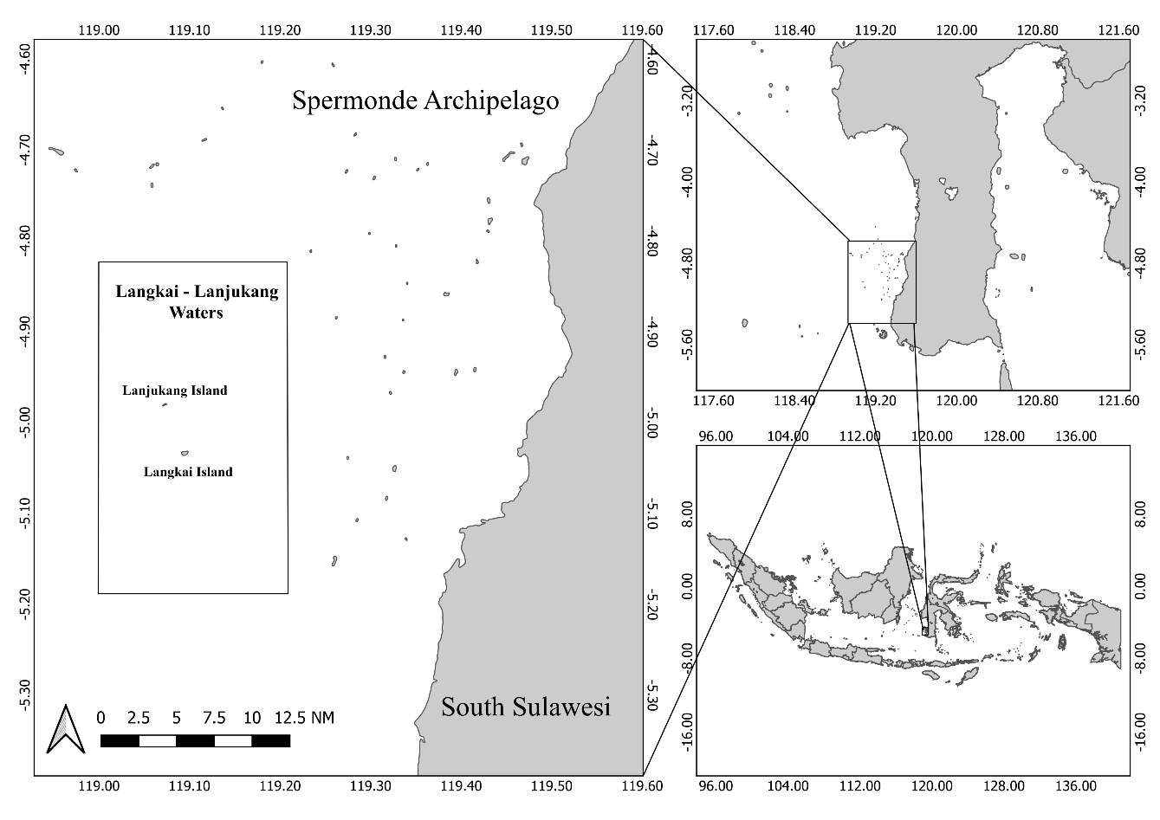
Fig 1. Research location

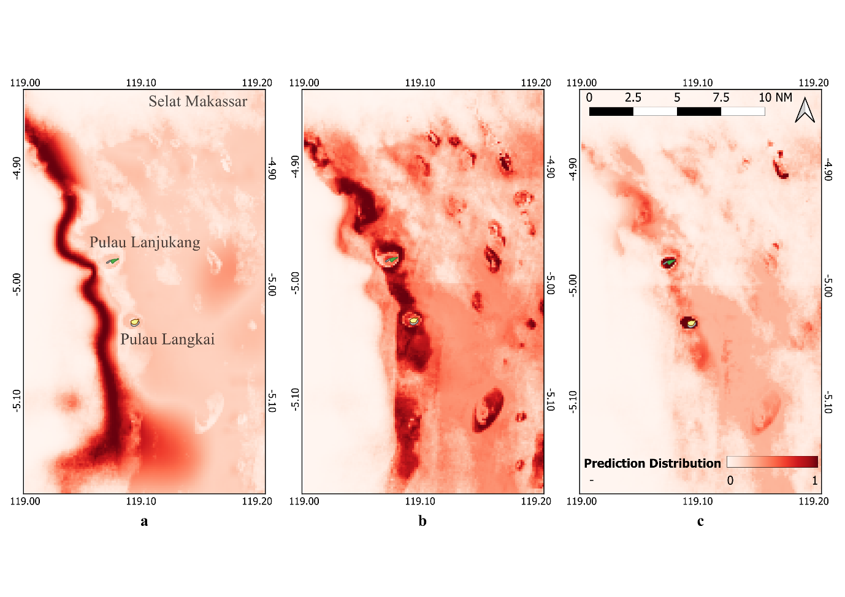
Fig 2. Shark Distribution of (A) Silky Shark (B) Whitetip Reef shark (C) Blacktip Reef Shark
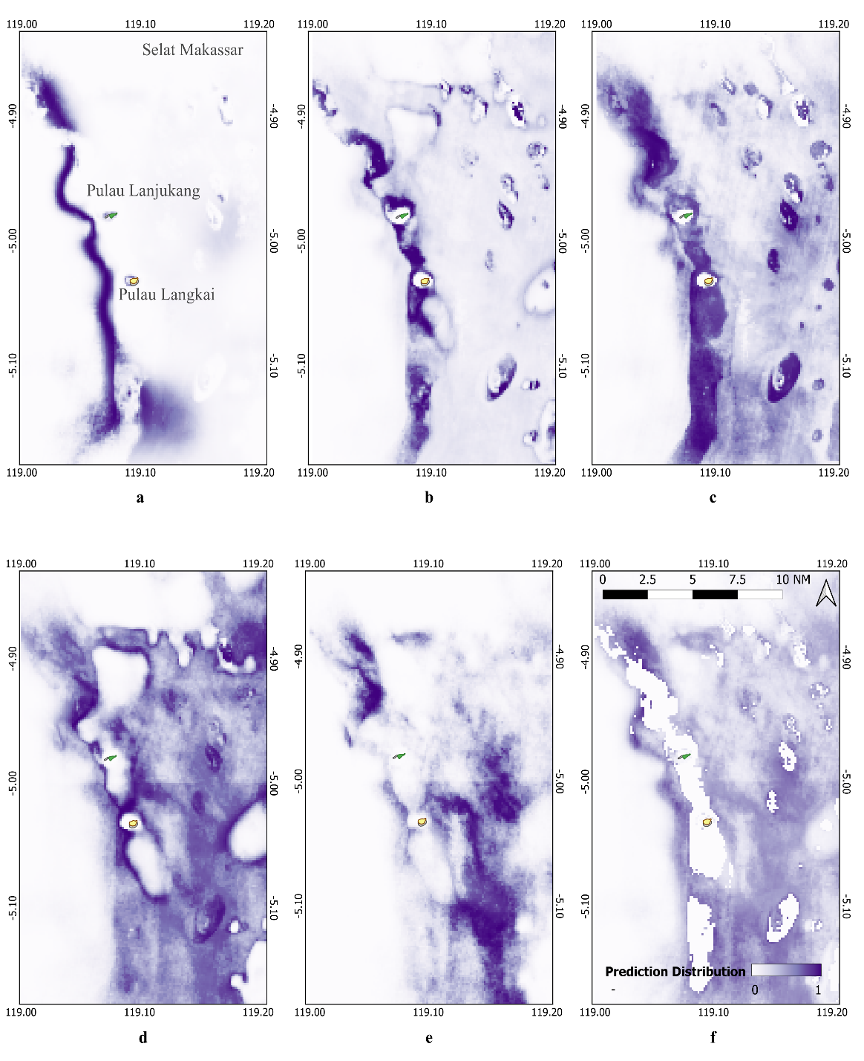
Fig 3. Fishing Efforts Distribution of (A) Large Fish Longline (B) Demersal Longline (C) Set Buoy Gear (D) Set Gillnet (E) Trammel Net (F) Total Fishing Efforts
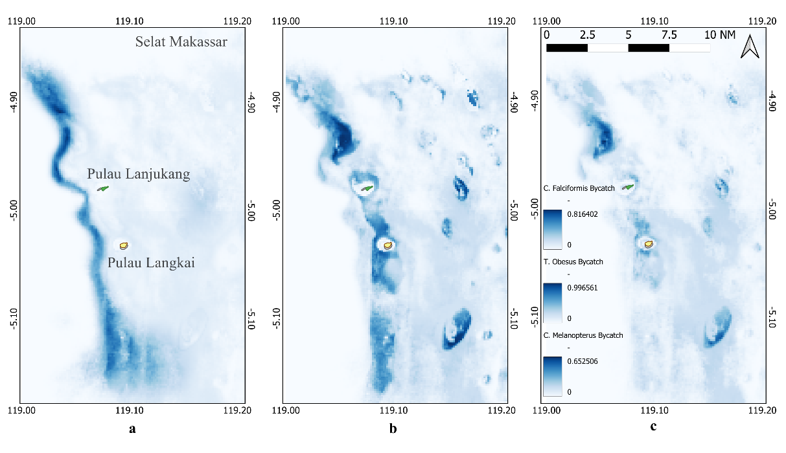
Fig 4. Bycatch Probability of (A) Silky Shark (B) Whitetip Reef shark (C) Blacktip Reef Shark

