COPPA UPDATE FROM JANUARY. 2025 to JUNE 2025
1. Summary information
The brief report illustrates a summary of information on the COPPA program from March. 2025 to June. 2025.
- Total observer: 12 captains
- Total trips conducted: 24
- Total catch volume: 26.660,5 Kg; CPUE: 1110,9kg/month (YFT: 852,5kg)
- Main ports: Hon Ro – Nha Trang; Tam Quan Bac – Binh Dinh

Specie | Catch volume | Percentage | CPUE
YFT | 20459,1 | 76,7% | 852,5
BET | 2756 | 10,3% | 114,8
SKJ | 7 | 0,0% | 0,3
SWO | 1673 | 6,3% | 69,7
BUM | 430 | 1,6% | 17,9
BLM | 179 | 0,7% | 7,5
MLS | 240 | 0,9% | 10,0
GBA | 104,5 | 0,4% | 4,4
GES | 18 | 0,1% | 0,8
WAH | 116 | 0,4% | 4,8
KGM | 113 | 0,4% | 4,7
DOL | 214,5 | 0,8% | 8,9
LEC | 49 | 0,2% | 2,0
ALX | 11 | 0,0% | 0,5
Rays | 2 | 0,0% | 0,1
Turtles | 37 | 0,1% | 1,5
Others | 251,4 | 0,9% | 10,5
Total | 26660,5 | 100% | 1110,9

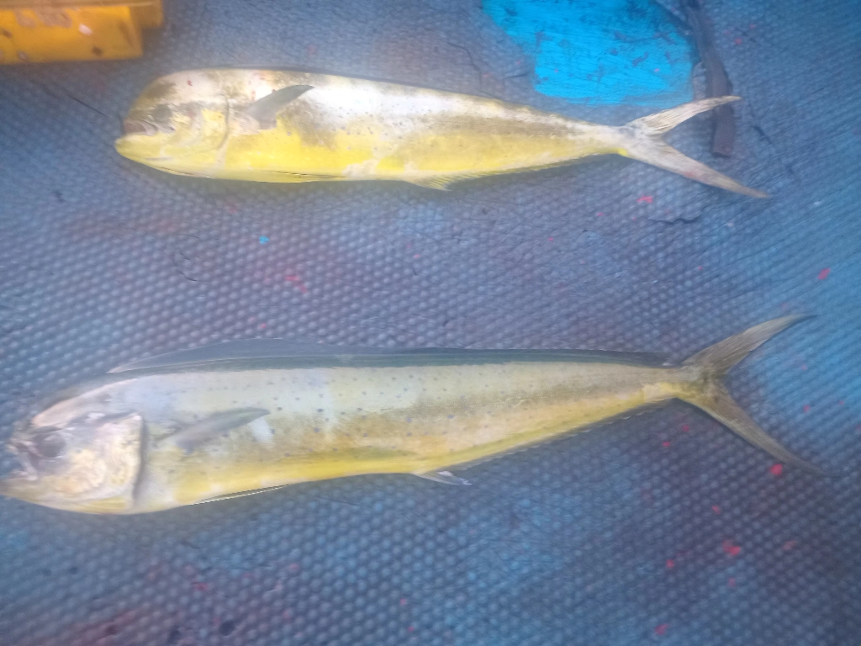
Figure 1. Mahi Mahi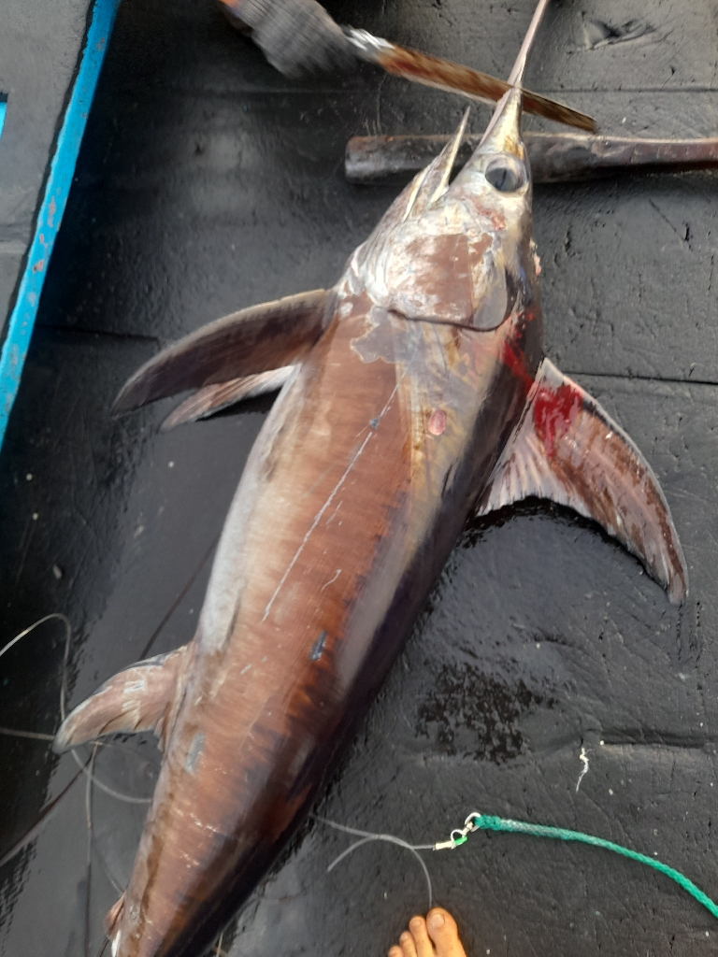
Figure 2. Sword fish

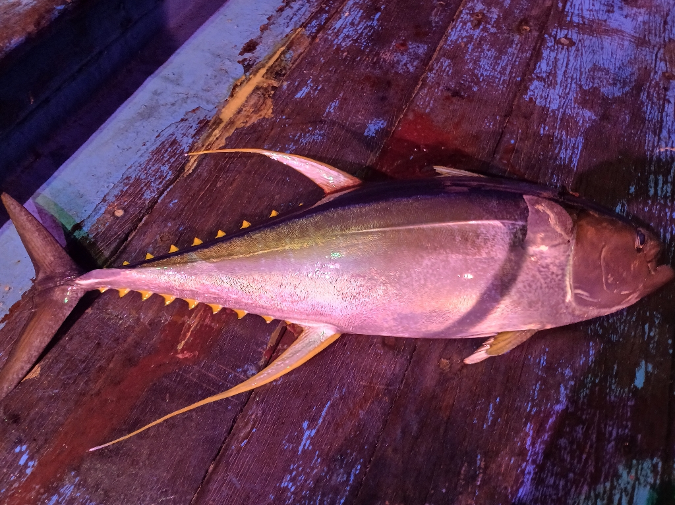
Figure 3. Yellowfin Tuna

