Action 6: Enhancement outcomes and management
Action Goal: Demonstrate that effective enhancement and fishery strategies are in place to address effects of enhancement activities on wild stock(s)
PIs 1.3.1, 1.3.2

- Brief overview on fish breeding programs in the Sakhalin Region.

During the meeting in Yuzhno-Sakhalinsk on August 08, 2024 Svetlana Sidorova, Head of the SKTU Aquaculture Department, said that “Sakhalin Region is the only region of the Russian Far East where fish breeding programs are very actively implemented. In 2023 there were 75 hatcheries, in 2024 – 78, and several salmon hatcheries are expected to be built in the next one to two years. Fish breeding programs cover more than 100 water bodies of the Sakhalin Region: full-scale operating hatcheries have been built in some water bodies and watercourses, while in others only juvenile Chum Salmon are stocked. The total juvenile salmon release in 2024 amounted to more than 1.4 billion fish. The main species is Chum Salmon (1.3 billion fish), followed by Pink Salmon (146 million fish) with small amounts of Coho and Masu Salmon”. Information can also be found on the website of the Sakhalin-Kuril Territorial Administration (hereinafter – SKTU): https://sakhalin.fish.gov.ru/activities/akvakultura/
According to the message on January 09, 2025 https://fishnews.ru/news/51652, 79 fish breeding facilities have been built in the region: 71 salmon hatcheries and 8 salmon nursery workshops. In 2024, salmon hatcheries in the Sakhalin Region planted over 1.3 billion Pacific salmon eggs for incubation.
The successful artificial reproduction of Pink and Chum salmon at certain Sakhalin Region facilities (Stekolshchikova et al., 2023, Stekolshchikova et al., 2024) is anticipated to be applied in salmon hatcheries in Kunashir.

- Hatcheries on Kunashir Island

Fish breeding programs for the restoration of Kunashir Pink and Chum Salmon populations were launched in 2012 (Romasenko, 2012). The release of juveniles from new salmon hatcheries started in 2018: in 2018 – from the Lagunnoye Lake Salmon Hatchery, in 2020 – from the Rikorda Salmon Hatchery, in 2024 – from the Tropinka Salmon Hatchery. In 2024, 36.021 million salmon juveniles were released on Kunashir Island.
Section 3.5 of Tatiana Tochilina’s report provides information about the new salmon hatchery on the Tropinka River: “A fish hatchery belonging to Island Fish Invest LLC with a capacity of 10 million of Pacific Salmon juveniles (Chum Salmon, Pink Salmon) is under construction in the lower reaches of the Tropinka River (Fig. 21). The release of juvenile Pacific salmon to the Tropinka River began in 2022. In 2024, 2.92 million juvenile Chum Salmon were released".
In Table 9 of that report, Tatiana Tochilina provides comparative data on the juvenile release from the Iturup and Kunashir Islands. As we can see, the release of juvenile Chum Salmon on Kunashir is significantly lower than on the neighboring Iturup Island: in 2023, it was 12% of the total release from the two islands, and in 2024 it was 8.5%.

Table 9 (numeration is according to Tatiana Tochilina’s report). Release of juvenile Pacific salmon from Iturup and Kunashir Islands in 2023-2024, million fish.
Species | 2023 |  |  | 2024
Species | Iturup | Kunashir | Total | Iturup | Kunashir | Total
Pink Salmon | 152.54 | 0.0 | 152.54 | 28.144 | 0.0 | 28.144
Chum Salmon | 353.103 | 42.22 | 395.323 | 421.472 | 36.021 | 457.493
TOTAL | 505.643 | 42.22 | 547.863 | 449.616 | 36.021 | 485.637

Table 10 of Tatiana Tochilina’s report presents the release of juveniles by salmon hatcheries into key rivers and other water bodies on Kunashir Island from 2018 to 2024.

Table 10 (numeration is according to Tatiana Tochilina’s report). Release of juvenile Chum Salmon by the salmon hatcheries on Kunashir Island from 2018 to 2024, million fish.
Name of the hatchery or water body | Release of juvenile Chum Salmon by year, million fish
Name of the hatchery or water body | 2018 | 2019 | 2020 | 2021 | 2022 | 2023 | 2024
Lagunnoye Lake Salmon Hatchery | 1.5 | 3.4 | 10.4 | 18.5 | 12.5 | 19.8 | 27.747
Prozrachny Stream | 0.0 | 0.0 | 0.0 | 0.0 | 0.0 | 0.0 | 0.151
Ilyushina River | 0.0 | 0.0 | 0.0 | 0.0 | 0.0 | 0.0 | 0.150
Rikorda River Salmon Hatchery | 0.0 | 0.0 | 14.2 | 14.6 | 14.1 | 17.9 | 5.751
Golovnina River | 0.0 | 0.0 | 0.0 | 0.0 | 2.4 | 0.5 | 0.1
Khlebnikova River | 0.0 | 0.0 | 0.0 | 0.0 | 0.0 | 1.0 | 0.1
Sennaya River | 0.0 | 0.0 | 0.0 | 0.0 | 0.0 | 1.0 | 0.1
Tropinka River | 0.0 | 0.0 | 0.0 | 0.0 | 0.5 | 2.0 | 2.923
TOTAL: | 1.5 | 3.4 | 24.6 | 32.1 | 29.5 | 42.2 | 36.021

Salmon hatcheries location and water bodies where juvenile Chum Salmon were released are presented in Figure 27 of the Tatiana Tochilina’s report.

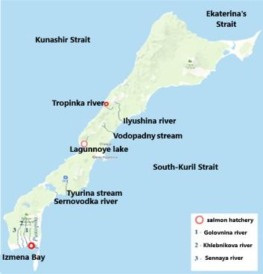
Figure 27 (numeration is according to Tatiana Tochilina’s report).
Map of Kunashir Island showing the location of fish hatcheries

- Fish breeding programs at PCF Yuzhno-Kurilsky Ryibokombinat Co., Ltd.

PCF Yuzhno-Kurilsky Ryibokombinat Co., Ltd. (hereinafter – YKRK) have one salmon hatchery on Kunashir Island, which is located in the Lagunnoye Lake basin.
The following table presents the numbers, dates and average weight of juvenile Chum Salmon released from the Lagunnoye Lake Salmon Hatchery over the past seven years, taken from Dmitry Pastukhov’s report No. 5 “Report on the number of juveniles released from the Lagunnoye Lake Salmon Hatchery”:

Year of fish release | Number of Chum Salmon juveniles released, million fish | Dates of fish release | Average weight, gram
2018 | 1.5 | From June 15 to June 16 | 2.6
2019 | 3.4 | From May 27 to June 20 | 0.8
2020 | 10.4 | From May 25 to July 1 | 1.1
2021 | 18.5 | From June 10 to July 2 | 1.2
2022 | 12.5 | From May 24 to June 30 | 1.0
2023 | 19.8 | From May 21 to June 20 | 0.952
2024 | 27.7 | From June 10 to June 13 | 0.9

In 2024, 14.3 million eggs were planted for incubation at the Lagunnoye Lake Salmon Hatchery, which will ensure the release of 12 million Chum Salmon fry in June 2025.

YKRK fish breeding programs are aimed at creating their own Chum Salmon broodstock and preserving “wild populations”. Since 2023 fish breeders have been collecting eggs for planting exclusively at the egg collecting station in the middle reaches of Pervukhina River, which allows “wild” Chum Salmon entering from the sea into the Lagunnoye Lake watercourse to spawn freely on natural spawning grounds. In 2024, all fish eggs (100%) were also collected from their own broodstock (Dmitry Pastukhov’s reports: 1. Fish catch log at the egg collecting station; 4. Report on eggs transportation).
Fish breeding activities are supported by scientific data on the dates of spawning runs, the gathering of biological traits, and the age of Chum Salmon. The 2024 Biological Analysis Report shows that data collection was conducted throughout the season from October 10 to November 10. The majority of fish were four year olds (age 3+). Thus, this is the returned Chum Salmon released in 2019-2021 from the Lagunnoye Lake Salmon Hatchery (Dmitry Pastukhov’s report: 3. Report on biological analysis).

- Actions for wild populations preservation

During the fishing season, YKRK implements a fishing strategy aimed at preserving the local populations of Kunashir Pink and Chum salmon. Receiving operational data from local fish biologists and contracted scientists about low escapement to spawning grounds, the company management initiates restrictive measures.
The company's specialists undertake measures to eliminate the impact of artificial reproduction on wild populations. These measures include:
- reducing fishing pressure by removing fishing gear before the official decisions approved by the Anadromous Fish Commission (hereinafter – the Commission) in the Sakhalin Region;
- provide escapement of Chum Salmon spawners to Lagunnoye Lake spawning grounds without obstacles;
- unimpeded spawning of wild Chum Salmon by preserving natural spawning grounds;
- collecting eggs from their own broodstock for use at the Lagunnoye Lake Salmon Hatchery, guaranteeing that 100% of the planting eggs comes from fish that have returned to the fishway;
- do not import eggs from other districts of the Sakhalin Region;
- do not catch spawners for artificial reproduction from neighboring rivers and lakes of Kunashir;
- continuation eggs otolith marking;
- start working on identifying Chum Salmon using otoliths.

In 2024, data collection on the dynamics of Chum Salmon entering Lagunnoye Lake from the sea continued. According to the report of the chief fish breeder Dmitry Pastukhov “2. Report on the timing of Chum Salmon entering the spawning grounds of Lagunnoye Lake, Pervukhina Stream and into the fishway”, it can be concluded that the Chum Salmon escapement to the fishway started three weeks earlier than to the mouth of Pervukhina Stream. Consequently, Chum Salmon were unimpededly fed and selected spawning grounds in the lake. The “hatchery” fish then entered the Pervukhina Stream and the fishway consequently.

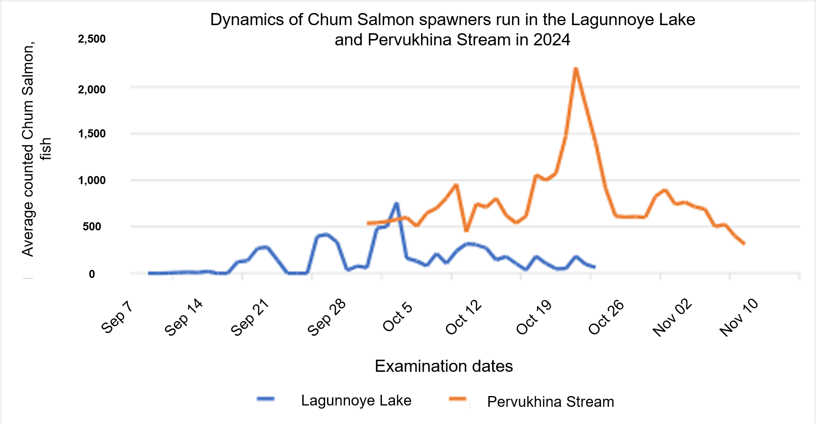

Therefore, the artificial reproduction of salmon on Kunashir Island, carried out by PCF Yuzhno-Kurilsky Ryibokombinat Co., Ltd., involves activities such as monitoring, scientific research, adaptive management, and artificial reproduction based on the genetic makeup of the Chum Salmon population, along with investments in restoring natural spawning grounds. This approach contributes to a comprehensive management strategy.

List of literature

Zhivotovsky L.A., Rubtsova G.A., Shitova M. V., Malinina T.V., Prokhorovskaya V.D., Rakitskaya T.A., Afanasyev K.I. Population Structure of Chum Salmon of the Russian Far East: Biogeographic Classification, Genetic Differentiation, and Ecogeographic Units. Russian Journal of Genetics (Genetika), 2022, Vol. 58, No. 4, pp. 438–449 (in Russian)

Romasenko L.V. Dynamics of the Pink Salmon Oncorhynchus gorbusha stock at Kunashir (Kuril Islands). Izvestiya TINRO, 2012, Vol. 168, pp. 42-58 (in Russian)

Stekolshchikova M.Yu., Palkina O.N., Batyuk Yu.A. The contribution of artificial reproduction to the fishery and maintenance of natural populations of Pink Salmon Oncorhynchus gorbuscha in Eastern Sakhalin in 2018. Problems of Fisheries, 2023. Vol. 24. No4. P. 119–135 (in Russian)

Stekolshchikova M.Yu. , Akinicheva E.G. , Batyuk Yu.A., Varaksin I.A. Estimating the occurrence of chum salmon Oncorhynchus keta of artificial origin on spawning grounds in the rivers and lakes of Iturup Island. Izvestiya TINRO, 2024, Vol. 204, No. 4, pp. 935–950 (in Russian)

Minutes of the meeting on August 08, 2024 in the Sakhalin-Kuril Territorial Administration of the Federal Agency for Fishery with the Head of the Aquaculture Department (Svetlana Vyacheslavovna Sidorova) (in Russian)

Tochilina T.G. Report to Contract Agreement No. 01/2024 dated March 11, 2024 on the topic: “1. Collection and analysis of biological and statistical data on the reproduction of Pink Salmon and Chum Salmon on Kunashir Island”

Dmitry Pastukhov's reports in 2024:
- Report on fishing at the hatchery and collecting eggs for planting
- Timing of the Chum Salmon returns in 2024
- Chum Salmon biological analysis report
- Report on the transportation of eggs in 2024
- Report on the release of juveniles

https://sakhalin.fish.gov.ru/activities/akvakultura/

https://fishnews.ru/news/51652

Lyudmila Fedorova
Fisheries Eco-Certification Consultant

March 11, 2025

