Action #7: Enhancement Program Information
Action Goal: Demonstrate obtaining relevant information and adequate assessment to determine the impact of enhancement activities on wild populations
PI 1.3.3
Action Description: Implement a program to mark salmon releases at the Lagunnoye Lake Salmon Hatchery. Develop and implement a comprehensive plan to estimate the contribution of hatchery produced fish to the fishery harvest, total escapement (wild plus enhanced), and hatchery broodstock.

To assess the contribution of hatchery fish to the commercial catch and obtain data on the total escapement to spawning grounds by wild and hatchery spawners, the company PCF Yuzhno-Kurilsky Ryibokombinat Co., Ltd. (hereinafter – YKRK) finances various scientific research by its own funds:

1 - scientific data collection on:
- dynamics of the spawning run from the sea into the Kunashir water bodies;
- escapement to spawning grounds (including the main water body of the fish hatchery – Lagunnoye Lake);
- biological characteristics of wild and hatchery Chum Salmon, including scale sampling for age determination;
- fishery statistics to make Chum Salmon stock assessments and estimate returns.
2 - timing and numbers of Chum Salmon entering from the sea to the Lagunnoye Lake fishway and to the Pervukhina Stream;
3 – otolith marking of juvenile Chum Salmon at the Lagunnoye Lake Salmon Hatchery in compliance with NPAFC rules and protocols;
4 - collecting and processing otoliths to directly assess the potential impact of hatchery produced fish on wild populations, and to evaluate the effectiveness of adopted fish breeding programs.

The aim of the first direction is to collect and analyze information on wild and hatchery Kunashir Chum Salmon and create a database on reproduction in Kunashir water bodies. In the future, when hatchery Chum Salmon returns will increase, this data will be used to assess both straying and the impact on wild populations (information presented in the Tochilina’s report for 2024).
The second direction is carried out by employees of the fish hatchery and security company, who daily collect information on the run intensity of Chum Salmon entering the Lagunnoye Lake fishway and Pervukhina Stream in the morning and evening hours. The data are recorded in a special log and confirm that “wild” Chum Salmon unimpededly fed and selected spawning grounds in the lake for 3-4 weeks (Figure 1). The “hatchery” Chum Salmon then enters Pervukhina Stream, which flows into the lake, and the fishway, where 100% of the entered fish are caught. “Wild” Chum Salmon have the opportunity to freely escape to lake spawning grounds and then freely reach spawning redds (information is presented in the report of the chief fish breeder Dmitry Pastukhov “2. Report on the timing of Chum Salmon …”).
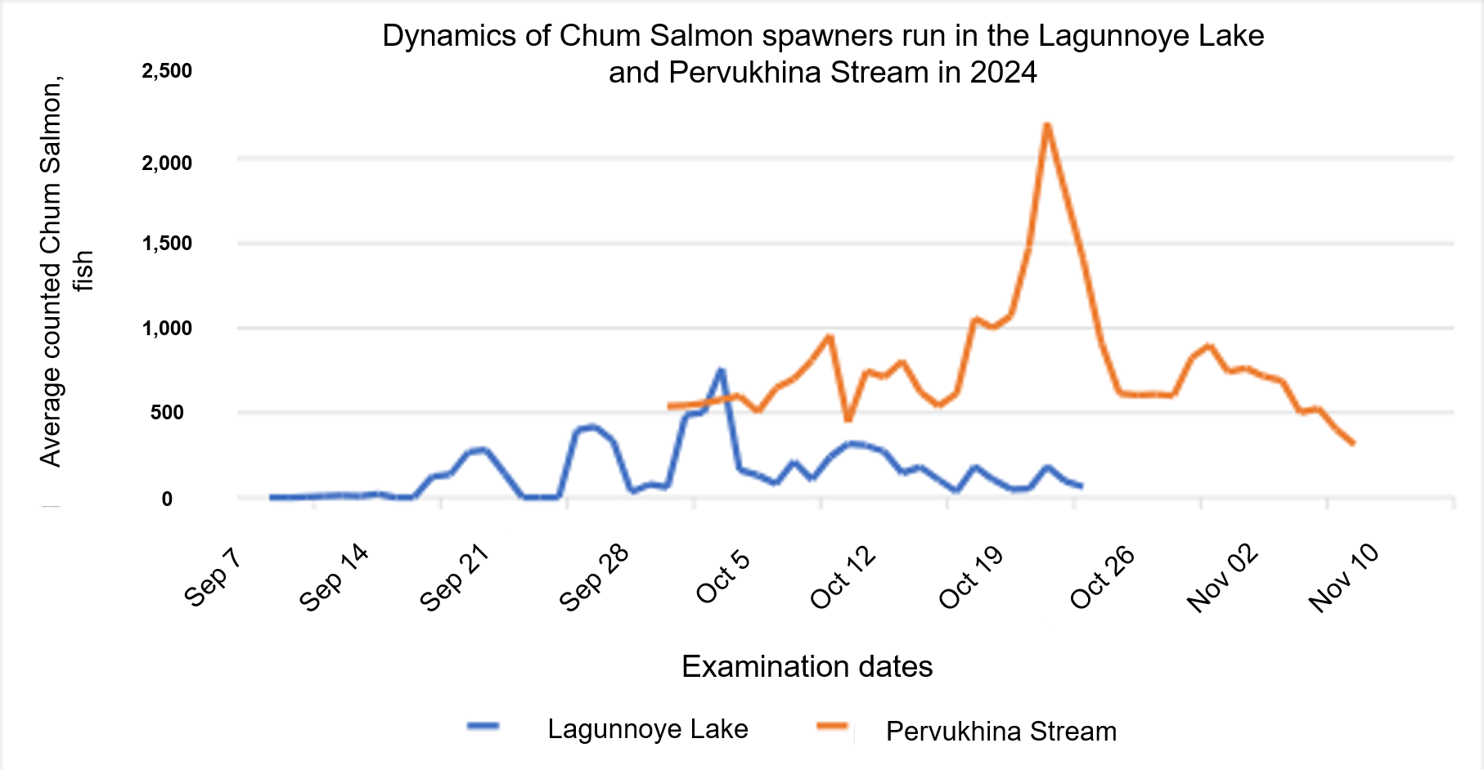
Figure 1 Dynamics of Chum Salmon spawners run in the Lagunnoye Lake fishway and the Pervukhina Stream mouth

The third direction: fish otolith marking in compliance with North Pacific Anadromous Fish Commission (NPAFC) rules and protocols is carried out with scientific support from the Otolithometry Department of the SakhNIRO Salmon Laboratory. This work has been carried out by YKRK for four years.
There are many methods for marking (tagging) fish otoliths. Among them, hatchery Chum Salmon are identified by analyzing the microchemical composition of otoliths (Mikheev et al., 2024). But the most common method in salmon breeding is marking otoliths by changing water temperature (thermal marking) or by periodically exposing eggs in a humid atmosphere (dry method). Lagunnoye Lake Salmon Hatchery has its own peculiarities in water supply systems and thermal regime of water for technological needs. Therefore, a dry method was chosen for this hatchery.
In the last two years (in 2023 and in 2024) 100% of fish production (eggs) planted at Lagunnoye Lake Salmon Hatchery were tagged. Data on tagged juvenile fish releases are presented in Dmitry Pastukhov's report “5. Report on the release of juveniles” (Table 1.).

Table 1. Release of tagged Chum Salmon juveniles from the Lagunnoye Lake Salmon Hatchery
Year of fish release | Dates of fish release  (from……...to………) | Average weight, gram | Number of Chum Salmon juveniles released, thousand fish
2025* | June 2025* | 0.9* | 12.0*
2024 | From June 10, 2024 to June 13, 2024 | 0.900 | 27.0
2023 | From May 31, 2023 to June 20, 2023 | 1.000 | 3.4
2022 | From June 01, 2022 to June 15, 2022 | 1.043 | 2.4
2021 | - | - | -
*Note: for 2025, the planned figures are given. During the 2024 fishing season, 14.3 million Chum Salmon eggs were collected, which were marked in December 2024 - January 2025.

All marking work was carried out in accordance with the recommendations of specialists from Otolithometry Department of the SakhNIRO Salmon Laboratory, and a contract was signed between SakhNIRO and YKRK for scientific support of this work. A similar contract has been signed in 2024-2025 (Technical scope for the research work, SakhNIRO, 2024). The assessment of the work and tagging quality in 2023-2024 is described in the SakhNIRO scientific report on the topic: ‘Scientific support for Chum Salmon otolith tagging at the Lagunnoye Lake Salmon Hatchery’. The report states that “As a result of Chum Salmon eggs tagging at the Lagunnoye Lake Salmon Hatchery, tags were clearly distinguish on all analyzed embryos (Figures 2.1 - 2.4 according to the report).

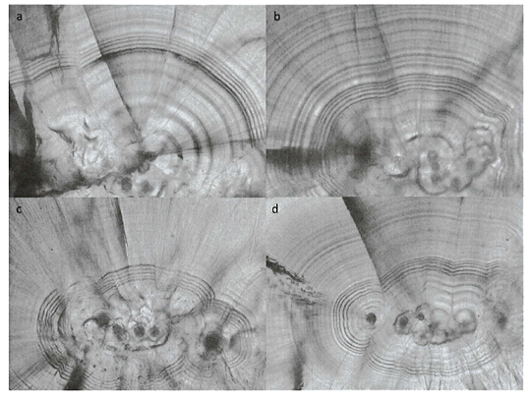
Figure 2. An example of distinct Chum Salmon otolith tags acquired using the dry method at the Lagunnoye Lake Salmon Hatchery (Figure 2.1 according to the SakhNIRO report)

Tagging results and digital photos of salmon otoliths from participating countries are sent to the North Pacific Anadromous Fish Commission (NPAFC) common database. A report on the release of tagged juvenile fish from Russian hatcheries in 2023, including the release of 26.379 million tagged Chum Salmon from the Lagunnoye Lake Salmon Hatchery, can be found at the website: https://www.npafc.org/published-documents-2023/. The protocol prescribed the 3.4H tag for tagging Chum Salmon eggs at the Lagunnoye Lake Salmon Hatchery in 2024 can be found at this website: https://www.npafc.org/published-documents-2024/. More information on the tag type and tagging methods are described in the SakhNIRO letter No. 202-2371 with recommendations on tagging farmed fish production dated November 18, 2024.

The fourth direction – data collection to directly assess the potential impact of hatchery produced fish on wild populations, and to evaluate the effectiveness of adopted fish breeding programs – is implemented by the YKRK in two ways:
1) by indirect assessment based on catch statistics during the fishing season: scientific studies conducted in 2024 allow for preliminary calculations, according to which the share of hatchery fish in the total stock amounted to 27.9%.
2) by direct assessment of the potential impact of hatchery fish on wild Chum Salmon populations. Collection of otoliths from adult fish to identify “hatchery” Chum Salmon was initiated in 2024. For this purpose, 600 pairs of otoliths have been collected: 300 from fish caught by trap nets (in Pervukhina Bay) and 300 from fish caught at the egg collection station (Pervukhina Stream). These samples are currently being processed. Work completion and a final report is expected in May-June 2025 (information from Tatiana Tochilina’s report in 2024), so a report for Fishery Progress on this data will be prepared by the ForSeaSolutions team in October 2025.
In 2025 it is expected to expand such research and contract fish biologists from the Otolithometry Department of the SakhNIRO Salmon Laboratory. These plans include the following actions:
- to collect adult fish otoliths from various marine fishing parcels, from the Lagunnoye Lake Salmon Hatchery, and from Kunashir natural water bodies;
- to estimate the Kunashir wild and hatchery Chum Salmon proportions in the annual catch;
- to estimate the share of wild Chum Salmon in the hatchery broodstock.
Thus, YKRK is successfully implementing a program on tagging fish production and identifying “hatchery” fish in the total Kunashir Chum Salmon stock. The Company is implementing the Plan to estimate the contribution of hatchery produced fish to the fishery harvest, total escapement (wild plus enhanced), and develop hatchery broodstock, adopted in April 2022.

List of documents and literature

1. Mikheev P.B., Koshelev V.N., Podorozhnyuk E.V. et al. Results of identification of autumn Chum Salmon Oncorhynchus keta (Salmoniformes) of hatch-breeder origin in the Amur River basin based on the analysis of the microchemical composition of otoliths based on the materials of 2020. Fisheries Issues, 2024. Vol. 25. No4. P. 77–88

2. Chief fish breeder Dmitry Pastukhov’s reports at the Lagunnoye Lake Salmon Hatchery in 2024:
No. 2. Timing of the Chum Salmon returns in 2024
No. 5. Report on the release of juveniles

3. Rebuild Local Salmon Stocks Plan for the period 2022-2026 at the Lagunnoye Lake Salmon Hatchery (Action 7 of the FIP Workplan). – PCF Yuzhno-Kurilsky Ryibokombinat Co., Ltd.

4. Scientific report on the topic: “Scientific support for Chum Salmon otolith tagging at the Lagunnoye Lake Salmon Hatchery (PCF Yuzhno-Kurilsky Ryibokombinat Co., Ltd.) in 2023. SakhNIRO. Yuzhno-Sakhalinsk, 2024

5. Technical scope for the research work on the topic: “Scientific support for Chum Salmon otolith tagging at the Lagunnoye Lake Salmon Hatchery”, SakhNIRO, 2024.

6. SakhNIRO letter No. 202-2371 with recommendations on tagging farmed fish production dated November 18, 2024.

7. Tochilina T.G. Report to Contract Agreement No. 01/2024 dated March 11, 2024 on the topic: “1. Collection and analysis of biological and statistical data on the reproduction of Pink Salmon and Chum Salmon on Kunashir Island”

NPAFC. Report on the release of juveniles in 2023. https://www.npafc.org/published-documents-2023/

NPAFC. Proposed labels for 2024. https://www.npafc.org/published-documents-2024/

Lyudmila Fedorova
Fisheries Eco-Certification Consultant
March 12, 2025

