

Action #1 Rebuilding Local Salmon Stocks

Action Objective: Rebuild wild Kunashir Island pink and chum salmon stocks within five years
PIs 1.1.1, 1.1.2

Annual scientific surveys are conducted on Kunashir Island to assess baseline conditions of local pink salmon and chum salmon stocks, with the majority of funding provided by PCF Yuzhno-Kurilsky Ryibokombinat Co., Ltd. In 2025, a comprehensive monitoring of pink salmon and chum salmon reproduction on Kunashir Island was carried out, based on spawning ground surveys, biological sampling, and analysis of fishery statistics. The results confirmed critically low returns: pink salmon spawners were absent or present only as isolated individuals in most surveyed watercourses, while average chum salmon escapement to spawning grounds reached approximately 0.5% of the normative level. No signs of spawning habitat degradation were detected, indicating that the decline in returns is primarily driven by external (mainly marine and climatic) factors. The Tochilina’s report further demonstrates that fishing pressure in 2025 was minimal due to voluntary reductions in fishing effort by Kunashir fishing companies, and that anomalous thermal conditions in coastal waters during migration periods were identified as the most likely driver of weak returns.
1. Current Status of Pink Salmon and Chum Salmon Stocks on Kunashir Island.
Pink Salmon (Oncorhynchus gorbuscha)
Field surveys conducted in 2025 indicate that natural salmon reproduction on Kunashir Island is characterized by extremely low spawning escapement. In most surveyed watercourses, pink salmon runs were either absent or limited to isolated individuals [1]. However, no signs of spawning substrate degradation or deterioration of spawning ground physical condition were detected. This indicates that the primary drivers of declining returns are processes occurring predominantly during the marine phase of the life cycle.
Figure 1 (from the Tochilina’s report, Fig. 44) clearly illustrates how pink salmon spawning escapement has changed over the past 10 years. The even-year generation was historically dominant. At present, both generations are in a depressed state.

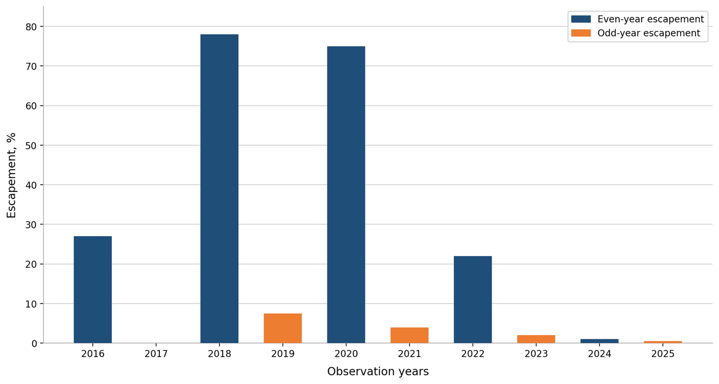

Fig. 1. (from Tochilina's report, Fig. 44). Pink salmon escapement to spawning grounds on Kunashir Island, 2016–2024.

In 2025, the average pink salmon spawning escapement was 0.12% against the standard density of 2 fish/m² (Table 2 from the Tochilina’s report). Pink salmon fishing on Kunashir Island in 2025 was effectively zero. Due to the extremely low population of this species, sampling of fish for scientific purposes and biological analyses were also not conducted.
Confirmation of the current prolonged pink salmon depression is provided by Kaev et al. (2024) [8]: the fishery results confirmed high interannual variability in stock abundance and instability of returns characteristic of the Sakhalin–Kuril region in recent years. In 2024, reduced fish returns were recorded in a number of areas, including a sharp drop in fish run intensity (particularly in August) following an encouraging start to the fishing season.
An analysis of pink salmon return dynamics in the Sakhalin–Kuril region in the 21st century, presented in another paper by Kaev et al. [7], shows that historical abundance peaks occurred in 2006–2013, after which returns have declined in several areas. Changes are asynchronous: the dynamics of individual local stocks differ, and the co-variation of abundance decreases with increasing spatial distance between areas [7]. These data indicate a mosaic pattern of stock formation for Southern Kuril pink salmon populations.
Chum Salmon (Oncorhynchus keta)
Field surveys in 2025 recorded an average spawning escapement of approximately 0.5% of the standard level (1.6 fish/m²), which is one of the lowest spawner density values recorded throughout the entire monitoring period [1]. For comparison, values in previous years were considerably higher, even accounting for interannual variability in returns: 2023 — 11.3%; 2024 — 6.35%; 2025 — 0.5%. The trend over recent years indicates a sustained decline in run abundance compared to periods of more favorable productivity (Fig. 2).
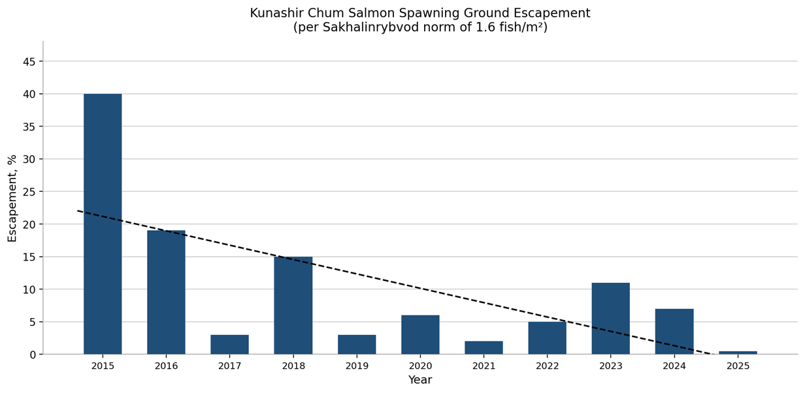
Fig. 2 (from Tochilina's report, Fig. 47). Chum salmon escapement to Kunashir spawning grounds (standard level of 1.6 fish/m²) from 2015 to 2025, with trend line.
Analysis of fishery statistics confirms the depressed state of the stock. The actual marine catch of chum salmon in 2025 was approximately 13.7 mt, substantially below the authorized harvest levels and below catches of more productive years [1]. Throughout the season, fishing companies voluntarily reduced their fishing effort: delayed entry into the fishery and early termination of the season due to extremely low spawner returns. Thus, fishing pressure was not a factor contributing to the decline in abundance. Figure 3 presents a graph showing the declining trend in chum salmon catches on Kunashir Island over the past 15 years.
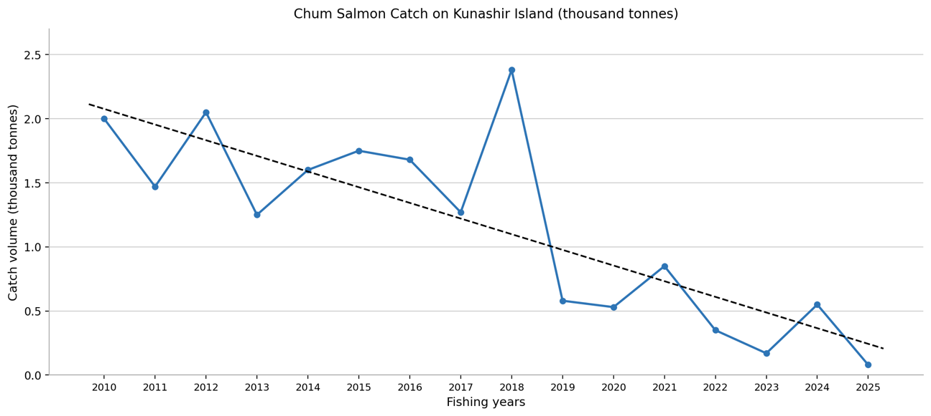
Fig. 3 (from Tochilina's report, Fig. 59). Chum salmon catch on Kunashir Island, 2010–2025, with trend line.
Biological analyses of chum salmon conducted in 2025 recorded a decline in average spawner body weight. The average weight of chum salmon spawners decreased to 2,089.9 g, which is substantially below the 2024 value (2,437.9 g) and significantly below values typical for the 1990s–2010s (3,086.0 g, per Kaev, 2017). One of the key causes of the decline in average chum salmon weight in 2025 was identified as deterioration in food availability during the marine phase of the life cycle. This process is associated with a combination of factors, including:
1) Changes in the structure and productivity of the oceanic food base, caused by ocean warming, which reduces the availability of high-energy prey (euphausiids, amphipods, small fish).
2) Shifts in high-productivity zones (fronts, upwellings, plankton and nekton aggregation zones) under the influence of anomalous temperatures. This means that traditional feeding areas become less favorable, and fish spend more time and energy searching for food.
3) Increased interspecific competition for resources among species sharing the same feeding grounds, including other chum salmon populations, pink salmon, and other Pacific salmon and fish species, which further exacerbates food resource deficits.
4) Accelerated metabolism under elevated temperature conditions increases energetic demands on fish; however, reduced food availability makes it impossible to compensate for these costs.
Specific features of the chum salmon stock age structure were noted in 2025. Biological analysis data indicate that the stock structure is shifting toward dominance of the 3+ age class, i.e., younger fish with lower body weight, lower absolute fecundity, a weaker contribution to overall population reproduction, and reduced capacity to compensate for interannual fluctuations in abundance.
Additionally, the Tochilina’s report notes that the condition of spawning substrates and channel sections where chum salmon spawn remains satisfactory: no signs of spawning ground degradation or significant anthropogenic habitat disturbances were detected [1]. This confirms that the decline in abundance is primarily driven by external factors operating during the marine phase of the life cycle.
2. Climatic Factors and the Marine Phase of the Pink and Chum Salmon Life Cycle
Salmon spends a significant part of their life cycle in the open ocean, where survival depends on temperature, food availability, and oceanographic processes. This means that even where spawning grounds are in good condition and fishing pressure is minimal, recovery can be slowed by oceanic factors. The problem of weak pink and chum salmon returns to Kunashir fits within a basin-scale climatic context, rather than being solely a consequence of local management.
Current international research confirms that Pacific salmon population dynamics are increasingly determined by large-scale climate-oceanographic processes in the North Pacific [2,3]. The North Pacific continues to experience long-term warming accompanied by marine heat anomalies. Changes are observed in the spatial distribution of salmon, in cohort structure, in average individual body weight, and in trophic interactions. Climate change exerts a systemic influence on the abundance and distribution of Pacific salmon. Rising sea surface temperatures, changes in winter SST anomalies, and associated shifts in food resource distribution affect the marine survival of cohorts. Range shifts toward more northern areas have been recorded. NPAFC Bulletin No. 7 systematizes current knowledge on the state of Pacific salmon under accelerating climate change and establishes a predictive framework through 2030. The key scientific conclusion: high variability in salmon stock productivity will persist through 2030, with increasing uncertainty in return forecasts. An adaptive, precautionary approach to management under climatic variability is recommended.
The conclusions of scientists who contributed to NPAFC documents are confirmed by other studies as well. A statistically significant correlation between winter SST values (January–March) in overwintering areas and subsequent salmon catches is demonstrated by Vanyushin et al. (2025): the study analyzes the relationship between sea surface temperature (SST) in winter (January–March) in the salmon winter feeding area of the Northwestern Pacific Ocean (NWP) and actual Pacific salmon catches for 1998–2024 [4]. A significant correlation was found between winter SST and catches: r = 0.77 for all salmon (odd years) and r = 0.68 for pink salmon. The key finding: SST during the overwintering period is critical, as Kunashir pink and chum salmon overwinter in the NWP — the zone where temperature anomalies are recorded.
According to Belonenko et al. (2025), interannual "cold" and "warm" states of the Sea of Okhotsk differ substantially in the structure of the cold intermediate layer and the water circulation system. The temperature difference at horizons 30–90 m between typical states reaches 1°C, accompanied by changes in density structure and current directions. In warm years, the transport of transformed Pacific waters through the Kuril Straits intensifies, while in cold years the density of coastal northern waters increases and the configuration of major gyres shifts [6]. In warm years, more active advection of transformed Pacific waters through the Kuril Straits is observed, while in cold years density anomalies strengthen in the northern part of the sea and the trajectory of the North Okhotsk Current shifts. These processes define background conditions, influence salinity and stratification, and also affect the marine phase of the pink and chum salmon life cycle. Given that juvenile salmon migration routes and the formation of salmon food resources occur in this water area, interannual hydrological classification is an important element of the scientific basis for catch forecasting.
Additional evidence of the transboundary nature of this problem is provided by Japanese sources. According to the Japanese industry publication Minato Shimbun [9], autumn chum salmon returns to Hokkaido rivers (the island neighboring Kunashir) in 2025 declined by 64% compared to long-term average values, reaching 5.61 million fish — one of the lowest levels recorded during the observation period. Japanese specialists attribute the decline primarily to changes in oceanographic conditions and rising sea surface temperatures affecting juvenile survival during the marine phase [9]. Given the proximity of Russian and Japanese salmon feeding grounds, these findings indicate the basin-scale nature of the observed stock depression and confirm that the decline in returns to the Southern Kuril region is part of a broader regional process.
Thus, the decline in salmon returns to the Southern Kuril region should be considered as part of a broader basin-scale climatic process [2,3,9].
It should be noted that during the marine phase, salmon exist within a multi-species population system that includes pollock, herring, capelin, and other nekton. Assessing the ecosystem background is critically important for understanding stock status. Changes in nekton structure imply changes in the food base, potential changes in competition, and shifts in the spatial structure of the ecosystem. Recovery of salmon stocks depends on the overall state of the Sea of Okhotsk ecosystem.
In spring 2025 (April 03 – May 18), a large-scale trawl survey was conducted in the Sea of Okhotsk (225 trawls, R/V Professor Kaganovsky), allowing the total abundance of aquatic organisms to be estimated at 34.0 billion fish with a biomass of 10.2 million t. [10]. Updated data were obtained on the spatial distribution of major commercial species (pollock, herring, capelin) that form the backbone of the regional nekton. This research demonstrates the scale of monitoring and the scientific foundation available in the region for assessing the marine phase of the life cycle. This is particularly relevant in the context of studying climate change impacts.

3. Freshwater Phase and Climate Vulnerability
Current research on freshwater ecosystems shows that river water temperatures are rising faster than air temperatures, and dissolved oxygen concentrations are declining at an accelerating rate [5]. The combination of rising temperatures and declining oxygen levels can create additional physiological stress for juvenile salmon and their spawners during the spawning period [5]. Even where spawning grounds remain structurally intact (as shown in the Tochilina’s report), freshwater ecosystems may be more vulnerable to climate change than previously assumed.
Thus, Pacific salmon stocks are currently experiencing a "double impact": the marine phase of their life cycle is unstable (sources 2–4), while the freshwater phase is also under pressure.

4. Management Conclusions
All of the above-referenced studies demonstrate that Kunashir Island has a scientific monitoring program used as a tool for stock recovery: survey methodologies, geographic coverage of surveys, biological analyses, and data submission to SakhNIRO/VNIRO — constituting a "regular, measurable monitoring" program on which adaptive management and recovery planning can be based.
The combination of local observations and international scientific data allows the following conclusions to be drawn:
- the decline in returns is primarily of climato-oceanographic nature [2,3,4,6,9];
- the region is characterized by high interannual and spatial variability in stock abundance [7,8];
- stock recovery requires an adaptive and precautionary approach [2,3];
- systematic monitoring of both the marine and freshwater phases of the life cycle is a key condition for achieving this Action.
According to the NPAFC analytical review (Bulletin 7, 2025), Pacific salmon dynamics in the North Pacific in the coming years will be characterized by high variability driven by continued ocean warming, interspecific competition, and changes in trophic structures, all of which create increased uncertainty in spawner return forecasts. Under these conditions, stock management requires an adaptive and precautionary approach. Implementation of Action 1 for the recovery of pink and chum salmon stocks on Kunashir is carried out within this international scientific framework and involves regular monitoring and flexible adjustment of fishing pressure.
The management and specialists of PCF Yuzhno-Kurilsky Ryibokombinat Co., Ltd. are implementing all of these approaches in their practice, and additional scientific research is funded at the company's own expense. Initiatives put forward by company management during the fishing season have led to changes in the fishery management system: the ban on pink salmon fishing, adopted at sessions of the Anadromous Fish Commission in Sakhalin Region in 2023 and 2024, has now been incorporated into the draft Harvest Strategy for 2025, representing a decision at a higher — federal — level. Thus, the FIP operates not on "slogans" but on an annual evidence base. However, recovery requires time and adaptive measures, as the decline is driven by regional climato-oceanographic factors, not only local ones.
Within the implementation of Action #1, the following remain priorities:
1) maintaining annual scientific monitoring of spawning grounds and biological parameters;
2) minimizing fishing pressure during periods of depressed pink and chum salmon returns to Kunashir Island;
3) incorporation of climatic factors in stock status assessments and activity planning.

References
[1] Tochilina T.G. (2025). Report on the results of pink salmon and chum salmon reproduction surveys on Kunashir Island.
[2] NPAFC (2025). Technical Report No. 23. Developing a Mechanistic Understanding of the Impact of a Changing Climate on Salmon Abundance and Distribution Trends. https://www.npafc.org/tr23/
[3] NPAFC (2025). Bulletin 7. Salmon in a Changing North Pacific Ocean through 2030. https://www.npafc.org/bulletin-7/
[4] Vanyushin V.V. et al. (2025). The influence of winter temperature factors on Pacific salmon catches. Voprosy Rybolovstva (Fisheries Issues), 2025. Vol. 26, No. 2, pp. 93–100.
[5] Nature Water / University of Waterloo (2025). River water temperature and declining dissolved oxygen under climate change.
[6] Belonenko T.V., Faiman P.A., Luchin V.A. (2025). Typical changes in oceanographic fields in the cold intermediate layer of the Sea of Okhotsk. Izvestiya TINRO. Vol. 205, No. 1, pp. 73–90.
[7] Kaev A.M. et al. (2025). Dynamics of abundance and runs of local pink salmon groups (2001–2024). Voprosy Rybolovstva (Fisheries Issues), 2025. Vol. 26, No. 2, pp. 113–126.
[8] Kaev A.M. et al. (2025). Pink salmon runs in 2024. Trudy VNIRO (VNIRO Proceedings). 2025. Vol. 200, pp. 46–60.
[9] Minato Shimbun (2025). Hokkaido autumn chum salmon returns decline by 64%.
[10] Sheibak A.Yu., Kuznetsova E.N., Antonov N.P. (2025). Results of the trawl survey of aquatic biological resources in the Sea of Okhotsk, spring 2025. Trudy VNIRO (VNIRO Proceedings). 2025. Vol. 201, pp. 193–198.

Liudmila Konstantinovna Fedorova
Fisheries Expert and Consultant

March 15, 2026

