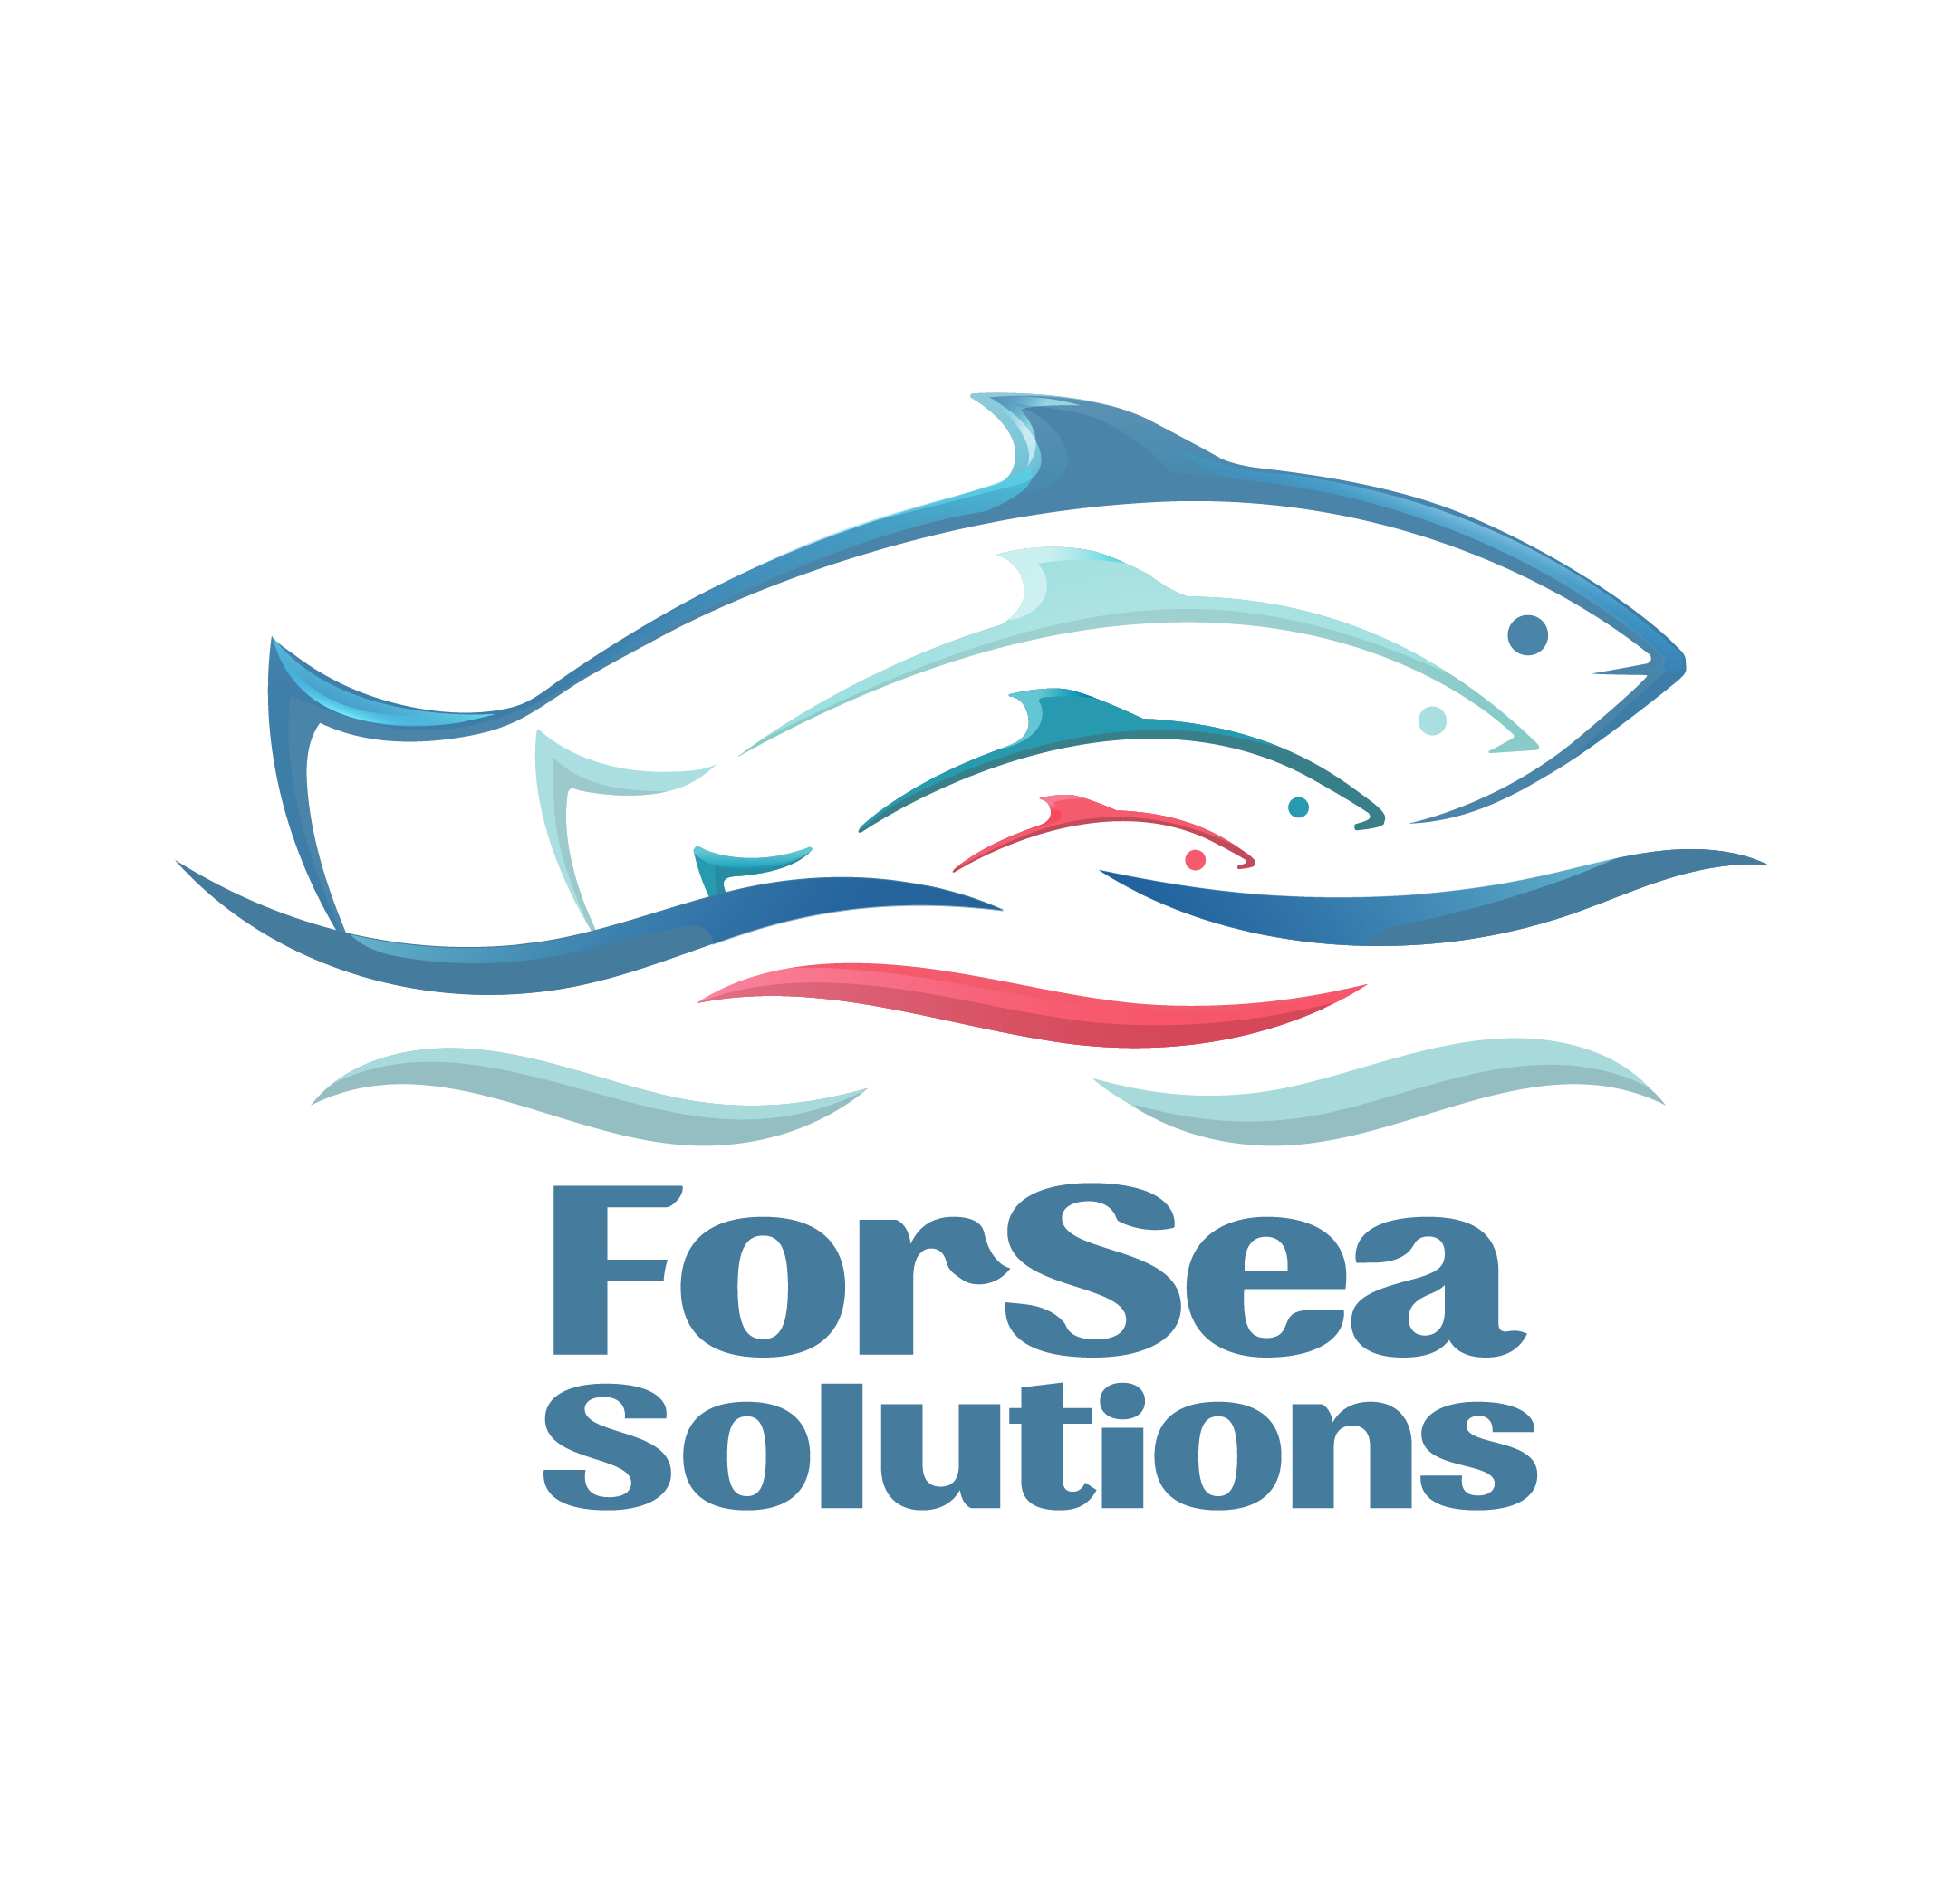

Action #6 Enhancement Outcomes and Management

Action Objective: Demonstrate that effective enhancement and fishery strategies are in place to address effects of enhancement activities on wild stock(s). .
PI 1.3.1

1. Hatchery Programs on Kunashir Island

The main data on hatchery programs conducted on Kunashir Island are taken from the report of contracted researcher Tatyana Tochilina. In 2025, the total release of chum salmon juveniles from Kunashir Island was 28.46 million fish, representing 7.2% of the total release from the Southern Kuril Islands (Table 1). As can be seen from Table 1, the majority of pink salmon and chum salmon juveniles are released from hatcheries on Iturup Island, neighboring Kunashir.

Table 1 (from Tochilina's report, Table 10). Release of Pacific salmon juveniles from Iturup and Kunashir Islands, 2023–2025, million fish.
Species | 2023 |  |  | 2024 |  |  | 2025
Species | Iturup | Kunashir | Total | Iturup | Kunashir | Total | Iturup | Kunashir | Total
Pink salmon | 152.54 | 0.0 | 152.54 | 28.144 | 0.0 | 28.144 | 16.08 | 0 | 16.08
Chum salmon | 353.103 | 42.22 | 395.323 | 421.472 | 36.021 | 457.493 | 395.5 | 28.46 | 423.96
TOTAL | 505.643 | 42.22 | 547.863 | 449.616 | 36.021 | 485.637 | 411.58 | 28.46 | 440.04

The release of juveniles from the Kunashir Island hatcheries into base rivers and other water bodies over the past 8 years is presented in Table 2 (from the Tochilina’s report, Table 11).

Table 2. Release of chum salmon juveniles into water bodies of fishery significance on Kunashir Island, 2018–2025, million fish.
Hatchery or water body | 2018 | 2019 | 2020 | 2021 | 2022 | 2023 | 2024 | 2025
Lagunnoye Lake Salmon Hatchery | 1.5 | 3.4 | 10.4 | 18.5 | 12.5 | 19.8 | 27.747 | 12.37
Prozrachny Stream | 0 | 0 | 0 | 0 | 0 | 0 | 0.151 | 0.05
Ilyushina River | 0 | 0 | 0 | 0 | 0 | 0 | 0.15 | 0.05
Rikorda Salmon Hatchery | 0 | 0 | 14.2 | 14.6 | 14.1 | 17.9 | 5.751 | 8.6
Golovnina River | 0 | 0 | 0 | 0 | 2.4 | 0.5 | 0.1 | 0
Khlebnikova River | 0 | 0 | 0 | 0 | 0 | 1.0 | 0.1 | 0.05
Sennaya River | 0 | 0 | 0 | 0 | 0 | 1.0 | 0.1 | 0.05
Tropinka River | 0 | 0 | 0 | 0 | 0.5 | 2.0 | 2.923 | 7.29
TOTAL | 1.5 | 3.4 | 24.6 | 32.1 | 29.5 | 42.2 | 36.021 | 28.46

The locations of hatcheries and water bodies where chum salmon juveniles were released are shown in Figure 1 (from the Tochilina’s report, Fig. 55).

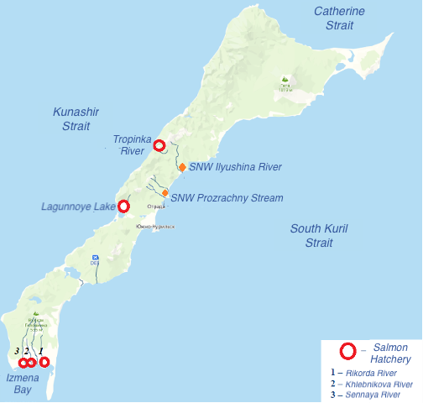
Fig. 1 (from Tochilina's report, Fig. 55). Map of Kunashir Island showing the locations of hatcheries and hatchery facilities.

2. Hatchery Programs of PCF Yuzhno-Kurilsky Ryibokombinat Co., Ltd.

PCF Yuzhno-Kurilsky Ryibokombinat Co., Ltd. (hereinafter — YKRK) operates one salmon hatchery on Kunashir Island, located in the Lagunnoye Lake basin. The hatchery programs of YKRK are aimed at establishing its own chum salmon broodstock and preserving wild populations. For this purpose, fish breeders have been collecting eggs for incubation exclusively at the company's own hatchery facility, located in the middle reaches of the Pervukhina Stream, since 2023. The Pervukhina Stream, in turn, flows into Lagunnoye Lake at a considerable distance from the outlet of the Lagunnoye Lake channel, which allows wild individuals entering from the sea to move freely throughout the entire lake area and spawn on natural spawning grounds.

Table 3 presents the volumes, timing, and average weight of chum salmon juveniles released by the Lagunnoye Hatchery over the past 8 years.

Table 3. Releases from the Lagunnoye Lake Salmon Hatchery (based on data from Pastukhov’s Report No. 5 "Report on Juvenile Release"):
Year | Number of chum salmon juveniles released (million fish) | Release dates (from... to...) | Average weight (grams)
2018 | 1.5 | Jun 15 – Jun 16 | 2.6
2019 | 3.4 | May 27 – Jun 20 | 0.8
2020 | 10.4 | May 25 – Jul 01 | 1.1
2021 | 18.5 | Jun 10 – Jul 02 | 1.2
2022 | 12.5 | May 24 – Jun 30 | 1.0
2023 | 19.8 | May 21 – Jun 20 | 0.952
2024 | 27.7 | Jun 10 – Jun 13 | 0.9
2025 | 12.4 | May 20 – May 30 | 1.206

In 2025, 2.976 million chum salmon eggs were collected, and the entire volume (100%) was collected from the company's own broodstock (Pastukhov’s Report No. 1).

All hatchery activities were accompanied by the collection of scientific information on spawner entry timing (Pastukhov’s Report No. 2), biological characteristics, and age structure of chum salmon. The report on biological analyses for 2025 shows that data collection was conducted throughout the entire season from Oct 14 to Nov 02 (Pastukhov’s Report No. 3). The majority of individuals were of age class 3+ (four-year-olds). This represents the return of chum salmon following juvenile release from the Lagunnoye Lake Salmon Hatchery in 2022.

3. Actions Aimed at Preserving Wild Populations

PCF Yuzhno-Kurilsky Ryibokombinat Co., Ltd. implements a harvest strategy aimed at conserving local pink salmon and chum salmon populations on Kunashir. Receiving operational data from local fish biologists and contracted researchers on low spawning ground escapement, company management reports as the initiator of restrictive measures in the fishery.

Company specialists implement a number of measures aimed at mitigating the effects of hatchery activities on wild populations. These include:

- reduction of fishing pressure by removing fishing gear prior to official decisions of the Anadromous Fish Commission;
- ensuring unimpeded passage of spawners to natural spawning grounds of Lagunnoye Lake;
- ensuring unimpeded spawning of wild individuals through protection of natural spawning grounds;
- collecting eggs for incubation at the Lagunnoye Lake Salmon Hatchery exclusively from the company's own broodstock, ensuring 100% collection only from individuals returning to the hatchery channel;
- rejection of egg transport from other areas of Sakhalin Region;
- prohibition on capture of spawners for hatchery purposes from neighboring rivers and lakes of Kunashir Island;
- continuation of hatchery product marking work;
- commencement of work on chum salmon individual identification by otolith analysis.

Thus, PCF Yuzhno-Kurilsky Ryibokombinat Co., Ltd. applies a comprehensive approach in its salmon hatchery management strategy on Kunashir Island, encompassing monitoring, scientific research, adaptive regulation, hatchery practices that account for the genetic structure of the chum salmon population, and significant investment in the protection of natural spawning grounds.

References

Tochilina T.G. REPORT under Contract Agreement dated May 13, 2025. Subject: "1. Collection and analysis of biological and statistical data on the reproduction of Pink and Chum salmon on Kunashir Island."

Reports of Chief Fish Breeder Dmitry Pastukhov for 2025:
1. Report No. 1 "On fishing at the hatchery and collecting eggs for planting"
2. Report No. 2 "On Timing of the Chum Salmon returns in 2025"
3. Report No. 3 "On Chum Salmon Biological Analyses"
4. Report No. 4 "On Egg Transportation in 2025"
5. Report No. 5 "On Juvenile Release"

Liudmila Konstantinovna Fedorova
Fisheries Expert and Consultant

March 15, 2026

