REPORT

under Contract Agreement dated May 13, 2025.

on Topic 2 "Sampling, preparation for analysis, and analysis of the microstructure of chum salmon otoliths from returns to Kunashir Island in 2025. Description of the occurrence of tagged specimens"

Principal Investigator: 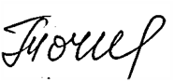 T.G. Tochilina

Moscow 2026
Table of Contents

 | Page
Introduction | 3
1. Objective and initial data | 4
2. Materials and Methodology.
2.1. Study Area, Timing, and Sample Collection Methods | 4
2.2. Preparation of Otoliths for Analysis | 6
2.3. Grinding and Polishing of Otoliths. | 6
2.4. Approaches to Tag Identification and Interpretation of Results | 9
3. Research Results | 10
3.1. Brief overview of otolith marking methods for Pacific  salmon | 10
3.2. Characteristics of marking of juvenile chum salmon from the Lagunnoye Lake Salmon Hatchery  2022–2023 | 11
3.3. Detection of Tagged Individuals in 2025 returns | 14
3.4. Distribution of tagged specimens by regions and dates  of Sample Collection | 17
4. Discussion of Results | 17
4.1. Estimated Proportion of Hatchery Fish in returns in 2025 | 18
4.2. Limitations of Calculations and directions for further research | 21
Conclusions | 22
References | 23

Introduction

Currently, artificial reproduction of Pacific salmon is a significant element of stock management in the North Pacific basin. Annual releases of juvenile salmon by hatcheries in Russia, Japan, the United States, Canada, and the Republic of Korea amount to billions of specimens, necessitating an objective assessment of the contribution of hatchery fish to commercial catches and spawning populations.
With the increasing scale of artificial reproduction, the task of differentiating between wild and hatchery-raised fish in mixed aggregations is particularly pressing. This is necessary both for assessing the biological effectiveness of hatchering measures (return rates of spawners, proportion of hatchery-raised fish in spawning runs) and for analyzing the potential impact of artificial reproduction on the structure and sustainability of wild populations.
The most reliable and internationally recognized method for identifying the origin of Pacific salmon is otolith marking — the formation of unique tags in the microstructure of otoliths during egg incubation and early ontogenesis. These marks persist throughout the fish's life and allow for reliable confirmation of their artificial origin when analyzing the spawners' returns.
Otolith marking is widely used in North Pacific countries as part of an international program coordinated by the North Pacific Anadromous Fish Commission (NPAFC). The program includes annual coordination of tagging schemes, maintenance of a unified tag database, and ensuring comparability of results among participating countries.
Modern scientific research confirms the method's high reproducibility when incubation and temperature control procedures are followed, as well as its effectiveness in assessing spawner returns and calculating commercial return rates. The summarized results of long-term scientific support for otolith marking, including work in the Magadan Region from 1998 to 2023, demonstrate that mass marking enables a transition from indirect estimates of reproduction efficiency to quantitatively confirmed data on the proportion of hatchery fish in spawning and commercial aggregations (Kalyakina et al., 2025).
The otolith marking program for chum salmon at the Lagunnoye Lake Salmon Hatchery is considered a key tool for obtaining reliable information on the contribution of artificial reproduction to stock formation. Generating time series data on the occurrence of tagged spawners allows for a transition from one-time observations to a systematic assessment of reproduction efficiency and its impact on natural populations.
This work, carried out within the framework of contractual obligations, is aimed at analyzing the microstructure of chum salmon otoliths from 2025 returns to Kunashir Island, identifying the occurrence of tagged specimens, and creating a factual database for further assessment of the proportion of hatchery fish in the structure of approaches.
The obtained results are part of a comprehensive monitoring system for artificial reproduction and are used for a scientifically based assessment of its effectiveness and potential impact on wild chum salmon populations on Kunashir Island.

1. Objective and initial data
The primary objective of this study is to collect and process otolith samples to identify tagged fish and describe the detection rate of otolith tags found in chum salmon released from the Lagunnoye Lake Salmon Hatchery in 2022 and 2023. The initial data consisted of 415 otolith samples collected during the 2025 season during biological analyses of chum salmon.
This work is based on field research conducted in 2025, as well as data from scientific publications and NPAFC reports.

2. Material and methodology
The work was carried out in accordance with the contract of PCF Yuzhno-Kurilsky Ryibokombinat Co., Ltd. (hereinafter referred to as YKRK) on the topic: 2. “Sampling, preparation for analysis and analysis of the microstructure of chum salmon otoliths from returns to Kunashir Island in 2025. Description of the occurrence of tagged specimens.”

2.1. Study Area, Timing, and Sample Collection Methods
Collection of biological material was carried out during fieldwork conducted during the period when chum salmon spawners entered the waters of Kunashir Island from September 20 to November 2, 2025. Key biological characteristics were recorded for each specimen. Otoliths were collected for subsequent identification of otolith markers. Otoliths were extracted using a standard method that ensures the preservation of diagnostically significant structural elements (Figures 1-2). Each sample was labeled with the location, date, and individual identification, allowing for subsequent comparison of the analysis results with the parameters of the fish studied (Figures 3 and 4).
Otoliths were collected during biological analyses of chum salmon: from trap nets - at the Yuzhno-Kurilsky Ryibokombinat plant; at the Lagunnoye Lake Salmon Hatchery weir during biological sampling of broodstock; and on the Ilyushina River - at the caviar collection point of the Lagunnoye Lake Salmon Hatchery.

The total volume of collected material is reflected in Table 1.
Table 1. – Amount of material collected during biological analyses of chum salmon in 2025.
Water body | Number of analyses | Number of scale samples collected, specimens | Scales examined for age, specimens | Otolith pairs collected and processed
R. Pervukhina | 3 | 300 | 300 | 295
Pervukhina Bay | 3 | 120 | 120 | 120

Figures 1 and 2 illustrate the extraction of otoliths. Figures 3 and 4 illustrate the process of recording the biological parameters of chum salmon spawners and compiling individual data used for subsequent scale and otolith analysis (scales and otoliths are placed in a scale book).

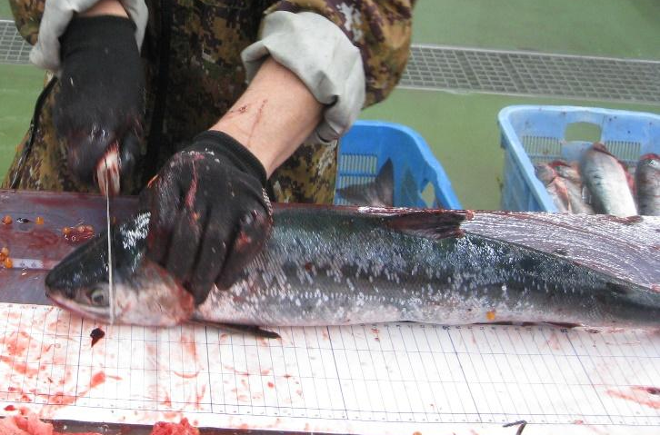 | 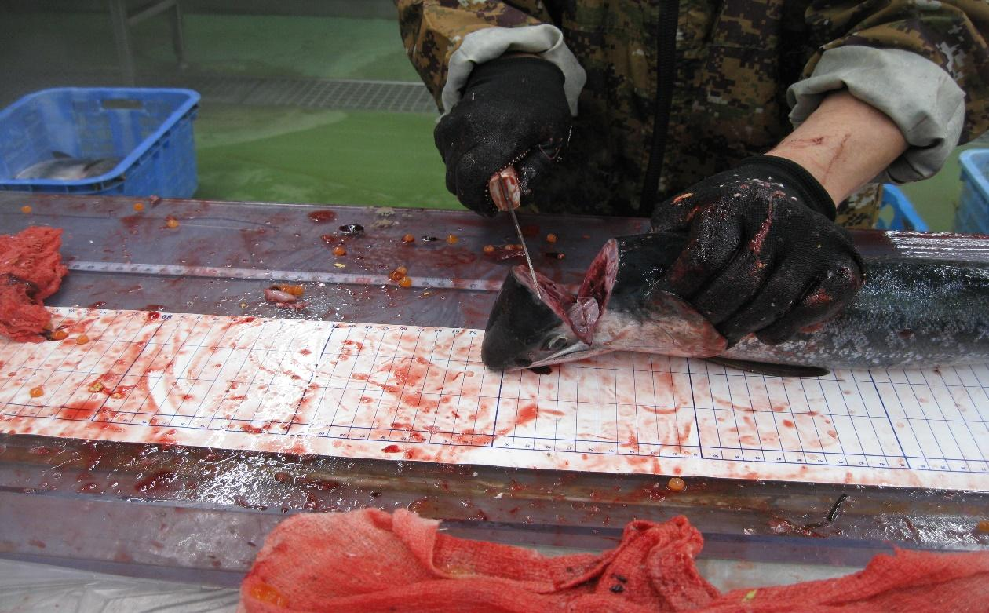
Fig. 1. Section of the frontal bone of the head of a chum salmon spawner for the removal of otoliths.

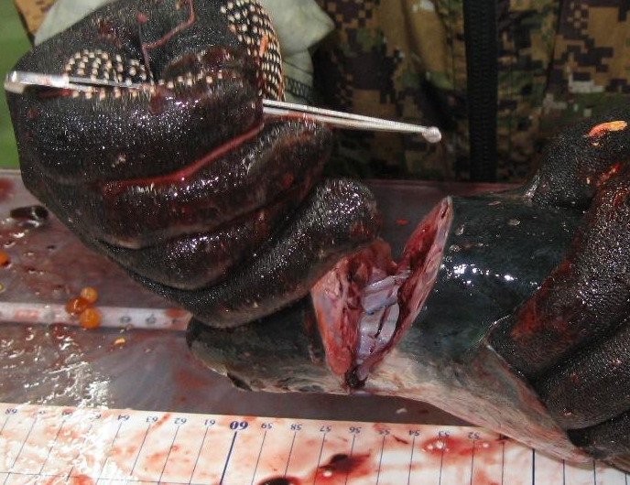

Fig. 2. Removal of the otolith from the auditory capsule of a chum salmon spawner

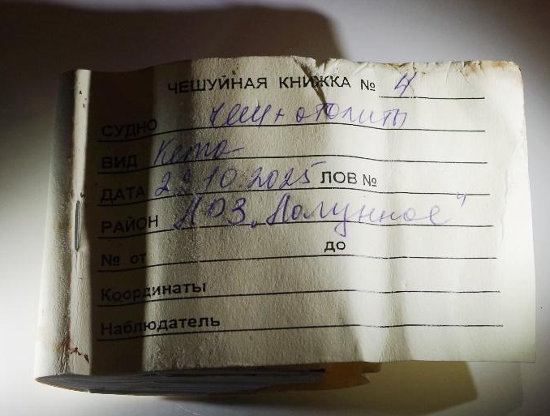 | 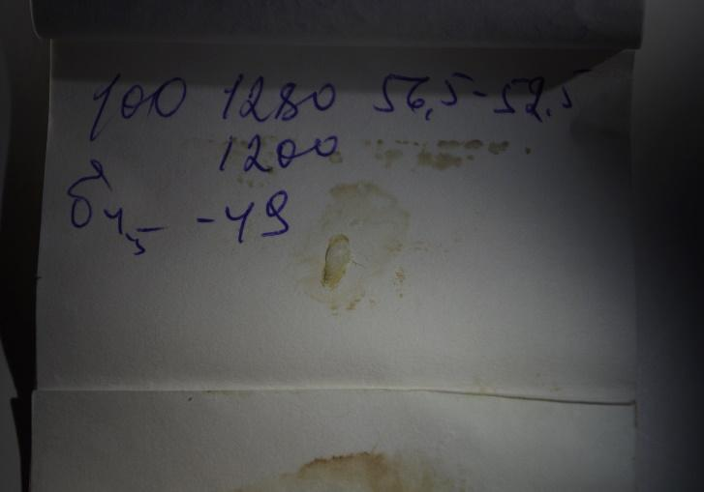
Fig. 3. Scale book of chum salmon spawners | Fig. 4. Individual page of the chum salmon spawner with biological analysis data, scales and otoliths

2.2. Preparation of Otoliths for Analysis
The processing of otoliths from chum salmon spawners to detect tags was carried out in the laboratory of the Federal State Budgetary Scientific Institution “VNIRO” (Moscow), which has an individual place that ensures separate storage and processing of the material (Fig. 5).

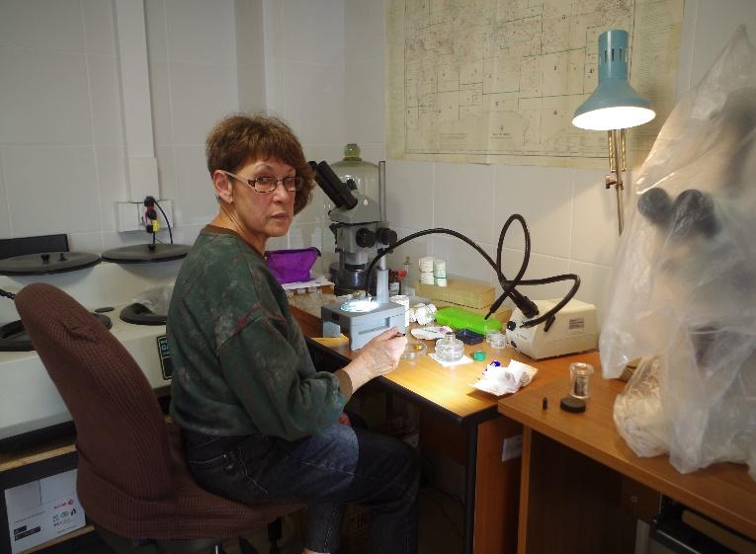
Fig. 5. Workstation for the otolith for grinding

2.3. Grinding and Polishing of Otoliths.
An otolith and a small amount of TriPod Wax thermoplastic cement were placed on a glass slide. The cement was melted using an alcohol lamp, after which the otolith was mounted on glass (Fig. 6). The prepared specimen was ready for subsequent polishing.
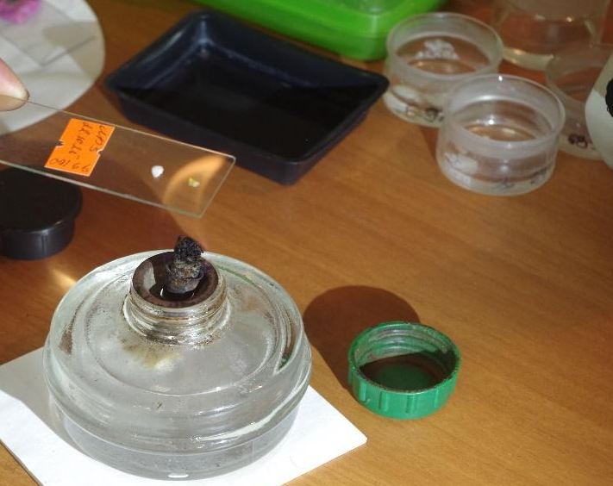 | 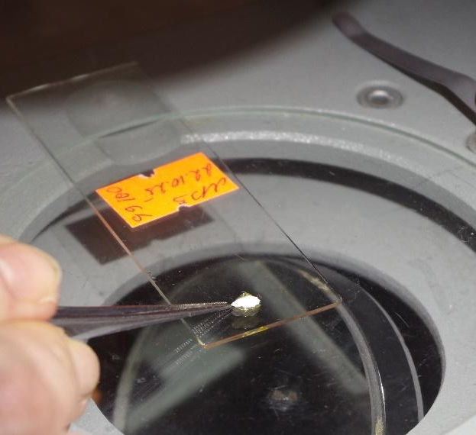
Fig. 6. Mounting of an otolith in thermoplastic cement

The initial grinding of the otolith was performed at low magnification using an MBS-10 stereomicroscope (Figure 7).
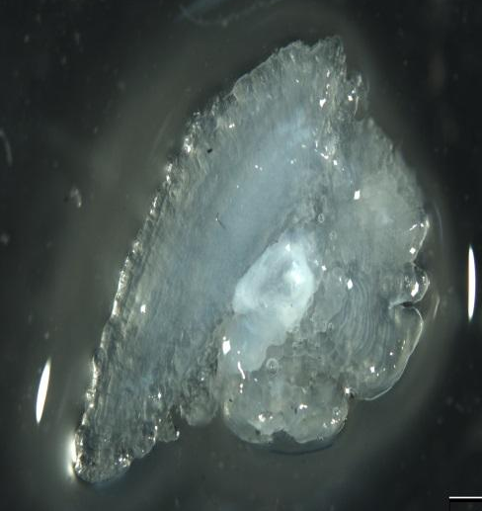  A) Unground otolith | 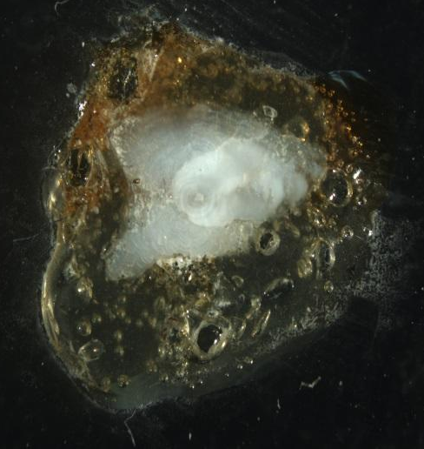  B) Ground otolith | 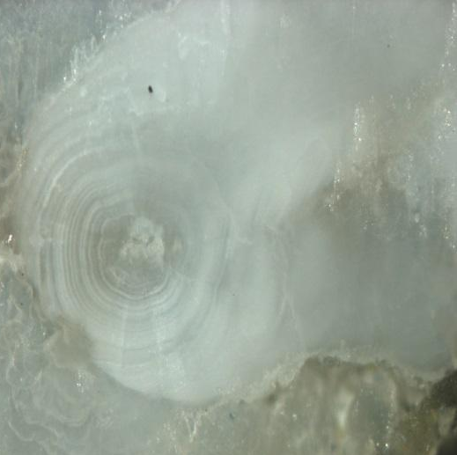  C) Ground otolith in thermoplastic cement
Fig. 7. Stages of initial grinding of the otolith of the chum salmon spawner

Next, manual grinding of otolith thin sections was performed (Figure 8). For grinding, abrasive grinding discs with a silicone-carbide coating from Buehler with an abrasiveness of 22 µm (P800), 15 µm (P1200), and 10 µm (P2500) were used.
During the grinding process, the otolith surface was periodically inspected under a microscope to determine the degree to which the thin section approached its central part (Fig. 9). This monitoring allowed for timely assessment of the specimen preparation progress and avoidance of unnecessary material removal. The specimens were viewed using a Leica DMLS trinocular microscope equipped with a Leica DC 100 digital camera, which provided visual quality control of the thin section and recording of the resulting images.
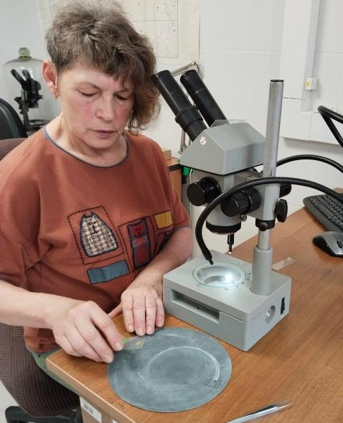  A) Repeated manual grinding of the otolith | 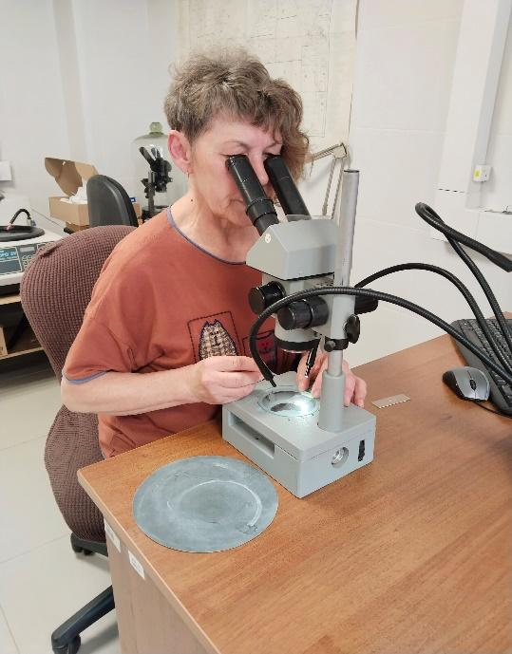  B) Examination of the thin section under the MBS-10 stereomicroscope

Fig. 8. Manual stage of otolith grinding

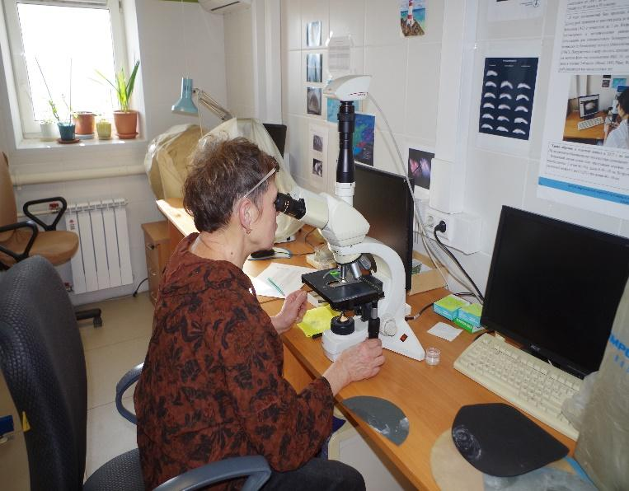
Fig. 9. Examination of the section of otolith under a microscope

The otoliths were polished on aluminum oxide disks (Buehler, USA). Initially, a 9-micron grit disk was used, then a 5-micron grit disk, and, if necessary, a 3-micron grit disk. To remove scratches that appeared after polishing and interfered with the identification of the marker, a 0.3-micron grit disk was used. When viewing under a microscope, the otolith section was treated with immersion oil. Immersion oil is used in microscopy to improve the image quality of the object being examined. Magnifications of 200x and 400x were used to detect the suspected marker (Figure 10).

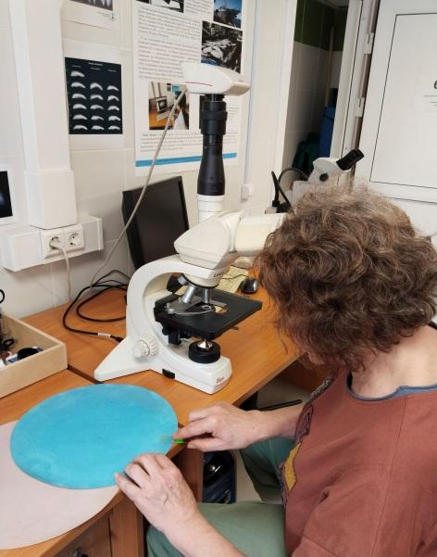 | 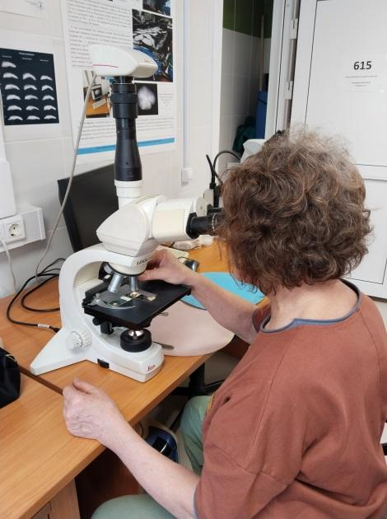
A) Polishing the otolith section B) Examination of the thin section for tags

Fig. 10. Working with an otolith section
After grinding was completed and the required degree of otolith structure exposure was achieved, the specimens were used for further microscopic analysis. At this stage, the quality of the resulting specimen, the degree of preservation of diagnostically significant elements, and the ability to identify marking features were assessed. The specimens prepared in this manner served as the basis for subsequent examination, description, and identification of the marking patterns.

2.4. Approaches to Tag Identification and Interpretation of Results

Identification of tags was performed based on visual analysis of the otolith structure and comparison of the observed pattern with known marking patterns. When examining the specimens, the presence of a tag, its legibility, its location within the otolith structure, and the degree to which it matched the expected pattern were taken into account. In cases where the tag was insufficiently clear or deviated from the intended pattern, such specimens were examined separately, taking into account possible differences in the marking conditions and preparation of the specimen. The obtained results were used to assess the occurrence of tagged individuals in the studied material and for a preliminary interpretation of the origin of the fish within the analyzed samples.

3. Research Results
3.1. Brief overview of otolith marking methods for Pacific salmon
Currently, two methods of otolith marking are used in practice: thermal and dry, which create a tag on the embryo's otoliths (Akinicheva 1996). This allows hatchery-bred fish to be identified at significant distances from the hatcheries.
Thermal otolith marking is the most common method of mass salmon marking in the United States, Canada, Japan, and Russia. In Alaska alone, over 3 billion salmon have been tagged in the past 10 years. The development and implementation of otolith thermal otolith marking methods for salmon was pioneered by American scientists. The first industrial-scale tagging was carried out in the United States at a salmon hatchery in Washington State in 1987.
With this method, otolith marking is achieved through periodic changes in the water temperature at which eggs are incubated or prelarvae are held at the hatchery. Some hatcheries use heating or cooling systems to adjust the temperature; at others, which have two water supply systems (river and well), thermal otolith marking can be performed during the embryonic period, from the eye stage until hatching (excluding hatching), as well as during the prelarval holding period until the onset of mixed feeding.
The dry otolith marking method is based on the ability of salmon eggs to develop normally in a humid atmosphere. The method was developed by Russian scientists in 1998.
Most Russian salmon hatcheries lack the ability to heat or cool sufficient volumes of water for thermal otolith marking or to change the water temperature in individual incubation units. Therefore, hatcheries in the Far Eastern regions primarily use the dry-method otolith marking method (Safronenkov et al., 1999; Akinicheva et al., 1998), which allows labeling to be carried out independently in each incubation apparatus. This method has been successfully used in Russia for over 20 years.
For tagging (usually at daily intervals), the eggs are dried in Box or Atkins-type incubators. During one marking cycle (when one dark and one light band forms), the eggs are kept out of water for 24 hours (in a humid atmosphere) and then washed with water for the same amount of time (in a normally operating incubator). This tag is fundamentally no different from a tag obtained by thermal otolith marking. The period of otolith marking of embryos using this method is from the eye pigmentation stage until the onset of hatching. This method is simple, convenient, and requires no special equipment. Its drawback is the inability to tag larvae and juvenile fish (Litvinenko, 2016).
For the Lagunnoye Lake Salmon Hatchery, the choice of a dry-method otolith marking method was driven by both technological and practical reasons. Under the plant's conditions, this method is the most accessible, manageable, and feasible for large-scale application, as it does not require complex water temperature control systems and can be performed directly in individual incubation units. Dry-method otolith marking allows marking to be carried out in a production environment without significantly complicating the technological process, which is why it was chosen as the primary method at the Lagunnoye Lake Salmon Hatchery.

3.2. Characteristics of marking of juvenile chum salmon from the Lagunnoye Lake Salmon Hatchery in 2022–2023.

Otolith marking of hatchery production in 2021 (with juvenile release in 2022) and 2022 (with juvenile release in 2023) was carried out on a trial basis. This was due to the initial phase requiring refinement of the dry method approach at the Lagunnoye Lake Salmon Hatchery, selection of optimal egg drying and irrigation regimes, and assessment of the feasibility of obtaining consistently legible labels without disrupting normal incubation. Furthermore, it was necessary to verify the reproducibility of the selected labeling parameters under production conditions and the ability to generate labels suitable for subsequent identification on returns. Therefore, the first two years were necessary for technological adaptation of the method, accumulation of practical experience, and a preliminary assessment of the quality of the resulting labels.
In 2021, the Lagunnoye Lake Salmon Hatchery conducted experimental marking with the 1.3n1N tag, and 2.4 million tagged juveniles were released in 2022. The following year, in the 2022–2023 season, the Lagunnoye Lake Salmon Hatchery conducted experimental marking of chum salmon juveniles using the dry method with the 4.2 N tag, and 3.4 million tagged juveniles were released (Table 2).
Table 2. - Release of juvenile chum salmon from the Lagunnoye Lake Salmon Hatchery in 2022 and 2023.
Total release  million fish | Release of tagged juveniles
Total release  million fish | Million fish | % of total release
Juvenile release in 2022
12.5 | 2.4 | 19.2
Juvenile release in 2023
9.8 | 3.4 | 17.2

Before the release, employees of the artificial reproduction and otolithometry sector SakhNIRO is selecting a batch of tagged juveniles to verify that the generated tags comply with the specified marking scheme. According to E. G. Akinicheva, an expert in otolith marking of Pacific salmon in the Sector of Artificial Reproduction and Otolithometry at SakhNIRO's Salmon Laboratory, an examination of otolith sections from juveniles released in 2022 revealed unsatisfactory marking quality on the aquaculture products: the detected tags did not comply with the design. Only one otolith was found to have a barely distinguishable tag (Fig. 11).

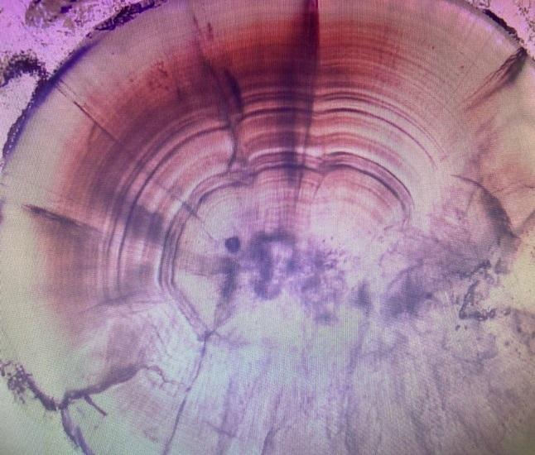 | 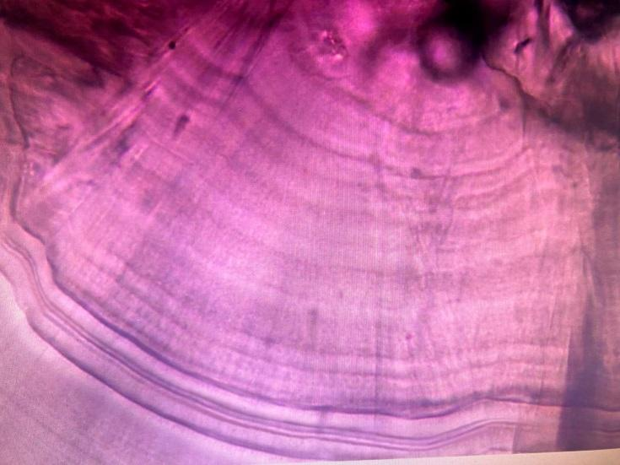

Fig. 11. Photo of the otolith tag of a juvenile chum salmon before its release in 2022.

During the examination of otolith sections from juvenile chum salmon released in 2023, satisfactory marking of the hatchery products was found, and the markings corresponded to the plan (Fig. 12). A photograph of the markings was provided by L.G. Akinicheva.

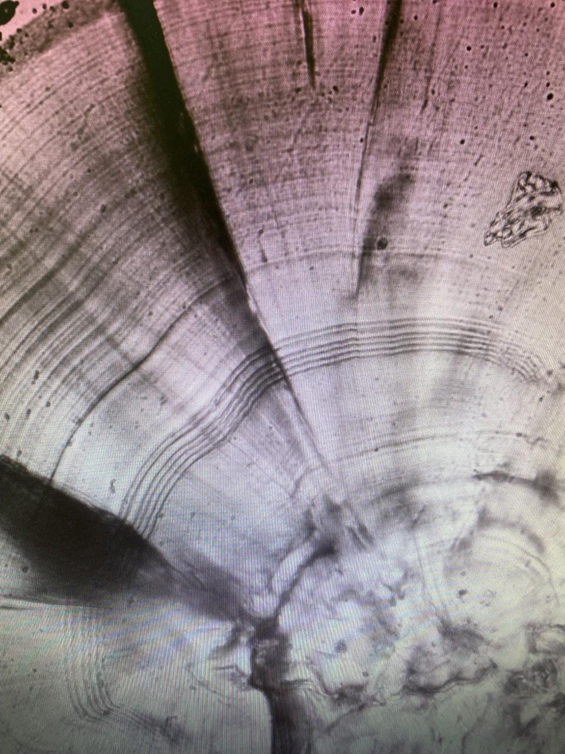 | 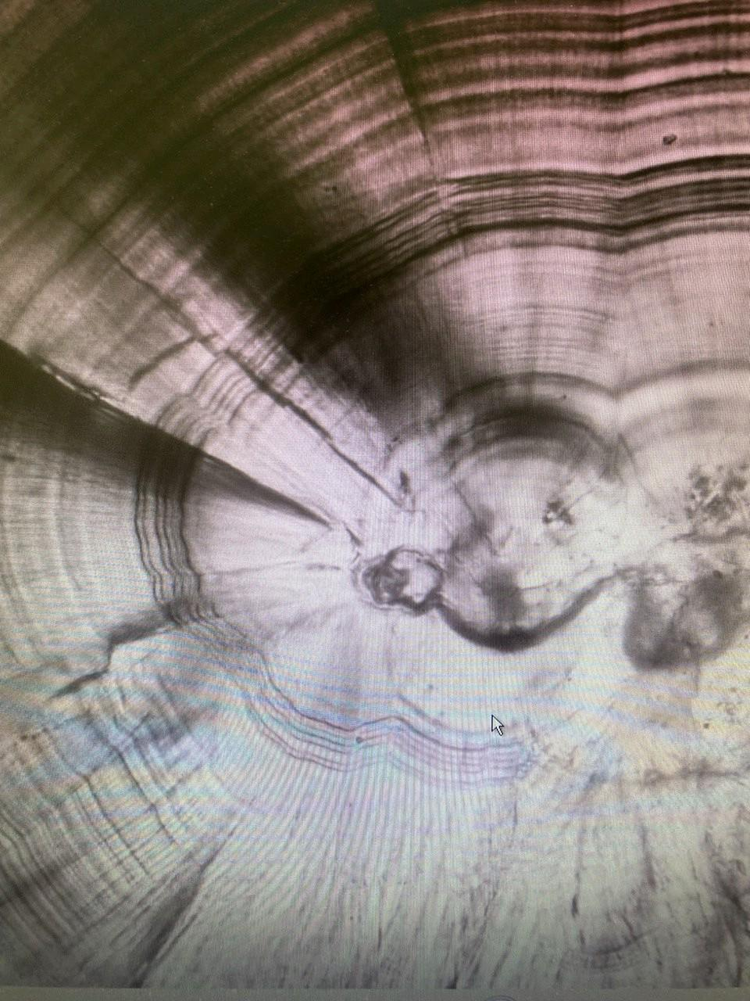

Fig. 12. Photo of the otolith tag of a juvenile chum salmon before its release in 2023.

In various regions in certain years, some tags on released salmon deviate from the expected pattern in various regions (Akinicheva, Rogatnykh, 2002). Such tags allow us to determine the hatchery origin of juveniles, but do not allow us to unambiguously determine the origin of fish in their feeding grounds at sea, where tagged salmon from all regions are present. The accumulated information allows us to characterize the main causes of deviations from the expected tag pattern during dry-method otolith marking.
Typically, a high proportion of non-standard tags is observed primarily when otolith marking recommendations are violated.
Excessively early start of marking is the most common mistake made during marking. Failure to properly drain or fill incubators, adjust the egg darkening regime in the incubators, adjust water flow, and evenly mix the eggs also impact marking quality.
In salmon hatcheries that use river water during the incubation period, it is important to eliminate the influence of air temperature fluctuations during the humid period and water temperature fluctuations during the water pause of the marking regimen to ensure high-quality marking. Daily water temperature fluctuations (when incubation facilities are supplied by river water) in the autumn can reach 3-4 ° C or more, creating a thermal otolith marking effect. This influence is an additional negative factor during dry-method otolith marking and can create unnecessary stripes on the otolith or disrupt the uniformity of the spacing between the marking stripes (Akinicheva, 2006).
Thus, the experience of the first two years of dry-method otolith marking at the Lagunnoye Lake Salmon Hatchery demonstrated that producing high-quality and consistently legible tags requires strict adherence to process parameters and further refinement of the tagging regimen. Therefore, the analysis of chum salmon returns in 2025 was particularly important, as it allowed for a transition from assessing tag quality at the juvenile release stage to testing the feasibility of identifying tagged hatchery-bred chum salmon in the catches on Kunashir Island.

3.3. Detection of Tagged Individuals in 2025 returns

To detect tagged mature chum salmon in catches from both the marine trap nets and the Lagunnoye Lake Salmon Hatchery, and to identify the tags, 415 otoliths were ground and examined: 120 from the sea-based catches and 295 from the Lagunnoye Lake Salmon Hatchery. Particular attention was paid to examining the thin sections of 2+ and 3+ age spawners. A total of 3 otoliths were found in the marine trap nets and 20 from the Lagunnoye Lake Salmon Hatchery.
During otolith grinding, 20 tags were detected from samples collected directly at the Lagunnoye Lake Salmon Hatchery's egg collecting station during biological analyses of the fish. Three tags were detected during the biological analysis on October 14, 2025 (Figure 13), seven tags were detected on October 22, 2025, and ten tags were detected on November 2, 2025 (Figures 14–15).
During biological analysis of chum salmon caught in marine trap nets in Pervukhina Bay, 2 tags were found on September 28, 2025, and 1 tag on October 18, 2025 (Figure 16).
All detected tags were from the 2022 release of juveniles. No tags from juveniles from the 2023 release were detected.
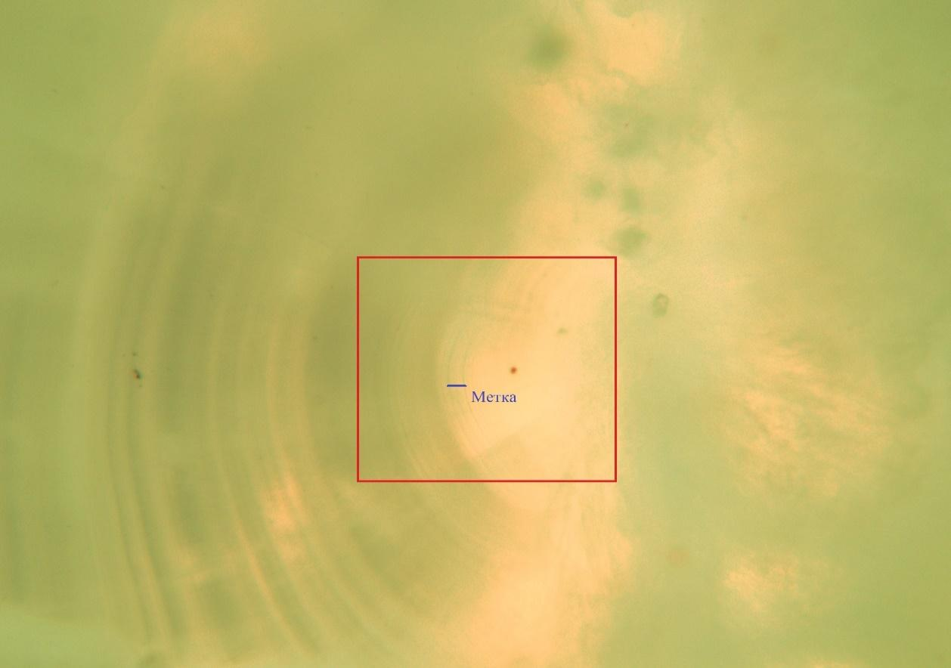
Fig. 13. Photo of the spawner's otolith tag of a chum salmon from the Lagunnoye Lake Salmon Hatchery from October 14, 2025
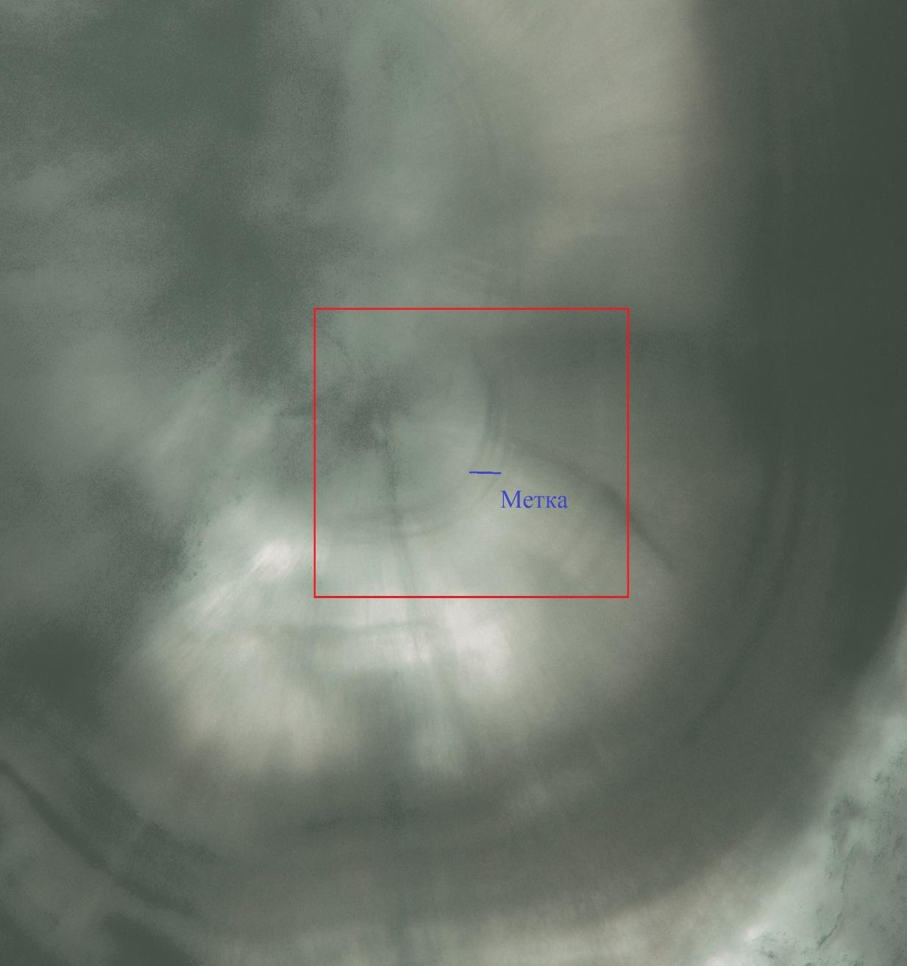
Fig. 14. Photo of the spawner's otolith tag of a chum salmon from the Lagunnoye Lake Salmon Hatchery from November 2, 2025.

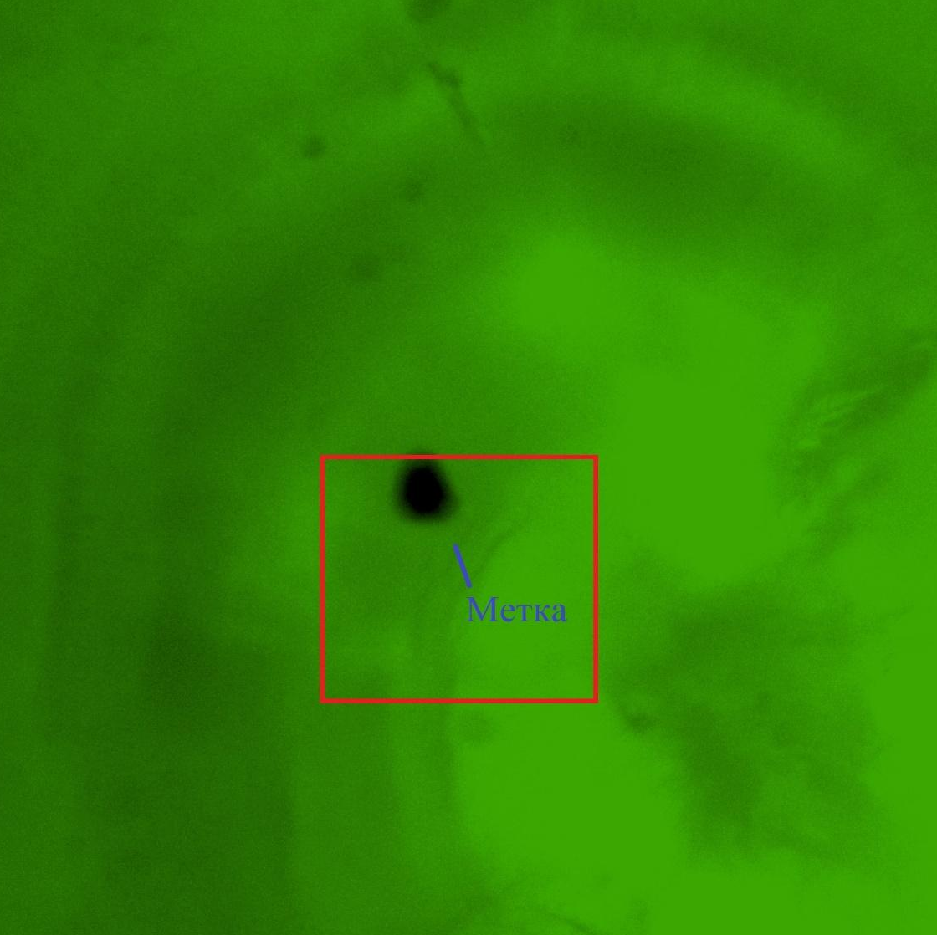
Fig. 15. Photo of the spawner's otolith tag of a chum salmon from the Lagunnoye Lake Salmon Hatchery from November 2, 2025.

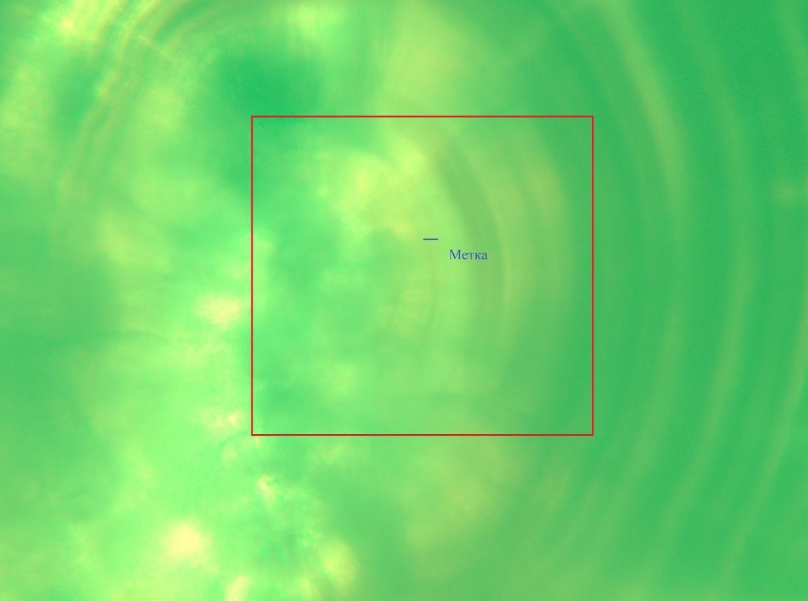
Fig. 16. Photo of the spawner's otolith tag of a chum salmon from trap nets in Pervukhina Bay from October 18, 2025
3.4. Distribution of tagged specimens by regions and of Sample Collection dates

As a result of the study, tagged specimens were found both in catches from marine trap nets and at the Lagunnoye Lake Salmon Hatchery. A total of three tagged specimens were identified in the marine catches, accounting for 2.5% of the sample (120 specimens). At the hatchery, 20 tagged specimens were found, accounting for 6.8% of the sample (295 specimens). Thus, the majority of tagged fish were recorded in samples collected directly at the Lagunnoye Lake Salmon Hatchery, which may be due to both the sample formation characteristics and the distribution of spawners during the approach and of Sample Collection period.
Tables 3 and 4 provide data on the location of detection of tagged individuals and their biometric characteristics.
Table 3. - Biological characteristics of individuals with otolith tags
Lagunnoye Lake Salmon Hatchery (hatchery weir of the Lagunnoye Lake Salmon Hatchery)

Bio-analysis date | Catch location | FL, cm | TL, cm | Total weight,  G | Carcass weight,  G | Sex | Maturity | Gonad weight,  G | Age
Oct 14  2025 | Salmon Hatchery Lagunnoye | 64.5 | 61.5 | 1930 | 1760 | ♂ | 3-4 | 69.5 | 3
Oct 14  2025 | Salmon Hatchery Lagunnoye | 61 | 57 | 1415 | 1320 | ♂ | 3-4 | 47.0 | 3
Oct 14  2025 | Salmon Hatchery Lagunnoye | 62 | 58 | 1400 | 1355 | ♂ | 3 | 19.0 | 3
Oct 22, 2025 | Salmon Hatchery Lagunnoye | 61.5 | 58.5 | 1415 | 1360 | ♂ | 4 | 46 | 3
Oct 22, 2025 | Salmon Hatchery Lagunnoye | 65.5 | 62 | 1975 | 1760 | ♂ | 4-5 | 47 | 3
Oct 22, 2025 | Salmon Hatchery Lagunnoye | 71 | 67.5 | 2305 | 2175 | ♂ | 4-5 | 57 | 3
Oct 22, 2025 | Salmon Hatchery Lagunnoye | 60.5 | 57 | 1655 | 1535 | ♂ | 4-5 | 55 | 3
Oct 22, 2025 | Salmon Hatchery Lagunnoye | 62 | 59 | 1820 | 1720 | ♂ | 4-5 | 49 | 3
Oct 22, 2025 | Salmon Hatchery Lagunnoye | 65.5 | 62 | 2230 | 2020 | ♂ | 4 | 61 | 3
Oct 22, 2025 | Salmon Hatchery Lagunnoye | 67 | 64 | 2545 | 2395 | ♂ | 4 | 72 | 3
Nov 02, 2025 | Salmon Hatchery Lagunnoye | 64 | 61.5 | 1785 | 1615 | ♂ | 4-5 | 64 | 3
Nov 02, 2025 | Salmon Hatchery Lagunnoye | 66 | 62 | 1760 | 1670 | ♂ | 4-5 | 55 | 3
Nov 02, 2025 | Salmon Hatchery Lagunnoye | 61 | 57 | 1145 | 1105 | ♂ | 4-5 | 30 | 3
Nov 02, 2025 | Salmon Hatchery Lagunnoye | 60.5 | 57 | 1435 | 1390 | ♂ | 5 | 0 | 3
Nov 02, 2025 | Salmon Hatchery Lagunnoye | 62 | 58 | 1420 | 1290 | ♂ | 4-5 | 62 | 3
Nov 02, 2025 | Salmon Hatchery Lagunnoye | 63 | 58 | 1625 | 1530 | ♂ | 4-5 | 50 | 3
Nov 02, 2025 | Salmon Hatchery Lagunnoye | 58 | 55 | 1215 | 1125 | ♂ | 4-5 | 34 | 3
Nov 02, 2025 | Salmon Hatchery Lagunnoye | 63 | 60 | 1675 | 1490 | ♂ | 4-5 | 31 | 3
Nov 02, 2025 | Salmon Hatchery Lagunnoye | 67.5 | 63 | 2065 | 1880 | ♂ | 4-5 | 33 | 3
Nov 02, 2025 | Salmon Hatchery Lagunnoye | 65 | 62 | 1885 | 1790 | ♂ | 4-5 | 51 | 3

Table 4. - Biological characteristics of individuals with otolith tags
Lagunnoye Lake Salmon Hatchery (Pervukhina Bay, marine trap nets)
Bio-analysis date | Catch location | FL, cm | TL, cm | Total weight, g | Carcass weight, g | Sex | Maturity | Gonad weight, g | AF | GSI | Age
Sep 28, 2025 | Pervukhina Bay, marine trap net. | 62 | 58 | 1865 | 1675 | ♂ | 3 | 110.0 | - | - | 3
Sep 28, 2025 | Pervukhina Bay, marine trap net. | 63 | 59 | 2065 | 1890 | ♂ | 3 | 30.0 | - | - | 3
Oct 18, 2025 |  | 67 | 64 | 2745 | 2290 | ♀ | 3 | 370.0 | 743 | 999 | 3

During the work on the otoliths of chum salmon spawners, no tags from other salmon hatcheries in the Sakhalin Region were found.

4. Discussion of Results

Forming a representative sample and adhering to standardized methodological approaches to otolith microstructure analysis are essential for accurately assessing the proportion of hatchery fish in returns. As demonstrated by years of scientific support for otolith marking programs at Far Eastern fisheries, only systematic accumulation and analysis of otolith collections, with the creation of consistent time series of data, allows for the transition from one-time observations to a statistically valid assessment of the effectiveness of artificial reproduction.
The practice of analyzing returns in various regions demonstrates the need for a sufficient sample size and a standardized approach to microscopic examination (magnification, section quality, digital image capture). This ensures comparability of results between observation years and increases the reliability of conclusions about the occurrence of tagged spawners. The application of these methodological principles in this study was aimed at creating a reliable database for further dynamic assessment of the share of hatchery-raised chum salmon in the structure of Kunashir Island runs.

4.1. Estimated share of factory fish in returns in 2025
As shown in Table 2, 2.4 million tagged juveniles were released in 2022, accounting for approximately 19.4% of the total release, and 3.4 million in 2023, or 17.2% of the total release. During the analysis of chum salmon otoliths from the 2025 returns, 415 specimens were examined, of which 23 specimens were found to have otolith tags. Therefore, the detection rate of tagged individuals in the studied sample was 5.5%.
However, the analysis revealed that in the 2025 returns, tags were found only in spawners of chum salmon age class 3+, while no tags were detected in fish age class 2+. Therefore, a calculated interpretation of the obtained data can only be applied to the generation of tagged juveniles released in 2022.
If we assume that 19.2% of the total release of juveniles was covered by marking in 2022, and the tagged spawners of age class 3+ identified in 2025 represent this generation, then the estimated share of chum salmon of hatchery origin from the Lagunnoye salmon farm in the studied sample of returns in 2025 could be approximately 39.4%.
The tables below present the logic of the reasoning and the results obtained.
Table 5 presents data on the chum salmon catch on Kunashir Island in 2025 by fishing area, including fish catches at the Lagunnoye and Rikorda salmon hatcheries, and Table 6 provides data on the age composition obtained from processing scale samples.

Table 5. Kunashir Island in 2025, metric tons (mt)
Total for Kunashir Island |  | 27.874
including:
Marine — total catch |  | 13.753
Including:
Pacific coast |  | 1.74
Sea of Okhotsk coast |  | 12.013
Hatchery — total catch |  | 14.121
including:
Lagunnoye Lake Salmon Hatchery |  | 10.524
Rikorda Hatchery |  | 3.597
Table 6. Age composition of chum salmon in Kunashir in 2025, %
 | 2+ | 3+ | 4+ | 5+ | Total amount, %
Ilyushina River | 16.7 | 69.4 | 13.9 | 0 | 100
r. Pervukhina (Salmon Hatchery) | 5.3 | 69.1 | 25.3 | 0.3 | 100
Pervukhina Bay | 25 | 62.5 | 12.5 | 0 | 100

Since mass releases of juvenile chum salmon from the Rikorda Hatchery coincide in years with similar releases from the Lagunnoye Lake Salmon Hatchery, we assume that the age groups in the chum salmon return to the Rikorda Hatchery coincide with or are approximately the same as those at the Lagunnoye Lake Salmon Hatchery.
Table 8 presents biometric data of chum salmon obtained during biological analyses and presented in the report on the topic “1. Collection and analysis of biological and statistical information on the reproduction of pink salmon and chum salmon on Kunashir Island” (Tochilina, 2026).

Table 8. Average weighted indicators of chum salmon on Kunashir Island in 2025
Dates | Water body name | Parameters | FL, cm |  |  |  | TL, cm |  |  |  | Weight, g |  |  |  | AF |  | N (fish).
Dates | Water body name | Parameters | ♂ |  | ♀ |  | ♂ |  | ♀ |  | ♂ |  | ♀ |  | ♀ |  | ♂ |  | ♀
Sept 28 –  Oct 18 | Bay  Pervukhina | Weighted average | 63.5 |  | 62.5 |  | 59.1 |  | 58.9 |  | 1822 |  | 2229 |  | 2027 |  | 72 |  | 84
Oct 10 –  Nov 11 | r. Pervukhina (Salmon Hatchery) | Weighted average | 65.0 |  | 65.6 |  | 61.4 |  | 62.2 |  | 1899 |  | 2076 |  | 1586 |  | 293 |  | 7
Sept 26 –  Oct 17 | Sernovodka River | Weighted average | 69.3 |  | 65.6 |  | 60.2 |  | 61.6 |  | 2874 |  | 3062 |  | 2145 |  | 35 |  | 16
Oct 02 –  Oct 21 | Ilyushina River | Weighted average | 61.2 |  | 59.9 |  | 57.7 |  | 56.3 |  | 2397 |  | 2331 |  | 2153 |  | 51 |  | 21
Weighted average for Kunashir |  |  |  | 64.6 |  | 62.6 |  | 60.5 |  | 59.0 |  | 2019 |  | 2342 |  | 2038 |  | 451 |  | 128

Table 9 presents data on the chum salmon catch on Kunashir Island in 2025, broken down by age group and linked to fishing areas.
Table 9. - Chum salmon catch on Kunashir Island in 2025 in accordance with age composition (Table 6) and with reference to fishing areas (Table 5), metric tons (mt)
Fishing area | Age groups |  |  |  | Total quantity, metric tons (mt)
 | 2+ | 3+ | 4+ | 5+
Ilyushina River (Pacific coast) | 0.291 | 1.208 | 0.242 | 0.000 | 1.740
Rikorda Hatchery | 0.191 | 2.485 | 0.911 | 0.010 | 3.597
Pervukhina River (Lagunnoye Lake Salmon Hatchery) | 0.558 | 7.272 | 2.663 | 0.032 | 10.524
Pervukhina Bay (Sea of Okhotsk coast) | 3.003 | 7,508 | 1,502 | 0.000 | 12.013
TOTAL for Kunashir Island: | 4.043 | 18.473 | 5.317 | 0.042 | 27.874

Based on biological analysis data conducted during the 2025 season (Table 8), and assuming identical weights of individuals from the Lagunnoye and Rikorda hatcheries, we can estimate the number of chum salmon caught. The resulting data are presented in Table 10.

Table 10. Estimated number of chum salmon caught on the island. Kunashir in 2025.
Fishing area | Weighted-average individual weight, grams |  | Catch, metric tons (mt) | Estimated number of individuals, specimens
Ilyushina River (Pacific coast) | 2378 | 1.740 |  | 732
Rikorda Hatchery | 1903 | 3.597 |  | 1890
Pervukhina River (Lagunnoye Lake Salmon Hatchery) | 1903 | 10.524 |  | 5530
Pervukhina Bay (Sea of Okhotsk coast) | 2041 | 12.013 |  | 5886
TOTAL for Kunashir Island: |  |  |  | 14038

Thus, according to the calculated data, the number of the part of the Kunashir chum salmon population captured during commercial fishing and fishing at salmon hatcheries in 2025 amounted to 14.038 specimens.
Knowing the number of individuals in the chum salmon catches (Table 10) and the number of individuals caught in each fishing area, we can calculate the share of chum salmon from the Lagunnoye Lake hatchery in these areas and in the total catches of Kunashir, and we can assume that in 2025 it was:
- At the hatchery of the Lagunnoye Lake Salmon Hatchery – 100%
- At the hatchery weir of the Rikorda Salmon Hatchery – 0%
- In catches on the Pacific coast – 0%
- In total catches – 39.4%
The obtained calculated data suggest that in 2025, the impact of chum salmon from the Lagunnoye Lake Salmon Hatchery on the overall structure of chum salmon returns and catches on Kunashir Island remained limited. Although the proportion of hatchery-origin fish at the Lagunnoye Lake Salmon Hatchery was expected to be 100%, their presence outside the immediate return area was minimal: no tagged individuals were detected at the Rikorda Hatchery or in catches on the Pacific coast. This suggests no evidence of significant spatial dissemination of chum salmon from the Lagunnoye Lake Salmon Hatchery to other fishing areas and, consequently, no significant pressure from hatchery-origin chum salmon on local populations of wild fish in the surveyed areas.

4.2. Limitations of Calculations and directions for further research

It should be noted, however, that this estimate is preliminary and should be considered a rough estimate of the contribution of hatchery-origin fish to the 2025 returns. Its accuracy depends on the representativeness of the sample studied and the completeness of tag detection. This limitation is also based on the fact that in 2025, extremely low chum salmon runs to Kunashir Island were observed (the lowest over the entire long-term observation period). Therefore, the selection of "wild" individuals for biological analysis was extremely limited, which could have distorted the final data.
The research results confirm that otolith marking remains the most objective tool for quantifying the contribution of artificial reproduction to the development of commercial and spawning populations of Pacific salmon. As demonstrated in summary studies of regional marking programs, the transition from assessing effectiveness based on juvenile release volumes to analyzing actual returns of spawners is only possible with a total or mass marking system. This is what is being done at the Lagunnoye Lake Salmon Hatchery.
Even a relatively small proportion of identified tagged individuals has high information value, since it allows:
- confirm the fact of return of specific generations;
- assess the direction of migration;
- calculate the coefficients of commercial return;
- to formulate scientifically based recommendations for optimizing production volumes.
The obtained data on the 2025 returns are not only the result of a separate study, but also part of an emerging time series of observations necessary for a long-term assessment of the effectiveness of artificial reproduction and its impact on natural populations of chum salmon on Kunashir Island.

Conclusions
The present report is based on field research materials conducted collected in 2025, as well as on data from scientific publications. Otolith collection was carried out during biological analyses of chum salmon: from trap nets during biological analyses of chum salmon: from trap nets at the Yuzhno-Kurilsk Fish Processing Plant; at the Lagunnoye Lake Salmon Hatchery weir during biological sampling of broodstock; and on the Ilyushina River at the caviar collection point of the Lagunnoye Lake Salmon Hatchery. A total of 415 pairs of chum salmon otoliths were collected: 120 pairs from marine trap nets and 295 pairs at the Lagunnoye Lake Salmon Hatchery. Particular attention was paid to examining thin sections of spawners aged 2+ and 3+, in the return. There was a total of 3 otoliths in the catches of marine trap nets; 20 at the Lagunnoye Lake Salmon Hatchery.

- In the 2021-2022 season, experimental marking of chum salmon juveniles using the dry method with the 1.3 n 1H tag was carried out at the Lagunnoye Lake Salmon Hatchery. 2.4 million tagged juveniles were released out of a total release of 12.5 million pieces, which amounted to 19.4%;
- In the 2022–2023 season, experimental marking of chum salmon juveniles with tag 4.2H using the dry method was carried out at the Lagunnoye Lake Salmon Hatchery. 3.4 million tagged juveniles were released out of a total release of 19.8 million pieces, which amounted to 17.2%;
- An analysis of the microstructure of chum salmon otoliths from returns to Kunashir Island in 2025 revealed marks of chum salmon spawners of age class 3+: 3 in the catches of sea fishermen; 20 at the Lagunnoye salmon processing plant;
- Analysis of the microstructure of chum salmon otoliths from returns to Kunashir Island in 2025 did not reveal any tags of age class 2+ chum salmon spawners;
- Due to the first experimental marking work being carried out in the 2021-2022 season, there is a large percentage of non-standard tags.
- No tags from other salmon hatcheries in the Sakhalin Region were found on the otoliths of chum salmon spawners.
- According to the estimated data, the number of the part of the Kunashir chum salmon population removed during commercial fishing and fishing at salmon hatcheries amounted to 14.038 instance.
- Available data do not indicate a significant impact of chum salmon returns from the Lagunnoye Lake Salmon Hatchery on the Kunashir ecosystem over the observed period outside the immediate hatchery return area. The majority of hatchery-origin fish identified were concentrated in the Lagunnoye Lake Salmon Hatchery area.
- To carry out detailed calculations and determine the share of hatchery fish of other generations and their share in the total catches of Kunashir, it is necessary to continue the work, collect and process additional information during the chum salmon fishing season of 2026–2028, and process otolith samples collected during these years.

List of references
- Akinicheva, E.G., "Peculiarities of Dry Marking of Pacific Salmon," Proceedings of the Conference "Conservation of Biodiversity in Kamchatka and Adjacent Seas," Petropavlovsk-Kamchatsky, 2006
- Akinicheva E.G. Experience of tagging salmon at salmon hatcheries using thermal otolith marking. Izvestiya TINRO, Vol. 36, No. 5, 1996
- Bugayev, N.A. Rastyagaeva, N.N. Romadenkova, M.A. Kudzina, D.A. Davidyuk, T.V. Gavryuseva, E.A. Ustimenko, E.V. Bochkova, E.G. Pogodaev. Results of long-term biological monitoring of Pacific salmon in salmon hatcheries of Kamchatka Krai. Izvestiya TINRO, Vol. 180, 2015.
- Litvinenko A.V., Popova D.S. "Efficiency of Some Sakhalin Fish Hatcheries Based on the Results of Mass Marking of Pacific Salmon." KamchatGTU Bulletin, No. 38, 2016.
- Shevlyakov E.A., Chistyakova A.I. Migrations of juvenile chum salmon to the Sea of Okhotsk, comparative analysis of the effectiveness of activities hatchering enterprises of the Russian Far East and Japan. Izvestiya TINRO 2017, Vol. 191
- Akinicheva E., Rogatnykh A., and Safronenkov B. 1998. Mass marking of salmon and identification of hatchery fish in mixed stocks. (NPAFC Doc. 379). Pacific Research Institute of Fishery and Oceanography, Magadan Branch, Magadan, Russia. 8p.
- Safronenkov B. Page, Akinicheva E.G., Rogatnykh A.Yu. 1999. Method for mass otolith marking of fish. Description of the invention to Russian Federation Patent No. 2150827, p. 12.
- Akinicheva E., Rogatnykh A. 2002. Thermal and Dry Marks on Salmon Released for Brood Year 2002 in Russia. NPAFC Doc . 650, 4p.
- Kalyakina M.E., Ignatov N.N., Litanyuk E.Ya. Evaluation of the effectiveness of artificial
Oncorhynchus species in the Magadan region based on otolith marking // Rybnoe khozyaistvo (Fisheries). 2025. No. 6. Page 108-117. https://doi.org/10.36038/0131-6184-2025-6-108-117 .
- Tochilina T.G. REPORT to the Contract No. of 05/13/2025. on the topic: “1. Collection and analysis biological and statistical information on the reproduction of pink salmon and chum salmon Kunashir Island. January 2026.

