Eastern Pacific Ocean Longline Swordfish

Fishery Improvement Project (FIP) Workplan

Introduction
This report contains detailed information about areas needing improvement in the performance of the longline fishery for swordfish in the Eastern Pacific Ocean for vessels flying Panama and Vanuatu flags.

The fishery was assessed with the methodology in the MSC publication, “Working Towards MSC Certification: a practical guide for fisheries improving sustainability”, then checked in May 2021 for conformity to the Environmental Rapid Assessment methodology by FisheryProgress.org. Areas for improvement for all areas scoring below MSC’s passing score of 80 were based on the MSC scoring guidepost requirements and the actions recommended in the MSC guide, “Working Towards MSC Certification: a practical guide for fisheries improving sustainability”. Specific details for each indicator are provided in the “Environmental Rapid Assessment” and the project scoping document.

Table 1: Workplan Overview
Workplan Template Version and Date | Workplan template version 3, October 2020
Start date (expected) | End date (anticipated month/year)
October 2020 | December 2026
FIP Lead (organization/individual responsible for Action Plan) | Improvements recommended by (meeting/group that supported the development)
Jochanan Liew, Fong Hsiang Ltd. | MSC and vetted with FIP participants and fishery stakeholders
FIP Coordinator (organization/individual responsible for reporting on FisheryProgress) | Workplan developed by (consultant or person)
Katrina Nakamura, PhD | Katrina Nakamura, PhD

Acronyms

FAO | Food and Agriculture Organization of the United Nations
IATTC | Inter-American Tropical Tuna Commission
WCPFC | Western and Central Pacific Fishery Commission
MCS | Monitoring, control and surveillance
FIP | Fishery Improvement Project
MSC | Marine Stewardship Council

Unit of Assessment(s)

Fill in the following table, which will be considered the scope against which the fishery is assessed against the MSC Fisheries Standard.

Table 2. Unit(s) of Assessment (UoA)
UoA 1 | Description
Target species (common and scientific name) | Swordfish, Xiphias gladius
Stock | East Pacific swordfish-IATTC, South Pacific swordfish stock-WCPFC
Geographical area | Eastern Pacific Ocean High Seas
Fishing method or gear type | Longline
Fishing fleet or group of vessels, or individuals fishing operators pursuing stock | 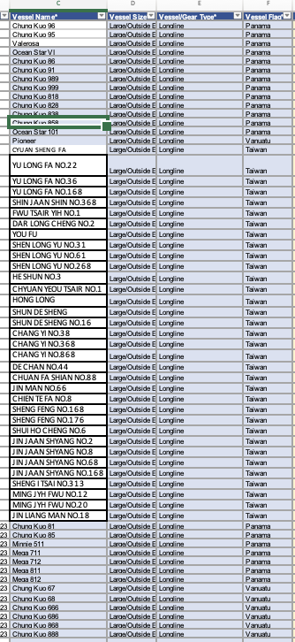

FIP Actions

The following improvements are indicated for areas scoring <80 in a preliminary assessment of the fishery to the MSC standard:
Principles and indicators where the fishery does not yet appear to “pass” the MSC Standard in 2024 |  |  | Preliminary score | FIP goals for this indicator per MSC guidance
ETP species | 2.3.1 | ETP species outcome | <60 | - Determine the level of indirect impact of the fishery on the identified ETP species. Determine whether the information basis is sufficient to draw confident and robust conclusions. (2.3.1, MSC 2016:197)   established for long-standing FIP vessels, implementing for new vessels
ETP species | 2.3.2 | ETP species management | 60-79 | Implement new measures and strategies, so that, where possible, these are binding and develop monitoring protocols to incentivize compliance. (2.3.2, MSC 2016:214)  established for long-standing FIP vessels, implementing for new vessels
ETP species | 2.3.3 | ETP species information | 60-79 | Consider the potential to engage vessel crews in the collection of ETP management information. This could include training on ETP species identifications and the recording of interactions, via logs and onboard manuals. Engage more widely in regional efforts to collect information and manage impacts on ETP species. (2.3.3, MSC 2016:226)  established for long-standing FIP vessels, implementing for new vessels
Ecosystem | 2.5.1 | Ecosystem outcome | 60-79 | Give consideration to the ecosystem role of the target species and the wider ecosystem impacts (both direct and indirect) in the setting of fishing opportunities. (2.5.1, MSC 2016:266)  First half has been done not yet the latter half.
Ecosystem | 2.5.3 | Ecosystem information | 60-79 | Consider the potential for unintended or indirect ecosystem impacts of the fishery and ensure that on-going research and data collection are adequate to identify these changes. (2.5.3, MSC 2016:302)  established for long-standing FIP vessels, implementing for new vessels

Table 3. Performance Indicator Action Plan Table for 2021-2022 Actions
Action Number and Name  (One sentence description) | Reduce the fishery's impacts on endangered, threatened and protected (ETP) species
Action Goals  (One sentence that describe the result of the action) | Boost the fishery's avoidance of endangered, threatened and protected (ETP) species and their survival when impacted by the fishing gear incidentally.  The FIP’s major action is taking up the RFMO recommendations for avoiding or safely releasing and handling seabirds, sea turtles, cetaceans and rays, striped marlin and overfished sharks.  - The FIP reviews and takes up recommendations that are based on the scientific findings and advice from both the WCPFC and IATTC for safe handling and live release of ETP species from longline gear.  - These include IATTC’s EB-02-03 - Workplan towards the adoption of best handling and release practices for vulnerable species In IATTC fisheries. Reference: IATTC, 2ND MEETING OF THE PERMANENT WORKING GROUP ON ECOSYSTEM AND BYCATCH and WCPFC’s longline-specific guidance found in CMM 2024-05 for sharks and CMM 2024-07 for cetaceans.
Action Description | FIP vessels are recording incidental interactions with sea birds, turtles, rays, sharks and non-targe species feeding from the baited hooks on the longline gear (non-retained species). FIP vessel operators and crew also received educational materials (courtesy of USA-NOAA) for practicing safe handling and release in addition to the IATTC and WCPFC.
Action Rationale | Improving the fishery to meet the standard set by the 60 scores for 2.3.1 and 80 scores for 2.3.2, 2.3.3 in the MSC standard is a necessary basis for sustaining the pelagic ecosystem and populations of endangered, threatened and protected species.
Expected Completion Date | December 2026
Priority | High
Estimated Cost | US$30,000 borne by vessel operators and US$25,000 by Fong Hsiang/SYM PAC for vessel instructions, research, tallying, analysis.
Responsible Parties | Fong Hsiang, FIP Vessels
MSC PI(s) Addressed by the Action | 2.3.1 ETP Species outcome  2.3.2 ETP species management  2.3.3 ETP species information

FIP Actions | Tasks/ Milestones | Responsible (lead) | Responsible (supporting role) | Starting date | Expected completion date | Evidence of completion / results
Record incidental species interactions with longline gear, educate and improve safe handling and release of ETP species feeding on baited hooks, implement RFMO CMMs for ETP and swordfish | FIP vessels are regularly capturing data on incidental interactions of ETP species and overfished/overfishing species of marlin and blue sharks | Jochanan Liew, Jayden Chen, | Fong Hsiang | November 2020 | December 2026 | Incidental interactions matrix
 | Compile data and research to learn the level of fishing impact, (a) direct and (b) indirect, and (c) the ecosystem role of swordfish. | Sustainability Incubator | Fong Hsiang, SYM PAC | December 2021 | December 2026 | Regular reporting on FP.org

