RAISING AWARENESS FOR FISHERMEN ABOUT LABOR RIGHTS - ETP SPECIES AND MARINE ENVIRONMENT PROTECTION/OCEAN PLASTIC WASTE
Time: October 7-10, 2025
Location: Vung Tau Ward, Ho Chi Minh City
In charge of implementation:
- Ba Ria Vung Tau Fish Meal and Fish Oil Association
- Southern Institute of Marine Research - Institute of Marine Research
- Fisheries Department
GOAL
Raising awareness for fishermen and coastal fishing communities on labor rights, ETP protection and marine environment/ocean plastic waste protection
Contenst
Disseminate and raise awareness for fishermen and coastal communities in Vung Tau about:
- 2019 Labor Law Practice Guide developed by the Vietnam Fisheries Association and ILO
- Vietnam Marine Mammal Rescue Procedure Guide, developed by the Ministry of Agriculture and Rural Development
- Guidelines for the Collection and Treatment of Plastic Waste at Sea, developed by REFIN

RESULT

- 78 fishermen and their wives were educated to raise awareness about labor rights, protecting marine mammals, and protecting the marine environment through activities of managing and collecting plastic waste at sea.
NEXT PLAN
- Continue to coordinate with the Fisheries Department to monitor the schedule of fishing vessel landing at the port to carry out the next times.

PHOTOS OF ACTIONS
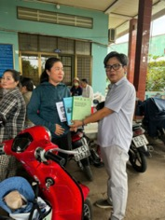 | 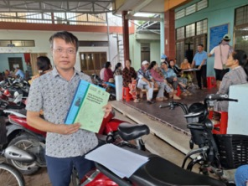
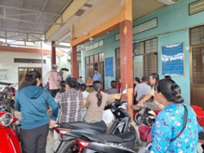 | 
 | 