Western Central Pacific Fisheries Commission 21st Annual Meeting 2024 - Suva, Fiji

Key Traceability attended the WCPFC 21st annual meeting held in Suva, Fiji between the 27th November and 3rd December 2024.
As part of the Client Action Plan which has actions and tasks developed to meet the conditions placed upon the fishery by the Conformity Assessment Body (CAB), the fishery representative needs to advocate for specific management measures to be improved/implemented. As the vessels in the fishery are all flagged to Vanuatu, advocacy and cooperation is needed with the Vanuatu fisheries department and their government delegation at relevant RFMO meetings.
Key Traceability met with two members ( Ajay Arudere, Acting Manager - Policy and Management and Mr. Jason Raubani) of the Vanuatu delegation during the WCPFC 21st annual meeting in Suva, and took this opportunity to explain that as part of the Tunago vessels remaining certified that the fishery must meet the Conformity Assessment Body requirements outlined in the Client Action Plan and ran through the agenda found in Appendix A and all conditions that involve VFD in Appendix B. The most pertinent action that has a deadline in 2025 is that the tools to implement the HCR of NP Albacore are shown to be effective in maintaining the targeted exploitation levels outlined in the Harvest Strategy 2023-01. It was appreciated that the Vanuatu delegation members took the time to meet and run through the conditions.
Along with meeting with the Vanuatu delegation, there was some important progress that took place within the commission meeting, which has been summarised below – please see underscored sections for those that explicitly relate to the Fortuna fishery:
Electronic Monitoring (EM):
- Adoption of interim minimum standards for electronic monitoring in WCPO tuna fisheries.
- Aimed at improving compliance, data accuracy, and independent monitoring, especially for longline vessels with low observer coverage (currently at 5%).
- Brings WCPFC in line with other tuna RFMOs globally.
Management Procedures (MP) and Conservation Measures:
- Candidate target reference points (TRPs) established for bigeye tuna.
- Monitoring strategy adopted for skipjack tuna.
- Harvest strategies work plan updated with latest scientific advice.
- Lack of agreement on an interim MP for South Pacific albacore tuna, though progress expected in 2025 with a dedicated management workshop planned.
Crew Labor Standards:
- First tuna RFMO to adopt rules addressing crew welfare on fishing vessels.
- Measure to be implemented within the next three years.
At-Sea Transshipment:
- No consensus reached on improving transshipment regulations.
- Agreement to revisit the issue in 2025 for further development.

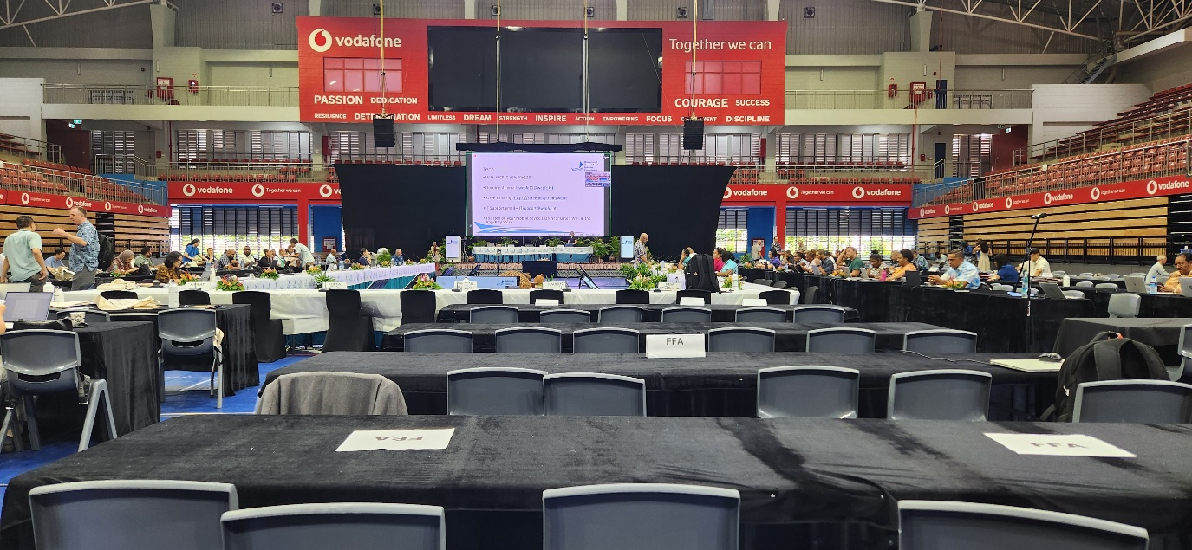
Figure 1 - KT attendance at the 21st WCPFC - Suva, Fiji

Appendix A

Agenda
Stock Status
- EPO BET
Harvest Strategy and HCRs
- Milestone deadlines
- Position statements
- Achieving objectives.
- NP Alb HCR
Observer Coverage
- Electronic Monitoring
- Human
SSIs
- Pelagic Stingray
- Mako shark
- Olive Ridley Turtle
MCS System’s
- Ability to enforce relevant management measures, strategies and/or rules in these areas.
Decision Making Process
- Information on the fishery’s performance and management action is available to stakeholders on request

Appendix B

Condition number | Condition | Performance Indicator (PI) | Deadline
1 | NP albacore needs a harvest control rule that ensures that the exploitation rate is reduced as the PRI is approached and is expected to keep the stock fluctuating around the target level and robust to the main uncertainties. The tools used to implement the HCR should be effective in achieving the required exploitation levels. | 1.2.2 (UoA1) | 2025
3 | There is evidence of regular review of the potential effectiveness and practicality of alternative measures to minimise UoA-related mortality of unwanted catch of main secondary species, particularly pelagic stingray, and they are implemented as appropriate. | 2.2.2 SI (e) | 2026
4 | Provide evidence that direct effects of the UoA are highly likely to not hinder recovery of longfin mako shark, shortfin mako shark, and olive ridley turtles | 2.3.1 SI (b) | 2027
5 | By Year 4 Information on the fishery’s performance and management action is available to stakeholders on request, and explanations are provided for any actions or lack of action associated with findings and relevant recommendations emerging from research, monitoring evaluation and review activity. | 3.2.2 SI (d) | 2027
6 | By year 4 of the surveillance audit, the national monitoring, control and surveillance system implemented in the fishery should have demonstrated an ability to enforce relevant management measures, strategies and/or rules. In addition, evidence should be provided that there is no systematic non-compliance in the fishery. Where there is non-compliance, evidence should be provided that sanctions are consistently applied and thought to provide effective deterrence | 3.2.3 | 2027

