Report on the extent of ghost gear fishing in the Irish Whiting fishery in ICES areas 6 & 7 (fulfilling Task 2.4.1 of the workplan)
Rationale for report
- Action 2.4.1 of the Irish Whiting FIP aims to develop a strategy to minimise and monitor ghost gear issues
- Task 5.1 in that action sets out to assess the extent to which ghost gear may be a problem in the Irish Whiting fishery
- This is the basis of this report which firstly examines the literature on the issue of ghost gear fishing in trawl and seine fisheries and secondly describes the findings from interviews with Irish Whiting fishermen fishing at different scales and across a range of Irish fishing grounds.
Consideration for the impacts of ghost gear is now a scoring requirement within Version 3 of the MSC standard. This is relevant under Principle 2 of the MSC standard and is a distinct scoring guidepost under a wide range of Principle 2 performance indicators including 2.1.2 In-scope management, 2.2.1 ETP/OOS species status, 2.2.2 ETP/OOS species management, 2.3.2 Habitat management strategy and 2.3.3 Habitat information.
The pre assessment was carried out under Version 2 and therefore this report is in preparation for Version 3 of the MSC standard.
A fishery must provide information on the extent to which ghost gear may be an issue within the fishery. The FIP must also provide evidence on how they avoid loss of gear and what procedures are in place on board to retrieve any lost gear. These 2 elements are covered in this report. The fishery is further assessed on measures and/or a strategy to minimise ghost gear and its impact on all in-scope species, on ETP species and on the habitat. This final element will be covered in a subsequent report in fulfilment of Task 5.1.

Review of research on ghost fishing in trawl fisheries

Ghost gear encompasses fishing gear that has been abandoned, lost or otherwise discarded, that continues to fish in the marine environment. In recent years research has been undertaken on the effects of ghost gear and ghost fishing on the marine environment and on mitigation measures to prevent ghost fishing.
Information on the effects of ghost fishing in European demersal fisheries is sparse. One recent study (Mengo et al, 2023) examined the views of English and French fishermen working in the Channel. They found that no active gear (i.e. trawls or seines) were reported as being lost. This supported the findings of other research such as Richardson et al, 2019 who concluded that active gears being attached to the vessel and therefore constantly monitored are less likely to be lost. Furthermore in the case of accidental loss the position will be known facilitating recovery. In addition, active gear’s high value guarantees that strong recovery efforts will be made.
Indirect evidence of the extent of ghost fishing by demersal fisheries in relevant waters was provided by a recent study (Russell et al, 2025) which provided a description on marine litter composition on the seafloor around the UK between 2016-2022 which looked at areas of the North Sea and Celtic Sea. This report noted that abandoned, lost, discarded and end of life fishing gear in the study, such as dolly ropes, net cuttings and trawl nets, were attributable to fishing gears used to catch demersal fish species. However, these are only small components of a demersal trawl and would therefore represent a minimal threat of ghost fishing to the stocks.
There are measures in place in both UK and EU legislation to manage and mitigate ghost fishing and these are described in the section below “Feedback from Irish Whiting Fishermen”.
Profile of the Irish Whiting fishery
Catches of whiting in the waters around Ireland usually form part of a mixed demersal fishery along with haddock (Melanogrammus aeglefinus) in demersal otter trawls and seine nets. On average approximately 2,350 tonnes of whiting were landed in mixed demersal fisheries by Irish vessels between 2021 and 2023, 77% of these were caught in 7g. In 2023 landings were worth approximately €2.6 million for Irish vessels.
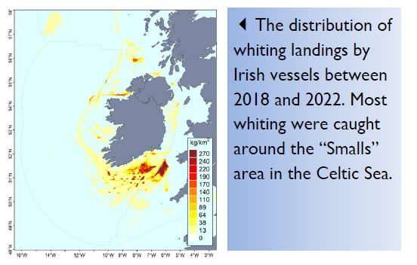
The figure below (taken from the Marine Institute 2025 Stock Book) shows that the majority of Whiting caught in area 7b-k is caught by seines. The seine fishery also targets Hake to a greater extent than the trawl fishery. Whiting, haddock and hake make up more than 60% of the total catch. The main bycatch species are cod, anglerfish, plaice, sole, ling and saithe.

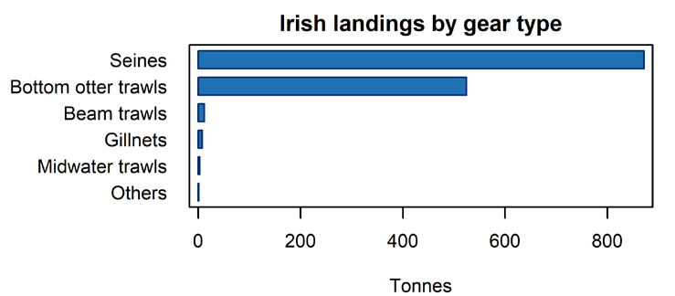
Whiting (Merlangius merlangus) in Division 7.a is taken as bycatch in the Nephrops fishery, with no targeted fisheries for this stock permitted.

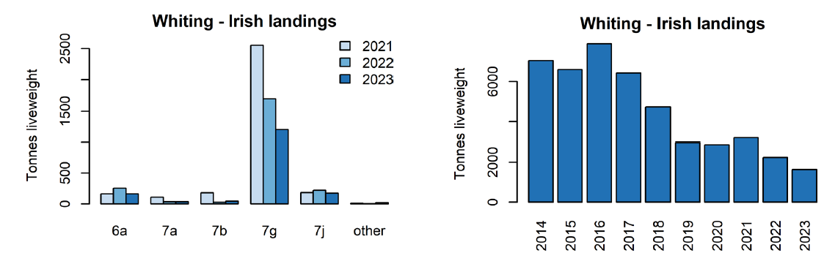

Fishing operations are carried out using seine nets and bottom trawls. The gear is used for between 4 to six years depending on the vessel. The main reason for purchasing new gear is if a vessel changes how it fishes, e.g., moving from seining to trawling or incorporating new selectivity measures such as a square mesh panel. Another reason to purchase is if there is an innovation in gear manufacture. An example would be a move to use T90 cod-end mesh which the majority of seiners have done over the past two years. In general the retirement of gear is a choice and not driven by gear losses at sea.

Feedback from Irish Whiting fishermen
Due to the fact that there have been no empirical studies of the prevalence of ghost fishing in Area 6 & 7 FIP Co-ordinators conducted a series of interviews with fishermen targeting Whiting across different fishing grounds and at different scales of operation. The points below summarise their views which were extremely consistent across all fishermen contacted.
Extent of gear losses
FIP co-ordinators spoke with 4 skippers of seiners and trawlers engaged in Whiting Fisheries in areas VI and VII. Two of the vessels are seining and two are trawling. The home ports of the vessels:
- Dunmore East
- Castletownbere
- Greencastle
- Howth
The skippers all felt that gear loss is not an issue and set out their reasoning for reaching this conclusion as described below.
The gear is used for between 4 to six years depending on the vessel. The main reason for purchasing new gear is if a vessel changes how it fishes, e.g., moving from seining to trawling or incorporating new selectivity measures such as a square mesh panel. Another reason to purchase is if there is an innovation in gear manufacture. An example would be a move to use T90 cod-end mesh which the majority of seiners have done over the past two years. In general the retirement of gear is a choice and not driven by gear losses at sea.
All skippers interviewed stated that loss of full nets is not an issue for a number of reasons.
For seiners the main reason is that this fishing method takes place on clean ground. i.e. ground without significant boulders which could cause problems with snagging the gear. This is due to the fact that seining depends on the use of long lengths of relatively light rope, which as its hauled back on to the vessel kicks up a cloud of sediment which corrals the fish into the centre and eventually into the codend. These fishing grounds have been fished for decades and any boulders that were present before fishing occurred there have been cleared. In addition, if a rope on one side of the gear does break the gear can still be retrieved using the rope on the other side. It is an extremely unlikely event that the ropes on both sides of the gear would break in the same fishing operation. If that does occur the gear can still be retrieved using buoys or accurate positional recording and the use of a creep or grapple hook.
Similarly in trawling for Whiting, in the event that a towing wire breaks during fishing, the gear is easily retrieved as there are other wires attached to the trawl gear. In the extremely unlikely event that a vessel broke several towing wires or had to drop the gear due to a problem with the vessel, such as a hydraulic breakdown on the winches or engine failure, the gear is buoyed for later retrieval or can be located using GPS positioning. All vessels have sophisticated GPS positioning equipment and track plotters. The vessels carry “creeps”, which are a steel type of anchor with multiple fins. These can be towed at the end of a wire over the lost gear and they will pick up the gear which can then be retrieved.
The fishermen also pointed out that, even if a seine or trawl net were lost, it would not continue to fish as it collapses on the bottom when it is not being towed by the vessel.
All demersal trawls have a footrope on each net. This is the part of the net that is in contact with the ground while towing. There are two categories of footropes used on FIP vessels. The first is “clean” footropes and these are used on very clean, flat seabed conditions and normally consist of two-inch rubbers threaded onto a wire. The vessels using these only fish on this bottom type and they get very little damage of any kind to the gears. These vessels stick to areas they have worked for many years and the seabed they fish on has been well cleared of obstructions and mapped.
The second type of footrope used are “rockhopper” footropes. These have two–inch rubbers and then a larger disc, which is normally from six inches in diameter to 14 inches in diameter, spaced out at intervals along the length of the footrope. This keeps the trawl off the ground and allows the vessel traverse over small patches of hard substrate and stones.
On occasion seine or trawl nets can be torn. However, all seiners and trawlers have skilled net menders onboard and the nets are repaired, either while at sea or onshore when the vessel returns to port. Following repair the nets are used again so even tearing a net does not lead to the retirement of gear. A tear in a net can be of two types: firstly, a rip, which is easily mended by stitching together the torn pieces. Secondly, a larger tear may require a section to be replaced. In this case an old section may be cut out and then replaced with a new section.
Old sections of net are not discarded by the vessels as they regard them as a risk to their own vessel and other vessels at sea. If discarded the old sections could float on the surface and easily foul propellers. For this reason, the old sections are brought ashore and disposed of in line with harbour waste management plans.
In Ireland, “Fishing for Litter” is a state-backed initiative where commercial fishing vessels bring ashore debris they catch in their nets. Participation in this initiative is a requirement for all FIP vessels.
The Environmental Protection Agency is currently putting in place an Extended Producer Responsibility (EPR) Scheme will officially commence in January 2026. In Ireland a contractor has been appointed to allow fishing gear producers to comply with SI No. 612 of 2022. The EPR means that there will be a charge put in place when a new net is purchased. This charge is placed in a fund which is then used for the appropriate disposal of end-of-life fishing gear. This all derisks the likelihood of gear being disposed of in the marine environment, as a register is being implemented in the gear manufacturers. This means there will be accountability for gear being put onto the market and retired at the end of its life.
Bord Iascaigh Mhara (Ireland's Seafood Development Agency) has been involved in several projects to reuse end-of-life fishing gear. Under the Net360 banner, end-of-life gears have been used in the manufacture of peaks in baseball caps, waste bins and various containers.
In summary, the practices of the fishermen themselves and the range of state initiatives in place all confirm that gear loss and ghost fishing is not a significant issue in the Whiting Fishery.

References
Mengo, E., Randall, P., Larsonneur, S., Burton, A., Hegron, L., Grilli, G., Russell, J. and Bakir, A., 2023. Fishers' views and experiences on abandoned, lost or otherwise discarded fishing gear and end-of-life gear in England and France. Marine Pollution Bulletin, 194, p.115372.
Richardson K, Hardesty BD, Wilcox C. Estimates of fishing gear loss rates at a global scale: A literature review and meta-analysis. Fish Fish. 2019; 20: 1218–1231. https://doi.org/10.1111/faf.12407
Russell, J., Barry, J., Randall, P., Silburn, B., McGoran, A.R., Reeve, C., Vieira, R. and Nel, H.A., 2025. Is there something fishy about that litter? A UK case study on abandoned, lost or otherwise discarded fishing gear. Marine Pollution Bulletin, 217, p.118054.

https://fishingforlitter.org/ireland/
https://haulitback.ie/

