Irish Brown Crab FIP report in on the extent of ghost gear fishing in the Irish Crab pot fishery (fulfilling Task 5.1 of the workplan)
Rationale for report
- Action 5 of the Irish Brown Crab pot FIP aims to develop a strategy to minimise and monitor ghost gear issues
- Task 5.1 in that action sets out to assess the extent to which ghost gear may be a problem in the Irish Brown Crab fishery
- This is the basis of this report which firstly examines the literature on the issue of ghost gear fishing in crustacean pot fisheries and secondly describes the findings from interviews with Irish crab pot fishermen fishing at different scales and across a range of Irish fishing grounds.
Consideration for the impacts of ghost gear is now a scoring requirement within Version 3 of the MSC standard. This is relevant under Principle 2 of the MSC standard and is a distinct scoring guidepost under a wide range of Principle 2 performance indicators including 2.1.2 In-scope management, 2.2.1 ETP/OOS species status, 2.2.2 ETP/OOS species management, 2.3.2 Habitat management strategy and 2.3.3 Habitat information.
The 2023 pre-assessment of the Irish Brown Crab fishery, conducted against Version 3 of the MSC standard stated that there is a need to improve information and address ghost gear within the fishery. Information on ghost gear management by the fleet is needed to support scoring of various guideposts under principle 2. It was determined that the Irish Brown Crab fishery should provide evidence on how the fishery may avoid loss of gear and what procedures are in place on board to retrieve any lost gear.
A fishery must provide information on the extent to which ghost gear may be an issue within the fishery. The FIP must also provide evidence on how they avoid loss of gear and what procedures are in place on board to retrieve any lost gear. These 2 elements are covered in this report. The fishery is further assessed on measures and/or a strategy to minimise ghost gear and its impact on all in-scope species, on ETP species and on the habitat. This final element will be covered in a subsequent report in fulfilment of Task 5.2.

Review of research on ghost fishing in crustacean pot fisheries
Ghost gear encompasses fishing gear that has been abandoned, lost or otherwise discarded, that continues to fish in the marine environment. In recent years research has been undertaken on the effects of ghost gear and ghost fishing on the marine environment and on mitigation measures to prevent ghost fishing. Static gears such as pots and traps are generally considered to have a lower impact on habitat and biodiversity when compared to mobile gears such as trawls.
Information on the effects of ghost gear in UK and European pot fisheries is sparse. One recent study (Mengo et al, 2023) examined the views of English and French fishermen working in the Channel. The main causes of gear losses as cited by fishers included gear conflict, adverse weather conditions and gear catching on benthic obstructions and fishermen estimated that 8.2% of pots were lost annually.
Indirect evidence of the extent of ghost fishing by pots in relevant waters was provided by a recent study (Russell et al, 2025) which provided a description on marine litter composition on the seafloor around the UK between 2016-2022 which looked at areas of the North Sea and Celtic Sea. This report noted that most abandoned, lost, discarded and end of life fishing gear in the study, such as dolly ropes, net cuttings and trawl nets, were attributable to fishing gears used to catch demersal fish species. For the Celtic Sea portion of this study only 3 pots were collected over a 2-year span which made up 0.2% of all marine litter encountered during this study.
Most research on the issue of ghost fishing in crustacean pots have been conducted in fisheries using gear that is not very comparable to the Irish pot fishery for Brown Crab. Studies conducted in a North American crab fishery found the type of pot may have a bearing on the effect of ghost gear with hard shell crab pots causing bycatch when left to passively fish for 2 years. While bycatch was noted in 41% of the retrieved derelict pots, most of this bycatch was found alive. The instance of abandoned pots, traps and ghost fishing was also investigated in the Norwegian snow crab fishery in the Barents Sea. This study shows that out of one thousand retrieved pots 43% were still fishing, containing an average of 3 snow crabs per trap being abandoned for a period of 1.5 years. In this study it was determined that length of time left passively fishing does seem to have an impact on ghost gear levels. This same study also revealed that that 98% of crabs caught by abandoned pots were alive. Of the few crabs found dead they were rapidly preyed on by larger crabs meaning dead crabs became a source of nutrition for the live crabs found in the abandoned trap.
The pot fisheries in the paragraph above are not comparable to the Irish crab fishery in 2 significant ways. Firstly some of these fisheries use single pots which means that when a marker buoy is lost it can be very difficult top retrieve them as opposed to the relatively long strings of pots used in the Irish fishery. Secondly the type of pots used may be of harder construction and often do not have any softer material used which as we can see in the section below allows for the escape of crabs from Irish gear over a relatively short time if lost.
There are measures in place in both UK and EU legislation to manage and mitigate ghost fishing. According to the UK Crab & Lobster Fisheries Management Plan, discussions held on management approaches for crab and lobster fisheries in English waters listed pot limitation as a potential management measure as it was noted that “Concerns were raised about the practice of ‘storing’ pots at sea, this was seen as an artefact of fishers having too many pots. Storing pots at sea was thought to contribute to spatial squeeze, gear conflict, and potentially ghost fishing if the gear is lost during bad weather”. Recovery of lost gear is also part of the measures to mitigate gear becoming ghost fishing gear. According to SAMS CreelMap project in the UK, the potential for pot and creel recovery is higher for nearshore and inshore waters. They note the opportunities to work with voluntary organisations such as Ghost Fishing UK to increase the range of depths from which they are able to recover lost gear. As a member of the EU, Ireland has commenced works under the Single-Use Plastics Directive and the Extended Producer Responsibility Directive to support a circular economy. These directives extend to fishing gear in order to promote uptake of more eco-conscious gear. However, more information is needed to understand ghost gear at an ecosystem level in Ireland.

Profile of the Irish Brown Crab fishery
Targeted fisheries for Brown Crab in Irish waters are spilt into 3 stock units, the southeastern stock, the southwestern stock and the northwestern or Malin Head stock. The Malin Head fishery is the oldest of the fisheries, developed during the 1960s. The Malin Head stock is also the most studied of the three with daily catch rates collected as part of the Sentinel Vessel Programme since the 1990s.
In Ireland, the majority of Brown Crab fishing is done by inshore small-scale fishing. This means vessels <13m fishing inside 12 nautical miles. Vessels are typically operating as day-boats with the exception being a few larger vessels fitted with vivier tanks which stay at sea for 3 to 10 days. In the northwest region there is a mix of smaller inshore vessels and larger live-holding or Vivier vessels which target offshore stocks. Brown Crab are predominately caught using baited soft-eye, side-entry pots. This fishing method has a low impact on the environment and is very selective, thereby greatly limiting the by-catch of other species.

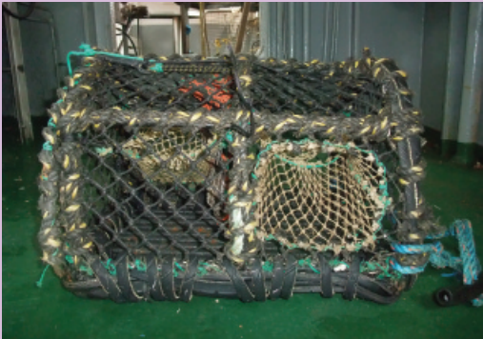
Figure 1. D section soft-eyed side-entry pot used in Irish Crab Fishery (image courtesy of BIM, 2021)

Feedback from Irish Brown Crab fishermen
Due to the fact that there have been no empirical studies of the prevalence of ghost fishing arising from Irish pot fisheries the Irish Crab FIP coordinators condicted a series of interviews with fishermen targeting Brown Crab across different crab fishing grounds and at different scales of operation. The points below summarise their views which were extremely consistent across all fishermen contacted.
Extent of pot losses
- The most significant point is that all fishermen estimated gear losses to be extremely low and decreasing.
- The main reasons for initial gear loss are poor weather or due to a trawler towing the gear. This usually results in the marker buoys at the end of the string being cut.
- When gear is temporarily lost it is almost always retrieved by towing with a grapple or creep, which are carried aboard all vessels. The grapple picks up the rope which links the individual pots together. There are usually 40 to 50 pots in a string which means that there is a long length that can be picked up by the grapple.
- If a fisherman fails to pick up the gear with a grapple, (which happens only seldomly) he may pick it up by continuing to fish across the line of orientation that the lost string was shot at. This usually retrieves any lost gear which will at some point become entangled in the gear being actively fished.
- The value of a string of 50 pots is approximately €5,000 so fishermen would always make significant efforts to retrieve the gear.
- Technological improvements in recording position where the gear was shot and orientation of the string also reduces instances of gear loss.
- Technological improvements are also helping to reduce the problem of gear losses to trawling.
- Some fishermen bring their gear in during the winter or leave them unbaited if left at sea.
Extent of ghost fishing in crab pots
- Fishermen consistently reported that Crabs will begin to escape from pots after 7 to 10 days. They mainly do this by cutting through the softer meshes around the eyes of the pots.
- Once they escape there is a hole in the pot which therefore won’t catch anything further.
- The number of crabs within the pots will continue to decrease and after a month no crab will remain in any lost pots.
- The photographs below submitted by one of the fishermen interviewed show such damage to the meshes.
Recycling options
- All crab fishermen said that there was a good market for older crab pots in the lobster fishery which is usually closer inshore where fishermen are happier to risk losses of older, less expensive gear.
- Many of the fishermen interviewed restore older pots themselves by replacing worn parts such as ropes and meshes or avail of local services provided by other fishermen who may be older retired fishermen.
The images below show holes in the mesh caused by crabs that had been in the pots for a week during bad weather. These holes are most often made in the less durable twine used to make the soft eyes commonly used in crab pots.
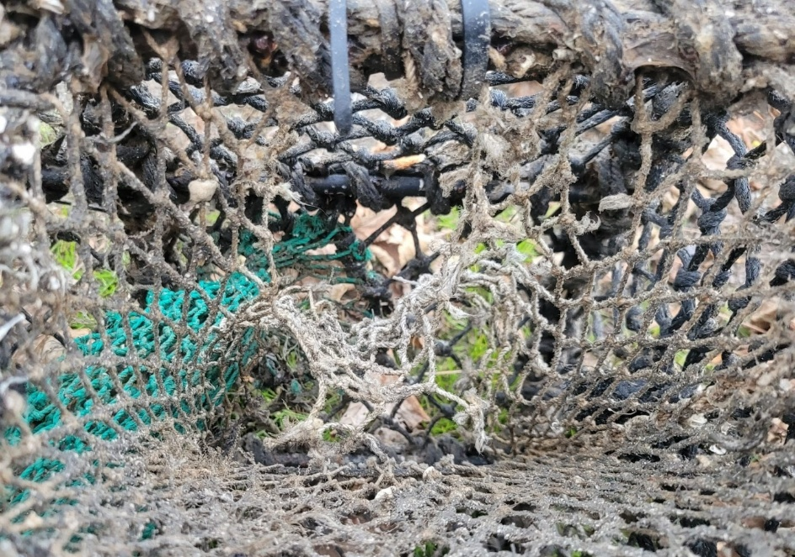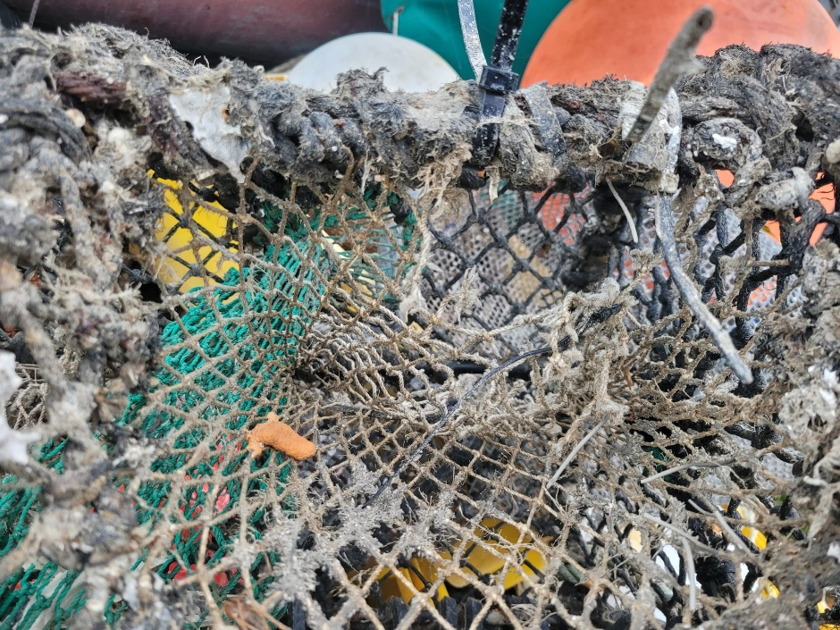

References
- B.I.M., 2021. BIM Brown Crab Handling and Quality Guide. https://bim.ie/wp-content/uploads/2021/03/BIMBrownCrabHandlingandQualityGuide.pdf
- ICES. 2023. Working Group on the Biology and Life History of Crabs (WGCRAB; outputs from 2020–2022 meetings). ICES Scientific Reports. 5:110. 123 pp. https://doi.org/10.17895/ices.pub.24720936
- Perry, S., Burmanje, J. Jackson, E., Rihan, D. 2023. Annual Fisheries Report: Findings of the National Seafood Survey 2023. Bord Iascaigh Mhara (BIM).
- Marine Institute & Bord Iascaigh Mhara (2025). Shellfish Stocks and Fisheries Review 2024: An assessment of selected stocks. Marine Institute, Galway, Ireland
- Mengo, E., Randall, P., Larsonneur, S., Burton, A., Hegron, L., Grilli, G., Russell, J. and Bakir, A., 2023. Fishers' views and experiences on abandoned, lost or otherwise discarded fishing gear and end-of-life gear in England and France. Marine Pollution Bulletin, 194, p.115372.
- Russell, J., Barry, J., Randall, P., Silburn, B., McGoran, A.R., Reeve, C., Vieira, R. and Nel, H.A., 2025. Is there something fishy about that litter? A UK case study on abandoned, lost or otherwise discarded fishing gear. Marine Pollution Bulletin, 217, p.118054.
- Benjamins, S., Fox, C., Marlow, J., Halpin, J., Rybanska, P., & Howe, J. 2024. Detection and characterisation of derelict creel fleets to evaluate marine megafauna entanglement risk in Scottish waters. CreelMap Final Project Report. Scottish Marine Environmental Enhancement Fund (SMEEF) projects 502257 / 502492.
- Thorbjørnsen, S.H., Synnes, A.E.W., Løset, I.D. and Kleiven, A.R., 2023. Hazard and catch composition of ghost fishing gear revealed by a citizen science clean-up initiative. Marine Policy, 148, p.105431.
- Cerbule, K., Herrmann, B., Larsen, R.B. and Yu, M., 2024. Ghost fishing by self-baited lost, abandoned or discarded pots in snow crab (Chionoecetes opilio) fishery. Journal for Nature Conservation, 82, p.126764.
- Humborstad, O.B., Eliassen, L.K., Siikavuopio, S.I., Løkkeborg, S., Ingolfsson, O.A. and Hjelset, A.M., 2021. Catches in abandoned snow crab (Chionoecetes opilio) pots in the Barents Sea. Marine Pollution Bulletin, 173, p.113001.
- Voss, C.M., Browder, J.A., Wood, A. and Michaelis, A., 2015. Factors driving the density of derelict crab pots and their associated bycatch in North Carolina waters.
- Sea-Fisheries Protection Authority., 2023. Guidance Document on Commercial Fishing Gear Types and Technical Measures v.1. Document reference: FFSU-FC-GN-OC-25. Accessed at: https://www.sfpa.ie/What-We-Do/Sea-Fisheries-Information/Commercial-Fishing-Gear-Types-and-Technical-Measures
- Proposed Fisheries Management Plan for Crab and Lobster in English Waters (2023), Department for Environment, Food & Rural Affairs, UK, Accessed at: https://consult.defra.gov.uk/fisheries-management-plans-1/crab-lobster-fmp-consultation/supporting_documents/Proposed%20Crab%20and%20Lobster%20Fisheries%20Management%20PlanJuly%202023.pdf

