Review of alternative measures to reduce interactions with pelagic stingrays, longfin mako shark, shortfin mako shark, and olive ridley turtles

Version 1.0 - January 2025

Introduction
The fishery targets albacore (Thunnus alalunga) and catches bigeye (T. obesus), skipjack (Katsuwonus pelamis) and yellowfin (T. albacares). The pelagic longline vessels are flagged to Taiwan, China, Federated States of Micronesia (FSM), Vanuatu, Cook Islands, Fiji, American Samoa, French Polynesia, New Caledonia and Panama and fish on the high seas (and occasionally in the national Exclusive Economic Zones (EEZs)) in the Pacific. The fishery is managed regionally by the Western and Central Pacific Fisheries Commission (WCPFC) in the Western and Central Pacific Ocean (WCPO) and by the Inter American Tropical Tuna Commission (IATTC) in the Eastern Pacific Ocean (EPO).
Elements of the FIP are MSC certified already and we have created this document in response to frequent conditions received for fisheries in the region. For any scores between 60 and 79 for any performance indicators, the CAB has assigned us a condition. We are required to make improvements to ensure that your fishery scores 80 for the relevant performance indicator during our certificate life and is usually checked before a fishery can enter reassessment. This is laid out in our Client Action Plan. This review is part of the actions identified in fisheries CAP and refers to the following conditions:
- Condition – 2.2.2 SI(e) - Develop a plan to regularly review alternative measures for minimising UoA-related mortality of unwanted catches of pelagic stingrays. This could potentially involve updating of the integrated bycatch management strategy based on continued collection of EM data, particularly data on hook or catch rates of unwanted species.
- Condition – 2.3.1 SI (b) - Develop a plan to obtain and provide evidence that incidental catches of longfin mako shark, shortfin mako shark, and olive ridley turtles by the UoA are highly likely to not hinder recovery of these species.
- Condition – 2.3.3SI(b) - Develop a plan to assess the quality of information being collected on catches of ETP species and make improvements to ensure that the obtain the information is being recorded at the species level and is adequate to measure trends and support a strategy to manage UoA impacts on ETP species.

Executive summary
Key information sources were observer data collected prior to the Covid-19 pandemic and electronic monitoring data. These data were used to identify the main primary species (tuna species, swordfish), main secondary species (blue shark, pelagic stingray), and ETP species. The UoAs impacts do not appear to harm the status of these species significantly, but increased monitoring coverage would help confirm whether this is the case. This literature review outlines a plan to regularly review alternative measures for minimising UoA-related mortality of unwanted catches of pelagic stingrays. This could potentially involve updating the integrated bycatch management strategy based on continued collection of EM data, particularly data on hook or catch rates of unwanted species, including pelagic stingrays, mako sharks and olive ridley turtles.
The fleet already has a string of practices in place including policies and strategies, training of ID and handling, use of circle hooks and whole finfish bait.

Review of alternative measures

Pelagic Stingrays
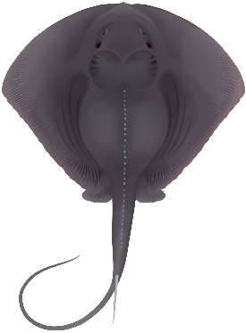
The pelagic stingray (Pteroplatytrygon violacea) is a species of stingray in the family Dasyatidae, and the sole member of its genus. It is characterised by the wedge-like shape of its pectoral fin disc, which is much wider than long, as well as by the pointed teeth in both sexes, whip-like tail with extremely long tail spine, and uniform violet to blue-green coloration. It generally reaches 59 cm (23 in) in width.
The pelagic stingray has a worldwide distribution in waters warmer than 19 °C (66 °F) and migrates seasonally to spend the summer closer to the continental shelf and at higher latitudes. The only stingray that almost exclusively inhabits the open ocean, this species is typically found in surface waters down to a depth of 100 m (330 ft). As a consequence of its midwater habits, its swimming style has evolved to feature more of a flapping motion of the pectoral fins, as opposed to the disc margin undulations used by other, bottom-dwelling stingrays.
Figure 1 - Pelagic stingray (MarineWise, 2024)
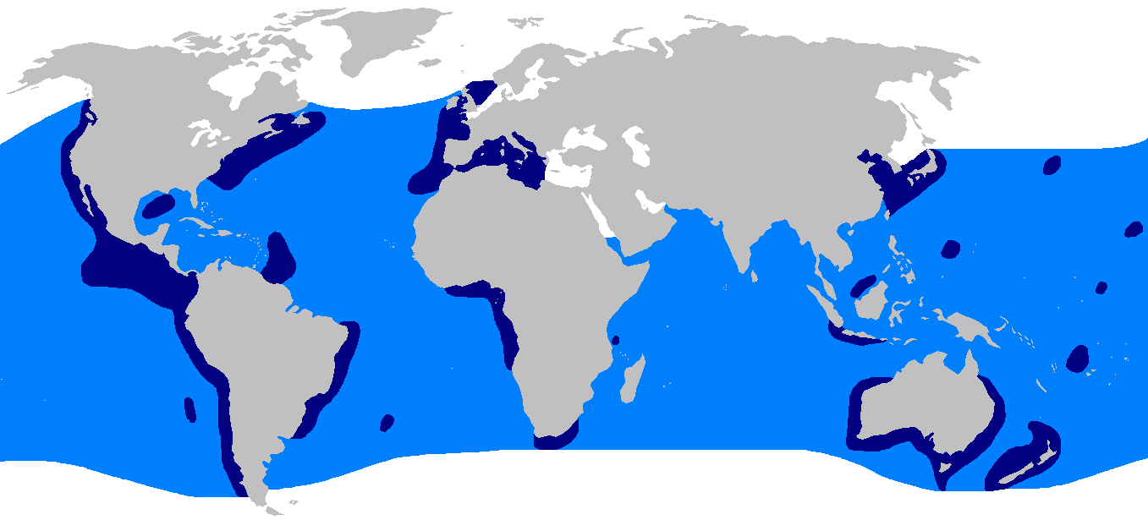
Figure 2 - Distribution of the pelagic stingray (Pteroplatytrygon violacea), based on Last and Stevens (2009) and Mollet (2002).
Current issues
This species is caught as bycatch throughout its range; it is of little economic value and usually discarded, often with high mortality. Rays incidentally caught on longlines suffer high mortality, as fishers are wary of being stung and remove the rays from the hooks by hitting the rays against the side of the boat, causing severe damage to the mouth and jaws. The extent of this global bycatch has yet to be quantified.
Despite the high bycatch rate in global fisheries, there is evidence that numbers of pelagic stingray are increasing, perhaps owing to the heavy bycatch of its natural predators and competitors (e.g., sharks). Along with the pelagic stingray's global distribution and prolific life history, this has led the International Union for Conservation of Nature (IUCN) to assess it as of Least Concern.
From similar fisheries EM data analysis from 2019-2020, incidences of stingray totalled 7,248 which equated to 1.23% of the UoAs catch (table 26, PCDR). Of the stingray that were caught, 40% were released. For the UoA fishery, an analysis conducted using EM data from one FIP vessel trip estimated a catch rate of two pelagic stingray per 1,000 hooks (Gilman et al. 2021a).

Alternative Measures
In general, the use of circle hooks is widely promoted for longline fisheries to reduce deep hooking and lethal injuries of any associated species. Although some studies report significant increase in pelagic stingray catch rates when J-style hooks (compared to circle hooks) are used (Piovano et al., 2010), most studies agree that circle hooks do not reduce the risk of capturing, but might improve discard survival, which might make them effective in reducing the detrimental effects of longlining on these species (Favaro et al., 2013). In some studies, despite an increase in elasmobranch (including stingrays) catch whilst using circle hooks, there was reduced haul back mortality and deep hooking relative to J-shaped hooks of the same or narrower width. However, if wide circle hooks are used, they seem to reduce pelagic stingray catch and at vessel mortality (AVM) rates (Gilman et al., 2016). In the same study by Gilman et al., (2016), it was found that using narrow circle hooks with fish as bait led to complete ingestion by pelagic stingray and led to deep hooking in the animal’s gut. Hence, as an adapted mitigation solution it can be proposed that larger, wider hooks baited with fish are used, as long as the target species catch rates are still demonstrably profitable (Gilman et al., 2016).
Further studies on the impact of circle hooks versus J-shaped hooks demonstrated that the self-shedding rates for circle hooks (average of 44.5days) are much longer compared to same size J-shaped hooks (within 6 days), and trailing gear could cause continuous necrosis of an animals’ tissues without expulsion of the hook (Poisson et al., 2019). This again highlighting the fact that it is crucial when implementing mitigation methods to consider all possible conflicting effects on other vulnerable taxa. Furthermore, this demonstrates the need to train crew members to adequately remove a hook from an animal if and when they are discovered attached to the line. Best practice handling and release techniques and training are provided by organisations such as the International Seafood Sustainability Foundation (ISSF). (See Appendix. ISSF Graphics for Best Handling Practices for the Safe Release of Sharks)
Pelagic stingray AVM is found to be low (less than 2%) (Carruthers et al., 2009; Coelho et al., 2012, Poisson et al., 2024). Currently there are no studies on pelagic stingray Post Release Mortality (PRM), but the PRM rates are assumed to be variable and vessel dependent, as stingrays are typically discarded without any particular care, and often with trailing fishing gear. Thus, as a conservation measure which could reduce PRM, the adoption of safe handling and release practices for stingrays could reduce drastically their mortality and avoid injuries to the crew. Fishers must be encouraged to use pliers or de-hookers for removing hooks, in the case they want to keep the hooks. If not, cutting the line as close as possible to the eye of the hook should be recommended, in order to reduce the amount of trailing line. Finally, cutting the line instead of removing the hook, in the case of deep hooking, seems to be the best practice. (Poisson et al., 2024)
Hutchinson et al. (2017) set forth the following recommendations for best handling practices for the safe release of mantas, mobulids and stingrays for longline fisheries: For small rays (under 30kg), gently bring on board and remove as much gear as possible by backing the hook out of its mouth. If hooks are embedded in the jaw, either cut the hook with bolt cutters or cut the line at the hook and gently return the animal to the sea. They specifically describe what should be avoided:
- Do not hit or slam a ray against the side of the vessel in an attempt to remove a ray from the line (this will cause severe damage and likely death to the animal)
- Do not cut the tail.
- Do not gaff a ray to bring aboard vessel.
- Do not drag or carry a ray by its “cephalic lobes” or tail.
- Do not carry or drag a ray by inserting your hands into the gill slits or the spiracles.

Next Steps
Going forward the client fleet should do the following:
- Continue to use wide circle hooks.
- Ensure the fleet is still using only whole finfish as bait that doesn’t allow complete ingestion by stingray.
- Ensure fishers attempt to remove as much gear as possible at release, leave hooks in when fully ingested and ensure fishers use safe-handling best practises as laid out by ISSF and skipper training workshops.

Longfin and Shortfin Mako Sharks
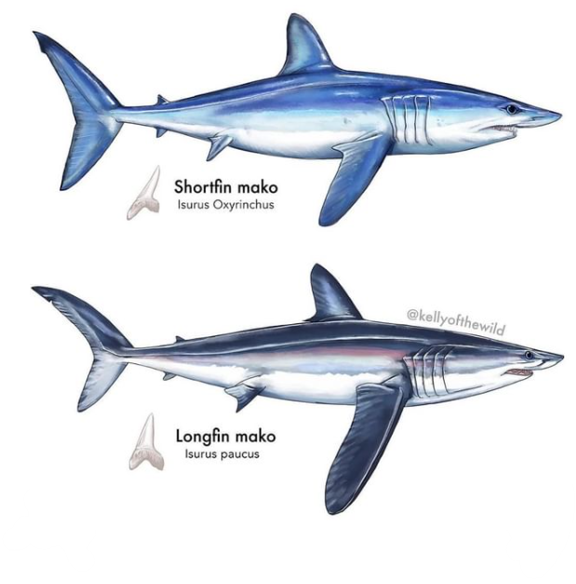
The longfin mako shark (Isurus paucus) is a species of mackerel shark in the family Lamnidae, with a probable worldwide distribution in temperate and tropical waters. An uncommon species, it is typically lumped together under the name "mako" with its better-known relative, the shortfin mako shark (I. oxyrinchus). The longfin mako is a pelagic species found in moderately deep water, having been reported to a depth of 220 m (720 ft). Growing to a maximum length of 4.3 m (14 ft), the slimmer build and long, broad pectoral fins of this shark suggest that it is a slower and less active swimmer than the shortfin mako.
Widely scattered records suggest that the longfin mako shark has a worldwide distribution in tropical and warm-temperate oceans; the extent of its range is difficult to determine due to confusion with the shortfin mako.
Figure 3 - Shortfin mako (top) and longfin mako shark (bottom) (NOAA, 2024).
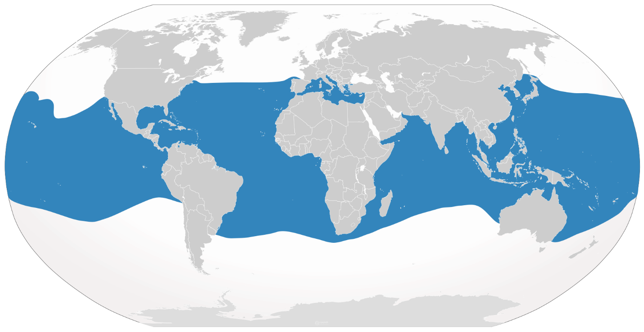
Figure 4 - Range of longfin mako shark (Isurus paucus).

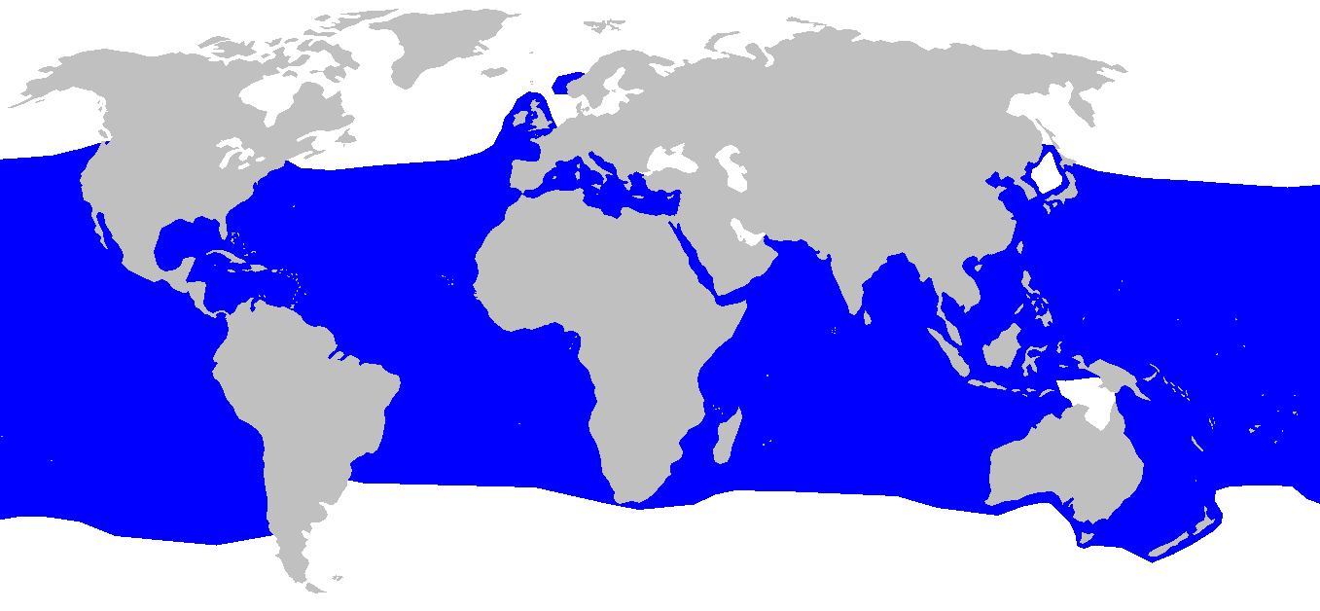
Figure 5 Distribution map for Isurus oxyrinchus.
Current issues
The longfin and shortfin mako are both currently classified as Endangered by the IUCN due to its uncommonness, low reproductive rate, and susceptibility to shark fishing gear. It has also been listed under Annex I of the Convention on Migratory Species Migratory Shark Memorandum of Understanding. This shark is caught, generally in low numbers, as bycatch on longlines intended for tuna, swordfish, and other pelagic sharks, as well as in anchored gillnets and on hook-and-line.
Approximately 24% of the global habitat of all pelagic shark species (including mako) overlaps with the operational area of pelagic longline fisheries (Queiroz et al., 2019). These hotspots are recorded in the figure below:
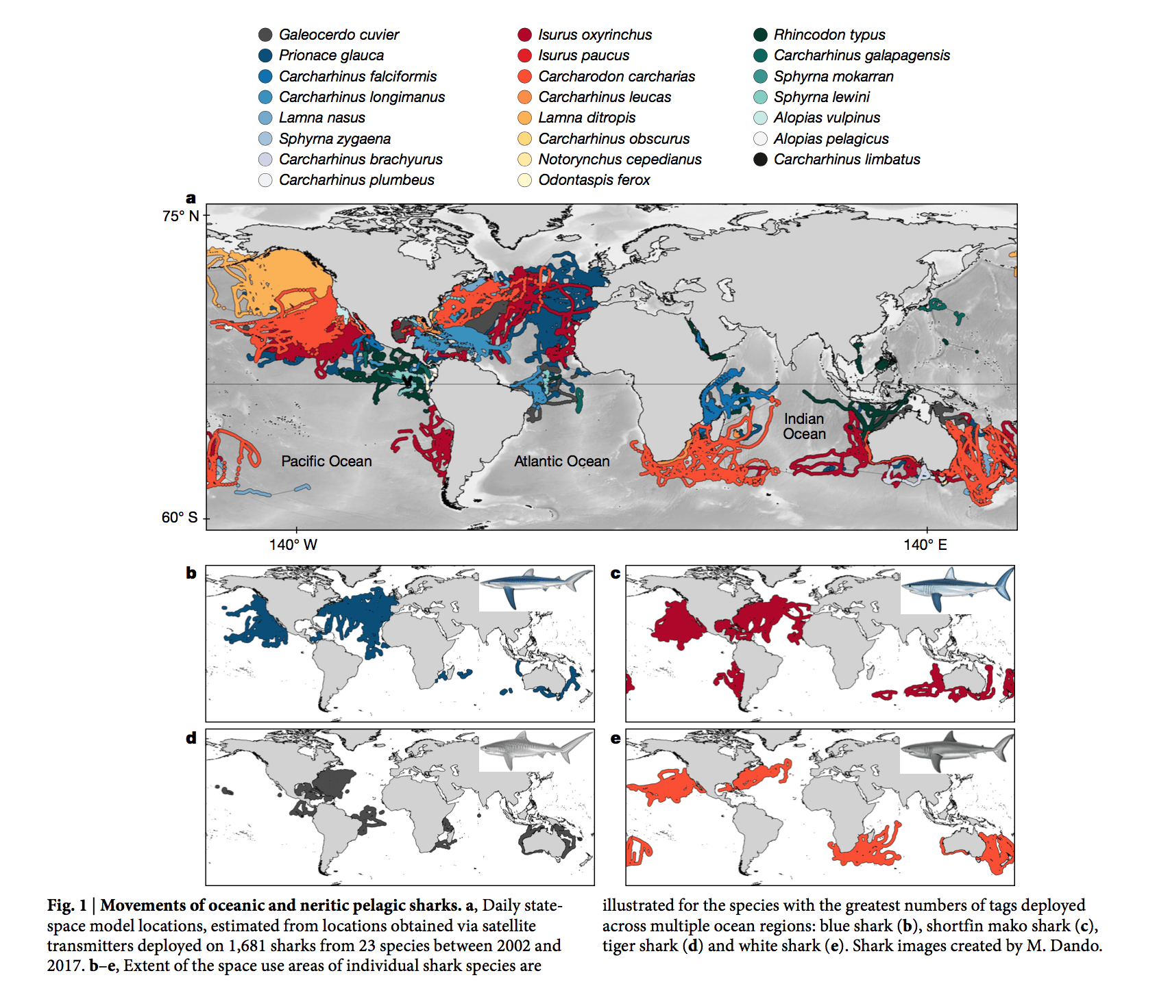
Figure 6 - Movements of pelagic sharks to show hotspots.
Bycatch mortality can be split into two categories: AVM (also called hooking/capture mortality) and PRM, and is highly variable between species (Gilman et al., 2008). For elasmobranchs, mortality rates are substantial and would serve to undercut any conservation measures based on mandatory release from fishing gear. The generally reported AVM estimates are in the range of 35–56% (Beerkircher et al., 2004; Coelho et al., 2012; Bromhead et al., 2012). PRM is the proportion of the fish discarded ‘alive’ that may die in the short-term as a consequence of any physical injury, trauma and physiological stress sustained during capture and handling (Pollock & Pine, 2007; Poisson et al., 2014). Injured fish may be also prone to infection (Borucinska et al., 2002; Adams et al., 2015), more susceptible to attack by predators and scavengers (Davis, 2002) or have sustained physiological damage that may affect the feeding and swimming behaviour, growth, the immune system or reproductive biology (Skomal, 2007), even over the longer term. Unlike the other mortality types, PRM is not readily observed nor measured, rendering it a “hidden mortality” and some studies have even argued that PRM could be a larger source of mortality than harvest mortality (Cramer, 2004; Douglas et al., 2010; Molina and Cooke, 2012). Studies of longline captured shortfin mako in the equatorial western Pacific Ocean, found a low PRM of uninjured mako after 60 days of capture (11.6%), which if considering the complete fishing interaction (haul back, handling, release), increase markedly to PRM=51.4% (Francis et al., 2023). In addition, PRM significantly increased to 63.2% if the mako were injured. Other studies reported lower PRM for mako shark – 22.8% across the ICCAT-managed region in the Atlantic (Miller et al., 2019), and about 30% in the NW Atlantic, where has shown little change over a 17-year period (2001–2018) (Campana et al., 2016; Bowlby et al., 2020). Survival estimates for shark bycatch may not only be species-specific but also fishery-specific, due to operational and gear configuration characteristics, as well as on how fishers release animals from the gear.

FIP Fleet
From the fisheries EM data analysis from 2019-2020, incidences with longfin were low. With two individuals being discarded in either a dead or unknown state (table 27, PCDR). However, there were 57 incidents with shortfin mako, with 42 being retained, 13 discarded dead or unknown and 2 released alive. Scaled up this represents 0.01% of the catch for longfin mako and 0.35% for shortfin mako.

Alternative Measures
Although some studies examining shark catch rates and mortality with different longline configurations have indicated circle hooks may not have such a great impact (Yokota et al., 2006; Afonso et al., 2012; Amorim et al. 2015), other studies have highlighted that sharks caught with circle hooks may survive better than those caught with J-hooks (Carruthers et al., 2009; Afonso et al., 2011; Fernandez-Carvalho et al., 2015). In addition, a meta-analysis of available data led Godin et al. (2012) to conclude that even though circle hooks did not affect catch rates of sharks, they did reduce AVM, because these hooks are more often hooked in the mouth or jaw and are less frequently ingested (deep hooked). Similarly French et al. (2015) observed a significant reduction in deep hooking with the use of circle hooks in recreational fishery compared to J-hooks, which in turn increases shark’s chance to survive as deep hooking has been shown to increase mortality rate significantly in many species (Bartholomew and Bohnsack, 2005; Reeves and Bruesewitz, 2007; Campana et al., 2009; Epperly et al., 2012; Kneebone et al., 2013) and especially shortfin mako deep hooked sharks were more than four times more likely to be retrieved from longlines dead than jaw-hooked sharks (Epperly et al., 2012).
The overall efficacy of prohibited species listings often used by fisheries managers to reduce fishing mortality on the most vulnerable taxa, is dependent on whether fisheries have a reduced encounter rate (i.e. they do not fish in any areas where prohibited species occur regularly or in higher abundance) and whether or not there is a low mortality (including AVM and PRM). Francis et al. (2023) also concludes that while `no-retention’ policies offer sharks an increased chance of survival, continued efforts should be made to avoid catching sharks altogether to minimize fishing impacts on shark populations. Their study shows that despite the relatively high post-release survival rates for mako and silky shark in the Pacific, these estimates are markedly reduced by nearly 40% when the proportion of overall catch surviving a fishery interaction (haul back, handling and release) is taken into consideration. Alongside traditional Marine Protected Area (MPA) development, Important Shark and Ray Areas (ISRA) are also a management measure that can be used to inform fishery management decisions in order to help reducing shark and ray ETP species encounter rates. The ISRA captures important aspects of shark biology, ecology and population structure and to encompass multiple aspects of species vulnerability, distribution, abundance, and key life cycle activities, as well as areas of high diversity.
Some studies have also explored the effect of leader material and found that shark catches can be reduced with nylon leaders, as sharks may bite through monofilament more easily than wire (Ward et al., 2008) Afonso et al. (2012) studied the effect of both hook type (circle vs J-hook) and leader material (nylon vs wire) on longline catch and mortality rates of target and bycatch species in a pelagic longline fishery targeting swordfish and tunas. Sharks constituted 45% of the bycatch and bite-offs (i.e. missing hooks) corresponded to ∼33% of the shark catch and occurred mostly on nylon leaders (97%). In addition, they found that hook type had no significant effect on catchability or mortality of any species or groups, while nylon leaders caught more bigeye tuna, and all target species combined.
Other potential mitigation measures include modifying the depths fished and soak times of longline gear in the ocean (Coelho et al., 2003; Mandelman et al., 2008; Afonso et al., 2011; Carruthers et al., 2011). The time spent hooked is an important factor to consider, especially for those fisheries with potentially long soak times. Broadhurst et al. (2014) noted that a high proportion of hammerhead sharks were caught after sunrise and suggested that setting lines only during the night could potentially reduce bycatch of this group.
Determining the utility and efficacy of mitigation measures for any longline fishery clearly requires detailed investigations as to the likely impacts on target species, and improving handling practices may be one of the more pragmatic approaches to improving discard survival (Ellis et al., 2017).
Some handling methods resulting in damage to the animal like gear removal with jaw damage (fishers cut through the jaw’s cartilage to remove a hook) or part removal, cause not only physical damage to the animal but it may often require additional handling time or time out of water that would also impact their vitality post-release. Lamnid sharks are well known for having high metabolic rates and correspondingly high oxygen requirements, which presumably explains why species like mako are more likely to die on the hook, due to a reduced ability to ram ventilate while hooked (Bernal et al., 2012). French et al. (2015) showed an overall low (10%) PRM rate and that handling onboard did not have a significant impact on mortality when ram ventilation is prioritised.
Hutchinson et al. (2021) showed that leaving sharks in the water and removing as much trailing gear as possible by either using a dehooker or cutting the line had the best survival outcomes, which in turn may reduce fishing mortality on shark population. Because most sharks are released by cutting the line (~84%), if fishers take time to remove as much trailing gear as possible, ideally leaving less than 1 m, survivorship can be improved by as much as 40% over 360 days. Notably, different species are released with different lengths of trailing gear likely due to differences in fishery operations (shorter branchlines and smaller vessels allow fishers to bring animals closer to the vessel to cut the line). Although the effect that trailing gear has on mortality and survival rates is not well understood, the length of trailing gear left on the shark, as a function of body length, was found to be a significant factor in determining PRM for both mako and silky shark. Longer trailing line may eventually entangle the shark, restricting its ability to capture prey or evade predators or incur higher energy expenditure (Hutchinson et al., 2021). It can also be suggested that trailing gear becomes more problematic for sharks the longer it is attached to the shark (e.g. increases risk of entanglement, Wegner & Cartamil, 2012). Despite some studies arguing that trailing gear had little effect on the mortality rates of pelagic sharks (Musyl & Gilman, 2018), it is well recommended in the literature to reduce the amount of fishing gear left on a shark before release (Musyl & Gilman, 2018; Hutchinson et al., 2021; Schaefer et al., 2021).French et al. (2015) indicate that leaving circle hooks in when too deep may be beneficial and increase post-release survival (PRS), rather than risk further internal injury trying to remove them. (Bartholomew and Bohnsack, 2005; Kneebone et al., 2013).

Next Steps
Going forward the client fleet should do the following:
- Continue to use wide circle hooks.
- Ensure the fleet is avoiding shark-important areas.
- Ensure the fleet is using nylon leaders and no shark lines or wire leaders.
- Consider modifying depths fished, soak times and hook setting timing.
- Ensure fishers attempt to remove as much gear as possible at release, leave hooks in when fully ingested and ensure fishers use safe-handling best practises as laid out by ISSF and skipper training workshops.
- Ensure fishers do not haul large sharks on deck due to crew safety and shark health.
- Ensure fishers minimise trailing gear (<1 m) at release.

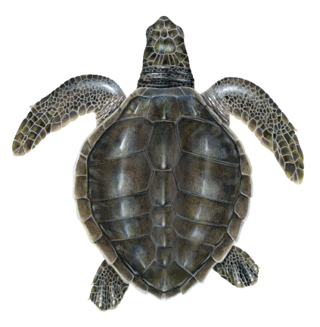
Olive Ridley Turtles
The olive ridley sea turtle (Lepidochelys olivacea), also known commonly as the Pacific ridley sea turtle, is a species of turtle in the family Cheloniidae. The species is the second smallest and most abundant of all sea turtles found in the world. L. olivacea is found in warm and tropical waters, primarily in the Pacific and Indian Oceans, but also in the warm waters of the Atlantic Ocean.
Olive ridley sea turtles are considered the most abundant, yet globally they have declined by more than 30% from historic levels. These turtles are considered endangered because of their few remaining nesting sites in the world. The eastern Pacific turtles have been found to range from Baja California, Mexico, to Chile. Pacific olive ridleys nest around Costa Rica, Mexico, Nicaragua, and the northern Indian Ocean; the breeding colony in Mexico was listed as endangered in the US on July 28, 1978.
Figure 7 - Olive Ridley Turtle (Up-well, 2024)

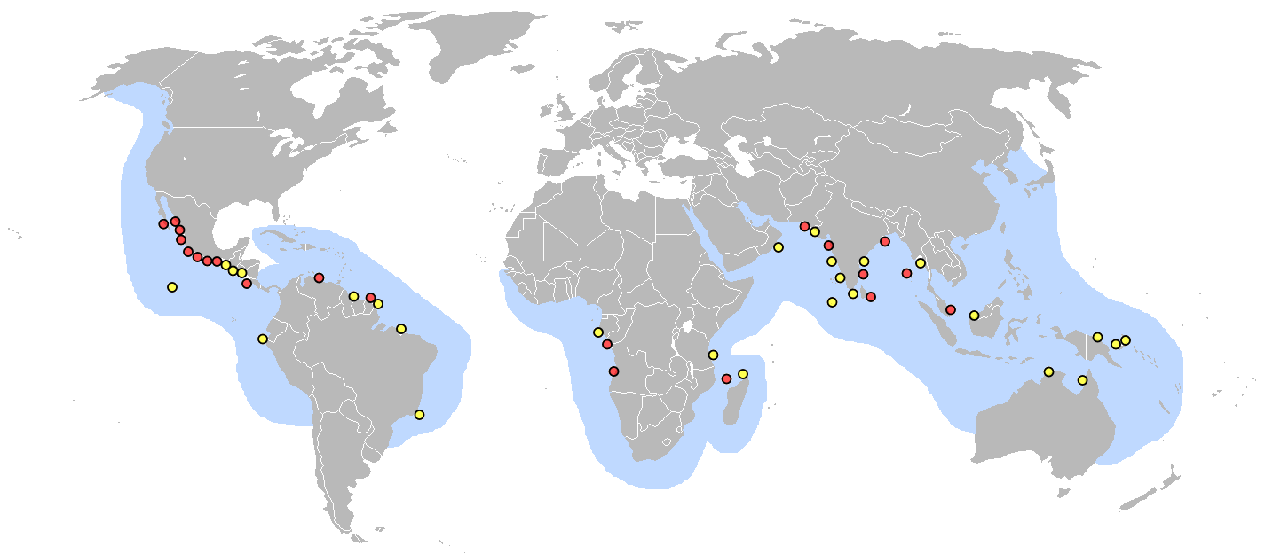
Figure 8 - L. olivacea distribution map: Red circles are major nesting grounds; yellow circles are minor nesting beaches.
Current issues
Major threats include mortality associated with boat collisions, and incidental takes in fisheries. Trawling, gill nets, ghost nests, longline fishing, and pot fishing have significantly affected olive ridley populations, as well as other species of marine turtles. Between 1993 and 2003, more than 100,000 olive ridley turtles were reported dead in Odisha, India from fishery-related practices. In addition, entanglement and ingestion of marine debris is listed as a major threat for this species. Coastal development, natural disasters, climate change, and other sources of beach erosion have also been cited as potential threats to nesting grounds.

FIP Fleet
From the fisheries EM data analysis and Observer data from incidences with olive ridley turtles was low. With two individuals being discarded in either a dead or unknown state (table 27, PCDR), with this being scaled up to represent 17 across the fleet representing 0.01% of the UoAs catch (table 31, PCDR).

Alternative Measures
Fishing gear improvements, adjustments to fishing methods, and closures of particular regions to fishing during nesting and hatching seasons are initiatives that are helping to reduce the olive ridley bycatch (National Wildlife Federation, 2021). Santos et al. (2012) demonstrated that in a pelagic swordfish longline fishery the change to circle hooks (from J-hooks) baited with mackerel (instead of squid) resulted in a significant reduction (85%) in olive ridley turtle interactions. Regardless of the hook style used, most olive ridley turtles were hooked in the mouth, which may be related to the species’ feeding behaviour. However, higher mortality rates (i.e. short term at-haul back mortality) are associated with the 10⁰ offset hook compared to the circle hook without offset. In addition, according to Caceres-Farias et al.(2022) to reduce injuries, the use of barbless circular hooks and knot-free buoy lines should be promoted.
Nearly all sea turtles incidentally caught on shallowest gear are alive at retrieval (Witzell, 1999). There is, however, the potential for high rates of PRM especially when turtles are released with hooks or lines remaining in their mouths, throats, gastrointestinal tracts, or flippers that can lead to infection (Aguilar et al., 1995, Chaloupka et al., 2004). Similarly, Watson et al. (2005) recommend attempting to remove all gear, because if left in place it may cause tissue damage, infection, and/or perforation of internal organs etc. A hook that is attached with a trailing line can also encircle a limb, restrict circulation, cut deeply into the tissue, and eventually cause loss of function. However, Parga (2012) observed that as long as the branch line was cut short (close to the mouth), some deep hooked sea turtles could swallow and even expel the hooks without major harm. For shallow set longline that uses circle hooks (with or without 10% offset), Swimmer et al. (2006) also concluded that olive ridley turtles that are lightly hooked and handled properly survive and generally behave normally following interactions with the gear. Thus, deep-setting longline gear and/or the use of J-hooks may drastically increase the mortality of hooked or entangled marine turtles and should be avoided.
Safe-handling best practices must be encouraged, as proper handling and hook removal largely influence the post-release survival probability. This suggests the importance of education of longline fishers to use dip nets to safely bring turtles on board and line cutters to cut line as close to the hook as possible at all times. (Swimmer et al., 2012)
Marine protected areas and/or time area closures are needed to reduce the impact of longline fishery on sea turtles and sharks. (Dapp et al., 2013)

Next Steps
Going forward the client fleet should do the following:
- Continue to use wide circle hooks.
- Ensure the fleet is avoiding olive ridley-important areas such as nesting sites.
- Consider modifying depths fished, soak times and hook setting timing.
- Ensure fishers attempt to remove as much gear as possible at release, leave hooks in when fully ingested and ensure fishers use safe-handling best practises as laid out by ISSF and skipper training workshops.
- Ensure fishers minimise trailing gear at release.
- Ensure fishers leave hooks when ingested too deep.

Next Steps
The actions of the client group identified through this review are mostly already in place across the fleet through their implementation of their ETP management strategy and policy. The fleet must continue to explore new science as it appears and consider locations fished, modifying depths fished, soak times and hook setting timing.
In addition to these actions, the fleet will need to continue analysing any new observer data (human or EM). The client group has also met with Satlink and DOS on any amendments or changes needed to the systems, their positioning or the data analysis to enable us to receive more and better-quality data, particularly data on hook or catch rates of unwanted species, to allow us to update the integrated bycatch management strategy. These changes to the system are planned for 2025 with the installation of new, higher quality systems with better field of views etc.

Conclusion
This review is part of the actions identified in fisheries CAP and refers to the following conditions:
- Condition 3 – 2.2.2 SI(e) - Develop a plan to regularly review alternative measures for minimising UoA-related mortality of unwanted catches of pelagic stingrays. This could potentially involve updating of the integrated bycatch management strategy based on continued collection of EM data, particularly data on hook or catch rates of unwanted species.
- Condition 4 – 2.3.1 SI (b) - Develop a plan to obtain and provide evidence that incidental catches of longfin mako shark, shortfin mako shark, and olive ridley turtles by the UoA are highly likely to not hinder recovery of these species.
- Condition 5 – 2.3.3SI(b) - Develop a plan to assess the quality of information being collected on catches of ETP species and make improvements to ensure that the obtain the information is being recorded at the species level and is adequate to measure trends and support a strategy.

References
Adams, D. H., Borucinska, J. D., Maillett, K., Whitburn, K. & Sander, T. E. (2015). Mortality due to a retained circle hook in a longfin mako shark Isurus paucus (Guitart‐Manday). Journal of Fish Diseases 38, 621–628.

Afonso, A. S., Hazin, F. H., Carvalho, F., Pacheco, J. C., Hazin, H., Kerstetter, D. W., Murie, D. & Burgess, G. H. (2011). Fishing gear modifications to reduce elasmobranch mortality in pelagic and bottom longline fisheries off Northeast Brazil. Fisheries Research 108, 336–343.

Afonso, A. S., Santiago, R., Hazin, H. & Hazin, F. H. (2012). Shark bycatch and mortality and hook bite-offs in pelagic longlines: interactions between hook types and leader materials. Fisheries Research 131–133, 9–14.

Aguilar R, Mas J, Pastor X (1995) Impact of Spanish swordfish longline fisheries on the loggerhead sea turtle Caretta caretta population in the western Mediterranean. In: Richardson JI, Richardson TH (eds) Proc 12th Annu Symp on Sea Turtle Biology and Conservation. NOAA Tech Mem NMFS-SEFSC-361, p 1–6

Amorim, S., Santos, M. N., Coelho, R. & Fernandez-Carvalho, J. (2015). Effects of 17/0 circle hooks and bait on fish catches in a Southern Atlantic swordfish longline fishery. Aquatic Conservation: Marine and Freshwater Ecosystems 25, 518–533.

Bartholomew A, Bohnsack JA (2005) A review of catch-and-release angling mortality with implications for no-take reserves. Rev Fish Biol Fisher 15: 129–154.

Beerkircher, L. R., Cortés, E. & Shivji, M. (2004). Characteristics of shark bycatch observed on pelagic longlines off the southeastern United States, 1992–2000. Marine Fisheries Review 64, 40–49.

Bernal, D., Carlson, J. K., Goldman, K. J., and Lowe, C. G. (2012). Energetics, metabolism, and endothermy in sharks and rays. In Biology of Sharks and Their Relatives, pp. 211–237. Ed. by J. C. Carrier, J. A.Musick, and M. R. Heithaus.CRCPress, Boca Raton, FL.

Bowlby, H., Joyce, W., Benoit, H. and Sulikowski, J. (2020). Evaluation of post-release mortality for porbeagle and shortfin mako sharks from the Canadian pelagic longline fishery. Collect Vol Sci Pap, 76, pp.365-373.
Borucinska, J., Kohler, N., Natanson, L. & Skomal, G. (2002). Pathology associated with retained fishing hooks in blue sharks, Prionace glauca (L.), with implications for their conservation. Journal of Fish Diseases 25, 515–521.

Broadhurst, M. K., Butcher, P. A., Millar, R. B., Marshall, J. E. & Peddemors, V. M. (2014). Temporal hooking variability among sharks on south-eastern Australian demersal longlines and implications for their management. Global Ecology and Conservation 2, 181–189.

Bromhead, D., Clarke, S. Hoyle, S., Muller, B., Sharples, P. & Harley, S. (2012). Identification of factors influencing shark catch and mortality in the Marshall Islands tuna longline fishery and management implications. Journal of Fish Biology 80, 1870–1894.

Cáceres-Farias, L., Reséndiz, E., Espinoza, J., Fernández-Sanz, H., & Alfaro-Núñez, A. (2022). Threats and vulnerabilities for the globally distributed Olive Ridley (Lepidochelys olivacea) sea turtle: A historical and current status evaluation. Animals, 12(14), 1837.

Campana SE, Joyce W, Manning MJ. (2009). Bycatch and discard mortality in commercially caught blue sharks Prionace glauca assessed using archival satellite pop-up tags. Mar Ecol Prog Ser 387: 241–253.

Campana SE, Joyce W, Fowler M. and Showell M. (2016). Discards, hooking, and post-release mortality of porbeagle (Lamna nasus), shortfin mako (Isurus oxyrinchus), and blue shark (Prionace glauca) in the Canadian pelagic longline fishery. ICES J Mar Sci. 73(2). pp.520–528.

Carruthers, E. H., Schneider, D. C. & Neilson, J. D. (2009). Estimating the odds of survival and identifying mitigation opportunities for common bycatch in pelagic longline fisheries. Biological Conservation 142, 2620–2630.

Carruthers, E. H., Neilson, J. D. & Smith, S. C. (2011). Overlooked bycatch mitigation opportunities in pelagic longline fisheries: Soak time and temperature effects on swordfish (Xiphias gladius) and blue shark (Prionace glauca) catch. Fisheries Research 108, 112–120.

Chaloupka M, Parker D, Balazs GH (2004) Modeling postrelease mortality of pelagic loggerhead sea turtles exposed to the Hawaii-based longline fishery. Mar Ecol Prog Ser 280: 285–293

Coelho, R., Bentes, L., Gonçalves, J., Lino, P. G., Ribeiro, J. & Erzini, K. (2003). Reduction of elasmobranch by‐catch in the hake semipelagic near‐bottom longline fishery in the Algarve (Southern Portugal). Fisheries Science 69, 293–299.

Coelho, R., J. Fernandez-Carvalho, P. G. Lino, and M. N. Santos. (2012). An overview of the hooking mortality of elasmobranchs caught in a swordfish pelagic longline fishery in the Atlantic Ocean. Aquatic Living Resources 25:311-319.

Cramer, J. (2004). Life after catch and release. Marine FisheriesReview, 66:27–30.

Davis, M. W. (2002). Key principles for understanding fish bycatch discard mortality. Canadian Journal of Fisheries and Aquatic Sciences 59, 1834–1843.

Derek Dapp, Randall Arauz, James R. Spotila, Michael P. O'Connor, (2013). Impact of Costa Rican longline fishery on its bycatch of sharks, stingrays, bony fish and olive ridley turtles (Lepidochelys olivacea), Journal of Experimental Marine Biology and Ecology, Volume 448, Pages 228-239

Douglas, J., Brown, P., Hunt, T., Rogers, M., and Allen, M. (2010). Evaluating relative impacts of recreational fishing harvest and discard mortality on Murray cod (Maccullochella peelii peelii). Fisheries Research, 106: 18–21.

Ellis, J.R., McCully Phillips, S.R. and Poisson, F. (2017). A review of capture and post‐release mortality of elasmobranchs. Journal of fish biology, 90(3), pp.653-722.

Epperly SP, Watson JW, Foster DG, Shah AK (2012) Anatomical hooking location and condition of animals captured with pelagic longlines: the grand banks experiments 2002–2003. B Mar Sci 88: 513–527.

Favaro, B., Côté, I.M. (2013). Do by-catch reduction devices in longline fisheries reduce capture of sharks and rays? A global meta-analysis, Fish and Fisheries

Fernandez-Carvalho, J., Coelho, R., Santos, M. N. & Amorim, S. (2015). Effects of hook and bait in a tropical northeast Atlantic pelagic longline fishery: Part II—Target, bycatch and discard fishes. Fisheries Research 164, 312–321.

Malcolm P. Francis, Warrick S. Lyon, Shelley C. Clarke, Brittany Finucci, Melanie R. Hutchinson, Steven E. Campana, Michael K. Musyl, Kurt M. Schaefer, Simon D. Hoyle, Tom Peatman, Diego Bernal, Keith Bigelow, John Carlson, Rui Coelho, Craig Heberer, David Itano, Emma Jones, Bruno Leroy, Kwang-Ming Liu, Hilario Murua, François Poisson, Paul Rogers, Caroline Sanchez, Yasuko Semba, Tim Sippel, Neville Smith, (2023). Post-release survival of shortfin mako (Isurus oxyrinchus) and silky (Carcharhinus falciformis) sharks released from pelagic tuna longlines in the Pacific Ocean. Aquatic Conservation: Marine and Freshwater Ecosystems Volume 33, Issue 4Apr 2023Pagesi-iv, 337-422

French, R.P., Lyle, J., Tracey, S., Currie, S. and Semmens, J.M. (2015). High survivorship after catch-and-release fishing suggests physiological resilience in the endothermic shortfin mako shark (Isurus oxyrinchus). Conservation physiology, 3(1), p.cov044.

Gilman, Shelley Clarke, Nigel Brothers, Joanna Alfaro-Shigueto, John Mandelman, Jeff Mangel, Samantha Petersen, Susanna Piovano, Nicola Thomson, Paul Dalzell, Miguel Donoso, Meidad Goren, Tim Werner, (2008). Shark interactions in pelagic longline fisheries, Marine Policy, Volume 32, Issue 1, Pages 1-18

Gilman, E., Chaloupka, M., Swimmer, Y., Piovano, S. (2016). A cross-taxa assessment of pelagic longline by-catch mitigation measures: conflicts and mutual benefits to elasmobranchs, Fish and Fisheries 17(3) 748-784.

Gilman, Milani Chaloupka, Chrissie Sieben, (2021) Ecological risks of a data-limited fishery using an ensemble of approaches, Marine Policy, Volume 133, 104752

Godin, A.C., Carlson, J.K. & Burgener, V. (2012). The effect of circle hooks on shark catchability and at-vessel mortality rates in longline fisheries. Bulletin of Marine Science 88, 469–483.

Melanie Hutchinson, Francois Poisson and Yonat Swimmer, (2017). Developing best handling practice guidelines to safely release mantas, mobulids and stingrays captured in commercial fisheries, Series: PIFSC working paper; WP-17-006.

Hutchinson, M., Siders, Z., Stahl, J. and Bigelow, K. (2021). Quantitative estimates of post-release survival rates of sharks captured in Pacific tuna longline fisheries reveal handling and discard practices that improve survivorship. (noaa.gov)

Kneebone J, Chisholm J, Bernal D, Skomal G (2013) The physiological effects of capture stress, recovery, and post-release survivorship of juvenile sand tigers (Carcharias taurus) caught on rod and reel. Fish Res 147: 103–114.

Mandelman, J. W., Cooper, P. W., Werner, T. B. & Lageux, K. M. (2008). Shark bycatch and depredation in the US Atlantic pelagic longline fishery. Reviews in Fish Biology and Fisheries 18, 427–442.

Philip Miller, Catarina C. Santos, John Carlson, Lisa Natanson, Enric Cortes, Federico Mas, Fabio Hazin, Paulo Travasso, David Macias, Josetxu Ortiz de Urbina, Rui Coelho, Andrés Domingo, (2019). Updates on post-release mortality of shortfin mako in the Atlantic using satellite telemetry. http://hdl.handle.net/10400.1/12799

Molina, J. M., and Cooke, S. J. (2012). Trends in shark bycatch research: current status and research needs. Reviews in Fish Biology and Fisheries, 22: 719–737.

Musyl MK, Gilman EL. (2018). Post-Release Fishing Mortality of Blue (Prionace Glauca) and Silky Shark (Carcharhinus Falciformes) from a Palauan-Based Commercial Longline Fishery.” Rev Fish Biol Fish. 28 (3): 567–86

The National Wildlife Federation (NWF). Olive Ridley Sea Turtle. 2021. Available online: https://www.nwf.org/Educational-Resources/Wildlife-Guide/Reptiles/Sea-Turtles/Olive-Ridley-Sea-Turtle

Parga, M. L. (2012). Hooks and sea turtles: a veterinarian's perspective. Bulletin of Marine Science, 88(3), 731-741.

Piovano, S., Clo, S., Giacoma, C. (2010). Reducing longline bycatch: The larger the hook, the fewer the
stingrays, Biological Conservation 143(1) (2010) 261-264.

Poisson, F., Filmalter, J. D., Vernet, A.-L. & Dagorn, L. (2014). Mortality rate of silky sharks (Carcharhinus falciformis) caught in the tropical tuna purse seine fishery in the Indian Ocean. Canadian Journal of Fisheries and Aquatic Sciences 71, 795–798

Poisson François, Catteau Sidonie, Chiera Caroline, Groul Jean-Marc, (2019). The effect of hook type and trailing gear on hook shedding and fate of pelagic stingray (Pteroplatytrygon violacea): New insights to develop effective mitigation approaches, Marine Policy, Volume 107.

François Poisson, Jim R. Ellis and Sophy R. McCully Phillips, (2024). Preliminary Insights on the Habitat Use and Vertical Movements of the Pelagic Stingray (Pteroplatytrygon violacea) in the Western Mediterranean Sea, Fishes 2024, 9(6), 238.

Pollock, K. H. & Pine, W. E. (2007). The design and analysis of field studies to estimate catch-and-release mortality. Fisheries Management and Ecology 14, 123–130.

Queiroz, N., Humphries, N. E., Couto, A., Vedor, M., da Costa, I., Sequeira, A. M. M., … Abercrombie, D. L. (2019). Global spatial risk assessment of sharks under the footprint of fisheries. Nature. doi:10.1038/s41586-019-1444-4

Reeves KA, Bruesewitz RE (2007) Factors influencing the hooking mortality of walleyes caught by recreational anglers on Mille Lacs, Minnesota. N Am J Fish Manage 27: 443–452.

Santos, M. N., Coelho, R., Fernandez-Carvalho, J., & Amorim, S. (2012). Effects of hook and bait on sea turtle catches in an equatorial Atlantic pelagic longline fishery. Bulletin of Marine Science, 88(3), 683-701.

Schaefer K, Fuller D, Castillo-Geniz JL, Godinez-Padilla CJ, Dreyfus M, Aires-da-Silva A. (2021). Post-release survival of silky sharks (Carcharhinus falciformis) following capture by Mexican flag longline fishing vessels in the northeastern Pacific Ocean. Fish Res. 234: 105779.

Skomal, G. B. (2007). Evaluating the physiological and physical consequences of capture on post-release survivorship in large pelagic fishes. Fisheries Management and Ecology 14, 81–89

Swimmer, Y., Arauz, R., McCracken, M., McNaughton, L., Ballestero, J., Musyl, M., ... & Brill, R. (2006). Diving behavior and delayed mortality of olive ridley sea turtles Lepidochelys olivacea after their release from longline fishing gear. Marine Ecology Progress Series, 323, 253-261.

Swimmer, Y., & Gilman, E. (2012). Report of the Sea Turtle Longline Fishery Post-release Mortality Workshop, November 15-16, 2011.

Watson, JW, Epperly, SP, Shah, AK, & Foster, DG (2005). Fishing methods to reduce sea turtle mortality associated with pelagic longlines. Canadian Journal of Fisheries and Aquatic Sciences, 62 (5), 965-981.

Ward P, Lawrence E, Darbyshire R, Hindmarsh S. (2008). Large-scale experiment shows that nylon leaders reduce shark bycatch and benefit pelagic longline fishers. Fish Res. 90 (1–3). pp.100–108.

Wegner, N. C. & Cartamil, D. P. (2012). Effects of prolonged entanglement in discarded fishing gear with substantive biofouling on the health and behavior of an adult shortfin mako shark, Isurus oxyrinchus. Marine Pollution Bulletin 64, 391–394.

Witzell WN (1999) The incidental capture of sea turtles by the U.S. pelagic longline fleet in the Western Atlantic Ocean. In: Williams P, Annino PJ, Plotkin P, Salvini KL (eds) Pelagic longline fishery interactions: Proceedings of an industry, academic and government experts, and stakeholders workshop, Silver Spring, MD, 24–25 May 1994, NOAA Tech Memo NMFS-OPR-7

Yokota, K., Kiyota, M. & Minami, H. (2006). Shark catch in a pelagic longline fishery: comparison of circle and tuna hooks. Fisheries Research 81, 337–341.

Appendix. ISSF Graphics for Best Handling Practices for the Safe Release of Sharks

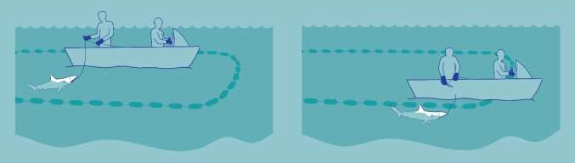
Figure 1. Example of crew members catching a shark inside the purse seine net with a hook and line and releasing it outside the net.

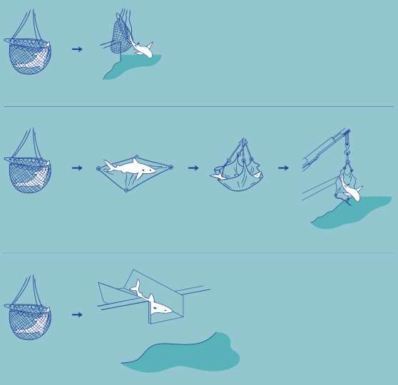

Figure 2. Examples of techniques to release medium or large sharks directly from the brailer to sea (top figure), to a purpose-built large-mesh cargo net or canvas sling, then to sea (middle figure) or to a metal ramp that connects to an opening on the top deck railing (bottom figure).

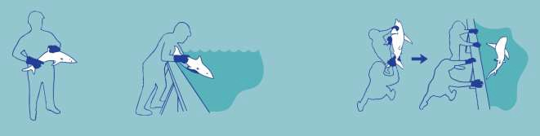

Figure 3. Examples of techniques to handle on deck and release small sharks by either one or two crew members.


Figure 4. Example of use of a stretcher bed to handle and transport sharks that were brought on deck.

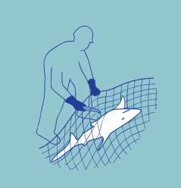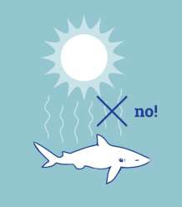
Figure 5. Example of crew member Figure 6. Release sharks to the sea as
cutting the net away from a shark soon as possible.
that was brought onboard entangled
in netting

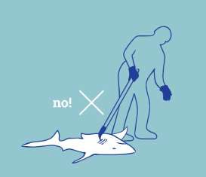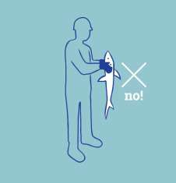

Figure 7. Do not cut or punch holes through Figure 8. Do not insert hands into the gill slits.
the shark’s body. Do not gaff a shark.

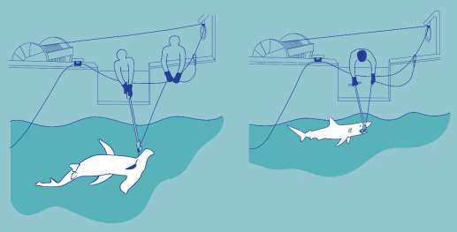
Figure 9. Example techniques to release sharks while they are in the water by using a long-handled line cutter to cut the gear as close to the hook as possible (left) or by using a long-handled dehooker to remove the hook (right).

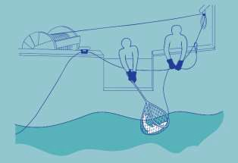
Figure 10. Example of the use of a dip net to bring the shark on board (left) and example of the use of a bolt cutter to remove the hook.

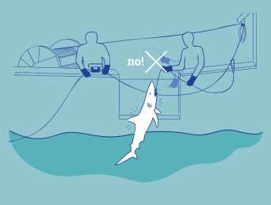

Figure 11. Do not strike a shark against any surface to remove the animal from the line.

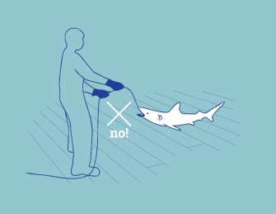
Figure 12. Do not try to remove a hook by pulling sharply on the branchline.

