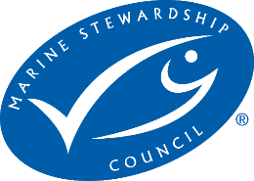

Tiger Prawns (Penaeus esculentus) & Endeavour Prawns (Metapenaeus endeavouri)

Torres Strait Prawn Fishery, Australia

Pre-Assessment Report

Assessor | Peter Trott, FishListic Pty Ltd
Fishery client | Queensland Seafood Industry Association Inc (QSIA)
Assessment type | Pre-assessment
Date | 31 July 2024
Report type | Draft Pre-assessment v3 MSC Fisheries Standard

Contents
Glossary 4
Executive summary 5
Report details 6
Aims and constraints of the pre-assessment 6
Evidence Requirements Framework 6
Version details 7
1. Units of Assessment and Units of Certification 7
2. Pre-assessment outcomes 8
2.1 Overview 8
2.2 Recommendations 8
2.3 Summary of potential conditions by Principle 8
2.4 Summary of Performance Indicator level scores 9
3. Background 10
3.1 Legislation 10
3.2 Fishery boundaries 11
3.3 Gear specifications 11
3.4 Fleet composition 12
3.5 Monitoring 12
3.6 Seasonal/temporal closures 13
3.7 Spatial closures 16
3.8 Effort caps 16
3.9 Harvest Strategy 17
4. Pre-assessment 20
4.1. Principle 1 20
4.1.1. Background 20
4.1.2 UoA species profiles 20
Principle 1 References: 28
Principle 1 Performance Indicator scores and rationales 31
4.2. Principle 2 46
4.2.1. Background 46
4.2.2 Designating species 46
4.2.3 In-scope species 52
4.2.4 ETP/OOS species 53
4.2.5 Habitats 59
4.2.6 Ecosystems 61
Principle 2 References: 61
Principle 2 Performance Indicator scores and rationales 66
4.3 Principle 3 101
4.3.1 Background 101
4.3.2 Legal framework 101
4.3.3 Fishery specific management 102
4.3.4 Consultation, roles and responsibilities 103
4.3.5 Compliance and enforcement 104
4.3.6 Evaluation and management reviews 104
Principle 3 References: 105
Principle 3 Performance Indicator scores and rationales 106
HARMONISATION 118
Template information, copyright and disclaimer 118

Glossary

AFMA | Australian Fisheries Management Authority
B_{MSY} | Biomass at Maximum Sustainable Yield
CSIRO | Commonwealth Scientific and Industrial Research Organisation
CITES | Convention on International Trade in Endangered Species
CMS | Convention on Migratory Species
CoC | Chain of Custody certification
CPUE | Catch per unit of effort
EEZ | Exclusive Economic Zone
ETP | Endangered, Threatened or Protected (species)
F | Fishing mortality rate
FMSY | Fishing mortality rate at Maximum Sustainable Yield
FRDC | Fisheries Research and Development Corporation
FAO | Food and Agriculture Organisation of the United Nations
FCR | Fisheries Certification Requirements (MSC)
HCR | Harvest Control Rule
HS | Harvest Strategy
HMS | Highly Migratory Species
IUCN | International Union for the Conservation of Nature
IUU | Illegal, Unregulated and Unreported
LRP | Limit Reference Point
MSE | Management Strategy Evaluation
MSC | Marine Stewardship Council
MEY | Maximum Economic Yield
MSE | Management Strategy Evaluation
MSY | Maximum Sustainable Yield
NPOA | National Plan of Action
NGO | Non Governmental Organisation
OOS | Out of Scope (species)
PI | Performance Indicator (MSC)
PRI | Point of recruitment impairment (MSC)
PSA | Productivity Susceptibility Analysis
PZJA | Protected Zone Joint Authority
RBF | Risk Based Framework (MSC)
SICA | Scale Intensity Consequence Analysis
SG | Scoring Guidepost (MSC)
TRP | Target Reference Point (B_{target}; F_{target})
TAC | Total Allowable Catch
TACE | Total Allowable Commercial Effort
TSPF | Torres Strait Prawn Fishery
TSPZ | Torres Strait Protected Zone
UoA | Unit of Assessment (MSC)
UoC | Unit of Certification (MSC)
VMS | Vessel Monitoring System

Executive summary

This report contains the results of a Marine Stewardship Council (MSC) pre-assessment of the Units of Assessment (UoA): Tiger prawns and Endeavour Prawns caught by the Torres Strait Prawn Fishery.
The pre-assessment was undertaken by consultation of FishListic Pty Ltd for the client Queensland Seafood Industry Association (QSIA). To our knowledge, this is the first time that this fishery has undergone a pre-assessment against any MSC Fisheries Standard, and this is the first pre-assessment using the updated Version 3.0 of the MSC Fisheries Standard. This pre-assessment was conducted primarily through robust desktop-based analysis, drawing on data and information directly from fishery sources, QDAF sources, scientific literature, and third-party expertise and experience. This information was used to assess the UoA against the MSC Fisheries Standard and Guidance V3 using a modified MSC pre-assessment template. Supporting the pre-assessment was the MSC Certification Processes and Guidance. It should be noted that site visits were not conducted but some stakeholder communications were possible to be conducted as part of this pre-assessment process.
As of 31 July 2024, the UoAs met the MSC Fisheries Standard. There are no Performance Indicators that did not meet the SG 60 benchmark (Table 3). A full list of the recommendations to meet the SG 80 bench mark for each scoring issue has been provided, although at a high level, the current shortfalls/deficiencies in the UoA might be rectified when/with —
- a greater understanding of stock structure of Blue Endeavour Prawns relative to different fishery management zones (e.g., TSPF, NPF and northern ECOTF). At present the stock assessment for this UoA is out of date, but updated assessments are available for other zones and can not be used for this UoA.

- further evidence that Tiger Prawns are an appropriate ‘indicator species’ for Endeavour prawns.

- improved observer coverage. The level of regular monitoring needs to be extended to more than one vessel per season. The HS outlines the desired level of 2.6% although there is no information on the minimum number of vessels.

- updating of the Ecological Risk Assessment (ERA) to a Level 2 assessment as recommended in the WTO approval. Particular attention needs to be given to those discard species that make up ≥5% of the total catch (i.e., Red-spot Monocle Bream).

- updating the Bycatch and Discarding Workplan as discussed by the TSPMAC and it should include species identified as moderate-high risk in the updated ERA and any species that make up ≥5% of the total catch.

- inclusion of Narrow Sawfish into formal management strategy. It is not included in the current Recovery Plan and cumulative impacts of prawn fisheries needs to be considered further.

Report details

Aims and constraints of the pre-assessment

The aim of this project was to undertake a confidential pre-assessment against the MSC Fisheries Standard version 3.0 to identify the main strengths and weaknesses of the various fishery units of assessment, and the extent to which the fishery is consistent with the MSC Fisheries Standard; this report is for Unit of Assessment (UoA) 1: Tiger prawns and UoA 2: Endeavour Prawn by the Torres Strait Prawn Fishery.

This report is a pre-assessment and does not attempt to duplicate a full assessment against the MSC Fisheries Standard. A full assessment involves a group of assessment team members and public consultation stages that are not included in a pre-assessment. A pre-assessment provides a provisional assessment based on information provided by the client.

Evidence Requirements Framework
Under v 3 of the MSC FS, it is compulsory to use the ‘Evidence Requirements Framework’ (ERF) to assess the quality of information used in the assessment, and to score several Performance Indicators (Table ERF 1). The ERF provides a framework to evaluate the “trueness,” and “precision” of information used and provides “guideposts for trueness and precision of information”. The Trueness Guideposts (TG) provide a framework for evaluating how much bias the information might have and whether that bias may be affecting the trueness of information. The ERF explains what information should be considered in the evaluation of trueness against the guideposts and provides a series of criteria used to structure the evaluation of information trueness. The precision of information must also be evaluated to determine which of the precision guideposts (PG) are met.

This pre-assessment provides some information relevant to the ERF at the appropriated scoring issues (Table ERF 1), noting that SG 100 is not scored during a pre-assessment.

Table ERF 1. Determination of the scoring guidepost (MSC Fisheries Toolbox)
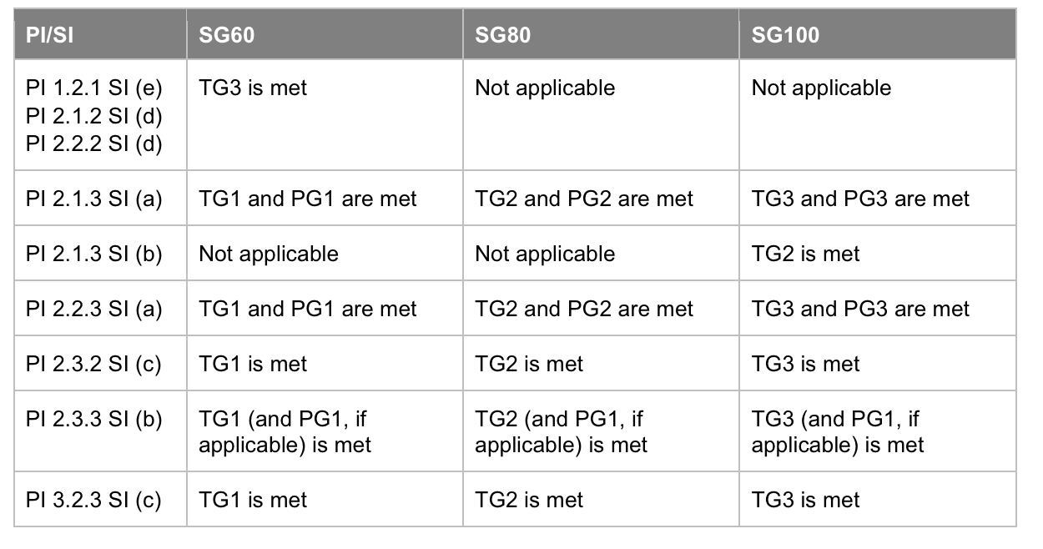
The ERF requirements are demanding and often require robust verification, validation and recent data to satisfy the guideposts. It is likely that the ERF could be challenging to the fishery. Based on current information regarding the fishery, its operations and data/information collection systems, a draft evaluation has been conducted to provide some level of insight into the expectations of MSC for the fishery under V3.0 and identifies areas that could be challenging for an unconditional pass (SG 80).

This pre-assessment report is for two UoAs from the same fishery (UoAs 1–2). The entire project included the assessment of numerous species from various zones of the ECOTF and Torres Strait region.

Version details

Table 1: Fisheries program documents versions
Document/Assessment Tree | Version number/Type
MSC Fisheries Certification Process (Guidance) | Version 3.0 (26/10/22, effective 01/05/23)
MSC Fisheries Standard | Version 3.0
Assessment tree | Default
MSC General Certification Requirements | Version 2.5
MSC Reporting Template | Version 1.3
MSC Pre-Assessment Reporting Template | Version 3.3

Units of Assessment and Units of Certification

The project included 12 UoA from various zones within the ECOTF and Torre Strait Prawn Fishery. This is the assessment report for UoA 1 Tiger prawns and UoA 2 Endeavour Prawn from the Torres Strait Prawn Fishery.

Fishers operating in the Fishery have no conviction listed for a serious crime, shark-finning violation or forced/child labour.

Table 2. Units of Assessment (UoA)
UoA 1 | Description
Target Stock | Tiger Prawn  - Brown, Penaeus esculentus;
Geographical area | Torres Strait Prawn Fishery
Fishing gear type(s) and, if relevant, vessel type(s) | Triple/Quad Demersal Otter Trawl
Client group | Queensland Seafood Industry Association
Other eligible fishers | TBA
Justification for choosing the Unit of Assessment | This UoA separated from the other 11 UoAs as the fishery operated in a different zone, with a different level of interaction and harvest strategy. This UoA was separated from UoA 2 as it is a different species.

UoA 2 | Description
Target Stock | Endeavour Prawns  - Blue, Metapenaeus endeavouri
Geographical area | Torres Strait Prawn Fishery
Fishing gear type(s) and, if relevant, vessel type(s) | Triple/Quad Demersal Otter Trawl
Client group | Queensland Seafood Industry Association
Other eligible fishers | TBA
Justification for choosing the Unit of Assessment | This UoA separated from the other 11 UoAs as the fishery operated in a different zone, with a different level of interaction and harvest strategy. This UoA was separated from UoA 1 as it is a different species.

Pre-assessment outcomes

2.1 Overview
Based on the current information made available to the assessment, as well as the current management regime that is in place, at present, the UoAs would likely meet the MSC Fisheries Standard v 3.0 with conditions.

2.2 Recommendations
To address the shortfalls identified above, the following is recommended:
Principle 1
Harvest Strategy
    - a) Provide evidence that the harvest strategy is responsive to the state of the Endeavour prawn stock.
1.2.3 b) Stock abundance and UoA removals of Endeavour prawns are monitored at a level of accuracy and coverage consistent with the harvest strategy.
1.2.4 b) The assessment of Blue Endeavour prawns estimates stock status relative to reference points.

Principle 2
In- scope species
2.1.2 b) Provide some evidence that the partial strategy is achieving the objectives for main in-scope species (i.e., discard species), such evidence should be based on the UoA and the species involved.
2.1.2 c) Implement a periodically review (≤ 5 years) of alternative measures to minimise UoA- related mortality of unwanted discard species.
2.1.3 a) Obtain adequate information to estimate the impact of the UoA on the stock status of probable main in-scope species (i.e., discard species if they constitute ≥5% total catch) with a high degree of accuracy.
2.1.3 c) Ensure that the information for probable main in-scope species (i.e., discard species) is adequate to support a partial management strategy.
ETP species
2.2.3 b) Ensure adequate information is available to support an ETP management strategy that includes the measurement of trends to evaluate the effectiveness of measures in place to minimise mortality.

2.3 Summary of potential conditions by Principle

Table 3. Summary of Principle level scores for UoAs 1 & 2 Torres Strait Prawn Fishery.
 | Principle of the MSC Fisheries Standard | Number of PIs with draft scoring range < 60 | Number of PIs with draft scoring ranges 60–79
UoA 1 Tiger prawns | Principle 1 – Stock status | 0/5 | 0/5
UoA 1 Tiger prawns | Principle 2 – Minimising environmental impacts | 0/12 | 3/12
UoA 1 Tiger prawns | Principle 3 – Effective management | 0/7 | 0/7
UoA 2 Endeavour prawns | Principle 1 – Stock status | 0/5 | 3/5
UoA 2 Endeavour prawns | Principle 2 – Minimising environmental impacts | 0/12 | 3/12
UoA 2 Endeavour prawns | Principle 3 – Effective management | 0/7 | 0/7

Summary of Performance Indicator level scores
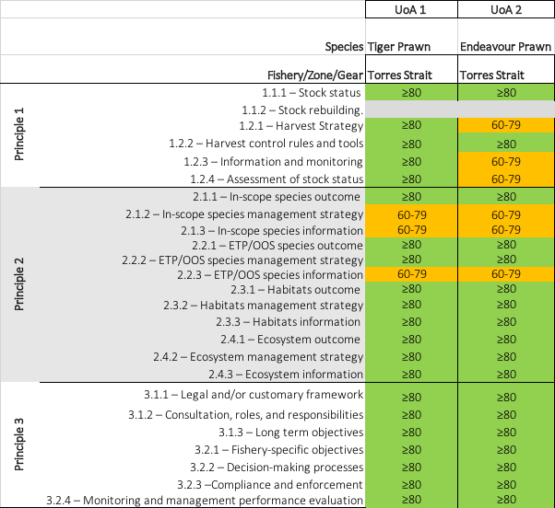

Background

3.1 Legislation

The TSPF operates in the eastern part of the Torres Strait. The fishery is shared by Australia and Papua New Guinea (PNG) under formal arrangements in the Torres Strait Treaty. The Australian component of the fishery is managed by the Torres Strait Protected Zone Joint Authority (PZJA), established under the Torres Strait Fisheries Act 1984 (Cth). Currently, all licences in the fishery are held by the non-Indigenous Transferable Vessel Holder Sector.

Under the Torres Strait Treaty, PNG is entitled to 25% of the TSPF resource in the Australian jurisdiction (excluding the effort in the ‘outside but near area’), and Australia is entitled to 25% of the TSPF resource in the PNG jurisdiction (Cocking, 2016). Historically, some Australian boats fished in PNG waters, but this ceased soon after the Torres Strait Treaty was ratified. There is no official record of PNG boats fishing in Australian waters, and PNG operators have only sporadically activated their entitlements to fish in their own waters of the TSPF.

Relevant fisheries legislation
- Torres Strait Fisheries Act 1984
- Torres Strait Fisheries Regulations 1985
- Torres Strait Fisheries (Torres Strait Prawn Fishery Total Allowable Effort Determination 2020)
- Torres Strait Prawn Fishery Management Plan 2009
- Torres Strait Prawn Fishery (Bycatch Reduction Devices) Instrument 2024

Other relevant legislation
- Marine Parks Act 2004;
- Environment Protection and Biodiversity Conservation Act 1999;
- Environment Protection and Biodiversity Conservation Regulations 2000

An outline of fishing operations is available online at: https://www.pzja.gov.au/commercial-fisheries-management/torres-strait-fisheries/torres-strait-prawn-fishery

Protected Zone Joint Authority (PZJA)
The PZJA comprises the Federal and State (Queensland) Ministers responsible for fisheries, and the Chair of the Torres Strait Regional Authority (TSRA). The PZJA is responsible for making decisions relating to PZJA fisheries, however many day to day decisions have been delegated to the PZJA agencies, improving management efficiencies and the ability to make timely decisions and management responses.

The Torres Strait Scientific Advisory Committee's (TSSAC) main role is to advise the PZJA on the strategic directions, priorities and funding for research relevant to meeting information needs and objectives of the PZJA and its relevant consultative bodies. The TSSAC includes members from each of the three main Protected Zone Joint Authority (PZJA) agencies (the Australian Fisheries Management Authority, the Torres Strait Regional Authority and Fisheries Queensland), industry members and scientific research members. The most recent TSSAC meeting with publicly available minutes was in April 2022. A 5-year research plan was available for all Torres Strait fisheries; it specified the research priorities and strategies that the PZJA intended to pursue, and provided background to the processes used to assemble and assess research proposals. Although the date on the research plan (2018–2023) has now closed, the advisory forums are required to review and update the fishery research plan annually so that the plan will always have a five year projection and remains current.

The Torres Strait Prawn Management Advisory Committee (TSPMAC) is made up of representatives from government, non-traditional inhabitant industry members, traditional inhabitant industry members, research experts and independent chair. The most recent meeting of the TSPMAC with publicly available minutes was in November 2022. At the January 2020 meeting, the Harvest Strategy Working Group discussed the use of effort triggers and the recommendation to move to CPUE (biomass proxy) triggers in the future. In July 2024, the new HS was released and included use of CPUE triggers.

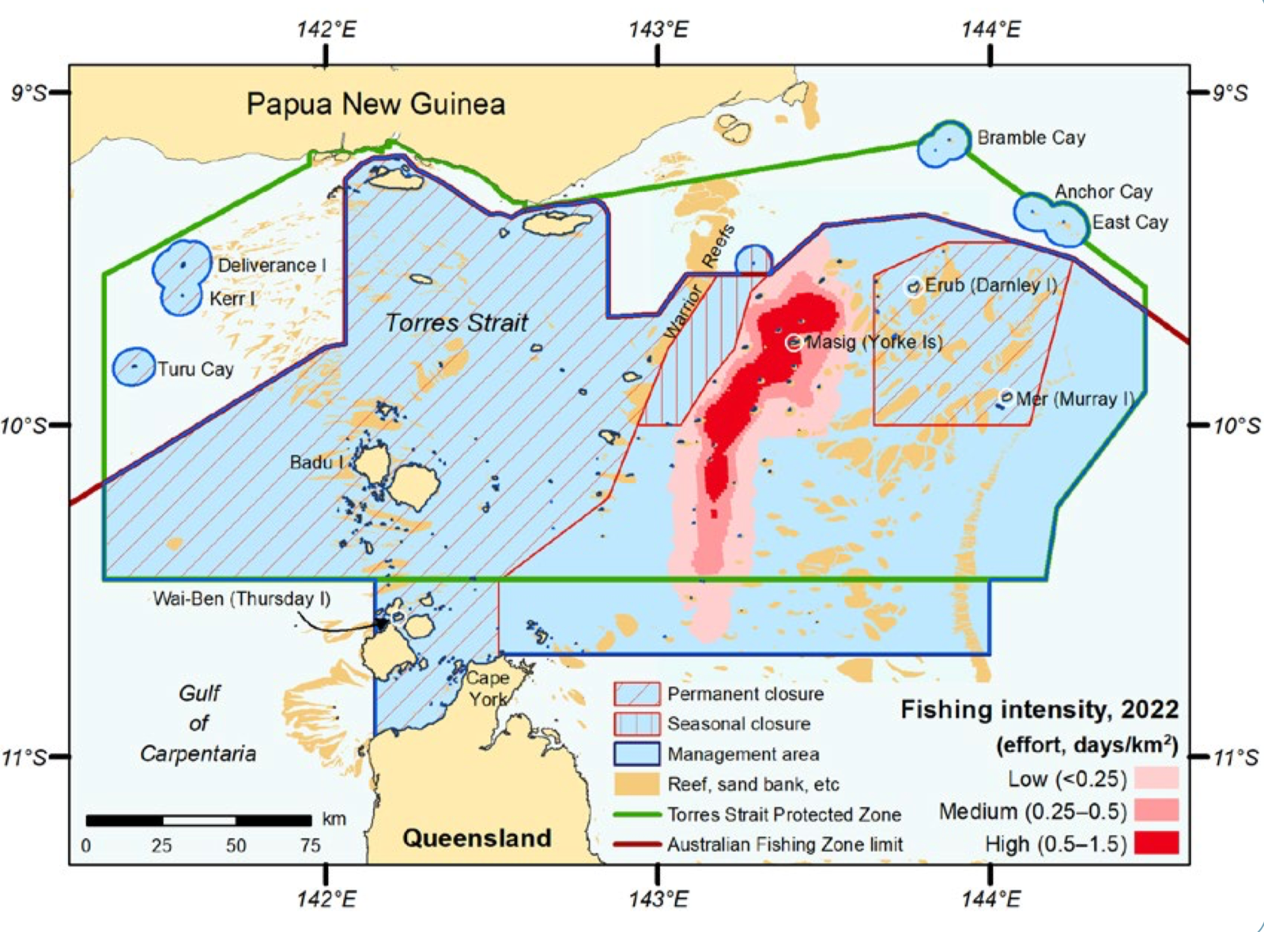
Figure 1. Fishing intensity of the Torres Strait Prawn Fishery in 2022 (Butler et al. 2023).

3.2 Fishery boundaries

The Torres Strait Prawn Fishery (TSPF) operates in the eastern part of the Torres Strait Protected Zone (TSPZ) and south of the TSPZ in nearby Queensland waters (called the ‘outside but near area’) (Figure 1).

3.3 Gear specifications

The TSPF is a multi-species prawn fishery which operates in the eastern part of the Torres Strait. Brown tiger prawns (Penaeus esculentus) and Blue endeavour prawns (Metapenaeus endeavouri) are the key target species. Red Spot king prawns (Melicertus longistylus), Moreton Bay bugs (Thenus spp), scallops (Amusium spp), slipper and shovel-nosed lobster (Scyllaridae) and squid (Teuthooidea) are taken as by-product (Turnbull and Cocking, 2022). Prawns are harvested using demersal otter trawl (prawn trawl) in the evening. Fishers usually deploy four nets divided into 2 pairs (i.e., quad-gear), with a pair of nets towed from a boom on each side of the fishing vessel. Trawl tows last between 2.5 and 4 hours at an average speed of around 3 knots. On average, fishers complete 3 or 4 tows per night (DSEWPaC 2013; Turnbull et al. 2007).

Bycatch Reduction Devices and Turtle Exclusion Devices

Bycatch reduction devices (BRD)s are mandatory in the fishery (Fisheries Management Notice 82), and must be recorded in specific gear logbooks (AFMA 2008). A new notice came into force on 20 June 2024 varying the types of BRDS allowed in the fishery. The six new BRDs include: Fisheye; Bigeye; Tom’s Fisheye; Kon’s Covered Fisheyes; FishEX 70; Popeye Fishbox. Each have different features that were designed to exclude specific bycatch species.

Turtle excluder devices (TEDs) are also mandatory and the design used is recorded in specific gear logbooks (AFMA 2008). A significant amount of research has been conducted in the northern prawn fisheries on the mitigate of ETP species interactions with the use of BRDs/TED. The use of TEDs is also a requirement of exporting prawns (shrimp) to the United States of America and the TSPF is listed as registered fishery under that certification.

Fleet composition

In 2022, there were 22 vessels operational in the TSPF (Turnbull & Cocking, 2023). Vessels and Operators may be “dual endorsed” to fish in the Northern Prawn Fishery or East Coast Otter Trawl Fishery.

Monitoring
The commercial fisher in control of the fishing operation is responsible for meeting the reporting requirements. The Bycatch and Discarding Work Plan outline how each component of the fishery is monitored:

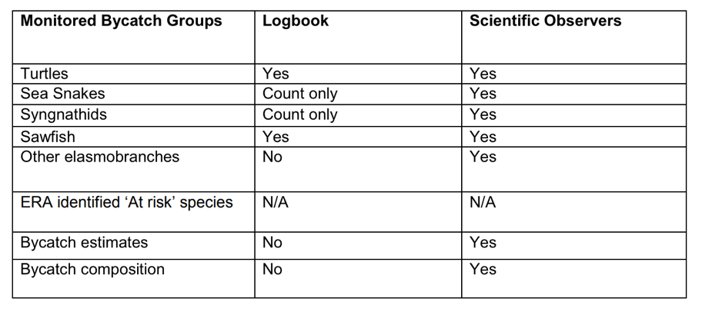

Logbooks
TSPF fishers are required to report retained species, gear, and fishing location in daily logbooks that are used for both the TSPF and the Northern Prawn Fishery (Figure 2). Logbooks are available in electronic form of paper form (Northern and Torres strait Prawn fisheries Daily fishing Log NP 16).

Vessel Monitoring System (VMS)
Since 2005, fishing activities (location and intensity) are also monitored by VMS. A boat is recorded to be fishing if it moves more than 250 m at any time between 1800 local time on that day and 0600 on the next day, and/or isn’t within a designated anchorage, and/or if the VMS system is failing to poll (Turnbull & Cocking, 2022). Annual catch summary reports are publicly available.

Independent Observer Program
The TSPF observer program aims to complete observer days which equate to 2.6% of the actual effort that occurs in the fishery each season. As observer days are budgeted based on financial year, not season (calendar year), AFMA monitors days to achieve the target as closely as possible. In 2020, AFMA prioritised observer deployments on high priority and/or high-risk trips as a primary mechanism to mitigate the risk of observers contracting and/or spreading COVID-19. In 2021, deployments continued to be disrupted due to restricted movement within Australia, in particular into remote and vulnerable communities. The TSPMAC reviews and discusses observer data, and discussions are publicly available in meeting minutes (Butler et al. 2023). Between 2007 and 2022, 22 different vessels have hosted observers, although in the recent three year (2019–2022), only one vessel hosted an observer each year, whereas 2016–2018 each had three different vessels.

Nine ‘Species of special interest’ were defined by traditional inhabitant members of the TSPMAC. Interaction with these species and ETP species are a primary objective of the observer program.

Research surveys
The TSPF has been well studied:
- Stobutzki et al. (2000) – composition, volume, and sustainability ranking
- Ellis et al. (2008) – Ecosystem based management options for the TSPF.
- Pantus et al. (2007) – MSE for effects of trawling
- Pitcher (2013) Environmental sustainability assessment of TSPF
- Turnbull & Rose (2007) – ERA Level 1

Seasonal/temporal closures

The fishing year starts on 1 Feb and concludes at the end of December.

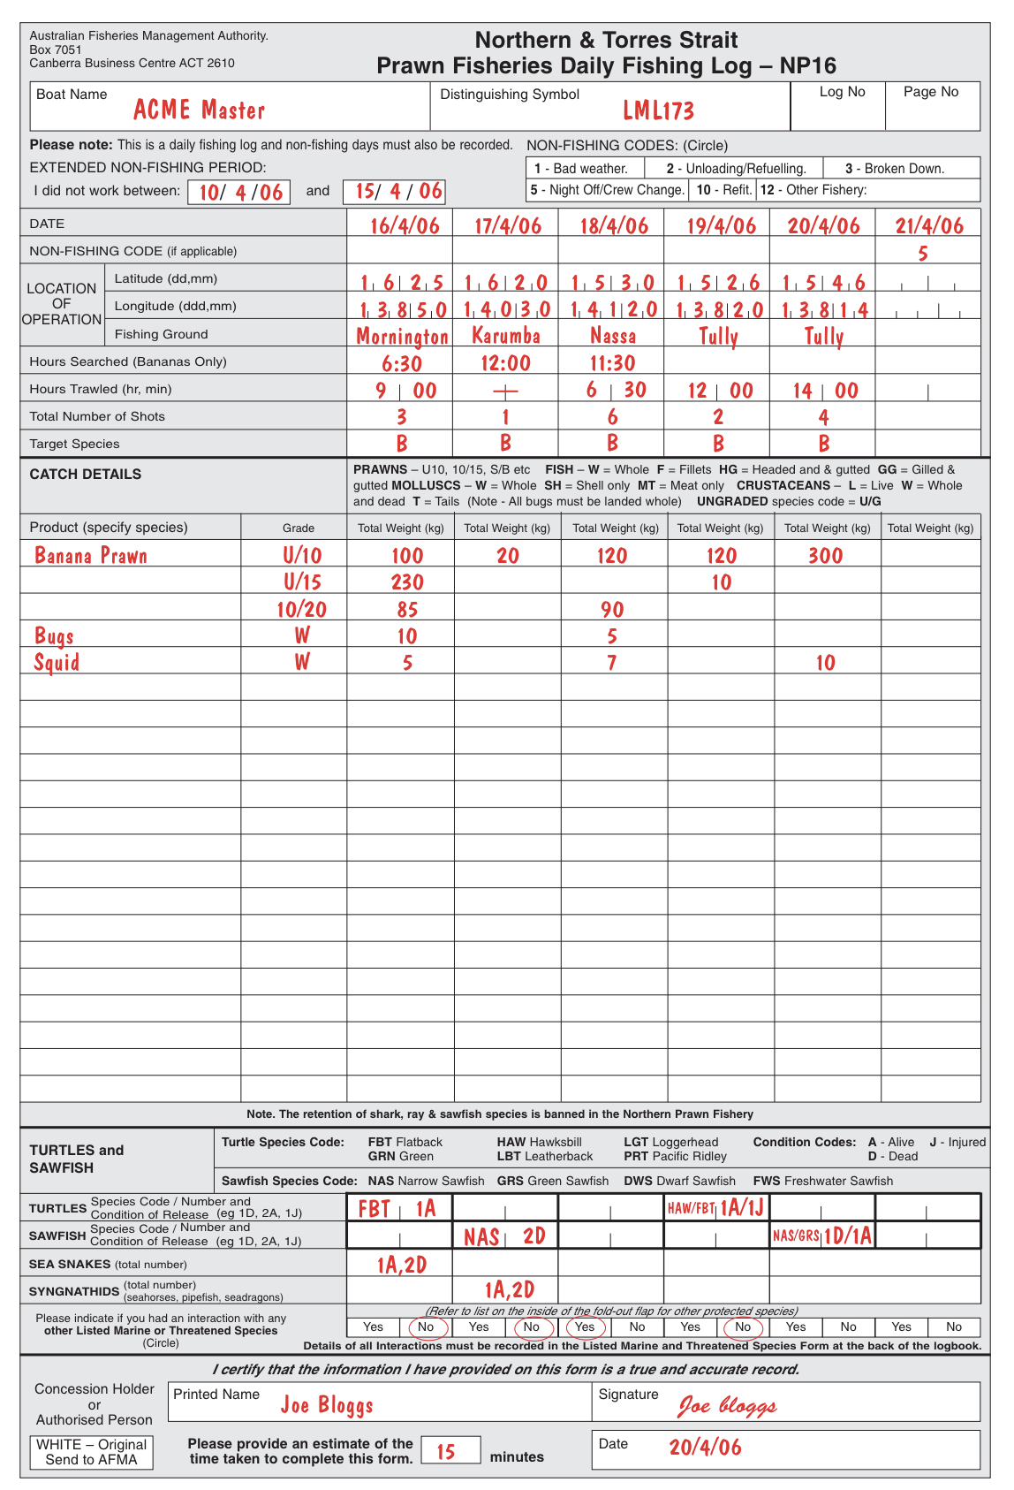
Figure 2. Commercial logbook example for Northern Prawn (including Torres Strait Prawn Fishery) that includes date, location, catch details and some of the more common ETP species (Source: AFMA 2008)
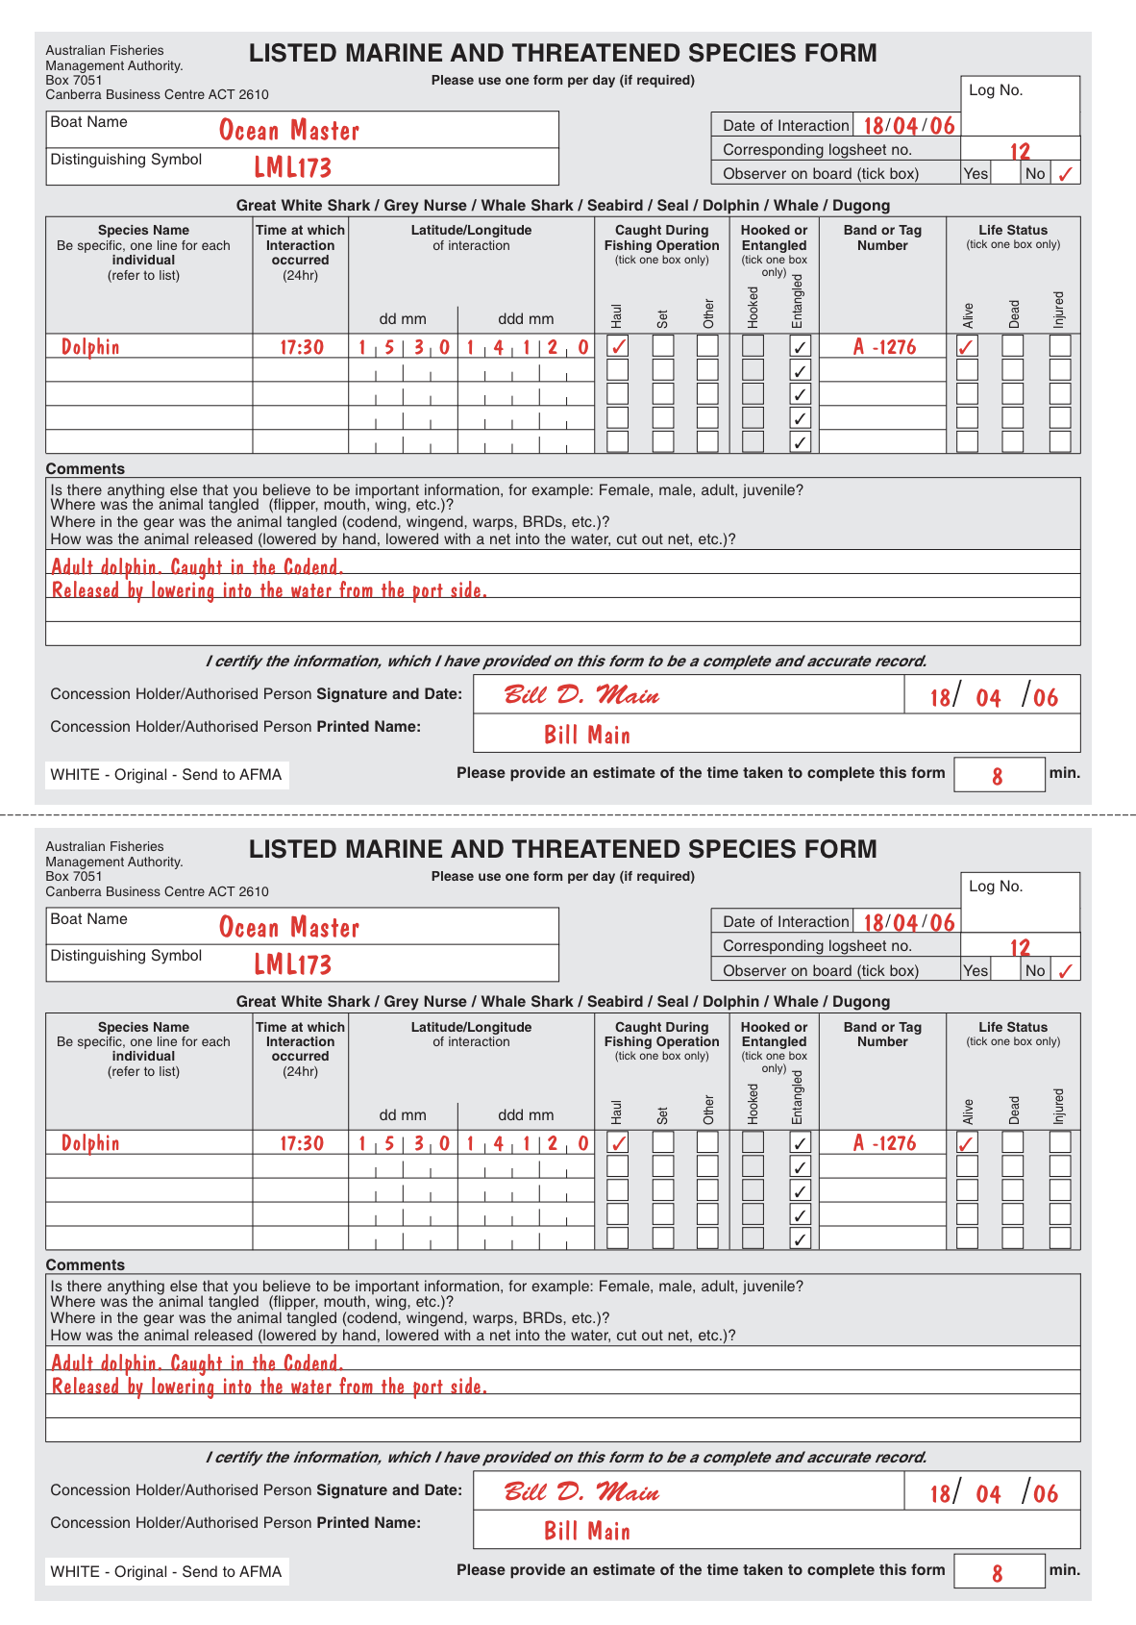
Figure 3. ETP interaction logbook for the northern prawn fisheries (including the Torres Strait Prawn Fishery). Common ETP species interactions are recorded on the daily logbook at Figure 2 (Source: AFMA 2008)

Spatial closures
Within the Torres Strait Prawn Fishery there are both seasonal and permanent area closures (Figure 4). These closures were in response to i) protection of undersized tiger prawns; ii) protection of pearl shell beds; and iii) protection of breeding populations of marine turtles (Butler et al. 2023). Trawl exclusion zones were implements in 2008 around Deliverance Island, Kerr Islet and Turu Cay to protect important nesting areas of Green turtle and Flatback turtle (TSRA, 2015).
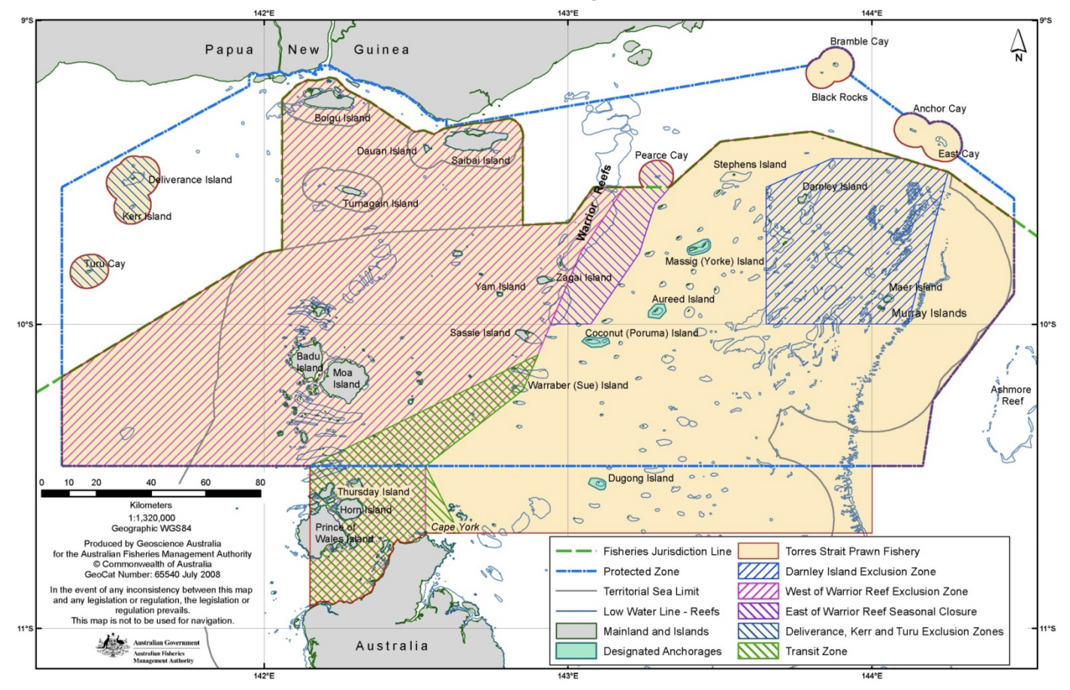Figure 4. Torres strait Prawn Fishery listing spatial closures (PZJA, 2023)

3.8 Effort caps
Fishing is limited by a Total Allowable Effort (TAE) in the form of total annual fishing days. This is the total number of days that could be fished by all licenced boats each year. The fishery currently operates well under the TAE limit each year, ranging between approximately 900 and 2700 fishing nights each season since 2016. The TAE limit must be set and determined by the PZJA at least every three years in the TSPF (S2.5 of the Torres Strait Prawn Fishery Management Plan 2009). The TAE was last set in 2023 to apply for the 2024, 2025 and 2026 fishing seasons.

The TAE applies to the 60 licences in the TSPF. The TAE is divided among these licences based on the number of effort units held by each licence holder (9,200 units total in the fishery) in accordance with a formula that is in S4.3 of the Plan).

According to logbook data, in 2022 the effort was 1,303 days, slightly up from 1,285 days in 2021. Effort in 2019 was 2,632 days and the recent decline is likely to be in response to the COVID-19 pandemic, coupled with rising running costs (Turnbull & Cocking 2023; Figure 5).
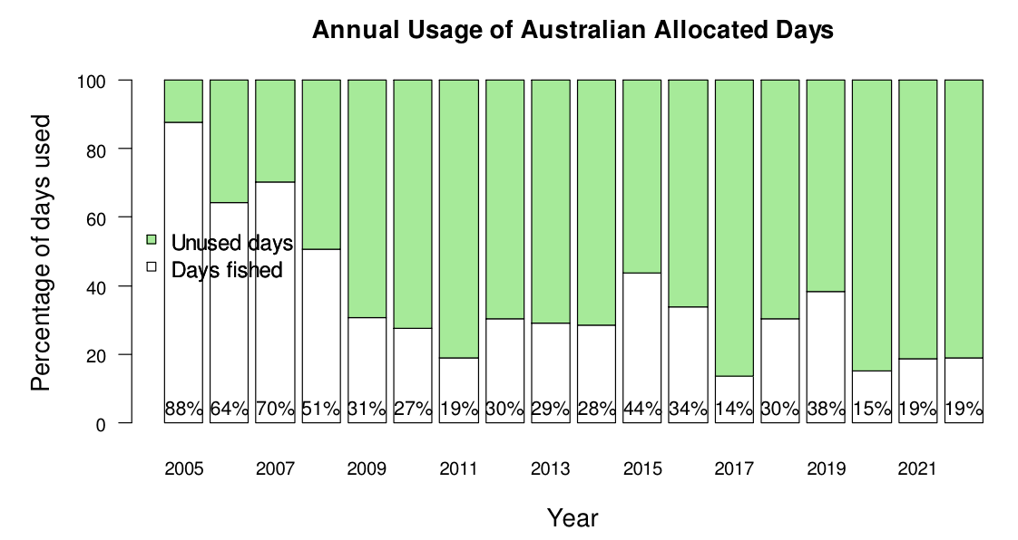

Figure 5. Proportion of the total TSPF Australian allocation (total of 6,867) of fishing days fished in each season since 2005 (Turnbull & Cocking, 2023)

3.9 Harvest Strategy
In 2010, the Torres Strait Prawn Fishery Harvest Strategy was developed and it was introduced in 2011. It’s development and implementation followed the guidance of the Commonwealth Fisheries Harvest Strategy Policy (2007). The HS was recently updated in July 2024, and was guided by the 2018 Commonwealth Harvest Strategy Policy (CHSP) and is consistent with objectives of the Torres Strait Fisheries Act 1984 (the Act) and the Torres Strait Prawn Fishery Management Plan 2009 (the Plan).
The key objective of the HS is to maximize the profitability of the fishery and minimize any management impediments that affect the economic efficiency of fishers within biologically sustainable limits. As such, the TSPF Harvest Strategy was designed to facilitate a move towards B_{MEY} when effort and economic viability in the fishery has increased.
This key objective is achieved through reviewing management regimes including input controls and monitoring their value in the fishery with respect to achieving objectives outlined in both the Torres Strait Fisheries Act 1984 and the TSPF Management Plan 2009.
The 2024 harvest strategy defines a set of trigger, target and limit reference points, and decision rules for the whole fishery, primarily based on Tiger prawn. Nominal CPUE is closely aligned with standardised CPUE for the TSPF Tiger prawn stock and is considered a very reliable indicator of abundance for TSPF tiger prawn stocks (Penney, 2019; Turnbull, 2019). A catch trigger is also in place for Endeavour prawn. Reference points are:
Target Reference Point: A biomass target at a nominal CPUE of 141kg/boat day, which corresponds to 60% of unfished biomass (0.6B₀). This level reflects the recent catch rates in the fishery.

Precautionary Reference Point Trigger: A biomass trigger at a nominal CPUE of 93kg/boat day which corresponds to 40% of unfished biomass (0.4 B₀). Triggering this precautionary relative biomass level (BPA – precautionary approach) would indicate that the stock has moved away from the target and is more than half way towards the limit reference point (0.25B₀). At this point further investigation would be required to confirm the decline in CPUE, determine reasons for this decline and consider management action to prevent further declines and ensure a return to target levels.

Limit Reference Point: A biomass limit trigger at a nominal CPUE level of 58 kg/boat-day, corresponding to 25% of unfished levels (0.25B₀). If triggered, the stock would be assumed to have declined to the limit reference point and immediate management action would be needed to halt further declines and to take
corrective action to increase the stock. This limit reference point has been set above the default limit under the harvest strategy policy, to build extra precaution into the triggers.

Fixed Total Allowable Effort Limit: With the introduction of the CPUE based management triggers, the 2024 harvest strategy maintains a fixed effort Total Allowable Effort (TAE) at the current E_{MSY} level (9,200 days). Under the requirements of the Torres Strait Prawn Fishery Management Plan 2009 (the Plan), the TAE is reviewed at least every three years 1 by the PZJA. Under the harvest strategy, the TAE would also be reviewed if the CPUE triggers are breached. The introduction of the CPUE based triggers within this harvest strategy adds additional precaution and ensures that the stock is monitored regularly against reference points and triggers and with annual reviews of CPUE based indicators.
The new harvest strategy does not set specific objectives, trigger points and decision rules to manage the Endeavour prawn (secondary target species) and the Red Spot King prawn (by-product species) stocks. These stocks are considered to be indirectly managed due to the stock overlap and relationship to the Tiger prawn species, and Tiger prawn being a more “sensitive” species to exploitation. More specific objectives are divided by category: biological, economical and social.
Biological objectives
To ensure tiger prawn stocks are maintained around the target reference point, 0.6B₀, as a proxy target for B_{MEY}. The agreed B_{TARG} is more precautionary than the proxy B_{MEY} (biomass at maximum economic yield) of 0.48B₀ as outlined in the HSP.
To maintain all stocks above the limit biomass level (B_{LIM}), of 0.25B₀ at least 90 percent of the time. The agreed B_{LIM} is more precautionary than the proxy of 0.2B₀ as outlined in the HSP.

The new HS states that: “separate triggers and reference points have not been set to monitor performance against the objectives for endeavour and red spot king prawns, because the Tiger and Endeavour prawn stocks have a very large spatial overlap. When species overlap to this extent, it is not possible to set different effort limits for the different species, as both species are caught within the same shot.”
Economical objectives
- Maintain catch rates at or around current levels, which equate to 0.6B₀, which deliver good economic returns.
- Minimise the risk of catch rates dropping below economically viable levels (B₄₀).

Short term economic objective
- To establish conservative trigger events which minimises the risk of overshooting the value of B_{MEY}.
- Not allowing the TAE to be set at a level above 9,200 fishing days before trigger one (1) is reached under section 6.2 and an accurate value of B_{MEY} is calculated.
Long Term Economic objective
- To ensure that the Tiger prawn stock is maintained, on average, at B_{MEY}. This objective will not be pursued until the research trigger (trigger one) is hit under section 6.2.
In setting a short term target of B_{MSY} with a long term target of B_{MEY}, the harvest strategy aims to move the TSPF to B_{MEY} when effort in the fishery increases.
Social objectives
- Maintaining a viable and flexible fishery to provide employment opportunities.
- Ensure that the issues of significance to the traditional sector are considered when setting the TAE for the fishery, as per the TSPF Plan and Torres Strait Fisheries Act objectives.
Evaluation, Reviews and Updates
The Commonwealth Fisheries Harvest Strategy Policy (2007) specifically requires that a Management Strategy Evaluation (MSE) be conducted to demonstrate that the 2011 harvest strategy was robust to the uncertainty inherent in the assessment and management of the respective fishery. Turnbull (2020) conducted a Management Strategy Evaluation of the potential impact of varying the season opening date over a three-month period (1st February to 1st April) on the economics of the fishery and the tiger prawn stock. This was achieved by simulating the fishery opening on the 1st February, 1st March and 1st April using a number of monthly fishing patterns and two levels of annual fishing effort. A sensitivity analysis of the effect of the timing of prawn recruitment was done by running the simulations with the recruitment pattern shifted one month earlier and one month later.
The procedure for reviewing the HS is contained within the HS. The HS has a five year review period, providing effort in the TSPF does not reach any of the triggers. Under certain circumstances, it may be necessary to amend harvest strategies in between reviews. These HS lists the appropriate circumstances to amending the HS, namely:
- the precautionary or trigger limit is breached.
- there is new information that substantially changes understanding of the status of a fishery, leading
- to improved estimates of indicators relative to reference points.
- drivers external to management of the fishery increase the risk to fish stock/s.
- it is clear the strategy is not working effectively, and the intent of the Harvest Strategy Policy is not being met
Further explanation on amendments can be found in Section 15 of the Commonwealth Harvest Strategy Policy Guidelines when the consultative and technical processes for amending harvest strategies are clearly defined.
Butler et al. (2023) noted that “The harvest strategy is currently being updated, with changes being proposed to targets and limit reference points. Community and industry engagement on the updated harvest strategy began in 2022 and the harvest strategy should be finalised in 2023 (AFMA 2023, pers. comm. 4 July”. The HS was released in July 2024 and as such a new MSE has not yet been conducted.

Pre-assessment

Principle 1

Background
The default Principal 1 decision tree (Figure 6) was used for this assessment.
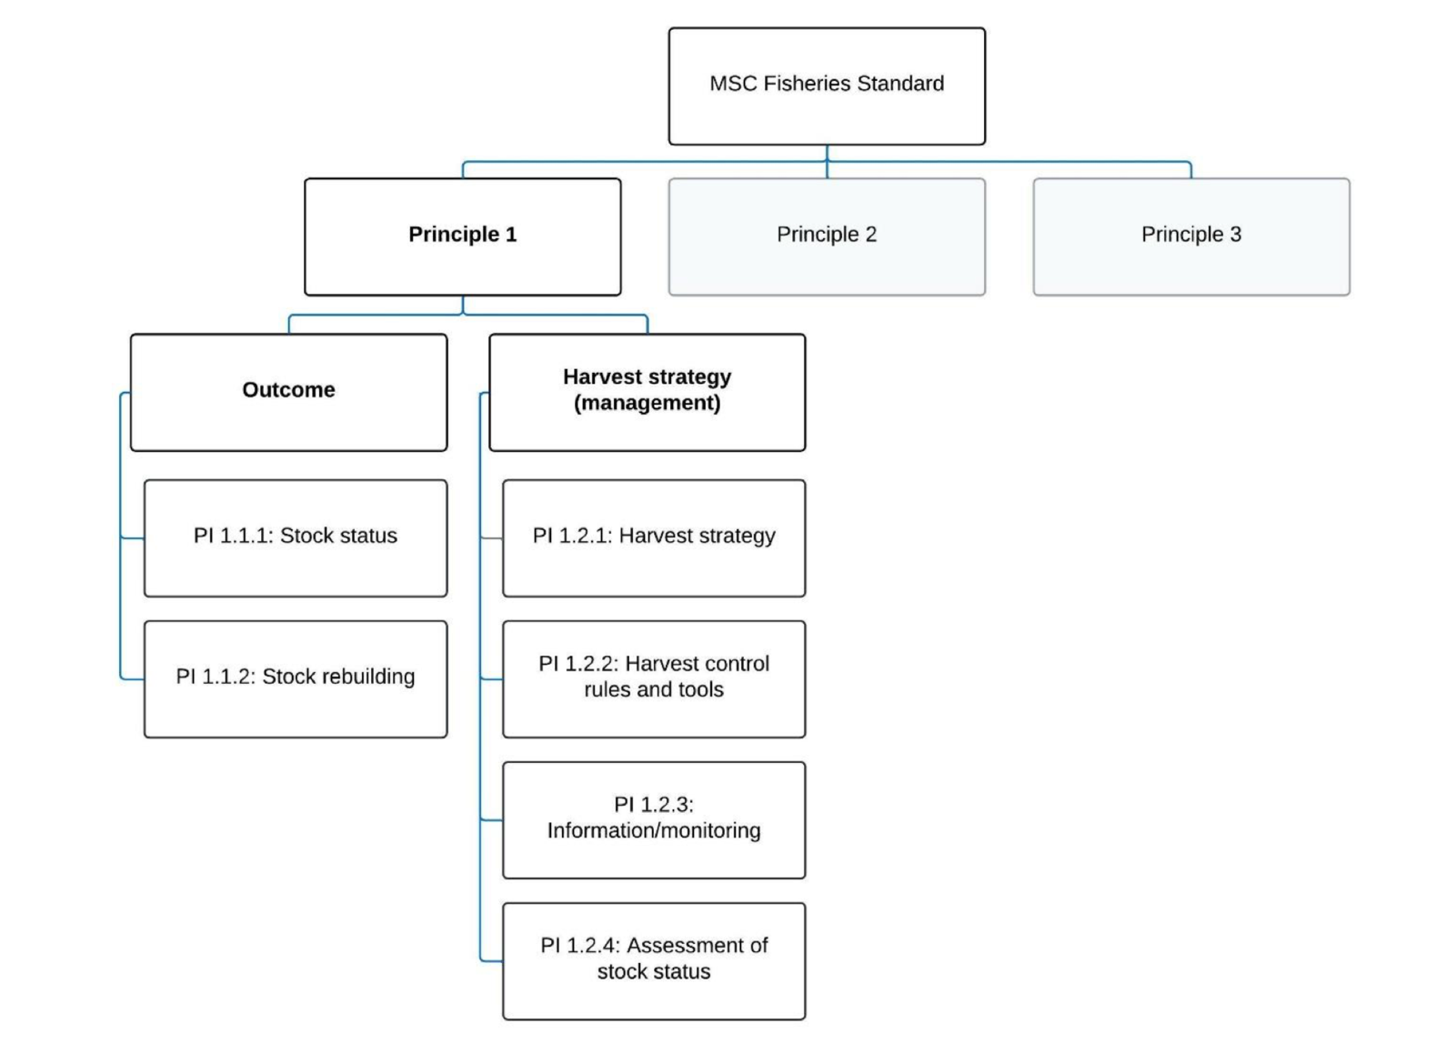
Figure 6. Decision tree for Principle 1 (MSC Fisheries Standard v3.)

4.1.2 UoA species profiles

4.1.2.1 Catch history

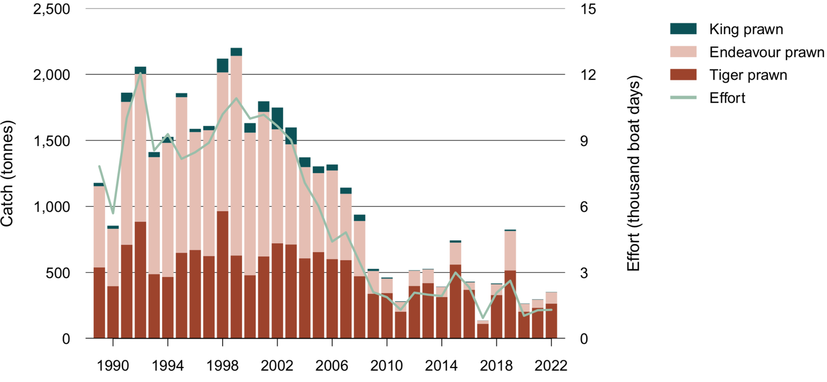

Figure 7 Prawn catch by species, and fishing effort, in the TSPF, 1989 to 2022 (Butler et al. 2023).

Table 6. Logbook (and VMS) data from the Torres Strait Prawn Fishery 2019–2022 (Cocking, 2023)
 | Data per year
 | 2019 | 2020 | 2021 | 2022
Number of vessels | 28 | 15 | 20 | 22
Days fished | 2652 | 1087 | 1336 | 1314
UoA 1 Tiger prawn catch (t) | 515 | 203 | 221 | 265
UoA 2 Endeavour prawn catch (t) | 298 | 60 | 60 | 87

Tiger prawns

In the TSPF, Tiger prawns is a collective term for two species: Brown tiger (Penaeus esculentus; and Grooved tiger (P. semisulcatus), although Brown Tiger Prawn make up the bulk of the catch.

Catch of Brown Tiger Prawn have fluctuated over time, closely linked to effort and ranging from a high of 965 t in 1998 to a low of 111 t in 2017. Catch has recently increased to 329 t in 2018 and 515 t in 2019. Between 2019 and 2022, the UoA’s total retained catch of Tiger prawns averaged 301 t per year (Table 6). Since 2007, catches have remained below MSY (617 t) although mean CPUE began to steadily increase in the year 2000, with a plateau since 2009 (Figure 8). Figure 9 outlines the CPUE relative to biomass reference points.

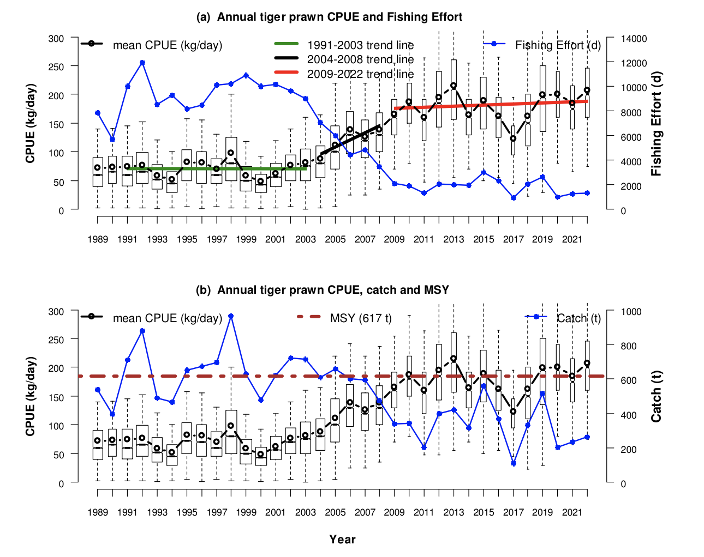

Figure 8. Tiger prawn catch rates (CPUE) as kilograms per vessel per day fished (kg/d) compared

with (a) fishing effort in days and (b) catch in tonnes. {Source: Turnbull & Cocking, 2023 see footnote}.

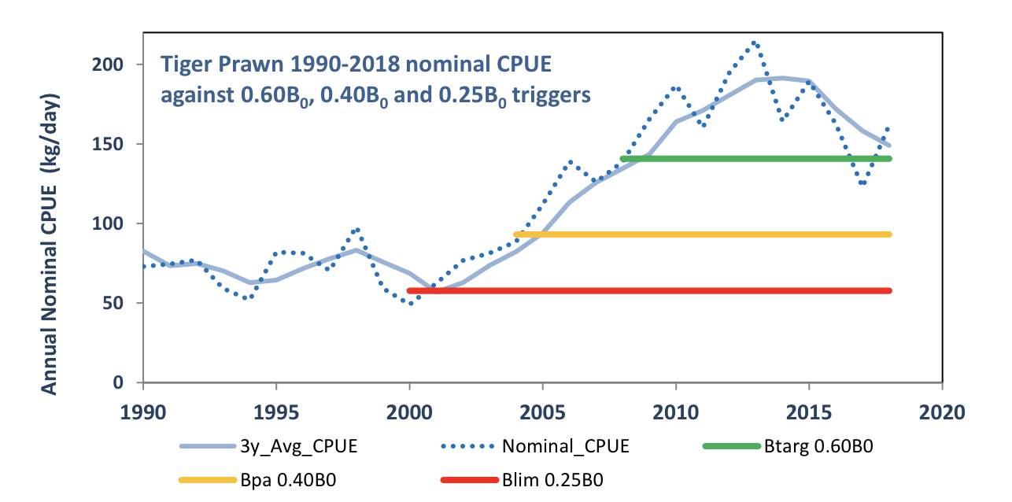

Figure 9. Tiger prawn 1990–2018 nominal CPUE against 0.6B₀, 0.4B₀ and 0.25B₀ (AFMA, 2024)

Endeavour Prawns

Annual catches of Blue endeavour prawn were relatively high during the 1990s, averaging more than 1,000 t and peaking at more than 1,500 t in 1999 (Figure 10). Annual catches have decreased since then, reaching the lowest reported catch of 25 t in 2017 (Butler et al. 2023). In 2022, 87 t of Endeavour prawn was retained by the TSPF (Figure 8). Over the past five years (2019–22), the total retained mean catch of Endeavour Prawn was only 126 t per year (Table 6; Figure 8). Endeavour prawns were managed within the 2011 TSP Harvest Strategy where effort triggers are used to manage the tiger prawn stock. However, the new HS states: “Separate triggers and reference points have not been set to monitor performance against the objectives for endeavour and red spot king prawns, because the Tiger and Endeavour prawn stocks have a very large spatial overlap. When species overlap to this extent, it is not possible to set different effort limits for the different species, as both species are caught within the same shot.” Furthermore, the HS states: “Performance measures from stock models indicate that Endeavour prawns are more resilient to fishing pressure than Tiger prawns at all levels of fishing effort. Therefore, as long as the more sensitive species, the Tiger prawn, is being fished sustainably under the harvest strategy, the less susceptible Endeavour prawns are also fished sustainably by default.” Tiger prawn are therefore an "indicator species” for Endeavour prawn stock status.

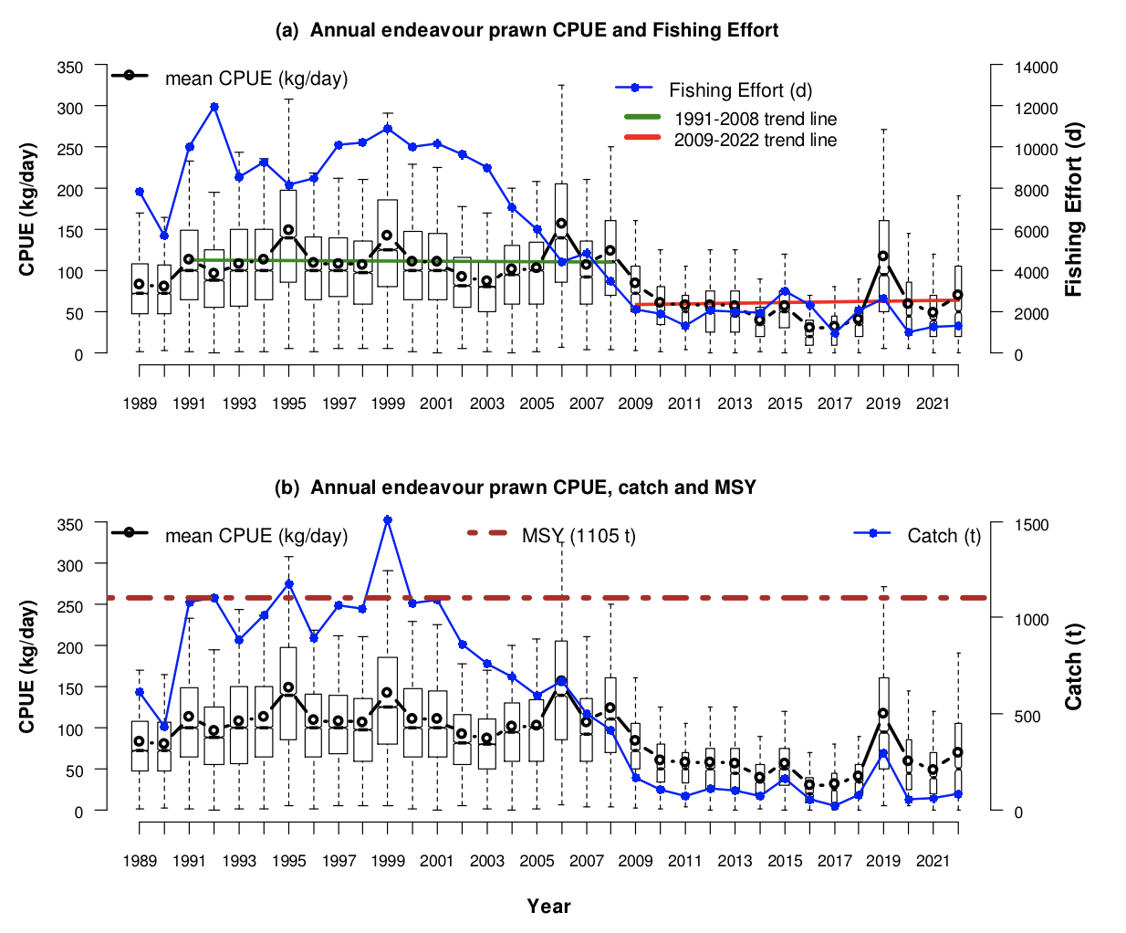
Figure 10. Endeavour prawn catch rates (CPUE) as kilograms per vessel per day fished (kg/d) compared with (a) fishing effort in days and (b) catch in tonnes. The boxplots show the range of daily vessel CPUE’s for each year {Source, Turnbull and Cocking, 2023; see footnote}

4.1.2.2 Ecology of UoA species

Brown Tiger prawns

Distribution & stock structure
Brown tiger prawns are endemic to tropical and subtropical waters of Australia that occur along the coastline of northern Australia from Shark Bay in Western Australia to the eastern coast of northern New South Wales (Somers 1987; Ward et al. 2006). Brown tiger prawns are sedentary in nature (Dichmont et al. 2001; Venables et al. 2004). The stock structure across northern Australia is uncertain. Brown tiger prawns are considered to constitute a single stock in Torres Strait for assessment and management purposes. A single fishery-level stock was assumed for determining status (Butler et al. 2023).

Life history
Brown Tiger prawns have an approximate life cycle of 2 years (Dichmont et al. 2006; Somers et al. 1991). Spawning activity peaks in January–March and August –October each year with females spawning in offshore waters < 50 m deep (Turnbull et al. 2007). About two weeks after spawning, post-larvae settle on inshore sea-grass nursery beds within an estuary (Turnbull et al. 2007) and stay for about three months in these nursery grounds. Young juveniles migrate back to offshore waters, and reach maturity at approximately six months of age or 32–39 mm carapace length (CL) (Somers 1987; Turnbull et al. 2007). The maximum observed size is 44 mm CL for Brown Tiger females, 35 mm CL for Brown Tiger males.

Stock assessment

Logbook records do not specify if catch is comprised of Penaeus esculentus, P. semisulcatus or a mix of both species, and as such Tiger prawns are modelled collectively. Whilst Lovett et al. (2023) found that a final overall proportion in the ECOTF to be 58% Brown Tigers and 42% Grooved Tiger prawns, in the TSPF is Tiger Prawn consists of almost entirely of Brown Tiger Prawn (Turnbull & Rose, 2007).

In the Torres Strait, the latest stock assessment update was conducted in 2019 (Turnbull 2019) using updated information on fishing power and catch-and-effort data up to 2018. However, the last full stock assessment, using fishery-independent surveys and biological data was completed in 2006 (O’Neill and Turnbull 2006). Since the 2006 assessment, additional biological and stock structure information was regularly collected (Turnbull et al. 2009; Turnbull, 2019). The updated delay-difference model, used a Beverton-Holt spawner-recruitment curve and recent CPUE data to calculate MSY.

Stock status

The most recent assessment update (Turnbull, 2019) indicated that Brown Tiger Prawn biomass has been steady over the recent decade, ranging from 60–80% of the unfished (1980) biomass. The assessment also found that fishing power has remained constant since 2000.

Tiger prawn MSY was estimated to be about 617 t (90 per cent confidence interval (CI) 507–763 t), which is comparable with the 2006 assessment of MSY (676 t) (O’Neill and Turnbull 2006). Estimated effort at MSY (E_{MSY}) has dropped substantially, from 8,389 to 3,846 fishing nights (90 %CI 3,165–4,757 nights), because of the substantial increase in recent CPUE (mean ~160.3 kg/day) relative to that used in the 2006 assessment (mean ~73.5 kg/day) (O’Neill and Turnbull 2006; Turnbull, 2019).

Whilst there are some uncertainties that still remain for this stock (i.e., the lack of fishery-independent data and particularly an independent index of abundance), the total effort and total catch in 2019 were substantially below the E_{MSY} and MSY, and biomass was substantially above the defined limit reference point (Butler and Steven 2020). In 2019, the biomass of this stock was unlikely to be depleted and that recruitment was unlikely to be impaired. The current level of fishing mortality (Table 6) is unlikely to cause the stock to become recruitment impaired.

Butler et a. (2021) stated that: “….the Torres Strait Prawn Fishery (Brown Tiger Prawn) management unit is classified as a sustainable stock.”

Blue Endeavour Prawn

Distribution & stock structure

Endeavour prawn is a species complex of Blue Endeavour (Metapenaeus endeavour)i and Red Endeavour (Metapenaeus ensis) prawns of similar sizes Both Endeavour prawns are endemic to the tropical and subtropical waters of Australia and are widely distributed along the coastline of northern Australia from Shark Bay in Western Australia to the eastern coast of northern New South Wales. In the TSPF, the vast majority of the Endeavour Prawn catch is likely to be Blue Endeavour, and as such Red Endeavour prawn is not assessed further. Little is known about the stock structure of blue endeavour prawns across this region. In Torres Strait, Blue endeavour prawns are considered to constitute a single fishery-level stock for assessment and management purposes (Butler et al. 2023).

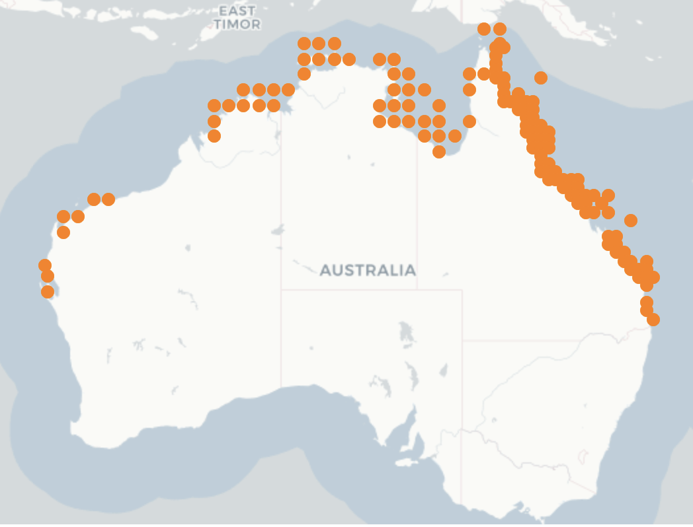
Figure 11. Distribution of Endeavour Prawns (Source: SAFS 2020)

Life history
Longevity is estimated to be 2 years. Sexual maturity occurs at: 24–26 mm CL.

Stock assessment
The most recent Blue endeavour prawn stock assessment for the TSPF was completed in 2009; it used both catch and standardised CPUE data to the end of 2007 and data from fishery-independent surveys (Turnbull et al. 2009). There has been no updated assessment or CPUE standardisation since 2009.
Although the 2009 assessment is now outdated, it indicated that the blue endeavour prawn biomass was around 80% of unfished biomass, and considerably higher than B_{MSY}, which was estimated to be 0.43B₀. Since the 2009 assessment, effort in the fishery has been well below historic levels (Turnbull & Cocking 2023). Nominal CPUE for blue endeavour prawns has decreased by nearly 50% in recent years, from an average of 111 kg/day for 1991 to 2003 (range 87–149 kg/day) to an average of 58 kg/day for 2009 to 2022 (range 30–117 kg/day) (Figure 10; Turnbull & Cocking, 2023). Nominal CPUE increased from 49 kg/day in 2021 to 71 kg/day in 2022 (Turnbull & Cocking 2023).
Given that stock structure is unclear, it may be important to consider the stock assessments of Endeavour Prawns outside of the TSPF areas. Roelofs et al. (2023) stated that: “The 2009 stock assessment is no longer regarded as a sound basis for determining stock status, hence there is insufficient information available to confidently classify the status of this stock”.
It is noteworthy to look at stock assessment for “stocks” from adjacent management regions. The most recent quantitative stock assessment on the east coast biological stock was undertaken by Fox et al. (2023). The assessment considered the spatial scope to be all east coast of Queensland using data to 2021. The assessment used a one-sex monthly delay-difference population model fitted to catch rates. An age-structured model was also trialled but there were no plausible outcomes from that model. Commercial catch rates were standardised to estimate an index of endeavour prawn abundance through time. In 2023, this eastern “stock” biomass was 69% (54–87%) of unfished biomass (Fox et al. 2023) and the average annual catch (2019–2022) was 367 t.
The neighbouring Northern Prawn Fishery (NPF) takes Endeavour Prawn in significant volumes (e.g., >500 t in 2022) and a stock assessment is available for this NPF “stock”. Zhou et al. (2023) provided a new stock assessment for this species from the NPF. In this assessment, separate models were developed assuming a single stock for the NPF area and others for four stocks. Scientific surveys show different reproduction and recruitment patterns in Endeavour prawns between the eastern regions and western regions of the Gulf of Carpentaria (Dichmont et al., 2008 cited in Zhou et al. 2023). To account for spatial heterogeneity, the Zhou et al (2023) assessment of Blue Endeavour Prawns was also based on four independent stock regions and uses biomass dynamics models. Zhou et al. noted that “Assuming one single stock or multiple sub-stocks does not lead to substantial differences about general stock status. However, spatial assessments provide detailed pictures revealing subtle variations among regions, e.g., biomass of Blue Endeavour Prawns in region 2 below target reference points.”

Stock status
Roelofs et al. (2020) suggested the Endeavour Prawn fishery was ‘undefined’. Further information is required to determine the relevance of more recent assessments conducted in fisheries that operate adjacent to the TSPF (i.e., NPF stock assessment (Zhou et al. 2023) or the eastern Queensland stock assessment (Fox et al. 2023)).

Principle 1 References
AFMA (2011), Harvest strategy for the Torres Strait Prawn Fishery, Australian Fisheries Management Authority, Canberra.

AFMA (2015) Torres Strait Prawn Fishery. Bycatch and Discarding Workplan 2015–2017, Australian Fisheries Management Authority, Canberra https://www.afma.gov.au/sites/default/files/2023-02/Torres%20Strait%20Prawn%20Fishery%20Bycatch%20and%20Discard%20Workplan.pdf

AFMA (2016) Torres Strait Prawn Fishery Export Accreditation, September 2016 https://www.dcceew.gov.au/environment/marine/fisheries/commonwealth/torres-strait/application-2017

AFMA (2022) Australian Fisheries Management Authority Annual Report 2021-22, Canberra Australia https://www.afma.gov.au/sites/default/files/2023-02/afma-annual-report-2021-22.pdf

Butler, I., B D’Alberto and A Cao (2023) Chapter 17: Torres Strait Prawn Fishery pp 280-288 In: Butler, I, Patterson, H, Bromhead, D, Galeano, D, Timmiss, T, Woodhams, J and Curtotti, R. Fishery status reports 2023, Australian Bureau of Agricultural and Resource Economics and Sciences, Canberra. CC BY 4.0. https://doi.org/10.25814/vgp4-xr81.
https://daff.ent.sirsidynix.net.au/client/en_AU/search/asset/1035183/18

Cocking, L. (2016), Torres Strait Prawn Fishery Handbook 2016, Australian Fisheries Management Authority. Canberra, Australia. https://www.afma.gov.au/sites/default/files/2023-02/torres-prawn-handbook-2016_with-code-of-practice-web-access.pdf

DEE (2017) Assessment of the Torres Strait Prawn Fishery Department of Energy and Environment, Canberra Australia. https://www.dcceew.gov.au/sites/default/files/env/pages/b8e55dc2-8460-40ab-a4b2-d887cbc13f18/files/assessment-report-torres-strait-prawn-fishery-2017.pdf

Die, D.J. (2003) Review of the stock assessment of the Torres Strait prawn fishery. Australian Fisheries Management Authority (AFMA), Canberra Australia

DSEWPaC (2013), Assessment of the Torres Strait Prawn Fishery, Department of Sustainability, Environment, Water, Population and Communities, Canberra.

Dichmont, C. M., A. R. Deng, A. E. Punt, W. Venables, and M. Haddon (2006). Management strategies for short-lived species: The case of Australia’s Northern Prawn Fishery: 1. Accounting for multiple species, spatial structure and implementation uncertainty when evaluating risk. Fisheries research 82.1-3: 204–220.

Dichmont, C., D. Die, A. Punt, W. Venables, J. Bishop, A. Deng, and Q. Dell (2001). Risk analysis and sustainability indicators for prawn stocks in the Northern Prawn Fishery. FRDC Project 1998/109. Hobart, Tasmania: CSIRO Marine Research; Fisheries Research and Development Corporation.

Dichmont, C. M., Deng, A. R., Punt, A. E., Venables, W. N., Ellis, N., Kompas, T., Ye, Y., et al. (2008). Bringing economic analysis and stock assessment together in the NPF: a framework for a biological and economically sustainable fishery. FRDC Final Report 2004/022. 223 pp.

Dichmont, C. M., Deng, A. R., A.E. Punt, Venables, W. N., Pascoe, S., Zhou, S., Kompas, T., et al. (2010). Developing techniques to estimate total allowable catches for the NPF major prawn species. FRDC Project 2007/018 Final Report. 369 pp

Fox, A. R., Lovett, R. A., Wickens, M. E. and Hillcoat, K.B. (2023) Stock assessment of Queensland east coast endeavour prawns (Metapenaeus endeavouri and Metapenaeus ensis), Australia, with data to December 2021.Technical Report. State of Queensland, Brisbane.

Laird, A., Cahill, J. and Liddell, B., 2016. Kon’s Covered Fisheyes BRD Trial Report. Northern Prawn Fishery 2016. http://www.afma.gov.au/wp-content/uploads/2017/05/Kons-Covered-Fisheyes-BRD-Trial- Report-Northern-Prawn-Fishery-2016_FINAL.pdf

MRAG (2023) Australia Northern Prawn Fishery Public Certification Report July 2023 Second re-assessment Public report. MRAG Americas. Available at https://fisheries.msc.org/en/fisheries/australia-northern-prawn/@@assessments

O’Neill, MF & Turnbull, CT (2006), Stock assessment of the Torres Strait Tiger Prawn Fishery (Penaeus esculentus), Queensland, Queensland Department of Primary Industries and Fisheries, Brisbane.

Pitcher, CR (2013), Environmental sustainability assessment update for habitats, assemblages and bycatch species in the Torres Strait Prawn Fishery, scientific technical report, CSIRO, Australia.

PZJA (2011) Industry Code of Practice for Responsible Disposal of Marine Debris Torres Strait Prawn Fishery. https://www.pzja.gov.au/corporate-and-reports/industry-code-practice-responsible-disposal-marine-debris-torres-strait-prawn

PZJA (2018) Strategic Research Plan for Torres Strait Fisheries 2018-2022, Protected Zone Joint Authority.

Somers, I, Poiner, I and Harris, A 1987, A study of the species composition and distribution of commercial penaeid prawns in Torres Strait, Australian Journal of Marine and Freshwater Research, 38: 47–61.

Somers, I. and G. Kirkwood (1991). Population ecology of the grooved tiger prawn, Penaeus semisulcatus, in the north-western Gulf of Carpentaria, Australia: growth, movement, age structure and infestation by the bopyrid para-
site Epipenaeon ingens. In: Marine and Freshwater Research 42.4, pp. 349–367.

Turnbull, C. T. and J. C. Atfield (2007). Fisheries long term monitoring program: summary of tiger and endeavour prawn survey results: 1998-2006. Brisbane, Queensland: Department of Primary Industries and Fisheries.

Turnbull, C, Furlani, D, Bulman, C & Dowdney, J 2007, Ecological risk assessment for the effects of fishing: report for the Torres Strait Prawn Fishery, report to the Australian Fisheries Management Authority, Canberra.

Turnbull, C. 2019, Updated tiger prawn stock assessment for the Torres Strait Prawn Fishery: a final report to AFMA for the TSPMAC and TSSAC, project 180802, Australian Fisheries Management Authority, Canberra.

Turnbull C. (2020) Management Strategy Evaluation of the Torres Strait Prawn Fishery A Final Report to AFMA Project: 190829 July 2020 Available at https://www.afma.gov.au/sites/default/files/2023-03/2019-0829_final_report%5B1%5D.pdf

Turnbull, Clive and Cocking, Lisa (2022), Torres Strait Prawn Fishery Data Summary 2021, Australian Fisheries Management Authority. Canberra, Australia. https://www.pzja.gov.au/sites/default/files/2023-01/data-summary-2021_final.pdf

Turnbull, Clive and Cocking, Lisa (2023), Torres Strait Prawn Fishery Data Summary 2022, Australian Fisheries Management Authority. Canberra, Australia. https://www.pzja.gov.au/sites/default/files/2023-07/Torres-Strait-Prawn-Fishery-Data-Summary-2022.pdf

Turnbull, C. and Rose, C.L. 2007. Towards ecologically sustainable management of the Torres Strait Prawn Fishery, CRC Torres Strait Task T1.5 Final Report. Department of Primary Industries and Fisheries, Queensland. https://www.daf.qld.gov.au/__data/assets/pdf_file/0017/56015/TS-Prawn-Report-Web.pdf

Turnbull, C, Tanimoto, M, O’Neill, MF, Campbell, A & Fairweather, CL 2009, Torres Strait spatial management research project 2007–09, final report for DAFF consultancy DAFF83/06, Queensland Department of Employment, Economic Development and Innovation, Brisbane.

van der Velde TD, Venables WN, Crocos PJ, Edgar S, Evans F, Rothlisberg PC (2021) Seasonal, interannual and spatial variability in the reproductive dynamics of Penaeus merguiensis. Mar Ecol Prog Ser 658:117-133. https://doi.org/10.3354/meps13540

Venables, W., R. Kenyon, J. Bishop, C. Dichmont, R. Deng, C. Burridge, B. Taylor, A. Donovan, S. Thomas, and S. Cheers (2006). Species Distribution and Catch Allocation: data and methods for the NPF, 2002-2004 Final Report. AFMA Project,(R01/1149). Australian Fisheries Management Agency, Canberra Australia.

Venables, W and Dichmont, C 2004, GLMs, GAMs and GLMMs: an overview of theory for applications in fisheries research, Fisheries Research, 70: 319–337.

Ward, R. D., J. R. Ovenden, J. R. S. Meadows, P. M. Grewe, and S. A. Lehnert (2006). Population genetic structure of the brown tiger prawn, Penaeus esculentus, in tropical northern Australia. Marine Biology 148(3): 599–607.

Zhou, S., Deng, A. R., Lei, Y., Miller, M., van Der Velde, T., and Hutton, T. (2022) Catch rate standardisation for endeavour prawns (Metapenaeus endeavouri and M. ensis) in the Northern Prawn Fishery. Final Report to Australian Fishery Management Authority. Brisbane, Australia.

Principle 1 – Performance Indicator scores and rationales

PI 1.1.1 – Stock status

PI 1.1.1 |  | The stock is at a level that maintains high productivity and has a low probability of recruitment overfishing
Scoring issue |  | SG 60 | SG 80 | SG 100
a | Stock status relative to recruitment impairment
a | Guidepost | It is likely that the stock is above the point of recruitment impairment (PRI). | It is highly likely that the stock is above the PRI. | There is a high degree of certainty that the stock is above the PRI.
a | Met? | Brown Tiger prawn - Yes | Brown Tiger prawn - Yes | Not scored
a | Met? | Blue Endeavour Prawn - Yes | Blue Endeavour Prawn - Yes | Not scored
Rationale |  | Brown Tiger Prawn  The most recent assessment update (Turnbull 2019) indicated that Brown Tiger Prawn biomass has been steady over the recent decade, ranging from 60–80% of the unfished (1980) biomass. The assessment also found that fishing power has remained constant since 2000. SG 60 and SG 80 are met as the stock is highly likely to be above PRI.  Blue Endeavour Prawn  Whilst there are recent stock assessments for this species from adjoining fishery areas (NPF: Zhou et al. 2023; ECOTF: Fox et al. 2023b) that report favourable stock status, the most recent stock assessment for the TSPF area was conducted by Turnbull et al. (2009); an update is required. Although the 2009 assessment is now outdated, it indicated that the blue endeavour prawn biomass was around 80% of unfished biomass, and considerably higher than B_{MSY}, which was estimated to be 0.43B₀. At the time of assessment, catches were sharply declining after reaching a peak in 1999 of 1500 t. Catches in 2008 were >450 t and since the 2009 assessment catches have continued to decline to < 100 t per year due to commercial incentives (i.e., higher value Tiger prawns).  The Harvest Strategy uses the less resilient species (Tiger prawns) as an indicator species to estimate status of Endeavour prawns. The 2024 HS stated that:  “Performance measures from stock models indicate that Endeavour prawns are more resilient to fishing pressure than Tiger prawns at all levels of fishing effort. Therefore, as long as the more sensitive species, the Tiger prawn, is being fished sustainably under the harvest strategy, the less susceptible Endeavour prawns are also fished sustainably by default. The Red Spot King prawn is a by-product with relatively low levels of catch recorded. In summary, although this harvest strategy does not set specific objectives, trigger points and decision rules to manage the Endeavour prawn (secondary target species) and the Red Spot King prawn (by-product species) stocks, these stocks are indirectly managed by default due to the stock overlap and relationship to the Tiger prawn species.”  Butler et al. (2023) classified the stock as “uncertain” and stated that:  “Torres Strait is a region experiencing environmental change due to climate change (Dutra et al. 2021; NESP ESCC Hub 2018), with potential implications for the productivity of fish stocks. As considerable time has passed since the stock assessment for blue endeavour prawns, it will become increasingly difficult to assume, without an approved updated stock assessment, that productivity has remained stable and that the outcomes of the 2009 assessment remain valid.”  The November 2022 TSPMAC meeting discussed updates on the ABARE stock status report and noted that: “It should be noted that the “uncertain” rankings against endeavor prawn are related to the absence of a recent stock assessment, despite the stocks appearing at a healthy level when catch rates are considered.”  Since the 2009 assessment, effort in the fishery has been well below historic levels (Turnbull & Cocking, 2023; Figure 5) and SG 60 is met. As the HS uses Tiger prawn as an indicator species and the stock assessment for Tiger prawn was above the target reference points and the fishery has been targeting this species in favour of Endeavour prawns SG 80 is met.

b | Guidepost |  | The stock is at or fluctuating around a level consistent with MSY. | There is a high degree of certainty that the stock has been fluctuating around a level consistent with MSY or has been above this level over recent years.
b | Met? |  | Brown Tiger prawn - Yes | Not scored
b | Met? |  | Blue Endeavour Prawn - Yes | Not scored
Rationale |  | Tiger prawn  Estimated virgin biomass (B₀) was 1044–1073 t and biomass at MSY (B_{MSY}) is estimated to be 346–415 t or 32–39% of B₀. Turnbull (2019) estimated current biomass was 60-88% of B₀. Fishing mortality has been ≤265 t in the three years since the stock assessment that suggested annual maximum sustainable yield was 606–676 t. SG 80 is met as the stock is highly likely to be above MSY.  Endeavour prawn  The most recent assessment (Turnbull et al. 2009) is now out of date but produced an MSY estimate of 1105 t. Butler et al. (2023) listed the species as ‘uncertain’ with regard to stock status although catches have been very small compared to historical levels. The harvest strategy for this fishery (AFMA 2011) uses Tiger prawn as an indicator species; Tiger prawn life history illustrate that they are more susceptible (‘sensitive’) to overfishing. Tiger prawn stocks are above MSY.  SG 80 is met.

Draft scoring range | Tiger Prawn ≥80
Draft scoring range | Endeavour Prawn ≥80
Information gap indicator | Information sufficient to score PI  A greater understanding of Endeavour prawn stock structure between fisheries and/or an updated stock assessment for the TSPF area would be beneficial.

PI 1.2.1 – Harvest strategy
PI 1.2.1 |  |  | There is a robust and precautionary harvest strategy in place
Scoring issue |  |  | SG 60 | SG 80 |  | SG 100
a |  | Harvest strategy design
 |  | Guide post | The harvest strategy is expected to achieve stock management objectives reflected in PI 1.1.1/PI 1.1.1A SG80. | The harvest strategy is responsive to the state of the stock and the elements of the harvest strategy work together towards achieving stock management objectives reflected in PI 1.1.1/PI 1.1.1A SG80. |  | The harvest strategy is responsive to the state of the stock and is designed to achieve stock management objectives reflected in PI 1.1.1/PI 1.1.1A SG80.
 |  | Met? | Brown Tiger prawn - Yes | Brown Tiger prawn - Yes | Not scored
 |  | Met? | Blue Endeavour prawn - Yes | Blue Endeavour prawn - No
Rationale |  |  | The Torres Strait Prawn Fishery Harvest Strategy 2011 was development and implementation followed the guidance of the Commonwealth Fisheries Harvest Strategy Policy (AFMA 2007).  The independent review of the 2011 TSPF HS noted that effort-based triggers are not suitable for fisheries using an effort cap as the primary management tool, and that effort does not give any indication of the underlying stock biomass level and is not a useful indicator of sustainability (Penney, 2019). Instead, triggers based on nominal CPUE were proposed. The HS was updated in July 2024 using nominal CPUE triggers.  The HS now has a five year review period (up from 4 years).  With regard to the harvest of Endeavour prawn, Butler et al. (2023) noted that: "…the TSPF has changed its targeting practices in recent years to focus more heavily on the tiger prawn stock. This behaviour may also limit the utility of nominal CPUE as an index of abundance for the stock and add weight to the need to better determine the state of the stock in relation to reference point.”  Both SG 60 and SG 80 are met for Tiger prawns. Endeavour prawns, the use of catch and effort triggers not be as appropriate given that fishers have favoured the targeting of Tiger prawns and as such CPUE triggers are based on the more sensitive Tiger prawn stock status. SG 60 is met for Endeavour prawn but further evidence is likely to be required regarding the suitability of using Tiger prawn as an indicator species and how an assessment of stock status will be conducted in the future for Endeavour prawn.
b | Harvest strategy evaluation
b | Guide post |  | The harvest strategy is likely to work based on prior experience or plausible argument. | The harvest strategy may not have been fully tested but evidence exists that it is achieving its objectives. |  | The performance of the harvest strategy has been fully evaluated and evidence exists to show that it is achieving its objectives including being clearly able to maintain stocks at target levels.
b | Met? |  | Tiger prawn - Yes | Tiger prawn - Yes |  | Not scored
 |  |  | Endeavour prawn - Yes | Endeavour prawn - Yes
Rationale |  |  | The key objective of the HS is to maximize the profitability of the fishery and minimize any management impediments that affect the economic efficiency of fishers within biologically sustainable limits. As such, the TSPF Harvest Strategy was designed to facilitate a move towards B_{MEY} when effort and economic viability in the fishery has increased.  The 2011 TSPF harvest Strategy was purposely set up to instigate new research initiatives. The results fed into the ongoing development of the new 2024 Harvest Strategy including moving to triggers based on nominal CPUE rather than effort based triggers, updating reference points and decision rules.  In 2019, a TSPMAC meeting noted that:  - “A harvest strategy working group was established, which included an independent stock assessment scientist, Andrew Penney as well as AFMA, Clive Turnbull, the TSPMAC scientific member and a TSPMAC Industry member.”  - “During the working group’s first meeting on 30 July 2019, the working group noted that the current effort triggers used in the harvest strategy do not provide any indication on the state of the tiger prawn stocks and a catch rate based trigger would be more useful as an indicator of potential declines and the need for further review within season. A review paper on approaches for developing harvest strategy was prepared by Dr Penney and presented to the MAC for consideration. The MAC noted the review paper was very useful and supported the recommendation of the HSWG to progress with CPUE based triggers.”  As a result of the ongoing discussions at TSPMAC meetings, AFMA identified a research need to assess the impact that ‘season-dates’ may have on fishery catch rates and profitability. Turnbull (2020) provided a management strategy evaluation (MSE) of the TSPF.  Butler et al. (2023) noted that: “The TSPF has a management objective of promoting economic efficiency and ensuring the optimal use of the fishery resource, consistent with the principles of ecologically sustainable development and a precautionary approach. Although these objectives are implicitly consistent with maximising net economic returns, the current target reference point in the harvest strategy for the fishery is not BMEY. This has been attributed to the low economic value of the fishery and the high cost of estimating a BMEY target (AFMA 2011). The BMSY target will remain until decision rules relating to increased fishing activity are activated that will require a BMEY target to be determined and implemented (AFMA 2011). Given the current low levels of fishing effort and relatively high biomass level for brown tiger prawns, the current low-cost approach to managing the fishery with precautionary triggers in place is appropriate.”  Given the new HS is based on years of reviews and assessments, both SG 60 and SG 80 are met for both UoA species.
c | Harvest strategy monitoring
c | Guide post |  | Monitoring is in place that is expected to determine whether the harvest strategy is working.
c | Met? |  | Tiger prawn- Yes  Endeavour prawn - Yes
Rationale |  |  | Monitoring of the TSPF includes the use of logbooks (compulsory) that include effort and catch data for both UoA species. The Vessel Monitoring System is mandatory for all vessels; spatial management measures can be evaluated using location data.  The AFMA e-monitoring program uses video and sensor data to independently validate fishing operations and fisheries’ logbook information. At present, the program has not been extended to the TSPF.  SG 60 is met for each UoA species
d | Harvest strategy review
d | Guidepost |  |  |  |  | The harvest strategy is periodically reviewed and improved as necessary.
d | Met? |  |  |  |  | Not scored
Rationale |  |  | Not scored
e | Shark finning
e | Guide post |  | There is a high degree of certainty that shark finning is not taking place. | It is highly likely that shark finning is not taking place. |  | There is a high degree of certainty that shark finning is not taking place.
e | Met? |  | NA | NA |  | NA
Rationale |  |  | Scoring issue need not be scored as sharks are not a P1 species.
f | Review of alternative measures
f | Guide post |  | There has been a review of the potential effectiveness and practicality of alternative measures to minimise UoA-related mortality of unwanted catch of the target stock. | There is a regular review of the potential effectiveness and practicality of alternative measures to minimise UoA-related mortality of unwanted catch of the target stock and they are implemented as appropriate. |  | There is a biennial review of the potential effectiveness and practicality of alternative measures to minimise UoA-related mortality of unwanted catch of the target stock, and they are implemented, as appropriate.
f | Met? |  | Yes | Yes |  | Not scored
Rationale |  |  | There has been a changing proportion of catch composition in the fishery that is largely due to high market value of Tiger Prawns. However, there is no precise estimate available for non-marketable catch Endeavour Prawns, the discarding of either species is very rare. Rather than discarding these species, fishers sell prawn product as “soft and broken” when there are imperfections. They are reported in fished statistics as “mixed prawn” as they include the two UoA species and damaged Red-spot King prawn. In 2022, 0.23 t of “mixed prawn” was reported. There is therefore no need for alternative measures as there is negligible “unwanted catch” (discards) of these two UoA species.

Draft scoring range | Brown Tiger prawn: ≥80
 | Blue Endeavour prawn: 60–79
Information gap indicator | There is sufficient information to score this PI.

PI 1.2.2 – Harvest control rules and tools

PI 1.2.2 |  |  | There are well-defined and effective HCRs in place
Scoring issue |  |  | SG 60 | SG 80 | SG 100
a |  | HCRs design and application
 |  | Guide post | Generally understood HCRs are in place or available that are expected to reduce the exploitation rate as the point of recruitment impairment (PRI) is approached. | Well defined HCRs are in place that ensure that the exploitation rate is reduced as the PRI is approached, are expected to keep the stock fluctuating around a target level consistent with (or above) MSY, or for key LTL species a level consistent with ecosystem needs. | The HCRs are expected to keep the stock fluctuating at or above a target level consistent with MSY, or another more appropriate level taking into account the ecological role of the stock, most of the time.
 |  | Met? | Tiger prawns - yes | Tiger prawns - yes
 |  |  | Endeavour Prawns: Yes | Endeavour Prawns: Yes
Rationale |  |  | A 2024 Harvest Strategy has well defined HCRs (decision rules) “in place”.  The HS was developed with Tiger Prawns as primary target species, there are also pre-determined management actions necessary to achieve biological, economical and/or social objectives for Endeavour prawns.  In summary, there are well-defined HCRs in place for Tiger and Endeavour prawns (SG 60 and 80 are met).
b | The robustness of HCRs to uncertainty
b | Guide post |  |  | The HCRs are likely to be robust to the main uncertainties. | The HCRs take account of a wide range of uncertainties including the ecological role of the stock, and there is evidence that the HCRs are robust to the main uncertainties.
b | Met? |  |  | Brown Tiger prawns -yes | Not scored
b |  |  |  | Blue Endeavour prawns - yes | Not scored
Rationale |  |  | HCRs (termed ‘decision rules’ in the HS) are used in the fishery.  The HS defines a set of trigger, target and limit reference points, and decision rules for the whole fishery, based on tiger prawn as the most sensitive (less-resilient) species. Catch triggers for Endeavour prawn are no longer considered appropriate and the new HS uses triggers based on nominal CPUE for Tiger prawns (i.e., tiger prawn are an indicator species).  In 2020, the TSPMAC discussed triggers and decision rules and noted: “Industry had some concern that there would be drastic action taken when we hit the first trigger, which could close the fishery. AFMA clarified that the first trigger is conservative and designed to start a conversation with the MAC, about what actions we do need to take, and to explore why the trigger may have been hit.” Nominal CPUE is monitored by AFMA throughout the fishing season to track the status of the stock against the reference points, and results of this analysis are considered by TSPMAC at least once annually. The PZJA shall be notified as required. As well as monitoring nominal CPUE, factors that may influence CPUE will be monitored, including economic and market factors that may impact fishing behaviour and CPUE, to determine whether CPUE decreases are likely a result of a stock decline, or changed fishing behaviour.  The new HS (AFMA 2024) includes the following HCRs:  - Target reference point (TRP): 141kg/ boat/ day – corresponding to a biomass of 0.6B₀. The target biomass reference point (B_{TARG}) has been set at 0.6B₀ which is an estimate of B_{MEY} and corresponds to a nominal CPUE of 141kg / boat / day.  - Precautionary reference point (triggered if reached two years in a row): 93kg/day/boat– corresponding to a biomass of 0.4B₀. The nominal CPUE indicator for this trigger will be calculated as the 3-year preceding rolling average of nominal CPUE for tiger prawns. The trigger (93kg) needs to be reached two years in a row to trigger the below response. Management action may be needed to prevent further declines and rebuild the stock to target levels. Responses to breaching the precautionary reference point:  - The TSPMAC meets to consider the implications and management advice including:  - Consider if a stock assessment is necessary (noting a minimum base level stock assessment (without fishing power updates) should be undertaken at least every five years).  - Consider whether a fishing power survey should be undertaken, as a part of a stock assessment, if one is completed (noting these are probably not required every five years, unless significant changes to the fleet are known).  - Review non-stock factors that may have led to lower CPUE, including but not limited to: i) Are the economic and market conditions influencing fishing behaviour (e.g. changes in fuel prices and prawn prices, low number of vessels etc.) resulting in lower CPUE? and/or ii) Are fishers changing target species e.g. targeting Endeavour Prawns rather than Tiger Prawns?  - Consider whether a reduction in TAE or actual fishing effort is required to halt overfishing and facilitate rebuilding of the stock towards the target.  - Limit Reference Point (triggered if reached in one year): 58 kg/day/boat – corresponding to a biomass of 0.25B₀. The nominal CPUE indicator for this trigger calculated is the nominal CPUE for tiger prawns in any one year (not a 3-year rolling average as in the precautionary trigger). The limit trigger signals that the stock has declined substantially to the limit and immediate management action is needed to halt further declines below the limit reference point and to rebuild the stock towards the target. Responses to breaching the limit reference point:  - Considering recommendations from the TSPMAC, implement measures to limit fishing mortality to levels that will halt overfishing and rebuild stock levels towards the target.  - Consideration should be given to conducting MSE evaluation and developing formal effort control rules that respond to future breaches of the CPUE triggers.  - Responses to breaching the LRP in multiple years will result in escalating management responses.  The stock assessments for Tiger and Endeavour prawns (Turnbull 2019; Turnbull 2009) examined many variables and identified the uncertainties including influences to recruitment/catches. SG 80 is met.
c | Evaluation of HCRs
c | Guide post |  | There is some evidence that tools used or available to implement HCRs are appropriate and effective in controlling exploitation. | Available evidence indicates that the tools in use are appropriate and effective in achieving the exploitation levels required under the HCRs. | Evidence clearly shows that the tools in use are effective in achieving the exploitation levels required under the HCRs.
c | Met? |  | Brown Tiger prawns - yes | Brown Tiger prawns - yes
c |  |  | Blue Endeavour prawns - yes | Blue Endeavour prawns - yes
Rationale |  |  | The TSPF Management Plan 2009 and the 2024 HS outline the tools in use.  For Tiger prawns and Endeavour prawns the tools in use include:  - monitoring of CPUE  - triggers for nominal CPUE  - spatial/temporal closures  - requirement for stock assessments  Other management tools include:  - limited access through primary commercial fishing licences (60 fishing licences)  - maximum vessel length  - gear restrictions such as net length and mesh size  - Observer coverage (1.54% of effort in 2022 with objective for 2.6 in latest HS)  The HCRs from the HS are outlined above in scoring issue (b). The rational for the decision rules are also outlined.  The application of decision rules relies on reliable stock assessments and/or knowledge of effort/catches relative to historical catches. The fishery did not reach the previous effort triggers set in the older HS. SG 60 and SG 80 are met.

Draft scoring range | Brown Tiger prawn: ≥80
Draft scoring range | Blue Endeavour prawn: ≥80
Information gap indicator | There is sufficient information to score this PI.

PI 1.2.3 – Information and monitoring
PI 1.2.3 |  |  | Relevant information is collected to support the harvest strategy
Scoring issue |  |  | SG 60 | SG 80 | SG 100
a |  | Range of information
 |  | Guide post | Some relevant information related to stock structure, stock productivity, and fleet composition is available to support the harvest strategy. | Sufficient relevant information related to stock structure, stock productivity, fleet composition, and other data are available to support the harvest strategy. | A comprehensive range of information (on stock structure, stock productivity, fleet composition, stock abundance, UoA removals, and other information such as environmental information), including some that may not be directly related to the current harvest strategy, is available.
 |  |  | Tiger prawns - Yes | Tiger prawns - Yes | Not scored
 |  | Met? | Endeavour Prawn - Yes | Endeavour Prawn - Yes | Not scored
Rationale |  |  | Fleet composition – sufficient  In 2022, there were 60 licences and 20 active vessels (Turnbull et al., 2023) in the TSPF.  Tiger prawns  Stock structure & productivity –sufficient  Brown tiger prawns are endemic to tropical and subtropical waters of Australia, while grooved tiger prawns have a wider Indo–West Pacific distribution. The susceptibility of each species to capture differs throughout the coastline regions (Lovett et al. 2023). Brown tiger prawns are more sedentary in nature. Life history and recruitment is understood. The stock structure across northern Australia is uncertain. Brown tiger prawns are considered to constitute a single stock in Torres Strait for assessment and management purposes. A single fishery-level stock was assumed for determining status (Butler et al. 2023).  Stock abundance – sufficient  The most recent assessment update (Turnbull, 2019) indicated that Brown Tiger Prawn biomass has been steady over the recent decade, ranging from 60–80% of the unfished (1980) biomass. The assessment also found that fishing power has remained constant since 2000.  UoA removals – sufficient  Logbook records do not specify if catches comprised of Penaeus esculentus, P. semisulcatus or a mix of both species, although in the TSPF is Tiger Prawn consists of almost entirely Brown Tiger Prawn (Turnbull & Rose, 2007).  Tiger prawns are the primary species taken by the TSPF and catches are recorded (Figure 7). Table 6 presents the UoA catch for the last four years.  SG60 and SG 80 are met for Tiger Prawns.  Endeavour Prawns  Stock structure & productivity –sufficient  Endeavour prawns are currently not the preferred species of the fishery due to commercial reasons. While both Blue (Metapenaeus endeavouri) and Red  Endeavour prawns (Metapenaeus ensis) are caught by the TSPF, the vast majority taken are Blue Endeavour prawns.  The stock structure of Endeavour Prawns remains unclear. Zhou et al. (2023) provided an overview of both species’ potential population structures (single versus four separate stocks) in the Gulf of Carpentaria and Commonwealth waters adjacent to the Northern Territory. However, scientific surveys suggested different reproduction and recruitment patterns between the eastern regions and western regions of the Gulf of Carpentaria (Dichmont et al., 2008). In Torres Strait, blue endeavour prawns are considered to constitute a single fishery-level stock for assessment and management purposes (Butler et al. 2023).t  Stock abundance – sufficient  Zhou et al (2023) provided a comprehensive overview of the species’ life history from northern Australia. The life history of the species is sufficient and was used in the most recent stock assessment (Turnbull et al. 2009) to determine stock abundance relative to unfished levels. The stock assessment needs to be updated and the Stock status is listed as ‘uncertain’ (Butler et al. 2023).  UoA removals – sufficient  Given the size of the fishery and catch size (87 t in 2022), knowledge of stock abundance is sufficient.  SG60 and SG 80 are met for Endeavour Prawns.
b | Monitoring
b | Guide post |  | Stock abundance and UoA removals are monitored and at least 1 indicator is available and monitored with sufficient frequency to support the harvest strategy. | Stock abundance and UoA removals are regularly monitored at a level of accuracy and coverage consistent with the harvest strategy, and 1 or more indicators are available and monitored with sufficient frequency to support the harvest strategy. | All information required by the harvest strategy is monitored with high frequency and a high degree of certainty, and there is a good understanding of the inherent uncertainties in the information (data) and the robustness of assessment and management in dealing with this uncertainty.
b | Met? |  | Brown Tiger Prawn -Yes | Brown Tiger Prawn -Yes | Not scored
 |  |  | Blue Endeavour Prawn - Yes | Blue Endeavour Prawn - No
Rationale |  |  | Logbooks: UoA removals are monitored by mandatory logbooks (Figures 2 & 3).  Commercial fishers are required to fill in a daily logbook that records what catch they land, where they caught their product, what fishing gear was used, and the time spent fishing. The logbook data is used to provide a comprehensive fisheries information system for managers, researchers and industry and ensure that the data meets the national standards for validation and coding, as developed by the Statistical Working Group of the Australian Fisheries Managers Forum (AFMF). The information provided in logbook returns is used for fisheries management and research purposes. A comprehensive and continuous series of catch and effort data from commercial fishers’ logbooks provides the basis for:  - scientific stock analysis when used in conjunction with other biological data (e.g. recruitment studies or effects of closures);  - economic analysis;  - descriptions of current fishing activity;  - short and long-term trends in the spatial and temporal distributions of fishing activity;  - responsible management and administration.  Fishers are also required to complete a logbook for any interactions that occur whilst fishing (Figure 3).  VMS: Commercial fishers are also required to use VMS, which reports the position and activity of their fishing vessels.  Stock assessments:  For Tiger prawns, the most recent stock assessment was undertaken with data to 2017 (Turnbull et al. 2019). The assessment and catch and effort data are sufficient to support the decision rules as prescribed in the HS for the fishery thereby meeting SG 60.  For Endeavour Prawn the most recent stock assessment is now outdated (Turnbull et al. 2009). However, catch and effort data is available to support the effort based decision rules as prescribed in the HS. Furthermore, Tiger prawns have been identified as a more sensitive species and are treated as an indicator of stock status for other species, including Endeavour Prawns; the SG 60 requirements are met.  Monitoring is conducted and performed regularly at a level of accuracy and coverage that are consistent with the decision rules (HCR) within the Harvest Strategy;  Whilst fishing behaviour has changed significantly since the last Endeavour prawn stock assessment (less targeting of this species), the new HS outlines the use of Tiger Prawn as a suitable indicator species for Endeavour prawn. However, no information was provided on how Endeavour prawn stock will be assessed (particularly if fishery behaviour changes again and this species becomes the dominant target species); does not meet SG 80 for Endeavour prawn.
c | Comprehensiveness of information
c | Guide post |  |  | There is good information on all other fishery removals from the stock.
c | Met? |  |  | Both - Yes
Rationale |  |  | There are mandatory logbooks apply to all commercial fisheries that operate take Tiger and Endeavour prawns and. Fisheries that take these species in significant volumes in NE Australia include: ECOTF Central & Northern region; and Northern Prawn Fishery. Mortality from the recreational sector are known to be negligible. SG 80 is met for both species.

Draft scoring range | Brown Tiger Prawn - ≥80
 | Blue Endeavour Prawn 60-79
Information gap indicator | There is sufficient information to score this PI.

PI 1.2.4 – Assessment of stock status

PI 1.2.4 |  |  | There is an assessment of the stock status
Scoring issue |  |  | SG 60 | SG 80 | SG 100
a |  | Appropriateness of assessment to stock under consideration
 |  | Guide post |  | The assessment is appropriate for the stock and for the harvest strategy. | The assessment takes into account the major features relevant to the biology of the species and the nature of the UoA.
 |  | Met? |  | Brown Tiger prawns - yes | Not scored
 |  | Met? |  | Blue Endeavour Prawn - yes | Not scored
Rationale |  |  | Tiger prawns  In the Torres Strait, the latest stock assessment update was conducted in 2019 (Turnbull, 2019) using updated information on fishing power and catch-and-effort data up to 2018. However, the last full stock assessment, using fishery-independent surveys and biological data was completed in 2006 (O’Neill and Turnbull 2006). Since the 2006 assessment, additional biological and stock structure information was regularly collected (Turnbull et al. 2009; Turnbull et al. 2019). The updated delay–difference model, used a Beverton–Holt spawner–recruitment curve and recent CPUE data to calculate MSY.  SG 80 is met.  Endeavour Prawn  The most recent Blue endeavour prawn stock assessment for the TSPF was completed in 2009; it used both catch and standardised CPUE data to the end of 2007 and data from fishery-independent surveys (Turnbull et al. 2009). There has been no updated assessment or CPUE standardisation. The current HS (AFMA 2011) states that Endeavour Prawn is a secondary species in the TSPF and that assessment of this species can be assumed from the status of the Tiger prawn stock assessment.  Furthermore, since the 2009 assessment, effort in the fishery has been well below historic levels (Turnbull & Cocking 2023).  SG 80 is met.
b | Assessment approach
b | Guide post |  | The assessment estimates stock status relative to generic reference points appropriate to the species category. | The assessment estimates stock status relative to reference points that are appropriate to the stock and can be estimated.
b | Met? |  | Tiger prawns - yes | Tiger prawns-yes
b |  |  | Endeavour prawn - Yes | Endeavour prawn- No
Rationale |  |  | Tiger prawns  Tiger prawn were last assessed by Turnbull (2019). The assessment provided spawning biomass estimates relative to unfished levels; target and limit reference points are also linked to unfished spawning biomass levels. In the HS, the target reference point was 60% unfished spawning biomass and the limit reference point was 20% unfished spawning biomass. Harvest control rules (decision rules) are used to set total allowable commercial effort (TACE). SG 60 and SG 80 are met.  Endeavour prawns  The target reference point (B_{targ}) of 60% of the unfished biomass and the limit reference point B_{lim} is 20% of unfished biomass are defined for this species in the 2011 HS. However, the most recent stock assessment (Turnbull 2009) is now outdated and the stock is listed as ‘uncertain’ (Butler et al. 2023). The 2024 Harvest Strategy uses the less resilient species (Tiger prawns) as an indicator species to estimate status of Endeavour prawns.  SG 60 is met.
c | Uncertainty in the assessment
c | Guide post |  | The assessment identifies major sources of uncertainty. | The assessment takes uncertainty into account. | The assessment evaluates stock status relative to reference points in a probabilistic way.
c | Met? |  | Tiger prawns - yes | Tiger prawn - yes | Not scored
c |  |  | Endeavour prawns - yes | Endeavour prawns – no | Not scored
Rationale |  |  | Tiger Prawns  The Tiger prawn stock assessment (Turnbull, 2019) generated 95% confidence intervals on all outputs. The Beverton-Holt and Ricker Spawner-Recruitment equations were fitted to the annual spawner and recruitment stock numbers. Sensitivity analysis was used to determine if CPUE was appropriate for updating the E_{MSY} estimate. The assessment also evaluated if the lower number of active vessels and the decline in fishing effort spread over the entire fishing season (rather than high and concentrated fishing effort in early months of the season) impacted CPUE data; SG 60 and 80 are met.  Endeavour prawns  The most current stock assessment for the TSPF was completed in 2009 using survey data to 2007. Given that this assessment is now out-dated, there is a level of uncertainty with respect to the current stock biomass level and the fishing effort required to reach each of the reference points (Butler et al. 2023). However, the older and current HS (AFMA 2011; AFMA 2024) state that Endeavour Prawn is a ‘secondary species’ and that its assessment can be based on the status of the Tiger prawn stock assessment (as Tiger prawn is more sensitive to exploitation); SG 60 is met.  AFMA (2011) stated that: “Performance measures from stock modeling indicate that as long as the more sensitive Tiger prawn species is being fished sustainably under the harvest strategy, the less susceptible Endeavour prawns are also managed sustainably.” SG 60 is therefore met.  Further information is required on the “stock modelling” mentioned in AFMA (2011) that stipulated Tiger prawn is a suitable indicator species. SG 80 is not met.
d | Evaluation of assessment
d | Guide post |  |  |  | The assessment has been tested and shown to be robust. Alternative hypotheses and assessment approaches have been rigorously explored.
d | Met? |  |  |  | Not scored
Rationale |  |  | Not scored
e | Peer review of assessment
e | Guide post |  |  | The assessment of stock status is subject to peer review. | The assessment has been internally and externally peer reviewed.
e | Met? |  |  | Tiger prawn - yes | Not scored
e |  |  |  | Endeavour prawn- no | Not scored
Rationale |  |  | Tiger Prawns  The 2003 assessment of Tiger prawns from the TSPF (O’Neill et al. 2005) was externally reviewed (Die et al. 2003), and the subsequent assessment (O’Neill and Turnbull, 2006) addressed the recommendations from that review. The latest assessment (Turnbull 2019) methodology was based on the O’Neill & Turnbull (2006) assessment. The latest assessment was subject to an internal review within the TSPMAC meeting context . SG 80 is met.  Endeavour Prawns  The previous, and now outdated, stock assessment (Turnbull, 2009) was then subject to an internal review. Although assessment of stock status is currently performed by reviewing catch and effort data, and using the outcome so Tiger prawn assessments as an indicator species (AFMA, 2011). SG 80 is not met as there is no discussion/review about the ongoing suitability of using Tiger prawns as an indicator species.

 | Tiger prawns: ≥80
Draft scoring range | Endeavour Prawns: 60-79
Information gap indicator | There is sufficient information to score this PI.

Principle 2

Background

The default Principal 2 decision tree (Figure 12) was used for this assessment.

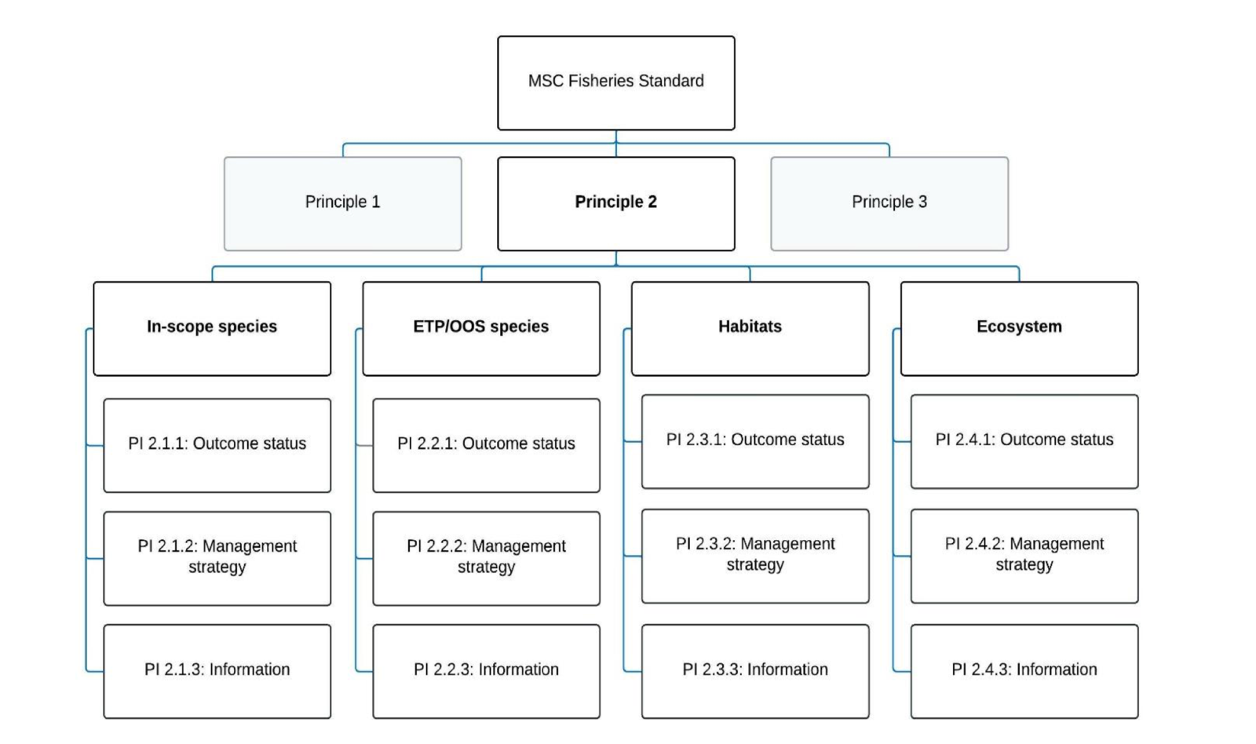
Figure 12. Decision tree for Principle 2 (MSC Fisheries Standard v3.)

4.2.2 Designating species

The MSC Standard v 3.0 outlines how to designate Principle 2 species. The Decision Tree (Figure 13) was used for each species. The target species of the fishery are brown tiger prawn (Penaeus esculentus) and blue endeavour prawn (Metapenaeus endeavouri). Byproduct species include Red-spot king prawn (Melicertus longistylus), Moreton Bay bugs (Thenus spp), octopus (Octopodidae), cuttlefish (Sepia spp) and squid (Teuthoidea).
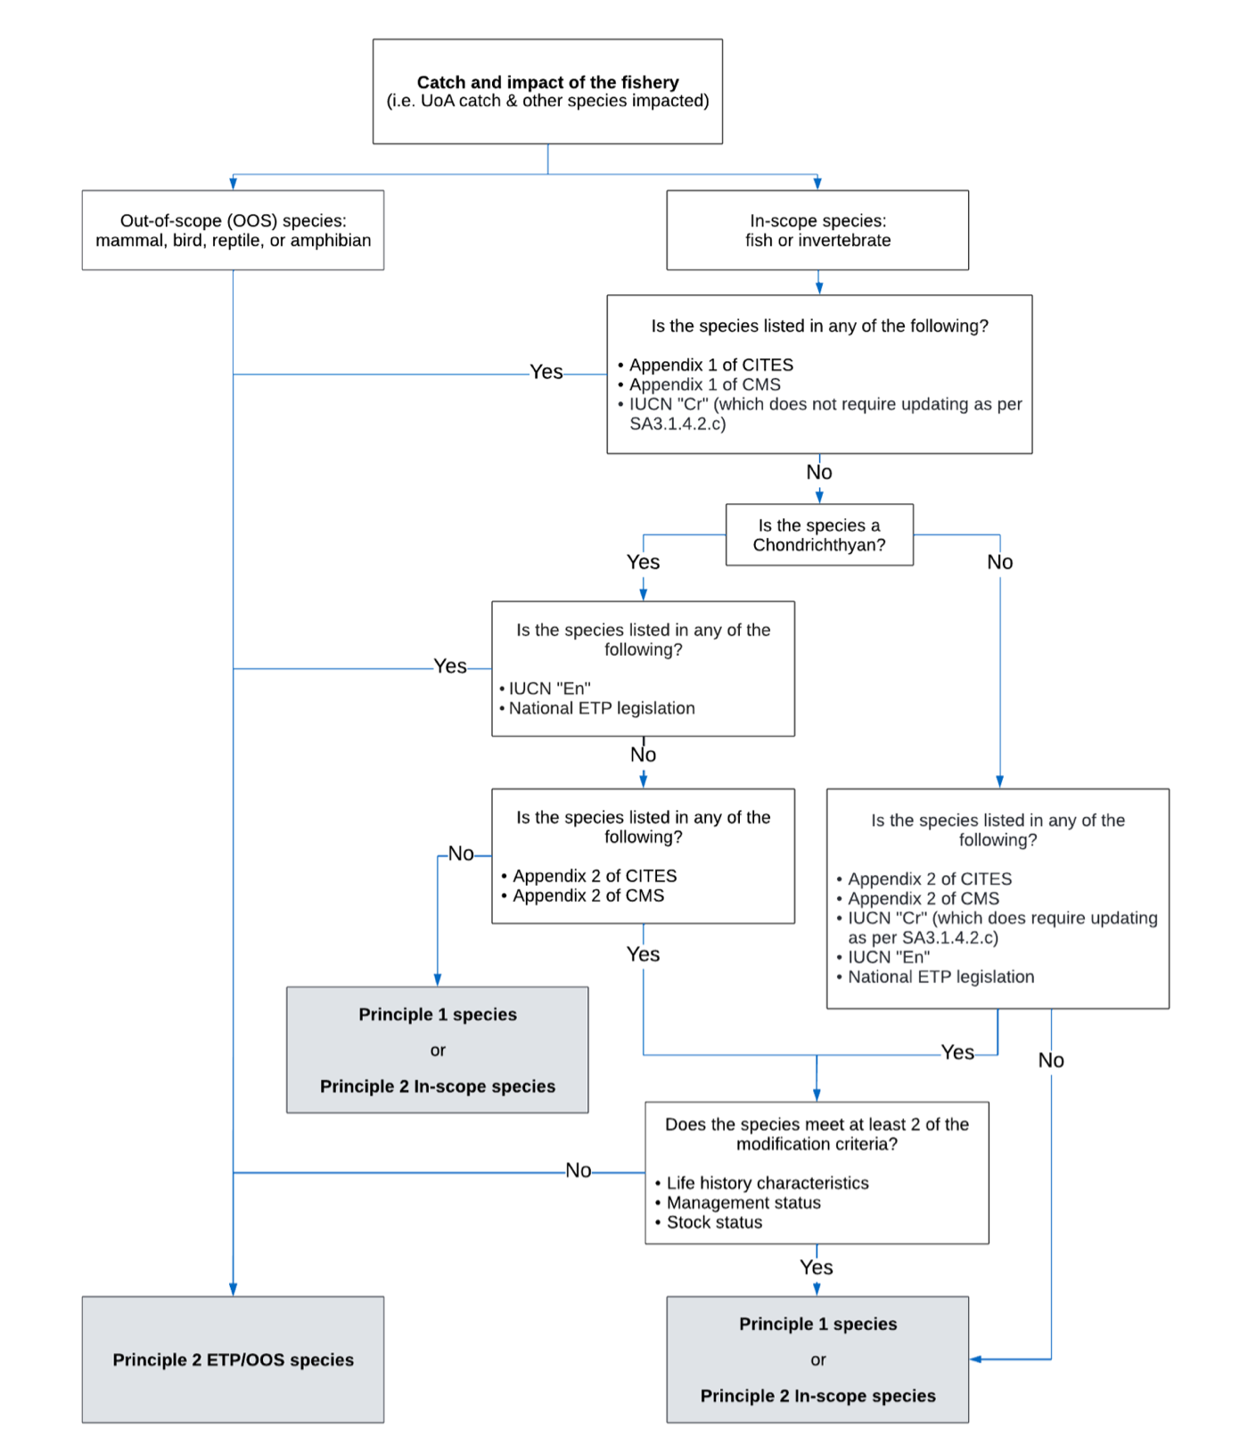
Figure 13. Decision tree for species categorisation from SA3 within the MSC Fisheries Standard v 3.0
Ecological Risk Assessments
A common method for assessing data-poor species is via ecological risk assessments (ERAs). ERAs use a matrix of fishery impacts (catch, effort, discard rate, etc.) and resilience attributes (growth rate, discard survival, exclusion by TEDs, etc.) to determine the ecological risk posed species by the UoA.

The TSPF environmental assessment was conducted by Pitcher et al. (2013) and it was reported changes in risk from 2005 (Pitcher et al. 2007) to 2011.
In 2005:
- the majority of highly exposed species were bycatch species of smaller fishes;
- 38 species had moderate to high exposure to trawled grounds;
- 56 had moderate to high exposure to trawl effort coverage;
- 6 species had very high exposure to effort, of which three had estimated exposure greater than their estimated standing stock.
- One species exceeded the limit reference point: Purple-spotted Bigeye (Priacanthus tayenus, at 1.25);
- One species exceeded the first conservative reference point: Rough Flutemouth (Fistularia petimba at 0.83); and

After considering relative catch rate information, Pitcher et al. (2013) stated that the potential risks were significantly reduced for the majority of species.
In 2011:
- 19 species had moderate to high estimates of annual catch and
- Two species had very high estimates of annual catch.
- The relative order of species exposure to trawling and sustainability risk was similar, but the levels were substantially reduced consistent with the reduced areal footprint of the fishery and amount of effort.
- One species had moderate high exposure to 2011 trawl grounds (i.e., Priacanthus tayenus, 50%);
- 11 species had 50–25% exposure and 26 species had exposure <25%.
- No species exceeded any of the sustainability reference points; the highest value (again for Priacanthus tayenus, at 0.31) was well below the second conservative reference point (0.6).

Bycatch/discard research

There is limited information on the proportion of the catch that is discarded by the fishery.

In 2004-06, surveys of bycatch (and all 92 subsamples) were dominated by teleosts ( 77% of the total bycatch weight), and crustaceans (17% of total bycatch) (Turnbull & Rose, 2007). Elasmobranchs were a very small percent of the bycatch. Over the 3 year of surveys, three small shark species and two small ray species were caught and discarded alive, namely:
- Carcharhinus dussumieri (whitecheek shark);
- Stegostoma fasciatum (zebra shark);
- Rhynchobatus australiae (white-spotted guitarfish);
- Dasyatis leylandi (painted maskray); and
- Gymnura australis (butterfly ray).

Only three species made up more than 5% of the discards by weight:
- Scolopsis taenioptera Nemipteridae 8.2%;
- Lethrinus genivittatus Lethrinidae 6.2%;
- Paramonacanthus spp Monacanthidae 5.1%).

No single species is likely to make up more than 5% of total catch (bycatch and retained species) although as a precaution S. taenioptera will be assessed as in-scope main species whilst the other two species are identified as in-scope minor species. Pitcher et al. (2013) stated that “In the 2011 update of the species assessment, the relative order of species exposure to trawling and sustainability risk was similar, but the levels were substantially reduced.” In 2011, no species exceeded any of the sustainability reference points; the highest value (0.31 Priacanthus tayenus) was also below the second conservative reference point. No other species were identified as main in-scope species.

Prawn trawling does not appear to have any marked effect on the bycatch of the TSPF. There were no major differences in the bycatch community structure between the areas open, partially closed and entirely closed to trawling however some of the dominant bycatch species were much more prevalent in either the open or closed area. These differences in distribution were due more to the environmental variables of depth, current stress and sediment type than prawn trawling, which is the case for other studies of prawn trawl bycatch in the Torres Strait, the Gulf of Carpentaria and Queensland.

In 1999, the first Bycatch Action Plan was developed to address growing public concern regarding prawn trawl operations and in recognition of initiatives being undertaken in adjacent trawl fisheries. An update in 2005, incorporated management advances for bycatch species. Additional management includes:
- the implementation of trawl exclusion zones in various areas (2008),
- mandatory use of turtle exclusion devices (TEDs) (2002)
- mandatory use of bycatch reduction devices (BRD) (2004).

The Bycatch and Discarding Workplan was updated in 2015 and the 2024–2029 Workplan has been drafted and is due for release later this year.

More information on the fishery can be found in the Torres Strait Prawn Fishery Handbook 2016 (Cocking, 2016).

Permitted species

The TSPF primarily targets Tiger prawns but also takes significant volumes of Blue Endeavour Prawn and Red-spot King Prawn (Figure 14). Eight other species are listed as by-product species. Table 7 presents species that are prohibited or have catch limits.
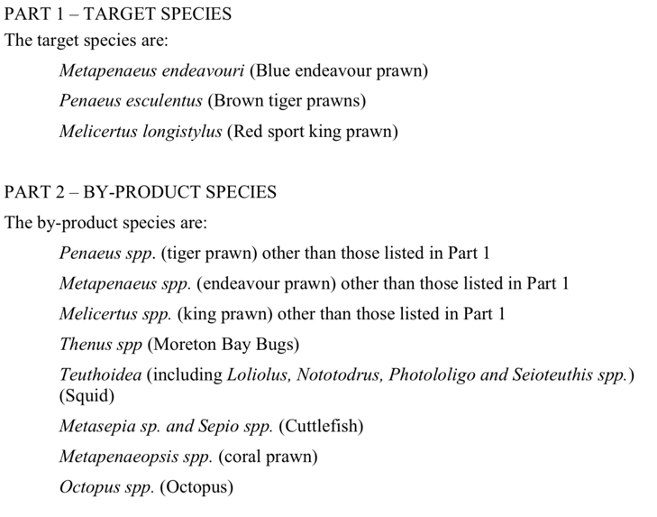

Figure 14. Target, by-product species permitted under the Torres Strait Prawn Fishery Management Plan 2009
Table 7. Species that are prohibited or have catch/size limits (Cocking, 2016)
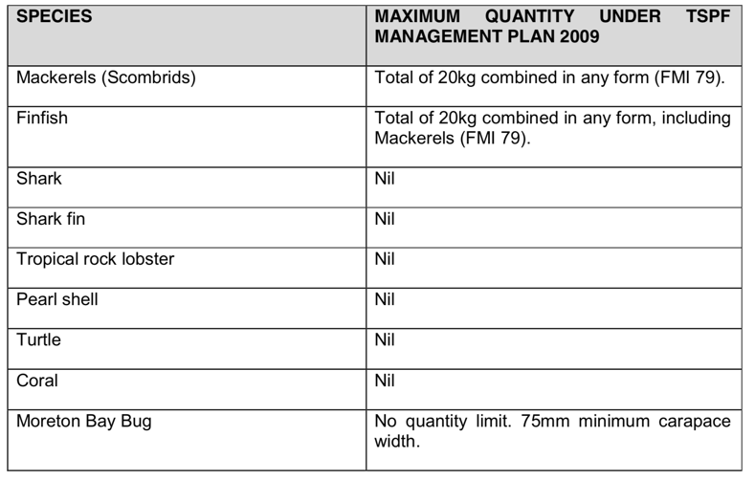

Wildlife Trade Operation Approval Application (EPBC Act)
In 2016, AFMA applied for WTO approval for export and in 2017 was assessed under Part 13 of the EPBC Act.

Species designation

The annual retained catch is well understood (Table 6); the fishery has no trade in shark or shark-fins (Figure (15) and as such, no shark is considered a main species (MSC SA 3.5.2.1c; Figure 16).

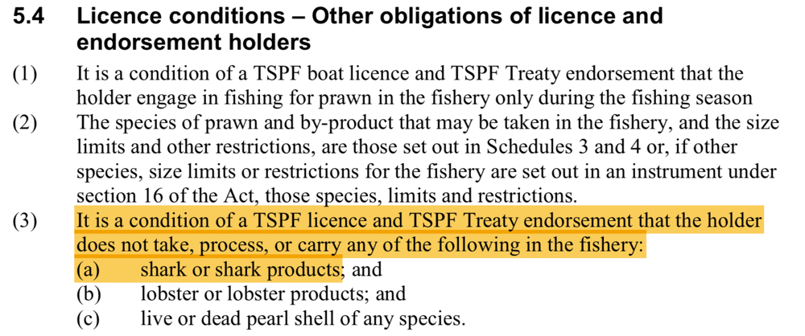

Figure 15. Torres Strait Prawn Fishery Management Plan 2009 relating to shark and shark products.

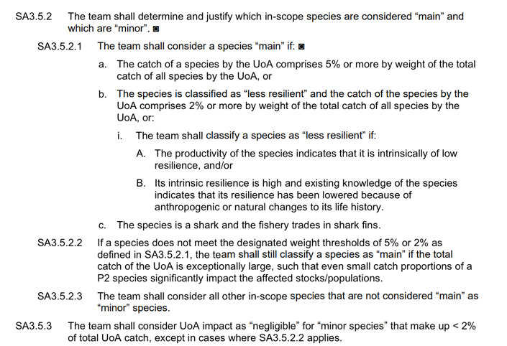
Figure 16. Default assessment tree guidance for definition of main and minor in-scope species

In 2022, the total retained catch for the TSPF was 353 tonnes (Butler et al. 2023) although the total catch (including discards) is unknown. However, using surrogate data from i Queensland’s northern ECOTF that also targets Tiger prawn, the estimated ratio of discard (kg) to retained (kg) was 4.5:1.0 (Wang et al. 2020).

Discard catch data is presented above from ERAs, observer data and research papers. The only species that may be considered as main in-scope species are listed in Table 8. No other retained species made up more than 5% of the total retained catch (Table 9).

Table 8. Reported annual retained catch (t) from the TSPF by year (Source: Butler et al. 2023; Turnbull & Cocking, 2023). (Yellow = P1 species)
Species | Retained catch (t) by year
Species | 2020 | 2021 | 2022
Bugs | 4.2 | 10.7 | 11.5
Cuttlefish | 0.25 | 0.21 | 0.15
Octopus | 0.16 | 0.07 | 0.03
Prawn – endeavour | 60 | 62 | 87
Prawn – mixed (various) | 0 | 0.33 | 0.23
Prawn – red spot king | 2.4 | 2.7 | 2.0
Prawn – tiger | 203 | 233 | 265
Squid | 0.12 | 0.25 | 0.09
Total | 270.13 | 309.26 | 366.00

Table 9. Retained and discard species categorisation into components for this assessment. At a ratio of ‘1.0 : 4.5’ for ‘retained : discards’, those discard species that made up ≥ 6.1% of the total discarded catch in research trawl would equate to ≥ 5% of total catch. (Yellow = P1; Blue = P2 Main; White = P2 minor; Green = ETP species)
Retained species | Species | Component
Retained species | Tiger prawns | UoA P1
Retained species | Endeavour Prawns | UoA P1
Retained species | Bugs (Thenus spp.) | In-scope minor
Retained species | Red-spot King prawns | In-scope minor
Retained species | Cuttlefish (Metasepia spp, Sepia spp) | In-scope minor
Retained species | Coral prawn | In-scope minor
Retained species | Squid (Teuthoidea) | In-scope minor
Retained species | Octopus (Octopus spp) | In-scope minor
Discarded species | Leatherjackets (Paramonacanthus spp) | In-scope minor
Discarded species | Purple-spotted Bigeye (Priacanthus tayenus) | In-scope minor
Discarded species | Red-spot Monocle Bream (Scolopsis taenioptera) | In-scope main
Discarded species | Long-spine Emperor Lethrinus genivittatus | In-scope minor
Discarded species | Marine Turtle | ETP
Discarded species | Pipehorse (Syngnathidae) | ETP
Discarded species | Narrow Sawfish (Anoxypristis cuspidata) | ETP
Discarded species | Sea snakes (various species) | ETP

4.2.3 In-scope species

Main in-scope species
One other species that potentially made up ≥5% of the total catch is assessed further .

Red-spot Monocle Bream
Scolopsis taenioptera (Cuvier, 1830) is a coastal fish species that occurs over sandy and muddy seafloor to depths of 50 m. It is distributed in the tropical and sub-tropical waters of the western Pacific Ocean from Taiwan to New Caledonia and eastern Indian Ocean from the Andaman Sea to northwestern Australia. Kakioka et al. (2017) examined the stock structure of this species in the western Pacific but did not include the Torres Strait region. It is known to swim in small schools and reaches 25 cm TL. Whilst there is no stock assessment, there is sufficient biological information on FishBase to use the Risk Based Framework (RBF) (Table 10). The trophic level of this species is 3.9, the generation time is 2.3 years and their resilience is considered high with a minimum population doubling time of <15 months. Fishing vulnerability is listed as low to moderate. The preliminary RBF produced an MSC PSA score ≥80.

Table 10. Risk Based Framework for main in-scope species (Red spot Monocle Bream) from the TSPF.
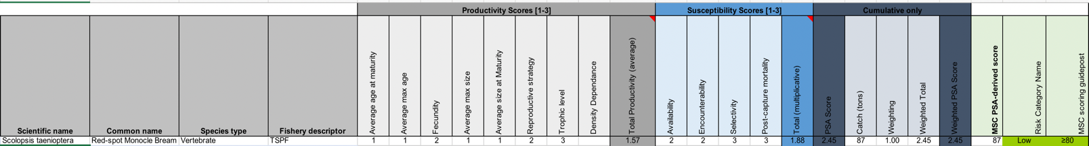

Minor in-scope species

Many other species are regularly discarded by the fishery, although studies have shown that the fishery interacts with a large number of species, most of which occur very infrequently in trawls and do not comprise a significant proportion of the total catch. Given that this is a pre-assessment report and minor in-scope species are only assessed to reach SG 100, no further attention is given to this group of species.

Management of In-scope species

In 2011, the harvest strategy for the TSPF was implemented (AFMA 2011). It was developed in accordance with the Commonwealth harvest strategy policy to manage the harvest of trawl fishery resources. The HS does not include any discard species, and as such, the management of Red-spot Monocle Bream falls under the Bycatch and Discarding Workplan and the TSPF Management Plan 2009.

Management of Discards

There are three basic approaches to minimising discards.
- The first approach is to avoid bycatch in the first instance. This is done through voluntary or compulsory closed seasons or closed waters to avoid catching fish or other species that will be discarded. This often includes closing water to fishing where there is a high likelihood of interactions.

- The second approach uses selective or alternative fishing equipment to reduce bycatch, by either preventing certain species from entering nets, or providing escape mechanisms for unwanted catch. TEDs and BRDs are mandatory. TEDs and BRDs resulted in significant decreases in the number of discards produced in the TSPF. Further information on BRDs is presented above at Section 3.1.3.

- A third approach aims to create a value for bycatch that would otherwise be discarded, providing market incentives to retain more catch and discard less. Whilst this has been investigated in other Australian trawl fisheries, it has not been investigated for the TSPF.

4.2.4 ETP/OOS species

Endangered, Threatened and/or Protected species (ETPs)
The MSC Standard v 3.0 outlines how to designate Principle 2 species, including determination of an ETP species (SA 3.1.4); noting that this has changed since the earlier MSC version to now include CITES/CMS Appendix II species.
Information on any listing with CITES or CMS is available at: https://www.speciesplus.net and the Australian database for listed species is at: https://www.environment.gov.au/cgi-bin/sprat/public/sprat.pl.
The Australian database also includes the IUCN RedList ranking as required in the decision tree at Figure 16.
Commercial fishers operating in TSPF are required to report all interactions with protected species using Northern Prawn Fisheries approved logbooks (Figure 4); quarterly ETP reports are prepared from this logbook data and shared publicly. Sea snakes were the most common ETP species reported in logbooks (Tables 11, 12 & 13).

Table 11. Reported ETP species interactions and life status for the TSPF in 2022 and 2023 (Source data: AFMA 2024)
Species | Sea snake | Narrow Sawfish | Marine Turtle | Pipefish
2022
Alive | 53 |  | 1
Injured/unknown | 150
TOTAL | 203 | 0 | 1 | 0
2023
Alive | 143 | 4 | 1
Injured/unknown | 711
Deceased | 10 |  |  | 1
TOTAL | 864 | 4 | 1 | 1

Table 12. ETP species interactions (without life status) and effort (days) for the TSPF from 2005 to 2022 (Turnbull, 2023).
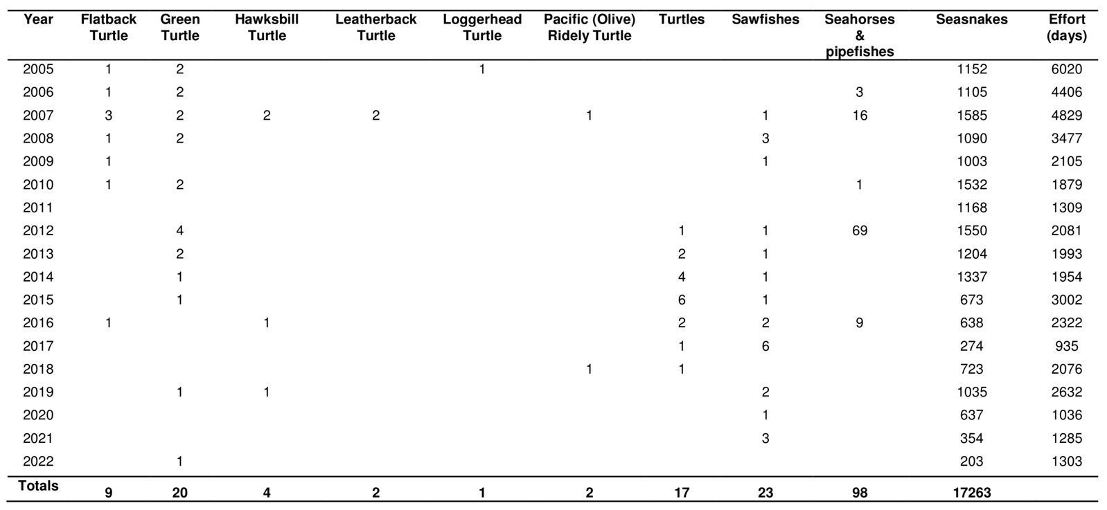

Table 13. Observer data for ETP species interactions during 2019-2022 fishing season observer trips.(TSPMAC 21, 2023)
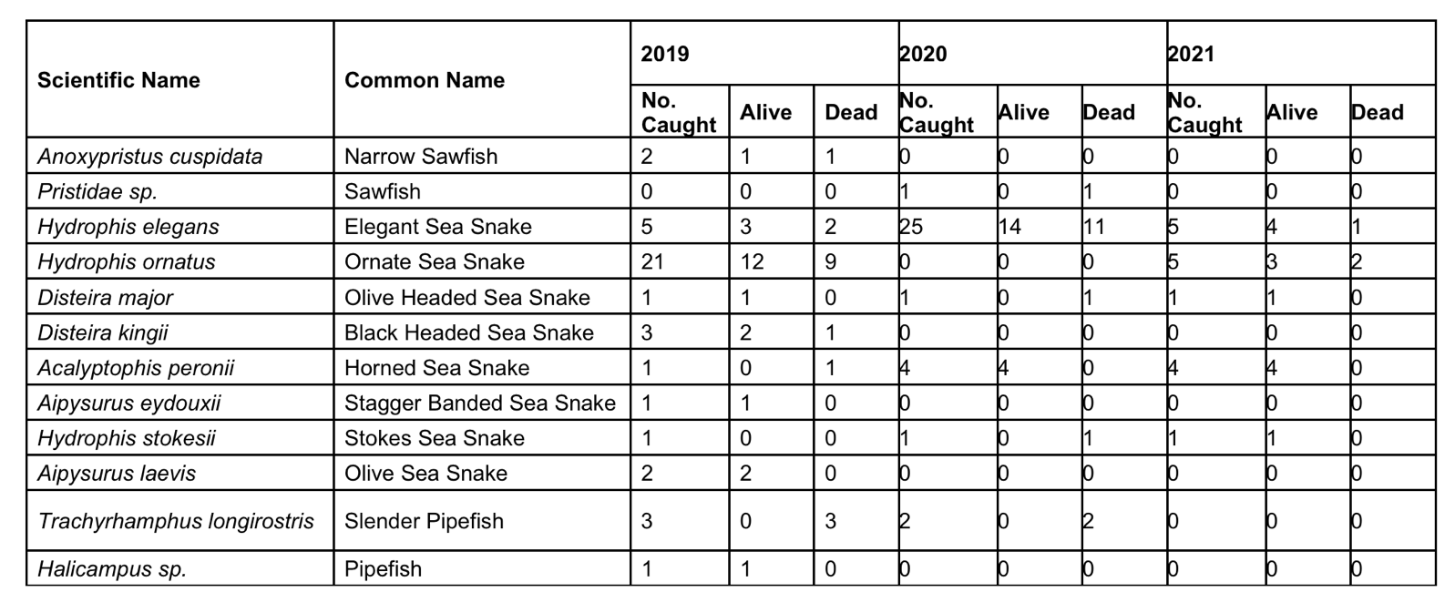
Not all species of conservation concern are listed ETPs (i.e., protected under national legislation and/or binding international agreements), particularly many sharks and rays. Additional information from the FRDC reports (Simpfendorfer et al. 2019) and International Plan of Action (Kyne et al. 2021) were included on stock status and risk assessment of sharks and rays. Sharks and rays are not retained by the fishery, and there is a Code of Practise for the safe handling of sharks and rays (included in the TSPF Handbook, Cocking 2016), to ensure that they are released with the highest chance of survival.

CITES
The Convention on International Trade in Endangered Species of Wild Fauna and Flora (CITES) is an international agreement between governments that aims to ensure that the international trade in wildlife does not threaten wild populations of plants and animals. The 19th meeting of the Conference of the Parties to the CITES (CITES CoP19) was held from 14 to 25 November 2022 in Panama City, Panama. Amendments to the CITES Appendices, including new listings, enter into force for all parties 90 days after the meeting (i.e., 23 February 2023), unless a delayed implementation date is agreed. Australia implements CITES through its national environment law, the Environment Protection and Biodiversity Act 1999 (EPBC Act). The List of CITES Species included in the EPBC Act was to be amended by 23 February 2023 to ensure that any Australian imports and exports of the species newly listed under CITES may continue.
CMS
The Convention on Migratory Species (CMS), also known as the Bonn Convention, is an environmental treaty of the United Nations that provides a global platform for the conservation and sustainable use of terrestrial, aquatic and avian migratory animals and their habitats.
Countries whose representatives have signed up to the CMS are known as ‘Parties to the CMS’. Australia became a Party of the CMS in 1991. All Parties to the CMS acknowledge the importance of acting to conserve migratory species. CMS has two Appendices. These Appendices list migratory species to which the Convention applies. The text of the Convention defines the basic obligations of the Contracting Parties towards species listed on Appendix I and Appendix II. These obligations are quite distinct for the two Appendices, and a migratory species can be listed in both Appendices at the same time, if the circumstances so warrant. Appendix I comprises migratory species that have been assessed as being in danger of extinction throughout all or a significant portion of their range. Appendix II covers migratory species that have an unfavourable conservation status and that require international agreements for their conservation and management. Appendices I and II may be amended at any meeting of the Conference of the Parties. An amendment to the Appendices shall enter into force for all Parties ninety days after the meeting of the Conference of the Parties. Those CMS listed species relevant to Australia are available at http://www.environment.gov.au/cgi-bin/sprat/public/publicshowmigratory.pl Species listed on CMS Appendices I and II are protected under the Environment Protection and Biodiversity Conservation Act 1999 (EPBC Act). Through listing the species as migratory under the EPBC Act, it becomes an offence to kill, injure, take, trade, keep or move the species in Commonwealth waters. In 2023, Australia produced a National report for migratory sharks and rays.

Narrow Sawfish (A. cuspidata)
The Narrow Sawfish has a wide northern Australian distribution (Peverell 2005). New research based on sawfish tissue samples from the Northern Prawn Fishery of northern Australia found fine-scale population structuring due to the limited movement of females (Feutry et al. 2021).
Outside of Australian waters, it once had a wide tropical Indo-West Pacific distribution (Figure 17). This species is the most biologically productive of the sawfishes. While the Pristis sawfishes are long lived, reaching between 30 and >50 years of age, the narrow sawfish (A. cuspidata) lives for only 9 years. Age at maturity is 3 years and litter sizes range of 5–16 pups. The generation length for narrow sawfish is much shorter, (4.6 years) compared to 14.6 and 17.2 years in the Pristis sawfishes. Consequently, the intrinsic rate of population increase is relatively high for narrow sawfish (0.27 yr-1), compared with the other species, which range from 0.02 yr-1 in the Green sawfish to 0.12 yr-1 in the Large-tooth sawfish (Dulvy et al., 2016).
Further taxonomic, life history and ecological data is available at:
- https://shark-references.com/species/view/Anoxypristis-cuspidata
- https://www.dcceew.gov.au/sites/default/files/documents/sawfish-river-sharks-multispecies-issues-paper.pdf
- 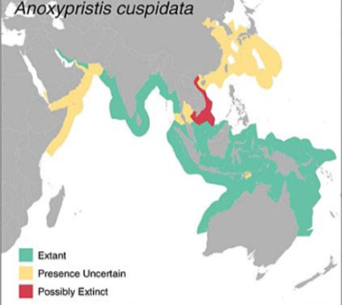

Figure 17. Narrow Sawfish Extent of Occurrence range maps (Source: Dulvy et al, 2016)
Anoxypristis cuspidata is the most common sawfish in the bycatch of commercial fisheries (including TSPF) across northern Australia (Feutry et al. 2021). Narrow sawfish is the most regularly caught sawfish in the MSC certified Northern Prawn Fishery (NPF where it made up about 92% of the catch composition for the sawfish group in the NPF between 2002 and 2019. However, recent estimates increasing two-fold from 2019 to 2020 in the NPF Tiger prawn sub-fishery. Whilst, past estimates of fishing mortality rates for the species in the NPF are reportedly “below a rate that would lead to significant population declines”, when considering the recent NPF increases and other fishing mortality (TSPF, ECOTF, Gulf of Carpentaria Inshore FinFish fishery), it is likely to be in excess of sustainable levels (Kyne et al. 2021).
The significant population reduction in the Narrow Sawfish largely occurred prior to the last three generations (pre-2000s), noting that protection and management measures have reduced mortality over the last 1–2 decades. Over the last three generations (18 years), it is suspected that the population has undergone a reduction of >30% and the Narrow Sawfish is assessed as Vulnerable. Although threatened here, Australia represents the most significant remaining global location for this species.
DoE (2015) produced a multi-species issue paper for sawfish and river sharks. Kyne et al. (2021) lists Narrow Sawfish population as ‘depleted’ and the IUCN RedList listed the species as ‘Critically Endangered’ in 2023.
The 2016 WTO application and 2017 did not mention any risk to sawfish species. Furthermore, the TSPF ERA (Pitcher et al. 2013) and report on the ecological sustainable management of the TSPF (Turnbull & Rose, 2007) did not mention sawfish specifically. A sawfish identification guide was included in the northern prawn fisheries N16 Logbook summary documents.

Marine turtles
Marine turtles are listed in Appendix I of CITES which prohibits international trade in specimens of these species. In Australia, it is illegal to kill, injure, take, trade, keep or move turtle species. Marine turtles are also listed in Appendix I of the CMS. CMS requirements for the signatory countries include prohibiting the taking of the species, with very restricted scope for exceptions; conserving and where appropriate restoring their habitats; preventing, removing or mitigating obstacles to their migration and controlling other factors that might endanger them. In Australia, marine turtles are EPBC listed as ‘vulnerable’ or ‘endangered’, marine and migratory. To meet the CMS and the EPBC requirements, an updated Recovery Plan for Marine Turtles in Australia 2017–2027 was developed (DEE, 2017).
There is significant research to monitor marine turtles in the Torres Strait region (TSRA, 2015). There are no population estimates for turtle stocks in the Torres Strait although the monitoring of key turtle nesting sites in Queensland has flagged concerns with respect to the Green turtle (Chelonia mydas) and Hawksbill turtle (Eretmochelys imbricate) stocks. The ERA (Pitcher et al. 2013) reported that interactions had dropped significantly following the mandatory implementation of TEDs and BRDs. The use of a Turtle Exclusion Device (TED) remains a pivotal component of the broader management plan and has been an effective risk-mitigation strategy employed for marine turtles. Research from both Australia and elsewhere has shown that the combined use of a TED with a Bycatch Reduction Device (BRD) can reduce landing rates for marine turtles by 97–99% (e.g., Campbell et al., 2020). Publicly available interaction data reported that in 2022–23, two Marine Turtles interactions were reported and released alive (Table 11).
The Recovery Plan for Marine Turtles requires that Australian fisheries management operate in accordance with the FAO Guidelines to Reduce Sea Turtle Mortality in Fishing Operations. The main requirements within the recovery plan relevant to domestic fisheries include:
- improving access and report of the most current bycatch information that will enhance the assessment of whether current fisheries interactions will impact on stock recovery.
- promotion and implementation of best practice and continued innovation of turtle bycatch mitigation.
The measures of success for the above actions include:
- domestic fisheries are compliant with fisheries legislation pertaining to bycatch;
- marine turtle species are accurately recorded in 90% of reported fishery interactions within Australia’s jurisdiction;
- marine turtle bycatch is reduced such that it does not impact stock recovery.

The TSPF’s impact on marine turtles was reduced significantly with the introduction of TEDs and turtles caught are released alive with mandatory reporting requirements. The trawl footprint is a very small fraction of marine turtle species distribution.

Sea snakes
There are at least 7 species of sea snakes recorded in the Torres Strait and observer data recorded interactions with eight species (Table 13).

Catch in prawn trawl fisheries prior to and after the implementation of bycatch reduction devices has been investigated in other management jurisdictions (Courtney et al. 2010; Courtney et al. 2014; Jacobsen et al. 2018).

In 2022, 203 Sea snake interactions were reported of which 53 were dead and 150 were injured/unknown, the remainder were released alive. Interactions increased to 864 in 2023 (Table 11). Species are not identified in logbooks although observer data suggests that the Ornate and the Elegant sea snakes are most commonly encountered (Table 13). Catches have declined (Table 12) between 2005–2022 (Turnbull, 2023), although in these 19 years the fishery interacted with 18,127 sea snakes (or an annual average of 954).

When considering cumulative impacts of interactions with MSC certified fisheries, it is important to consider the Northern Prawn Fishery and northern zone of the East Coast Otter Trawl Fishery, and their impacts on these species of sea snakes (Fry et al. 2021; Dedini et al. 2023). In 2021, the NPF recorded 13,691 interactions, and the ECOTF interacted with 426 sea snakes in the same year.

Pipefish
In late 2001, syngnathids (pipefish and seahorse etc.) were included in the list of marine species under Part 13 of the EPBC Act. As a result of this listing, it is an offence to kill, injure, take or trade syngnathids and solenostomids in, or from, a Commonwealth area. Family Syngnathidae are all classified as no-take and are subject to mandatory reporting requirements (Figure 4). One pipefish was reported in logbooks in 2022 and 2023 (Table 11) and the species was not determined. In 2019–21, observer data (Table 13) identified two species.

Ghost nets

Ghost nets are defined as abandoned, lost or otherwise discarded fishing gear (ALDFG) in the marine environment and are a global problem. Fishing gear could be lost from vessels for a variety of reasons, including but not limited to stowed gear being washed overboard, gear being lost or abandoned during fishing operations and nets or net repairs being discarded whilst at sea (Richardson et al., 2018). Lost fishing gear (e.g. ground chains, trawl net) is likely to sink, with localised smothering effects on a small area of habitat where it lands, however trawl net will not generally continue ‘ghost’ fishing, and the level of lost or discarded fishing gear in the trawl industry is likely to be relatively low.

Pollution of the marine environment by ships, including fishing vessels, is strictly controlled by the International Convention for the Prevention of Pollution from Ships (known as MARPOL). With regard to legislation, the Australian Maritime Safety Authority also have legislative responsibility for marine pollution and providing safe navigation.

In 2011, an industry wide Code of Practice for the Responsible Disposal of Marine Debris was initiated and introduced by the TSPMAC. The Codes of Practice are voluntary, except where parts of the Codes have been given, or may be given, binding legal effect by means of agreements or legislation. The Code sets out some mandatory requirements under the International Convention for the Prevention of Pollution from Ships (MARPOL) relevant to the TSPF. In addition, it outlines voluntary guidelines and standards of behaviour for responsible fishing practices to ensure the effective conservation, management and development of resources, with due respect for the ecosystem and biodiversity. Whilst the document is considered as a guideline only, it is the fishers’ responsibility to understand the relevant legislation and other mandatory documents such as MARPOL. The Code of Practice was designed to be clearly displayed and accessible in the wheelhouse of each vessel in the fishery, and are distributed to all operators in the TSPF.

Habitats
The new MSC Standard classifieds habitats as 'More Sensitive' or 'Less Sensitive', based on the time it takes to recover from the impacts of fishing.
- More sensitive habitat: a habitat unable to recover to at least 80% of its unimpacted structure and function within 20 years if fishing were to cease entirely.
- Less sensitive habitat: a habitat able to recover to at least 80% of its unimpacted structure and function within 20 years if fishing were to cease entirely.
The contact of trawl gear without capture was considered to pose an initial high risk of damage to habitats. Trawl gear can cause direct physical damage to marine plants and animals on the seabed. Some other activities of the fishery may also impact on habitats; however, these were all assessed as posing a low initial risk. Trawl gear may impact on habitats by removing structural habitat elements such as sponges, which are subsequently discarded. Loss of fishing gear (e.g. ground chains, trawl net) is considered rare and would be likely to sink, with localised smothering effects on a small area of habitat where it lands, however a trawl net will not generally continue to ‘ghost’ fishing, and the level of lost or discarded fishing gear in the trawl industry is believed to be relatively low/negligible. Boat maintenance and emissions could potentially impact marine plants and animals by contaminating the water column and the seabed with toxic chemicals (e.g. fuel, oil or anti-fouling chemicals), however, the fleet size and amount of chemicals carried is relatively small compared with all shipping activity in the area, and most maintenance is carried out in port or on land.
The Torres Strait is a shallow water body with a complex hydrodynamic environment between north-east Australia's Cape York Peninsula and Papua New Guinea (Figure 1). The area covers more than 48,000 km² and is prone to high velocity tidal currents, with many shoals, reefs and islands (Carter et al. 2023). The Torres Strait is not influenced from river input from the Australian coast, although the northern region of the TS is subjected to limited river outflows from Papua New Guinea (Waterhouse et al. 2021). Mangroves are widespread but more abundant in the northern areas with large mangrove islands (Duke et al. 2015). Seagrass meadows are also common throughout Torres Strait, but are most abundant in nearshore waters, on and surrounding reefs and in subtidal waters in the western region (Haywood et al. 2008; Carter et al. 2014; 2021). The extensive seagrass habitats located around the GNE channel provides vital nursery ground habitats for juvenile prawns associated with the fishery.
Detailed information is available on the habitat types of the Torres Strait (Carter et al. 2014; Lawrey & Stewart, 2016; Carter et al. 2023) and the impacts of trawling on them (Pantus et al. 2007; Ellis et al. 2008). Data on seagrass distribution have been collected since the early 1980s, and Carter et al. (2023) validated and synthesized historical seagrass spatial data to create a publicly available database. Thirteen seagrass species were identified in depths ranging from intertidal to 38 m below mean sea level.
Pantus et al. (2007) provided a management system evaluation for minimising habitat and ecosystem impacts of the TSPF. Ellis et al. (2008) found that, for the Torres Strait prawn fishery, the single management control with the biggest effect on the habitat was total fishing effort.
In summary, comprehensive information is available on the habitat types of the Torres Strait and the impacts of trawling on them and VMS information provides fine scale information on fishing effort sufficient to detect any increase in risk. The nature, distribution and vulnerability of the main habitat types in the fishing area are well studied and allow effective strategy to ensure the TSPF does not reduce habitat structure and function to the point of serious or irreversible harm.

Habitat Management
There are several measures to manage habitat impacts
- Spatial closures: Trawling is permanently prohibited in various regions (Figure 4).
- Effort reduction and cap: In the last two decades significant reductions in nominal effort have occurred for the fishery. Fishing is limited by a Total Allowable Effort (TAE) in the form of total annual fishing days. This is the total number of days that could be fished by all licenced boats each year. The fishery currently operates well under the TAE limit each year, ranging between approximately 900 and 2700 fishing nights each season since 2016. The TAE limit must be set and determined by the PZJA at least every three years in the TSPF (S2.5 of the Torres Strait Prawn Fishery Management Plan 2009). The TAE was last set in 2023 to apply for the 2024, 2025 and 2026 fishing seasons. The TAE applies to the 60 licences in the TSPF. The TAE is divided among these licences based on the number of effort units held by each licence holder (9,200 units total in the fishery) in accordance with a formula that is in S4.3 of the Plan).
- Gear restrictions: The size and power of vessels and the gear that they trawl with are restricted through legislation. Of particular importance for habitats is the restriction on the weight of chains.
- VMS: all vessels are required to use VMS to ensure compliance with spatial and temporal closures, and to make it easy for compliance officers to know where vessels are when undertaking compliance activity.
- Research: Substantial research activity to evaluate and manage the impacts of the fishery on habitats, particularly within the TS (e.g. Ellis et al. 2008).
Closures are designed to protect each bioregion in the marine park in no-take areas. While these measures in combination with more generic measures such as effort and gear limitations are probably sufficient to ensure that the UoA is unlikely to reduce structure and functions of habitats to the point where there would be serious or irreversible harm.
Closed areas, effort caps and gear restrictions are all effective management tools that are proven effective in management of habitat impacts, but only when coupled with an appropriate compliance program. The VMS is a critical and effective component of compliance to ensure adherence with closures and efficacy of compliance surveillance. Collectively, these measures form at least a partial strategy.

Ecosystems
Torres Strait in north-eastern Australia support globally significant seagrass ecosystems that underpin fishing and cultural heritage of the region (Carter et al. 2023). The impacts of the TSPF on the broader ecosystem within the TS was part of the ecological risk assessment (Pitcher et al. 2013).
This assessment considered impacts on specific ecosystem processes: particle feeding, primary production, herbivory, predation, bioturbation, detritivory, scavenging, symbiosis, reef building, competition, connectivity, and species introductions. It concluded that trawling posed a low risk to all these processes.

Ecosystem Management
There are a number of management measures that comprise the management strategy for ecosystems.
- Spatial and temporal closures: Trawling is permanently prohibited in various regions (Figure 4).
- Effort reduction and cap: The TAE limit must be set and determined by the PZJA at least every three years in the TSPF (S2.5 of the Torres Strait Prawn Fishery Management Plan 2009). The TAE was last set in 2023 to apply for the 2024, 2025 and 2026 fishing seasons. The TAE applies to the 60 licences in the TSPF. The TAE is divided among these licences based on the number of effort units held by each licence holder (9,200 units total in the fishery) in accordance with a formula that is in S4.3 of the Plan).
- Bycatch reduction devices: The use of BRDs and TEDs of particular specifications is mandatory. These devices are particularly important for turtle and sawfish exclusion.
- Logbook data collection of interactions: fishers are required by law to record interactions with ETP species. While it is likely these data are under-represented, they do provide a useful insight into potential changes in interactions levels with ETP species.
- Substantial research activity to evaluate and manage the impacts of the fishery on the ecosystem.

A purpose of the Parties in establishing the Protected Zone was to protect and preserve the marine environment and indigenous fauna and flora in and in the vicinity of the Protected Zone. This is explicitly outlined in the legislation (e.g., Article 13 and Article 14 of the Torres Strait Treaty). Collectively these measures constitute at least a partial strategy which is expected to restrain impact of the UoA on the ecosystem.

Evidence Requirements Framework
Under v 3 of the MSC FS, it is compulsory to use the ‘Evidence Requirements Framework’ (ERF) to assess the quality of information used in the assessment, and to score several Performance Indicators within Principle 2. The ERF provides a framework to evaluate the “trueness,” and “precision” of information used and provides “guideposts for trueness and precision of information”. The Trueness Guideposts provide a framework for evaluating how much bias the information might have and whether that bias may be affecting the trueness of information. The ERF explains what information should be considered in the evaluation of trueness against the guideposts and provides a series of criteria used to structure the evaluation of information trueness. The precision of information must also be evaluated against B1.3.2 – B1.3.4 to determine which of the precision guideposts is met. This includes P2 species through Performance indicators 2.1.2 SI(d) and 2.2.2. SI(d); shark finning; 2.1.3 SI(a & b) and 2.2.3 SI (a); and ETP/OOS 2.2.3 SI (a & b).

Principle 2 References:
Brewer, D., Heales, D., Milton, D., Dell, Q., Fry, G., Venables, B. & Jones, P. (2006). The impact of turtle excluder devices and bycatch reduction devices on diverse tropical marine communities in Australia's northern prawn trawl fishery. Fisheries Research 81, 176-188.

Butler, I., B D’Alberto and A Cao (2023) Chapter 17: Torres Strait Prawn Fishery pp 280-288 In: Butler, I, Patterson, H, Bromhead, D, Galeano, D, Timmiss, T, Woodhams, J and Curtotti, R. Fishery status reports 2023, Australian Bureau of Agricultural and Resource Economics and Sciences, Canberra. CC BY 4.0. https://doi.org/10.25814/vgp4-xr81.
https://daff.ent.sirsidynix.net.au/client/en_AU/search/asset/1035183/18

Campbell, M. J., Courtney, A. J., Wang, N., McLennan, M. F., and Zhou, S. (2017) Estimating the impacts of management changes on bycatch reduction and sustainability of high-risk bycatch species in the Queensland East Coast Otter Trawl Fishery: FRDC Final Report Project number 2015/014, Brisbane, Queensland. CC BY 3.0 Available at: https://era.daf.qld.gov.au/id/eprint/9354/1/Estimating%20impacts%20of%20management%20changes%20on%20bycatch%20reduction_2017_campbell.pdf

Campbell, M.J (2022) Assessing ecological risk posed to common rays by prawn trawling. PhD Thesis, James Cook University. Access to this file is available from: https://doi.org/10.25903/yphx%2Dyk52

Carter, A., Cheers, S., Chetwynd, D., Colefax, A., Cook, S., Davie, P., Ellis, N., Fellegara, I., Forcey,K., Furey, M., Gledhill, D., Hendriks, P., Jacobsen, I., Johnson, J., Jones, M., Last, P., Marks, S., McLeod, I., Sheils, J., Sheppard, J., Smith, G., Strickland, C., Van der Geest, C., Venables, W., Wassenberg, T., Yearsley, G. (2007). Mapping and Characterisation of Key Biotic & Physical Attributes of the Torres Strait Ecosystem. CSIRO/QM/QDPI CRC Torres Strait Task Final Report.145 pp.
Carter, A, Taylor, H., and M. Rasheed (2014) Torres Strait mapping: seagrass consolidation: 2002-2014. Report. TropWATER, James Cook University, Cairns, QLD, Australia.
Carter, A. B., M. David, T. Whap, L. R. Hoffmann, A. Scott, and M. Rasheed. (2021). Torres Strait Seagrass 2021 Report Card. James Cook University, p. 76 https://researchonline.jcu.edu.au/70797/
Carter, A., S McKenna, MA Rasheed, H Taylor, C van de Wetering, K Chartrand, C Reason, C Collier, L Shepherd, J Mellors, L McKenzie, NC Duke, A Roelofs, N Smit, R Groom, D Barrett et al. (2023) Seagrass spatial data synthesis from north-east Australia, Torres Strait and Gulf of Carpentaria, 1983 to 2022. Limnology and Oceanography Letters Volume 9, Issue 1 p. 7-22 https://doi.org/10.1002/lol2.10352
Carter, E. and H. Thulstrup (2022) Report on the Joint World Heritage Centre/IUCN Reactive Monitoring Mission to the Great Barrier Reef (Australia)From 21 To 30 March 2022. IUCN and UNESCO report, Available from https://www.dcceew.gov.au/parks-heritage/great-barrier-reef/world-heritage#toc_2.

Cocking, L. (2016), Torres Strait Prawn Fishery Handbook 2016, Australian Fisheries Management Authority. Canberra, Australia.
Coles, R., Grech, A., Rasheed, M. and McKenzie, L. (2012) Evaluating risk to seagrasses in the Tropical Indo-Pacific Region. Proceedings of the 12th International Coral Reef Symposium, Cairns, Australia, 9-13 July 2012. Mini-Symposium 15b – Seagrasses and seagrass ecosystems.
Courtney, A.J., M.J. Campbell, M.L. Tonks, D.P. Roy, S.W. Gaddes, J.A. Haddy, P.M. Kyne, D.G. Mayer, & K.E. Chilcott (2014)
Effects of bycatch reduction devices in Queensland's (Australia) deepwater eastern king prawn (Melicertus plebejus) trawl fishery,
Fisheries Research, 157: 113–123.

Courtney, A.J., Haddy, J.A., Campbell, M.J., Roy, D.P., Tonks, M.L., Gaddes, S.W., Chilcott, K.E., O'Neill, M.F., Brown, I.W., McLennan, M., Jebreen, J.E., van der Geest, C., Rose, C., Kistle, S., Turnbull, C.T., Kyne, P.M., Bennett, M.B. and Taylor, J. (2007) Bycatch weight, composition and preliminary estimates of the impact of bycatch reduction devices in Queensland's trawl fishery. Queensland.

Courtney, A.J., B.L. Schemel, R. Wallace, M.J. Campbell, D.G. Mayer and B. Young (2010) Reducing the impact of Queensland's trawl fisheries on protected sea snakes Report to the Fisheries Research and Development Corporation Project No. 2005/053, The State of Queensland, Department of Employment, Economic Development and Innovation, Department of Primary Industries and Fisheries. Brisbane, Queensland. pp: 307. https://era.daf.qld.gov.au/id/eprint/3709/1/BycatchFinalReport2007-FullReport.pdf

Courtney, A.J., C. M. Spillman, R. Lemos, J. Thomas , G. M. Leigh and A. B. Campbell. (2015) Physical oceanographic influences on Queensland reef fish and scallops Final Report FRDC 2013/020 December 2015 Available at: https://era.daf.qld.gov.au/id/eprint/5028/1/Final%20Report%202013-020%20Physical%20oceanographic%20influences%20on%20Queensland%20reef%20fish%20and%20scallops.pdf

Dodt, N. (2005). Fisheries Long Term Monitoring Program: Syngnathids in the East Coast Trawl Fishery: a review and trawl survey. Department of Primary Industries, Queensland. https://era.daf.qld.gov.au/id/eprint/6433/
Duke, N. C., D. Burrows, and J. Mackenzie. 2015. Mangrove and freshwater wetland habitat status of the Torres Strait Islands–biodiversity, biomass and changing condition of wetlands. Report to the National Environmental Research Program. Reef and Rainforest Research Centre Limited, p. 84

Dutra, L, Plagányi, E, Kenyon, R, Hutton, T, Murphy, N, Blamey, L, Edgar, S & Moeseneder, C 2021, Scoping a future project to address impacts from climate variability and change on key Torres Strait Fisheries, final report for project ‘Climate variability and change relevant to key fisheries resources in the Torres Strait’ to the Australian Fisheries Management Authority, CSIRO.
Ellis, Nick & Pantus, Francis & Welna, Andrzej & Butler, Alan. (2008). Evaluating ecosystem-based management options: Effects of trawling in Torres Strait, Australia. Continental Shelf Research. 28. 2324-2338. 10.1016/j.csr.2008.03.031.
Fox, A. R., Lovett, R. A., Wickens, M. E. and Hillcoat, K.B. (2023) Stock assessment of Queensland east coast endeavour prawns (Metapenaeus endeavouri and Metapenaeus ensis), Australia, with data to December 2021.Technical Report. State of Queensland, Brisbane.

Fry, G., Laird, A. and Lawrence, E. (2021) Monitoring interactions with bycatch species using crew- member observer data collected in the Northern Prawn Fishery: 2017 – 2019. Final Report to AFMA; R2017/0835. June 2021. CSIRO, Australia. Pp. 236.

Grech, A., & Coles, R. (2011). Interactions between a Trawl Fishery and Spatial Closures for Biodiversity Conservation in the Great Barrier Reef World Heritage Area, Australia. PloSOne, E 6(6): e21094.,

Gehrke, P.C., Sheaves, M.J., Terry, J.P., Boseto, D., Ellison, J.C., Figa, B.S. and Wani, J. (2011) Chapter 7: Vulnerability of freshwater and estuarine fish habitats in the tropical Pacific to climate change. In: Vulnerability of tropical Pacific fisheries and aquaculture to climate change (Eds. Bell, J., Johnson, J.E. and Hobday, A.J.) Secretariat of the Pacific Community, Noumea, New Caledonia.

Harry, A.V. (2011). Life histories of commercially important tropical sharks from the Great Barrier Reef World Heritage Area. PhD thesis. James Cook University, Queensland, Australia.
Haywood, M. D. E., and others. 2008. Mapping and characterisation of the inter-reefal benthic assemblages of the Torres Strait. Cont. Shelf Res. 28: 2304–2316. doi:10.1016/j.csr.2008.03.039
Jacobsen, I., Zeller, B., Dunning., M., Garland., A., Courtney, T., Jebreen, E., 2018. An ecological risk Assessment of the southern Queensland east coast otter trawl fishery and river and inshore beam trawl fishery. Queensland Department of Agriculture and Fisheries, Queensland Australia. Available at: https://www.daf.qld.gov.au/__data/assets/pdf_file/0004/1402672/Sth-QLD-Trawl-ERA-Final.pdf

Johnson, J.E., Marsh, H., Hamann, M., Duke, N., Burrows, D., Bainbridge, S., Sweatman, H., Brodie, J., Bohensky, E., Butler, J., Laurance, S. (2015) Tropical Research in Australia’s Torres Strait region. Report to the National Environmental Research Program. Reef and Rainforest Research Centre Limited, Cairns (33pp.). http://www.nerptropical.edu.au/sites/default/files/publications/files/NERP-TE-SYNTHESIS-REPORT-TORRES-STRAIT-COMPLETE.pdf

Kyne, P.M., (2008). Chondrichthyans and the Queensland East Coast Trawl Fishery. University of Queensland, Australia.

Kyne, P., Courtney, A., Campbell, M., Chilcott, K., Gaddes, S., Turnbull, C., Van Der Geest, C. and Bennett, M. (2002) An overview of the elasmobranch bycatch of the Queensland East coast trawl fishery (Australia). Northwest Atlantic Fisheries Organisation NAFO SCR Document. 2(00): 97

Kyne, P.M., Heupel, M.R., White, W.T. and Simpfendorfer, C.A. (2021). The Action Plan for Australian Sharks and Rays 2021. National Environmental Science Program, Marine Biodiversity Hub, Hobart. Available at: https://www.nespmarine.edu.au/system/files/Shark_Action_Plan_FINAL_Sept7_2021_WEB_RGB.pdf

Last P.R. and Stevens J.D. (2009) Sharks and Rays of Australia. 2nd Ed. Australia: CSIRO Publishing, Hobart, Australia.
Lawrey P., and Stewart, M. (2016) Mapping the Torres Strait Reef and Island Features: Extending the GBR Features (GBRMPA) dataset. Report to the National Environmental Science Programme. Reef and Rainforest Research Centre Limited, Cairns (103pp.).
Long BG and Taranto TJ. (1997) Habitat Classification Of Seabed Areas Of Torres Strait, Northern Australia. CSIRO Division of Marine Research, QLD, Australia.
NESP Earth Systems and Climate Change Hub. 2018. Climate change in the Torres Strait: implications for fisheries and marine ecosystems, Earth Systems and Climate Change Hub Report No. 4, NESP Earth Systems and Climate Change Hub, Australia. https://nespclimate.com.au/wp-content/uploads/2016/03/ESCC-R004-TS-CC-fisheries-workshop-180601.pdf
Pantus F, Ellis N, Browne M, Okey T, Robinson M, Rochester W, and Welna A (2007). Torres Strait Management Scenario Evaluation: Effects of Trawling. Report on CRC Torres Strait task T3.3. CSIRO, Cleveland. 120 pp.
Pitcher, C.R., Haywood, M., Hooper, J., Coles, R., Bartlett, C., Browne, M., Cannard, T., Carini, G., Carter, A., Cheers, S., Chetwynd, D., Colefax, A., Cook, S., Davie, P., Ellis, N., Fellegara, I., Forcey, K., Furey, M., Gledhill, D., Hendriks, P., Jacobsen, I., Johnson, J., Jones, M., Last, P., Marks, S., McLeod, I., Sheils, J., Sheppard, J., Smith, G., Strickland, C., Van der Geest, C., Venables, W., Wassenberg, T., Yearsley, G. (2007). Mapping and Characterisation of Key Biotic & Physical Attributes of the Torres Strait Ecosystem. CSIRO/QM/QDPI CRC Torres Strait Task Final Report. 145 pp.

Pears, R.J., Morison, A.K., Jebreen, E.J., Dunning, M.C., Pitcher, C.R., Courtney, A.J., Houlden, B. and Jacobsen, I.P. (2012) Ecological risk assessment of the East Coast Otter Trawl Fishery in the Great Barrier Reef Marine Park: Technical report. Great Barrier Reef Marine Park Authority. Townsville, Queensland. pp: 263.
http://elibrary.gbrmpa.gov.au/jspui/bitstream/11017/1148/1/ECOTF_ERA_Technical_web.pdf

Peverell SC (2009) Sawfish (Pristidae) of the Gulf of Carpentaria, Queensland, Australia. MSc Dissertation, James Cook University, Townsville.

Pitcher, C.R., Doherty, P., Arnold, P., Hooper, J., Gribble, N., Bartlett, C., Browne, M., Campbell, N., Cannard, T., Cappo, M., Carini, G., Chalmers, S., Cheers, S., Chetwynd, D., Colefax, A., Coles, R., Cook, S., Davie, P., De’ath, G., Devereux, D., Done, B., Donovan, T., Ehr, G., 2007. Seabed biodiversity on the continental shelf of the Great Barrier Reef World Heritage Area, Australian Institute of Marine Science, CSIRO, Queensland Museum, Queensland Department of Primary Industries & CRC Reef Research Centre, task final report, CSIRO.

Pitcher, C.R., Ellis, N., Althaus, F., Williams, A., McLeod, I., Bustamante, R., Kenyon, R., Fuller, M., 2016. Implications of current spatial management measures for AFMA ERAs for habitats - FRDC Project No 2014/204, CSIRO Oceans & Atmosphere, Brisbane. https://doi.org/577.770994

Pitcher, C.R. (2013) Environmental sustainability assessment update for habitats, assemblages and bycatch
species in the Torres Strait Prawn Fishery. Scientific Technical Report. CSIRO, Australia. Available at: https://www.afma.gov.au/sites/default/files/2023-02/Environmental%20sustainability%20assessment%20update%20for%20Torres%20Strait%20Prawn%20Fishery.pdf

Poiner, I. R., Glaister, J., Pitcher, C. R., Burridge, C., Wassenberg, T. J., Gribble, N., Hill, B. J., Blaber, S. J. M., Milton, D., Brewer, D. & Ellis, J. R. (1998). The environmental effects of prawn trawling in the far northern section of the Great Barrier Reef: 1991–96. Final Report to GBRMPA and FRDC. CSIRO Division of Marine Research – Queensland Department of Primary Industries Report. https://www.frdc.com.au/project/1993-096

Richardson, K., R. Gunn, C. Wilcox, B.D. Hardesty (2018) Understanding causes of gear loss provides a sound basis for fisheries management Marine Policy 96:278-84
Simpfendorfer, C., Chin, A., Rigby, C., Sherman, S., White, W. (2019) Shark futures: a report card for Australia’s sharks and rays’, Centre for Sustainable Tropical Fisheries and Aquaculture, James Cook University Available at: https://www.frdc.com.au/sites/default/files/products/2013-009-DLD.pdf

TSRA (2015) Torres Strait Dugong and Turtle Management Project Marine Turtle Monitoring Project Report 2014-15 May 2015 Torres Strait Region Authority and Australian Government, Available at: https://www.tsra.gov.au/__data/assets/pdf_file/0008/13976/TSRA-2015-Marine-Turtle-Monitoring-Project-Report-2014-2015.pdf

Turnbull, C. and Rose, C.L. 2007. Towards ecologically sustainable management of the Torres Strait Prawn Fishery, CRC Torres Strait Task T1.5 Final Report. Department of Primary Industries and Fisheries, Queensland. https://www.daf.qld.gov.au/__data/assets/pdf_file/0017/56015/TS-Prawn-Report-Web.pdf

Wang, N. (2015). Sustainability and optimality in fisheries management. PhD thesis. The University of Queensland.

Wang, N., Courtney, A. J., Campbell, M. J., and Yang, W.-H. (2020) Quantifying long-term discards from Queensland’s (Australia) east Coast otter trawl fishery. ICES Journal of Marine Science, 77: 680–691. doi:10.1093/icesjms/fsz205 Available at: https://academic.oup.com/icesjms/article/77/2/680/5644309 Accessed 2 March 2024

Waterhouse, J., Apte, S.C., Petus, C., Angel, B.M., Wolanski, E., Bainbridge, S., Tracey, D., Jarolimek, C.V., King, J., Mellors, J., Brodie, J., (2021). Assessing the influence of the Fly River discharge on the Torres Strait. Report to the National Environmental Science Program. Reef and Rainforest Research Centre Limited, Cairns (188.pp). https://nesptropical.edu.au/wp-content/uploads/2021/06/NESP-TWQ-Project-5.14-Final-Report_COMPLETE.pdf

Welch, David & Saunders, Thor & Robins, Julie & Harry, Alastair & Johnson, Johanna & Maynard, Jeffrey & Saunders, Richard & Pecl, Gretta & Sawynok, Bill & Tobin, Andrew. (2014). Implications of climate change impacts on fisheries resources of northern Australia. Part 1: Vulnerability assessment and adaptation. FRDC Project 2010/565

Principle 2 Performance Indicator scores and rationales

In-scope Species

PI 2.1.1 – In-scope species outcome
PI 2.1.1 |  | The UoA aims to maintain in-scope species above the PRI and does not hinder recovery of in-scope species if they are below the PRI
Scoring issue |  | SG 60 | SG 80 | SG 100
a | Main in-scope species stock status
a | Guide post | Main in-scope species are likely to be above the PRI.  or  If the species is below the PRI, it is likely that the UoA does not hinder recovery and rebuilding. | Main in-scope species are highly likely to be above the PRI.  or  If the species is below the PRI, there is evidence of recovery, or it is highly likely that the UoA does not hinder recovery and rebuilding. | There is a high degree of certainty that main in-scope species are fluctuating around a level consistent with MSY.
 |  | Red-spot Monocle Bream  – Yes | Red-spot Monocle Bream  – yes
Rationale |  | There are no ‘main in-scope’ species retained by the fishery that constitute ≥ 5 % of the total catch. However, one discard species (i.e., Red-spot Monocle Bream) is likely to constitute ≥5% of the total catch as it makes up ≥8% of discards in research surveys (Turnbull & Rose, 2007). There is some information regarding species composition and volume of discards as the fishery has an observer program (albeit small, in 2022 1.54% of trawls were observed) (Butler et al. 2023). Whilst there is no ratio of retained:discarded for volume for this fishery surrogate data is available; in the nearby northern ECOTF that also takes Tiger prawns using the same gear type, there are estimated discard volumes of 4.5 kg per 1.0 kg of retained species (Wang et al. 2020). If using his same ratio, Red-spot Monocle Bream qualifies as ‘in-scope main species’ whilst the other species are minor in-scope species.  Version 3 of the MSC Fisheries Standard includes updates to the Risk-Based Framework to ensure it delivers precautionary and robust outcomes. The use of an RBF for Red-spot Monocle Bream is required. A draft RBF was attempted (Table 10) and the MSC-PSA score was 87 using precaution when data is unknown (e.g., post capture mortality etc.).
b | Minor in-scope species stock status
b | Guide post |  |  | Minor in-scope species are highly likely to be above the PRI.  or  If below the PRI, there is evidence that the UoA does not hinder the recovery and rebuilding of minor in-scope species.
b | Met? |  |  | Not scored
Rationale |  | Not scored.

Draft scoring range | ≥80
Information gap indicator

PI 2.1.2 – In-scope species management strategy
PI 2.1.2 |  |  | There is a strategy in place that is designed to maintain or to not hinder rebuilding of in-scope species
Scoring issue |  |  | SG 60 | SG 80 | SG 100
a |  | Management strategy in place
 |  | Guide post | There are measures in place for the UoA, if necessary, that are expected to maintain or to not hinder rebuilding of the main in-scope species at/to the in-scope species outcome SG60 level. | There is a partial strategy in place for the UoA, if necessary, that is expected to maintain or to not hinder rebuilding of the main in-scope species at/to the in-scope species outcome SG80 level.  or  Where in-scope species outcome fails to meet the SG80, a demonstrably effective strategy is in place between all MSC UoAs that categorise this species as main in-scope to ensure that they collectively do not hinder recovery and rebuilding. | There is a strategy in place for the UoA for managing main and minor in-scope species at the in-scope species outcome SG80 level.
 |  |  | Red-spot Monocle Bream  – Yes | Red-spot Monocle Bream  – yes
Rationale |  |  | The TSPF only takes one other species (i.e., Red-spot Monocle Bream) in volumes that equate to ≥5% of the total catch. Red-spot Monocle Bream is not retained and there is no knowledge of post-capture mortality (this susceptibility characteristic scored 3 in the RBF (Table 10)). However, there are measures that constitute a partial strategy, including:  - mandatory requirement to use TEDs and BRDs. All trawl nets in the TSPF are required to have at least one recognised BRD installed. BRDs allow for the effective escape of non-target species (including undersized, non-permitted and protected species) that may interact with trawl gear in the fishery.  - Bycatch and Discarding Workplan. Whilst the work plan does not directly mention this species, it details a program of actions to address priority bycatch issues in accordance with legislative and policy responsibilities.  - The Fishery Management Paper 15 – the AFMA Bycatch Strategy was developed to provide consistency in and guide the management of bycatch across all Commonwealth fisheries.  Measures that would indirectly afford protection to Red-spot Monocle Bream include  - effort triggers  - catch triggers for target species  - spatial/temporal closures  - limited access through primary commercial fishing licences (60 fishing licences)  - maximum vessel length  - gear restrictions such as net length and mesh size  - mandatory TEDs and BRDs  - VMS  - observer coverage (1.54% of effort in 2022 but set at 2.6% in latest HS);  Whilst reporting discards is not required there is an observer program is in place and research projects have been used to determine species composition, volumes etc. SG 60 and SG 80 is met.
b | Management strategy effectiveness
b | Guide post |  | The measures, if necessary, are considered likely to work for the main in-scope species, based on plausible argument. | There is some evidence that the measures/partial strategy, if necessary, is achieving the objectives for main in-scope species set out in scoring issue (a), based on some information directly about the UoA and/or species involved. | There is evidence that the partial strategy/strategy is achieving the objectives set out in scoring issue (a), based on information directly about the UoA and/or species involved.
b |  |  | Red-spot Monocle Bream  – Yes | Red-spot Monocle Bream  – no
Rationale |  |  | BRD’s are mandatory in the fishery as outlined in the TSPF Management Plan 2009 and Bycatch and Discarding Work Plan 2015–2017. There is evidence that BRDs reduces bycatch volume, although there is no data to determine the precise level for Red-spot Monocle Bream. Turnbull and Rose (2007) noted that “the dominant bycatch species of the Torres Strait prawn fishery have changed little in two decades. Six of the top ten dominant species occurred within the top twelve dominant species from the combined earlier studies in the Torres Strait (Turnbull et al. 2001), that is: Scolopsis taenioptera; Nemipterus furcosus; Nemipterus hexodon; Nemipterus peronii (all bream); Paramonacanthus spp (leatherjackets); and Priancanthus tayenus (bigeye)”. Since the assessment by Turnbull & Rose (2007), different BRD designs have been reviewed, tried and implemented in the fishery.  The TSPMAC discussed the potential update of the Bycatch and Discarding Work Plan in November 2022. The format and performance criteria that could be included in the update was discussed. SG 60 is met although the Bycatch and Discarding workplan requires updating and further data (evidence) to ascertain if current BRDs have reduced/mitigated Red-spot Monocle Bream catch or post-capture mortality is required; SG 80 is not met
c | Review of alternative measures
c | Guide post |  | There is a review of alternative measures to minimise UoA-related mortality of unwanted catch of main in-scope species | There is a review at least once every 5 years of alternative measures to minimise UoA-related mortality of unwanted catch of main in-scope species and they are implemented, as appropriate. | There is a review that happens every 2 years of alternative measures to minimise UoA-related mortality of unwanted catch of all in-scope species, and they are implemented, as appropriate.
c |  |  | Red-spot Monocle Bream  – Yes | Red-spot Monocle Bream  – no
Rationale |  |  | There is substantial evidence that BRDs have reduced the proportion of discards taken by the TSPF; BRDs are mandatory in the fishery. There is a formal discard/bycatch workplan for the fishery; new/current BRD effectiveness is regularly tested, discussed by the TSPMAC and implemented as evidenced by the new measures introduced under Notice in June 2024. Measures aimed at other components of the fishery would incidentally reduce catches of some species (effort restrictions, VMS, gear restrictions, closures etc.). SG 60 is met although the Bycatch and Discarding workplan requires updating SG 80 is not met.
d | Shark finning
d | Guide post |  | There is a high degree of certainty that shark finning is not taking place.
d | Met? |  | Yes
Rationale |  |  | Sharks are not retained by the fishery and the fishery does not operate in shark fins. The possession of any shark products by fishers operating in the TSPF is prohibited under the TSPF Management Plan (Figure 15). There is also a Code of Practice for the safe handling of sharks and rays within the TSPF Handbook 2016 (Cocking 2016) to encourage high survivability of discards. Compliance officers conduct in port and at sea inspections, and the observers are used by the fishery providing additional confidence that are sharks are discarded whole.  The Evidence Requirement Framework is mandatory for this scoring issue and a Trueness Guidepost (TG) of TG 3 is required. There is information to confirm the adoption of an  non-retention policy in the UoA. Furthermore, there is information to confirm the enforcement of non-retention policy in the UoA. SG 60 is met.
e | Ghost gear management strategy
e | Guide post |  | There are measures in place for the UoA, if necessary, that are expected to minimise ghost gear and its impact on all in-scope species. | There is a partial strategy in place for the UoA, if necessary, that is expected to minimise ghost gear and its impact on all in-scope species. | There is a strategy in place for the UoA, if necessary, that is expected to minimise ghost gear and its impact on all in-scope species.
e | Met? |  | Yes | Yes | Not scored
Rationale |  |  | Some measures are in place that are expected to prevent or remediate gear loss in the UoA. Anecdotal information suggests that considerable effort is put into the immediate recovery of lost gears due to their high value, combined with improvements in navigation and gear marking technologies.  In 2011, an industry wide Code of Practice for the Responsible Disposal of Marine Debris was initiated and introduced by the TSPMAC. The Codes of Practice are voluntary, except where parts of the Codes have been given, or may be given, binding legal effect by means of agreements or legislation. The Code sets out some mandatory requirements under the International Convention for the Prevention of Pollution from Ships (MARPOL) relevant to the TSPF. In addition, it outlines voluntary guidelines and standards of behaviour for responsible fishing practices to ensure the effective conservation, management and development of resources, with due respect for the ecosystem and biodiversity. Whilst the document is considered as a guideline only, it is the fishers’ responsibility to understand the relevant legislation and other mandatory documents such as MARPOL. The Code of Practice was designed to be clearly displayed and accessible in the wheelhouse of each vessel in the fishery, and are distributed to all operators in the TSPF.  Pollution of the marine environment by ships, including fishing vessels, is strictly controlled by the International Convention for the Prevention of Pollution from Ships (known as MARPOL).  Under MARPOL Annex V, vessel operators are currently required to report the loss or discharge of fishing gear that poses a significant threat to the marine environment or navigation. With regard to legislation, the Australian Maritime Safety Authority (AMSA) also have legislative responsibility for marine pollution and providing safe navigation. States and Territories, have complementary frameworks. With regard to the “Accidental loss or discharge of fishing gear”, fishing vessel operators are also required to record the discharge or loss of fishing gear in their garbage record book or ships log. Whilst there are no specific ECOTF management measures within Queensland’s legislation that are expected to minimise ghost gear and it’s impact on in-scope species, the MARPOL requirements together with the above measures are likely to be sufficient for SG 60 and SG 80 to be met.

Draft scoring range | 60-79
Information gap indicator | Survivability estimates unavailable.

PI 2.1.3 – In-scope species information
PI 2.1.3 |  |  | Information is adequate to determine the impact of the UoA on in-scope species and the effectiveness of management measures or strategies in place
Scoring issue |  |  | SG 60 | SG 80 | SG 100
a |  | Information adequacy for assessment of impact on main in-scope species
 |  | Guide post | Information is adequate to broadly understand the impact of the UoA on the stock status of main in-scope species. | Information is adequate to estimate the impact of the UoA on the stock status of main in-scope species with a high degree of accuracy. | Information is adequate to estimate the impact of the UoA on the stock status of main in-scope species with a very high degree of accuracy.
 |  |  | Red-spot Monocle Bream  – Yes | Red-spot Monocle Bream  – no
Rationale |  |  | It is well acknowledged and understood that the TSPF catches many other species that are discarded. There is ongoing rigorous at-sea testing of BRDs/TEDs has demonstrated that the devices were effective in reducing overall bycatch as discussed at TSPMAC meetings. However, data on species compositions and volumes is not publicly available. Post-trawl survivability (PTS) on species that make up ≥5% of the total catch is lacking.  Determining those species that were ‘main’ or ‘minor’ in-scope species in this assessment is based on older research survey data (e.g., Turnbull and Rose, 2007); updates are now required given that new BRDs have been implemented in the fishery, or species composition/volume from recent BRD trials needs to be made available.  Whilst a number of monitoring programs collect information on the TSPF including fishery dependent catch and effort logbooks, observer data, processor returns and VMS. Only retained species are recorded in the fishery dependent logbook. Such information would allow the determination of risk with a high degree of accuracy; SG 60 is currently met.  It is a requirement to use the ERF for this scoring issue (i.e., in-scope main species) and as such information has been compiled into the relevant tables.  Table ERF2. In-scope main species Evidence Requirements Framework information.  Using the information present in Table ERF2 the evaluation must stipulate which Trueness Guidepost (Table ERF3) and Precision Guidepost (Table ERF 4) is met. This will be used to relate the outcome given here, back to an MSC score using Table ERF1.  Trueness Guideposts  Table ERF3. Guideposts for the trueness of information.  2 TG3  As a result of the information provided in Table ERF2, it is considered that TG1 and TG2 would be met, and most likely that TG3 level would not be satisfied. This is mainly due to some main factors associated with the information, these are:  - There is no recording of discards in daily logbooks;  - There is no understanding of post-release survivability of discard species.  - Lack of understanding of unobserved mortality of ‘alive’ discarded species (scavengers, stress etc.);  - There is some ongoing independent observer coverage program operational in the fishery.  The next stage of the ERF requires that the assessment to evaluate the “precision” of the information for the catch monitoring system in place in the fishery.  Table ERF4. Guideposts for the precision of information.  PG1 is met for main in-scope species (including discard species) although the catches of discards are only estimated from research surveys, ecological risk assessments and scientific observers rather than daily logbooks that collect retained species and ETP interactions only. Discards make up a large proportion of the total catch. The fishery is subject to a Bycatch and discarding workplan and strategic research plan. Only one other species met the definition of main in-scope species. Part a) of PG 1 is met as years of research surveys with sustainability assessments for discard species (Stobutski et al. 2000), the ERA also with research surveys (Turnbull and Rose, 2007) and sustainability assessments again with research surveys (Pitcher et al. 2013), estimated catch (volume and as a proportion of total discards). Part b) of PG1 is met as these surveys were reported to management authorities. Part c) is met as according to the Bycatch and Discarding Workplan, scientific coverage monitors “bycatch estimates” and “bycatch composition”. When determining if PG2 is met, table B6 within the MSC Fisheries Standard Toolbox is required. There is extensive knowledge about the fleet that is used during both research surveys and observer trips, although there is a paucity of information about the potential for biological and ecological characteristics of discard species to influence catch data. (i.e., there is no information on seasonal trends or preferred depths/habitats). Given that the catch monitoring system for discard species (i.e., observer coverage and research surveys) is unlikely to account for the main sources of random error. PG 2 is not met.  Based on ERF 1, SG 60 is met, although SG 80 is not met.
  Criteria | Assessment | Determination (high/medium/low)
  Objectivity:  To what extent is the information free from conflict of interest | Fishers must complete a catch and effort logbook for retained species (species composition and weights) and a wildlife Interactions logbook for ETP interactions. The catch and effort logbook do not record discard species composition or weights. There is an independent observer program for validation or verification of logbooks that observes about 2% of the effort (aim to be 2.6% in latest HS). Estimated catch from the catch and effort logbooks is adjusted using validated catches reported in monthly unloading logbooks. The unloading logbooks provide for a higher level of objectivity since there is a financial incentive to ensure accuracy. Logbook data may be less objective because it is self-reported by the vessel captain. As stated above, logbooks do not record discards. Logbooks as well as an unload sheet must be submitted. There is some recent quantitative information on the catch of non-target species that were used in the ERA and sustainability assessment (Turnbull & Rose, 2007; Pitcher et al. 2013). An update of the ERA was listed as a condition of export approval. | There is medium objectivity.
  Relevance:  To what extent is the information pertinent or connected to the matter in hand? | This performance indicator looks at determination of interaction/impact  of the fishery on non-target species, information on interactions, mortalities and discards of non-target species. The fishers catch and effort logbooks cover the entire fleet, but are only capturing target species (prawn) and some secondary species and ETP species. The logbooks do not record discard species. Therefore, relevance is significantly diminished in considering this PI. The ETP Logbook records are relevant to ETP scoring issues only. GB1.2.2., specifically Table GB1, provides guidance on what “relevant information” is and should be considered, only four out of the eight sources are identified in the fishery (log book self-reporting (but does not capture discards) landing and sales accounting through unload reports, VMS, and research studies and the BRD research projects. The Observer program and BRD research projects captures information on discard species. This data is discussed and presented at the TSPMAC and annual Data Summary. The ERA (Turnbull & Rose, 2007) and the sustainability assessment (Pitcher et al. 2013) presents information on discards. Both assessments considered discard species of the TSPF as low risk. There appears to be a focus on species listed as ‘special interest species’ by Traditional Member of the TSPMAC and data on these species are collected by the independent observer program. There is no video monitoring through Electronic Monitoring systems. In summary, there is some systematic independent verification of discarded bycatch/byproduct species. (Minor in-scope species catch is not considered as a pre-assessment MSC requirement). | Low-medium relevance.
  Completeness:  To what extent does the information capture all relevant elements and dimensions? | Fishing trips are relatively homogeneous in terms of fishing location, gear used, length of trip, and target species. There is observer coverage on an ongoing basis for the fishery, albeit at a low level in recent years (1 vessel for 2% of total fishing effort). Retained Logbook data is verified during the unloading logbook recording process, is complete across all the fishery. New BRDs were recently implemented in the fishery (June 2024). In order to assess effectiveness of the BRD, data was collected and analysed on diversity and volume of retained species and bycatch/ETP species taken during trials. | Medium completeness.
  Consistency:  To what extent are different information  sources in agreement? | It is only possible to understand and appreciate the levels of consistency between various data sources of retained catch since the daily logbooks do not record discards and there is no e-monitoring. However, there is an independent observer program that provides a means of verifying fishing dependent data.  Research surveys frequently find the same species make up the bulk of bycatch but at lower volumes as new BRDs are introduced; Stobutski et al. (2000) reported that nine species made up 50% of the discards. Three years of surveys (2004–06) were conducted (Turnbull & Rose, 2007) and in 2011 the relative order of species exposure to trawling and their sustainability risk was similar to previous studies (Pitcher et al. 2013). | Low-medium consistency.
  TG1 | TG2 | TG3
  There is potential for bias to exist in the information, but its effect on trueness can be anticipated and is not considered to be consequential. | There is limited potential for bias to exist in the information, but where it might exist, its effect on trueness is broadly understood and is not considered to be consequential. | Most potential sources of bias have been mitigated, and where bias might exist, its effect on trueness is well understood and is not considered to be consequential.
  PG1 | PG2 | PG3
  A catch monitoring system is in place that facilitates:  a. the estimation of catches; and  b. reporting of catch information to management authorities; and  c. independent verification of catches with coverage that is representative of the UoA’s fishing operations. | A catch monitoring system that:  a. Is expected to account for the main sources of random error that may affect the precision of catch estimates; and  b. Has in place independent observation of catches with coverage that is representative of the UoA’s fishing operations. | The catch monitoring system enables a census of catches using independent observation.
b | Information adequacy for assessment of impact on minor in-scope species
b | Guide post |  |  |  | Information is adequate to estimate the impact of the UoA on the stock status of minor in-scope species with a high degree of accuracy.
b | Met? |  |  |  | Not scored
Rationale |  |  | Not scored
c | Information adequacy for management strategy
c | Guide post |  | Information is adequate to support measures to manage main in-scope species. | Information is adequate to support a partial strategy to manage main in-scope species. | Information is adequate to support a strategy to manage all in-scope species and evaluate with a high degree of certainty whether the strategy is achieving its objective.
 |  |  | Red-spot Monocle Bream  – Yes | Red-spot Monocle Bream  – no
Rationale |  |  | A number of monitoring programs collect information on the TSPF including fishery dependent catch and effort logbooks, observer date, processor returns and VMS. Only retained species are recorded in the fishery dependent logbook. Qualitative data on byproduct, bycatch and discards (and ETP interactions) is collected by observers. Past surveys and ERAs (Pitcher et al. 2013; Turnbull & Rose 2007) also summarised information on species that interact with the fishery; SG 60 is met. In 2017 the fishery was assessed by the EPBC Act to gain export approval.  The Harvest Strategy (AFMA 2011) states that AFMA are to consider conducting a Level 2 Ecological Risk Assessment when triggers have been reached. However, the 2017 Assessment of the TSPF against the EPBC Act (DEE, 2017) noted that: “The last Ecological Risk Assessment was completed in 2007. AFMA have advised a revised risk assessment is anticipated for 2018–19 regardless of whether the triggers are reached in 2011 Torres Strait Prawn fishery Harvest Strategy.” In 2020, the TSPMAC noted that:  “A TSPMAC ecological risk assessment also needs to be in the plan for the next five years. This may either use the AFMA standard ERA methodology, or an updated sustainability assessment.”  At SG 80, information must be adequate to support a “partial strategy” including the ability to detect any changes in risk level to main in-scope species; SG 80 is not met for Red-spot Monocle Bream.

Draft scoring range | 60-79
Information gap indicator | ERA requires updating given changes to fishery or observer data on discards needs to be made available.

Endangered, Threatened and Protected Species (or Out of Scope Species)

PI 2.2.1 – ETP/OOS species outcome
PI 2.2.1 |  | The direct effects of the UoA do not hinder recovery of the ETP/OOS unit to favourable conservation status
Scoring issue |  | SG 60 | SG 80 | SG 100
a | Direct effects
a | Guide  post | The direct effects of the UoA are unlikely to hinder recovery of the ETP/OOS unit to favourable conservation status. | The direct effects of the UoA are highly unlikely to hinder recovery of the ETP/OOS unit to favourable conservation status. | There is a high degree of certainty that the direct effects of the UoA do not hinder recovery of the ETP/OOS unit to favourable conservation status.
 | Met? | Sea snakes - yes | Sea snakes - yes | Not scored
 | Met? | Turtles - yes | Turtles - yes | Not scored
 | Met? | Narrow Sawfish - yes | Narrow Sawfish - yes | Not scored
Rationale |  | Sea snakes  No species of sea snake is currently listed as threatened under Queensland or Australian legislation, but all species of sea snakes are considered a 'listed marine species' under the Environment Protection and Biodiversity Conservation Act 1999 and are 'protected species' under the Nature Conservation Act 1992 and the Great Barrier Reef Marine Park Act 1975.  Eight species of sea-snake have known interaction with the fishery. The IUCN RedList ranking for each of the Medium risk species are listed below:  In 2022, 203 Sea snake interactions were reported of which 53 were dead and 150 were injured/unknown, the remainder were released alive. Interactions increased to 864 in 2023 (Table 11). Species are not identified in logbooks although observer data suggests that the Ornate and the Elegant sea snakes are most commonly encountered (Table 13). Catches have declined (Table 12) between 2005–2022 (Turnbull, 2023), although in these 19 years the fishery interacted with 18,127 sea snakes (or an annual average of 954).  The ERA for adjoining ECOTF (Dedini et al. 2023) noted that: “In the ECOTF, the length of the interaction will have a considerable impact on the chance of a sea snake surviving the event. For individuals that are able to escape through a BRD, the long-term consequences of the interaction will be minimal. Risk levels will be notably higher for individuals that cannot escape through a BRD and are retained within the codend of the net. In the ECOTF, logbook data indicates that between three and 30 per cent of landed sea snakes die due to drowning or injuries sustained during the fishing event (Department of Agriculture and Fisheries, 2023).¹⁸ Without a mechanism to validate TEPA data, it is difficult to assess the accuracy of these reports.” Whilst species identification is not reported in logbooks, there are reports by species during observer trips and research projects quantifying otter trawl catch compositions and effectiveness of BRDs and TEDs in the TSPF. Campbell et al. (2018) noted that substantial resources have been expended in trialling technologies that mitigate the incidental capture of species of conservation concern by commercial prawn trawlers.  When considering cumulative impacts of interactions with MSC certified fisheries, it is important to consider the Northern Prawn Fishery and ECOTF take similar species as the TSPF. Sea snakes are subject to the threat abatement plan that lead to the introduction of BRDs on all prawn trawlers in Australian waters, including the TSPF. SG 60 and 80 are met.  Marine turtles  Research has shown that the combined use of a TED with a Bycatch Reduction Device (BRD) dramatically reduces landing rates for marine turtles. The TSPF reported interaction with six marine turtle species over the past 19 years (Table 13) including:  - 1 loggerhead (Caretta caretta)  - 20 green turtles (Chelonia mydas)  - 9 Flatback turtles (Natator depressus)  - 2 Leatherback turtles (Dermochelys coriacea)  - 4 Hawksbill turtles (Eretmochelys imbricata)  - 2 Olive Ridley turtles (Lepidochelys olivacea)  A further 17 were unidentified. From this data it is difficult to ascertain how many were released alive. In 2022 and 2023 two marine turtles were reported and both were released alive (Table 11).  In Australia, marine turtles are EPBC listed as ‘vulnerable’ or ‘endangered’, marine and migratory. To meet the CMS and the EPBC requirements, an updated Recovery Plan for Marine Turtles in Australia 2017–2027 was developed (DEE, 2017). The Action Plan requires that Australian fisheries management should be undertaken in accordance with the FAO Guidelines to Reduce Sea Turtle Mortality in Fishing Operations. The main requirements within the recovery plan relevant to domestic fisheries include:  - improving access and report of the most current bycatch information that will enhance the assessment of whether current fisheries interactions will impact on stock recovery.  - promotion and implementation of best practice and continued innovation of turtle bycatch mitigation.  The measures of success for the above actions include:  - domestic fisheries are compliant with fisheries legislation pertaining to bycatch;  - marine turtle species are accurately recorded in 90% of reported fishery interactions within Australia’s jurisdiction;  - marine turtle bycatch is reduced such that it does not impact stock recovery (DEE, 2017).  The TSPFs impact on marine turtles was reduced significantly with the introduction of TEDs and most turtles caught are released alive with mandatory reporting requirements. TSPF trawl footprint is a very small fraction of marine turtle species distribution.  SG 60 and 80 are met.  Sawfish  All Australian sawfish populations were depleted historically with the development of gillnet and trawl fisheries due to their high catchability. UoA impact: The UoA has a known interaction with Narrow Sawfish with 27 Narrow Sawfish reported in 2005–23 from the TSPF.  Narrow sawfish  The significant population reduction in the Narrow Sawfish largely occurred prior to the last three generations (pre-2000s), noting that protection and management measures have reduced mortality over the last two decades. Over the last three generations (18 years), it is suspected that the population has undergone a reduction of >30% and the Narrow Sawfish is assessed as Vulnerable. Although threatened here, Australia represents the most significant remaining global location for this species.  DoE (2015) produced a multi-species issue paper for sawfish and river sharks. Kyne et al. (2021) lists Narrow Sawfish population as ‘depleted’. In 2023, Narrow Sawfish was listed as ‘critically endangered’ by the IUCN RedList.  It is important to consider cumulative impacts of fisheries on Narrow Sawfish. Catches are much greater in the NPF, and there is no evidence of declining trends (in NPF) catches between 2010 and 2019 (Fry et al, 2021). However, in 2021, NPF catch for all sectors was 980 Narrow Sawfish, of which 544 (55%) were discarded alive (survivability unknown). Whilst, past estimates of fishing mortality rates for the species in the NPF are reportedly “below a rate that would lead to significant population declines”. Further information is required to determine if the recent increase in NPF catches (from 228 in 2019 to 980 in 2021), in combination with the catches from other fisheries (Queensland GoCIFF: 56 in 2019; Queensland ECOTF nil in 2019 but 49 in 2012–24; Northern Territory ONLF 20 in 2019) are likely to be in excess of sustainable levels. In a single year (2021), the NPF caught 980 of which 436 were dead/injured. The direct effects of the UoA (TSPF) are highly unlikely to hinder the recovery of this species and SG 60 and SG 80 are met.
  Species | IUCN RedList listing & Date
  Elegant sea snake (Hydrophis elegans) | Least Concern 2009.
  Ornate sea snake (H. ornatus) | Least Concern 2009
  Stagger-banded sea snake (A. eydoiuxii) | Least Concern 2018.
  Olive sea snake (A. laevis) | Least Concern 2018
  Spectacled sea snake (Hydrophis kingii) | Least Concern 2009
  Horned Sea snake (H. peronii) | Least Concern 2009
  Stoke’s Sea Snake (H. stockesii) | Least Concern 2009
  Olive-headed Sea snake (Disteira major) | Least Concern

Draft scoring range | ≥80
Information gap indicator

PI 2.2.2 – ETP/OOS species management strategy
PI 2.2.2 |  |  | The UoA has precautionary management strategies in place designed to:  - Ensure that incidental catches of the ETP/OOS unit are minimised and where possible eliminated  - Ensure that the UoA does not hinder recovery to Favourable Conservation Status.
Scoring issue |  |  | SG 60 | SG 80 | SG 100
a |  | Management strategy in place
 |  | Guide post | There are measures in place, if necessary, that are expected to minimise the UoA-related mortality of the ETP/OOS unit and achieve the ETP/OOS outcome SG80 level of performance. | There is a strategy in place, if necessary, that is expected to minimise the UoA-related mortality of the ETP/OOS unit and achieve the ETP/OOS outcome SG80 level of performance. | There is a comprehensive strategy in place that is expected to minimise the UoA-related mortality of the ETP/OOS unit and achieve the ETP outcome SG80 level of performance.
 |  | Met? | Yes | Yes | Not scored
Rationale |  |  | The TSPF fishery meets CITES requirements for all Appendix 1 listed species, most specifically because under the EPBC Act, Part 13, trade in Appendix 1 listed species is prohibited. The TSPF was also reaccredited for wildlife trade operations (WTO) under the EPBC Act Part13 in 2017 to allow export of product from the fishery (DEE, 2017). This means that the then Department of Environment (now named Department of Climate Change, Energy, the Environment and Water - DCCEEW) was satisfied that the current management approach complies with ESD guidelines (DEWR, 2007).  ETP species are managed according to the AFMA’s Ecological Risk Management (ERM) guide and Policy (e.g., Pitcher et al. 2013) and the AFMA Bycatch Strategy 2017-2022. The management of protected species is also consistent with the objective of the TSPF Management Plan 2009 and TSPF Harvest Strategy.  Measures in place that are expected to minimise ETP mortality include:  - Mandatory implementation of BRDs and TEDs have been proven to reduce the catch of sea snakes, turtles and other ETP species.  - Code of Practise for the identification and handling of ETP species  - Observer coverage to collect data and verify logbook data. The HS (AFMA 2024) states that “the primary objective of the TSPF observer program is to collect fishery dependent data on by-catch and TEP (threatened, endangered and protected) species”.  - Compulsory reporting of ETP in daily logbooks (paper or electronic)  - Public quarterly reporting of ETP species interactions including life status.  - VMS to monitor vessel operations  - Spatial and temporal closures  In addition, the following species/group specific measures are recognised:  Sea snakes: There are measures in place that have shown to minimise sea snake mortality. The implementation of BRDs dramatically reduced the catch of sea-snakes in other similar fisheries (Pears et al. 2012) and they are mandated in the fishery. Species are not identified in logbooks although observer data is available for species composition and volume.  Marine turtles: The fishery’s impact on marine turtles was reduced significantly with the introduction of TEDs and most turtles caught are released alive. The Marine Turtle Recovery Plan 2021 provides a comprehensive strategy to manage direct and indirect impacts. The introduction of turtle excluder devices (TEDs) in has dramatically reduced turtle mortalities when used correctly, with fewer captures and the majority being released alive. TEDs are mandatory in the TSPF.  Narrow Sawfish: The 2016 WTO application and 2017 did not mention any risk to sawfish species. Furthermore, the TSPF ERA (Pitcher et al. 2013) and report on the ecological sustainable management of the TSPF (Turnbull & Rose, 2007) did not mention sawfish specifically. However, a sawfish identification guide was included in the northern prawn fisheries N16 Logbook summary documents and the measures above afford protection to this species.  In summary, there are measures in place that are expected to ensure the UoA does not hinder the recovery of ETP species. This is evidenced through the specific and direct development and implementation of BRDs and TEDs in the fishery to manage ETP interactions, along with the general measures of the fishery through temporal and spatial closures, gear design, and effort restrictions. Therefore, SG60 is met. Given that there is also an observer program in place and a bycatch and discarding work plan SG 80 is met.
b | Management strategy effectiveness
b | Guide post |  |  | Evidence indicates that the measures, strategy or comprehensive strategy have reduced or minimised the mortality of the ETP/OOS unit.
b | Met? |  |  | Yes
Rationale |  |  | There is a nationally co-ordinated approach to managing some species with a “comprehensive strategy” for sawfish and marine turtles; it is uncertain if these strategies have reduced or minimised mortality in the UoA. However, there are a number  of management measures for all ETP species relevant to the UoA:  - Spatial closures  - Effort reduction and cap  - Bycatch reduction devices and TEDs  - Monitoring, including the use of logbook data  - Observer program  Collectively these measures could be expected to ensure the UoA does not hinder recovery of ETP species if implemented effectively. Several studies have demonstrated that TEDs are an effective tool in significantly reducing capture of turtles and elasmobranchs including sawfish in prawn trawlers (e.g. Courtney et al. 2007; Courtney et al. 2014). Similarly, research has demonstrated that fish-eye devices and square mesh cod-ends reduce mortality of sea-snakes (Braccini et al., 2012). While it has been demonstrated that fish-eye devices reduce sea-snake interactions significantly, it is unclear if these reductions are sufficient enough to prevent population declines.  In summary, the exclusion capabilities of TEDs for turtles, sharks and rays (including sawfish) is well understood. There is an objective basis for confidence that the measures will work, based on information directly about the fishery and/or the species involved. SG 80 is met
c | Review of alternative measures to minimise mortality of the ETP/OOS unit
c | Guide post |  |  | There is a review at least once every 5 years of the alternative measures to minimise UoA-related mortality of the ETP/OOS unit and they are implemented as appropriate for the ETP/OOS unit. | There is a review that happens every 2 years of alternative measures to minimise UoA- related mortality of the ETP/OOS unit, and they are implemented, as appropriate for the ETP/OOS unit.
c | Met? |  |  | Yes | Not scored
Rationale |  |  | Considerable research effort has been undertaken to develop bycatch reduction technologies and turtle excluder devices that have proven to substantially reduce the risks to ETPs. Each BRD functions differently and each has different features which help to exclude different types of bycatch species. The fishing industry works with government to research the most efficient BRDs to use on trawlers and in June 2024 a Notice on BRD use was updated to include six new designs.
d | Shark finning
d | Guide post |  | There is a high degree of certainty that shark finning is not taking place.
d | Met? |  | Yes
Rationale |  |  | Sharks and ray are caught and discarded whole as bycatch in the TSPF.  The possession of any shark products by fishers operating in the TSPF is prohibited with fishers being required to return all chondrichthyans to the sea as quickly as practicable (AFMA 2011). Compliance officers conduct in port and at sea inspections, and the observer program provides additional confidence that are sharks are discarded whole.  Use of the ‘Evidence Requirement Framework’ is mandatory for this scoring issue and a Trueness Guidepost (TG) of TG 3 is required. There is information to confirm the adoption of a non-retention policy in the UoA. Furthermore, there is information to confirm the enforcement of non-retention policy in the UoA. SG 60 is met.
e | Ghost gear management strategy
e | Guide post |  | There are measures in place, if necessary, for the UoA that are expected to minimise ghost gear and its impact on the ETP/OOS unit. | There is a partial strategy in place for the UoA, if necessary, that is expected to minimise ghost gear and its impact on the ETP/OOS unit. | There is a strategy in place for the UoA, if necessary, that is expected to minimise ghost gear and its impact on the ETP/OOS unit.
e | Met? |  | Yes | Yes | Not scored
Rationale |  |  | In 2011, an industry wide Code of Practice for the Responsible Disposal of Marine Debris was initiated and introduced by the TSPMAC. The Codes of Practice are voluntary, except where parts of the Codes have been given, or may be given, binding legal effect by means of agreements or legislation. The Code sets out some mandatory requirements under the International Convention for the Prevention of Pollution from Ships (MARPOL) relevant to the TSPF. In addition, it outlines voluntary guidelines and standards of behaviour for responsible fishing practices to ensure the effective conservation, management and development of resources, with due respect for the ecosystem and biodiversity. Whilst the document is considered as a guideline only, it is the fishers’ responsibility to understand the relevant legislation and other mandatory documents such as MARPOL. The Code of Practice was designed to be clearly displayed and accessible in the wheelhouse of each vessel in the fishery, and are distributed to all operators in the TSPF.

Draft scoring range | ≥80
Information gap indicator

PI 2.2.3 – ETP/OOS species information
PI 2.2.3 |  |  | Information is adequate to determine the impact of the UoA on the ETP/OOS unit and the effectiveness of management measures or strategies in place
Scoring issue |  |  | SG 60 | SG 80 | SG 100
a |  | Information adequacy for assessment of impacts
 |  | Guide post | Information is adequate to broadly understand the impact of the UoA on the ETP/OOS unit. | Information is adequate to estimate the impact of the UoA on the ETP/OOS unit, and to estimate whether the UoA may be a threat to its recovery, with a high degree of accuracy. | Information is adequate to estimate the impact of the UoA on the ETP/OOS unit, and to estimate whether the UoA may be a threat to its recovery, with a very high degree of accuracy.
 |  |  | Sea snakes - yes | Sea snakes - yes
 |  |  | Marine turtles - yes | Marine turtles - yes
 |  |  | Sawfish - yes | Sawfish - yes
Rationale |  |  | ERAs  A Level 1 (SICA) ERA was completed in 2007 (Turnbull & Rose 2007). It covered 112 protected species occurring in the area of the fishery. Protected species were found to be at moderate-high risk. A sustainability assessment has been completed (Pitcher et al. 2013) and suggests there were no sustainability concerns, although the majority of ETP species interactions are with sea snakes.  Sea snakes  Courtney et al. (2010) evaluated the impact on sea snakes from Queensland prawn trawlers. There is an effective mechanism to validate logbook data and as such there is a reduced risk of non-compliance for reporting interactions. Species are rarely identified as fishers generally discard ETPs as quickly as possible to allow for greater chance of survival. Life status is reported by remains unverified. Observer data is available for specific identification. SG 60 and SG 80 are met.  Marine turtles  The fishery’s impact on marine turtles was reduced significantly with the introduction of TEDs and most turtles that are caught are released alive. The trawl footprint is a small fraction of marine turtle species distribution. Furthermore, there are ongoing efforts to understand how the interactions with the prawn trawl gear occur and find alternative measures to minimize the impact on ETPs. SG 60 and SG 80 are met.  Sawfishes  The TSPF’s impact on Narrow Sawfish was reduced significantly with the introduction of BRDs and TEDs. From the logbook data, most sawfish are released alive although survivability requires investigation. The recovery plan for Sawfishes does not include Narrow Sawfish, although it is the subject of research projects. Given that the vessels use VMS, interactions are reported in logbooks by species, life status and observer data is available, information is adequate to estimate the impact of the UoA on Sawfishes; SG 60 and SG 80 are met.  The Evidence Requirements Framework is required for this scoring issue and as such information has been compiled into the relevant tables.  Table ERF5. ETP species Evidence Requirements Framework Information  Using the information present in Table ERF5 the evaluation must stipulate which Trueness Guidepost (Table ERF6) and Precision Guidepost (Table ERF 7) is met. This will be used to relate the outcome given here, back to an MSC score using Table ERF1.  Trueness Guideposts  Table ERF6. Guideposts for the trueness of information.  2 TG3  As a result of the information provided in Table ERF5, it is considered that TG1 and TG 2 are met. Although sea snakes are the most common ETP species and they are not reported by species; TG3 is not met. The next stage of the ERF requires that the assessment to evaluate the “precision” of the information for the catch monitoring system in place in the fishery.  Table ERF7. Guideposts for the precision of information.  PG1 is met for ETPs as interactions are estimated from logbook data, research surveys, ecological risk assessments and scientific observers. Reporting interactions is mandatory, and the independent observer program is representative of the UoAs fishing operation (albeit a low level of coverage from a single vessel in recent years).  Part a) of PG 1 is met as logbooks are mandatory, and there are years of research surveys with sustainability assessments (Stobutski et al. 2000), the ERA also with research surveys (Turnbull and Rose, 2007) and sustainability assessments again with research surveys (Pitcher et al. 2013), estimated the level of ETP interaction by the UoA. Logbook ETP interactions are reported publicly on the AFMA website.  Part b) of PG1 is met as logbook data is reported to AFMA, and observer reports and surveys were reported to management authorities to verify logbook data.  Part c) is met as according to the Bycatch and Discarding Workplan, both logbooks and scientific coverage monitor ETP species with logbooks reporting “counts only” for sea snakes and syngnathids.  When determining if PG2 is met, table B6 in the MSC Fisheries Standard Toolbox is required. There is extensive knowledge about the fleet and fishing operations. Some ecological characteristics of the ETPs are understood (e.g. life history, distribution, habitat and depth preferences), although there is minimal information on potential seasonal variations of interactions, particularly for sea snake species composition. The design of the monitoring program would allow influences of variability although in recent seasons only one vessel has been used in the program. Prior to Covid restrictions, three vessels were use in the program each year and these three vessels varied from year to year. The single vessel used in recent years has also varied from season to season and the proportion of effort observed has remained near 2%. Given that the catch monitoring system for ETPs (i.e., logbooks; observer coverage and research surveys) is likely to account for the main sources of random error. PG 2 is met.  Based on ERF 1, SG 60 and SG 80 is met.
  Criteria | Assessment | Determination (high/medium/low)
  Objectivity:  To what extent is the information free from conflict of interest | Fishers must complete a catch and effort logbook for retained species (species composition and weights) and a wildlife Interactions logbook for ETP interactions. There is an independent observer program for validation or verification of logbooks that observes about 2% of the effort. Logbook data may be less objective because it is self-reported by the vessel captain. There is some recent quantitative information on the interactions with ETP species that were used in the ERA and sustainability assessment (Turnbull & Rose, 2007; Pitcher et al. 2013). VMS data is also available. An update of the ERA was listed as a condition of export approval. | There is medium objectivity.
  Relevance:  To what extent is the information pertinent or connected to the matter in hand? | This performance indicator looks at determination of interaction/impact of the fishery on ETP species, including information on interactions, known mortalities and life status of discards. The fishers catch and effort logbooks cover the entire fleet. The Observer program and BRD research projects captures information. This data is discussed and presented at the TSPMAC and quarterly Data Summary. The ERA (Turnbull & Rose, 2007) and the sustainability assessment (Pitcher et al. 2013) presents information on ETP species. There is no video monitoring through Electronic Monitoring systems. In summary, there is some systematic independent verification of ETP species. | Medium- High relevance.
  Completeness:  To what extent does the information capture all relevant elements and dimensions? | Fishing trips are relatively homogeneous in terms of fishing location, gear used, length of trip, and target species. There is observer coverage on an ongoing basis for the fishery, albeit at a low level in recent years (1 vessel for 2% of total fishing effort). New BRDs were recently implemented in the fishery (June 2024) and TEDS are also mandatory in order to assess effectiveness of the BRD/TED, data was collected and analysed on diversity and volume of retained species and bycatch/ETP species taken during trials. Guides on ETP species are distributed for species identification, although sea snakes are not identified to a species level and they are the most common ETP species to interact with the fishery. | Medium completeness.
  Consistency:  To what extent are different information  sources in agreement? | It is possible to understand and appreciate the levels of consistency between various data sources of ETP species interactions since the daily logbooks can be verified by independent observer program.  Research surveys frequently find the same ETP species but at lower volumes with BRDs/TEDs are introduced. Species codes are used in logbooks to report turtle and sawfish species. Sea snake and syngnathid species are not identified in logbooks, but they are identified by observer and research surveys. All other uncommon ETP species groups are identified to a species level in logbooks and observer reports. Species identification guides are available. | Low-medium consistency.
  TG1 | TG2 | TG3
  There is potential for bias to exist in the information, but its effect on trueness can be anticipated and is not considered to be consequential. | There is limited potential for bias to exist in the information, but where it might exist, its effect on trueness is broadly understood and is not considered to be consequential. | Most potential sources of bias have been mitigated, and where bias might exist, its effect on trueness is well understood and is not considered to be consequential.
  PG1 | PG2 | PG3
  A catch monitoring system is in place that facilitates:  a. the estimation of catches; and  b. reporting of catch information to management authorities; and  c. independent verification of catches with coverage that is representative of the UoA’s fishing operations. | A catch monitoring system that:  a. Is expected to account for the main sources of random error that may affect the precision of catch estimates; and  b. Has in place independent observation of catches with coverage that is representative of the UoA’s fishing operations. | The catch monitoring system enables a census of catches using independent observation.
b | Information adequacy for management strategy
b | Guide post |  | Information is adequate to support measures to manage impacts on the ETP/OOS unit. | Information is adequate to support a strategy to manage impacts on the ETP/OOS unit, and to measure trends to evaluate the effectiveness of the measures to minimise mortality. | Information is adequate to support a comprehensive strategy to manage impacts on the ETP/OOS unit, and to evaluate the effectiveness of the measures to minimise mortality with a high degree of certainty.
b | Met? |  | Yes | No | Not scored
Rationale |  |  | The management measures/strategy for ETP is discussed at 2.2.2(a)  - The Marine Turtle Recovery Plan 2021 provides a comprehensive strategy to manage direct and indirect impacts. The introduction of turtle excluder devices (TEDs) in has dramatically reduced turtle mortalities when used correctly, with fewer captures and the majority being released alive. TEDs are mandatory in the fishery.  - Sea snakes interactions with prawn trawler have been significantly researched. Courtney et al. (2010) investigated measures to mitigate the impact posed to sea snakes. Roy & Jebreen (2011) further investigated BRDs in the Red-spot (central) prawn sector of the ECOTF.  - Narrow Sawfish are not included in the multi-species Recovery Plan.  Information is sufficient to measure trends and support a strategy to manage impacts on ETPs species in the TSPF, although for some species, trends cannot be statistically significant because due to the effectiveness of the measures to reduce interactions, sufficient catch data cannot be collected. The neighbouring Northern Prawn Fishery interacts with similar ETP species (albeit at a higher volume) and noted that populations declines have not been identified for any ETP species or groups (Fry et al, 2021).  All ETP species have also been assessed for risk, irrespective of the level of interactions, during the ERA (Turnbull & Rose, 2007) and Sustainability assessment (Pitcher et al. 2013) SG60 and SG80 are met.  Some ETP interactions are not reported at species level (sea snakes) and long-term post-capture survival is unknown. The Queensland ECOTF is involved in an FRDC funded project to improve the understanding of the impact of discarding on sea snake (i.e., survivability) when using a common technique (i.e., grasping tail and flinging snake overboard). Results from that project will also benefit the TSPF knowledge-gap.

Draft scoring range | 60-79
Information gap indicator

Habitats

PI 2.3.1 – Habitats outcome
PI 2.3.1 |  |  | The UoA does not cause serious or irreversible harm to habitat structure and function, considered on the basis of the area covered by the governance body(ies) responsible for fisheries management in the area(s) where the UoA operates
Scoring issue |  |  | SG 60 | SG 80 | SG 100
a |  | Less sensitive habitats
 |  | Guide post | The UoA is unlikely to reduce structure and function of less sensitive habitats to a point where there would be serious or irreversible harm. | The UoA is highly unlikely to reduce structure and function of less sensitive habitats to a point where there would be serious or irreversible harm. | There is evidence that the UoA is highly unlikely to reduce structure and function of less sensitive habitats to a point where there would be serious or irreversible harm.
 |  | Met? | Yes | Yes | Not scored
Rationale |  |  | The new MSC Standard classifieds habitats as 'More Sensitive' or 'Less Sensitive', based on the time it takes to recover from the impacts of fishing.  - Less sensitive habitat: a habitat able to recover to at least 80% of its unimpacted structure and function within 20 years if fishing were to cease entirely.  Information is available on the habitat types of the TS and the impacts of trawling (Pitcher et al., 2007; Jacobsen et al., 2018).  Pitcher et al. (2007) provided maps of the distribution and abundance of ~250 seabed species throughout the TSPZ region. The likely extent of past effects of trawling on benthos and bycatch over the entire TSPZ region, which indicated that trawl effort had a significant effect on the biomass of 8.2% of ~250 species mapped; with negative change of -3% to -18% for 3.5% of species and positive change of +3% to +63% for 4.7% of species). Estimates of exposure to trawl effort (pre 2006) showed that about 80% of the ~250 species mapped had low or very low exposure, and at the other extreme about 21 species had moderate-high to very-high exposure — of these species, after taking relative catch rates into account, six had moderate-high to very high estimates of proportion caught annually and 13 had moderate-low. The remainder (237) had low or very low estimates of proportion caught annually. Long-term monitoring was a key recommendation.  There is sufficient information to evaluate the impact the fishery has on the habitats encountered by the UoAs and, and the MSC Benthic Impacts Tool will be required to assess less sensitive habitats further; SG 80 is met.
b | More sensitive habitats
b | Guide post |  | The UoA is unlikely to reduce structure and function of more sensitive habitats to a point where there would be serious or irreversible harm. | The UoA is highly unlikely to reduce structure and function of more sensitive habitats to a point where there would be serious or irreversible harm. | There is evidence that the UoA is highly unlikely to reduce structure and function of more sensitive habitats to a point where there would be serious or irreversible harm.
b | Met? |  | Yes | Yes | Not scored
Rationale |  |  | The new MSC Standard classified habitats as 'More Sensitive' or 'Less Sensitive', based on the time it takes to recover from the impacts of fishing.  - More sensitive habitat: a habitat unable to recover to at least 80% of its unimpacted structure and function within 20 years if fishing were to cease entirely.  Detailed information is available on the habitat types of the Torres Strait and the impacts of trawling on them (Pitcher et al., 2007; Pitcher et al. 2013). Pitcher et al. (2013) provided information on exposure and possible sustainability risks for all habitats across the TSPZ and ‘outside but-near’ areas and for several hundred bycatch and benthos species, and their assemblages, in the TS region. It was concluded that due to low effort in 2011, all assessed risk was either low or negligible. In 2011, 19% of the fishing allocation was fished, this is comparable to current effort levels of 15% in 2020 and 18% in 2021.  Based on the information provided, the UoA is unlikely to reduce structure and function of the more sensitive habitats to a point where there would be serious or irreversible harm. Therefore, meeting SG60. The UoA’s fishing location, effort and retained catch is known. The MSC Benthic Impacts Tool is available to assess more sensitive habitats further if required; SG 80 is met.

Draft scoring range | ≥80
Information gap indicator | the MSC Benthic Impacts Tool will be required to assess more sensitive habitats further.

PI 2.3.2 – Habitats management strategy
PI 2.3.2 |  |  | There is a strategy in place that is designed to ensure the UoA does not pose a risk of serious or irreversible harm to the habitats
Scoring issue |  |  | SG 60 | SG 80 | SG 100
a |  | Management strategy in place
 |  | Guide post | There are measures in place, if necessary, that are expected to achieve the habitat outcome SG80 level. | There is a partial strategy in place, if necessary, that is expected to achieve the habitat outcome SG80 level or above. | There is a strategy in place for managing the impact of all MSC UoAs/non-MSC fisheries on habitats.
 |  | Met? | Yes | Yes | Not scored
Rationale |  |  | There are a number of measures in place that are expected to achieve habitat outcome SG 80 at 2.3.1 above. They include:  - Limited entry;  - Effort reduction and cap  - Gear and mesh restrictions. The size and power of vessels and the gear that they trawl with are restricted through legislation. Of particular importance for habitats is the restriction on the weight of chains;  - Line (strip) fishing to reduce trawl footprint;  - Spatial and temporal closures.  - VMS for real-time effort management and compliance with spatial management. All vessels are required to use VMS to ensure compliance with spatial and temporal closures, and to make it easy for compliance officers to know where vessels are when undertaking compliance activity;  - Substantial research activity to evaluate and manage the impacts of the fishery on habitats (Pantus et al. 2007; Pitcher 2013);  - ERA (Turnbull & Rose, 2007) to assess the risk the fishery poses to benthic habitats. The assessment of the TSPF against the EPBC Act (AFMA, 2016; DEE; 2017) identified the need to update the ERA.  Collectively, these measures could form a partial strategy. Any new information on trends in the overall level and spatial distribution of trawl effort in the context of habitats within the TSPF should continue to be evaluated in future planned ERA assessments (Level 2). Closed areas, effort caps and gear restrictions are all effective management tools that are proven effective in management of habitat impacts, but only when coupled with an appropriate compliance program. The VMS is a critical and effective component of compliance to ensure adherence with closures and efficacy of compliance surveillance.  There are several temporal and spatial closures within the footprint of the UoA; Therefore, there is a partial strategy in place, if necessary, that is expected to achieve the Habitat Outcome 80 level of performance or above and SG 60 and 80 are met.
b | Management strategy effectiveness
b | Guide post |  | The measures, if necessary, are considered likely to work, based on plausible argument. | There is some evidence that the measures/partial strategy, if necessary, is achieving the objectives set out in SI (a), based on information directly about the UoA and/or habitats involved. | There is evidence that the partial strategy/strategy is achieving the objectives set out in SI (a), based on information directly about the UoA and/or habitats involved.
b | Met? |  | Yes | Yes | Not scored
Rationale |  |  | The primary management measures for the fishery are: a total allowable effort (TAE) cap which combined with spatial and temporal closures act to constrain fishing effort and the use of VM to monitor compliance with closures and effort caps.  The TAE applies to the 60 licences in the TSPF. The TAE is divided among these licences based on the number of effort units held by each licence holder (9,200 units total in the fishery) in accordance with a formula that is in S4.3 of the Plan).  According to logbook data, in 2022 the effort was 1,303 days, slightly up from 1,285 days in 2021. Effort in 2019 was 2,632 days and the recent decline is likely to be in response to the COVID-19 pandemic, coupled with rising running costs (Turnbull & Cocking 2023).  Pantus et al. (2007) provided a management system evaluation for minimising habitat and ecosystem impacts of the TSPF. Ellis et al. (2008) found that, for the Torres Strait prawn fishery, the single management control with the biggest effect on the habitat was total fishing effort.  Therefore, there is some evidence that the measures/partial strategy will work, based on information directly about the UoA and/or habitats involved and SG 60 and 80 are met.
c | Compliance with management requirements and other MSC UoAs’/non-MSC fisheries’ measures to protect more sensitive habitats
c | Guide post |  | Information is adequate to broadly understand compliance in the UoA with management requirements to protect more sensitive habitats. | Information is adequate to determine, with a high degree of accuracy, compliance in the UoA with both its management requirements and protection measures afforded to more sensitive habitats by other MSC UoAs/non-MSC fisheries, where relevant. | Information is adequate to determine, with a very high degree of accuracy, compliance in the UoA with both its management requirements and with protection measures afforded to more sensitive habitats by other MSC UoAs/ non-MSC fisheries, where relevant.
c | Met? |  | Yes | Yes | Not scored
Rationale |  |  | In order to monitor compliance with both spatial/temporal closures and regional effort caps, VMS is compulsory on all vessels. There is a high level of compliance with the management regime. AFMA has dedicated teams that monitor and investigate non-compliance by Australian fishers, whether they are licensed or not to participate in a specific fishery. The Domestic Compliance and Enforcement Program sets out AFMA’s risk based, intelligence led compliance program targeting key threats to the sustainability of Commonwealth fisheries. VMS compliance rates remained high with an average of 98.2 % of all Commonwealth vessels reporting to AFMA via their VMS at any one time. This is the highest average annual VMS compliance rate achieved since VMS became compulsory in 2007, slightly above the average target of 98 % for the year. For closed areas, AFMA undertakes closure monitoring through automated alerts using VMS data to determine if a vessel is within any closure. The alerts are triggered when a vessel is detected within the closure and travelling at less than five knots.  The Evidence Requirement Framework is required for this scoring issue (Trueness Guideposts only). There is some quantitative evidence available, (i.e., VMS and fishery footprint) that demonstrates that the UoA complies with both its management requirements and with protection measures afforded to more sensitive habitats (VMEs) by other MSC UoAs/non-MSC fisheries (i.e., closures within the broader marine parks) where relevant. Given that that there is information to confirm the adoption and enforcement of management measures to protect more sensitive habitats, TG 60 and TG 80 are met, and SG 60 and SG 80 are met.
d | Ghost gear management strategy
d | Guide post |  | There are measures in place, if necessary, for the UoA that are expected to minimise ghost gear and its impact on all habitats. | There is a partial strategy in place for the UoA, if necessary, that is expected to minimise ghost gear and its impact on all habitats. | There is a strategy in place for the UoA, if necessary, that is expected to minimise ghost gear and its impact on all habitats.
d | Met? |  | Yes | Yes | Not scored
Rationale |  |  | For trawl operations, loss of fishing gear has the greatest potential to impact the marine environment through physical damage to seabed assemblages, plants or microhabitats within the immediate area (Jacobsen et al. 2018).  Gear loss in the TSPF is likely to be very low and retrieval is the first option if gear is damaged or lost. In 2011, an industry wide Code of Practice for the Responsible Disposal of Marine Debris was initiated and introduced by the TSPMAC. The Codes of Practice are voluntary, except where parts of the Codes have been given, or may be given, binding legal effect by means of agreements or legislation. The Code sets out some mandatory requirements under the International Convention for the Prevention of Pollution from Ships (MARPOL) relevant to the TSPF. In addition, it outlines voluntary guidelines and standards of behaviour for responsible fishing practices to ensure the effective conservation, management and development of resources, with due respect for the ecosystem and biodiversity. Whilst the document is considered as a guideline only, it is the fishers’ responsibility to understand the relevant legislation and other mandatory documents such as MARPOL. The Code of Practice was designed to be clearly displayed and accessible in the wheelhouse of each vessel in the fishery, and are distributed to all operators in the TSPF.  Pollution of the marine environment by ships, including fishing vessels, is strictly controlled by the International Convention for the Prevention of Pollution from Ships (known as MARPOL). Under MARPOL Annex V, vessel operators are currently required to report the loss or discharge of fishing gear that poses a significant threat to the marine environment or navigation. With regard to legislation, the Australian Maritime Safety Authority (AMSA) also have legislative responsibility for marine pollution and providing safe navigation. States and Territories, including Queensland have complementary frameworks. With regard to the “Accidental loss or discharge of fishing gear”, Fishing vessel operators are also required to record the discharge or loss of fishing gear in their garbage record book or ships log.  With specific TSPF measures (Code of Practice) that are expected to minimise ghost gear and it’s impact on in-scope species, the MARPOL requirements together with the above measures are likely to be sufficient for SG 60 and SG 80 to be met.

Draft scoring range | ≥80
Information gap indicator

PI 2.3.3 – Habitats information
PI 2.3.3 |  |  | Information is adequate to determine the impact of the UoA on habitats, including changes in the risk posed by the UoA over time
Scoring issue |  |  | SG 60 | SG 80 | SG 100
a |  | Information quality
 |  | Guide post | The types and distribution of habitats are broadly understood. | The nature, distribution, and vulnerability of habitats in the UoA area are known at a level of detail relevant to the scale and intensity of the UoA. | The distribution of  The distribution of habitats is known over their range, with particular attention given to the occurrence of vulnerable habitats. habitats is known over their range, with particular attention to the occurrence of vulnerable habitats.
 |  | Met? | Yes | Yes | Not scored
Rationale |  |  | In MSC FS version 3, the RBF for habitats is replaced with a Benthic Impact Tool which will require a significant level of information to assess PI 3.2.1.  Detailed information is available on the habitat types of the Torres Strait (Carter et al. 2014; Lawrey & Stewart, 2016; Carter et al. 2023) and the impacts of trawling on them (Pantus et al. 2007; Ellis et al. 2008). Data on seagrass distribution have been collected since the early 1980s, and Carter et al. (2023) validated and synthesized historical seagrass spatial data to create a publicly available database. Thirteen seagrass species were identified in depths ranging from intertidal to 38 m below mean sea level. SG 60 is met.  In summary, the types and distribution of habitats in the fishing area are broadly understood and SG 60 is met. The scale of the fishery is known and effort is capped and understood relative to the available trawl area; SG 80 is met.
b | Information adequacy for assessment of impacts
b | Guide post |  | Information is adequate to broadly understand the impacts of gear use on habitats. | Information is adequate to estimate the impacts of the UoA on habitats with a high degree of accuracy. | Information is adequate to estimate the impacts of the UoA on habitats with a very high degree of accuracy.
b | Met? |  | Yes | Yes | Not scored
Rationale |  |  | The ERA (Turnbull & Rose, 2007) and habitat mapping used environmental variables as surrogates for benthic habitats provide a broad understanding of the main habitat types in the TSPF.  The Evidence Requirements Framework is required for this scoring issue.  There is information on the spatial and temporal distribution of fishing effort in the UoA in relation to habitats, particularly seagrasses. VMS and effort data is used to understand the impact of the gear used in the UoA on habitats. Pantus et al. (2007) provided a management system evaluation for minimising habitat and ecosystem impacts of the TSPF. Ellis et al. (2008) found that, for the Torres Strait prawn fishery, the single management control with the biggest effect on the habitat was total fishing effort. TG 1 and TG 2 of the ERF are met.  At present information in the Torres Strait is adequate to estimate the impacts of the UoA with a high degree of accuracy; SG 60 and SG 80 are met.
c | Monitoring
c | Guide post |  |  | Adequate information continues to be collected to detect any increase in risk to habitats. | Changes in habitat distributions over time are measured.
c | Met? |  |  | Yes | Not scored
Rationale |  |  | The UoA collects effort and location data via logbooks and VMS. Heat maps of fishing effort are available for the UoA and would allow for monitoring the impact of fishing on the benthic environment and detecting changes in risk. SG 80 is met

Draft scoring range | ≥80
Information gap indicator

Ecosystems

PI 2.4.1 – Ecosystem outcome
PI 2.4.1 |  | The UoA does not cause serious or irreversible harm to the key elements underlying ecosystem structure and function
Scoring issue |  | SG 60 | SG 80 | SG 100
a | Ecosystem status
a | Guide post | The UoA is unlikely to disrupt the key elements underlying ecosystem structure and function to a point where there would be serious or irreversible harm. | The UoA is highly unlikely to disrupt the key elements underlying ecosystem structure and function to a point where there would be serious or irreversible harm. | There is evidence that the UoA is highly unlikely to disrupt the key elements underlying ecosystem structure and function to a point where there would be serious or irreversible harm.
a | Met? | Yes | Yes | Not scored
Rationale |  | The Torres Strait is a region of rich biodiversity and great cultural significance. The Torres Strait has the largest continuous area of seagrass meadows in the world, significant areas of high diversity coral reefs, extensive areas of coastal mangroves, and productive fisheries (Johnson et al. (2015).  Freshwater and sediment input from nearby coastal rivers in PNG influence the marine ecosystem. The Fly River is the largest river in the region and can influence the northern Torres Strait, transporting large quantities of sediment to marine habitats (Gehrke et al. 2011). The influence of runoff from PNG delivered by these large river flows has been identified as a major threat to seagrass in Torres Strait (Coles et al. 2012) and is also likely to affect reefs in the northeast of the region (Johnson et al. 2015).  Information on the impact of the TSPF since introducing bycatch reduction devices on TEP and individual species supports the work from Pitcher et al. (2013) on the benthic assemblages of the TS. Pitcher et al. (2007) provided an excellent foundation for understanding the ecosystem and determining measures to assess changes in risk. Combined with the ERA (Turnbull & Rose, 2007), there is sufficient information to assess changes in risk to the ecosystem.  Pantus et al. (2007) and Ellis et al. (2008) also examined the consequences of differing management measures over time (i.e., effort reductions) on habitats and ecosystem. Furthermore, the latest ERA (Turnbull and Rose 2007) and sustainability assessment (Pitcher et al. 2013) assessed the impacts of the fishery. Ellis et al. (2008) found that the greatest effect on ecosystem was the level of effort in the fishery. The level of effort is managed in the TSPF; at present only 19% of the allocation is being used by the fishery and as such there has been significant latent effort in the fishery since 2008 when it was last ≥50% (Figure 5).  Discards are not reported in logbooks. Knowledge of discards is collected through observer reports with only one species (Red-spot Monocle Bream) being caught in significant volumes. Wang, et al., (2020) estimated the weight of annual discards (i.e., discards and bycatch) in the ECOTF using three different methods; retained catch, effort and swept area. Similar data would be beneficial for the TSPF.  Some studies have indicated that the fishery poses some level of risk to species but a low risk to the ecosystem structure and function (Pitcher et al. 2013; DEE 2017). The UoA is highly unlikely to disrupt the key elements underlying ecosystem structure and function to a point where there would be a serious or irreversible harm. Therefore, SG80 in met.

Draft scoring range | ≥80
Information gap indicator | Information sufficient to score PI

PI 2.4.2 – Ecosystem management strategy
PI 2.4.2 |  | There are measures in place to ensure the UoA does not pose a risk of serious or irreversible harm to ecosystem structure and function
Scoring issue |  | SG 60 | SG 80 | SG 100
a | Management strategy in place
a | Guide post | There are measures in place, if necessary, which considers the potential impacts of the UoA on the key elements underlying ecosystem structure and function. | There is a partial strategy in place, if necessary, that is expected to achieve the Ecosystem outcome SG80 level. | There is a strategy in place for managing the impact of the UoA on the key elements underlying ecosystem structure and function.
a | Met? | Yes | Yes | Not scored
Rationale |  | For Principle 1 species (Tiger prawns and Endeavour prawns), the primary management method is Individual Effort Units and a total allowable effort cap by region. The Harvest Strategy is in place for these species (AFMA, 2011).  For ETP species, Turnbull & Rose (2007) and Pitcher et al. (2013) together provide evidence that the measures are likely to work and indeed that they are being implemented successfully. The BRD research specific to prawn trawl operations provides increased confidence that the impact of the fishery on other species and ETPs is minimised. Studies provide some confidence and evidence that these measures are being implemented successfully. Sea snakes are the most commonly encountered ETP species and although protected, none are listed as threatened, endangered etc by the IUCN (all low concern). BRDs provide a mitigation measure for sea snakes and new BRDs were recently approved for use by the fishery.  For discards, there are no other measures specific to discarding and there is no formal discard/bycatch workplan for the fishery. Observer coverage data illustrated that one species (Red-spot Monocle Bream) is taken at a significant proportion of the total catch. Turnbull & Rose (2007) noted that: “Prawn trawling does not appear to have any marked effect on the bycatch of the TSPF. There were no major differences in the bycatch community structure between the areas open, partially closed and entirely closed to trawling however some of the dominant bycatch species were much more prevalent in either the open or closed area.” Measures aimed at other components of the fishery would incidentally reduce catches of some species (effort reductions, VMS, gear restrictions, use of BRDs, closures etc.) and there are no measures directly in place to monitor changes in species composition, and observers provide additional data on discard species; although survivability of discards is a developing area of research (e.g., Campbell 2022) and has not been used in the TSPF .  With regard to habitat impacts, closures were designed to protect a representative sample of habitats. Ellis et al. (2008) found that spatial closures offered a lower level of protection than having a low level of effort in the fishery.  Collectively these measures are expected to restrain the impact of the UoAs on the ecosystem. Therefore, SG60 is met. There are few measures in place regarding the lack of ongoing recording of discards with the exception of observers.  In summary, there are measures in place for most ecological aspects that interact with the UoA, including harvest strategy, monitoring, recovery plan for some ETP species, spatial closures, gear requirements (e.g., restriction on gear type/size, mandatory use of TEDs and BRDs) SG 60 and 80 are met.
b | Management strategy effectiveness
b | Guide post | The measures, if necessary, are considered likely to work, based on plausible argument. | There is some evidence that the measures/partial strategy, if necessary, is achieving the objectives set out in scoring issue (a), based on some information directly about the UoA and/or the ecosystem involved. | There is evidence that the partial strategy/strategy is achieving the objectives set out in scoring issue (a) based on information directly about the UoA and/or ecosystem involved.
b | Met? | Yes | Yes | Not scored
Rationale |  | Measures include:  - Spatial and temporal closures with VMS monitoring  - Limited entry  - Limited effort  - Gear and mesh restrictions  - Mandatory use of Bycatch reduction devices and Turtle Exclusion Devices.  - Monitoring and data collection (observers, logbooks, VMS, surveys etc.).  - Substantial research activity to evaluate and manage the impacts of the fishery on the ecosystem (e.g.  - Ecological risk assessments (Turnbull & Rose, 2007).  The harvest strategy (AFMA 2024) is the primary tool used to manage the fishery. The HS includes regional effort cap for target Tiger prawns (and secondary species/byproduct species as a default of the effort cap). With the introduction of the CPUE based management triggers, the new harvest strategy maintains a fixed effort Total Allowable Effort (TAE) at the current E_{MSY} level (9,200 days).  Trigger will provide appropriate warning of stock decline and allow effective measures to be taken to keep the stock at sustainable levels and trending towards the target reference point. In addition to the target reference point, a precautionary trigger and a limit reference point are in place to prompt consideration of appropriate action should the stock decline significantly below the target. There is evidence that BRDs ad TEDS are effective at reducing bycatch and ETP species interactions. The volume of discards has been reduced with the reduction in bycatch, although volumes are still significant. Observer data is used to monitor species composition and volumes of commonly caught discard species. Collectively these measures may be considered as ‘partial strategy’ and may assist in ensuring that the UoA does not hinder the key elements underlying ecosystem structure and function. SG 60 is met. Whilst there are still weaknesses regarding post-capture mortality of ETP and discard species in the UoA, the ecosystem component of the ERA and sustainability assessment was ranked low risk (Turnbull & Rose; Pitcher et al. 2013). SG 80 is met.

Draft scoring range | ≥80
Information gap indicator

PI 2.4.3 – Ecosystem information
PI 2.4.3 |  | There is adequate knowledge of the ecosystem and the main impacts of the UoA on key ecosystem elements
Scoring issue |  | SG 60 | SG 80 | SG 100
a | Information quality
a | Guide post | Information is adequate to identify the key elements of the ecosystem. | Information is adequate to broadly understand the key elements of the ecosystem.
a | Met? | Yes | Yes
Rationale |  | Information is adequate to broadly understand the key elements of the ecosystem (Ellis et al. 2008; Turnbull & Rose, 2007; Pitcher et al. 2013).  SG 60 and SG 80 is met.
b | Investigation of UoA impacts
b | Guide post | Main impacts of the UoA on the key ecosystem elements can be inferred from existing information | Main impacts of the UoA on the key elements of the ecosystem have been investigated in detail. | Main interactions between the UoA and the key ecosystem elements have been investigated in detail.
b | Met? | Yes | Yes | Not scored
Rationale |  | The main impacts of the UoA on the key ecosystem elements can be inferred from existing information, and some have been investigated in detail (Ellis et al. 2008); SG 60 is met. The UoA does not retain P2 species and only Red-spot Monocle Bream are caught (and discarded) in significant volumes. Habitats and ecosystem assemblages are well understood. Data on discard composition specific to the UoA region is collected in BRD trail projects and observer reports. SG 80 is met.
c | Understanding of component functions
c | Guide post |  | The main functions of the components in the ecosystem are known. | The impacts of the UoA on the components are identified and the main functions of these components in the ecosystem are understood.
c | Met? |  | Yes | Not scored
Rationale |  | The main functions of the components (i.e., P1 target species, ETP species and habitats) in the ecosystem are known (Turnbull 2019; Ellis et al. 2008; Turnbull & Rose, 2007; Pitcher et al. 2013). SG 80 is met.
d | Monitoring
d | Guide post |  | Adequate data continue to be collected to detect any increase in risk level. | Information is adequate to support the development of strategies to manage ecosystem impacts.
d | Met? |  | yes | Not scored
Rationale |  | A Level 1 ERA was last conducted on the TSPF in 2007 using date to 2006 (Turnbull & Rose 2007) it assessed a suite of physical, chemical, ecological and other process that are important to the functioning of the TS.  All vessels in the fishery are required to have vessel monitoring system (VMS) installed and operational to verify fishing effort reported in the logbooks VMS is used to draw down effort unit quotas in real time, with logbooks (QDAF, 2021).  All retained catch is recorded in the fishery dependent logbooks (Figure 3), or ETP logbooks (Figure 4). There is ongoing fishery independent monitoring program in place.  Bycatch and discards have been quantified by previous studies investigating the effectiveness of BRDs and TEDs in Australian prawn fisheries (e.g., Courtney, et al., 2007; Courtney, et al., 2014; Laird et al. 2016; Wang et al. 2020) and information specific to the TSPF is collected by observers.  Information about habitats, and vulnerability in the area of operation is known (Ellis et al. 2008; Pitcher et al. 2013).  In summary, data continues to be collected for the TSPF for retain species, ETP species interactions, and VMS. There is a paucity of ongoing data collection for discard species composition, volume changes over time and survivability of discards. Although Turnbull & Rose (2008) reported that the impact to bycatch is low risk. SG 80 is met.

Draft scoring range | ≥80
Information gap indicator

4.3 Principle 3

4.3.1 Background
The default Principal 3 decision tree (Figure 17) was used for this assessment.

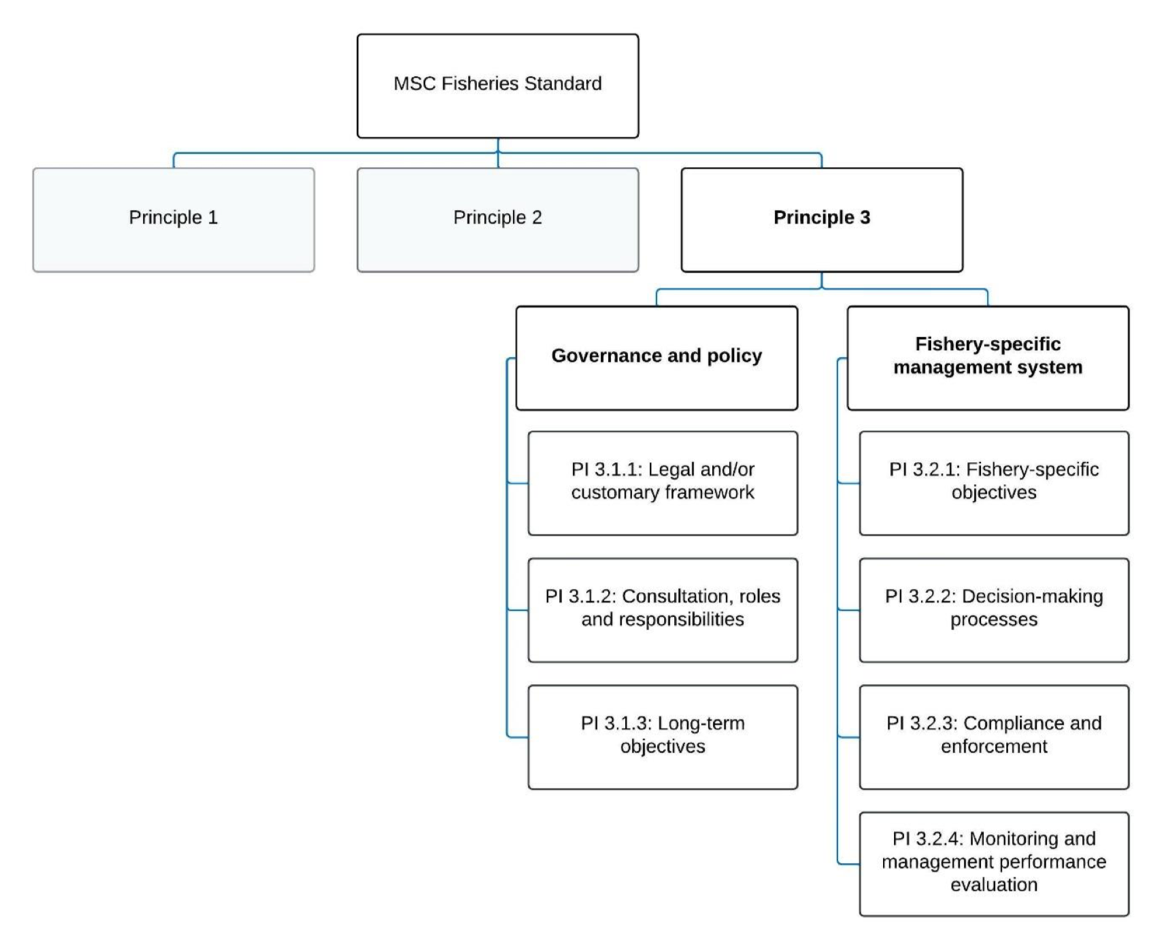
Figure 17. Decision tree for Principle 3 (MSC Fisheries Standard v3.)

4.3.2 Legal framework

The Torres Strait Treaty (the Treaty) was ratified in 1985 and details the sovereignty and maritime boundaries in the area between Australia and PNG. The Treaty establishes the Protected Zone Joint Authority (PZJA) and aims to protect the traditional way of life and livelihood of the Traditional Inhabitants of the Torres Strait and adjacent coastal areas of the two countries. Australia and PNG have an obligation to cooperate in the conservation, management and utilisation of the TSPZ fisheries and both countries enjoy sovereign rights within the TSPZ. This includes the right to a share of the commercial harvest of swimming fish and sedentary species on the respective sides of the agreed fisheries and seabed jurisdiction lines (AFMA 2016).
Fisheries in the Torres Strait are managed on behalf of the Protected Zone Joint Authority (PZJA) by AFMA, the Queensland Department of Agriculture Fisheries and Forestry and the Torres Strait Regional Authority.
Like other Torres Strait fisheries, the TSPF is managed against objectives that differ from those of solely Australian Government–managed fisheries. The TSPF management objectives are relevant to economic performance, but have a broader focus on social and cultural factors.
There are catch sharing arrangements between Australia and Papua New Guinea (PNG) that are agreed under the Torres Strait Treaty .
- Torres Strait Fisheries Act 1984
- Torres Strait Prawn Fishery Management Plan 2009 (the Plan), other legislative instruments and policy.
- The Torres Strait Prawn Fishery Harvest Strategy (AFMA 2011) was developed in accordance with the Commonwealth Fisheries Harvest Strategy Policy: Framework for applying an evidence-based approach to setting harvest levels in Commonwealth fisheries (June 2018) (HSP) and consistent with objectives of the Torres Strait Fisheries Act 1984.
The TSF Act and the Plan provide objectives which are to be pursued in managing the fishery and require a balance of managing fisheries sustainably, cost effectively and for optimum utilisation. In addition to this, the PZJA is required to have regard to the rights and obligations conferred on Australia by the Torres Strait Treaty, in particular the protection of the traditional way of life and livelihood of the Traditional Inhabitants including the capacity to engage in traditional fishing. Further details of the legislation underpinning the fishery can be found at www.pzja.gov.au. fish declarations (size, possession and form requirements etc.) that apply to commercial and recreational fishers in Queensland.
Queensland

The Fisheries Act 1994 (FA) and Fisheries (Commercial Fisheries) Regulation 2019 provide the formal legislative and administrative framework for all fisheries management in Queensland. The FA contains explicit objectives including the application of the principles of ecologically sustainable development. These objectives are consistent with national regulatory requirements including the Environmental Protection and Biodiversity Conservation Act 1999 (administered by the Australian Government).

The TSPF is also subject to a range of provisions outlined in non-fisheries specific legislation surrounding marine parks (e.g., Marine Parks Act 2004 (Qld), Great Barrier Reef Marine Park Zoning Plan 2003 (Commonwealth) and the Great Barrier Reef Marine Park (GBRMP) Act 1975 (administered by the GBR Marine Park Authority). In addition, as part of the Wildlife Trade operation approval under the EPBC Act, one of the conditions requires the Queensland Department of Agriculture and Fisheries (DAF) to work with the GBRMP authority to develop a total effort cap for trawl operations within the GBR World Heritage Area.

4.3.3 Fishery specific management

The TSPF is a cross-jurisdictional fishery sharing the Tiger, Endeavour and Red-spot King prawn stocks with PNG. The TSPF is managed through the Torres Strait Prawn Fisheries Management Plan 2009 (the plan). The objectives of the plan are:

- To ensure the optimum utilisation of the fishery resources within the TSPF is consistent with the principles of ecologically sustainable development and the exercise of the precautionary principle.
- To promote economic efficiency in the utilisation of the fisheries resources within the TSPF.
- To ensure cooperative, efficient and cost effective management of the fishery.
- To manage the fishery’s interactions with the marine environment including the incidental capture of non-target species and impacts on demersal habitats.

Input control include:
- the use of Total Allowable Effort (TAE) on fishing nights (9200 days shared between Australia and PNG);
- Individual transferable effort units;
- Limited entry;
- Vessel size restrictions;
- Gear specifications;
- Spatial and temporal closures.

Other legislative instruments relevant to the TSPF include:

The Torres Strait Prawn Fishery (Bycatch Reduction Devices) Instrument 2024

4.3.4 Consultation, roles and responsibilities

Management Advisory Committee (MAC)
Consultation in the TSPF takes place largely through the TSPMAC. The TSPMAC is made up of:
- commercial non Traditional Inhabitant industry members,
- Traditional Inhabitants (i.e. Torres Strait Islanders) and
- State and Commonwealth Government representatives, who actively participate in the development of management arrangements (including Fisheries Queensland, AFMA and the TSRA). Industry and

Traditional Inhabitant members on TSPMAC are representatives of the larger commercial industry and Traditional Inhabitant stakeholder groups. TSPF licence holders are made aware of the consultation processes through the TSPF handbook, including how to voice their views through the TSPMAC industry members. The TSPMAC provides the forum where issues relating to the fishery are discussed, problems identified and possible solutions developed.

AFMA
AFMA is responsible for providing day to day fisheries management services for the PZJA including compliance and licencing, and undertakes its delegated functions in consultation with PZJA agencies.

In 2015, AFMA took over the responsibilities for placement of traditional inhabitant representatives on the PZJA consultative forums, including the TSPMAC. In the past, representatives were nominated by the TSRA. Traditional inhabitant members are now elected by their peers. There are still four traditional inhabitant members on the committee as well as the fisheries portfolio member from the TSRA Board. This change was made to improve ownership of the role of representation on the Torres Strait Committees. It is essential that people who undertake the traditional inhabitant roles have expertise and drive, and also carry the respect and confidence of the Torres Strait community. This will ensure that the views and aspirations of Torres Strait Islander and Aboriginal people of the region are well represented and considered in the forums of the PZJA (AFMA, 2016).

AFMA (on behalf of the PZJA), consults with registered native title body corporates (RNTBC), registered native title claimants and any representative Aboriginal and Torres Strait Islander bodies. In accordance with section 24HA(2) of the Native Title Act 1993, AFMA on behalf of the PZJA undertakes native title notification for formal Future Act Notification. In addition, AFMA engages with RNTBCs, registered claimants and representative bodies through formal consultation and as invited participants on the PZJA advisory bodies. A summary of all native title notifications undertaken by AFMA since 2019 can be found on the PZJA website: https://www.pzja.gov.au/native-title-notifications

PZJA Standing Committee
The TSPMAC advises the PZJA, through the PZJA Standing Committee on management issues for the fishery to assist the PZJA in decision making. The PZJA Standing Committee is made up of the CEO of AFMA, the Deputy Director General of Fisheries Queensland and the General Manager of the TSRA and considers matters before they are presented to the PZJA.

Working groups
Working groups are also formed when specialist advice is required, such as the Harvest Strategy Working Group which was used to develop the TSPF Harvest Strategy.

Torres Strait Scientific Advisory Committee
The PZJA receives research advice relevant to the Torres Strait fisheries from the Torres Strait Scientific Advisory Committee (TSSAC). TSSAC is also responsible for identifying information needs and research gaps, developing a strategic research plan, soliciting/reviewing research proposals and reports, reviewing/assessing fisheries stock assessments, and advising on the effective delivery of research results. The TSSAC, which is comprised of research organisations, fisheries managers, Traditional Inhabitants and industry, also advises the TSPMAC on scientific issues associated with TSPZ fisheries

4.3.5 COMPLIANCE AND ENFORCEMENT

AFMA delivers the domestic compliance functions in the Torres Strait in accordance with the National Compliance and Enforcement Program. There were four compliance officers based in the Thursday Island office delivering both domestic and foreign compliance outcomes. During 2021, five TSP vessels committed offences against the TSFA. Four vessels were alleged to be fishing in PNG waters, and another offence relating to vessel tracking. After further investigation, these matters were dealt with through education and cautions rather than sanctions. One at-sea inspection was conducted during 2021 of a TSP vessel. Five at-sea and port inspections were conducted in 2022 of TSP vessels.

AFMA have established specialised multi-disciplinary Compliance Risk Management Team (CRMT) in order to target priority risks in Torres Strait fisheries. Identified priority risks specific to the Torres Strait include:
- unlicensed fishing,
- unlicensed fish receiving and non-compliance with catch/landing reporting to AFMA.
- Retaining/Catching no take/restricted species.
Compliance continues to educate and raise awareness of retention of byproduct and legislative requirements in particular. Further details are contained in AFMA’s National Compliance and Enforcement Program document accessible on the AFMA website. An AFMA Compliance report for Torres Strait Prawn Fishery is produced every two years.

4.3.6 EVALUATION AND MANAGEMENT REVIEWS
There are several mechanisms in place for monitoring and evaluating the performance of various aspects of the management system of the TSPF, including:
- The trawl fishery working group reviews harvest strategy decision rules, implementation of WTO conditions, stock assessment processes and other management proposals.
- The fishery is subject to an assessment against the Australian Government’s Guidelines for the Ecologically Sustainable Management of Fisheries under the EPBC Act is generally completed every three years (most recently in 2017).
- Assessments of target and important byproduct are conducted every 1–3 years through the SAFS process, although SAFS has been delayed.

Principle 3 References:

Department Agriculture, Water and the Environment. (2021). Assessment of the Queensland East Coast Otter Trawl Fishery. Canberra: Department of Agriculture, Water and Environment. https://www.dcceew.gov.au/sites/default/files/documents/qld-east-coast-otter-trawl-assessment-2021.pdf

Butler, I. A. Roelofs & M. Kangas (2020) Banana Prawns 2020 Status of Australian Fish Stocks. FRDC, Canberra, Australia. Available at: https://www.fish.gov.au/report/272-BANANA-PRAWNS-2020# Access 22 March 2024.
SCS (2023) Papua New Guinea Torres Strait tropical rock lobster fishery MSC Fishery Assessment Report Public Certification Report. October 2023.
Zeller, B., 2017. Submission for the reassessment of the Queensland East Coast Otter Trawl Fishery Part 13 Accreditation and Wildlife Trade Operation approval under the Environment Protection and Biodiversity and Conservation Act 1999 A report prepared by the Queensland De. Brisbane, Queensland.

Principle 3 Performance Indicator scores and rationales

Government and Policy

PI 3.1.1 – Legal and/or customary framework
PI 3.1.1 |  | The management system exists within an appropriate and effective legal and/or customary framework which ensures that it:  - Is capable of delivering sustainability in the UoA(s);  - Observes the legal rights created explicitly or established by custom of people dependent on fishing for food or livelihood; and  - Incorporates an appropriate dispute resolution framework
Scoring issue |  | SG 60 | SG 80 | SG 100
a | Compatibility of laws or standards with effective management
a | Guide post | There is an effective national legal system and a framework for cooperation with other parties, where necessary, to deliver management outcomes consistent with MSC Principles 1 and 2. | There is an effective national legal system and organised and effective cooperation with other parties, where necessary, to deliver management outcomes consistent with MSC Principles 1 and 2. | There is an effective national legal system and binding procedures governing cooperation with other parties that deliver management outcomes consistent with MSC Principles 1 and 2.
a | Met? | Yes | Yes | Not scored
Rationale |  | The Torres Strait Prawn Fishery (TSPF) operates in the eastern part of the Torres Strait Protected Zone (TSPZ) and south of the TSPZ in nearby Queensland waters (called the ‘outside but near area’) (Figure 1). This fishery is shared by Australia and Papua New Guinea (PNG) under formal arrangements in the Torres Strait Treaty.  The Australian component of the fishery is managed by the Torres Strait Protected Zone Joint Authority (PZJA), established under the Torres Strait Fisheries Act 1984 (Cth). Currently, all licences in the fishery are held by the non-Indigenous Transferable Vessel Holder Sector. Under the Torres Strait Treaty, PNG is entitled to 25% of the TSPF resource in the Australian jurisdiction (excluding the effort in the ‘outside but near area’), and Australia is entitled to 25% of the TSPF resource in the PNG jurisdiction (Cocking 2016 cited in Butler et al. 2023).  Since the Torres Strait Treaty was ratified, both PNG and Australia have entered into formal agreements to cooperatively manage six fisheries in the Torres Strait, including the TSPF. The cooperation between PNG and Australia in managing the fishery within the TSPZ is governed by binding procedures and that their cooperation has delivered the fishery management outcomes consistent with the MSC Principle 1 and 2.  SG 60 and SG 80 are met.
b | Resolution of disputes
b | Guide post | The management system incorporates or is subject by law to a mechanism for the resolution of legal disputes arising within the system. | The management system incorporates or is subject by law to a transparent mechanism for the resolution of legal disputes which is considered to be effective in dealing with most issues and that is appropriate to the context of the UoA. | The management system incorporates or is subject by law to a transparent mechanism for the resolution of legal disputes, which is appropriate to the context of the fishery and has been tested and proven to be effective.
b | Met? | Yes | Yes | Not scored
Rationale |  | Since the Torres Strait Treaty was ratified, both PNG and Australia have entered into formal agreements to cooperatively manage six fisheries in the Torres Strait, including the TSPF. The cooperation between PNG and Australia in managing the fishery within the TSPZ is governed by binding procedures and that their cooperation has delivered the fishery management outcomes consistent with the MSC Principle 1 and 2.  Schedule 1 of the Torres Strait Fisheries Act 1994 relates to the Treaty. With regard to disputes, it states that “Any dispute between the Parties arising out of the interpretation or implementation of the Treaty shall be settled by consultation or negotiation.”  There is a lack of public information on the mechanism for resolution of legal disputes. Any person who has been given an information notice relating to the appeal decision can apply for a review of a decision under the FA. SG 60 and SG 80 are met.
c | Respect for rights
c | Guide post | The management system has a mechanism to generally respect the legal rights created explicitly or established by custom of people dependent on fishing for food or livelihood in a manner consistent with the objectives of MSC Principles 1 and 2. | The management system has a mechanism to observe the legal rights created explicitly or established by custom of people dependent on fishing for food or livelihood in a manner consistent with the objectives of MSC Principles 1 and 2. | The management system has a mechanism to formally commit to the legal rights created explicitly or established by custom of people dependent on fishing for food and livelihood in a manner consistent with the objectives of MSC Principles 1 and 2.
c | Met? | Yes | Yes | Not scored
Rationale |  | The rights of customary fishers are recognised by the Torres Strait Fisheries Act 1984.  The principal purpose of the Parties (i.e., Australia and PNG) in establishing the Torres Strait Protected Zone (TSPZ), and in determining its northern, southern, eastern and western boundaries, is to acknowledge and protect the traditional way of life and livelihood of the traditional inhabitants including their traditional fishing and free movement. This means the Torres Strait traditional inhabitants of both PNG and Australia may undertake traditional fishing activities in both the Australian and PNG waters of the TSPZ.  Article 12 of the Torres Strait Treaty between Australia and the Independent State of PNG states that explicitly reserves the practices of the traditional customary rights by the traditional inhabitants of the Torres Strait: “where the traditional inhabitants of one Party enjoy traditional customary rights of access to and usage of areas of land, seabed, seas, estuaries and coastal tidal areas that are in or in the vicinity of the Protected Zone and that are under the jurisdiction of the other Party, and those rights are acknowledged by the traditional inhabitants living in or in proximity to those areas to be in accordance with local tradition, the other Party shall permit the continued exercise of those rights on conditions not less favorable than those applying to like rights of its own traditional inhabitants”.

Draft scoring range | ≥80
Information gap indicator

PI 3.1.2 – Consultation, roles, and responsibilities
PI 3.1.2 |  | The management system has effective consultation processes that are open to interested and affected parties. The roles and responsibilities of organisations and individuals who are involved in the management process are clear and understood by all relevant parties
Scoring issue |  | SG 60 | SG 80 | SG 100
a | Roles and responsibilities
a | Guide post | Organisations and individuals involved in the management process have been identified. Functions, roles, and responsibilities are generally understood. | Organisations and individuals involved in the management process have been identified. Functions, roles, and responsibilities are explicitly defined and well understood for key areas of responsibility and interaction. | Organisations and individuals involved in the management process have been identified. Functions, roles, and responsibilities are explicitly defined and well understood for all areas of responsibility and interaction.
a | Met? | Yes | Yes | Not scored
Rationale |  | The roles and responsibilities of organisations and individuals who are involved in the management process are clear and understood by all relevant parties.  Organisations and individuals involved in the management process have been established through the Consultative Structure of the PZJA. This Consultative Structure consists of a Standing Committee and advisory bodies namely: TS Scientific Advisory Committee (TSSAC) and TS Prawn Fishery Management Advisory Committee (TSPMAC). The Standing Committee is responsible for delivering strategic and operational advice to the PZJA. In delivering its advice, the Standing Committee is informed by the works of the advisory bodies above. AFMA is responsible for providing day to day fisheries management services for the PZJA including compliance and licencing, and undertakes its delegated functions in consultation with PZJA agencies. In conclusion, the roles and responsibilities of various institutions in relation to TSPF management are explicitly defined and well understood for all areas of responsibility.  SG 60 and SG 80 are met.
b | Consultation processes
b | Guide post | The management system includes consultation processes that obtain relevant information from the main affected parties, including local knowledge, to inform the management system. | The management system includes consultation processes that regularly seek and accept relevant information, including local knowledge. The management system demonstrates consideration of the information obtained. | The management system includes consultation processes that regularly seek and accept relevant information, including local knowledge. The management system demonstrates consideration of the information and explains how it is used or not used.
b | Met? | Yes | Yes | Not scored
Rationale |  | Through the meetings of the Standing Committee and advisory bodies, consultation processes are taken place and informed by the knowledges of the wide-ranges of stakeholders, member of the Committee and advisory bodies, that include: the islander representative, non-indigenous industry representative (fishers or processors), Australian and Queensland government officials, scientist (mostly from CSIRO), and PNG representative.  TSPMAC minutes are publicly available at file:///Users/peter2/Downloads/TSPMAC-21-29-30Nov-Agenda-Papers.pdf  Public consultation is also available for the application for export approval (wildlife trade operation, AFMA 2016; DEE 2017). SG 60 and SG 80 are met.
c | Participation
c | Guide post |  | The consultation process provides opportunity for all interested and affected parties to be involved. | The consultation process provides opportunity and encouragement for all interested and affected parties to be involved, and facilitates their effective engagement.
c | Met? |  | Yes | Not scored
Rationale |  | The consultations relevant to management measures (e.g., results of the stock assessment) are regularly taken place. TSPMAC meetings include representative from various stakeholder each with an opportunity to speak and set agenda items  There is evidence that during past meetings, industry members raised concerns regarding potential for effort shift etc. The consultation processes that are in place for the TSPF and across fisheries in the PZJA provide opportunity for all interested parties and affected parties to be involved; SG80 is met.

Draft scoring range | ≥80
Information gap indicator

PI 3.1.3 – Long term objectives
PI 3.1.3 |  | The management policy has clear long-term objectives to guide decision-making that are consistent with the MSC Fisheries Standard, and incorporates the precautionary approach
Scoring issue |  | SG 60 | SG 80 | SG 100
a | Objectives
a | Guide post | Long-term objectives to guide decision-making, consistent with the MSC Fisheries Standard and the precautionary approach, are implicit within management policy. | Clear long-term objectives that guide decision-making, consistent with the MSC Fisheries Standard and the precautionary approach, are explicit within management policy. | Clear long-term objectives that guide decision-making, consistent with the MSC Fisheries Standard and the precautionary approach, are explicit within and required by management policy.
a | Met? | Yes | Yes | Not scored
Rationale |  | The long-term objectives of the TSPZ and the management of fisheries resources the area, are described in the Torres Strait Treaty and in the Australian Torres Strait Fisheries Act No. 23, 1984 and PNG Fisheries (Torres Strait Protected Zone) Act 1984 and PNG Fisheries Management Act 1998.  The TSPZ objectives as described under the Torres Strait Treaty, Article 10 includes:  - to acknowledge and protect the traditional way of life and livelihood of the traditional inhabitants including their traditional fishing and free movement.  - to protect and preserve the marine environment and indigenous fauna and flora in and in the vicinity of the Protected Zone.  - The Australian Torres Strait Fisheries Act No. 23, 1984 stated the following long-term objectives:  - to acknowledge and protect the traditional way of life and livelihood of traditional inhabitants, including their rights in relation to traditional fishing;  - to protect and preserve the marine environment and indigenous fauna and flora in and in the vicinity of the Protected Zone;  - to adopt conservation measures necessary for the conservation of a species in such a way as to minimise any restrictive effects of the measures on traditional fishing;  - to administer the provisions of Part 5 of the Torres Strait Treaty (relating to commercial fisheries) so as not to prejudice the achievement of the purposes of Part 4 of the Torres Strait Treaty in regard to traditional fishing;  - to manage commercial fisheries for optimum utilisation;  - to share the allowable catch of relevant Protected Zone commercial fisheries with Papua New Guinea in accordance with the Torres Strait Treaty;  - to have regard, in developing and implementing licensing policy, to the desirability of promoting economic development in the Torres Strait area and employment opportunities for traditional inhabitants.  In summary, there are clear long-term objectives for the establishment and management of the fishery resources within the TSPZ, consistent with the MSC Principles 1 and 2 and that the precautionary approach is explicit and required by the management policy.

Draft scoring range | ≥80
Information gap indicator

Fishery Specific Management Systems

PI 3.2.1 – Fishery-specific objectives
PI 3.2.1 |  | The fishery-specific management system has clear, specific objectives designed to achieve the outcomes expressed by MSC Principles 1 and 2
Scoring issue |  | SG 60 | SG 80 | SG 100
a | Objectives
a | Guide post | Objectives, which are broadly consistent with achieving the outcomes expressed by MSC Principles 1 and 2, are implicit within the fishery-specific management system. | Short and long-term objectives, which are consistent with achieving the outcomes expressed by MSC Principles 1 and 2, are explicit within the fishery-specific management system. | Well-defined and measurable short- and long-term objectives, which are demonstrably consistent with achieving the outcomes expressed by MSC Principles 1 and 2, are explicit within the fishery-specific management system.
a | Met? | Yes | Yes | Not scored
Rationale |  | The Torres Strait Prawn Management Plan 2009 sets out short and long term objectives for the fishery.  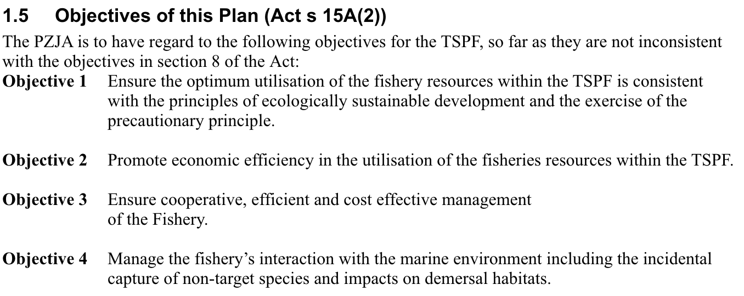  TSPF Harvest Strategy (AFMA 2024)  The key objective of the 2011 harvest strategy was to maximize the profitability of the fishery and minimize any management impediments that affect the economic efficiency of fishers within biologically sustainable limits. As such, the 2011 TSPF Harvest Strategy was designed to facilitate a move towards B_{MEY} when effort and economic viability in the fishery has increased.  In 2019, an independent review of the TSPF HS was initiated (Penney, 2019) following an update of the Tiger Prawn stock assessment that revealed problems with the effort-based triggers being used in the 2011 TSPF HS. The review noted that effort-based triggers are not suitable for fisheries using an effort cap as the primary management tool, and that effort does not give any indication of the underlying stock biomass level and is not a useful indicator of sustainability. Triggers based on nominal CPUE were proposed and are not used in the new 2024 HS (AFMA 2024). Tiger Prawn CPUE is closely correlated with stock biomass in the TSPF, and changes in CPUE reliably indicate changes in underlying stock biomass, and the risk of overfishing. CPUE triggers relate to changes in underlying biomass and are intended to prompt consideration of management options to halt the CPUE decline and rebuild the stock towards the target.  In summary, defined and measurable short and long-term objectives, which are demonstrably consistent with achieving the outcomes expressed by MSC’s Principle 1 are implicit within the fishery’s management system achieving SG60. Components of Principle 2 (in-scope species and habitats) are within the Management Plan therefore SG 80 is met.

Draft scoring range | ≥80
Information gap indicator

PI 3.2.2 – Decision-making processes
PI 3.2.2 |  | The fishery-specific management system includes effective decision-making processes that result in measures and strategies to achieve the objectives, and has an appropriate approach to actual disputes in the fishery
Scoring issue |  | SG 60 | SG 80 | SG 100
a | Decision-making processes
a | Guide post | There are some decision-making processes in place that result in measures and strategies to achieve the fishery-specific objectives. | There are established decision-making processes that result in measures and strategies to achieve the fishery-specific objectives.
a | Met? | Yes | Yes
Rationale |  | The decision-making process has been established through the Consultative structure of the Protected Zone Joint Authority (PZJA) and the TSPMAC. These processes have resulted in measures and strategies to sustainably managed the fishery, including a review (Penney 2019) of the previous HS (AFMA 2011) and implementation of the new HS (AFMA 2024) following advice discussed from that review. There are decision rules in place with appropriate triggers and prescribed management measures; together, this meets SG 60 and SG 80.
b | Responsiveness of decision-making processes
b | Guide post | Decision-making processes respond to serious issues identified in relevant research, monitoring, evaluation, and consultation, in a transparent, timely and adaptive manner, and take some account of the wider implications of decisions. | Decision-making processes respond to serious and other important issues identified in relevant research, monitoring, evaluation, and consultation, in a transparent, timely, and adaptive manner, and take account of the wider implications of decisions. | Decision-making processes respond to all issues identified in relevant research, monitoring, evaluation, and consultation, in a transparent, timely, and adaptive manner, and take account of the wider implications of decisions.
b | Met? | Yes | Yes | Not scored
Rationale |  | At the TSPZ PZJA level, decision making processes respond to all issues identified in relevant research, monitoring, and consultation in a transparent manner. The decision-making process at the PZJA level is supported by and taken place within the various established consultative mechanisms including the TSPMAC whom their recommendations are used to inform the decision making by the Standing Committee responsible for delivering strategic and operational advice to the PZJA. Issues around determination of research priorities within the TSPZ is addressed by the TS Scientific Advisory Committee (TSSAC). SG 60 is met.  Until recently, there was a Torres Strait Fisheries Strategic Research Plan in place (2018–2023), although there is no information is this Strategy is in the process of being updated. It is important to note that the issues identified in the WTO application have differing levels of being addressed, and some recommendations remain outstanding. For example, there are some time-based conditions that have been place on the WTO (e.g., need for a Level 2 ERA). SG 80 is met as the decision-making processes of the TSPF clearly responded to the most serious issues first (introducing new BRD designs into the fishery). The HS was recently updated (July 2024).
c | Use of precautionary approach
c | Guide post |  | Decision-making processes use the precautionary approach and are based on best available information.
c | Met? |  | Yes
Rationale |  | The precautionary approach is explicit in the TS Prawn Fishery Management Plan 2009 and at the broader overarching legislative instruments, there is also evidence of the fishery specific decision-making processes (e.g. establishing precautionary trigger limits) use the precautionary approach within the 2024 harvest strategy. SG 80 is met.
d | Accountability and transparency of management system and decision-making process
d | Guide post | Some information on the fishery’s performance and management action is generally available on request to stakeholders. | Information on the fishery’s performance and management action is available on request, and explanations are provided for any actions or lack of action associated with findings and relevant recommendations emerging from research, monitoring, evaluation, and review activity. | Formal reporting to all interested stakeholders provides comprehensive information on the fishery’s performance and management actions and describes how the management system responded to findings and relevant recommendations emerging from research, monitoring, evaluation, and review activity.
d | Met? | Yes | Yes | Not scored
Rationale |  | The decision-making process for the TSPF is transparent and recorded in the formalized minutes of the TSPMAC meetings, available to fishery stakeholders and public as they are accessible online through the PZJA website. The information provided through the above-mentioned website are very extensive and includes the fishery performance over the years and the management measures and actions taken accordingly. Comprehensive information of the fishery that includes the background of the fishery, fishery rules, and monitoring is regularly updated and available in the form of a Handbook and Data Summary Reports (Turnbull and Cocking 2023).  There are several formal reporting mechanisms available to all interested stakeholders that provides comprehensive information on stock status, compliance activities, management changes, explanations for lack of actions, and industry projects/initiatives underway; SG 60 and SG 80 are met.
e | Approach to disputes
e | Guide post | Although the management authority or fishery may be subject to continuing court challenges, it is not indicating a disrespect or defiance of the law by repeatedly violating the same law or regulation necessary for the sustainability of the fishery. | The management system or UoA is attempting to comply in a timely fashion with judicial decisions arising from any legal challenges. | The management system or UoA acts proactively to avoid legal disputes or rapidly implements judicial decisions arising from legal challenges.
e | Met? | Yes | Yes | Not scored
Rationale |  | The consultation and advisory processes ensure that the management system acts proactively to avoid legal disputes. No legal disputes for the TSPF were identified by the assessment team. SG 60 and 80 is met.

Draft scoring range | ≥80
Information gap indicator

PI 3.2.3 – Compliance and enforcement
PI 3.2.3 |  | Monitoring, control, and surveillance (MCS) mechanisms ensure the management measures in the UoA are enforced and complied with
Scoring issue |  | SG 60 | SG 80 | SG 100
a | MCS system
a | Guide post | Monitoring, control and surveillance mechanisms exist, and are implemented in the fishery and there is a reasonable expectation that they are effective. | A monitoring, control and surveillance system has been implemented in the fishery and has demonstrated an ability to enforce relevant management measures, strategies and/or rules. | A comprehensive monitoring, control and surveillance system has been implemented in the fishery and has demonstrated a consistent ability to enforce relevant management measures, strategies and/or rules.
a | Met? | Yes | Yes | Not scored
Rationale |  | Compliance activities include on-water inspections, verification of catch and effort reported in logbooks, and checks of ETP species logbooks. There are also port inspections of gear. Fleet composition is well understood and sufficient data are collected to support the harvest strategy including vessel details, VMS data, fishing effort (hours and distribution), and vessel power of the fleet.  AFMA delivers the domestic compliance functions in the Torres Strait in accordance with the National Compliance and Enforcement Program. There were four compliance officers based in the Thursday Island office delivering both domestic and foreign compliance outcomes. During 2021, five TSP vessels committed offences against the TSFA. Four vessels were alleged to be fishing in PNG waters, and another offence relating to vessel tracking. After further investigation, these matters were dealt with through education and cautions rather than sanctions. One at-sea inspection was conducted during 2021 of a TSP vessel. Five at-sea and port inspections were conducted in 2022 of TSP vessels.  AFMA have established specialised multi-disciplinary Compliance Risk Management Team (CRMT) in order to target priority risks in Torres Strait fisheries. Identified priority risks specific to the Torres Strait include;  unlicensed fishing,  unlicensed fish receiving and non-compliance with catch/landing reporting to AFMA.  Retaining/Catching no take/restricted species.  Compliance continues to educate and raise awareness of retention of byproduct and legislative requirements in particular;  Further details are contained in AFMA’s National Compliance and Enforcement Program document accessible on the AFMA website. An AFMA Compliance report for Torres Strait Prawn Fishery is produced every two years.  SG 80 is met.
b | Sanctions
b | Guide post | Sanctions to deal with non-compliance exist and there is some evidence that they are applied. | Sanctions to deal with non-compliance exist, are consistently applied and thought to provide effective deterrence. | Sanctions to deal with non-compliance exist, are consistently applied and demonstrably provide effective deterrence.
b | Met? | Yes | yes | Not scored
Rationale |  | The sanctions applied for breaches of regulations operate on a sliding scale. AFMA operates an effective compliance system but focuses primarily of awareness raising (education) prior to the start of the fishing season. If infringements are detected, the penalty process implemented equates to the seriousness of offence, culminating in a sequence of warnings, expedited offences, and prosecutions, leading to license confiscation for serious offences. The main tool applied is AFMA Commonwealth Fisheries Infringement Notices (CFINs), which are on the spot fines. SG 80 is met.
c | Compliance (information)
c | Guide post | Fishers are generally thought to comply with the management system for the fishery under assessment, including, when required, providing information of importance to the effective management of the fishery. | Some evidence exists to demonstrate fishers comply with the management system under assessment, including, when required, providing information of importance to the effective management of the fishery. | There is a high degree of confidence that fishers comply with the management system under assessment, including, providing information of importance to the effective management of the fishery.
c | Met? | Yes | Yes | Not scored
Rationale |  | Some evidence exists to demonstrate fishers comply with the management system, including, when required, providing information of importance to the effective management of the fishery. In the event of offences detected AFMA’s typical first response is to educate the skippers, and thereafter to issue CFIRs, or place good behaviour bonds on infringing vessels.  The Evidence Requirements Framework is required for the Scoring Issue (Trueness Guidepost only). TG 1 and TG 2 are met as there is information to confirm the adoption and enforcement of management regulations in the UoAs.  SG 60 and SG80 are met.
d | Compliance (outcome)
d | Guide post |  | There is no evidence of systematic non-compliance
d | Met? |  | yes
Rationale |  | There is no evidence of systematic non-compliance. The low degree confidence on the catch reporting by the traditional inhabitants as stated above is not considered as systematic non-compliance because that reporting is not yet mandatory. In the near future and subject to stakeholder consultations and agreement, the PZJA (AFMA) is looking into introducing a mandatory catch reporting requirement for this traditional inhabitant sector within the TSPZ (AFMA 2023).

Draft scoring range | ≥80
Information gap indicator | Compliance data for fleet, number of inspections, number of sanctions, cases of re-offending etc.

PI 3.2.4 – Monitoring and management performance evaluation
PI 3.2.4 |  | There is a system for monitoring and evaluating the performance of the fishery-specific management system against its objectives. There is effective and timely review of the fishery-specific management system
Scoring issue |  | SG 60 | SG 80 | SG 100
a | Evaluation coverage
a | Guide post | There are mechanisms in place to evaluate some parts of the fishery-specific management system. | There are mechanisms in place to evaluate key parts of the fishery-specific management system. | There are mechanisms in place to evaluate all parts of the fishery-specific management system.
a | Met? | Yes | Yes | Not scored
Rationale |  | There are mechanisms in place to evaluate key parts of the fishery-specific management system (harvest strategy and management plan), through the TSPMAC, research, compliance and monitoring. Turnbull (2020) conducted an MSE on the fishery.  SG 60 and SG 80 are met.
b | Internal and/or external review
b | Guide post | The fishery-specific management system is subject to occasional internal review. | The fishery-specific management system is subject to regular internal and occasional external review. | The fishery-specific management system is subject to regular internal and external review.
b | Met? | Yes | Yes | Not scored
Rationale |  | The fishery-specific management system is subject to regular internal and occasional external review. There are several mechanisms in place for monitoring and evaluating the performance of various aspects of the management system of the TSPF, including:  - The trawl fishery working group reviews harvest strategy decision rules, implementation of WTO conditions, stock assessment processes and other management proposals.  - The fishery is subject to an assessment against the Australian Government’s Guidelines for the Ecologically Sustainable Management of Fisheries under the EPBC Act is generally completed every three years (most recently in 2017).  - Assessments of target and important byproduct are conducted every 1–3 years through the SAFS process, although SAFS has been delayed.  SG 60 and SG80 are met.

Draft scoring range | ≥80
Information gap indicator

Harmonisation
Principle 1 Harmonisation
There are no other certified fisheries on this stock although the MSC certified Northern Prawn Fishery takes Tiger prawn from northern Australia.

Principle 2 Harmonisation
There is one other Torres Strait MSC certified fishery that has a spatial overlap with the Unit of Assessment. Therefore, there is need to consider the Tropical Rock Lobster Fishery under Principle 2 of cumulative impacts.

Principle 3 Harmonisation
There is one other fishery that Torres Strait that is MSC certified (PNG Tropical Rock Lobster fishery) but this operates under the management of PZJA and PNG; the PNG aspects of management are implemented using a different management legislation. This different combination of management organisations and arrangements means that harmonization may not be appropriate or required.

Template information, copyright and disclaimer

The Marine Stewardship Council’s ‘MSC Pre-Assessment Reporting Template v3.3’ and its content is copyright of “Marine Stewardship Council” - © “Marine Stewardship Council” 2022. All rights reserved.

A controlled document list of MSC program documents is available on the MSC website (https://www.msc.org/for-business/certification-bodies/supporting-documents).

This MSC pre-assessment has been undertaken using publicly available material generated primarily through web-searches and from confidential fishery data provided by the Client or data formally requested from the Queensland Department of Agriculture and Fisheries . Source material used to justify scoring is referenced. It is not impossible that additional material exists (particularly that held internally by the management and scientific agencies responsible for the management of the fishery) that could influence the justification and scores.

Assessor Disclaimer: All reasonable efforts have been taken to ensure the quality of this report, the authors do not warrant that the information is free from errors or omissions. The authors do not accept any form of liability, be it contractual, tortuous or otherwise, for the contents of this report or for any consequences arising from its use or any reliance placed upon it. This information is intended explicitly for the use by the Client and their chosen partners for the assessment of the defined UoA using the MSC Fisheries Standard v3. The author does not provide permission under any circumstances for the information presented in this report to be made publicly available to third parties without the written consent from the Client.

https://www.federalregister.gov/documents/2021/04/30/2021-09077/bureau-of-oceans-and-international-environmental-and-scientific-affairs-annual-certification-of
https://www.pzja.gov.au/torres-strait-fisheries/torres-strait-prawn-fishery/torres-strait-prawn-fishery-handbook-and-data
https://www.pzja.gov.au/advisory-committees/pzja-committees/torres-strait-prawn-management-advisory-committee-tspmac
Management strategy evaluation (MSE):a procedure where alternative management strategies are tested and compared using simulations of stock and fishery dynamics; MSE can be used to test harvest strategies.
The boxplots show the range of daily vessel CPUE’s for each year. The median CPUE is indicated by notch and line near the middle of the boxes and black line with circles is plot of the mean (average) CPUE for each year. Fifty percent of the records are within the rectangles. The “whiskers or dotted lines” extending from the rectangles show the overall range. The width of the rectangles indicates the number of records for each season.
The boxplots show the range of daily vessel’s CPUE’s for each year. The median CPUE is indicated by notch and line near the middle of the boxes and black line with circles is plot of the mean (average) CPUE for each year. Fifty percent of the records are within the rectangles. The “whiskers or dotted lines” extending from the rectangles show the overall range. The width of the rectangles indicates the number of records for each season.
https://www.pzja.gov.au/torres-strait-fisheries/torres-strait-prawn-fishery/torres-strait-prawn-fishery-handbook-and-data
https://www.dcceew.gov.au/sites/default/files/env/pages/89160a83-68a6-4f07-81d3-e7df1a02bdbd/files/torres-strait-prawn-application-2016.pdf
https://www.dcceew.gov.au/sites/default/files/env/pages/b8e55dc2-8460-40ab-a4b2-d887cbc13f18/files/assessment-report-torres-strait-prawn-fishery-2017.pdf
https://fishbase.se/summary/SpeciesSummary.php?ID=5875&AT=Red-spot+monocle+bream
https://www.afma.gov.au/protected-species/threatened-and-endangered-species-reporting
https://www.cms.int/sites/default/files/document/MOS1_Inf_5_6_Report_from_Australia_0.pdf
https://www.nespmarine.edu.au/system/files/Feutry%20et%20al_A12_Theme%202_M18_Anoxypristis%20cuspidata%20population%20structure_1.pdf
https://fisheries.msc.org/en/fisheries/australia-northern-prawn/@@assessments
https://www.researchgate.net/publication/377496999_Anoxypristis_cuspidata_The_IUCN_Red_List_of_Threatened_Species_2023_eT39389A58304073
https://www.pzja.gov.au/resources/dugong-and-turtle-fisheries
https://www.fao.org/3/I0725E/i0725e.pdf
https://wetlandinfo.des.qld.gov.au/wetlands/facts-maps/wildlife/?AreaID=lga-torres-strait-island&Kingdom=animals&Class=reptiles
Vulnerable Marine Environments (VMEs) were assessed in early versions of the MSC Standard, and they are now considered “more sensitive habitats” (SA3.11.3.1).
https://www.amsa.gov.au/international-requirements-fishing-gear-marking-and-reporting/reporting-lost-or-discharged-fishing
https://elibrary.gbrmpa.gov.au/jspui/retrieve/62d985cf-79b1-4615-b80a-9b43c8b517f3/gbrmpa-VA-SeaSnakes-11-7-12.pdf
https://www.iucnredlist.org/species/176734/7292879
https://www.iucnredlist.org/species/176737/7293481
https://www.iucnredlist.org/species/176746/132780885
https://www.iucnredlist.org/species/132475824/83766285
https://www.iucnredlist.org/species/176761/7299189
https://www.iucnredlist.org/species/176756/7298218
https://www.iucnredlist.org/species/176708/136257093
https://www.iucnredlist.org/species/176729/7292011
https://www.fao.org/3/I0725E/i0725e.pdf
When a sawfish does encounter a net, the morphology of their rostrum increases the probability of an entanglement.
Vulnerable Marine Environments (VMEs) were assessed in early versions of the MSC Standard, and they are now considered “more sensitive habitats” (SA3.11.3.1).
Vulnerable Marine Environments (VMEs) were assessed in early versions of the MSC Standard, and they are now considered “more sensitive habitats” (SA3.11.3.1).
https://www.pzja.gov.au/sites/default/files/2023-01/data-summary-2021_final.pdf
https://www.amsa.gov.au/international-requirements-fishing-gear-marking-and-reporting/reporting-lost-or-discharged-fishing

