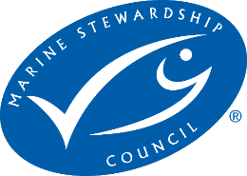

Tiger Prawns (Brown, Penaeus esculentus; Grooved, P. semisulcatus; Black, P. monodon) & Endeavour Prawns (Blue, Metapenaeus endeavouri; Red, Metapenaeus ensis)

North Zone: East Coast Otter Trawl Fishery, Queensland, Australia

Pre-Assessment Report

Assessor | Peter Trott, FishListic Pty Ltd
Fishery client | Queensland Seafood Industry Association Inc (QSIA)
Assessment type | Pre-assessment
Date | 19 June 2024
Report type | Draft Pre-assessment v3 MSC Fisheries Standard

Contents

Glossary 3
Executive summary 4
Report details 5
Aims and constraints of the pre-assessment 5
Version details 5
1. Units of Assessment and Units of Certification 5
2. Pre-assessment outcomes 7
2.1 Overview 7
2.2 Recommendations 7
2.3 Summary of potential conditions by Principle 8
2.4 Summary of Performance Indicator level scores 8
3. Background 11
3.1.1 Legislation 11
3.1.2 Fishery boundaries 12
3.1.3 Gear specifications 13
3.1.4 Fleet composition 15
3.1.5 Monitoring 15
3.1.6 Seasonal/temporal closures 15
3.1.7 Spatial closures 17
3.1.8 Effort caps 18
4. Pre-assessment 19
4.1. Principle 1 19
4.1.1. Background 19
4.1.2 UoA species profiles 19
Principle 1 References 30
Principle 1 – Performance Indicator scores and rationales 33
4.2. Principle 2 47
4.2.1. Background 47
4.2.2 Designating species 47
4.2.3 In-scope species 54
4.2.4 ETP/OOS species 56
4.2.5 Habitats 65
4.2.6 Ecosystems 71
Principle 2 References: 72
Principle 2 Performance Indicator scores and rationales 76
4.3 Principle 3 111
4.3.1 Background 111
4.3.2 Legal framework 111
4.3.3 Fishery specific management 112
4.3.4 Consultation, roles and responsibilities 113
Principle 3 References: 115
Principle 3 Performance Indicator scores and rationales 116
Template information, copyright and disclaimer 131
List of Tables 131

Glossary

B_{MSY} | Biomass at Maximum Sustainable Yield
CSIRO | Commonwealth Scientific and Industrial Research Organisation
CITES | Convention on International Trade in Endangered Species
CMS | Convention on Migratory Species
CoC | Chain of Custody certification
CPUE | Catch per unit of effort
EEZ | Exclusive Economic Zone
ETP | Endangered, Threatened or Protected (species)
F | Fishing mortality rate
FMSY | Fishing mortality rate at Maximum Sustainable Yield
FRDC | Fisheries Research and Development Corporation
FAO | Food and Agriculture Organisation of the United Nations
FCR | Fisheries Certification Requirements (MSC)
HCR | Harvest Control Rule
HS | Harvest Strategy
HMS | Highly Migratory Species
IUCN | International Union for the Conservation of Nature
IUU | Illegal, Unregulated and Unreported
LRP | Limit Reference Point
MSE | Management Strategy Evaluation
MSC | Marine Stewardship Council
MEY | Maximum Economic Yield
MSE | Management Strategy Evaluation
MSY | Maximum Sustainable Yield
NPOA | National Plan of Action
NGO | Non Governmental Organisation
OOS | Out of Scope (species)
PI | Performance Indicator (MSC)
PRI | Point of recruitment impairment (MSC)
PSA | Productivity Susceptibility Analysis
QDAF | Queensland Department of Agriculture and Fisheries
RBF | Risk Based Framework (MSC)
SICA | Scale Intensity Consequence Analysis
SG | Scoring Guidepost (MSC)
TRP | Target Reference Point (B_{target}; F_{target})
TAC | Total Allowable Catch
TACE | Total Allowable Commercial Effort
UoA | Unit of Assessment (MSC)
UoC | Unit of Certification (MSC)
VMS | Vessel Monitoring System

Executive summary

This report contains the results of a Marine Stewardship Council (MSC) pre-assessment of the Units of Assessment (UoA): Tiger prawns and Endeavour Prawns caught by the Queensland East Coast Otter Trawl Fishery in the Northern region.
The pre-assessment was undertaken by consultation of FishListic Pty Ltd for the client Queensland Seafood Industry Association (QSIA). To our knowledge, this is the first time that this fishery has undergone a pre-assessment against any MSC Fisheries Standard, and this is the first pre-assessment using the updated Version 3.0 of the MSC Fisheries Standard. This pre-assessment was conducted primarily through robust desktop-based analysis, drawing on data and information directly from fishery sources, QDAF sources, scientific literature, and third-party expertise and experience. This information was used to assess the UoA against the MSC Fisheries Standard and Guidance V3 using a modified MSC pre-assessment template. Supporting the pre-assessment was the MSC Certification Processes and Guidance. It should be noted that site visits were not conducted but some stakeholder communications were possible to be conducted as part of this pre-assessment process.
As of 19 June 2024, the UoA failed to meet the MSC Fisheries Standard. There are three Performance Indicators that did not meet the SG 60 benchmark (Table 3). A full list of the recommendations to meet the SG 80 bench mark for each scoring issue has been provided, although at a high level, the current shortfalls/deficiencies in the UoA might be rectified when/with:
- The harvest strategy that was implemented in 2021 has not yet been tested; it will take time to demonstrate its effectiveness.

- There is no formal discard/bycatch workplan for the fishery. There is no consistent, ongoing recording or monitoring of bycatch and discards.

- There is no data yet available for fishery independent monitoring or reporting for validation of fishery dependent information e.g., monitoring of catch composition, ETP reporting, habitat impacts. An electronic monitoring program has only recently been implemented. Information on desired or current up-take by fishers in the northern fleet is required. Furthermore, the monitoring of discards is not listed as an objective of e-monitoring.

- Compliance data for the UoA is not publicly available and as such it is unclear if there is systematic non-compliance.

Report details

Aims and constraints of the pre-assessment

The aim of this project was to undertake a confidential pre-assessment against the MSC Fisheries Standard version 3 to identify the main strengths and weaknesses of the various fishery units of assessment, and the extent to which the fishery is consistent with the MSC Fisheries Standard; this report is for Unit of Assessment (UoA) 3: Tiger prawns and UoA 4: Endeavour Prawn by the Queensland East Coast Otter Trawl Fishery (ECOTF) from the Northern zone.

In the longer term, the outcomes of each pre-assessment report may lead to the development of a Fisheries Improvement Project and action plan to improve the environmental sustainability credentials of the fishery. This project was restricted to commercial ECOTF fisheries only.

This pre-assessment has been constrained to some extent by issues with access to data. Specifically, an inability to accurately identify effort and catch associated with the UoA, including the regional breakdown of catch that might also be an issue at full assessment.

This report is a pre-assessment and does not attempt to duplicate a full assessment against the MSC Fisheries Standard. A full assessment involves a group of assessment team members and public consultation stages that are not included in a pre-assessment. A pre-assessment provides a provisional assessment based on information provided by the client. This pre-assessment did not use the new Evidence Requirement Framework (ERF) tool to ensure the accuracy and trueness of data supplied by the client.

This pre-assessment report is for two UoAs from the same Northern fishery management zone of the ECOTF (UoAs 3–4). The entire project included the assessment of numerous species from various zones of the ECOTF and Torres Strait region.

Version details

Table 1: Fisheries program documents versions
Document/Assessment Tree | Version number/Type
MSC Fisheries Certification Process (Guidance) | Version 3.0 (26/10/22, effective 01/05/23)
MSC Fisheries Standard | Version 3.0
Assessment tree | Default
MSC General Certification Requirements | Version 2.5
MSC Reporting Template | Version 1.3
MSC Pre-Assessment Reporting Template | Version 3.3

Units of Assessment and Units of Certification

The project included 12 UoA from various zones within the ECOTF and Torre Strait Prawn Fishery. This is the assessment report for UoA 3 Tiger prawns and UoA 4 Endeavour Prawn from the northern zone of the ECOTF.

Fishers operating in the northern zone of the East Coast Otter Trawl Fishery have no conviction listed for a serious crime, shark-finning violation or forced/child labour.

Table 2: Units of Assessment (UoA)
UoA 3 | Description
Target Stock | Tiger Prawn  - Brown, Penaeus esculentus;  - Grooved, P. semisulcatus;  - Black, P. monodon.
Geographical area | Northern Zone, Queensland (ECOTF)
Fishing gear type(s) and, if relevant, vessel type(s) | Triple/Quad Demersal Otter Trawl
Client group | Queensland Seafood Industry Association
Other eligible fishers
Justification for choosing the Unit of Assessment | This UoA separated from the other 10 UoAs as the fishery operated in a different zone, with a different level of interaction and harvest strategy. This UoA was separated from UoA 4 as it is a different species.

UoA 4 | Description
Target Stock | Endeavour Prawns  - Metapenaeus endeavouri  - Metapenaeus ensis
Geographical area | Northern Zone, Queensland ECOTF
Fishing gear type(s) and, if relevant, vessel type(s) | Triple/Quad Demersal Otter Trawl
Client group | Queensland Seafood Industry Association
Other eligible fishers
Justification for choosing the Unit of Assessment | This UoA separated from the other 10 UoAs as the fishery operated in a different zone, with a different level of interaction and harvest strategy. This UoA was separated from UoA 3 as it is a different species.

Pre-assessment outcomes

2.1 Overview
Based on the current information made available to the assessment, as well as the current management regime that is in place, at present, the UoAs would fail to meet the MSC Fisheries Standard v 3.0.

2.2 Recommendations
At this stage, it is advised that the UoAs enter into a Fisheries Improvement Project (FIP) before undergoing a full MSC assessment; to address the shortfalls identified above, the following is recommended:
Principle 1
Harvest Strategy
    - b) Provide evidence that the harvest strategy is achieving its objectives for Tiger prawn and Endeavour prawns.

Principle 2
In- scope species
    - a) Provide sufficient information to accurately determine the main in-scope species are above PRI or if below PRI that the UoA does not hinder their recovery/rebuilding;
2.1.2 a) Implement a partial strategy measures that are expected to maintain (or that do not hinder the rebuilding) of main in-scope species (i.e., include main discard species in the harvest strategy)
    - b) Provide some evidence that the partial strategy is achieving the objectives for main in-scope species (i.e., discard species), such evidence should be based on the UoA and the species involved.

2.1.2 c) Implement a periodically review (≤ 5 years) of alternative measures to minimise UoA- related mortality of unwanted discard species.
2.1.3 a) Obtain adequate information to estimate the impact of the UoA on the stock status of probable main in-scope species (i.e., discard species if they constitute ≥5% total catch) with a high degree of accuracy.
2.1.3 c) Ensure that the information for probable main in-scope species (i.e., discard species) is adequate to support a partial management strategy.
ETP species
2.2.2 a) Implement a strategy that is expected to minimise UoA-related mortality of ETP species
2.2.3 a) Ensure adequate information is used to i) estimate the impact of the UoAs on Sea snakes and Narrow Sawfish and ii) estimate whether the UoAs may threaten these ETP species recovery with a high degree of accuracy.
2.2.3 b) Ensure adequate information is available to support an ETP management strategy that includes the measurement of trends to evaluate the effectiveness of measures in place to minimise mortality.
Ecosystems
2.4.3 d) Ensure that monitoring collects adequate data to detect any increase in risk level to the ecosystem and main impacts of the UoAs on key ecosystem elements.

Principle 3

Fishery specific management

3.2.1 a) Ensure that the fishery-specific management system has explicit short and long term objectives that are consistent with achieving the outcomes of MSC Principle 1 and Principle 2

3.2.3 d) Ensure that the UoA management measures are enforced and complied with by providing evidence of compliance and ruling out systematic non-compliance.

2.3 Summary of potential conditions by Principle

Table 3. Summary of Principle level scores for UoAs 3 & 4, ECOTF Northern Zone.
UoA 3 Tiger Prawns
Principle of the Fisheries Standard | Number of PIs with draft scoring range < 60 | Number of PIs with draft scoring ranges 60–79
Principle 1 – Stock status | 0/5 | 1/5
Principle 2 – Minimising environmental impacts | 3/12 | 3/12
Principle 3 – Effective management | 0/7 | 1/7
UoA 4 Endeavour Prawn
Principle of the Fisheries Standard | Number of PIs with draft scoring range < 60 | Number of PIs with draft scoring ranges 60–79
Principle 1 – Stock status | 0/5 | 1/5
Principle 2 – Minimising environmental impacts | 3/12 | 3/12
Principle 3 – Effective management | 0/7 | 1/7

Summary of Performance Indicator level scores

Table 4. UoA 3 Tiger Prawn Performance Indicator level draft scores and comments for those that scored < 80

Principle 1 | 1.1.1 – Stock status | ≥80
Principle 1 | 1.1.2 – Stock rebuilding. Not applicable
Principle 1 | 1.2.1 – Harvest Strategy | 60-79 | HS was implemented in 2021 and no evidence yet that meeting objectives
Principle 1 | 1.2.2 – Harvest control rules and tools | ≥80
Principle 1 | 1.2.3 – Information and monitoring | ≥80
Principle 1 | 1.2.4 – Assessment of stock status | ≥80
Principle 2 | 2.1.1 – In-scope species outcome | <60 | Discard species stock levels unknown.
Principle 2 | 2.1.2 – In-scope species management strategy | <60 | Significant volume of discards. Discards remain unmonitored. Stock status of discards is unknown. No specific measures in place for species identified as high risk in ERA
Principle 2 | 2.1.3 –In-scope species information | <60 | Discard species composition is understood but monitoring is poor. No biomass information available and catch records do not include discards.
Principle 2 | 2.2.1 – ETP/OOS species outcome | ≥80
Principle 2 | 2.2.2 – ETP/OOS species management strategy | 60-79 | Measures in place and a broad strategy is available for marine turtles and Green sawfish, however a strategy for sea snakes and Narrow sawfish is lacking.
Principle 2 | 2.2.3 – ETP/OOS species information | 60-79 | Species composition of sea snakes taken by the northern UoA requires updating. Survivability information for discarded ETPs (namely sea snakes) is currently lacking.
Principle 2 | 2.3.1 – Habitats outcome | ≥80
Principle 2 | 2.3.2 – Habitats management strategy | ≥80
Principle 2 | 2.3.3 – Habitats information | ≥80
Principle 2 | 2.4.1 – Ecosystem outcome | ≥80
Principle 2 | 2.4.2 – Ecosystem management strategy | ≥80
Principle 2 | 2.4.3 – Ecosystem information | 60-79 | Discard species interaction data missing. Although ecosystem component ranked as low risk in the ERA, several discard species ranked high risk in ERA and no further attempts to collect/verify biological, species composition or interaction data for the north has been made since the new ECOTF zones were implemented.
Principle 3 | 3.1.1 – Legal and/or customary framework | ≥80
Principle 3 | 3.1.2 – Consultation, roles, and responsibilities | ≥80
Principle 3 | 3.1.3 – Long term objectives | ≥80
Principle 3 | 3.2.1 – Fishery-specific objectives | 60-79 | Explicit long and short-term objectives for ETPs (including sea snakes and Narrow sawfish) and discards are absent.
Principle 3 | 3.2.2 – Decision-making processes | ≥80
Principle 3 | 3.2.3 –Compliance and enforcement | 60-79 | Available data is for entire ECOTF. Evidence is required regarding compliance levels and the number of sanctions to decipher if that are acting as effective deterrent in the northern region.
Principle 3 | 3.2.4 – Monitoring and management performance evaluation | ≥80

Table 5. UoA 4 Endeavour Prawn Performance Indicator level draft scores and comments for those that scored < 80
Principle 1 | 1.1.1 – Stock status | ≥80
Principle 1 | 1.1.2 – Stock rebuilding. Not applicable
Principle 1 | 1.2.1 – Harvest Strategy | 60-79 | HS was implemented in 2021 and no evidence yet that meeting objectives
Principle 1 | 1.2.2 – Harvest control rules and tools | ≥80
Principle 1 | 1.2.3 – Information and monitoring | ≥80
Principle 1 | 1.2.4 – Assessment of stock status | ≥80
Principle 2 | 2.1.1 – In-scope species outcome | <60 | Discard species stock levels unknown.
Principle 2 | 2.1.2 – In-scope species management strategy | <60 | Significant volume of discards. Discards remain unmonitored. Stock status of discards is unknown. No specific measures in place for species identified as high risk in ERA
Principle 2 | 2.1.3 –In-scope species information | <60 | Discard species composition is understood but monitoring is poor. No biomass information available and catch records do not include discards.
Principle 2 | 2.2.1 – ETP/OOS species outcome | ≥80
Principle 2 | 2.2.2 – ETP/OOS species management strategy | 60-79 | Measures in place and a broad strategy is available for marine turtles and Green sawfish, however a strategy for sea snakes and Narrow sawfish is lacking.
Principle 2 | 2.2.3 – ETP/OOS species information | 60-79 | Species composition of sea snakes taken by the northern UoA requires updating. Survivability information for discarded ETPs (namely sea snakes) is currently lacking.
Principle 2 | 2.3.1 – Habitats outcome | ≥80
Principle 2 | 2.3.2 – Habitats management strategy | ≥80
Principle 2 | 2.3.3 – Habitats information | ≥80
Principle 2 | 2.4.1 – Ecosystem outcome | ≥80
Principle 2 | 2.4.2 – Ecosystem management strategy | ≥80
Principle 2 | 2.4.3 – Ecosystem information | 60-79 | Discard species interaction data missing. Although ecosystem component ranked as low risk in the ERA, several discard species ranked high risk in ERA and no further attempts to collect/verify biological, species composition or interaction data for the north has been made since the new ECOTF zones were implemented.
Principle 3 | 3.1.1 – Legal and/or customary framework | ≥80
Principle 3 | 3.1.2 – Consultation, roles, and responsibilities | ≥80
Principle 3 | 3.1.3 – Long term objectives | ≥80
Principle 3 | 3.2.1 – Fishery-specific objectives | 60-79 | Explicit long and short-term objectives for ETPs (including sea snakes and Narrow sawfish) and discards are absent.
Principle 3 | 3.2.2 – Decision-making processes | ≥80
Principle 3 | 3.2.3 –Compliance and enforcement | 60-79 | Available data is for entire ECOTF. Evidence is required regarding compliance levels and the number of sanctions to decipher if that are acting as effective deterrent in the northern region
Principle 3 | 3.2.4 – Monitoring and management performance evaluation | ≥80

 | 3.2.4 – Monitoring and management performance evaluation | ≥80

Background

3.1.1 Legislation

Relevant fisheries legislation
- Fisheries Act 1994;
- Fisheries (General) Regulation 2019;
- Fisheries (Commercial Fisheries) Regulation 2019;
- Fisheries Declaration 2019;
- Fisheries Quota Declaration 2019.

Other relevant legislation
- Great Barrier Reef Marine Park Act 1975
- Great Barrier Reef Marine Park Regulations 2019
- Marine Parks Act 2004;
- Environment Protection and Biodiversity Conservation Act 1999;
- Environment Protection and Biodiversity Conservation Regulations 2000

An outline of fishing operations is available online at: https://www.business.qld.gov.au/industries/farms-fishing-forestry/fisheries/commercial/profile/trawl/east/operate

The management of the East Coast Otter Trawl Fishery is divided by region (Figure 1) using five harvest strategies. Each ECOTF harvest strategy, including northern zone HS, is available at: https://www.daf.qld.gov.au/business-priorities/fisheries/sustainable/harvest-strategy

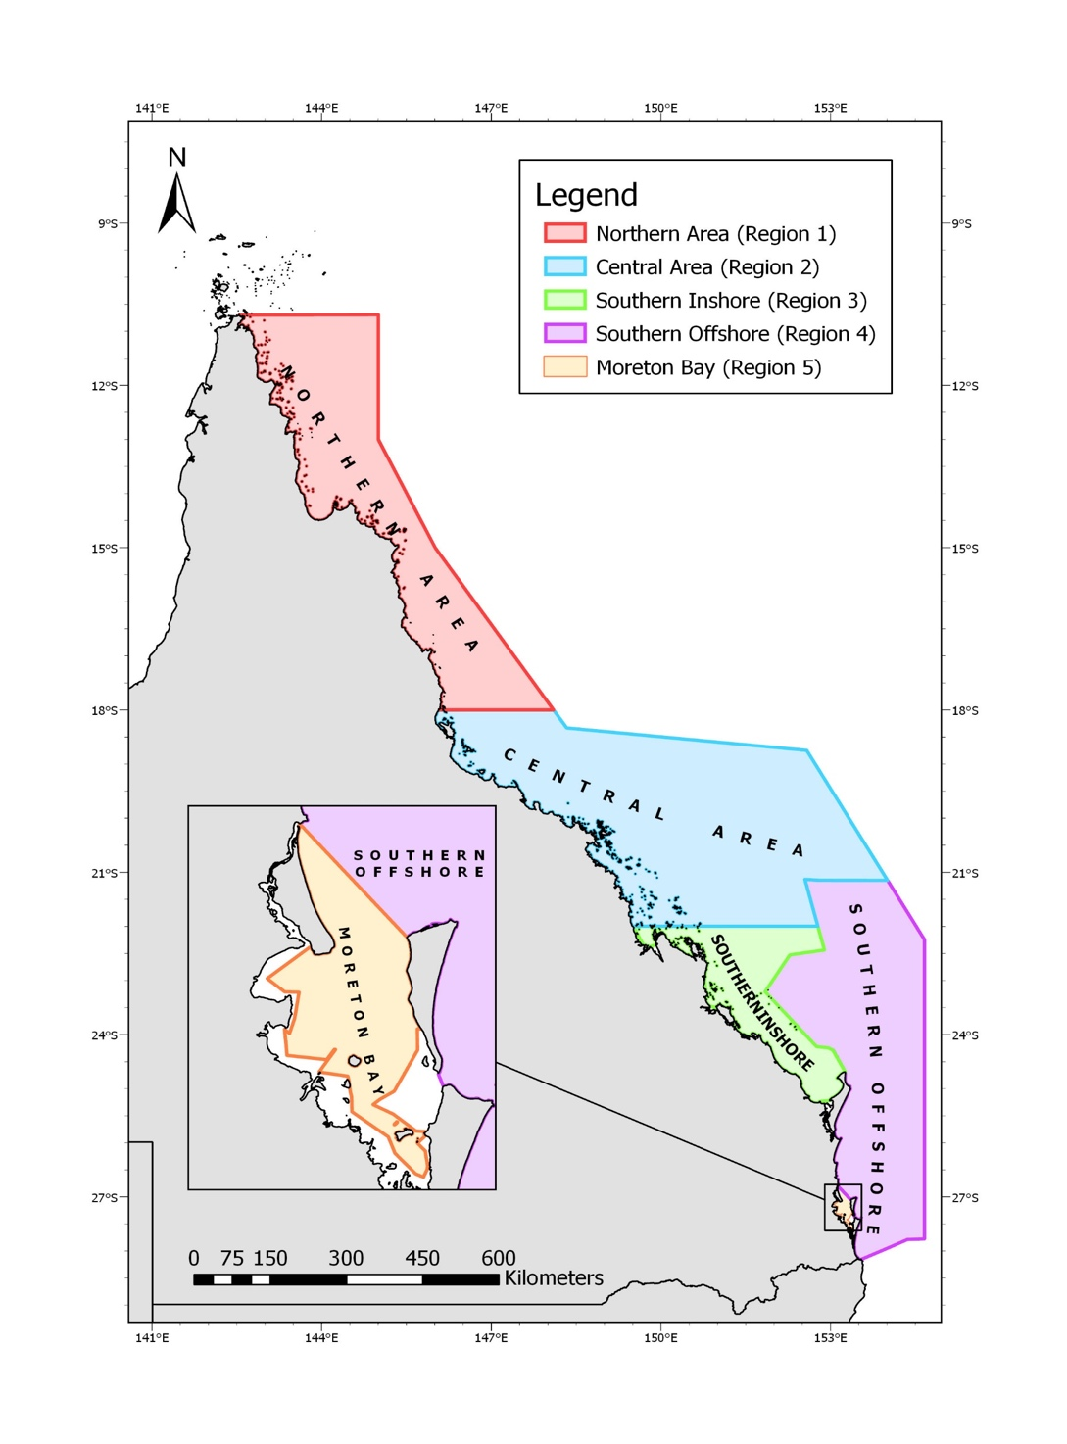
Figure 1. Management regions of the Queensland East Coast Otter Trawl Fishery (Source: QDAF)

3.1.2 Fishery boundaries

The ECOTF covers all tidal waters (excluding estuaries) east of longitude 142°31.89’E out to the East Coast Offshore Constitutional Settlement (OCS) Boundary between Cape York and the Queensland/New South Wales (NSW) border (Figure 1). The type of fishery symbol attached to a commercial fishing licence delimits the area that can be fished.
As part of the subdivision of the ECOTF, effort units and licence allocations are divided between the fishery management regions: 1) Northern, 2) Central, 3) Southern Inshore 4) Southern Offshore and 5) Moreton Bay.

Effort units can only be used in the relevant management region. The Northern region operates from Cape York to latitude 18 degrees (Figure 1).

3.1.3 Gear specifications

The ECOTF uses demersal otter trawl gear to harvest prawns, scallops, bugs, squid, and several by-product species. The fleet uses trawl nets designed to operate on or near the seabed targeting these species mainly over muddy, sandy or silty habitats that are found away from coral reefs. Head-rope height varies according to target species, as does the detailed configuration of nets. Queensland east coast otter trawlers have traditionally used flat, rectangular ‘otter’ boards to spread their nets, but there is an increasing tendency to use more streamlined and smaller boards.

There are three net types used in the ‘northern region’ (e.g., double, triple, quad). Quad net arrangements (four towed nets) are most frequently used in the fishery. Fishers report the net type used, and QDAF record net type effort data for each type (Figure 2).

Effort data was made available to the assessment team. In 2022, ‘Bison’ ‘Louvre’ and ‘Killfoil’ were the most common design, although there are various otter board types and effort (days) fished with each type is reported, and recorded by QDAF and data was made available to the assessment team. The sheer force of water on the angled board forces each board sideways until the net is spread and held open. The otter trawl net has chains hung below the footrope to disturb the prawns as the net is towed along the seabed, making them jump into the mouth of the oncoming net. The type of ground gear (i.e., chain configuration) is reported by fishers, and recorded by QDAF; effort data for each ground gear type was made available to the assessment team and in 2022 the most common ground gear used in the Northern region was ‘drop chain’.

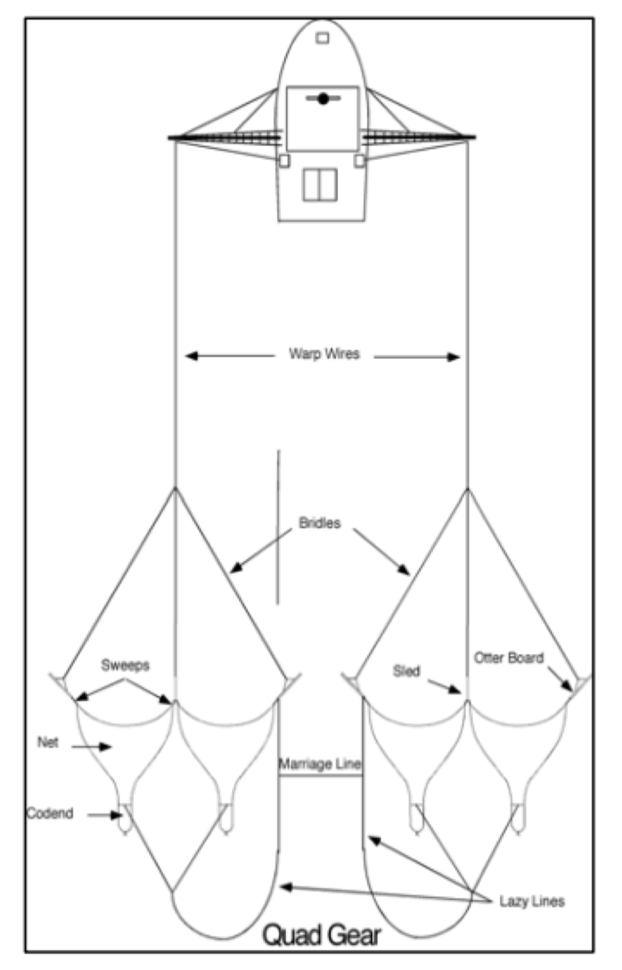
Figure 2: Illustration of Quad Gear otter board trawl in operation (Source; QDAF,2021)

Bycatch Reduction Devices and Turtle Exclusion Devices
In 1999, bycatch reduction devices (BRD)s became mandatory in the fishery. Under the Fisheries (Commercial Fisheries) Regulation 2019, commercial fishers operating in the east coast trawl fishery must install an approved BRD in each net used. There are five types of BRDs, with different features that were designed to exclude specific bycatch species.
Within the Northern trawl area, the following BRDs are used:
- Fisheye
- Square mesh codend specific for area
- Bigeye
- Square mesh panel
- V Cut and Bell Cod-end

In 2004, Turtle excluder devices (TEDs) became mandatory. A significant amount of research has been conducted on the ECOTF since the introduction of BRDs/TEDs, for example:
- Roy & Jebreen (2011) investigated the use of BRDs in the ECOTF and provide useful information on reductions in ETP and unwanted species interactions relative to target species catches.
- Courtney et al. (2010) quantified the species composition, catch rates and mortality rates of sea snakes caught incidentally by the ECOTF. They found data provided by fishers in the SOCI logbook had significantly under estimated the incidental catch and mortality of sea snakes imposed by the ECOTF. The project also tested different BRDs during a research charter and found that the fisheye BRD reduced the sea snake catch rate by 63% compared to a control net with no BRD, with no reduction in the catch rate of marketable prawns.
- Wang et al. (2020) examined the quantity of discards by sector over the period of BRD introduction to 2014.
- Campbell (2022) provides a comprehensive overview of BRD and TED research in prawn trawls and investigated post trawl survival of batoid species from the ECOTF.
The use of TEDs is also a requirement of exporting prawns (shrimp) to the United States of America and the ECOTF is listed as registered fishery under that certification.

Fleet composition

As of July 2023, there were 365 T1 symbols {and 16 T2 (concessional)} symbols (Dedini & Jacobsen, 2023).

Monitoring
The commercial fisher in control of the fishing operation is responsible for meeting these reporting requirements.

Pre-trip notices
Commercial fishers must give a pre-trip notice before they commence a fishing operation, or if any details have changed since they last submitted a pre-trip notice.

Logbooks
Fishers are required to report retained species, effort and fishing location in daily logbooks (Figure 3); there is a note regarding ETP species interactions at the bottom of each logbook page. A further ETP species interaction logbook is also required to be completed (Figure 4). Fishers may use the eFisher app to submit logbooks and other fishery information such as: customise reporting; view licence and fishery symbol details; check quota use; manage vessel tracking units; report trip notices. There are guides and training versions of the App to ensure fishers are supported when using this means of logbook submission.

Fishing activities (location and intensity) are also monitored by VMS; Logbook maps are also available online. The fisher must report the interaction by submitting a protected animal interaction logbook (Figure 5) report within 24 hours (electronically) or 7 days (paper) after the fishing operation ends. If the interaction is with a marine mammal, the fisher must report the interaction to the Wildlife Hotline on 1300 264 625 within 24 hours. If the interaction is with a species listed, the fisher must also report the interaction to Fisheries Queensland on phone number and/or email provided within 48 hours after the fishing operation ends (unless reporting logbooks electronically).

Seasonal/temporal closures

For the Northern zone, the fishing year starts on 1 March and concludes end of February the following year, although there is an and as such the Northern zone operates for 9.5 months per year.

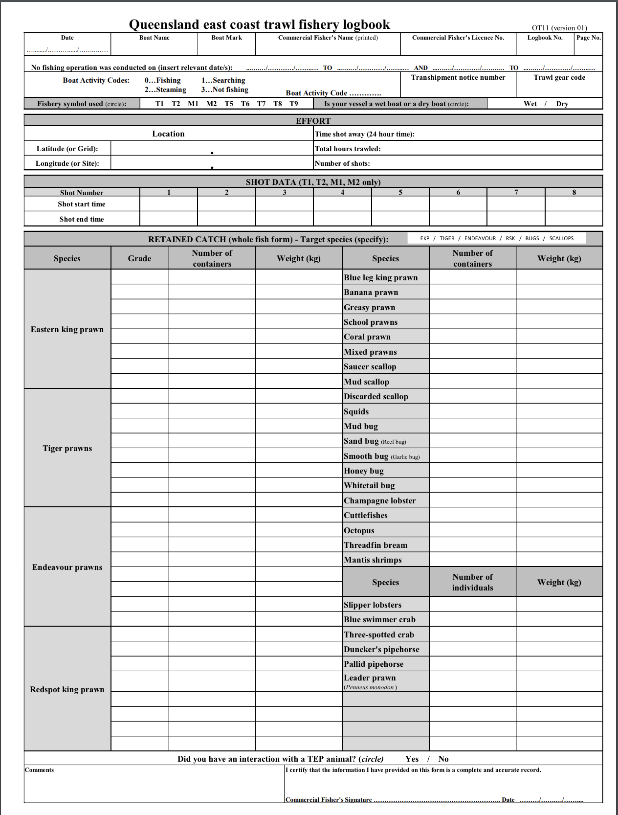
Figure 3. Commercial logbook for the ECOTF (Source: QDAF, 2024)
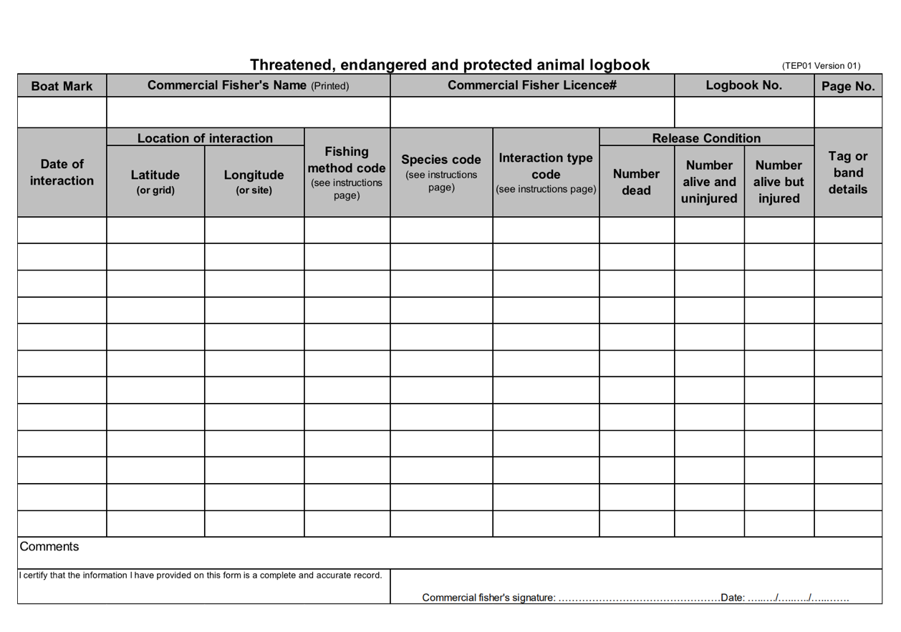
Figure 4. ETP interaction logbook for the ECOTF (Source: QDAF, 2024)

Spatial closures
Within the ECOTF there are both seasonal and permanent area closures, particularly in waters of the Great Barrier Reef World Heritage Area (Department of Agriculture and Fisheries, 2020). However, there are other closures in the area of operation of the northern trawl region of the ECOTF fishery.
Lovett et al. (2023) provided a synopsis of the closed areas over time for the northern and central Tiger prawn fishery (Figure 5) that were identified for the purpose of stock assessment.

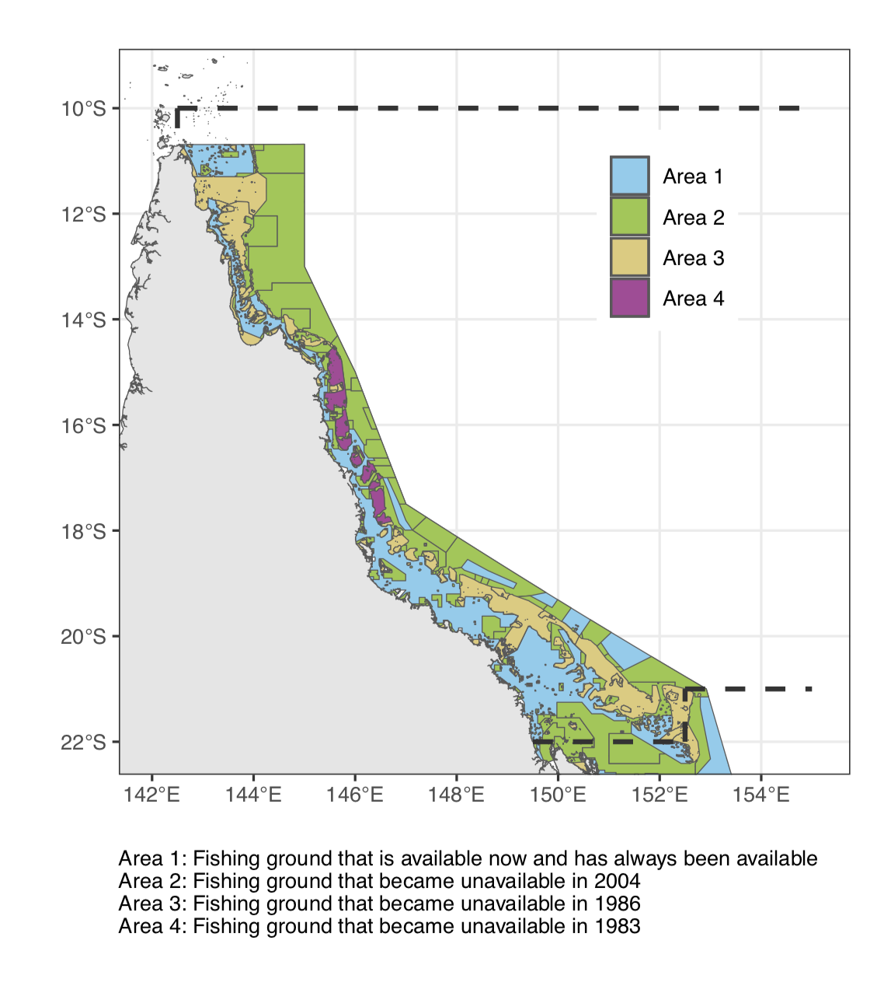
Figure 5. Assessment region defined by dashed lines—coloured fill represents changes through time of available trawling area within the defined assessment region

3.1.8 Effort caps
Effort unit entitlements for licence holders are renewed each year. Effort units can only be used in the relevant management region (e.g., they can not be transferred from northern to central or vice versa).The northern region effort cap is set at 250,178 effort units and daily updates are available at FishNet online .
From 2024– 25 onwards, effort caps will be informed by stock assessments and will provide recommendations around effort levels to achieve a target biomass of 60% of unfished levels (QDAF, 2022).

Pre-assessment

Principle 1

Background
The default Principal 1 decision tree (Figure 6) was used for this assessment.
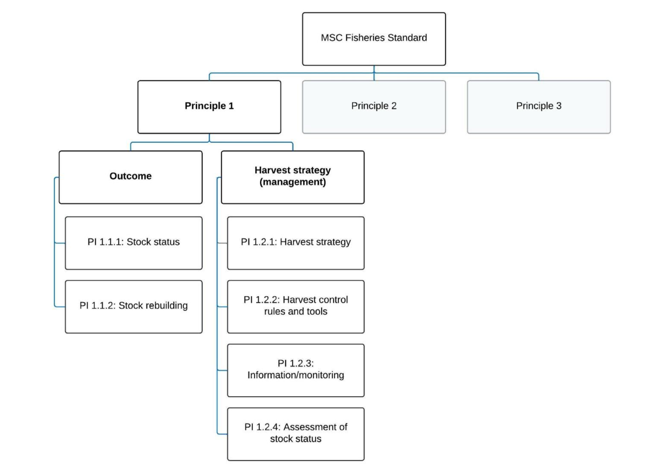
Figure 6. Decision tree for Principle 1 (MSC Fisheries Standard v3.)

4.1.2 UoA species profiles

4.1.2.1 Catch history

Table 6. Logbook catch data for Tiger Prawn and Endeavour Prawn from the ECOTF, UoA = Northern region.
Catch Data | 2019 | 2020 | 2021 | 2022
ECOTF Tiger prawn catch (t) | 1075 | 1227 | 1097 | 1052
UoA Tiger prawn catch (t) | 574.8 | 468.1 | 606.2 | 585.4
ECOTF Endeavour prawn catch (t) | 423.8 | 347.5 | 425.0 | 273.2
UoA Endeavour prawn catch (t) | 326.1 | 252.3 | 322.6 | 201.6

Tiger prawns

Tiger prawns is a collective term for two species: Brown tiger (Penaeus esculentus) and grooved tiger (P. semisulcatus). They are taken in the ECOTF within the Northern, Central and Moreton Bay Trawl regions. Tiger prawns are also a minor component of the southern offshore trawl region and rarely reported in the southern inshore catches.

Between 2017 and 2021, the northern zone’s total retained catch of Tiger prawns averaged 558.6 t per year (Table 7). In the late 90s and early 2000s, there was a decreasing catch trend, and fishery adjustment (including substantial reductions in fleet size and total fishing effort) was evident in the reduced (yet stable) stable catches from 2006 to 2021 (Figure 7). Recreational, Indigenous and charter harvests were non-existent or negligible for tiger prawns and were not included in the stock assessment (Lovett et al. 2023).

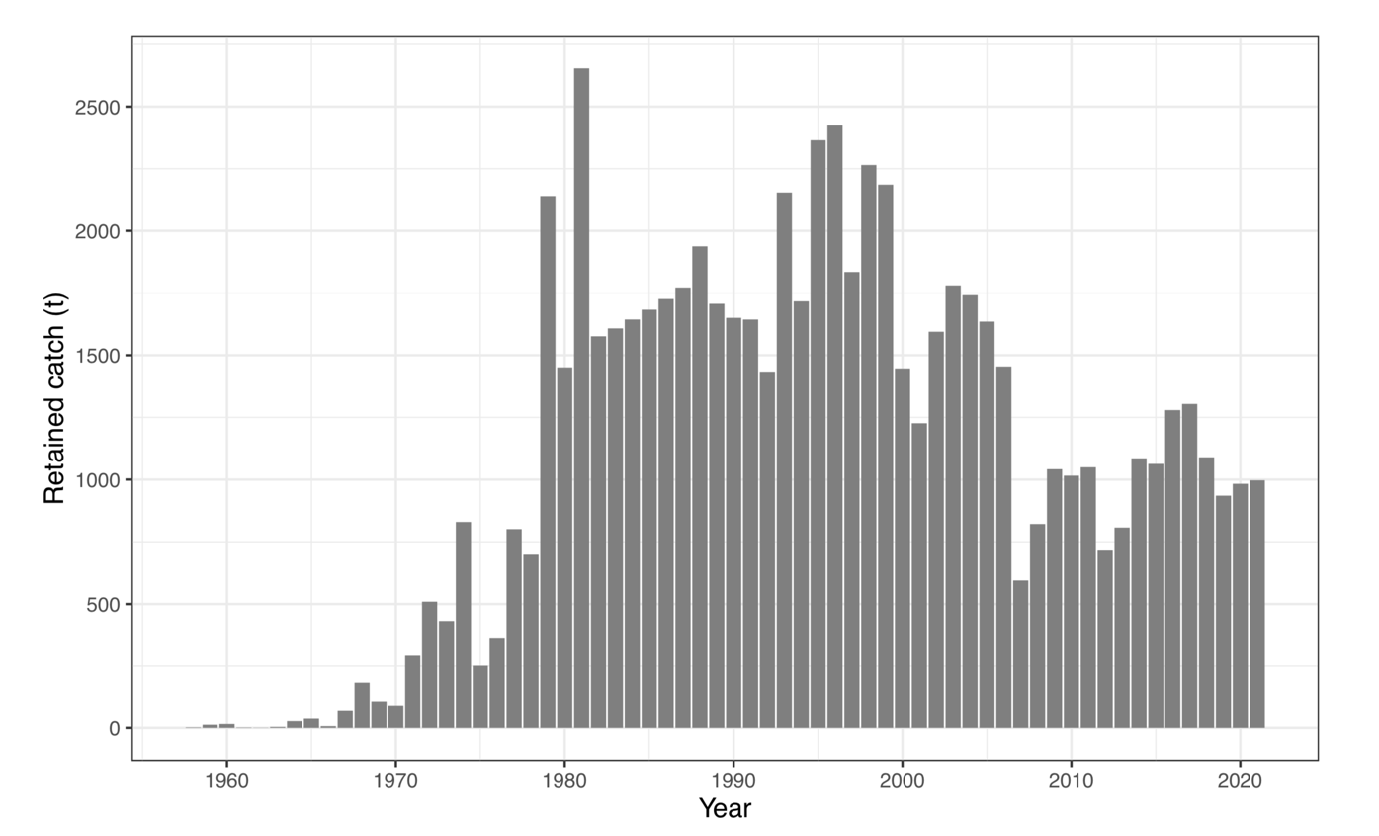
Figure 7. Annual estimated retained catch (tonnes) of Queensland’s east coast Tiger Prawn between 1958 and 2021 (Lovett et al. 2023)

Endeavour Prawns

Most of the endeavour prawn harvest of the ECOTF comes from the Cape York Peninsula waters from north of Cairns, where the adults tend to inhabit inshore reef lagoons (QDAF, 2021a). In 2022, the northern region of the ECOTF took 74% of the total retained catch (Table 8), whilst the central region took 45 t and the Moreton Bay region took 19 t. Over the past five years (2017–21), the northern zone total retained mean catch of Endeavour Prawn was 275.6 t per year (Table 8; Figure 8); the mean annual catch (for the two most recent years: 2021–22) for the UoA was 262 t. Endeavour prawns are managed as a Tier 2 species within the Harvest Strategy (Figure 14; QDAF, 2021e). The harvest control rules for this species are:
- Commercial catch will be monitored to assess changes in fishing mortality.
- Annual commercial catch triggers (300–520 t) are used to assess changes in fishing mortality when compared to historic catch levels (2010 to 2019)

The mean annual catch (58 t) is currently outside the commercial range listed in the HS (10–50 t). However, the HS stated that “a review is to be undertaken to understand the reason for the increased harvest, assess the risks and ensure catch of a species does not increase more than 20% above the upper catch range.” It is unclear if a review was triggered; however, the 2023 stock assessment found the biomass to be above B_{target}.

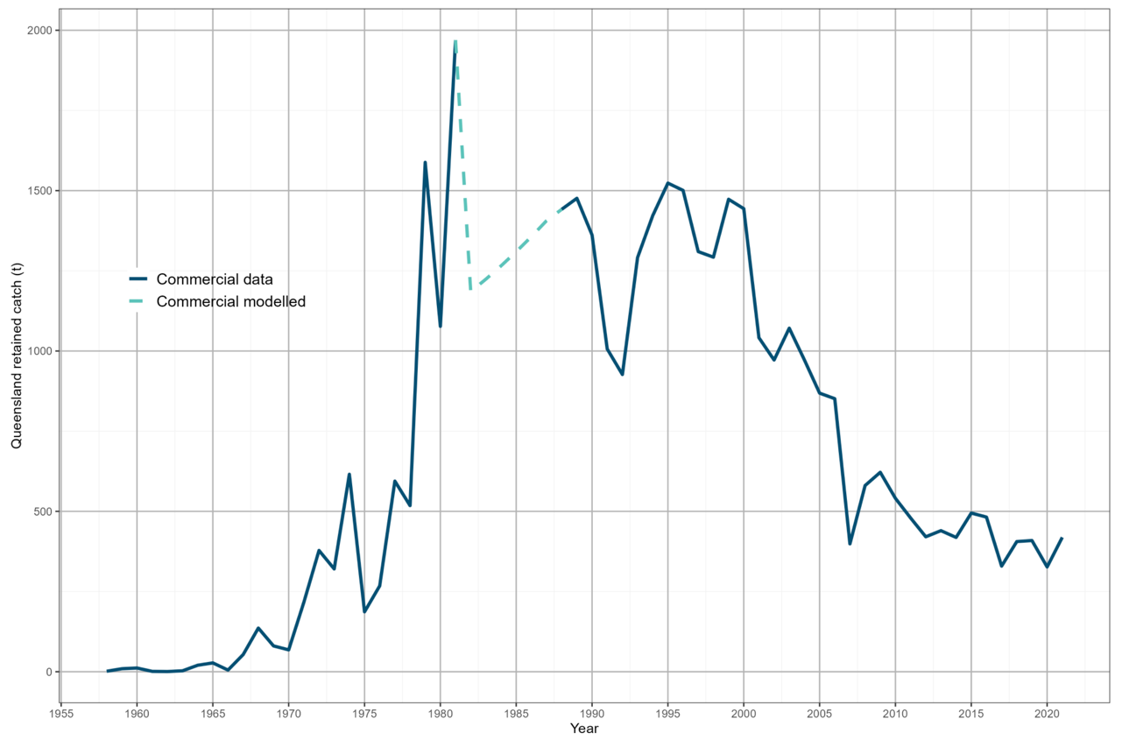

Figure 8. Endeavour prawn retained used in the stock assessment (Fox et al. 2023).

4.1.2.2 Ecology of UoA species

Tiger prawns

Distribution & stock structure
Brown tiger prawns are endemic to tropical and subtropical waters of Australia, while grooved tiger prawns have a wider Indo–West Pacific distribution. Both species occur along the coastline of northern Australia from Shark Bay in Western Australia to the eastern coast of northern New South Wales (Somers 1987; Ward et al. 2006).
Migratory behaviour differs between the species with the grooved tiger prawn displaying more mobile behaviour of regular movements from the inshore feeding grounds to spawn in offshore waters; Brown tiger prawns are more sedentary in nature (Dichmont et al. 2001; Venables et al. 2004). Subsequently, the susceptibility of each species to capture also differs throughout the coastline regions (Lovett et al. 2023).

Life history
Both Brown and Grooved Tiger prawns have an approximate life cycle of 2 years (Dichmont et al. 2006; Somers et al. 1991).
Spawning activity peaks in January–March and August –October each year with females spawning in offshore waters < 50 m deep (Turnbull et al. 2007). About two weeks after spawning, post-larvae settle on inshore sea-grass nursery beds within an estuary (Turnbull et al. 2007) and stay for about three months in these nursery grounds. Young juveniles migrate back to offshore waters, and reach maturity at approximately six months of age or 32–39 mm carapace length (CL) (Somers 1987; Turnbull et al. 2007). The maximum observed size is 44 mm CL for Brown females, 35 mm CL for Brown males, 52 mm CL for Grooved females and 38 mm CL for Grooved male prawns.

Stock assessment

Logbook records do not specify if catch is comprised of Penaeus esculentus, P. semisulcatus or a mix of both species, and as such Tiger prawns are modelled collectively although Lovett et al. (2023) found that a final overall proportion was calculated, resulting in 58% Brown Tigers and 42% Grooved Tigers.

Lovett et al. (2023) updated the stock assessment for Tiger prawns from the east coast of Queensland. Tiger prawns were previously assessed at the sector level (northern and southern sectors, split at 16◦ S) by Wang (2015) and at the management region level by Helidoniotis (2021), using a weekly delay-difference model.

The latest assessment (Lovett et al. 2023) used a one-sex monthly delay-difference population model, fitted to catch rates. An age-structured model Stock Synthesis model was also trialled; however, this did not lead to outcomes that were considered plausible by the assessment team and was therefore deemed an unsuitable method to assess tiger prawns for the east coast of Queensland at this time.

Stock status

In 2021, the stock level of Tiger Prawns was estimated to be 79% of unfished biomass (70–89% range across the 95% credible interval) (Figure 9; Lovett et al. 2023). Lovett et al. (2023) noted that whilst the stock is currently above the TRP, biomass was declining. Helidoniotis (2021) estimated the stock was at around 49–50% of unfished levels in 2019 for the central and northern trawl management regions combined.

The difference in final biomass predictions between Helidoniotis (2021) of 50% unfished biomass for central and Lovett et al. (2023) was explored thoroughly via a bridging analysis presented at ‘Appendix E Bridging Analysis’ within Lovett et al. (2023).

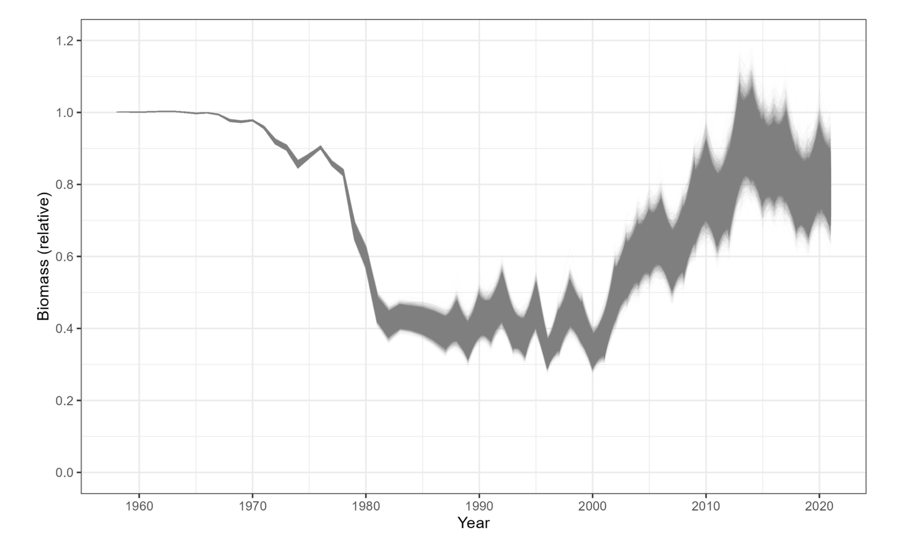
Figure 9: Predicted biomass trajectory relative to unfished for tiger prawns, from 1958 to 2021—grey lines represent individual MCMC samples (Source: Lovett et al. 2023).
Table 7. History of Prawn management in Queensland (Lovett et al. 2023).
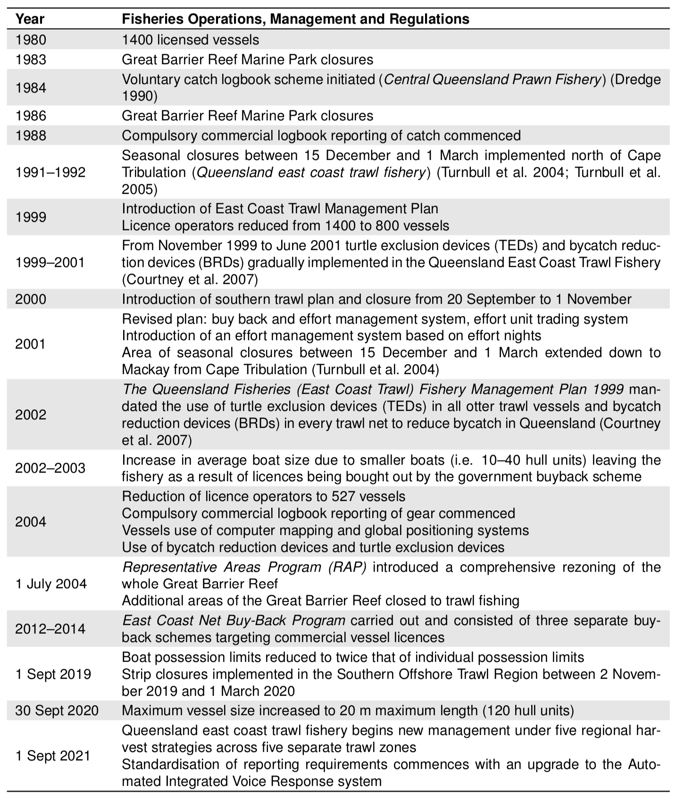

Endeavour Prawn

Distribution & stock structure

Endeavour prawns (Metapenaeus endeavouri and Metapenaeus ensis) are endemic to the tropical and subtropical waters of Australia and are widely distributed along the coastline of northern Australia from Shark Bay in Western Australia to the eastern coast of northern New South Wales.

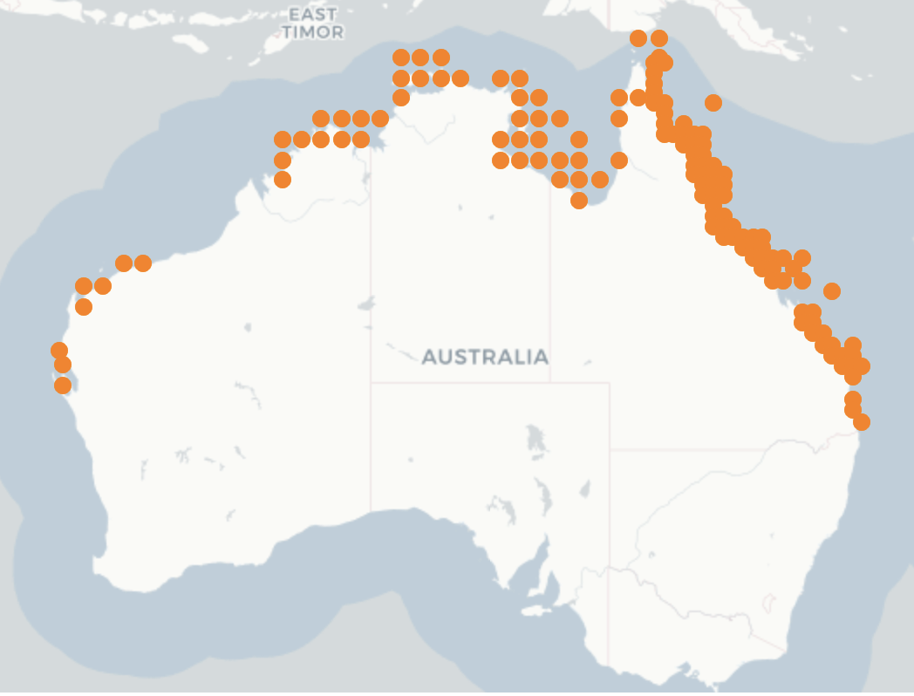
Figure 10. Distribution of Endeavour Prawns (Source: SAFS 2020)

Life history
Endeavour prawn is a species complex or Blue Endeavour and Red Endeavour prawns of similar sizes. Sexual maturity is months 24–26 mm CL.

Stock assessment
The most recent quantitative stock assessment on the biological stock was undertaken by Fox et al. (2023b). The assessment considered the spatial scope to be all east coast of Queensland using data to 2021. The assessment used a one-sex monthly delay-difference population model fitted to catch rates. An age-structured model was also trialled but there were no plausible outcomes from that model. Commercial catch rates were standardised to estimate an index of endeavour prawn abundance through time (Figure 11).
Endeavour prawns had previously been assessed at the sector level (northern and southern sectors, split at 16◦ S) by Wang (2015), using data from 1988 to 2013.

Stock status

Roelofs et al. (2020) suggested the ECOTF Endeavour Prawn fishery was ‘sustainable’ and ‘not overfished’ based on the low fishing mortality relative to historical levels. Biomass declined between 1958 and 1997 to 34% of unfished biomass. In 2023, stock biomass was 69% (54–87%) of unfished biomass (Figure 11; Fox et al. 2023b).

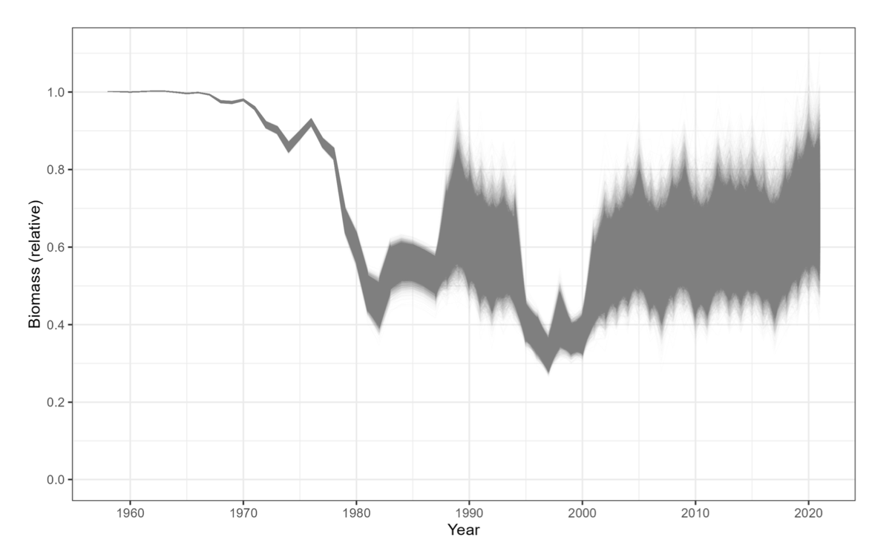
Figure 11. Predicted biomass trajectory relative to unfished for endeavour prawns, from 1958 to 2021—grey lines represent individual MCMC samples (Source: Fox et al. 2023b)

Table 8. Summary of model outcomes for all endeavour prawn scenarios—B₂₀₂₁ % is the most likely biomass in 2021 relative to unfished in 1968 with the 95 % credible interval (CI) (Fox et al. 2023b).
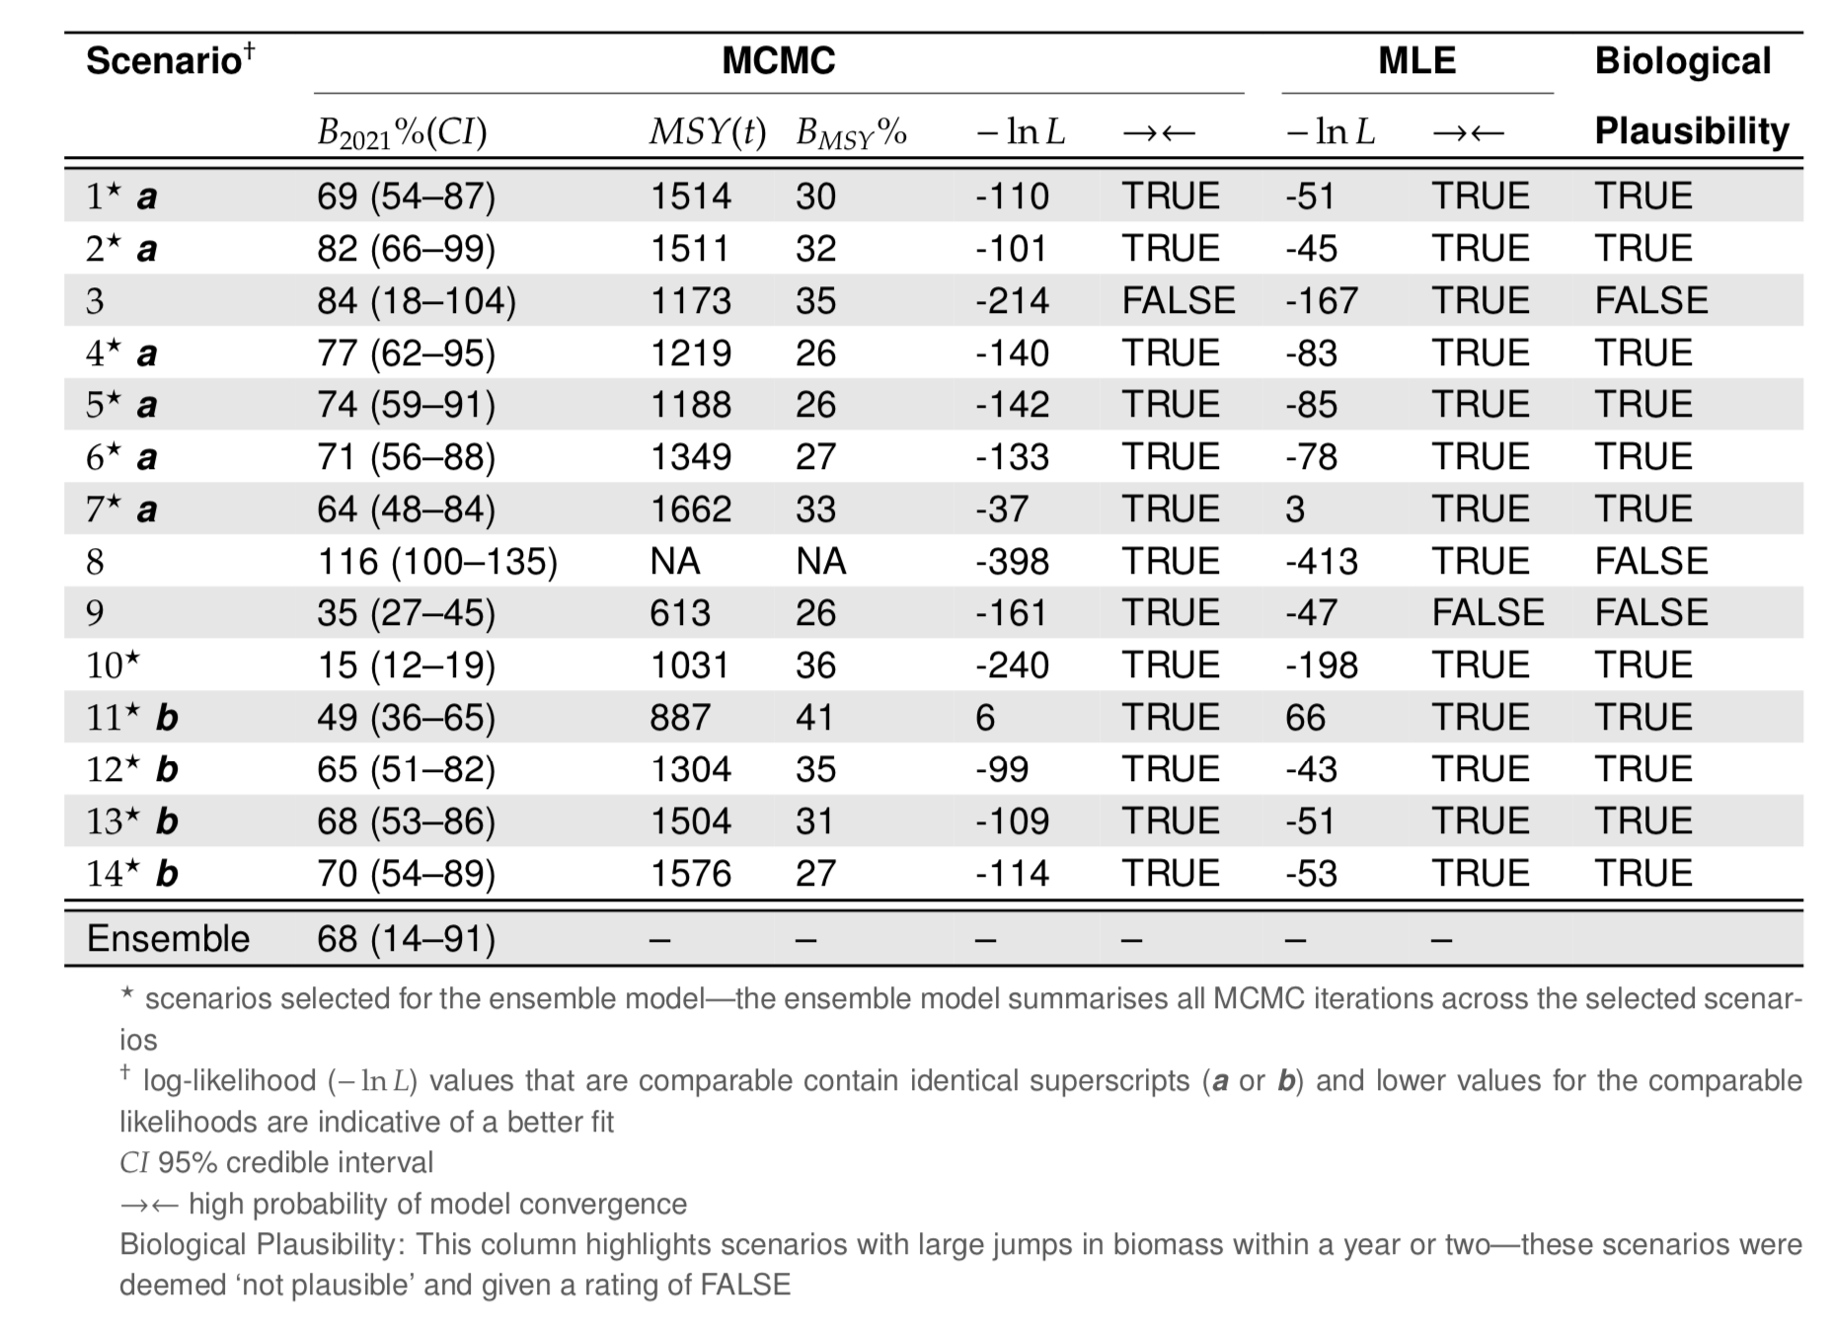

4.1.2.3 Harvest strategy

Tiger prawns
Brown and Grooved Tiger prawns are Tier 1 species managed collectively within the Northern Trawl Region Harvest Strategy (QDAF, 2021e). There is a target reference point of 60% unfished spawning biomass and the limit reference point of 20% unfished spawning biomass. Harvest control rules (decision rules) are used to set total allowable commercial effort (TACE) (Figure 12).

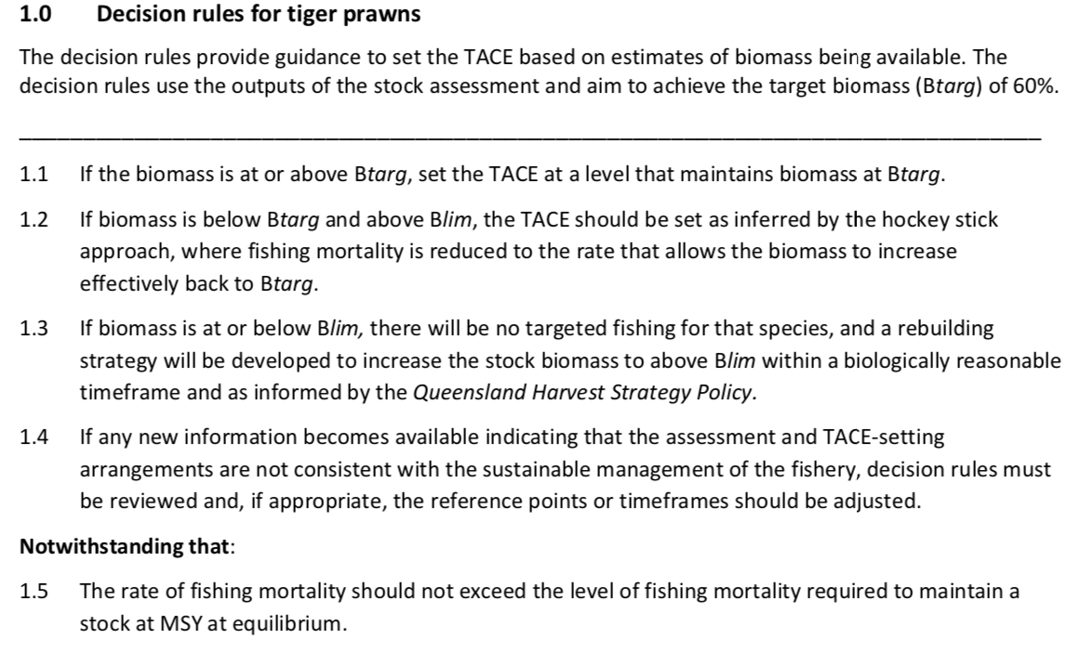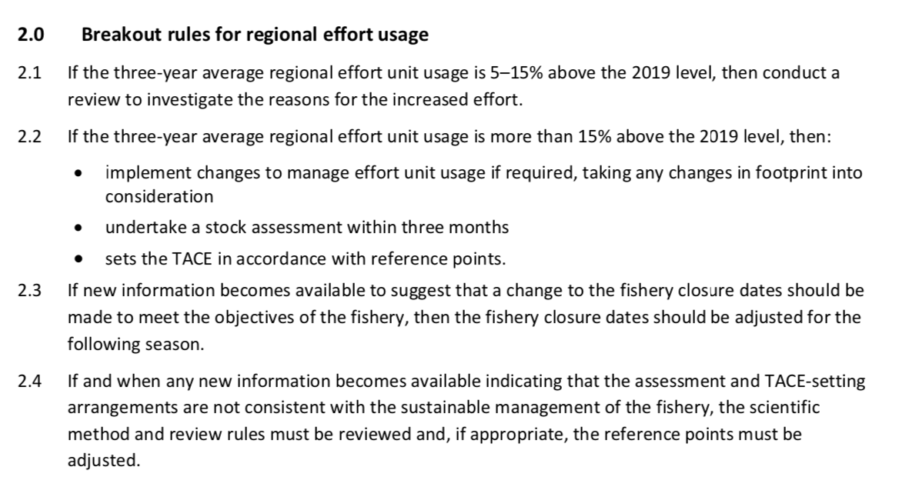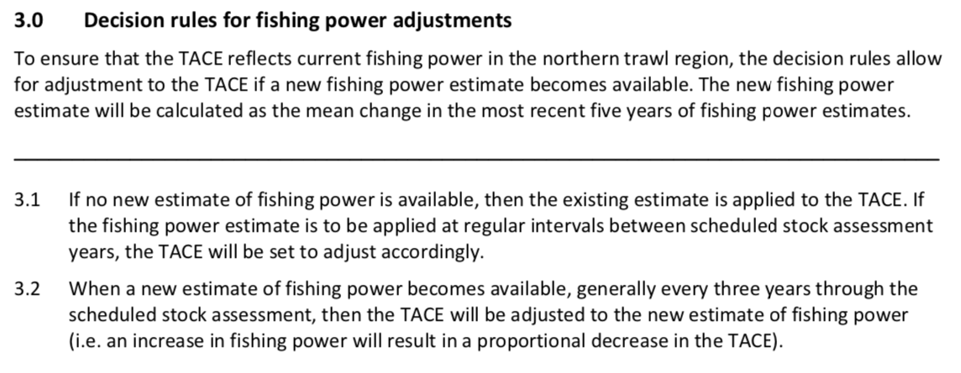
Figure 12. Harvest strategy decision rules for Tiger Prawns from Northern Trawl Region of the ECOTF (QDAF, 2021d).

Endeavour Prawns
Endeavour Prawns are a Tier 2 species within the Northern Trawl Region HS (QDAF, 2021e; Figure 13).

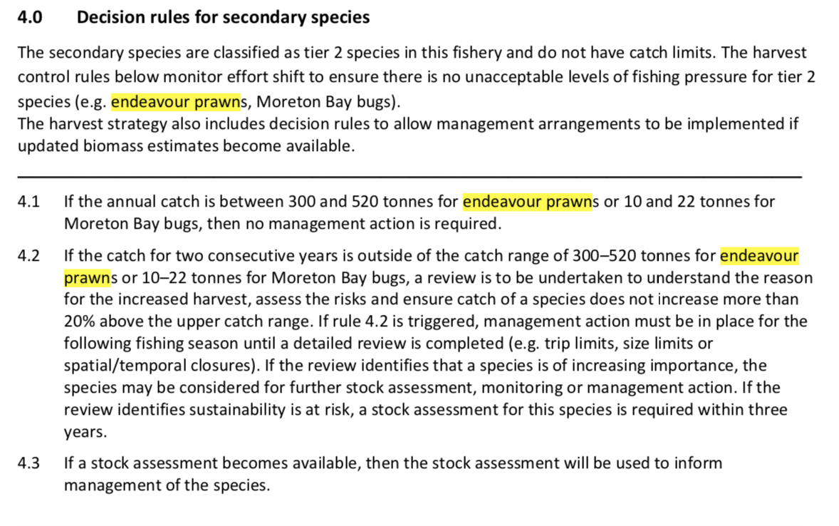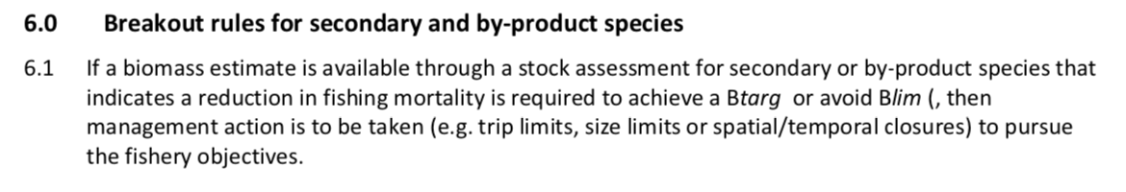
Figure 13. Secondary species Harvest strategy decision rules and breakout rules for Secondary/By-product species including Endeavour Prawns from Northern Trawl Region of the ECOTF (QDAF, 2021e).

Other management arrangements

Management in Queensland applies a range of input controls including vessel entry limitations, boat- day/effort-unit allocations, vessel and gear size restrictions and spatial and temporal closures

- Effort caps
  - FishNet lists current the effort cap units, usage and dates.
- Annual reset dates
- Annual closures
Other management methods include:
- Limited access through primary commercial fishing boat licences
- 20 m maximum vessel length
- hull unit (HU) limit of 120 HU
- gear restrictions such as net length and mesh size
- spatial and temporal closures

Fishery monitoring programs have changed since 2015. Courtney et al. (2014) provided a comprehensive of the fishery and the management pre-2015.

Evaluations of management measures

With regard to reviewing the harvest strategy, each harvest strategy will remain in place for a period of five years, after which time it will be fully reviewed in accordance with the Fisheries Act 1994. The harvest strategy may also be subject to further review and amendment as appropriate within the five-year period if any of the following circumstances arise:
- there is new information that substantially changes the status of a fishery, leading to improved estimates of indicators relative to reference points
- drivers external to management of the fishery increase the risk to fish stock/s
- it is clear the strategy is not working effectively and the intent of the harvest strategy policy is not being met.

Given the above, the 2021 Harvest Strategy is due for renewal in 2026.

Principle 1 References

Bio-inspecta (2023) Australia east coast king prawn fishery Marine Stewardship Council Public Certification Report 23 June 2023. Report available at https://fisheries.msc.org/en/fisheries/australia-east-coast-king-prawn/ accessed 1 February 2024.

Courtney, A., Campbell, M., Tonks, M., Roy, D., Gaddes, S., Haddy, J., Chilcott, K. (2014). Effects of bycatch reduction devices in Queensland’s (Australia) deepwater eastern king prawn (Melicertus plebejus) trawl fishery. Fisheries Research, 157, 113-123.

Courtney, A., Haddy, J., Campbell, M., Roy, D., Tonks, M., Gaddes, S., Kyne, P. (2007). Bycatch weight, composition and preliminary estimates of the impact of bycatch reduction devices in Queensland's trawl fishery. Canberra: Fisheries Research and Development Corporation, Project 2000/170. 307 pp. https://era.daf.qld.gov.au/id/eprint/3709/1/BycatchFinalReport2007-FullReport.pdf

Dedini, E., I. Jacobsen and J. Zieth (2023) East Coast Otter Trawl Fishery Ecological Risk Assessment Species of Conservation Concern. Technical Report. Fisheries Queensland, Department of Agriculture and Fisheries. Available at Accessed 15 Feb 2024.

Dedini E. and I. Jacobsen (2023) ECOTF Scoping Study. Fisheries Queensland, Department of Agriculture and Fisheries. Available at https://era.daf.qld.gov.au/id/eprint/9572/1/East%20Coast%20Otter%20Trawl%20Fishery%20Scoping%20Study%20FINAL.pdf

Dichmont, C. M., A. R. Deng, A. E. Punt, W. Venables, and M. Haddon (2006). Management strategies for short-lived species: The case of Australia’s Northern Prawn Fishery: 1. Accounting for multiple species, spatial structure and implementation uncertainty when evaluating risk. Fisheries research 82.1-3: 204–220.

Dichmont, C., D. Die, A. Punt, W. Venables, J. Bishop, A. Deng, and Q. Dell (2001). Risk analysis and sustainability indicators for prawn stocks in the Northern Prawn Fishery. FRDC Project 1998/109. Hobart, Tasmania: CSIRO Marine Research; Fisheries Research and Development Corporation.

Fox, A. R., Lovett, R. A., Wickens, M. E. and Hillcoat, K.B. (2023) Stock assessment of Queensland east coast endeavour prawns (Metapenaeus endeavouri and Metapenaeus ensis), Australia, with data to December 2021.Technical Report. State of Queensland, Brisbane.

Grech, A., & Coles, R. (2011). Interactions between a Trawl Fishery and Spatial Closures for Biodiversity Conservation in the Great Barrier Reef World Heritage Area, Australia. PloSOne, E 6(6): e21094., doi:10.1371/journal.pone.0021094. doi: doi:10.1371/journal.pone.0021094

Helidoniotis, F. (2021). Stock assessment of Queensland east coast tiger prawns (Penaeus esculentus and Penaeus
semisulcatus). Brisbane, Queensland: Department of Agriculture and Fisheries.

Jacobsen, I., Zeller, B., Dunning, M., Garland, A., Courtney, T., & Jebreen, E. (2018). An ecological risk Assessment of the southern Queensland east coast otter trawl fishery and river and inshore beam trawl fishery. Brisbane: State of Queensland. Retrieved from https://www.daf.qld.gov.au/__data/assets/pdf_file/0004/1402672/Sth-QLD-Trawl-ERA- Final.pdf

Lovett, R. A., Fox, A. R., Wickens, M. E. and Hillcoat, K. B. (2023) Stock assessment of Queensland east coast tiger prawns (Penaeus esculentus and Penaeus semisulcatus), Australia, with data to December 2021. Technical Report. State of Queensland, Brisbane. Available at: https://era.daf.qld.gov.au/id/eprint/9560/ (accessed 3 May 2024)

MRAG (2023) Australia Northern Prawn Fishery Public Certification Report July 2023 Second re-assessment Public report. MRAG Americas. Available at https://fisheries.msc.org/en/fisheries/australia-northern-prawn/@@assessments

Pears, R., Morison, A., Jebreen, E., Dunning, M., Pitcher, C. C., Houlden, B., & Jacobsen, I. (2012). Ecological risk assessment of the East Coast Otter Trawl Fishery in the Great Barrier Reef Marine Park. Brisbane: Great Barrier Reef Marine Park Authority.
QDAF(2020b). Queensland Fisheries Summary October 2020. Brisbane: State of Queensland. Department of Agriculture and Fisheries. https://www.publications.qld.gov.au/dataset/e7f0da0a-3904- 424b-ab48-a63bf7157823/resource/873e3106-5993-4efb-a3dc- 6b5dc1a1f2f0/fs_download/queensland-fisheries-summary-report.pdf
QDAF (2021a) Status report for reassessment and approval under protected species and export provisions of the Environment Protection and Biodiversity Conservation Act 1999 (EPBC Act) Queensland Department of Agriculture and Fisheries, State of Queensland. 85 pp. https://www.dcceew.gov.au/sites/default/files/env/consultations/e1ba225f-3edc-4f76-b93e-bb8cc69b0939/files/qld-east-coast-trawl-fishery-submission-2021.pdf

QDAF (2021b) Trawl fishery (southern offshore A and B regions) harvest strategy: 2021– 2026. Queensland Department of Agriculture and Fisheries, State of Queensland. 19 pp.

QDAF (2021c) Trawl fishery (southern inshore) harvest strategy: 2021– 2026. Queensland Department of Agriculture and Fisheries, State of Queensland. 19 pp.

QDAF (2021d) Trawl fishery (central) harvest strategy: 2021– 2026. Queensland Department of Agriculture and Fisheries, State of Queensland. 19 pp. https://www.publications.qld.gov.au/ckan-publications-attachments-prod/resources/b0d530dc-34ba-4dd7-9109-b79f3a785203/central-trawl-region-harvest-strategy.pdf?ETag=46f5f6a23c974621e5c8428a0cc56942

QDAF (2021e) Trawl fishery (northern) harvest strategy: 2021– 2026. Queensland Department of Agriculture and Fisheries, State of Queensland. 19 pp. https://www.publications.qld.gov.au/ckan-publications-attachments-prod/resources/2d129e11-bfc9-4a41-a766-3104bbcaa677/northern-trawl-region-harvest-strategy.pdf?ETag=e411c45e75e8150e35c8c35340e47282

QDAF (2022) Queensland east coast otter trawl fishery. Consultation on proposed management actions. Discussion paper. Fisheries Queensland, State of Queensland. 22 pp.

Roy, D., and E. Jebreen (2011) Extension of Fisheries Research and Development Corporation funded research results on improved bycatch reduction devices to the Queensland East Coast Otter Trawl Fishery. Report to the Fisheries Research and Development Corporation Project No. 2008/101 May 2011. Available at: https://era.daf.qld.gov.au/id/eprint/3903/1/FRDC_BRDs_Otter_Trawl_Fishery-Final_report.pdf

Somers, I. (1987). Sediment type as a factor in the distribution of commercial prawn species in the
western Gulf of Carpentaria, Australia. In: Marine and Freshwater Research 38.1, pp. 133–149.

Somers, I. and G. Kirkwood (1991). Population ecology of the grooved tiger prawn, Penaeus semisulcatus, in the north-western Gulf of Carpentaria, Australia: growth, movement, age structure and infestation by the bopyrid para-
site Epipenaeon ingens. In: Marine and Freshwater Research 42.4, pp. 349–367.

Taylor, M. D and D, D Johnson (2020). Evaluation of adaptive spatial management in a multijurisdictional trawl fishery. In: Regional Studies in Marine Science, p. 101206. DOI:10.1016/j.rsma.2020.101206

Turnbull, C. T. and J. C. Atfield (2007). Fisheries long term monitoring program: summary of tiger and endeavour prawn survey results: 1998-2006. Brisbane, Queensland: Department of Primary Industries and Fisheries.

van der Velde TD, Venables WN, Crocos PJ, Edgar S, Evans F, Rothlisberg PC (2021) Seasonal, interannual and spatial variability in the reproductive dynamics of Penaeus merguiensis. Mar Ecol Prog Ser 658:117-133. https://doi.org/10.3354/meps13540

Venables, W., R. Kenyon, J. Bishop, C. Dichmont, R. Deng, C. Burridge, B. Taylor, A. Donovan, S. Thomas, and S. Cheers (2006). Species Distribution and Catch Allocation: data and methods for the NPF, 2002-2004 Final Report. AFMA Project,(R01/1149). Australian Fisheries Management Agency, Canberra Australia.

Ward, R. D., J. R. Ovenden, J. R. S. Meadows, P. M. Grewe, and S. A. Lehnert (2006). Population genetic structure of the brown tiger prawn, Penaeus esculentus, in tropical northern Australia. Marine Biology 148(3): 599–607.

Principle 1 – Performance Indicator scores and rationales

PI 1.1.1 – Stock status

PI 1.1.1 |  | The stock is at a level that maintains high productivity and has a low probability of recruitment overfishing
Scoring issue |  | SG 60 | SG 80 | SG 100
a | Stock status relative to recruitment impairment
a | Guidepost | It is likely that the stock is above the point of recruitment impairment (PRI). | It is highly likely that the stock is above the PRI. | There is a high degree of certainty that the stock is above the PRI.
a | Met? | Tiger prawn - Yes | Tiger prawn - Yes | Not scored
a | Met? | Endeavour Prawns - Yes | Endeavour Prawns - yes | Not scored
Rationale |  | Tiger Prawn  Tiger prawns is a collective term for two species: Brown tiger (Penaeus esculentus) and grooved tiger (P. semisulcatus).  In 2021, the stock level of Tiger Prawns was estimated to be 79% of unfished biomass (70–89% range across the 95% credible interval) (Lovett et al. 2023). The point at which recruitment would become impaired is not explicitly determined, but the stock was above the B_{target} target reference point (60%). Estimated MSY is 1520 t and the catch in 2021 was 997 t (65% of MSY) leaving at B_{MSY} of 35%. SG 60 and SG 80 are met as the stock is highly likely to be above PRI.  Endeavour Prawn  The most recent stock assessment (Fox et al. 2023) estimated the biomass. In 2023, stock biomass was 69% (54–87%) of unfished biomass (Figure 11; Fox et al. 2023b). The point at which recruitment would become impaired is not explicitly determined, but the stock was above the B_{target} target reference point (60%) and above the B_{MSY} of 34%. SG 60 and SG 80 are met as the stock is highly likely to be above PRI.

 | Guidepost |  | The stock is at or fluctuating around a level consistent with MSY. | There is a high degree of certainty that the stock has been fluctuating around a level consistent with MSY or has been above this level over recent years.
 | Met? |  | Tiger prawn - Yes | Not scored
 | Met? |  | Endeavour Prawns - Yes | Not scored
Rationale |  | Tiger prawn  Estimated MSY is 1520 t and the catch in 2021 was 997 t (65% of MSY) leaving at B_{MSY} of 35%. SG 80 is met as the stock is highly likely to be above MSY.  Endeavour prawn  The most recent assessment (Fox et al. 2023) found that the biomass was at 69% of unfished levels. The stock was above B_{MSY} of 34%. SG 80 are met as the stock is highly likely to be at a level consistent with MSY.

Draft scoring range | Tiger Prawn ≥80
Draft scoring range | Endeavour Prawn ≥80
Information gap indicator | Information sufficient to score PI

PI 1.2.1 – Harvest strategy
PI 1.2.1 |  |  | There is a robust and precautionary harvest strategy in place
Scoring issue |  |  | SG 60 | SG 80 |  | SG 100
a |  | Harvest strategy design
 |  | Guide post | The harvest strategy is expected to achieve stock management objectives reflected in PI 1.1.1/PI 1.1.1A SG80. | The harvest strategy is responsive to the state of the stock and the elements of the harvest strategy work together towards achieving stock management objectives reflected in PI 1.1.1/PI 1.1.1A SG80. |  | The harvest strategy is responsive to the state of the stock and is designed to achieve stock management objectives reflected in PI 1.1.1/PI 1.1.1A SG80.
 |  | Met? | Tiger prawn - Yes | Tiger prawn - Yes | Not scored
 |  | Met? | Endeavour prawn - Yes | Endeavour prawn - Yes
Rationale |  |  | A HS for the northern zone of the ECOTF was approved and implemented in 2021. The HS was designed in accordance with the 2021 Queensland harvest strategy policy. The HS includes managing the fisheries performance against key indicators through monitoring, stock assessment and explicit decision rules.  Tiger prawn are target (Tier 1) species whilst Endeavour Prawn are listed as a Tier 2 species. The harvest strategy includes decision rules (Figures 12–13) to allow management arrangements to be implemented if updated biomass estimates become available or if catches exceed historical commercial catches (2010–2019). As the level of exploitation changes outside of historic levels, species will be elevated to higher levels of monitoring, assessment and management.  With regard to being responsive, the HS outlines that the ‘northern region harvest strategy workshop’ is held at least annually to discuss elements of the harvest strategy. Further information is presented in the relevant working group.  The monitoring program requires a review of catch and effort data; adjustment of the annual commercial catch triggers are used to assess changes in fishing mortality when compared to historic catch levels; and bringing forward management decisions if needed. Both SG 60 and SG 80 are met.
b | Harvest strategy evaluation
b | Guide post |  | The harvest strategy is likely to work based on prior experience or plausible argument. | The harvest strategy may not have been fully tested but evidence exists that it is achieving its objectives. |  | The performance of the harvest strategy has been fully evaluated and evidence exists to show that it is achieving its objectives including being clearly able to maintain stocks at target levels.
b | Met? |  | Tiger prawn - Yes | Tiger prawn - No |  | Not scored
 |  |  | Endeavour prawn - Yes | Endeavour prawn - No
Rationale |  |  | The HS for the northern region was first adopted in 2021. There has been no formal MSE conducted. The HS contains pathways to ensure monitoring and stock assessments for Tier 1 (Tiger prawns) and Tier 2 (including Endeavour prawns) if catches exceed historical ranges.  There have been stock assessments since its release (Fox et al. 2023; Lovett et al. 2023)  The HS was designed in accordance with the Queensland HS Policy which was developed as a part of - the largest fisheries reform in Queensland's history.  The primary objective of the Queensland east coast otter trawl fishery is to: “maintain the target species in the northern trawl region at, or returned to, a target spawning biomass level that aims to maximise economic yield (MEY) for the fishery.”  In pursuing the primary objective, the harvest strategy aims to:  • minimise and mitigate any unacceptable ecological risks arising from fishing-related activities  • maximise economic performance of the commercial sector  • monitor the broader social and economic benefits of the fishery to the community.  The HS was developed for the northern zone of the ECOTF with Tiger Prawn as the Tier 1 target species; Endeavour Prawns are tier 2 secondary species. There are pre-determined management actions necessary to achieve ecological, economic and/or social objectives. SG 60 is met for both species.  For Tiger Prawn, harvest from all zones does not exceed MSY. The stock assessments used fishery data to 2021 (the year the HS was implemented) so there is no “evidence” that the HS is meeting the objective. Catches from the north in 2022 (585 t) were in line with previous years and it is likely that the HS is achieving its objectives. SG 80 is not met.  For Endeavour Prawn, the harvest from all zones does not exceeds MSY. The stock assessed used data to 2021 (the year the HS was implemented) so there is no “evidence” that the HS is meeting the objective. Catches in 2022 (201.6 t) were lower than previous years and it is likely that the HS is achieving its objectives. SG 80 is not met.
c | Harvest strategy monitoring
c | Guide post |  | Monitoring is in place that is expected to determine whether the harvest strategy is working.
c | Met? |  | Yes
Rationale |  |  | Monitoring of the ECOTF includes the use of logbooks (compulsory) that include effort and catch data for both UoA species. The Vessel Monitoring System is mandatory for all vessels; spatial management measures can be evaluated using location data. The Fisheries data validation plan was created in 2018 as one of the key actions under the Queensland Sustainable Fisheries Strategy: 2017-2027. It provides a framework for the collection and validation of more accurate fisheries information with specific action items. An update/review of the Data Validation Plan was conducted in 2023. As a part of the Plan, a program for electronic monitoring is currently being rolled-out. SG 60 is met for each UoA species
d | Harvest strategy review
d | Guidepost |  |  |  |  | The harvest strategy is periodically reviewed and improved as necessary.
d | Met? |  |  |  |  | Not scored
Rationale |  |  | Not scored
e | Shark finning
e | Guide post |  | There is a high degree of certainty that shark finning is not taking place. | It is highly likely that shark finning is not taking place. |  | There is a high degree of certainty that shark finning is not taking place.
e | Met? |  | NA | NA |  | NA
Rationale |  |  | Scoring issue need not be scored as sharks are not a P1 species.
f | Review of alternative measures
f | Guide post |  | There has been a review of the potential effectiveness and practicality of alternative measures to minimise UoA-related mortality of unwanted catch of the target stock. | There is a regular review of the potential effectiveness and practicality of alternative measures to minimise UoA-related mortality of unwanted catch of the target stock and they are implemented as appropriate. |  | There is a biennial review of the potential effectiveness and practicality of alternative measures to minimise UoA-related mortality of unwanted catch of the target stock, and they are implemented, as appropriate.
f | Met? |  | Yes | Yes |  | Not scored
Rationale |  |  | Whilst there is no precise estimate available for non-marketable catch of Tiger and Endeavour Prawns, the discarding of these species is very rare. Rather than discarding these species, fishers sell soft and broken prawn product as “headless “when there are imperfections. There is therefore no need for alternative measures as there is negligible “unwanted catch” (discards) of these two UoA species.

Draft scoring range | 60–79
Information gap indicator | There is sufficient information to score this PI.

PI 1.2.2 – Harvest control rules and tools

PI 1.2.2 |  |  | There are well-defined and effective HCRs in place
Scoring issue |  |  | SG 60 | SG 80 | SG 100
a |  | HCRs design and application
 |  | Guide post | Generally understood HCRs are in place or available that are expected to reduce the exploitation rate as the point of recruitment impairment (PRI) is approached. | Well defined HCRs are in place that ensure that the exploitation rate is reduced as the PRI is approached, are expected to keep the stock fluctuating around a target level consistent with (or above) MSY, or for key LTL species a level consistent with ecosystem needs. | The HCRs are expected to keep the stock fluctuating at or above a target level consistent with MSY, or another more appropriate level taking into account the ecological role of the stock, most of the time.
 |  | Met? | Tiger prawns - yes | Tiger prawns - yes
 |  |  | Endeavour Prawns: Yes | Endeavour Prawns: Yes
Rationale |  |  | A Harvest Strategy for the Northern region of the ECOTF with well defined HCRs (decision rules) was implemented in 2021 and is considered “in place”.  The HS for the northern sub-fishery was developed with Tiger Prawns as the Tier 1 target species, there are also pre-determined management actions necessary to achieve ecological, economic and/or social objectives for tier 2 byproduct species (including Endeavour prawns). This ensures that the fishery operates at sustainable levels, as defined in Queensland’s Sustainable Fisheries Strategy 2017– 2027 (QDAF, 2017).  Tiger prawns:  Figure 12 outlines the decision rules for Tier 1 species. Harvest control rules (decision rules) are used to set total allowable commercial effort (TACE). A new stock assessment is available (Lovett et al. 2023) and it provided biomass estimates relative to reference points. The target reference point B_{targ} is 60% of the unfished biomass and the limit reference point B_{lim} is 20% of unfished biomass. Estimated MSY was 1520 t and the catch in 2021 was 997 t (65% of MSY) leaving at B_{MSY} of 35%. Break-out rules for this species are presented in the HS.  Endeavour Prawn:  A new stock assessment was conducted in 2023 (Fox et al. 2023) that provided stock status relative to the biomass reference points. The target reference point B_{targ} is 60% of the unfished biomass and the limit reference point B_{lim} is 20% of unfished biomass. Maximum Sustainable Yield (B_{MSY}) for Endeavour Prawn was defined at 30% of unfished biomass (Fox et al. 2023). Decision rules for Endeavour prawns (and other Tier 2 species) are based on historical catches (2010–2019) and presented at Figure 13. If the level of exploitation changes outside of historic levels, this species will be elevated to higher levels of monitoring, assessment and management.  In summary, there are well-defined HCRs in place for Tiger and Endeavour prawns from the Northern region (SG 60 and 80 are met).
b | The robustness of HCRs to uncertainty
b | Guide post |  |  | The HCRs are likely to be robust to the main uncertainties. | The HCRs take account of a wide range of uncertainties including the ecological role of the stock, and there is evidence that the HCRs are robust to the main uncertainties.
b | Met? |  |  | Tiger prawns -yes | Not scored
b |  |  |  | Endeavour prawns - yes | Not scored
Rationale |  |  | The HCRs (termed ‘decision rules’ in the HS) that are in use are based on outcomes of the latest stock assessment relative to reference points (B_{targ}, B_{lim}, B_{MSY}). The application of decision rules relies on reliable stock assessments and/or knowledge of effort/catches relative to historical catches.  The stock assessments for Tiger and Endeavour prawns (Lovett et al. 2023; Fox et al. 2023) examined many variables and identified the uncertainties including influences to recruitment/catches. SG 80 is met.
c | Evaluation of HCRs
c | Guide post |  | There is some evidence that tools used or available to implement HCRs are appropriate and effective in controlling exploitation. | Available evidence indicates that the tools in use are appropriate and effective in achieving the exploitation levels required under the HCRs. | Evidence clearly shows that the tools in use are effective in achieving the exploitation levels required under the HCRs.
c | Met? |  | Tiger prawns - yes | Tiger prawns - yes
c |  |  | Endeavour prawns - yes | Endeavour prawns - yes
Rationale |  |  | The 2021 Northern HS outlines the tools in use. The HCRs (termed ‘decision rules’ in the HS) that are in use are based on outcomes of the latest stock assessment relative to reference points (B_{targ}, B_{lim}, B_{MSY}). The application of decision rules relies on reliable stock assessments and/or knowledge of effort/catches relative to historical catches; SG 60 is met.  For Tier 1 & Tier 2 species the tools in use include:  - monitoring of catch rates  - effort triggers  - catch triggers  - trip limits,  - size limits  - spatial/temporal closures  - requirement for stock assessment within three years  Other management measures designed for Tier 1 species but would impact Tier 2 species include:  - limited access through primary commercial fishing licences  - 20 m maximum vessel length  - hull unit (HU) limit of 120 HU  - gear restrictions such as net length and mesh size  The 2023 stock assessments (Fox et al. 2023; Lovett et al. 2023) provide evidence that the stock has not been subject to overfishing, with Tiger and Endeavour stocks being above the 60% target threshold. SG 80 is met for these species.

Draft scoring range | Tiger prawn: ≥80
Draft scoring range | Endeavour prawn: ≥80
Information gap indicator | There is sufficient information to score this PI.

PI 1.2.3 – Information and monitoring
PI 1.2.3 |  |  | Relevant information is collected to support the harvest strategy
Scoring issue |  |  | SG 60 | SG 80 | SG 100
a |  | Range of information
 |  | Guide post | Some relevant information related to stock structure, stock productivity, and fleet composition is available to support the harvest strategy. | Sufficient relevant information related to stock structure, stock productivity, fleet composition, and other data are available to support the harvest strategy. | A comprehensive range of information (on stock structure, stock productivity, fleet composition, stock abundance, UoA removals, and other information such as environmental information), including some that may not be directly related to the current harvest strategy, is available.
 |  |  | Tiger prawns - Yes | Tiger prawns - Yes | Not scored
 |  | Met? | Endeavour Prawn - Yes | Endeavour Prawn - Yes | Not scored
Rationale |  |  | Fleet composition – sufficient  As of May 2024, there were 355 T1 symbols and 15 T2 (concessional) symbols (Dedini & Jacobsen, 2023) operating in the ECOTF. A full list of current licence holders is available on  Tiger prawns  Stock structure & productivity –sufficient  Brown tiger prawns are endemic to tropical and subtropical waters of Australia, while grooved tiger prawns have a wider Indo–West Pacific distribution. The susceptibility of each species to capture differs throughout the coastline regions (Lovett et al. 2023). As migratory behaviour differs; the grooved tiger prawn displaying more mobile behaviour of regular movements from the inshore feeding grounds to spawn in offshore waters whereas the Brown tiger prawns are more sedentary in nature. Life history and recruitment is understood for both species.  Stock abundance – sufficient  Helidoniotis et al. (2021) provided an estimate of 49% unfished biomass for the north region Tiger prawns although the most recent update (Lovett et al. 2023) assumed a single population that estimated that the biomass was 79% of B₀ and declining.  UoA removals – sufficient  Logbook records do not specify if catch is comprised of Penaeus esculentus, P. semisulcatus or a mix of both species, and as such Tiger prawns are modelled collectively; Lovett et al. (2023) found that a final overall proportion was calculated, resulting in 58% Brown Tigers and 42% Grooved Tigers.  Tiger prawns are taken in the ECOTF within the Northern, Central and Moreton Bay Trawl regions. Tiger prawns are also a minor component of the southern offshore trawl region and rarely reported in the southern inshore catches (e.g., 350 kg in 2022 compared to total ECOTF of 1,051,646 kg). Table 8 presents the UoA catch relative to the ECOTF catch for the last four years.  SG60 and SG 80 are met for Tiger Prawns.  Endeavour Prawns  Stock structure & productivity –sufficient  Endeavour prawns are generally not the target species of the fishery, they tend to be defined and recorded as a bycatch of tiger prawns (Dichmont et al. 2001; Dichmont et al. 2006). While both Blue (Metapenaeus endeavouri) and Red  Endeavour prawns (Metapenaeus ensis) are also caught by the ECOTF, the two species are generally reported as ‘endeavour prawns’ and not distinguishable in the logbook records. The stock structure of Endeavour Prawns remains unclear. Zhou et al. (2023) provided an overview of both species’ potential population structures (single versus four separate stocks) in the Gulf of Carpentaria and Commonwealth waters adjacent to the Northern Territory. However, scientific surveys suggested different reproduction and recruitment patterns between the eastern regions and western regions of the Gulf of Carpentaria (Dichmont et al., 2008). Fox et al. (2023) treated Endeavour prawns as a single stock for stock taken north of 22◦ S by the Central and Northern (UoA) operations.  Stock abundance – sufficient  The life history of the species is sufficient and is used in the recent stock assessment (Fox et al. 2023) to determine stock abundance relative to unfished levels. Zhou et al (2023) provided a comprehensive overview of the species’ life history from northern Australia.  In the northern region, the estimated Endeavour Prawn maximum sustainable yield (MSY) has been defined (Fox et al. 2023). Given the size of the fishery and catch size, knowledge of stock abundance is sufficient.  UoA removals – sufficient  In 2022, the total retained ECOTF catch was only 273.2 t of which 201.6 t was taken by the UoA. In 2021, the ECOTF catch was 425.0 t of which 322.6 t was taken by the UoA. A significant quantity (436 t in 2021) is taken by the Northern Prawn Fishery, although the stocks are unlikely to be the same.  SG60 and SG 80 are met for Endeavour Prawns.
c | Monitoring
c | Guide post |  | Stock abundance and UoA removals are monitored and at least 1 indicator is available and monitored with sufficient frequency to support the harvest strategy. | Stock abundance and UoA removals are regularly monitored at a level of accuracy and coverage consistent with the harvest strategy, and 1 or more indicators are available and monitored with sufficient frequency to support the harvest strategy. | All information required by the harvest strategy is monitored with high frequency and a high degree of certainty, and there is a good understanding of the inherent uncertainties in the information (data) and the robustness of assessment and management in dealing with this uncertainty.
c | Met? |  | Yes | Yes | Not scored
Rationale |  |  | Logbooks: UoA removals are monitored by mandatory logbooks.  Commercial fishers are required to fill in a daily logbook that records what catch they land, where they caught their product, what fishing gear was used, and the time spent fishing. The logbook data is used to provide a comprehensive fisheries information system for managers, researchers and industry and ensure that the data meets the national standards for validation and coding, as developed by the Statistical Working Group of the Australian Fisheries Managers Forum (AFMF). The information provided in logbook returns is used for fisheries management and research purposes. A comprehensive and continuous series of catch and effort data from commercial fishers’ logbooks provides the basis for:  - scientific stock analysis when used in conjunction with other biological data (e.g. recruitment studies or effects of closures);  - economic analysis;  - descriptions of current fishing activity;  - short and long-term trends in the spatial and temporal distributions of fishing activity;  - responsible management and administration.  VMS: Commercial fishers are also required to use VMS, which reports the position and activity of their fishing vessels.  Since 2005 fishers have been required to complete a SOCI logbook for any interactions that occur whilst fishing.  Port sampling occurs, along with samples taken from suppliers and wholesalers.  Stock assessments:  For Tiger prawns, the most recent stock assessment was undertaken with data to 2021 (Lovett et al. 2023). The assessment is sufficient to support the decision rules as prescribed in the HS for the fishery for a Tier 1 species thereby meeting SG 60.  For Endeavour Prawn the most recent stock assessment (Fox et al. 2023) is sufficient to support decision rules as prescribed in the HS for a Tier 2 species. This meet the SG 60 requirements.  Monitoring is conducted and performed regularly at a level of accuracy and coverage that are consistent with the decision rules (HCR) within the Harvest Strategy; SG 80 is met for both species.
d | Comprehensiveness of information
d | Guide post |  |  | There is good information on all other fishery removals from the stock.
d | Met? |  |  | Yes
Rationale |  |  | There are mandatory logbooks apply to all commercial fisheries that operate take Tiger and Endeavour prawns. Other fisheries that take these species in significant volumes include: ECOTF Central region; Northern Prawn Fishery, Torres Strait Prawn Fishery). Mortality from the recreational sector are known to be negligible. SG 80 is met for both species.

Draft scoring range | ≥80
Information gap indicator | There is sufficient information to score this PI.

PI 1.2.4 – Assessment of stock status

PI 1.2.4 |  |  | There is an assessment of the stock status
Scoring issue |  |  | SG 60 | SG 80 | SG 100
a |  | Appropriateness of assessment to stock under consideration
 |  | Guide post |  | The assessment is appropriate for the stock and for the harvest strategy. | The assessment takes into account the major features relevant to the biology of the species and the nature of the UoA.
 |  | Met? |  | Tiger prawns - yes | Not scored
 |  | Met? |  | Endeavour Prawn - yes | Not scored
Rationale |  |  | Tiger prawns  Lovett et al. (2023) updated the stock assessment for Tiger prawns from the east coast of Queensland. Tiger prawns were previously assessed at the sector level (northern and southern sectors, split at 16◦ S) by Wang (2015) and at the management region level by Helidoniotis (2021), using a weekly delay-difference model.  The 2023 assessment (Lovett et al. 2023) used a one-sex monthly delay-difference population model, fitted to catch rates. An age-structured model Stock Synthesis model was also trialled; however, this did not lead to outcomes that were considered plausible by the assessment team and was therefore deemed an unsuitable method to assess tiger prawns for the east coast of Queensland at this time. SG 80 is met.  Endeavour Prawn  A stock assessment was recently conducted (Fox et al. 2023).  The stock assessment included input data through to December 2021. All assessment inputs and outputs were referenced on a calendar year basis (that is, ‘2021’ means January 2021–December 2021). The assessment used a one-sex monthly delay-difference population model, fitted to catch rates. An age-structured model was also trialled. Fourteen scenarios were run covering a range of modelling assumptions and sensitivity tests to investigate model uncertainty and sensitivity to fixed parameters and model assumptions. The method of assessment was appropriate for this species and SG 80 is met.
b | Assessment approach
b | Guide post |  | The assessment estimates stock status relative to generic reference points appropriate to the species category. | The assessment estimates stock status relative to reference points that are appropriate to the stock and can be estimated.
b | Met? |  | Tiger prawns - yes | Tiger prawns-yes
b |  |  | Endeavour prawn - Yes | Endeavour prawn- Yes
Rationale |  |  | Tiger prawns  Tiger prawn were last assessed by Lovett et al. (2023). The assessment provided spawning biomass estimates relative to unfished levels; target and limit reference points are also linked to unfished spawning biomass levels. As a Tier 1 species in the HS, the target reference point was 60% unfished spawning biomass and the limit reference point was 20% unfished spawning biomass. Harvest control rules (decision rules) are used to set total allowable commercial effort (TACE). SG 60 and SG 80 are met.  Endeavour prawns  The target reference point (B_{targ}) is 60% of the unfished biomass and the limit reference point B_{lim} is 20% of unfished biomass. Maximum Sustainable Yield (B_{MSY}) for Endeavour Prawn was defined at 30% of unfished biomass (Fox et al. 2023). This ensures that the fishery operates at sustainable levels, as defined in Queensland’s Sustainable Fisheries Strategy 2017– 2027 (QDAF, 2017).  The most recent stock assessment (Fox et al. 2023) provided estimates of stock status relative to unfished levels and to MSY. It also provided estimates of fishing effort, adjusted for changes in fishing power of the fleet, that would meet sustainability and economic targets. SG 60 and SG 80 are met.
c | Uncertainty in the assessment
c | Guide post |  | The assessment identifies major sources of uncertainty. | The assessment takes uncertainty into account. | The assessment evaluates stock status relative to reference points in a probabilistic way.
c | Met? |  | Tiger prawns - yes | Tiger prawn - yes | Not scored
c |  |  | Endeavour prawns - yes | Endeavour prawns – yes | Not scored
Rationale |  |  | Tiger Prawns  The Tiger prawn stock assessment (Lovett et al. 2023) generated confidence intervals on all outputs. A Markov chain Monte Carlo (MCMC) was performed on ten scenarios  MCMC results were used to report biomass estimates with associated uncertainty. Scenarios that were examined estimated the changes in MSY and biomass with confidence intervals.  Endeavour prawns  The stock assessment (Fox et al. 2023) generated confidence intervals on all outputs. The biomass estimate was 78% with credible intervals of 54-87%. The Bayesian term ‘credible interval’ reflects that there is a 95% probability that the parameter or quantity is within that interval, conditional on the data and the model. The assessment team initially selected 11 scenarios for the ensemble model; the ensemble model summarises all Markov chain Monte Carlo (MCMC) iterations across the selected scenarios. Eleven of the 14 sensitivity scenarios also resulted in biologically plausible biomass trajectories with a high probability of convergence. The project team decided that the MCMC optimisation method found a slightly better fit when compared to the Maximum Likelihood Estimation (MLE) method. Scenarios that were examined estimated the changes in MSY and biomass with confidence intervals  SG 60 and 80 are met.
d | Evaluation of assessment
d | Guide post |  |  |  | The assessment has been tested and shown to be robust. Alternative hypotheses and assessment approaches have been rigorously explored.
d | Met? |  |  |  | Not scored
Rationale |  |  | Not scored
e | Peer review of assessment
e | Guide post |  |  | The assessment of stock status is subject to peer review. | The assessment has been internally and externally peer reviewed.
e | Met? |  |  | Tiger prawn - yes | Not scored
e |  |  |  | MBB - yes | Not scored
Rationale |  |  | All recent stock assessments are easily assessable https://www.daf.qld.gov.au/business-priorities/fisheries/monitoring-research/data/stock-assessment-program  In Queensland, there is an internal peer-review process for stock assessments involving a stock assessment project team.  Tiger Prawns  The latest assessment (Lovett et al. 2023) was subject to a review team including members outside of Queensland Fisheries as outlined in the acknowledgement section of the stock assessment. SG 80 is met.  Endeavour Prawns  The stock assessment (Fox et al. 2023) was subject to a review team including members outside of Queensland Fisheries as outlined in the acknowledgement section of the stock assessment. SG 80 is met.

 | Tiger prawns: ≥80
Draft scoring range | Banana Prawns: ≥80
Information gap indicator | There is sufficient information to score this PI.

Principle 2

Background

The default Principal 2 decision tree (Figure 14) was used for this assessment.

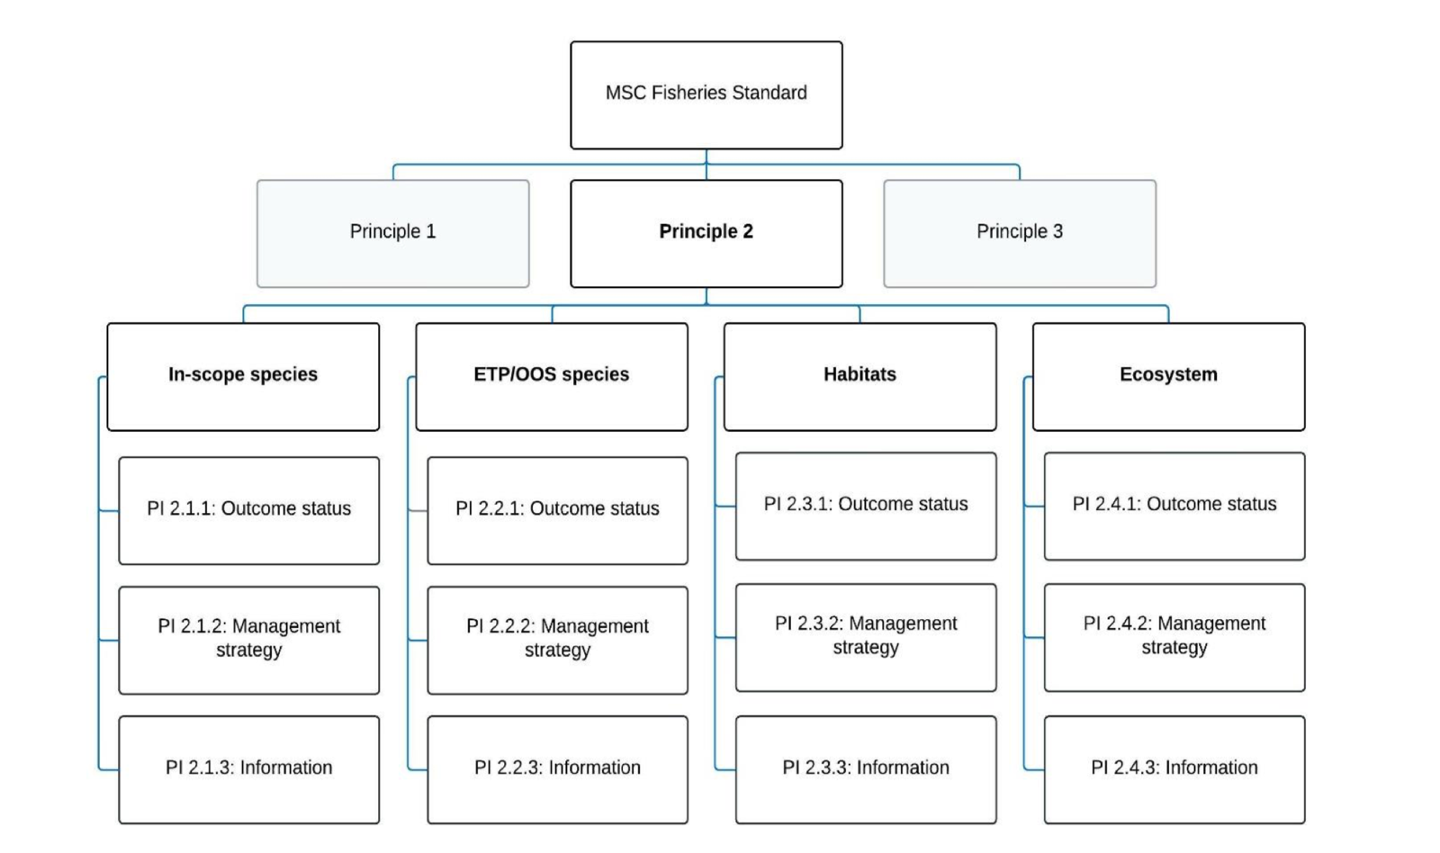
Figure 14. Decision tree for Principle 2 (MSC Fisheries Standard v3.)

4.2.2 Designating species

The MSC Standard v 3.0 outlines how to designate Principle 2 species. The Decision Tree (Figure 15) was used for each species listed in the QFish database (2016–2023) noting that Tiger prawns and Endeavour Prawns were assessed at Principle 1. As discarding is considered to be significant in the ECOTF (Campbell et al. 2017), and logbooks do not quantify all discard species, this assessment also used published research data and ecological risk assessments (ERAs) to identify and quantify discard species for the northern trawl region.
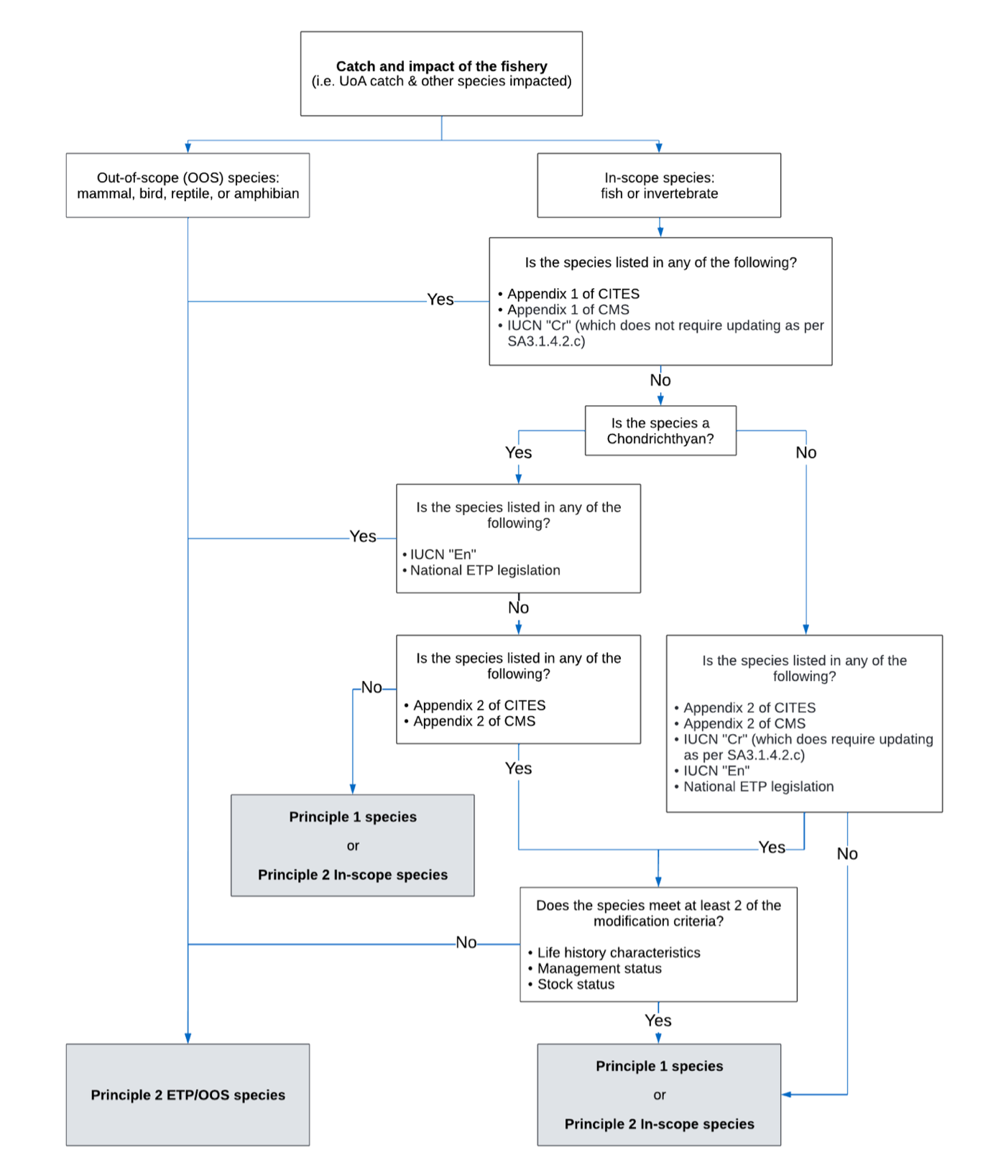
Figure 15. Decision tree for species categorisation from SA3 within the MSC Fisheries Standard v 3.0
The ECOTF is a large and complex fishery, encompassing multiple sub-sectors, across multiple bioregions and using slightly different gears and configurations of turtle exclusion devices (TEDs) and bycatch reduction devices (BRDs) in each sub-sector. As a result, the composition of other species taken in the fishery varies both spatially and temporally. Studies have shown that the fishery interacts with a large number of species, most of which occur very infrequently in trawls (e.g. Poiner et al., 1999; Courtney et al., 2007) and do not comprise a significant proportion of the total catch.

Permitted species and Species listed in logbooks
Table 9 outlines the target and byproduct species of each sector of the ECOTF. The northern sub-fishery primarily targets Brown and grooved tiger prawns (Penaeus esculentus and Penaeus semisulcatus) as the Tier 1 species (P1 species).

- Secondary (Tier 2) species also include:
  - Endeavour Prawns (Metapenaeus endeavouri) (P1 species)
  - Moreton Bay Bugs (P2 species)
  - Banana prawns (P2 species)

- Byproduct (Tier 3) species include:
  - Balmain Bugs (Ibacus chacei, I. brucei & I. alticrenatus)
  - Blue-swimmer crab (Portunus armatus)
  - Cuttlefish (Metasepia spp, Sepia spp),
  - Mantis shrimp (Family Squillidae),
  - Octopus (Octopus spp),
  - Pipefish (Solegnathus dunckeri, Solegnathus hardwickii),
  - Red champagne lobster (Linuparus trigonus),
  - Slipper lobster (Scyllarides spp),
  - Threadfin bream (Family Nemipteridae) and
  - Three-spotted crabs (Portunus sanguinolentus).

Table 9. Target (Tier 1), secondary (Tier 2) and permitted species as outlined in the regional East Coast Otter Trawl Fishery (ECOTF) harvest strategies 2 All five regional harvest strategies can be accessed at: https://www.daf.qld.gov.au/business-priorities/fisheries/sustainable/harvest-strategy (Source: Dedini et al. 2023b).
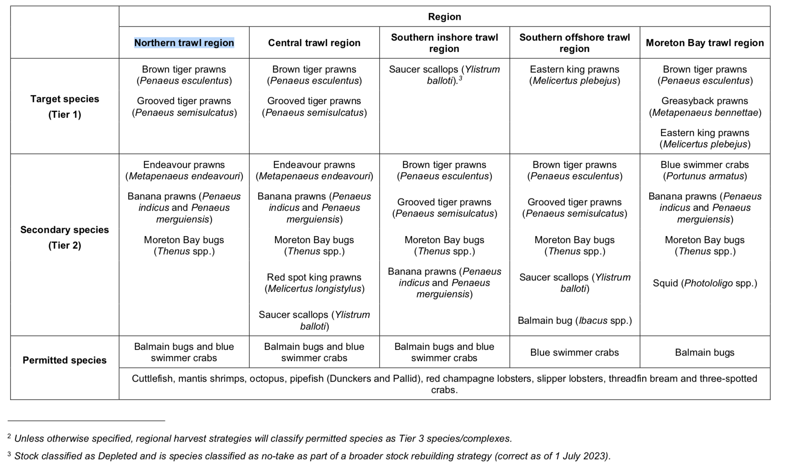

Ecological Risk Assessments
A common method for assessing data-poor species is via ecological risk assessments (ERAs). ERAs use a matrix of fishery impacts (catch, effort, discard rate, etc.) and resilience attributes (growth rate, discard survival, exclusion by TEDs, etc.) to determine the ecological risk posed species by the UoA.

In 2018, an ERA was published for the southern portion of the ECOTF (Jacobsen et al., 2018) and this is not relevant to these UoAs. The earlier ERA (Pears et al. 2012), did not used a zone equivalent to the UoA, instead the “tiger and endeavour prawn” zone was assessed and this region stretched from Mackay Queensland to the Torres Strait (i.e., it includes the Northern, Central and some of the southern inshore zone Figure 1).

A recent ERA for the ECOTF (Dedini et al. 2023) was completed using a Productivity & Susceptibility Analysis (PSA) for species of conservation concern and included an assessment by region. As the PSA can over-estimate risk for some species (Zhou et al., 2016), the 2023 ERA also included a Residual Risk Analysis (RRA). The ERA prioritised assessments for non-target species. This ERA used the new zones of the ECOTF.

The entire ECOTF list was rationalised to 62 species consisting of six marine turtles, 13 sea snakes, nine syngnathids, 12 sharks and 22 batoids (Dedini et al. 2023). When the outputs of the PSA and RRA were taken into consideration, 12 species were categorised as being at high risk from fishing activities in the ECOTF. Of notable importance, nine of the 12 high-risk ratings were classified as ‘precautionary’ as they are more representative of the potential risk. As the ECOTF SOCC ERA is based at a whole-of-fishery level, ratings assigned to some species may not accurately account for variations at a management region level; it was advised that regional risk variations will be explored more in an additional risk assessment involving the ECOTF. The Trawl Fisheries Working Group met regularly and the minutes are publicly available. In November 2023, the communique stated that: “Fisheries Queensland provided an update on the Environmental Risk Assessment (ERA) for the East Coast Otter Trawl Fishery (ECOTF). Development of regional risk assessments are currently in the planning stages. Public consultation on the draft risk assessments for individual trawl regions is tentatively planned for early 2024 and the final version published in mid-end 2024”.

Five species were listed as high risk/precautionary high risk in the latest ECOTF ERA for SOCC (Dedini et al. 2023) and have the potential to interact with the northern trawl operations including:
- Australian Butterfly ray (Gymnura australis) – Precautionary high risk
- Green sawfish (Pristis zijsron) – High risk
- Eastern angel shark (Squatina albipunctata) – Precautionary high risk
- Black-spotted whipray (Maculabatis astra) – Precautionary high risk
- Brown whipray (Maculabatis toshi) – Precautionary high risk

Wildlife Trade Operation Approval Application (EPBC Act)
In 2021, the ECOTF applied for WTO approval for export and was assessed under Part 13 of the EPBC Act. Eleven conditions were imposed on the fishery.

Bycatch/discard research
Research trawl data has been used to describe and quantify the bycatch in the ECOTF (Courtney, et al., 2007; 2008) in order to test the effectiveness of square mesh codend BRD (i.e., any reduction in bycatch rates in the fishery). There is no data specific to the north zone only. Courtney et al. (2007) and (2008) found that bycatch consisted of 224 taxa, including gurnards, flatheads, sandpaper fish, hermit and charybdid crabs, mantis shrimps, sea urchins, dragonets, snipefish, carids and lizardfish. Seven of these taxa comprised approximately 50% of the bycatch of which the following made up more than 5% of discards, by weight:
- Three-spined cardinalfish (Apogonops anomalus, 14.0%)
- Orange-freckled flathead (Ratabulus diversidens, 10.7%),
- Gurnard (Lepidotrigla argus, 8.7%),
- Orangemouth lizardfish (Saurida filamentosa, 5.9%),

Forty-five taxa accounted for 90% of the bycatch by weight however, 71% of taxa (159 species) were present in fewer than 10% of bycatch samples. Total bycatch rate in the fishery was significantly reduced (29%) using a combination of TED and 47.6 mm square mesh codend BRD. Catches of a number of species were reduced by > 80% (e.g., Graham’s conger, dumpling squid and stargaze cuttlefish). There was no significant reduction in the capture of elasmobranchs, which may in part be due to their low occurrence. In addition, codend type had little effect on bycatch assemblages, with assemblages more influenced by latitude and depth.

Wang, et al., (2020) estimated the weight of annual discards (i.e., bycatch) in the ECOTF by sector. The identification of bycatch species was not the subject of that study, although discards of <5000 t per year are reported in the central/northern (Tiger/Endeavour prawn) sub-fishery in 2014 (Figure 16). Between 2007 and 2014, discards were about 5000 t per year. There is substantial evidence that BRDs significantly reduced discard rates, but their effect was inconsistent across sectors/regions (Courtney et al. 2007).

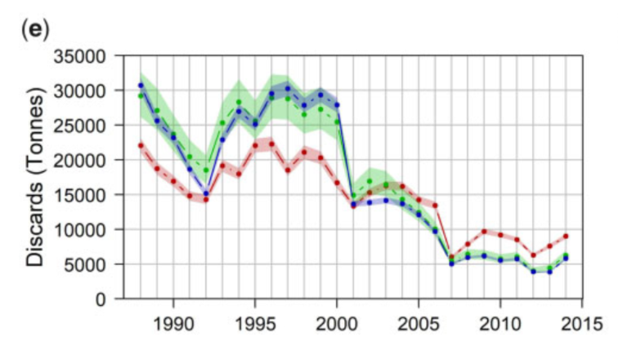
Figure 16. Annual discards in the ECOTF for operations targeting Tiger and Endeavour Prawns. Posterior means and 95% credible intervals from each of the three methods from January 1988 to December 2014. Means for various methods: the retained catch, effort, and swept area methods are red, green, and blue lines, respectively. (Wang et al. 2020)

Understanding post trawl survivability of discards is in its infancy, although Campbell et al. (2017) provided some estimates for the Common Stingaree and the Eastern Shovelnose Ray from prawn trawls to the south. The mean PTS for female and male Common Stingarees was 33.5% and 17.3%, respectively, and 86.8% for Eastern Shovelnose Rays (both sexes combined).

Species designation

The annual retained catch is well understood (Table 7); the fishery has no trade in shark or shark-fins and as such, no shark is considered a main species (MSC SA 3.5.2.1c; Figure 17).

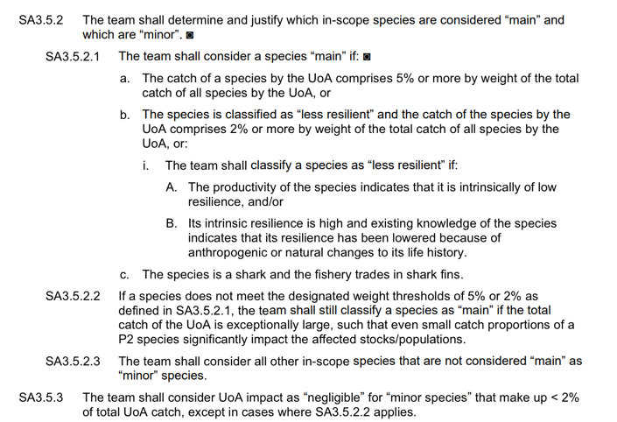
- Figure 17. Default assessment tree guidance for definition of main and minor in-scope species

In 2022, the total retained catch for northern zone was 980.5 tonnes although the total catch (including discards) is unknown. Wang et al. (2020) quantified discards by sector (i.e., target species) using data to 2015 (i.e., prior to the introduction of the HS); clear changes in discard quantities were evident following the introduction of BRDs and TEDs. However, Wang et al. found that: “Partitioning the fishery into sectors increased the amount of variation in discard rates”. Given that the sectors used in their analysis differ to the management areas now used in the ECOTF, and that multiple species are taken in the area that covers the central trawl region, it is difficult to determine the level of discarding in the Northern region with accuracy from Wang et al (2020). However, the Northern HS lists Tiger Prawn as the Tier 1 species, and by using discard data from the Tiger prawn fishery (Wang et al. 2020) it is estimated that between 5,000 and 9,000 t was discarded in 2014 and the ratio of discard (kg) to retained (kg) was 4.5:1.0

Discard and interaction (SOCC) catch data is presented above from ERAs and research papers. No other retained species made up more than 5% of the total retained catch (Tables 9 and 10).

Table 10. Reported annual retained catch (t) from the northern region of the ECOTF by year (Source: QDAF FDR- 663) ETP species in italics with asterisks and species that make up ≥5% of retained catch in bold and highlighted. (Yellow = P1 species, Orange = P2 main species Blue = P2 minor species)
Species | Retained catch (t) by year
Species | 2020 | 2021 | 2022
Bug - honey |  | 0 | 0.272
Bugs - Balmain | 1.021 | 0.231 | 0
Bugs - Moreton bay | 4.0783 | 5.4719 | 0
Bugs - mud |  | 1.2105 | 5.2365
Bugs - sand |  | 0.448 | 8.157
Butterflybream - unspecified | 1.177 | 1.831 | 4.592
Crab - blue swimmer | 0.1518 | 0.23019 | 0.6011
Cuttlefish | 1.098 | 2.318 | 3.8245
Mantis shrimp - unspecified | 0 | 0.057 | 0
Octopus - unspecified | 0.561 | 0.8704 | 0.55665
Prawn - banana | 4.145 | 12.63446 | 2.15923
Prawn - blue leg king | 13.12 | 8.468 | 1.814
Prawn - eastern king | 2.227 | 6.673 | 16.323
Prawn - endeavour | 252.264 | 322.6195 | 201.599
Prawn - leader | 0.3803 | 1.383 | 1.36057
Prawn - red spot king | 1.996 | 10.747 | 15.255
Prawn - tiger | 468.1215 | 606.153 | 585.3645
Prawn - unspecified |  | 5.101 | 24.7927
Scallop - mud | 9.679829 | 2.672 | 2.1613
Squid - unspecified | 0.684 | 2.1635 | 1.456
Total | 991.28245 | 875.52505 | 760.704729

Table 11. Retained and discard species categorisation into components for this assessment. Discard species specific to the Northern region are unknown, and as such, discard species that were identified as high or precautionary high risk in the 2012 (Pears et al. 2012) and/or 2023 (Dedini et al. 2023). ERAs or those ETP species listed in ETP logbooks are listed here. Saucer Scallop are discarded with mandatory reporting in logbooks. (Yellow = P1; Orange = P2 Main; Blue = P2 minor; Green = ETP species)
Retained species | Species | Component
Retained species | Tiger prawns (Penaeus esculentus and P. semisulcatus) | UoA P1
Retained species | Moreton Bay Bugs (Thenus australiensis & T. parindicus) | In-scope minor
Retained species | Red-spot King prawns | In-scope minor
Retained species | Banana Prawns | In-scope minor
Retained species | Endeavour Prawns | UoA P1
Retained species | Blue-legged (western) King Prawns | In-scope minor
Retained species | Balmain Bugs (Ibacus chacei, I. brucei & I. alticrenatus) | In-scope minor
Retained species | Blue-swimmer crab (Portunus armatus) | In-scope minor
Retained species | Cuttlefish (Metasepia spp, Sepia spp) | In-scope minor
Retained species | Slipper lobster (Scyllarides spp) | In-scope minor
Retained species | Mantis shrimp (Family Squillidae) | In-scope minor
Retained species | Octopus (Octopus spp) | In-scope minor
Retained species | Red champagne lobster (Linuparus trigonus) | In-scope minor
Retained species | Slipper lobster (Scyllarides spp) | In-scope minor
Retained species | Threadfin bream (Family Nemipteridae) | In-scope minor
Retained species | Three-spotted crabs (Portunus sanguinolentus). | In-scope minor
Retained species | Pipefish (Solegnathus hardwickii, S. dunckeri,) | ETP
Discarded species | Eastern Angel shark (Squatina albipunctata) | In-scope main
Discarded species | Blackspotted Whipray (Himantura astra) | In-scope main
Discarded species | Brown Whipray (M. toshi) | In-scope main
Discarded species | Australian Butterfly ray (Gymnura australis) | In-scope main
Discarded species | Green Sawfish (Pristis zijsron) | ETP
Discarded species | Sea snakes (12 species) | ETP

4.2.3 In-scope species

There are no other retained species taken than make up ≥5% of the total catch. However, there is no discard data specific to the northern trawl. Estimating risk to the main discard species is therefore based on the ERA (Pears et al. 2012; Dedini et al. 2023) as the other ERA (Jacobsen et al. 2018) is specific to the southern zone of the ECOTF. Pears et al. (2012) was conducted prior new management measures and zonation. The 2012 ERA identified the following discard species as high risk in the northern part of the ECOTF, although there is no recent information to ascertain if any of these species make up ≥5% of the total catch in the northern zone:
- Yellowspot Goatfish Parupeneus indicus
- Grey-spotted Catshark Asymbolus analis
- Orange-spotted Catshark Asymbolus rubiginosus
- Sawtail Catshark Figaro boardmani
- Sydney Shark Dipturus australis
- Endeavour skate D. endeavouri
- Blacktip skate D. melanospilus
- Argus skate D. polyommata
- Australian Butterfly Ray Gymnura australis
- Eastern Shovelnose Ray Aptychotrema rostrate
- Blackspotted Whipray Himantura astra
- Blue-spotted Maskray Neotrygon kuhii
- Speckled Maskray N. picta
- Common Stingaree Trygonoptera testacea
- Sandyback Stingaree Urolophus bucculentus
- Kapala Stingaree U. kapalensis

The elasmobranchs were assessed again in the newest ERA (Dedini et al. 2023) that only examined the SOCC (i.e., ETP species and elasmobranchs) and Green sawfish P. zijsron was listed as ‘high risk’ in the northern region; it is therefore reviewed further under ETP below. A further four elasmobranchs were ranked as ‘precautionary high risk’ in the northern zone and as they are not ETP species, they will be reviewed below as in-scope main species .

From the above, other species that were identified as potential in-scope main (Table 11) using research data and ERA outcomes. Stock status reference points are still unavailable for these species; any further assessment would require the RBF process to score in-scope main species that are discarded.

Minor in-scope species

Many other species are regularly discarded by the northern sub-fishery, although studies have shown that the fishery interacts with a large number of species, most of which occur very infrequently in trawls (e.g. Poiner et al., 1999; Courtney et al., 2007) and do not comprise a significant proportion of the total catch. Given that this is a pre-assessment report and minor in-scope species are only assessed to reach SG 100 no further attention is given to this group of species.

Management of In-scope species

In March 2022, the harvest strategy for the northern region was approved and implemented (QDAF, 2021e). It was developed in accordance with the Queensland harvest strategy policy to manage the harvest of trawl fishery resources within the northern trawl region.

The HS includes decision rules for:
- Tier 1 (Tiger prawns);
- Secondary (Tier 2) species (Endeavour Prawns, Banana Prawns; Moreton Bay Bugs).
- Byproduct (Tier 3) species (Balmain bugs; blue swimmer crabs; cuttlefish; mantis shrimps; octopus ; pipefish; red champagne lobsters; slipper lobsters; threadfin bream; three-spotted crabs).

Decision rules for the Tier 3 species are presented at Figure 18.

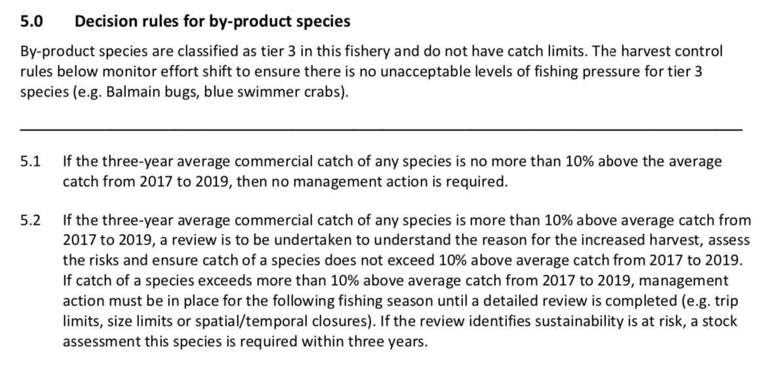

Figure 18. By-product species: Harvest strategy decision rules by-product species including from Northern Trawl Region of the ECOTF (QDAF, 2021d).

Management of Discards

There are three basic approaches to minimising discards.
- The first approach is to avoid bycatch in the first instance. This is done through voluntary or compulsory closed seasons or closed waters to avoid catching fish or other species that will be discarded. This often includes closing water to fishing where there is a high likelihood of interactions.

- The second approach uses selective or alternative fishing equipment to reduce bycatch, by either preventing certain species from entering nets, or providing escape mechanisms for unwanted catch. In 2000, the Queensland government implemented significant management changes via the Fisheries (East Coast Trawl) Management Plan 1999, which reduced nominal effort in the fishery by about 50%. TEDs and BRDs were also introduced as part of the Trawl Plan. By 2002, all vessels operating in the ECOTF were required to have both a TED and at least one of seven prescribed BRDs installed in their nets.

TEDs and BRDs resulted in significant decreases in the number of discards produced in the ECOTF. Further information on BRDs is presented above at Section 3.1.3.

- A third approach aims to create a value for bycatch that would otherwise be discarded, providing market incentives to retain more catch and discard less. Whilst this has been investigated in other Australian trawl fisheries, it has not been investigated for the ECOTF.

4.2.4 ETP/OOS species

Endangered, Threatened and/or Protected species (ETPs)
The MSC Standard v 3.0 outlines how to designate Principle 2 species, including determination of an ETP species (SA 3.1.4); noting that this has changed since the earlier MSC version to now include CITES/CMS Appendix II species.
Information on any listing with CITES or CMS is available at: https://www.speciesplus.net and the Australian database for listed species is at: https://www.environment.gov.au/cgi-bin/sprat/public/sprat.pl.
The Australian database also includes the IUCN RedList ranking as required in the decision tree at Figure 15.
Commercial fishers operating in ECOTF are required to report all interactions with protected species using Queensland Fisheries approved logbooks (Figure 4) quarterly reports are prepared from this logbook data although there is no differentiation of the data for specific region or net type configuration (prawn/scallop). Accurate information must be available to monitor and manage the impacts of the UoA on protected species.
ECOTF logbook data reveal few interactions with species of conversation interest (SOCI). Interactions are defined as any physical contact with a protected species, including interactions with fishing gear and vessel collisions. Interaction data is made publicly available on the portal.
There is no break down by region, but the reported interactions from Q4 2022 to Q3 2023 for the east coast trawl (ECOTF) include:
- Sea snakes (1321 caught of which 133 dead/injured)
- Narrow sawfish (10 caught of which 3 dead/injured)
- Green turtle (4 caught, nil dead/injured)
- Loggerhead turtle (3 caught, nil dead/injured)
- Pipefish/seahorses (110 caught, nil dead/injured – presumably spp other than retained spp but uncertainty remains)
- Estuary stingray (1 caught, nil dead).
Not all SOCC reported in logbooks are ETPs (i.e., protected under national legislation and/or binding international agreements), particularly many sharks and rays. Additional information from the FRDC reports (Simpfendorfer et al. 2019) and International Plan of Action (Kyne et al. 2021) were included on stock status and risk assessment of sharks and rays. Pears et al., (2012) assessed the potential risk the ECOTF posed to Species of Conservation Concern (SOCC) including 6 species of turtles, 16 species of sea snakes, 6 species of seahorses and pipefish and 33 species of sharks and rays. Dedini et al. (2023) identified 19 shark/ray species that have the potential to interact with the northern fishery. Of these the following were ranked as high risk (HR) or precautionary high risk (PHR):
- Green sawfish P. zijsron - HR
- Eastern Angel shark Squatina albipunctata - PHR
- Australian Butterfly ray Gymnura australis - PHR
- Blackspotted Whipray Himantura astra - PHR
- Brown Whipray M. toshi - PHR

A data request for ETP species interactions with a break-down between regions illustrated that the only ETP species reported for the northern sub-fishery are sea snakes (undefined species) and one green turtle.

CITES
The Convention on International Trade in Endangered Species of Wild Fauna and Flora (CITES) is an international agreement between governments that aims to ensure that the international trade in wildlife does not threaten wild populations of plants and animals. The 19th meeting of the Conference of the Parties to the CITES (CITES CoP19) was held from 14 to 25 November 2022 in Panama City, Panama. Amendments to the CITES Appendices, including new listings, enter into force for all parties 90 days after the meeting (i.e., 23 February 2023), unless a delayed implementation date is agreed. Australia implements CITES through its national environment law, the Environment Protection and Biodiversity Act 1999 (EPBC Act). The List of CITES Species included in the EPBC Act was to be amended by 23 February 2023 to ensure that any Australian imports and exports of the species newly listed under CITES may continue. Proposals to include hammerhead sharks (Sphyrnidae spp) and guitarfish (Rhinobatidae spp) in Appendix II to CITES were adopted and these listings became effective from 23 February 2023. Proposals to include requiem sharks (Carcharhinidae spp) in Appendix II were also adopted with “delayed listings”. The requiem shark listing will come into effect after a 12-month implementation delay on 25 November 2023.

CMS
The Convention on Migratory Species (CMS), also known as the Bonn Convention, is an environmental treaty of the United Nations that provides a global platform for the conservation and sustainable use of terrestrial, aquatic and avian migratory animals and their habitats.
Countries whose representatives have signed up to the CMS are known as ‘Parties to the CMS’. Australia became a Party of the CMS in 1991. All Parties to the CMS acknowledge the importance of acting to conserve migratory species. CMS has two Appendices. These Appendices list migratory species to which the Convention applies. The text of the Convention defines the basic obligations of the Contracting Parties towards species listed on Appendix I and Appendix II. These obligations are quite distinct for the two Appendices, and a migratory species can be listed in both Appendices at the same time, if the circumstances so warrant. Appendix I comprises migratory species that have been assessed as being in danger of extinction throughout all or a significant portion of their range. Appendix II covers migratory species that have an unfavourable conservation status and that require international agreements for their conservation and management. Appendices I and II may be amended at any meeting of the Conference of the Parties. An amendment to the Appendices shall enter into force for all Parties ninety days after the meeting of the Conference of the Parties. Those CMS listed species relevant to Australia are available at http://www.environment.gov.au/cgi-bin/sprat/public/publicshowmigratory.pl Species listed on CMS Appendices I and II are protected under the Environment Protection and Biodiversity Conservation Act 1999 (EPBC Act). Through listing the species as migratory under the EPBC Act, it becomes an offence to kill, injure, take, trade, keep or move the species in Commonwealth waters. In 2023, Australia produced a National report for migratory sharks and rays although there is no information on guitarfish/wedgefishes; these species shall be treated as ETP in this pre-assessment.

Sawfishes

Sawfish interactions by region as reported in ECOTF logbooks (2012–2022) are presented in Table 12 together with more recent data that has not been separated by region.

Table 12. Annual sawfish interactions with the ECOTF as reported in ETP logbooks (Figure 4) and recent interaction data made publicly available .
ECOTF – north (UoA) | Green Sawfish |  |  | Narrow Sawfish |  |  | Largetooth Sawfish
ECOTF – north (UoA) | Alive | Injured | Dead | Alive | Injured | Dead | Alive | Injured | Dead
2012 | 0 | 0 | 0 | 1 | 0 | 0 | 0 | 0 | 0
2013 | 0 | 0 | 0 | 1 | 0 | 1 | 0 | 0 | 0
2014 | 0 | 0 | 0 | 3 | 2 | 0 | 0 | 0 | 0
2015 | 0 | 0 | 0 | 2 | 1 | 1 | 0 | 0 | 0
2016 | 1 | 1 | 0 | 4 | 2 | 0 | 0 | 0 | 0
2017 | 2 | 0 | 0 | 0 | 0 | 1 | 0 | 1 | 0
2018 | 1 | 0 | 0 | 13 | 3 | 0 | 0 | 0 | 0
2019 | 0 | 0 | 0 | 0 | 0 | 0 | 0 | 0 | 0
2020 | 0 | 0 | 0 | 0 | 0 | 0 | 0 | 0 | 0
2021 | 0 | 0 | 0 | 0 | 0 | 0 | 0 | 0 | 0
2022 | 0 | 0 | 0 | 0 | 0 | 0 | 0 | 0 | 0
North - TOTAL | 4 | 1 | 0 | 24 | 8 | 3 | 0 | 1 | 0
ECOTF - Northern | Green Sawfish |  |  | Narrow Sawfish |  |  | Largetooth Sawfish
ECOTF - Northern | Alive | Injured | Dead | Alive | Injured | Dead | Alive | Injured | Dead
2012 | 0 | 0 | 0 | 0 | 0 | 0 | 0 | 0 | 0
2013 | 0 | 0 | 0 | 0 | 0 | 0 | 0 | 0 | 0
2014 | 0 | 0 | 0 | 0 | 0 | 0 | 0 | 0 | 0
2015 | 0 | 0 | 0 | 0 | 0 | 0 | 0 | 0 | 0
2016 | 0 | 0 | 0 | 0 | 0 | 0 | 0 | 0 | 0
2017 | 3 | 0 | 0 | 1 | 0 | 0 | 0 | 0 | 0
2018 | 4 | 0 | 0 | 1 | 0 | 1 | 0 | 0 | 0
2019 | 0 | 0 | 0 | 0 | 0 | 0 | 0 | 0 | 0
2020 | 0 | 0 | 0 | 0 | 0 | 0 | 0 | 0 | 0
2021 | 0 | 0 | 0 | 0 | 0 | 0 | 0 | 0 | 0
2022 | 0 | 0 | 0 | 0 | 0 | 0 | 0 | 0 | 0
Central - TOTAL | 7 | 0 | 0 | 2 | 0 | 1 | 0 | 0 | 0
 | Green Sawfish |  |  | Narrow Sawfish |  |  | Largetooth Sawfish
ECOTF – all | Alive | Injured | Dead | Alive | Injured | Dead | Alive | Injured | Dead
2023 |  |  |  | 7 |  | 3
2024 (Jan- March) |  |  |  |  | 1
ECOTF TOTAL | 12 |  |  | 49 |  |  | 1

Green sawfish (Pristis zijsron)
Green Sawfish are Critically Endangered by the IUCN RedList. Further information on sawfish research projects is available at https://www.sharksandraysaustralia.com/research/. Green sawfish were once widely distributed in the Indian Ocean and off Indonesia and Australia although population declines due to overfishing have caused restrictions, e.g., once found south to Sydney, its east coast range has contracted to north Queensland (Kyne et al. 2021).
Green sawfish are very large, slender sawfish with a shark-like body. The maximum length recorded in Australian waters is 730 cm (Last & Stevens, 2009). Green sawfish occur in inshore coastal environments including estuaries, river mouths, embayments and along sandy and muddy beaches, as well as offshore marine habitat (Stevens et al., 2005; Thorburn et al., 2003). They inhabit both very shallow water (<1m) and offshore waters (>70 m) where commercial trawls operate (Stevens et al., 2005). Green sawfish do not utilise freshwater environments. The population structure of Green sawfish has been assessed (Phillips et al., 2011; Phillips, 2012). Green sawfish are genetically structured in northern Australian waters with at least the assemblages from the west coast, the Gulf of Carpentaria and the east coast being genetically distinct, although precise population boundaries are unclear (Phillips et al., 2011; Phillips, 2012). The Recovery Plan (2015) outlines the known stock structure of Green Sawfish in Australian waters, including identification of pupping locations (Figure 19).

Peverell (2009) examined the age (vertebral bands) of 18 green sawfish from northern Australia. Average size at birth was 76 cm, and the average growth in the first year was 52 cm, and 33 cm in the second year. Longevity was estimated to be 53 years (based on a maximum size of 540 cm, the locally recorded maximum size). Based on the observations of a single post partum female, size and age at maturity was estimated at 380 cm and nine years. The size at maturity of males is unknown. There is a need to update this Recovery Plan with new data and potentially include Narrow Sawfish given its depleted status and the “under threatened listing assessment” being due in 30 October 2024.
The ERA for the NT ONLF (DITT, 2020) lists Green sawfish as medium risk.
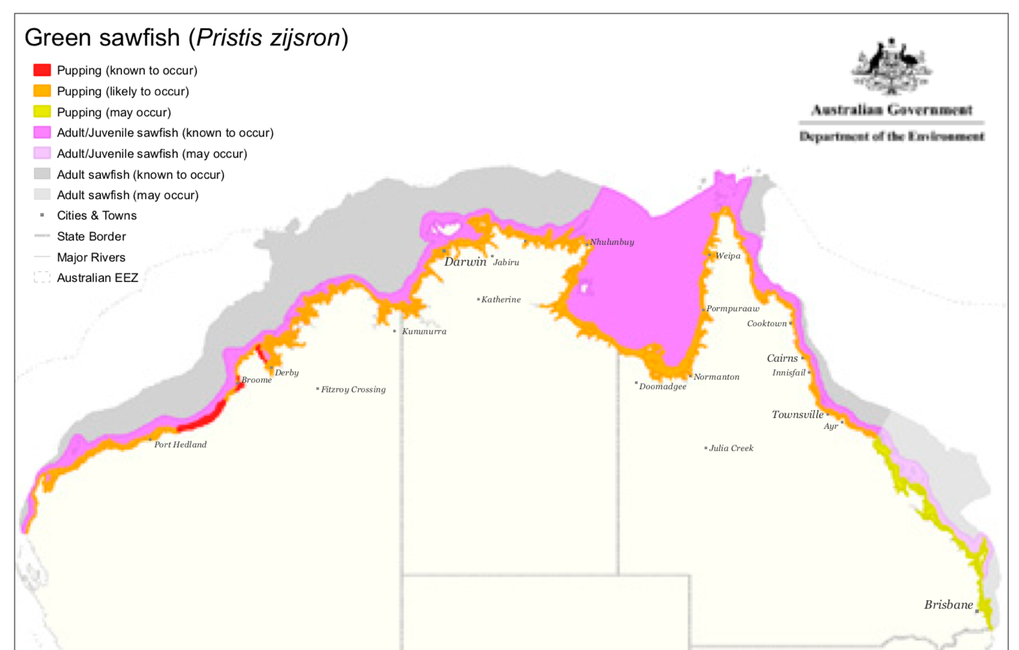

Figure 19. Australian distribution of Green Sawfish (Source: DoE, 2015)

The ERA (Dedini et al. 2023) listed this species as high risk for the ECOTF as a whole. Range descriptions for the Green Sawfish (Pristis zijsron) are based on historical observations and suggest the species is found across a large expanse of the ECOTF. However, this information is considered (Dedini et al. 2023) to be outdated and it is hypothesised that the east coast P. zijsron distribution has contracted to north Queensland (Kyne et al., 2021). Interactions with the ECOTF are more likely to occur in areas north of the Whitsundays (Harry et al., 2011), which is within the operational area of the central sub-fishery. However, between 2012 and 2022, five interactions from the northern region were reported, of which four were released alive and one was released injured (Table 12). The last reported Green sawfish interaction for the ECOTF was in 2018 (four in the Central and 1 in the North).
A recovery plan is available for Green Sawfish (combined with other Pristis sawfish and river sharks). There is little information on current population sizes or long-term rates of population change. The recovery plan does not include the Narrow Sawfish as it is not listed by the EPBC Act. The SPRAT profile for each species provides a comprehensive overview of the legal status, population status etc.
Under the CMS, all sawfish species are protected and Australia is a signatory country to the Memorandum of Understanding (MoU) Sharks. Under this agreement, recommended actions relevant to fisheries include:
- Enforce compliance with fisheries management regulations, landing and trade bans;
- Improve capacity in species identification through trainings and the dissemination of available ID guides;
- Identify effective approaches to reduce bycatch and improve survivorship of sawfishes such as:
  - gear modifications and fishing practices e.g., shot times and safe release handling guidelines
  - options for spatial management
  - post-release survivorship of sawfishes to inform improved handling and release protocols.
- Enhance or develop collection of fishery data (including landings, discards, size frequency, catch and effort).
The North UoA met this agreement as follows:
- Fisheries regulations are strongly enforced by Queensland. Vessel Monitoring Systems (VMS) are used on all Queensland commercial fishing vessels to track their location, validate reported fishing activity, and enhance QDAF’s capacity to undertake vessel inspections.
- Sawfish are easily identified by their unique ‘saw’ or rostrum. The following guides are available to allow for correct species identification:
- Looking after protected species in Queensland – a guide to commercial fishers;
- Australia’s sawfish ID guide (SARA)

Narrow Sawfish (A. cuspidata)
The Narrow Sawfish has a wide northern Australian distribution (Peverell 2005). New research based on sawfish tissue samples from the Northern Prawn Fishery of northern Australia found fine-scale population structuring due to the limited movement of females (Feutry et al. 2021).
Outside of Australian waters, it once had a wide tropical Indo-West Pacific distribution (Figure 20). This species is the most biologically productive of the sawfishes. While the Pristis sawfishes are long lived, reaching between 30 and >50 years of age, the narrow sawfish (A. cuspidata) lives for only 9 years. Age at maturity is 3 years and litter sizes range of 5–16 pups. The generation length for narrow sawfish is much shorter, (4.6 years) compared to 14.6 and 17.2 years in the Pristis sawfishes. Consequently, the intrinsic rate of population increase is relatively high for narrow sawfish (0.27 yr-1), compared with the other species, which range from 0.02 yr-1 in the green sawfish to 0.12 yr-1 in the Large-tooth sawfish (Dulvy et al., 2016).
Further taxonomic, life history and ecological data is available at:
- https://shark-references.com/species/view/Anoxypristis-cuspidata
- https://www.dcceew.gov.au/sites/default/files/documents/sawfish-river-sharks-multispecies-issues-paper.pdf
- 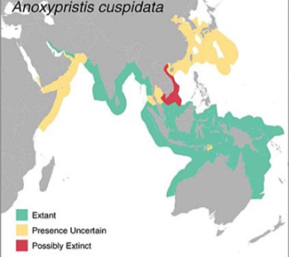

Figure 20. Narrow Sawfish Extent of Occurrence range maps (Source: Dulvy et al, 2016)
Anoxypristis cuspidata is the most common sawfish in the bycatch of commercial fisheries across northern Australia (Feutry et al. 2021). Narrow sawfish is the most regularly caught sawfish in the MSC certified Northern Prawn Fishery (NPF where it made up about 92% of the catch composition for the sawfish group in the NPF between 2002 and 2019. However, recent estimates increasing two-fold from 2019 to 2020 in the NPF Tiger prawn sub-fishery. Whilst, past estimates of fishing mortality rates for the species in the NPF are reportedly “below a rate that would lead to significant population declines”, when considering the recent NPF increases and other fishing mortality (ECOTF, Gulf of Carpentaria Inshore FinFish fishery), it is likely to be in excess of sustainable levels (Kyne et al. 2021).
The significant population reduction in the Narrow Sawfish largely occurred prior to the last three generations (pre-2000s), noting that protection and management measures have reduced mortality over the last 1–2 decades. Over the last three generations (18 years), it is suspected that the population has undergone a reduction of >30% and the Narrow Sawfish is assessed as Vulnerable. Although threatened here, Australia represents the most significant remaining global location for this species.
DoE (2015) produced a multi-species issue paper for sawfish and river sharks. Kyne et al. (2021) lists Narrow Sawfish population as ‘depleted’ and the IUCN RedList listed the species as ‘Critically Endangered’ in 2023. The ECOTF ERA (Dedini et al. 2023) lists this species as Medium Risk. Recorded interactions in the ECOTF come from the northern (UoA) and central region only. Between 2012 and 2022, 35 Narrow Sawfish interactions were reported for the north (and three for the central region); a further 11 (3 deceased) reported in the ECOTF as a whole (North and/or Central) in 2023–Q1 2024. Of the 35 reported in the northern region, three were deceased and eight were injured – the remainder were released alive (Table 12). Interestingly, there have been no reported Narrow Sawfish interactions since 2018 in either region but interactions were again noted in 2023–24.
New research based on sawfish tissue samples from the Northern Prawn Fishery of northern Australia found fine-scale population structuring due to the limited movement of females (Feutry et al. 2021).

Marine turtles
Marine turtles are listed in Appendix I of CITES which prohibits international trade in specimens of these species. In Australia, it is illegal to kill, injure, take, trade, keep or move turtle species. Marine turtles are also listed in Appendix I of the CMS. CMS requirements for the signatory countries include prohibiting the taking of the species, with very restricted scope for exceptions; conserving and where appropriate restoring their habitats; preventing, removing or mitigating obstacles to their migration and controlling other factors that might endanger them. In Australia, marine turtles are EPBC listed as ‘vulnerable’ or ‘endangered’, marine and migratory. To meet the CMS and the EPBC requirements, an updated Recovery Plan for Marine Turtles in Australia 2017–2027 was developed (DEE, 2017).
The ERA (Dedini et al. 2023) listed marine turtles as medium or precautionary medium risk for the ECOTF as a whole. All six species are considered ‘north’ as a key risk region. The use of a Turtle Exclusion Device (TED) remains a pivotal component of the broader ECOTF management plan and has been an effective risk-mitigation strategy employed for marine turtles. Research from both Australia and elsewhere has shown that the combined use of a TED with a Bycatch Reduction Device (BRD) can reduce landing rates for marine turtles by 97–99% (e.g., Campbell et al., 2020). Publicly available interaction data reported that in 2021–22, four Marine Turtles interactions were reported with the entire ECOTF (three loggerhead (Caretta caretta) and one green turtle (Chelonia mydas)); ETP interaction data for 2014–2022 from the north region reported an interaction with one green turtle in 2021, and it was reported to be released alive.
The Action Plan requires that Australian fisheries management should be undertaken in accordance with the FAO Guidelines to Reduce Sea Turtle Mortality in Fishing Operations. The main requirements within the recovery plan relevant to domestic fisheries include:
- improving access and report of the most current bycatch information that will enhance the assessment of whether current fisheries interactions will impact on stock recovery.
- promotion and implementation of best practice and continued innovation of turtle bycatch mitigation.
The measures of success for the above actions include:
- domestic fisheries are compliant with fisheries legislation pertaining to bycatch;
- marine turtle species are accurately recorded in 90% of reported fishery interactions within Australia’s jurisdiction;
- marine turtle bycatch is reduced such that it does not impact stock recovery (DEE, 2017).

The ECOTF’s impact on marine turtles was reduced significantly with the introduction of TEDs and most turtles caught are released alive with mandatory reporting requirements. ECOTF Northern trawl footprint is a very small fraction of marine turtle species distribution.

Sea snakes
There are at least 15 species of sea snakes recorded in the ECOTF catch prior to and after the implementation of bycatch reduction devices (Courtney et al. 2010; Courtney et al. 2014; Jacobsen et al. 2018). The latest ERA (Dedini et al. 2023) listed six sea snakes as low (1) and medium (11) risk for the northern region.

In 2022, 257 Sea snake interactions were reported with the entire ECOTF of which 3 were dead and two were injured, the remainder were released alive. Logbook data provided by QDAF suggests that sea snake interaction in the northern region makes up a varying proportion of the total report interactions for the ECOTF each year (Table 13), although in 2020 more than half of all interactions came from this area. Note: the boundaries and names of the regions within the ECOTF have varied since 2019. In 2023, the total number of sea snake interactions for the entire ECOTF increased to a new peak of 1968 (509 dead/injured). Region specific data is not available for 2023.

Pears et al. (2012) stated that: “There is considerable overlap between the spatial distribution of some sea snake species and trawl fishing effort in the Great Barrier Reef Region. Most of the incidental trawl fishing mortality for sea snakes (Courtney et al. 2010), and therefore most of the risk, occurred in the central Queensland red-spot king prawn sector of the ECOTF.” The newer ERA (Dedini et al. 2023) noted that: “the absence of an effective mechanism to validate logbook data increases the risk of non-compliance e.g. the non-reporting of sea snake interactions and the submission of erroneous release-fate data.” When considering cumulative impacts of interactions with MSC certified fisheries, it is important to consider the Northern Prawn Fishery and its impacts on these species of sea snakes (Fry et al. 2021).

Table 13. Reported Sea snake interaction and life status recorded by logbooks in the north sub-fishery and entire ECOTF by year
YEAR | LIFE STATUS | Total  NUMBER OF INTERACTIONS in ECOTF | Northern region - NUMBER OF INTERACTIONS | % of total reported interactions in the UoA
2019 | Alive | 508 | 9 | 1.7%
 | Injured | 1 | - | 1.7%
 | Dead | 23 | - | 1.7%
2020 | Alive | 1317 | 185 | 13.5%
 | Injured | 43 | 2 | 13.5%
 | Dead | 50 | 4 | 13.5%
2021 | Alive | 413 | 224 | 54.2%
 | Injured | 5 | 1 | 54.2%
 | Dead | 8 | 6 | 54.2%
2022 | Alive | 252 | 40 | 16.7%
 | Injured | 2 | - | 16.7%
 | Dead | 3 | 3 | 16.7%

Pipefish
In late 2001, syngnathids (pipefish and seahorse etc.) were included in the list of marine species under Part 13 of the EPBC Act. As a result of this listing, it is an offence to kill, injure, take or trade syngnathids and solenostomids in, or from, a Commonwealth area. However, for those caught in the ECOTF, their fate (discard/retention) will depend on its status within the fishery. Solegnathus dunckeri and S. hardwickii make up a high percentage of the ECOTF syngnathid catch (Connolly et al., 2001; Dodt, 2005). Under Part 2 of the Fisheries Declaration 2019, the take of ‘pipefish’ (S. dunckeri and S. hardwickii) is restricted by a combined trip limit of 50 individuals and both species must be discarded once this limit is reached. The latest ERA (Dedini et al. 2023) did not list Duncker’s Pipehorse (S. dunckeri) as high or medium risk for the Northern region although five syngnathids were listed as medium risk.

Dodt (2005) reported that about 5,500–11,000 syngnathids are retained annually by the ECOTF and the average wet weight was < 60 grams. Whilst volumes may differ with the use of different BRD and TED combinations, in 2019–2022, the northern zone (UoA) did not retain any pipefish. It is unclear if operators are required to record discard numbers (or fates) for S. dunckeri and S. hardwickii in ETP logbooks. As post-trawl survivability of discarded pipefish is unknown, fishing-mortality rates for both species will also be higher than retained catches in logbook entries.

The remaining members of the Family Syngnathidae are all classified as no-take and are subject to mandatory reporting requirements through the TEPA logbook (Figure 4). Historical catch data for non-retainable syngnathids is limited, with less than 10 interactions reported through the logbook program over the last 10 years (Department of Agriculture and Fisheries, 2023).

Ghost nets

Ghost nets are defined as abandoned, lost or otherwise discarded fishing gear (ALDFG) in the marine environment and are a global problem. Fishing gear could be lost from vessels for a variety of reasons, including but not limited to stowed gear being washed overboard, gear being lost or abandoned during fishing operations and nets or net repairs being discarded whilst at sea (Richardson et al., 2018). Lost fishing gear (e.g. ground chains, trawl net) is likely to sink, with localised smothering effects on a small area of habitat where it lands, however trawl net will not generally continue ‘ghost’ fishing, and the level of lost or discarded fishing gear in the trawl industry is likely to be relatively low. Bio-inspecta (2023) noted that: “Gear loss in the fishery is low, with industry data reporting 3 boards, 3 skids and 4 nets lost between 2015-2019” although there is no further information if this is for that single UoA of the southern offshore EKP sub-fishery or for the entire ECOTF. Further information is needed regarding northern region gear loss at sea and recycling/disposal facilities available at ports.

Pollution of the marine environment by ships, including fishing vessels, is strictly controlled by the International Convention for the Prevention of Pollution from Ships (known as MARPOL). With regard to legislation, the Australian Maritime Safety Authority also have legislative responsibility for marine pollution and providing safe navigation. States and Territories, including Queensland have complementary frameworks. With regard to the “accidental loss or discharge of fishing gear”, fishing vessel operators are also required to record the discharge or loss of fishing gear in their garbage record book or ships log.

Habitats
The new MSC Standard classifieds habitats as 'More Sensitive' or 'Less Sensitive', based on the time it takes to recover from the impacts of fishing.
- More sensitive habitat: a habitat unable to recover to at least 80% of its unimpacted structure and function within 20 years if fishing were to cease entirely.
- Less sensitive habitat: a habitat able to recover to at least 80% of its unimpacted structure and function within 20 years if fishing were to cease entirely.
Detailed information is available on the habitat types of the GBRMP and the impacts of trawling on them (Pitcher et al., 2007; Jacobsen et al., 2018). The GBR Seabed Biodiversity project (AIMS, 2024) identified habitats contained within the GBR and defined their distribution and provided finer scale assessments of the species assemblages. There has been extensive research on the effect of trawling on reef bottom types in tropical north Queensland (Pitcher et al. 2000) and the likelihood of otter trawlers interacting with seagrass meadows within the Great Barrier Reef World Heritage Area (GBRWHA) has been reported as part of the Cooperative Research Centre (CRC) and Marine and Tropical Sciences Research Facility programs (Coles et al. 2007).
The 2012 ERA (Pear et al. 2012) provided an overview of the ecological sub-components. Nine habitat types were identified by the AIMS Seabed Biodiversity Project (Figure 21). These habitats were defined using a dataset of available biological and physical data plus video data characterising the seabed and biological structural types (e.g. seagrass, sponge garden). An additional habitat type was defined by this assessment. Habitat 10 covered an area of 14,056 square km located in the southern GBR Region between about 90 and 300 m depths and was outside of the area now referred to as Northern zone. Fishing location is known, and in 2022, 19 grid locations were fished in the northern sub-fishery of the ECOTF (Figure 1).
As an additional step in the ERA identification process, to ensure all potentially impacted habitats were considered, the assessment looked at additional areas in deeper waters of the Marine Park that are open to trawling but outside of the area covered by all 10 habitat types already identified for detailed assessment (i.e. at other areas where the otter trawl fishery is allowed to operate within the GBRMP not already covered by habitats 1 to 10). To do this, 2005 and 2009 otter trawl fishing effort for the region was overlaid on the habitats assessed (Figure 21). As the level of trawl effort was low, habitat type(s) in the area are likely to be at low or negligible risk from trawling, and were therefore not included in that detailed assessment. Other deepwater areas are likely to be occasionally fished, but at current very low effort levels in these habitats they are also likely to be at low or negligible risk from trawling.
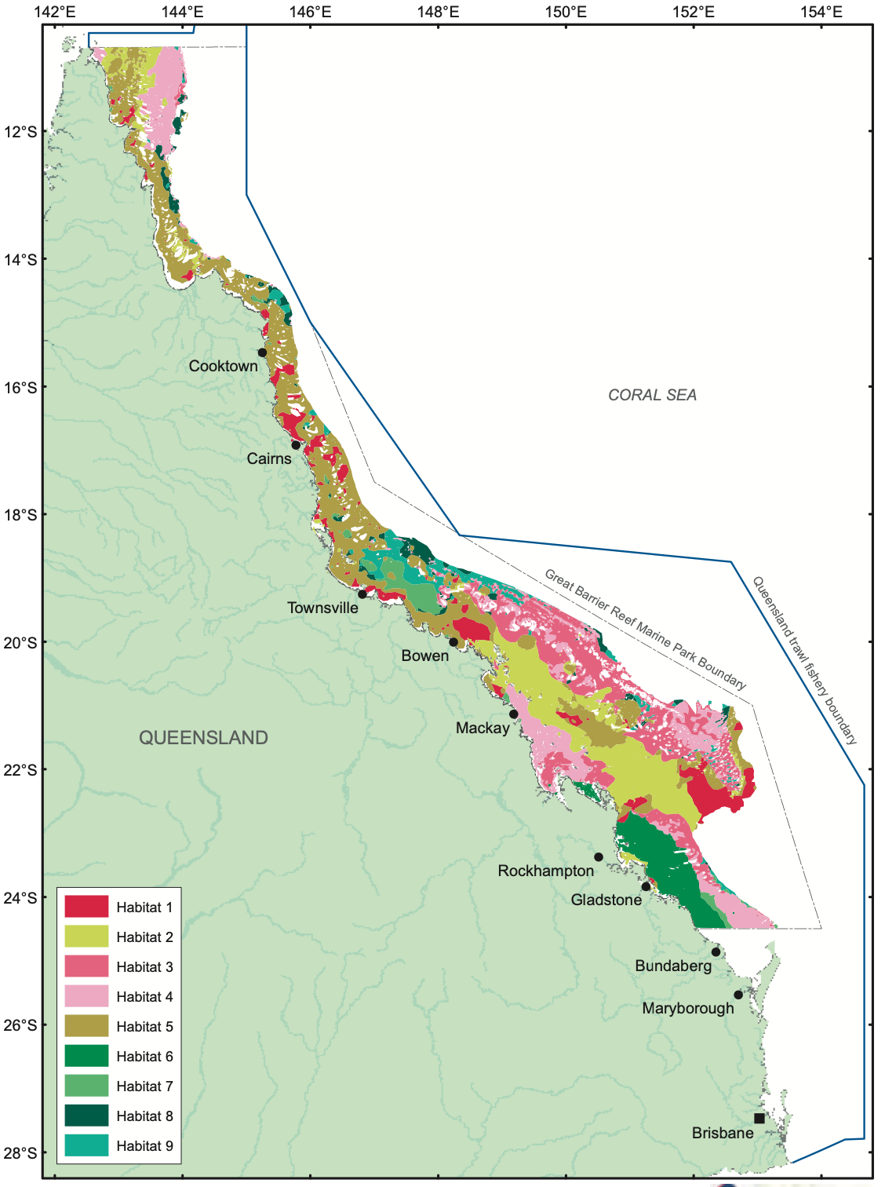
Figure 21. Map of predicted distribution of habitat types 1 to 9 in the Great Barrier Reef Marine Park (Source: (Pitcher et al., 2007))

The habitat types were characterised as follows:
- Habitat 1 represents the most barren seabed type, almost entirely bare (making up about 20% of the habitat area) and bioturbated (>70%) with very little observed biogenic habitat. It is distributed in muddy areas of the inshore and mid-shelf, as well as the deep end of the Capricorn Channel.
- Habitat 2 is also very barren, with some bioturbation (about 20%), 60–70% bare seabed and very little epi-benthos or algae (<1%). It is distributed in muddy–sandy areas of the southern mid-shelf and far north.
- Habitat 3 has significant patches of whip gardens, sponge gardens, gorgonian gardens, alcyonarians, and algae separated by tracts of bare seabed (about 70%). This habitat may also include very small amounts of hard coral gardens, Halimeda and Caulerpa. It is distributed in low mud, higher current areas, primarily in the southern Great Barrier Reef.
- Habitat 4 is similar to habitat 3, but with more algae (about 16%). It also had Halimeda and seagrass. This habitat may also include very small amounts of live reef corals, hard coral gardens, alcyonarians and Caulerpa. Habitat 4 is distributed in low mud, high current areas with higher benthic irradiance, in both the southern and far northern Great Barrier Reef.
- Habitat 5 represents mostly bioturbated (about 40%) and bare seabed (about 40%) with a little algae and seagrass algal habitat and small amounts of whip, sponge and gorgonian gardens, live reef corals, hard coral gardens, Halimeda, alcyonarians and Caulerpa. It is distributed over much of the shelf in northern and northern sections of the Great Barrier Reef.
- Habitat 6 represents seagrass (about 30%) and algal (about 10%) habitats with about 10 per cent bioturbated and about 35% bare seabed. May also include very small amounts of whip, sponge, and gorgonian gardens, alcyonarians, and Halimeda. It is distributed along much of the inner half of the shelf in the southern Capricorn section of the Great Barrier Reef.
- Habitat 7 represents patchy seagrass (about 30%) and algal (about 15%) habitat with about 40% bare seabed. It is distributed along the mid-shelf from Cape Upstart
to Innisfail. This habitat also has very small amounts of whip, sponge, and gorgonian gardens, Halimeda, flora (i.e. unidentified marine plants other than Halimeda and Caulerpa), and Caulerpa.
- Habitat 8 represents much of the Halimeda (> 40%) habitat, as well as some other algae (about 20%) and about 12% bare seabed. Other characteristics include small amounts of whip gardens, sponge gardens, seagrass, live reef corals, hard coral gardens, gorgonian gardens, flora (as above), Caulerpa, and bioturbation.
- Habitat 9 represents about 35% patchy algae (including some Halimeda) with about 15% bioturbation and about 35% bare seabed. Other characteristics include small amounts of whip gardens, sponge gardens, seagrass, live reef corals, hard coral gardens, gorgonian gardens, Caulerpa, and alcyonarians. Habitat 9 is distributed primarily in the outer-shelf offshore from Townsville.

The contact of trawl gear without capture was considered to pose an initial high risk of damage to habitats in the GBR Region. Trawl gear can cause direct physical damage to marine plants and animals on the seabed. Some other activities of the fishery may also impact on habitats; however, these were all assessed as posing a low initial risk. Trawl gear may impact on habitats by removing structural habitat elements such as sponges, which are subsequently discarded. Loss of fishing gear (e.g. ground chains, trawl net) is considered rare and would be likely to sink, with localised smothering effects on a small area of habitat where it lands, however a trawl net will not generally continue to ‘ghost’ fishing, and the level of lost or discarded fishing gear in the trawl industry is believed to be relatively low/negligible. Boat maintenance and emissions could potentially impact marine plants and animals by contaminating the water column and the seabed with toxic chemicals (e.g. fuel, oil or anti-fouling chemicals), however, the fleet size and amount of chemicals carried is relatively small compared with all shipping activity in the area, and most maintenance is carried out in port or on land.
The ERA outcomes and level of overall risk posed by the fishery is presented in Table 14. Only habitat 10 was considered high risk in both 2005 and 2009 and this is outside the UoA area. Habitats 3, 6, 7, 8, and 9 were intermediate-low risk and habitat types 1, 2, 4 and 5 considered low risk (Morison and Pears, 2012).
Table 14. Risk assessment of marine habitats (ordered according to 2009 risk levels) (source: (Morison and Pears, 2012)).
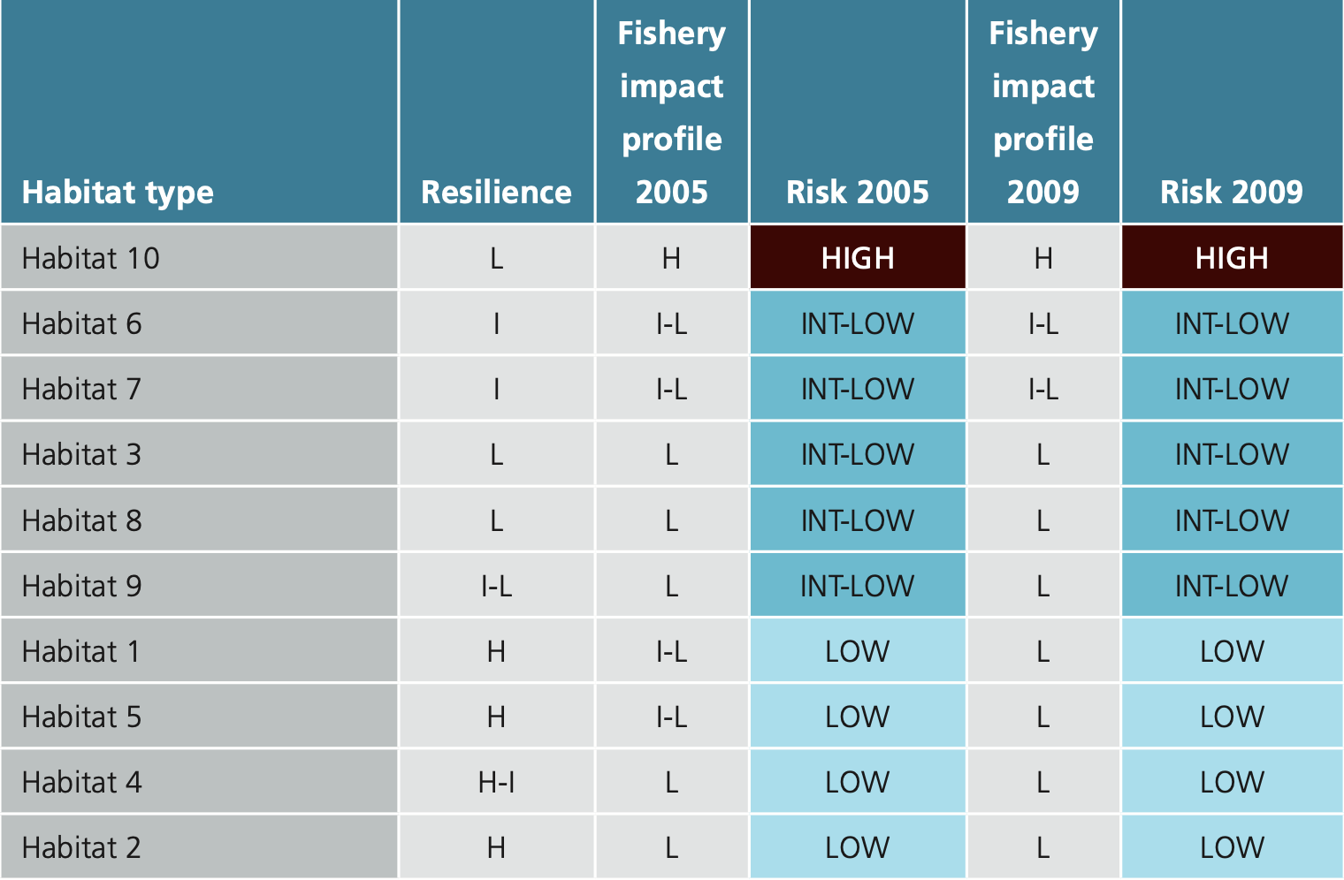
It is important to note that the various types of zones in the GBRMP consider the ecological impacts of different fishing methods, with around 33% of the Marine Park set aside as “no fishing” and a further 33% prohibiting trawling. Therefore, a total of over 66% of waters within the GBRMP are closed to the ECOTF. These zones contribute to the maintenance of ecosystem processes, resilience and biodiversity of the GBR ecosystem. Areas zoned as no-trawl areas are also important for the dependent communities of plants and animals that live there, including the fish stocks that depend on those communities. One habitat type has 20% and all the others had greater than 20% in zones closed to trawling. These protected areas act as a safeguard to ensure that marine habitats in the GBR will not be altered irreversibly by trawling. Additionally, the study confirmed that at least 20% of the 850 species analysed and the 16 species assemblages assessed were protected. Even though 34% of GBR waters are open to trawling, only 7% and 6% of the Marine Park and World Heritage Area were trawled more than once per year in 2005 and 2009, respectively.
The most recent ERA that encompasses habitats in the northern region was performed by Pears et al. (2012).
Detailed information is available on the habitat types of the GBRMP and the impacts of trawling on them (Pitcher et al. 2007) and VMS information provides fine scale information on fishing effort sufficient to detect any increase in risk. The nature, distribution and vulnerability of the main habitat types in the GBRMP are well studied and allow effective strategy to ensure the ECOTF does not reduce habitat structure and function to the point of serious or irreversible harm.

Habitat Management
There are several measures to manage habitat impacts for these UoAs that occur largely within the boundaries of the GBRMP:
- Spatial closures: Trawling is permanently excluded from 66 % of the GBRMP and approximately 42% of the total fishery area (Pears et al. 2012). Closures protect sensitive, representative habitats within the GBRMP, GBR Coastal MP and GSS MP.
- Effort reduction and cap: In the last two decades significant reductions in nominal effort have occurred for the fishery. An effort cap has been established to maintain the fishery at 5% less effort than 1996 levels.
- Gear restrictions: The size and power of vessels and the gear that they trawl with are restricted through legislation. Of particular importance for habitats is the restriction on the weight of chains.
- VMS: all vessels are required to use VMS to ensure compliance with spatial and temporal closures, and to make it easy for compliance officers to know where vessels are when undertaking compliance activity.
- Research: Substantial research activity to evaluate and manage the impacts of the fishery on habitats, particularly within the GBRMP (e.g. Poiner et al, 1999; Pitcher et al, 2007).
Closures within the GBRMP under the GBRMP Zoning Plan are designed to protect at least 20% of each bioregion in the marine park in no-take areas. While these measures in combination with more generic measures such as effort and gear limitations are probably sufficient to ensure that the UoA is unlikely to reduce structure and functions of habitats to the point where there would be serious or irreversible harm, there is insufficient information on the overlap of the fishery with habitats south of the GBRMP at this stage.
Closed areas, effort caps and gear restrictions are all effective management tools that are proven effective in management of habitat impacts, but only when coupled with an appropriate compliance program. The VMS is a critical and effective component of compliance to ensure adherence with closures and efficacy of compliance surveillance. Collectively, these measures form at least a partial strategy. The Seabed Biodiversity Project (Pitcher et al. 2007) provides compelling and objective evidence that the strategy is working to minimise the risk to habitats.

Marine Parks
The fishery operations partly within the Great Barrier Reef Marine Park and World Heritage Area. Zoning restricts trawling to the General Use (Light Blue) Zone in the Great Barrier Reef Marine Park. Zoning incorporates Queensland Government trawl closures in the Habitat Protection (Dark Blue) Zone. Trawling is restricted to the General Use Zone in the Marine Park and occurs in about 7% of the Marine Park area (Grech and Coles 2011).
The North region of the ECOTF operates from 1 March – end of February but there are extensive seasonal and permanent area closures across the fishery, particularly in waters of the Great Barrier Reef World Heritage Area (QDAF, 2021d).

The ECOTF, like all fisheries operating in the Marine Park, are assessed against the Australian Government’s Guidelines for the Ecologically Sustainable Management of Fisheries and continued operation is approved under the EPBC Act.

Ecosystems
Pitcher et al. (2007) provides an excellent basis for understanding the ecosystem and determining measures to assess changes in risk. Additional information on the impact of bycatch reduction devices on ETP and individual species extends the work from the Seabed Biodiversity Project. Together this information is sufficient to assess changes in risk to the ecosystem. Pitcher et al. (2007) provide detailed assessments of the risk of trawling on the GBRMP habitats and associated species assemblages. They also examine the effects of changes in management over time (i.e., effort reductions). The ERA by Jacobsen, et al., (2018) was for the southern region of the ECOTF and it did not assess risk to the broader ecosystem.
The impacts of the ECOTF on the broader ecosystem within the GBRMP was part of the ecological risk assessment (Pears et al. 2012). This assessment considered impacts on specific ecosystem processes: particle feeding, primary production, herbivory, predation, bioturbation, detritivory, scavenging, symbiosis, reef building, competition, connectivity, and species introductions. It concluded that trawling posed a low risk to all these processes.

Pitcher et al. (2007) demonstrated that trawling impacts on habitats and their associated species assemblages were at sustainable levels, and were highly unlikely to be causing serious or irreversible effects to the ecosystem of the GBR. Reductions in effort have been observed in this region since the late 1990’s and therefore it is considered highly unlikely that the fishery is causing serious or irreversible harm to the ecosystem. Notably, there have been several quantitative studies on the impacts of trawl bycatch reduction devices (Courtney et al. 2007) that provide additional confidence that these gear modifications further reduce the impact of trawling on individual species, species assemblages and ETPs.

Ecosystem Management
There are a number of management measures that comprise the management strategy for ecosystems.
- Spatial and temporal closures: Trawling is permanently excluded from 66.2% of the GBRMP and approximately 42% of the total ECOTF area (Pears et al. 2012). Substantial spatial closures outside of the GBR also exist, as well as some seasonal closures and daytime trawling bans.
- Effort reduction and cap: In the last two decades significant reductions in nominal effort have occurred for the fishery; an effort cap has been established to maintain the fishery at 5% less effort than 1996 levels.
- Bycatch reduction devices: The use of BRDs and TEDs of particular specifications is mandatory. These devices are particularly important for turtle and sawfish exclusion. Fish eye devices have been demonstrated to significantly reduce capture of sea-snakes and have been recently made mandatory in regions with the highest levels of sea-snake interaction.
- Logbook data collection of interactions: fishers are required by law to record interactions with ETP species. While it is likely these data are under-represented, they do provide a useful insight into potential changes in interactions levels with ETP species.
- Substantial research activity to evaluate and manage the impacts of the fishery on the ecosystem (e.g. Poiner et al, 1999; Pitcher et al, 2007).

Collectively these measures constitute at least a partial strategy which is expected to restrain impact of the UoA on the ecosystem.

The harvest strategies for each of the ECOTF fishing regions also contain a set of decision rules for minimising and mitigating high ecological risks arising from fishing related activities. All five regional harvest strategies have similar decision rules (Figure 22).
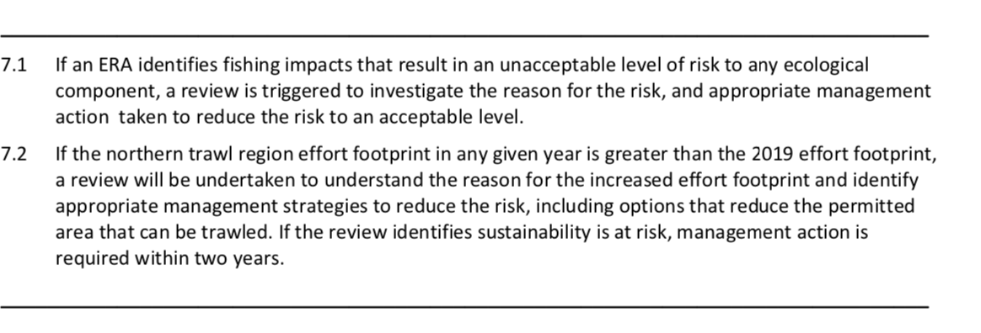
Figure 22. Decision rules for the northern region of the ECOTF relevant to the management of risk posed to the ecosystem.

Principle 2 References:

Australian Institute of Marine Science (AIMS) (2024): Seabed biodiversity on the continental shelf of the Great Barrier Reef World Heritage Area (CRC-Reef Task Number: C1.1.2). Australian Institute of Marine Science (AIMS).dataset.
https://researchdata.edu.au/seabed-biodiversity-continental-number-c112/1376420

Bio-inspecta (2023) Australia east coast king prawn fishery Marine Stewardship Council Public Certification Report 23 June 2023. Report available at https://fisheries.msc.org/en/fisheries/australia-east-coast-king-prawn/ accessed 1 February 2024.

Brewer, D., Heales, D., Milton, D., Dell, Q., Fry, G., Venables, B. & Jones, P. (2006). The impact of turtle excluder devices and bycatch reduction devices on diverse tropical marine communities in Australia's northern prawn trawl fishery. Fisheries Research 81, 176-188.

Campbell, M. J., Courtney, A. J., Wang, N., McLennan, M. F., and Zhou, S. (2017) Estimating the impacts of management changes on bycatch reduction and sustainability of high-risk bycatch species in the Queensland East Coast Otter Trawl Fishery: FRDC Final Report Project number 2015/014, Brisbane, Queensland. CC BY 3.0 Available at: https://era.daf.qld.gov.au/id/eprint/9354/1/Estimating%20impacts%20of%20management%20changes%20on%20bycatch%20reduction_2017_campbell.pdf

Campbell, M.J (2022) Assessing ecological risk posed to common rays by prawn trawling. PhD Thesis, James Cook University. Access to this file is available from: https://doi.org/10.25903/yphx%2Dyk52

Carter, E. and H. Thulstrup (2022) Report on the Joint World Heritage Centre/IUCN Reactive Monitoring Mission to the Great Barrier Reef (Australia)From 21 To 30 March 2022. IUCN and UNESCO report, Available from https://www.dcceew.gov.au/parks-heritage/great-barrier-reef/world-heritage#toc_2.

Connolly, R. M., Cronin, E. R. & Thomas, B. E. (2001). Trawl Bycatch of Syngnathids in Queensland: Catch Rates, Distribution and Population Biology of Solegnathus Pipehorses (Seadragons). Gold Coast: School of Environmental and Applied Sciences, Griffith University.

Courtney, A., Campbell, M., Roy, D., Tonks, M., Chilcott, K., & Kyne, P. (2008). Round scallops and square meshes: a comparison of four codend types on the catch rates of target species and by- catch in the Queensland (Australia) saucer scallop (Amusium balloti) trawl fishery. Marine and Freshwater Research, 849–864 .

Courtney, A.J., M.J. Campbell, M.L. Tonks, D.P. Roy, S.W. Gaddes, J.A. Haddy, P.M. Kyne, D.G. Mayer, & K.E. Chilcott (2014)
Effects of bycatch reduction devices in Queensland's (Australia) deepwater eastern king prawn (Melicertus plebejus) trawl fishery,
Fisheries Research, 157: 113–123.

Courtney, A.J., Haddy, J.A., Campbell, M.J., Roy, D.P., Tonks, M.L., Gaddes, S.W., Chilcott, K.E., O'Neill, M.F., Brown, I.W., McLennan, M., Jebreen, J.E., van der Geest, C., Rose, C., Kistle, S., Turnbull, C.T., Kyne, P.M., Bennett, M.B. and Taylor, J. (2007) Bycatch weight, composition and preliminary estimates of the impact of bycatch reduction devices in Queensland's trawl fishery. Queensland.

Courtney, A.J., B.L. Schemel, R. Wallace, M.J. Campbell, D.G. Mayer and B. Young (2010) Reducing the impact of Queensland's trawl fisheries on protected sea snakes Report to the Fisheries Research and Development Corporation Project No. 2005/053, The State of Queensland, Department of Employment, Economic Development and Innovation, Department of Primary Industries and Fisheries. Brisbane, Queensland. pp: 307. https://era.daf.qld.gov.au/id/eprint/3709/1/BycatchFinalReport2007-FullReport.pdf

Courtney, A.J., C. M. Spillman, R. Lemos, J. Thomas , G. M. Leigh and A. B. Campbell. (2015) Physical oceanographic influences on Queensland reef fish and scallops Final Report FRDC 2013/020 December 2015 Available at: https://era.daf.qld.gov.au/id/eprint/5028/1/Final%20Report%202013-020%20Physical%20oceanographic%20influences%20on%20Queensland%20reef%20fish%20and%20scallops.pdf

Dedini, E., I. Jacobsen and J. Zieth (2023) East Coast Otter Trawl Fishery Ecological Risk Assessment Species of Conservation Concern. Technical Report. Fisheries Queensland, Department of Agriculture and Fisheries. Available at Accessed 15 Feb 2024.

Dedini E. and I. Jacobsen (2023) ECOTF Scoping Study. Fisheries Queensland, Department of Agriculture and Fisheries. Available at
https://era.daf.qld.gov.au/id/eprint/9572/1/East%20Coast%20Otter%20Trawl%20Fishery%20Scoping%20Study%20FINAL.pdf

Department Agriculture, Water and the Environment. (2021). Assessment of the Queensland East Coast Otter Trawl Fishery. Canberra: Department of Agriculture, Water and Environment. https://www.dcceew.gov.au/sites/default/files/documents/qld-east-coast-otter-trawl-assessment-2021.pdf

Department of Employment, Economic Development and Innovation. (2012). Annual Status Report 2011 East Coast Otter Trawl Fishery. Brisbane: Department of Employment, Economic Development and Innovation. Retrieved from https://www.daf.qld.gov.au/__data/assets/pdf_file/0005/66938/ASR_ECOTF2011.pdf

Dodt, N. (2005). Fisheries Long Term Monitoring Program: Syngnathids in the East Coast Trawl Fishery: a review and trawl survey. Department of Primary Industries, Queensland. https://era.daf.qld.gov.au/id/eprint/6433/

Fox, A. R., Lovett, R. A., Wickens, M. E. and Hillcoat, K. B. (2023a) Stock assessment of Queensland east coast red spot king prawns (Melicertus longistylus), Australia, with data to December 2021. Technical Report. State of Queensland, Brisbane.

Fox, A. R., Lovett, R. A., Wickens, M. E. and Hillcoat, K.B. (2023b) Stock assessment of Queensland east coast endeavour prawns (Metapenaeus endeavouri and Metapenaeus ensis), Australia, with data to December 2021.Technical Report. State of Queensland, Brisbane.

Fry, G., Laird, A. and Lawrence, E. (2021) Monitoring interactions with bycatch species using crew- member observer data collected in the Northern Prawn Fishery: 2017 – 2019. Final Report to AFMA; R2017/0835. June 2021. CSIRO, Australia. Pp. 236.

Grech, A., & Coles, R. (2011). Interactions between a Trawl Fishery and Spatial Closures for Biodiversity Conservation in the Great Barrier Reef World Heritage Area, Australia. PloSOne, E 6(6): e21094.,

Harry, A.V. (2011). Life histories of commercially important tropical sharks from the Great Barrier Reef World Heritage Area. PhD thesis. James Cook University, Queensland, Australia.

Jacobsen, I., Zeller, B., Dunning., M., Garland., A., Courtney, T., Jebreen, E., 2018. An ecological risk Assessment of the southern Queensland east coast otter trawl fishery and river and inshore beam trawl fishery. Queensland Department of Agriculture and Fisheries, Queensland Australia. Available at: https://www.daf.qld.gov.au/__data/assets/pdf_file/0004/1402672/Sth-QLD-Trawl-ERA-Final.pdf

Kangas, MI, Sporer, EC, Hesp, SA, Travaille, KL, Brand-Gardner, SJ, Cavalli, P and Harry, AV (2015), Shark Bay Prawn Managed Fishery, Western Australian Marine Stewardship Council Report Series, 2: 294 pp.

Kyne, P.M., (2008). Chondrichthyans and the Queensland East Coast Trawl Fishery. University of Queensland, Australia.

Kyne, P., Courtney, A., Campbell, M., Chilcott, K., Gaddes, S., Turnbull, C., Van Der Geest, C. and Bennett, M. (2002) An overview of the elasmobranch bycatch of the Queensland East coast trawl fishery (Australia). Northwest Atlantic Fisheries Organisation NAFO SCR Document. 2(00): 97

Kyne, P.M., Heupel, M.R., White, W.T. and Simpfendorfer, C.A. (2021). The Action Plan for Australian Sharks and Rays 2021. National Environmental Science Program, Marine Biodiversity Hub, Hobart. Available at: https://www.nespmarine.edu.au/system/files/Shark_Action_Plan_FINAL_Sept7_2021_WEB_RGB.pdf

Last P.R. and Stevens J.D. (2009) Sharks and Rays of Australia. 2nd Ed. Australia: CSIRO Publishing, Hobart, Australia.

Morison, A.K., Pears, R.J., (2012). Assessment of the ecological vulnerability of the East Coast Otter Trawl Fishery to Climate Change. Great Barrier Reef Marine Park Authority Assessment_ecological_vulnerability_ECOTF_climate_change.pdf

Pears, R.J., Morison, A.K., Jebreen, E.J., Dunning, M.C., Pitcher, C.R., Courtney, A.J., Houlden, B. and Jacobsen, I.P. (2012) Ecological risk assessment of the East Coast Otter Trawl Fishery in the Great Barrier Reef Marine Park: Technical report. Great Barrier Reef Marine Park Authority. Townsville, Queensland. pp: 263.
http://elibrary.gbrmpa.gov.au/jspui/bitstream/11017/1148/1/ECOTF_ERA_Technical_web.pdf

Peverell SC (2009) Sawfish (Pristidae) of the Gulf of Carpentaria, Queensland, Australia. MSc Dissertation, James Cook University, Townsville.

Pitcher, C.R., Doherty, P., Arnold, P., Hooper, J., Gribble, N., Bartlett, C., Browne, M., Campbell, N., Cannard, T., Cappo, M., Carini, G., Chalmers, S., Cheers, S., Chetwynd, D., Colefax, A., Coles, R., Cook, S., Davie, P., De’ath, G., Devereux, D., Done, B., Donovan, T., Ehr, G., 2007. Seabed biodiversity on the continental shelf of the Great Barrier Reef World Heritage Area, Australian Institute of Marine Science, CSIRO, Queensland Museum, Queensland Department of Primary Industries & CRC Reef Research Centre, task final report, CSIRO.

Pitcher, C.R., Ellis, N., Althaus, F., Williams, A., McLeod, I., Bustamante, R., Kenyon, R., Fuller, M., 2016. Implications of current spatial management measures for AFMA ERAs for habitats - FRDC Project No 2014/204, CSIRO Oceans & Atmosphere, Brisbane. https://doi.org/577.770994

Poiner, I. R., Glaister, J., Pitcher, C. R., Burridge, C., Wassenberg, T. J., Gribble, N., Hill, B. J., Blaber, S. J. M., Milton, D., Brewer, D. & Ellis, J. R. (1998). The environmental effects of prawn trawling in the far northern section of the Great Barrier Reef: 1991–96. Final Report to GBRMPA and FRDC. CSIRO Division of Marine Research – Queensland Department of Primary Industries Report. https://www.frdc.com.au/project/1993-096
QDAF (2021) Trawl fishery (southern inshore) harvest strategy: 2021–2026. Queensland Department of Agriculture and Fisheries, State of Queensland, Australia. Available at https://www.publications.qld.gov.au/ckan-publications-attachments-prod/resources/25136e07-b01d-4809-b27d-34f6c9b24976/southern-inshore-trawl-region-harvest-strategy.pdf?ETag=f72bdd36e470a5c00ad281623d45c048 Accessed 1 March 2024.
QDAF (2021b) Status report for reassessment and approval under protected species and export provisions of the Environment Protection and Biodiversity Conservation Act 1999 (EPBC Act) https://www.dcceew.gov.au/sites/default/files/env/consultations/e1ba225f-3edc-4f76-b93e-bb8cc69b0939/files/qld-east-coast-trawl-fishery-submission-2021.pdf

DAF (2021c) Trawl fishery (southern offshore A and B regions) harvest strategy: 2021–2026. Queensland Department of Agriculture and Fisheries, State of Queensland, Australia. Available at https://www.publications.qld.gov.au/ckan-publications-attachments-prod/resources/b23ffab7-c4b0-4441-b4f4-0ef040208f2a/southern-offshore-trawl-region-harvest-strategy.pdf?ETag=84ba013db7f40f491c7f203f04e47556 Accessed 1 March 2024.
QDAF (2021d) Trawl fishery (central) harvest strategy: 2021–2026. Queensland Department of Agriculture and Fisheries, State of Queensland, Australia. Available at https://www.publications.qld.gov.au/ckan-publications-attachments-prod/resources/b0d530dc-34ba-4dd7-9109-b79f3a785203/central-trawl-region-harvest-strategy.pdf?ETag=46f5f6a23c974621e5c8428a0cc56942
QDAF (2021e) Trawl fishery (northern) harvest strategy: 2021– 2026. Queensland Department of Agriculture and Fisheries, State of Queensland. 19 pp. https://www.publications.qld.gov.au/ckan-publications-attachments-prod/resources/2d129e11-bfc9-4a41-a766-3104bbcaa677/northern-trawl-region-harvest-strategy.pdf?ETag=e411c45e75e8150e35c8c35340e47282

QDAF (2022) Queensland fisheries summary report Fisheries catch and effort data https://www.daf.qld.gov.au/__data/assets/pdf_file/0004/1423831/queensland-fisheries-summary-report.pdf

Richardson, K., R. Gunn, C. Wilcox, B.D. Hardesty (2018) Understanding causes of gear loss provides a sound basis for fisheries management Marine Policy 96:278-84

Rigby, C.L., White, W.T. and Simpfendorfer, C.A. (2016) Deepwater chondrichthyan bycatch of the eastern king prawn fishery in the southern great barrier reef, Australia. PLoS ONE. 11(5): e0156036
Simpfendorfer, C., Chin, A., Rigby, C., Sherman, S., White, W. (2019) Shark futures: a report card for Australia’s sharks and rays’, Centre for Sustainable Tropical Fisheries and Aquaculture, James Cook University Available at: https://www.frdc.com.au/sites/default/files/products/2013-009-DLD.pdf

Wang, N. (2015). Sustainability and optimality in fisheries management. PhD thesis. The University of Queensland.

Wang, N., Courtney, A. J., Campbell, M. J., and Yang, W.-H. (2020) Quantifying long-term discards from Queensland’s (Australia) east Coast otter trawl fishery. ICES Journal of Marine Science, 77: 680–691. doi:10.1093/icesjms/fsz205 Available at: https://academic.oup.com/icesjms/article/77/2/680/5644309 Accessed 2 March 2024

Welch, David & Saunders, Thor & Robins, Julie & Harry, Alastair & Johnson, Johanna & Maynard, Jeffrey & Saunders, Richard & Pecl, Gretta & Sawynok, Bill & Tobin, Andrew. (2014). Implications of climate change impacts on fisheries resources of northern Australia. Part 1: Vulnerability assessment and adaptation. FRDC Project 2010/565

Principle 2 Performance Indicator scores and rationales

In-scope Species

PI 2.1.1 – In-scope species outcome
PI 2.1.1 |  | The UoA aims to maintain in-scope species above the PRI and does not hinder recovery of in-scope species if they are below the PRI
Scoring issue |  | SG 60 | SG 80 | SG 100
a | Main in-scope species stock status
a | Guide post | Main in-scope species are likely to be above the PRI.  or  If the species is below the PRI, it is likely that the UoA does not hinder recovery and rebuilding. | Main in-scope species are highly likely to be above the PRI.  or  If the species is below the PRI, there is evidence of recovery, or it is highly likely that the UoA does not hinder recovery and rebuilding. | There is a high degree of certainty that main in-scope species are fluctuating around a level consistent with MSY.
 |  | Discard species – No | Discard species – No
Rationale |  | There are no ‘main in-scope’ species retained by the Northern region that constitute ≥2% or 5 % of the total catch.  Discard species:  There is a paucity of information regarding species composition and volume of discards relevant to the northern region only (i.e., available research data did not split the ECOTF into the management zones currently in use). However, there is data (Wang et al. 2020) that suggests volumes of 4.5 kg of discards per 1.0 kg of retained species in the tiger/endeavour prawn sector. Wang et al. quantified discard data but did not evaluate species composition.  There is a mandatory requirement to use larger TEDs and as such most large bycatch species are eliminated from trawl catch the focus has been on reducing the proportion of smaller bycatch species. All trawl nets in the ECOTF are required to have at least one recognised BRD installed. BRDs allow for the effective escape of non-target species (including undersized, non-permitted and protected species) that may interact with trawl gear in the fishery.  ERA data provides an overview of the studies conducted in the ECOTF and only Green sawfish) ranked high risk for the northern region; as an ETP species it is assessed at PI 2.2.1 below.  Whipfin ponyfish, Blacktip tripodfish, swimming crabs and Rough flutemouth are considered common in northern trawls (Pears et al. 2012). However, there is no stock status data available for any of the common discard species listed in Pears et al. (2012). The latest (2021) WTO assessment requested the used of an indicator species for monitoring discards; an indicator species has not been chosen.  Version 3 of the MSC Fisheries Standard includes updates to the Risk-Based Framework to ensure it delivers precautionary and robust outcomes. The used of an RBF for each discard species is required.
b | Minor in-scope species stock status
b | Guide post |  |  | Minor in-scope species are highly likely to be above the PRI.  or  If below the PRI, there is evidence that the UoA does not hinder the recovery and rebuilding of minor in-scope species.
b | Met? |  |  | Not scored
Rationale |  | Not scored.  It is worth noting that all retained ‘minor in-scope species are assessed as part of the Status of Australian Fish Stocks (SAFS) process (https://fish.gov.au). The same can not be said to the many discard species that make up a significant proportion of the total catch.

Draft scoring range | < 60
Information gap indicator | Discards:  - Species composition of discards by volume/number is lacking. It may be that no single discard species make up ≥5% of the total catch in the northern zone, but data is lacking.  - RBF required for discard species that may make up more than 5% of the total catch.

PI 2.1.2 – In-scope species management strategy
PI 2.1.2 |  |  | There is a strategy in place that is designed to maintain or to not hinder rebuilding of in-scope species
Scoring issue |  |  | SG 60 | SG 80 | SG 100
a |  | Management strategy in place
 |  | Guide post | There are measures in place for the UoA, if necessary, that are expected to maintain or to not hinder rebuilding of the main in-scope species at/to the in-scope species outcome SG60 level. | There is a partial strategy in place for the UoA, if necessary, that is expected to maintain or to not hinder rebuilding of the main in-scope species at/to the in-scope species outcome SG80 level.  or  Where in-scope species outcome fails to meet the SG80, a demonstrably effective strategy is in place between all MSC UoAs that categorise this species as main in-scope to ensure that they collectively do not hinder recovery and rebuilding. | There is a strategy in place for the UoA for managing main and minor in-scope species at the in-scope species outcome SG80 level.
 |  |  | Discard species – no | Discard species – no
Rationale |  |  | The HS for the UoA does not mention discard species; instead it mentions retained species (Tier 1, Tier 2 and Tier 3 species) or those species identified as high risk in the ERA process. Reporting discards is not required and independent monitoring is irregular (usually associated with testing gear modifications). The RBF process for commonly discarded species (as identified by the ERA etc.) will be required as there is no management in place. There is no formal discard/bycatch workplan for the fishery. SG 60 is not met.
b | Management strategy effectiveness
b | Guide post |  | The measures, if necessary, are considered likely to work for the main in-scope species, based on plausible argument. | There is some evidence that the measures/partial strategy, if necessary, is achieving the objectives for main in-scope species set out in scoring issue (a), based on some information directly about the UoA and/or species involved. | There is evidence that the partial strategy/strategy is achieving the objectives set out in scoring issue (a), based on information directly about the UoA and/or species involved.
b |  |  | Discard species - no | Discard species – no
Rationale |  |  | Given that discards make a high proportion of the total catch measures are necessary. BRDs are mandatory in the fishery. There are no other measures specific to discarding and there is no formal discard/bycatch workplan for the fishery. Measures aimed at other components of the fishery would incidentally reduce catches of some species (effort reductions, VMS, gear restrictions, use of BRDs, closures etc.) although there are no measures directly in place to monitor changes in species composition, abundance or impact to discard species SG 60 is not met.
c | Review of alternative measures
c | Guide post |  | There is a review of alternative measures to minimise UoA-related mortality of unwanted catch of main in-scope species | There is a review at least once every 5 years of alternative measures to minimise UoA-related mortality of unwanted catch of main in-scope species and they are implemented, as appropriate. | There is a review that happens every 2 years of alternative measures to minimise UoA-related mortality of unwanted catch of all in-scope species, and they are implemented, as appropriate.
c |  |  | Discard species -yes | Discard species – no
Rationale |  |  | Discard species  There is substantial evidence that BRDs have reduced the proportion of discards taken by the ECOTF (Brewer et al. 2006; Courtney et al. 2014). There are no management measures in place for discards, although those in place for other components of the fishery would aid some discard species (e.g., VMS, gear restrictions, spatial and temporal closures etc.).  Campbell et al. (2017) reviewed the ECOTF management changes (pre-Fishery Strategy) with respect to impact on bycatch species. One ERA (Dedini et al. 2023) has been conducted since the introduction of the HS (QDAF, 2021e) although this primarily focused on ETP species. The ERA by (Pears et al. 2012) Campbell (2022) provides a comprehensive overview of BRD and TED research in prawn trawls and investigated post trawl survival of batoid species from the ECOTF. The use of electronic monitoring is being investigated by the fishery; alternative measures have been investigated and are the subject of ongoing discussions, as such SG 60 is met. The HS for the sub-fishery is due for renewal in 2026–27 (five years), although there is no requirement to include discard species in the updated HS; SG 80 is not met.
d | Shark finning
d | Guide post |  | There is a high degree of certainty that shark finning is not taking place.
d | Met? |  | Yes
Rationale |  |  | Sharks are not retained by the fishery and the fishery does not operate in shark fins. The possession of any shark products by fishers operating in the ECOTF was prohibited in 2001 and, since then, fishers have been required to return all chondrichthyans to the sea as quickly as practicable (Campbell, 2022). Compliance officers conduct in port and at sea inspections, and the electronic monitoring is being trialled for the fishery will provide additional confidence that are sharks are discarded whole. SG 60 is met.  The Evidence Requirement Framework is mandatory for this scoring issue.
e | Ghost gear management strategy
e | Guide post |  | There are measures in place for the UoA, if necessary, that are expected to minimise ghost gear and its impact on all in-scope species. | There is a partial strategy in place for the UoA, if necessary, that is expected to minimise ghost gear and its impact on all in-scope species. | There is a strategy in place for the UoA, if necessary, that is expected to minimise ghost gear and its impact on all in-scope species.
e | Met? |  | Yes | Yes | Not scored
Rationale |  |  | Some measures are in place that are expected to prevent or remediate gear loss in the UoA. Anecdotal information suggests that considerable effort is put into the immediate recovery of lost gears due to their high value, combined with improvements in navigation and gear marking technologies. However, it is apparent that some ECOTF nets are lost as Bio-inspecta (2023) noted that with regard to potential for gear loss that: “Gear loss in the fishery is low, with industry data reporting 3 boards, 3 skids and 4 nets lost between 2015-2019.”  Measures include:  - Marking and identification requirements  - Spatial closures;  - Use of VMS  - Effort limits;  - Gear design specifications;  - Gear loss reporting requirements.  The northern sub-fishery of the ECOTF is not expected to make a significant contribution to the number of ghost nets although loss of fishing gear was broadly assessed in the ECOTF ERA as a potential risk for inshore habitats/ecosystems (i.e., the UoA). For trawl operations, loss of fishing gear has the greatest potential to impact the marine environment through physical damage to seabed assemblages, plants or microhabitats within the immediate area (Pears et al. 2012).  Pollution of the marine environment by ships, including fishing vessels, is strictly controlled by the International Convention for the Prevention of Pollution from Ships (known as MARPOL). Under MARPOL Annex V, vessel operators are currently required to report the loss or discharge of fishing gear that poses a significant threat to the marine environment or navigation. With regard to legislation, the Australian Maritime Safety Authority (AMSA) also have legislative responsibility for marine pollution and providing safe navigation. States and Territories, including Queensland have complementary frameworks. With regard to the “Accidental loss or discharge of fishing gear”, fishing vessel operators are also required to record the discharge or loss of fishing gear in their garbage record book or ships log. Whilst there are no specific ECOTF management measures within Queensland’s legislation that are expected to minimise ghost gear and it’s impact on in-scope species, the MARPOL requirements together with the above measures are likely to be sufficient for SG 60 and SG 80 to be met.

Draft scoring range | <60
Information gap indicator | Discard species volume and composition data is missing for the northern trawl region. Survivability estimates available for some species, but missing data on those species listed as high risk or main in-scope.

PI 2.1.3 – In-scope species information
PI 2.1.3 |  |  | Information is adequate to determine the impact of the UoA on in-scope species and the effectiveness of management measures or strategies in place
Scoring issue |  |  | SG 60 | SG 80 | SG 100
a |  | Information adequacy for assessment of impact on main in-scope species
 |  | Guide post | Information is adequate to broadly understand the impact of the UoA on the stock status of main in-scope species. | Information is adequate to estimate the impact of the UoA on the stock status of main in-scope species with a high degree of accuracy. | Information is adequate to estimate the impact of the UoA on the stock status of main in-scope species with a very high degree of accuracy.
 |  |  | Discard species - no | Discard species - no
Rationale |  |  | Discard species  It is well acknowledged and understood that the ECOTF catches many other species that are discarded. Discards generated by the ECOTF have been widely researched (e.g. Courtney et al., 2008; Courtney et al., 2014; Courtney et al., 2006; Wang et al., 2020; Campbell 2022).  It is not mandatory to record discards (except Scallops only taken in other regions) and the use of electronic monitoring is currently in a trial period. Qualitative information is available on species composition from research projects and ERAs.  ERAs provide information on those species most at risk for ECOTF as a whole and future ERAs are likely to be differentiated by region. Two qualitative ERAs have been used to assess the population status of species caught by penaeid trawls in Queensland.  Pears et al. (2012) assessed the risk posed to a number of species groups and habitats by the QECOTF within the Great Barrier Reef Marine Park; 11 chondrichthyan species ranked as high risk based on high levels of interaction with the fishery, poor or very poor post-release survival, and ineffective TEDs.  Jacobsen et al. (2018) found that ECOTF posed a high risk to 15 chondrichthyans species in the area south of the GBRMP for similar reasons as Pears et al, although Jacobsen et al. (2018) was not based on the northern region operations. The latest ERA relevant to the northern region was Dedini et al. (2023) and they noted that: “Data deficiencies were most prevalent in risk assessments involving the syngnathids, batoids and sharks; particularly for maximum age, age at sexual maturity and fecundity” As such, the ERA used precaution during the PSA.  Rigorous at-sea testing of BRDs/TEDs has demonstrated that the devices were effective in reducing overall bycatch but ineffective for the two most common chondrichthyans caught: Eastern Shovelnose Ray (Aptychotrema rostrata) and Common Stingaree (Trygonoptera testacea) (Courtney et al., 2006; 2008; Campbell et al. 2017; Campbell 2022). Post-trawl survivability (PTS) has also been investigated for these species (Campbell 2022).  Whilst a number of monitoring programs collect information on the ECOTF including fishery dependent catch and effort logbooks, processor returns and VMS. Only retained species are recorded in the fishery dependent logbook. Qualitative data on byproduct, bycatch and discards (and ETP interactions) specific to the ECOTF as a whole is the subject of a current e-monitoring trial. Such information would allow the determination of risk with a high degree of accuracy; SG 60 is not currently met.
b | Information adequacy for assessment of impact on minor in-scope species
b | Guide post |  |  |  | Information is adequate to estimate the impact of the UoA on the stock status of minor in-scope species with a high degree of accuracy.
b | Met? |  |  |  | Not scored
Rationale |  |  | Not scored
c | Information adequacy for management strategy
c | Guide post |  | Information is adequate to support measures to manage main in-scope species. | Information is adequate to support a partial strategy to manage main in-scope species. | Information is adequate to support a strategy to manage all in-scope species and evaluate with a high degree of certainty whether the strategy is achieving its objective.
 |  |  | Discard species - yes | Discard species- no
Rationale |  |  | A number of monitoring programs collect information on the ECOTF including fishery dependent catch and effort logbooks, processor returns and VMS. Only retained species are recorded in the fishery dependent logbook. Qualitative data on byproduct, bycatch and discards (and ETP interactions) specific to the ECOTF as a whole is the subject of a current e-monitoring trial; past ERAs also summarise information on species that interact with the fishery, although the most recent ERA for the northern region that involves discards was Pears et al. (2012).  At SG 80, information must be adequate to support a “partial strategy” including the ability to detect any changes in risk level to main in-scope species, however since the termination of the observer program in 2012, there has been no fishery independent monitoring of retained species and no recording of discards, except by targeted research programs (Courtney, et al., 2007; 2014) until the installation of cameras and review/verification of fishery data. Given that the program is not yet established (i.e. no data is available), information is not yet adequate to support any partial strategy to manage main in-scope species and SG 80 is not met.

Draft scoring range | <60
Information gap indicator | With regard to discard species, information is inadequate to broadly understand the impact of the UoA on the stock status.

Endangered, Threatened and Protected Species (or Out of Scope Species)

PI 2.2.1 – ETP/OOS species outcome
PI 2.2.1 |  | The direct effects of the UoA do not hinder recovery of the ETP/OOS unit to favourable conservation status
Scoring issue |  | SG 60 | SG 80 | SG 100
a | Direct effects
a | Guide  post | The direct effects of the UoA are unlikely to hinder recovery of the ETP/OOS unit to favourable conservation status. | The direct effects of the UoA are highly unlikely to hinder recovery of the ETP/OOS unit to favourable conservation status. | There is a high degree of certainty that the direct effects of the UoA do not hinder recovery of the ETP/OOS unit to favourable conservation status.
 | Met? | pipehorse – yes | pipehorse – yes | Not scored?
 |  | Sea snakes - yes | Sea snakes - yes | Not scored?
 |  | Turtles - yes | Turtles - yes | Not scored?
 |  | Sawfish - yes | Sawfish - yes
Rationale |  | There is no break down of ETP species caught in logbooks by region, but the reported interactions from Q4 2022 to Q3 2023 for the east coast trawl (ECOTF) include:  - Sea snakes (1321 caught of which 133 dead/injured) - assessed below  - Narrow sawfish (10 caught of which 3 dead/injured) – assessed below  - Green turtle (4 caught, nil dead/injured) – assessed below  - Loggerhead turtle (3 caught, nil dead/injured) - assessed below  - Pipefish/seahorses (110 caught, nil dead/injured – reviewed below  - Estuary stingray (1 caught, nil dead) – not an ETP species, not assessed  Pears, et al., (2012) assessed the potential risk the entire ECOTF posed to Species of Conservation Concern (SOCC) including 6 species of turtles, 16 species of sea snakes, 6 species of seahorses and pipefish and 33 species of sharks and rays. The updated ERA for the entire ECOTF (Dedini et al. 2023) was completed using a Productivity & Susceptibility Analysis (PSA) and assessed risk by region. The ERA prioritised assessments for non-target species, specifically species of conservation concerns (SOCC). The entire ECOTF list was rationalised to 62 species consisting of six marine turtles, 13 sea snakes, nine syngnathids, 12 sharks and 22 batoids. When the outputs of the ERA were taken into consideration, 12 species were categorised as being at high risk from fishing activities in the ECOTF. Of notable importance, nine of the 12 high-risk ratings were classified as ‘precautionary’ as they are more representative of the potential risk (all nine were sharks/rays and there is no obligation to report interactions in logbooks).  When considering the UoA northern region only, the following species were listed as HR or Precautionary HR in the latest ERA (Dedini et al. 2023):  - Green sawfish P. zijsron  - Eastern Angel shark Squatina albipunctata  - Blackspotted Whipray Himantura astra  - Brown Whipray M. toshi  - Australian butterfly ray  Of these only the Green sawfish is an ETP species. For the other species, stock status reference points are unavailable; any further assessment would require the RBF process to score in-scope main species that are discarded  Pipefish  Although all syngnathids are protected species, there is an exemption to permit the taking of two syngnathid species. The take of S. dunckeri (and S. hardwickii) is restricted by a combined trip limit of 50 individuals and both species must be discarded once this limit is reached (no information if trip limit has ever been met).  There is a no recent known interaction with the UoA and pipehorse that are listed as a Tier 3 species in the harvest strategy (i.e., they are not recorded as in retained species or ETP species logbooks). Although all syngnathids are protected species, there is an exemption to permit the taking of two syngnathid species. The take of S. dunckeri and S. hardwickii is restricted by a combined trip limit of 50 individuals and both species must be discarded once this limit is reached. Unlike other regions of the ECOTF, the latest ERA (Dedini et al. 2023) did not list Duncker’s Pipehorse (S. dunckeri) as having an interaction with the UoA; five other syngnathids were listed as medium risk, including Pallids (S. harwickii) that ranked as medium risk across all sectors of the ECOTF.  Sea snakes  No species of sea snake is currently listed as threatened under Queensland or Australian legislation, but all species of sea snakes are considered a 'listed marine species' under the Environment Protection and Biodiversity Conservation Act 1999 and are 'protected species' under the Nature Conservation Act 1992 and the Great Barrier Reef Marine Park Act 1975.  Six species of sea-snake have known interaction with the northern sub-fishery of these 11 were medium risk and one was low risk. The IUCN RedList ranking for each of the Medium risk species are listed below:  In 2022, 257 Sea snake interactions were reported with the entire ECOTF of which 3 were dead and two were injured, the remainder were released alive.  Logbook data provided by QDAF suggests that sea snake interaction in the northern region makes up a varying proportion of the total report interactions for the ECOTF (1-54%; Table 13). In the four years of 2019–22, 2625 sea snakes were reported from the entire ECOTF of which 474 were from the northern region; only 43 interactions were reported in 2022. Majority of reported sea-snake interactions record the life status; in 2022, 252 sea snake interactions were recorded for the entire ECOTF, of which only three were reported as deceased and two as injured. There was a marked increase in 2023, with the total number of sea snake interactions for the entire ECOTF reaching a new peak of 1968 (509 dead/injured). Region specific data is not yet available for 2023.  The ERA (Dedini et al. 2023) noted that: “In the ECOTF, the length of the interaction will have a considerable impact on the chance of a sea snake surviving the event. For individuals that are able to escape through a BRD, the long-term consequences of the interaction will be minimal. Risk levels will be notably higher for individuals that cannot escape through a BRD and are retained within the codend of the net. In the ECOTF, logbook data indicates that between three and 30 per cent of landed sea snakes die due to drowning or injuries sustained during the fishing event (Department of Agriculture and Fisheries, 2023).¹⁸ Without a mechanism to validate TEPA data, it is difficult to assess the accuracy of these reports.” Whilst species identification is not reported in logbooks, there are reports by species during research projects quantifying otter trawl catch compositions and effectiveness of BRDs and TEDs (Courtney et al. 2014). Campbell et al. (2018) noted that substantial resources have been expended in trialling technologies that mitigate the incidental capture of species of conservation concern by commercial prawn trawlers.  The ERA (Dedini et al. 2023) noted that: “the absence of an effective mechanism to validate logbook data increases the risk of non-compliance e.g. the non-reporting of sea snake interactions and the submission of erroneous release-fate data.” It is important to note that e-monitoring has recently been initiated in the fishery. When considering cumulative impacts of interactions with MSC certified fisheries, it is important to consider the Northern Prawn Fishery and its impacts on these species of sea snakes (Fry et al. 2021). Sea snakes are subject to the threat abatement plan that lead to the introduction of BRDs on all prawn trawlers in Australian waters, including the ECOTF. SG 60 and 80 are met.  Marine turtles  The latest ERA (Dedini et al. 2023) listed marine turtles as medium or precautionary medium risk for the ECOTF as a whole. Six species considered ‘north’ as a medium or precautional medium risk region. Research has shown that the combined use of a TED with a Bycatch Reduction Device (BRD) dramatically reduces landing rates for marine turtles. In 2021–22, publicly available interaction data reported four Marine Turtles interactions for the entire ECOTF (three loggerhead (Caretta caretta) and one green turtle (Chelonia mydas)) of which one was injured and three were released alive. Of these interactions, northern region logbook data reported two green turtle (released alive) in 2021. In Australia, marine turtles are EPBC listed as ‘vulnerable’ or ‘endangered’, marine and migratory. To meet the CMS and the EPBC requirements, an updated Recovery Plan for Marine Turtles in Australia 2017–2027 was developed (DEE, 2017). The Action Plan requires that Australian fisheries management should be undertaken in accordance with the FAO Guidelines to Reduce Sea Turtle Mortality in Fishing Operations. The main requirements within the recovery plan relevant to domestic fisheries include:  - improving access and report of the most current bycatch information that will enhance the assessment of whether current fisheries interactions will impact on stock recovery.  - promotion and implementation of best practice and continued innovation of turtle bycatch mitigation.  The measures of success for the above actions include:  - domestic fisheries are compliant with fisheries legislation pertaining to bycatch;  - marine turtle species are accurately recorded in 90% of reported fishery interactions within Australia’s jurisdiction;  - marine turtle bycatch is reduced such that it does not impact stock recovery (DEE, 2017).  The ECOTF’s impact on marine turtles was reduced significantly with the introduction of TEDs and most turtles caught are released alive with mandatory reporting requirements. ECOTF North trawl footprint is a very small fraction of marine turtle species distribution.  SG 60 and 80 are met.  Sawfish  All Australian sawfish populations were depleted historically with the development of gillnet and trawl fisheries due to their high catchability. UoA impact: The UoA has a known interaction with Green Sawfish and Narrow Sawfish. Although there have been no interactions in 2018–2022, 11 Narrow Sawfish were reported in 2022–24 from the ECOTF, although the region is unclear (Table 12). In 2012–2018, 35 Narrow sawfish were caught (and released) and of these three were deceased from the Northern region. Over the same period, five Green Sawfish were caught (and released), and of these, one was injured (nil deceased). ECOTF interaction data from 2022 to Q1 2024 reported 10 Narrow Sawfish interactions and no Green Sawfish interactions, although there is no further break-down by region.  Narrow sawfish  The significant population reduction in the Narrow Sawfish largely occurred prior to the last three generations (pre-2000s), noting that protection and management measures have reduced mortality over the last two decades. Over the last three generations (18 years), it is suspected that the population has undergone a reduction of >30% and the Narrow Sawfish is assessed as Vulnerable. Although threatened here, Australia represents the most significant remaining global location for this species.  DoE (2015) produced a multi-species issue paper for sawfish and river sharks. Kyne et al. (2021) lists Narrow Sawfish population as ‘depleted’. In 2023, Narrow Sawfish was listed as ‘critically endangered’ by the IUCN RedList.  It is important to consider cumulative impacts of fisheries on Narrow Sawfish. Catches are much greater in the NPF, and there is no evidence of declining trends (in NPF) catches between 2010 and 2019 (Fry et al, 2021). However, in 2021, NPF catch for all sectors was 980 Narrow Sawfish, of which 544 (55%) were discarded alive (survivability unknown). Whilst, past estimates of fishing mortality rates for the species in the NPF are reportedly “below a rate that would lead to significant population declines”. Further information is required to determine if the recent increase in NPF catches (from 228 in 2019 to 980 in 2021), in combination with the catches from other fisheries (Queensland GoCIFF: 56 in 2019; Northern Territory ONLF 20 in 2019) are likely to be in excess of sustainable levels. Whilst there were no interactions have been recorded for the UoA in 2018–2022, 11 interactions were reported for the ECOTF (region unclear). The total reported interaction for the ECOTF (all areas) for the 12.25 years from 2012–2024 (Q1) was 49 of which 7 were deceased; the maximum reported interaction for the UoA is 46 of which 6 were deceased. In a single year (2021), the NPF caught 980 of which 436 were dead/injured. The direct effects of the UoA (northern ECOTF) are highly unlikely to hinder the recovery of this species and SG 60 and SG 80 are met.  The direct effects of the UoA are highly unlikely to hinder recovery of the ETP/OOS unit to favourable conservation status.  Green sawfish  Green Sawfish are ‘Critically Endangered’ by the National IUCN RedList. A recovery plan is available for Green Sawfish (combined with other Pristis sawfish and river sharks). There is little information on current population sizes or long-term rates of population change. The Sawfish recovery plan states that there is little information available on the current or long term population changes of Green Sawfish, although significant declines in a few generations have been noted.  It is also important to consider cumulative impacts of other MSC certified fisheries in the area. In 2020–21, 81 Green Sawfish were also caught by the Northern Prawn Fishery, of which 33 were discarded dead. Logbook data from the Queensland GoCIFF N12 fishing symbol reported 19 Green Sawfish in the same period, and the entire ONLF reported 27 interactions. As such, in 2020–21, the reported Green Sawfish catch for these three fisheries (NPF, GOCIFF N12 and ONLF) was 127 individuals; further data is required on inshore fisheries in the GoC. A Recovery Plan is available for Green Sawfish (combined with other Pristis sawfish and river sharks) although Narrow sawfish are not included in the Plan.  The UoA has a known interaction with Green Sawfish and Narrow Sawfish, although there have been no interactions since 2018 (Table 12). In 2012–2018, 35 Narrow sawfish were caught (and released) and of these three were deceased. Over the same period, five Green Sawfish were caught (and released), and of these, one was injured (nil deceased).  In summary, the UoA is likely to have some, albeit limited, spatial overlap with ETPs, and the compulsory use of BRDs and TEDs are known to reduce interactions with ETPs. The assessment team concluded the direct effects of the UoA are highly likely to not hinder recovery of green sawfish, marine turtles and sea snakes and SG 60 and 80 are met. With regard to pipefish, whilst localised depletions and stock structure and status remains unclear, the UoA (north) does not have any reported interactions with these species from either retained or ETP species logbooks and as such SG 60 and 80 are met for these species.
  Species | IUCN RedList listing & Date
  Elegant sea snake (Hydrophis elegans) | Least Concern 2009.
  Mosaic sea snake (A. mosaicus) | Least Concern 2018.
  Spine-bellied sea snake (H. curtus) | Least Concern 2018.
  Beaked sea snake (H. zweifeli) | Data deficient 2009 .
  Spectacled sea snake (Hydrophis kingii) | Least Concern 2009
  Horned Sea snake (H. peronii) | Least Concern 2009

Draft scoring range | ≥80
Information gap indicator

PI 2.2.2 – ETP/OOS species management strategy
PI 2.2.2 |  |  | The UoA has precautionary management strategies in place designed to:  - Ensure that incidental catches of the ETP/OOS unit are minimised and where possible eliminated  - Ensure that the UoA does not hinder recovery to Favourable Conservation Status.
Scoring issue |  |  | SG 60 | SG 80 | SG 100
a |  | Management strategy in place
 |  | Guide post | There are measures in place, if necessary, that are expected to minimise the UoA-related mortality of the ETP/OOS unit and achieve the ETP/OOS outcome SG80 level of performance. | There is a strategy in place, if necessary, that is expected to minimise the UoA-related mortality of the ETP/OOS unit and achieve the ETP/OOS outcome SG80 level of performance. | There is a comprehensive strategy in place that is expected to minimise the UoA-related mortality of the ETP/OOS unit and achieve the ETP outcome SG80 level of performance.
 |  | Met? | Sea snakes - yes | Sea snakes - no | Not scored
 |  | Met? | Marine turtles - yes | Marine turtles - no | Not scored
 |  |  | Sawfish - yes | Sawfish - no
Rationale |  |  | Under the Fisheries (Commercial Fisheries) Regulation 2019, commercial fishers are required to have on board, make entries, and submit an ETP animal interaction logbook for all interactions with protected species (Figure 4).  At present, the management of interactions of each ETP species/group is not compiled under one ECOTF management strategy. However, QDAF have developed such strategies for other fisheries (e.g., ECIFF ETP Management Strategy) that clearly outlines the responsibilities and management responses following interactions.  Fisheries Declaration 2019 sets out the mandatory use of BRDs and TEDs of particular specifications. These devices are particularly important for turtle and sawfish exclusion, and recently fish-eye devices were regulated to reduce the capture of sea-snakes.  Pipefish: The ECOTF is unique in that it permits the take of a known ETP species protected by Federal legislation. However, the SI notes “if necessary”, and given that the UoA has not retained or discarded Pipefish, it is not assessed further. It should be noted that as a whole fishery, obligations about the reporting of discarded pipefish in ECOTF ETP logbooks remains unclear.  Sea snakes: There are measures in place that have shown to minimise sea snake mortality. The implementation of BRDs dramatically reduced the catch of sea-snakes (Pears et al. 2012) and they are now mandated in the fishery. Species are not identified in logbooks although those at risk to the UoA were assessed in the ERA (Dedini et al. 2023).  Marine turtles: The ECOTF’s impact on marine turtles was reduced significantly with the introduction of TEDs and most turtles caught are released alive. ECOTF Northern sub-fishery trawl footprint is a very small fraction of marine turtle species distribution. Furthermore, there are ongoing efforts to understand how the interactions with the prawn trawl gear occur and find alternative measures to minimize the impact on ETPs.  Sawfish: Green sawfish have a recovery plan although narrow sawfish are not included in the plan (measures afforded to Green sawfish would inadvertently minimise Narrow Sawfish interactions). SG 60 is met. SG 80 is not met.  In summary, there are measures in place that are expected to ensure the UoA does not hinder the recovery of ETP species. This is evidenced through the specific and direct development and implementation of BRDs and TEDs in the fishery to manage ETP interactions, along with the general measures of the fishery through temporal and spatial closures, gear design, and effort restrictions. Therefore, SG60 is met. However, there are no specific ‘strategy’ in place for ETPs (e.g., sea snakes), therefore SG80 in not met.
b | Management strategy effectiveness
b | Guide post |  |  | Evidence indicates that the measures, strategy or comprehensive strategy have reduced or minimised the mortality of the ETP/OOS unit.
b | Met? |  |  | Yes – sea snakes
b |  |  |  | Yes – marine turtles
b |  |  |  | Yes – Sawfish
Rationale |  |  | There is a nationally co-ordinated approach to managing some species with a “comprehensive strategy” for sawfish and marine turtles; it is uncertain if these strategies have reduced or minimised mortality in the UoA. However, there are a number  of management measures for all ETP species relevant to the UoA:  - Spatial closures: Trawling is permanently excluded from 66.2% of the GBRMP and approximately 42% of the total fishery area (Pears et al. 2012).  - Effort reduction and cap: In the last two decades significant reductions in nominal effort have occurred for the fishery. Also an effort cap has been established to maintain the fishery at 5% less effort than 1996 levels.  - Bycatch reduction devices: Fisheries Declaration 2019 sets out the mandatory use of BRDs and TEDs of particular specifications. These devices are particularly important for turtle and sawfish exclusion, and recently fish-eye devices were regulated to reduce the capture of sea-snakes.  - Monitoring, including the use of logbook data: fishers are required by law to record interactions with ETP species.  Collectively these measures could be expected to ensure the UoA does not hinder recovery of ETP species if implemented effectively. The main weakness in the existing arrangements is the absence of ongoing independent monitoring of ETP interactions, particularly in the context of weaknesses in fishery logbook reporting, which limits the capacity of the management agency to monitor the effectiveness of the measures and means that existing arrangements could not be considered a strategy.  Several studies have demonstrated that TEDs are an effective tool in significantly reducing capture of turtles and elasmobranchs including sawfish (e.g. Courtney et al. 2007; Courtney et al. 2014). Similarly, research has demonstrated that fish-eye devices and square mesh cod-ends reduce mortality of sea-snakes in the red-spot king prawn fishery (Braccini et al., 2012). While it has been demonstrated that fish-eye devices reduce sea-snake interactions significantly, it is unclear if these reductions are sufficient enough to prevent population declines. At present, there is a lack of ongoing independent monitoring of sea snake interactions, and this undermines the capacity of QDAF to assess the effectiveness of new gear requirements. The electronic monitoring project will provide additional verification data.  In summary, the exclusion capabilities of TEDs for turtles, sharks and rays (including sawfish) is well understood (e.g. (Kyne, et al. 2007)). There is an objective basis for confidence that the measures will work, based on information directly about the fishery and/or the species involved. SG 80 is met
c | Review of alternative measures to minimise mortality of the ETP/OOS unit
c | Guide post |  |  | There is a review at least once every 5 years of the alternative measures to minimise UoA-related mortality of the ETP/OOS unit and they are implemented as appropriate for the ETP/OOS unit. | There is a review that happens every 2 years of alternative measures to minimise UoA- related mortality of the ETP/OOS unit, and they are implemented, as appropriate for the ETP/OOS unit.
c | Met? |  |  | Yes | Not scored
Rationale |  |  | Considerable research effort has been undertaken to develop bycatch reduction technologies and turtle excluder devices that have proven to substantially reduce the risks to other species as well (e.g. Courtney et al. 2007; Courtney et al. 2010). Importantly, QDAF has acted to ensure implementation through legislation. There is a regular review of the potential effectiveness of these devices annually using the daily catch logbooks (Figure 3) and SOCI logbooks (Figure 4) completed by fishers, ongoing monitoring and compliance programs. Each BRD functions differently and each has different features which help to exclude different types of bycatch species.  The fishing industry works with government to research the most efficient BRDs to use on trawlers. As a result of scientific research there is a requirement to use BRDs (see Schedule 2 Fisheries (Commercial Fisheries) Regulation 2019). There is clear evidence that alternative measures are continually considered in working group meetings. For example, on Day 1 of November meeting “Members discussed the flow on benefits of independent onboard monitoring, including the need for improved education and training of protected species identification and reporting for skippers and crew.”). As such, there is some evidence that alternative measures are discussed, reviewed and implemented, as necessary. SG 80 is met.
d | Shark finning
d | Guide post |  | There is a high degree of certainty that shark finning is not taking place.
d | Met? |  | Yes
Rationale |  |  | Sharks and ray are caught and discarded whole as bycatch in the ECOTF. Sharks and rays are not reported in ETP logbooks but there is considerable research data available on the level of interactions (e.g., Campbell 2022; Kyne et al. 2002; Rigby et al. 2016) and the impact has been assessed in the latest ERA (Dedini et al. 2023).  The possession of any shark products by fishers operating in the ECOTF was prohibited in 2001 and, since then, fishers have been required to return all chondrichthyans to the sea as quickly as practicable (Campbell, 2022). Compliance officers conduct in port and at sea inspections, and the electronic monitoring is being trialled for the fishery will provide additional confidence that are sharks are discarded whole.  Use of the ‘Evidence Requirement Framework’ is mandatory for this scoring issue.
e | Ghost gear management strategy
e | Guide post |  | There are measures in place, if necessary, for the UoA that are expected to minimise ghost gear and its impact on the ETP/OOS unit. | There is a partial strategy in place for the UoA, if necessary, that is expected to minimise ghost gear and its impact on the ETP/OOS unit. | There is a strategy in place for the UoA, if necessary, that is expected to minimise ghost gear and its impact on the ETP/OOS unit.
e | Met? |  | Yes | Yes | Not scored
Rationale |  |  | Some measures are in place that are expected to prevent or remediate gear loss in the UoA. Anecdotal information suggests that considerable effort is put into the immediate recovery of lost gears due to their high value, combined with improvements in navigation and gear marking technologies. However, it is apparent that some trawl nets are lost with Bio-inspecta (2023) noting that with regard to potential for gear loss in either the whole ECOTF or UoC (it is unclear which) that: “Gear loss in the fishery is low, with industry data reporting 3 boards, 3 skids and 4 nets lost between 2015-2019.”  Measures include:  - Marking and identification requirements  - Spatial closures;  - Use of VMS;  - Effort limits;  - Gear design specifications;  - Gear loss reporting requirements.  The northern sub-fishery of the ECOTF is not expected to make a significant contribution to the number of ghost nets although loss of fishing gear was broadly assessed in the ECOTF ERA as a potential risk for inshore habitats/ecosystems (i.e., the UoA). For trawl operations, loss of fishing gear has the greatest potential to impact the marine environment through physical damage to seabed assemblages, plants or microhabitats within the immediate area (Pears et al. 2012).  Pollution of the marine environment by ships, including fishing vessels, is strictly controlled by the International Convention for the Prevention of Pollution from Ships (known as MARPOL). Under MARPOL Annex V, vessel operators are currently required to report the loss or discharge of fishing gear that poses a significant threat to the marine environment or navigation. With regard to legislation, the Australian Maritime Safety Authority (AMSA) also have legislative responsibility for marine pollution and providing safe navigation. States and Territories, including Queensland have complementary frameworks. With regard to the “Accidental loss or discharge of fishing gear”, Fishing vessel operators are also required to record the discharge or loss of fishing gear in their garbage record book or ships log. Whilst there are no specific ECOTF management measures within Queensland’s legislation that are expected to minimise ghost gear and it’s impact on in-scope species, the MARPOL requirements together with the above measures are likely to be sufficient for SG 60 and SG 80 to be met.

Draft scoring range | 60-79
Information gap indicator

PI 2.2.3 – ETP/OOS species information
PI 2.2.3 |  |  | Information is adequate to determine the impact of the UoA on the ETP/OOS unit and the effectiveness of management measures or strategies in place
Scoring issue |  |  | SG 60 | SG 80 | SG 100
a |  | Information adequacy for assessment of impacts
 |  | Guide post | Information is adequate to broadly understand the impact of the UoA on the ETP/OOS unit. | Information is adequate to estimate the impact of the UoA on the ETP/OOS unit, and to estimate whether the UoA may be a threat to its recovery, with a high degree of accuracy. | Information is adequate to estimate the impact of the UoA on the ETP/OOS unit, and to estimate whether the UoA may be a threat to its recovery, with a very high degree of accuracy.
 |  |  | Sea snakes - yes | Sea snakes - no
 |  |  | Marine turtles - yes | Marine turtles - yes
 |  |  | Sawfish - yes | Sawfish - yes
Rationale |  |  | ERAs  For the Northern region the most relevant ERA is Pears, et al., (2012) which assessed the potential risk the ECOTF posed to Species of Conservation Concern (SOCC) including 6 species of turtles, 16 species of sea snakes, 6 species of seahorses and pipefish and 33 species of sharks and rays. Dedini et al. (2023) provided an updated ERA for the ECOTF by region for ETP species (plus elasmobranchs). Not all SOCC reported in logbooks are ETPs (i.e., protected under national legislation and/or binding international agreements), particularly many sharks and rays. Additional information from the FRDC reports (Simpfendorfer et al. 2019) and International Plan of Action (Kyne et al. 2021) were included on stock status and risk assessment of sharks and rays.  Sea snakes  Courtney et al. (2010) evaluated the impact on sea snakes. Dedini et al. (2023) noted that with the absence of an effective mechanism to validate logbook data there is an increase to the risk of non-compliance. The example provided was the non-reporting of sea snake interactions and the submission of erroneous release-fate data. Omissions and erroneous fate data, combined with catch data uncertainty makes it more difficult to assess the interaction/encounterability potential and reduces the accuracy of mortality rate estimates. Species are rarely identified as fishers generally discard ETPs as quickly as possible to allow for greater chance of survival. Life status is reported by remains unverified. A new FRDC research project on ETP mitigation in the ECOTF has recently started. It includes improving the understanding the impact of discarding on sea snake (i.e., survivability) when using a common technique (i.e., grasping tail and flinging snake overboard). At present SG 60 is met although SG 80 is not met.  Marine turtles  The ECOTF’s impact on marine turtles was reduced significantly with the introduction of TEDs and most turtles that are caught are released alive. ECOTF northern region trawl footprint is a small fraction of marine turtle species distribution. Furthermore, there are ongoing efforts to understand how the interactions with the prawn trawl gear occur and find alternative measures to minimize the impact on ETPs. SG 60 and SG 80 are met.  Sawfishes  The ECOTF’s impact on Green Sawfish and Narrow Sawfish was reduced significantly with the introduction of BRDs and TEDs. From the logbook data, most sawfish are released alive although survivability requires investigation. The recovery plan for Sawfishes does not include Narrow Sawfish, although it is the subject of research projects. Given that the vessels use VMS, interactions are reported in logbooks by species, life status and location is recorded by grid code, information is adequate to estimate the impact of the UoA on Sawfishes; SG 60 and SG 80 are met.
b | Information adequacy for management strategy
b | Guide post |  | Information is adequate to support measures to manage impacts on the ETP/OOS unit. | Information is adequate to support a strategy to manage impacts on the ETP/OOS unit, and to measure trends to evaluate the effectiveness of the measures to minimise mortality. | Information is adequate to support a comprehensive strategy to manage impacts on the ETP/OOS unit, and to evaluate the effectiveness of the measures to minimise mortality with a high degree of certainty.
b | Met? |  | Yes | No | Not scored
Rationale |  |  | There is no specific ETP management strategy for the ECOTF like other Queensland fisheries (e.g., Protected Species management strategy for the east coast inshore Fishery), although there are measures to monitor and manage impacts of the UoA. Furthermore, Marine Turtles and Sawfishes are managed as a part of National Plans.  - The Marine Turtle Recovery Plan 2021 provides a comprehensive strategy to manage direct and indirect impacts. The introduction of turtle excluder devices (TEDs) in has dramatically reduced turtle mortalities when used correctly, with fewer captures and the majority being released alive. TEDs are mandatory in the ECOTF.  - Sea snakes have been significantly researched in the GBR area. Courtney et al. (2010) investigated measures to mitigate the impact posed to sea snakes. Roy & Jebreen (2011) further investigated BRDs in the Red-spot (central) prawn sector of the ECOTF. A new FRDC research project on ETP mitigation in the ECOTF has recently started. It includes improving the understanding the impact of discarding on sea snake (i.e., survivability) when using a common technique (i.e., grasping tail and flinging snake overboard).  - Green Sawfish are including in the multi-species Recovery Plan and the information available to the plan. Narrow Sawfish are not included in the Strategy.  In the ECOTF, there are measures in place to manage impacts (see 2.2.2), although the ECOTF is a unique fishery as it permits the retention of pipefish that are protected under Federal legislation. Catches are reported in logbooks and the UoA does not retain pipefish, and the ETP logbooks have not reported any interactions with the UoA.  Whilst there is no “strategy”, there is sufficient information collected to support current measures for marine turtles, sea snakes and sawfish. Once data is available from the new project (2023-009) funded by the FRDC (ETP species interaction monitoring and mitigation in the ECOTF), this SI will need to be reassessed.

Draft scoring range | 60-79
Information gap indicator

Habitats

PI 2.3.1 – Habitats outcome
PI 2.3.1 |  |  | The UoA does not cause serious or irreversible harm to habitat structure and function, considered on the basis of the area covered by the governance body(ies) responsible for fisheries management in the area(s) where the UoA operates
Scoring issue |  |  | SG 60 | SG 80 | SG 100
a |  | Less sensitive habitats
 |  | Guide post | The UoA is unlikely to reduce structure and function of less sensitive habitats to a point where there would be serious or irreversible harm. | The UoA is highly unlikely to reduce structure and function of less sensitive habitats to a point where there would be serious or irreversible harm. | There is evidence that the UoA is highly unlikely to reduce structure and function of less sensitive habitats to a point where there would be serious or irreversible harm.
 |  | Met? | Yes | Yes | Not scored
Rationale |  |  | The new MSC Standard classifieds habitats as 'More Sensitive' or 'Less Sensitive', based on the time it takes to recover from the impacts of fishing.  - Less sensitive habitat: a habitat able to recover to at least 80% of its unimpacted structure and function within 20 years if fishing were to cease entirely.  Information is available on the habitat types of the GBRMP and the impacts of trawling (Pitcher et al., 2007; Jacobsen et al., 2018). The GBR Seabed Biodiversity project (AIMS, 2024) identified habitats contained within the GBR and defined their distribution and provided finer scale assessments of the species assemblages. It was determined that the reductions in trawl effort that occurred up until 2006 were sufficient that even the most vulnerable habitat types had demonstrated significant recovery.  The ECOTF operations are principally focussed over benthic habitats of sand, silt, and mud (DEEDI, 2012). In general, vessels do not use heavy impacting trawl gear and the use of trawl spikes, ploughs and rippers are prohibited (QDAF, 2021).  Pears et al. (2012) assessed habitats in the ECOTF area and provided comprehensive information on benthic habitats provided into ten habitats; only Habitat 10 was ranked as high risk and this habitat fall outside of the UoA area. There is sufficient information to evaluate the impact the fishery has on the habitats encountered by the UoAs and, and the MSC Benthic Impacts Tool will be required to assess less sensitive habitats further; SG 80 is met.
b | More sensitive habitats
b | Guide post |  | The UoA is unlikely to reduce structure and function of more sensitive habitats to a point where there would be serious or irreversible harm. | The UoA is highly unlikely to reduce structure and function of more sensitive habitats to a point where there would be serious or irreversible harm. | There is evidence that the UoA is highly unlikely to reduce structure and function of more sensitive habitats to a point where there would be serious or irreversible harm.
b | Met? |  | Yes | Yes | Not scored
Rationale |  |  | The new MSC Standard classified habitats as 'More Sensitive' or 'Less Sensitive', based on the time it takes to recover from the impacts of fishing.  - More sensitive habitat: a habitat unable to recover to at least 80% of its unimpacted structure and function within 20 years if fishing were to cease entirely.  Detailed information is available on the habitat types of the GBRMP and the impacts of trawling on them (Pitcher et al., 2007; DEEDI, 2012).  Pears et al (2012) noted that for the entire ECOTF: “Several of the shelf habitat types that are trawled in the Great Barrier Reef Region had a relatively high resilience to trawling, and these tend to be predominantly muddy, sandy or silty habitats where prawns are abundant. Although the resilience of other shelf habitat types was lower, their exposure to trawling was low to very low, and they had high levels of protection under the zoning. Hence, all of the shelf habitat types (habitats 1 to 9) had relatively low fishery impact profiles leading to low or intermediate-low risks.”  The GBR Seabed Biodiversity project (AIMS, 2024) identified habitats contained within the GBR and defined their distribution and provided finer scale assessments of the species assemblages. The seabed sediments in the habitat of the UoA are reported as inner-shelf gravel, mid-shelf gravel and mid-shelf carbonate (Table 14). It is likely that this information would have been obtained from limited seabed sampling and there is no detailed knowledge about seabed habitats in the area.  Trawling is permanently excluded from 66% of the GBRMP and approximately 42% of the total fishery area (Pears et al. 2012). Closures aim to protect sensitive, representative habitats within the marine parks (Figure 21).  Based on the information provided, the UoA is unlikely to reduce structure and function of the more sensitive habitats to a point where there would be serious or irreversible harm. Therefore, meeting SG60. Pears et al. (2012) assessed habitats in the ECOTF area and provided comprehensive information on benthic habitats divided into ten habitats; only Habitat 10 was ranked as high risk. Habitat 10 is located in the southern GBR Region outside the range of the UoA. The UoA’s fishing location, effort and retained catch is known, and in 2022, 19 grid locations were fished in the northern sub-fishery of the ECOTF (Figure 1). In 2022, the most common grid locations were D10; E11; G13 and I18 although number of fishing days was spread between the 19 grids. The MSC Benthic Impacts Tool is available to assess more sensitive habitats further if required; SG 80 is met.

Draft scoring range | ≥80
Information gap indicator | Without evidence to evaluate the impact the fishery has on the habitats encountered and, and the MSC Benthic Impacts Tool will be required to assess more sensitive habitats further.

PI 2.3.2 – Habitats management strategy
PI 2.3.2 |  |  | There is a strategy in place that is designed to ensure the UoA does not pose a risk of serious or irreversible harm to the habitats
Scoring issue |  |  | SG 60 | SG 80 | SG 100
a |  | Management strategy in place
 |  | Guide post | There are measures in place, if necessary, that are expected to achieve the habitat outcome SG80 level. | There is a partial strategy in place, if necessary, that is expected to achieve the habitat outcome SG80 level or above. | There is a strategy in place for managing the impact of all MSC UoAs/non-MSC fisheries on habitats.
 |  | Met? | Yes | Yes | Not scored
Rationale |  |  | There are a number of measures in place that are expected to achieve habitat outcome SG 80 at 2.3.1 above. They include:  - Limited entry;  - Effort reduction and cap: In the last two decades significant reductions in nominal effort have occurred for the fishery. Also an effort cap has been established to maintain the fishery at 5% less effort than 1996 levels;  - Gear and mesh restrictions. The size and power of vessels and the gear that they trawl with are restricted through legislation. Of particular importance for habitats is the restriction on the weight of chains;  - Line (strip) fishing to reduce trawl footprint;  - Spatial and temporal closures. Trawling is permanently excluded from 66% of the GBRMP and approximately 42% of the total fishery area (Pears et al. 2012). Closures protect sensitive, representative habitats within the GBRMP;  - VMS for real-time effort management and compliance with spatial management. All vessels are required to use VMS to ensure compliance with spatial and temporal closures, and to make it easy for compliance officers to know where vessels are when undertaking compliance activity;  - Substantial research activity to evaluate and manage the impacts of the fishery on habitats, particularly within the GBRMP;  - ERA to assess the risk the fishery poses to benthic habitats. The risk to benthic habitats has also been assessed through ERAs, which identified several benthic habitats as intermediate or high risk (see Pears, et al., 2012) although scores were precautionary due to data deficiencies;  - The assessment of the ECOTF against the EPBC Act also highlighted the need to address risk to habitats identified as being at or above intermediate risk from the impacts of fishing (Department Agriculture, Water and the Environment, 2021) with an FRDC project ‘Habitat ecological risk assessment for eco-regions with high trawl footprints, in southern Queensland and northern NSW’ currently underway to fill information gaps on benthic habitats for future ERAs. However, this project does not consider the UoA area.  Collectively, these measures could form a partial strategy. Any new information on trends in the overall level and spatial distribution of trawl effort in the context of habitats within the ECOTF should continue to be evaluated in future ERA assessments. Closed areas, effort caps and gear restrictions are all effective management tools that are proven effective in management of habitat impacts, but only when coupled with an appropriate compliance program. The VMS is a critical and effective component of compliance to ensure adherence with closures and efficacy of compliance surveillance.  The Northern HS includes an indicator specifically for effort based on maintaining the trawl footprint below the 2019 effort footprint with the following decision rule:  “If the northern trawl region effort footprint in any given year is greater than the 2019 effort footprint, a review will be undertaken to understand the reason for the increased effort footprint and identify appropriate management strategies to reduce the risk, including options that reduce the permitted area that can be trawled. If the review identifies sustainability is at risk, management action is required within two years”  There are several temporal and spatial closures within the footprint of the UoA; Therefore, there is a partial strategy in place, if necessary, that is expected to achieve the Habitat Outcome 80 level of performance or above and SG 60 and 80 are met.
b | Management strategy effectiveness
b | Guide post |  | The measures, if necessary, are considered likely to work, based on plausible argument. | There is some evidence that the measures/partial strategy, if necessary, is achieving the objectives set out in SI (a), based on information directly about the UoA and/or habitats involved. | There is evidence that the partial strategy/strategy is achieving the objectives set out in SI (a), based on information directly about the UoA and/or habitats involved.
b | Met? |  | Yes | Yes | Not scored
Rationale |  |  | The primary management measure for the ECOTF is Individual Effort Units and a total allowable effort cap for the region (QDAF 2021) which combined with spatial and temporal closures act to constrain fishing effort.  There were substantial reductions in the number of licensed trawlers, effort and catch have occurred since the now superseded Fisheries (East Coast Trawl) Management Plan and re-zoning of the GBRMP in 2004 (Courtney, et al., 2014) with less than half the area zoned available to the ECOTF, and only 48% of the available fishing time is used (Grech & Coles, 2011).  In order to monitor compliance with both spatial/temporal closures and regional effort caps, VMS is compulsory on all vessels. There is a high level of compliance with the management regime (QDAF, 2021b).  Therefore, there is some evidence that the measures/partial strategy will work, based on information directly about the UoA and/or habitats involved and SG 60 and 80 are met.
c | Compliance with management requirements and other MSC UoAs’/non-MSC fisheries’ measures to protect more sensitive habitats
c | Guide post |  | Information is adequate to broadly understand compliance in the UoA with management requirements to protect more sensitive habitats. | Information is adequate to determine, with a high degree of accuracy, compliance in the UoA with both its management requirements and protection measures afforded to more sensitive habitats by other MSC UoAs/non-MSC fisheries, where relevant. | Information is adequate to determine, with a very high degree of accuracy, compliance in the UoA with both its management requirements and with protection measures afforded to more sensitive habitats by other MSC UoAs/ non-MSC fisheries, where relevant.
c | Met? |  | Yes | Yes | Not scored
Rationale |  |  | In order to monitor compliance with both spatial/temporal closures and regional effort caps, VMS is compulsory on all vessels. There is a high level of compliance with the management regime (QDAF, 2021).  Compliance checks are conducted in port and at sea and checks are made on the use of BRDs and other management requirements (e.g., gear types). The average BRD compliance rate for the ECOTF fleet in 2013–2016 was 95% while average management regime compliance was 86% (QDAF, 2021).  Consideration of other fisheries in the UoA area is required to avoid the possibility of cumulative impact as the MSC FS v3 states that scoring issue (c) needs to be scored if:  “… a. The UoA impacts a “more” sensitive habitat, and/or b. Another MSC UoA or non-MSC fishery, where relevant, impacts a “more” sensitive habitat within the UoA’s “managed area””  Whilst there is an MSC certified EKP sub-fishery operating in ECOTF (Bio-inspecta, 2023); it operates as a component within the southern offshore EKP fishery which is southeast to the UoA being assessed here. There is some quantitative evidence available, (i.e., VMS and fishery footprint) that demonstrates that the UoA complies with both its management requirements and with protection measures afforded to more sensitive habitats (VMEs) by other MSC UoAs/non-MSC fisheries (i.e., closures within the broader marine parks) where relevant. SG 60 and SG 80 are met.
d | Ghost gear management strategy
d | Guide post |  | There are measures in place, if necessary, for the UoA that are expected to minimise ghost gear and its impact on all habitats. | There is a partial strategy in place for the UoA, if necessary, that is expected to minimise ghost gear and its impact on all habitats. | There is a strategy in place for the UoA, if necessary, that is expected to minimise ghost gear and its impact on all habitats.
d | Met? |  | Yes | Yes | Not scored
Rationale |  |  | The Northern trawl region of the ECOTF is not expected to make a significant contribution to the number of ghost nets although the loss of fishing gear was only broadly assessed in the ECOTF ERA as a potential risk for inshore habitats/ecosystems. For trawl operations, loss of fishing gear has the greatest potential to impact the marine environment through physical damage to seabed assemblages, plants or microhabitats within the immediate area (Jacobsen et al. 2018).  Gear loss in the fishery is likely to be very low and retrieval is the first option if gear is damaged or lost. The northern sub-fishery of the ECOTF is not expected to make a significant contribution to the number of ghost nets although loss of fishing gear was broadly assessed in the ECOTF ERA as a potential risk for inshore habitats/ecosystems (i.e., the UoA). For trawl operations, loss of fishing gear has the greatest potential to impact the marine environment through physical damage to seabed assemblages, plants or microhabitats within the immediate area (Pears et al. 2012).  Pollution of the marine environment by ships, including fishing vessels, is strictly controlled by the International Convention for the Prevention of Pollution from Ships (known as MARPOL). Under MARPOL Annex V, vessel operators are currently required to report the loss or discharge of fishing gear that poses a significant threat to the marine environment or navigation. With regard to legislation, the Australian Maritime Safety Authority (AMSA) also have legislative responsibility for marine pollution and providing safe navigation. States and Territories, including Queensland have complementary frameworks. With regard to the “Accidental loss or discharge of fishing gear”, Fishing vessel operators are also required to record the discharge or loss of fishing gear in their garbage record book or ships log. Whilst there are no specific ECOTF management measures within Queensland’s legislation that are expected to minimise ghost gear and it’s impact on in-scope species, the MARPOL requirements together with the above measures are likely to be sufficient for SG 60 and SG 80 to be met.

Draft scoring range | >80
Information gap indicator

PI 2.3.3 – Habitats information
PI 2.3.3 |  |  | Information is adequate to determine the impact of the UoA on habitats, including changes in the risk posed by the UoA over time
Scoring issue |  |  | SG 60 | SG 80 | SG 100
a |  | Information quality
 |  | Guide post | The types and distribution of habitats are broadly understood. | The nature, distribution, and vulnerability of habitats in the UoA area are known at a level of detail relevant to the scale and intensity of the UoA. | The distribution of  The distribution of habitats is known over their range, with particular attention given to the occurrence of vulnerable habitats. habitats is known over their range, with particular attention to the occurrence of vulnerable habitats.
 |  | Met? | Yes | Yes | Not scored
Rationale |  |  | In MSC FS version 3, the RBF for habitats is replaced with a Benthic Impact Tool which will require a significant level of information to assess PI 3.2.1.  The types of habitat that the fishery interacts with is well understood based on locations from logbook returns, VMS and the habitat types within the GBRMP having been well characterised and mapped over several decades). Earlier ERA’s considered habitats (Pears et al. 2012; Jacobsen et al. 2018) ranked the risk as intermediate to high risk. Pears et al. (2012) is more relevant to the Northern trawl region than Jacobsen et al. (2018). Pears et al. noted that “Several of the shelf habitat types that are trawled in the Great Barrier Reef Region had a relatively high resilience to trawling, and these tend to be predominantly muddy, sandy or silty habitats where prawns are abundant. Although the resilience of other shelf habitat types was lower, their exposure to trawling was low to very low, and they had high levels of protection under the zoning. Hence, all of the shelf habitat types (habitats 1 to 9) had relatively low fishery impact profiles leading to low or intermediate-low risks.”  In summary, the types and distribution of habitats in the fishing area are broadly understood and SG 60 is met. The scale and effort of the fishery is known and understood relative to the available trawl area; SG 80 is met.
b | Information adequacy for assessment of impacts
b | Guide post |  | Information is adequate to broadly understand the impacts of gear use on habitats. | Information is adequate to estimate the impacts of the UoA on habitats with a high degree of accuracy. | Information is adequate to estimate the impacts of the UoA on habitats with a very high degree of accuracy.
b | Met? |  | Yes | Yes | Not scored
Rationale |  |  | Two ERAs (Pears, et al., 2012; Jacobsen, et al., 2018) and habitat mapping (Pitcher, et al., 2018) that used environmental variables as surrogates for benthic habitats provide a broad understanding of the main habitat types in the ECOTF; For the Northern region, only Pears et al. (2012) is relevant and SG 60 is met. There is a lack of specific information on the distribution of marine benthic assemblages e.g., sponge, seagrass and corals (Pears, et al., 2012; Jacobsen, et al., 2018; Pitcher, et al., 2018). Dedini et al. (2023) noted that: “While marine habitats and species assemblages have been considered in previous assessments (Pears et al., 2012a; Pears et al., 2012b; Jacobsen et al., 2015), information levels for these two ecological components (e.g. Habitat 10) have shown little improvement. Some of these deficiencies are now being actively addressed as part of a broader survey being undertaken by the Commonwealth Scientific and Industrial Research Organisation (CSIRO). This program has yet to progress to a point where the outputs would support the inclusion of either ecological component in Phase 1 of the ECOTF ERA update.”  At present information in the northern region is adequate to estimate the impacts of the UoA with a high degree of accuracy; SG 80 is met.
c | Monitoring
c | Guide post |  |  | Adequate information continues to be collected to detect any increase in risk to habitats. | Changes in habitat distributions over time are measured.
c | Met? |  |  | Yes | Not scored
Rationale |  |  | The harvest strategy includes a habitat performance indicator based on maintaining the trawl footprint below the 2019 effort with the following decision rule:  “If the northern trawl region effort footprint in any given year is greater than the 2019 effort footprint, a review will be undertaken to understand the reason for the increased effort footprint and identify appropriate management strategies to reduce the risk, including options that reduce the permitted area that can be trawled. If the review identifies sustainability is at risk, management action is required within two years”  The UoA collects effort and location data via logbooks and VMS. Heat maps of fishing effort are not available for the UoA and would allow for monitoring the impact of fishing on the benthic environment and detecting changes in risk. SG 80 is met

Draft scoring range | ≥80
Information gap indicator

Ecosystems

PI 2.4.1 – Ecosystem outcome
PI 2.4.1 |  | The UoA does not cause serious or irreversible harm to the key elements underlying ecosystem structure and function
Scoring issue |  | SG 60 | SG 80 | SG 100
a | Ecosystem status
a | Guide post | The UoA is unlikely to disrupt the key elements underlying ecosystem structure and function to a point where there would be serious or irreversible harm. | The UoA is highly unlikely to disrupt the key elements underlying ecosystem structure and function to a point where there would be serious or irreversible harm. | There is evidence that the UoA is highly unlikely to disrupt the key elements underlying ecosystem structure and function to a point where there would be serious or irreversible harm.
a | Met? | Yes | Yes | Not scored
Rationale |  | Information on the impact of the ECOTF since introducing bycatch reduction devices on TEP and individual species (e.g., Rigby et al. 2016) expands the work from AIMS Seabed Biodiversity Project. Pitcher et al. (2007) provided an excellent foundation for understanding the ecosystem and determining measures to assess changes in risk. Combined with the ERAs (Pears et al. 2012; Jacobsen et al. 2018), there is sufficient information to assess changes in risk to the ecosystem. Pitcher et al. (2007) also examined the consequences of differing management measures over time (i.e., effort reductions). Furthermore, the latest ERA (Dedini et al. 2023) assessed the impacts of the fishery on species of conservation concern, including ETP species, shark and rays etc.  Discards are not reported in logbooks. Campbell et al. (2017) examined the discards of the entire ECOTF following the mandatory implementation of TEDs and BRDs. Wang, et al., (2019) estimated the weight of annual discards (i.e., discards and bycatch) in the ECOTF by sector (target species rather than region) using three different methods; retained catch, effort and swept area. ).  Shark and ray bycatch remain a significant issue in the fishery as a whole although they are not caught in sufficient quantities (>2% of catch) to be assessed as a main in-scope species. They are the subject of a larger ETP project that started in 2023 and due for completion in December 2025 (FRDC project 2023-009). Whilst bycatch declined dramatically with the introduction of TEDs and BRDs, the catch of small elasmobranchs was not altered as they are small enough to pass through the devices. The post-trawl survivability of some batoid species has been studied (Campbell et al. 2017; Campbell, 2022) and the survivability of sea snakes is the subject of the current FRDC project 2023-009.  Some studies have indicated that the fishery poses some level of risk to species but a low risk to the ecosystem structure and function (Pears et al. 2012). The UoA is highly unlikely to disrupt the key elements underlying ecosystem structure and function to a point where there would be a serious or irreversible harm. Therefore, SG80 in met.

Draft scoring range | ≥80
Information gap indicator | Information sufficient to score PI

PI 2.4.2 – Ecosystem management strategy
PI 2.4.2 |  | There are measures in place to ensure the UoA does not pose a risk of serious or irreversible harm to ecosystem structure and function
Scoring issue |  | SG 60 | SG 80 | SG 100
a | Management strategy in place
a | Guide post | There are measures in place, if necessary, which considers the potential impacts of the UoA on the key elements underlying ecosystem structure and function. | There is a partial strategy in place, if necessary, that is expected to achieve the Ecosystem outcome SG80 level. | There is a strategy in place for managing the impact of the UoA on the key elements underlying ecosystem structure and function.
a | Met? | Yes | Yes | Not scored
Rationale |  | For Principle 1 species (Tiger prawns), the primary management method is Individual Effort Units and a total allowable effort cap by region.  Endeavour Prawn are managed as Tier 2 species. .  The northern region operations do not retain any other species at a significant proportion although measures are in place for other Tier 2 and Tier 3 species. SG 60 is met.  For ETP species, Pitcher et al. (2007), Pears et al. (2012) and Dedini et al., (2023) together provide evidence that the measures are likely to work and indeed that they are being implemented successfully. The BRD research specific to the ECOTF provides increased confidence that the impact of the fishery on other species and ETPs is minimised. Studies provide some confidence and evidence that these measures are being implemented successfully. There is no Protected Species Management Strategy for the ECOTF like the East Coast Inshore Fishery.  For discards, there are no other measures specific to discarding and there is no formal discard/bycatch workplan for the fishery. Measures aimed at other components of the fishery would incidentally reduce catches of some species (effort reductions, VMS, gear restrictions, use of BRDs, closures etc.) although there are no measures directly in place to monitor changes in species composition, abundance or impact to discard species. Impacts remain on small elasmobranchs (Rigby et al. 2016) and survivability of discards is a new area of research (Campbell 2022).  With regard to habitat impacts, there are substantial spatial closures associated with Marine Parks. Closures were designed to protect a representative sample of habitats within the park. Closures within the GBRMP under the GBRMP Zoning Plan are designed to protect at least 20% of each bioregion in the marine park in no-take areas.  Collectively these measures are expected to restrain the impact of the UoAs on the ecosystem. Therefore, SG60 is met. There are no measures in place regarding the lack of ongoing recording of discards. Recommendation 07 of the IUCN/UNESCO report (Cartern & Thulstrup, 2022) for reactive monitoring of the GBR was to: “Develop and implement appropriate mandatory independent mechanisms for discard and bycatch monitoring, such as e-monitoring via vessel-based cameras, on all gill-net and trawl vessels within the property.” A new trial observer program (electronic) has been designed with various objectives and outcomes will not be available until later 2025- early 2026.  In summary, there are measures in place for most ecological aspects that interact with the UoA, including monitoring (e.g., logbooks for retained and ETP species and new e-monitoring), recovery plan for some ETP species, spatial closures, gear requirements (e.g., restriction on gear type/size, mandatory use of TEDs and BRDs) SG 60 is met.  A ‘partial strategy’ may be considered in place for the UoA given that there are many decision rules within the northern HS (QDAF, 2021e) relevant to retained species and a specific ecosystem decision rule:  “If an ERA identifies fishing impacts that result in an unacceptable level of risk to any ecological component, a review is triggered to investigate the reason for the risk, and appropriate management action taken to reduce the risk to an acceptable level.”  The most recent ERA the included the UoA was in 2012 (Pears et al. 2012) through a collaborative project between the Great Barrier Reef Marine Park Authority, Fisheries Queensland and the Queensland Seafood Industry Association. The 2012 ERA was for the entire Great Barrier Reef Marine Park area (i.e., prior to the new regions being defined for the ECOTF) and the ecosystem was ranked as low risk. Dedini et al. (2023) conducted an ERA for ETP species and sharks only. SG 80 is met.
b | Management strategy effectiveness
b | Guide post | The measures, if necessary, are considered likely to work, based on plausible argument. | There is some evidence that the measures/partial strategy, if necessary, is achieving the objectives set out in scoring issue (a), based on some information directly about the UoA and/or the ecosystem involved. | There is evidence that the partial strategy/strategy is achieving the objectives set out in scoring issue (a) based on information directly about the UoA and/or ecosystem involved.
b | Met? | Yes | Yes | Not scored
Rationale |  | Measures include:  - Spatial and temporal closures with VMS monitoring  - Limited entry  - Limited effort  - Gear and mesh restrictions  - Mandatory use of Bycatch reduction devices and Turtle Exclusion Devices.  - Monitoring and data collection (logbooks, VMS, surveys etc.).  - Substantial research activity to evaluate and manage the impacts of the fishery on the ecosystem (e.g. Campbell et al., 2018; Hobday et al., 2011; Pitcher et al., 2007)  - Ecological risk assessments (Pears et al. 2012; Dedini et al. 2023).  - Fishery Strategy which prioritises the use of harvest strategies to ensure stock remain above the target reference point.  The harvest strategy (QDAF, 2021e) is the primary tool used to manage the fishery. The HS includes regional effort cap for target and byproduct species, and if triggered, closes the fishery to trawling. The HS also includes objectives to ensure that the trawl footprint remains below the 2019 footprint, and has legislated area specific BRDs to addressing some of the high and intermediate risks identified in ERA process (QDAF 2021).  Collectively these measures may be considered as ‘partial strategy’ and may assist in ensuring that the UoA does not hinder the key elements underlying ecosystem structure and function. For example, the mandatory use of BRDs and TEDs has been are effective with a 29% reduction in bycatch rates (Courtney, et al., 2014). Wang, et al., (2019) estimated the weight of annual discards (i.e., bycatch) in the ECOTF by target species sector; SG 60 is met. Whilst there are still weaknesses regarding discard species monitoring in the UoA, the ecosystem component of the ERA was ranked low risk (Pears et al. 2012). SG 80 is met

Draft scoring range | ≥80
Information gap indicator

PI 2.4.3 – Ecosystem information
PI 2.4.3 |  | There is adequate knowledge of the ecosystem and the main impacts of the UoA on key ecosystem elements
Scoring issue |  | SG 60 | SG 80 | SG 100
a | Information quality
a | Guide post | Information is adequate to identify the key elements of the ecosystem. | Information is adequate to broadly understand the key elements of the ecosystem.
a | Met? | Yes | Yes
Rationale |  | Information is adequate to broadly understand the key elements of the ecosystem (see Grech and Coles, 2011; Hogan, 2009; Morison and Pears, 2012; Pears et al. 2012; Pitcher et al., 2007).  SG 60 and SG 80 is met.
b | Investigation of UoA impacts
b | Guide post | Main impacts of the UoA on the key ecosystem elements can be inferred from existing information | Main impacts of the UoA on the key elements of the ecosystem have been investigated in detail. | Main interactions between the UoA and the key ecosystem elements have been investigated in detail.
b | Met? | Yes | No | Not scored
Rationale |  | The main impacts of the UoA on the key ecosystem elements can be inferred from existing information, and some have been investigated in detail (Grech and Coles, 2011; Hogan, 2009; Morison and Pears, 2012; Pitcher et al., 2007; Wang et al. 2019); SG 60 is met. The UoA does not retain P2 species and significant research has been conducted on discards (e.g., Courtney et al 2007). However, since the new management zones, data on discard composition specific to the UoA region is lacking and more detailed information is required to investigate the impact posed to ecosystem functions.
c | Understanding of component functions
c | Guide post |  | The main functions of the components in the ecosystem are known. | The impacts of the UoA on the components are identified and the main functions of these components in the ecosystem are understood.
c | Met? |  | Yes | Not scored
Rationale |  | The main functions of the components (i.e., P1 target species, ETP species and habitats) in the ecosystem are known (Grech and Coles, 2011; Hogan, 2009; Morison and Pears, 2012; Pears et al. 2012; Pitcher et al., 2007). SG 80 is met.
d | Monitoring
d | Guide post |  | Adequate data continue to be collected to detect any increase in risk level. | Information is adequate to support the development of strategies to manage ecosystem impacts.
d | Met? |  | No | Not scored
Rationale |  | ERAs have been conducted on the ECOTF that have assessed a suite of physical, chemical, ecological and other process that are important to the functioning of the GBR (Pears, et al., 2012; Dedini et al 2023).  All vessels in the fishery are required to have vessel monitoring system (VMS) installed and operational to verify fishing effort reported in the ECOTF logbooks VMS is used to draw down effort unit quotas in real time, with logbooks (QDAF, 2021).  All retained catch is recorded in the fishery dependent logbooks (Figure 3), or ETP logbooks (Figure 4). Although there is no ongoing fishery independent monitoring program in place, there is a new trial electronic monitoring project may be used to assess discard species in the future, at present the objective of the project is the verification of logbook (retained and ETP) data.  Bycatch and discards have been quantified by previous studies (Courtney, et al., 2007; Courtney, et al., 2014; Rigby, et al., 2016; Wang et al. 2020) although the ongoing reporting of discards is not currently required.  Information about habitats in the northern region, and vulnerability in the area of operation is known (Coles et al. 2007; Pitcher, et al., 2018; Pears et al. 2012).  In summary, data continues to be collected for the ECOTF including the northern trawl sector. Ongoing information collected includes retain species, ETP species interactions, and VMS. There is a paucity of ongoing data collection for discard species composition, volume changes over time and survivability of discards. SG 80 is not currently met although this SI will need to be revisited if/when e-monitoring data becomes available.

Draft scoring range | 60-79
Information gap indicator

4.3 Principle 3

4.3.1 Background
The default Principal 3 decision tree (Figure 23) was used for this assessment.

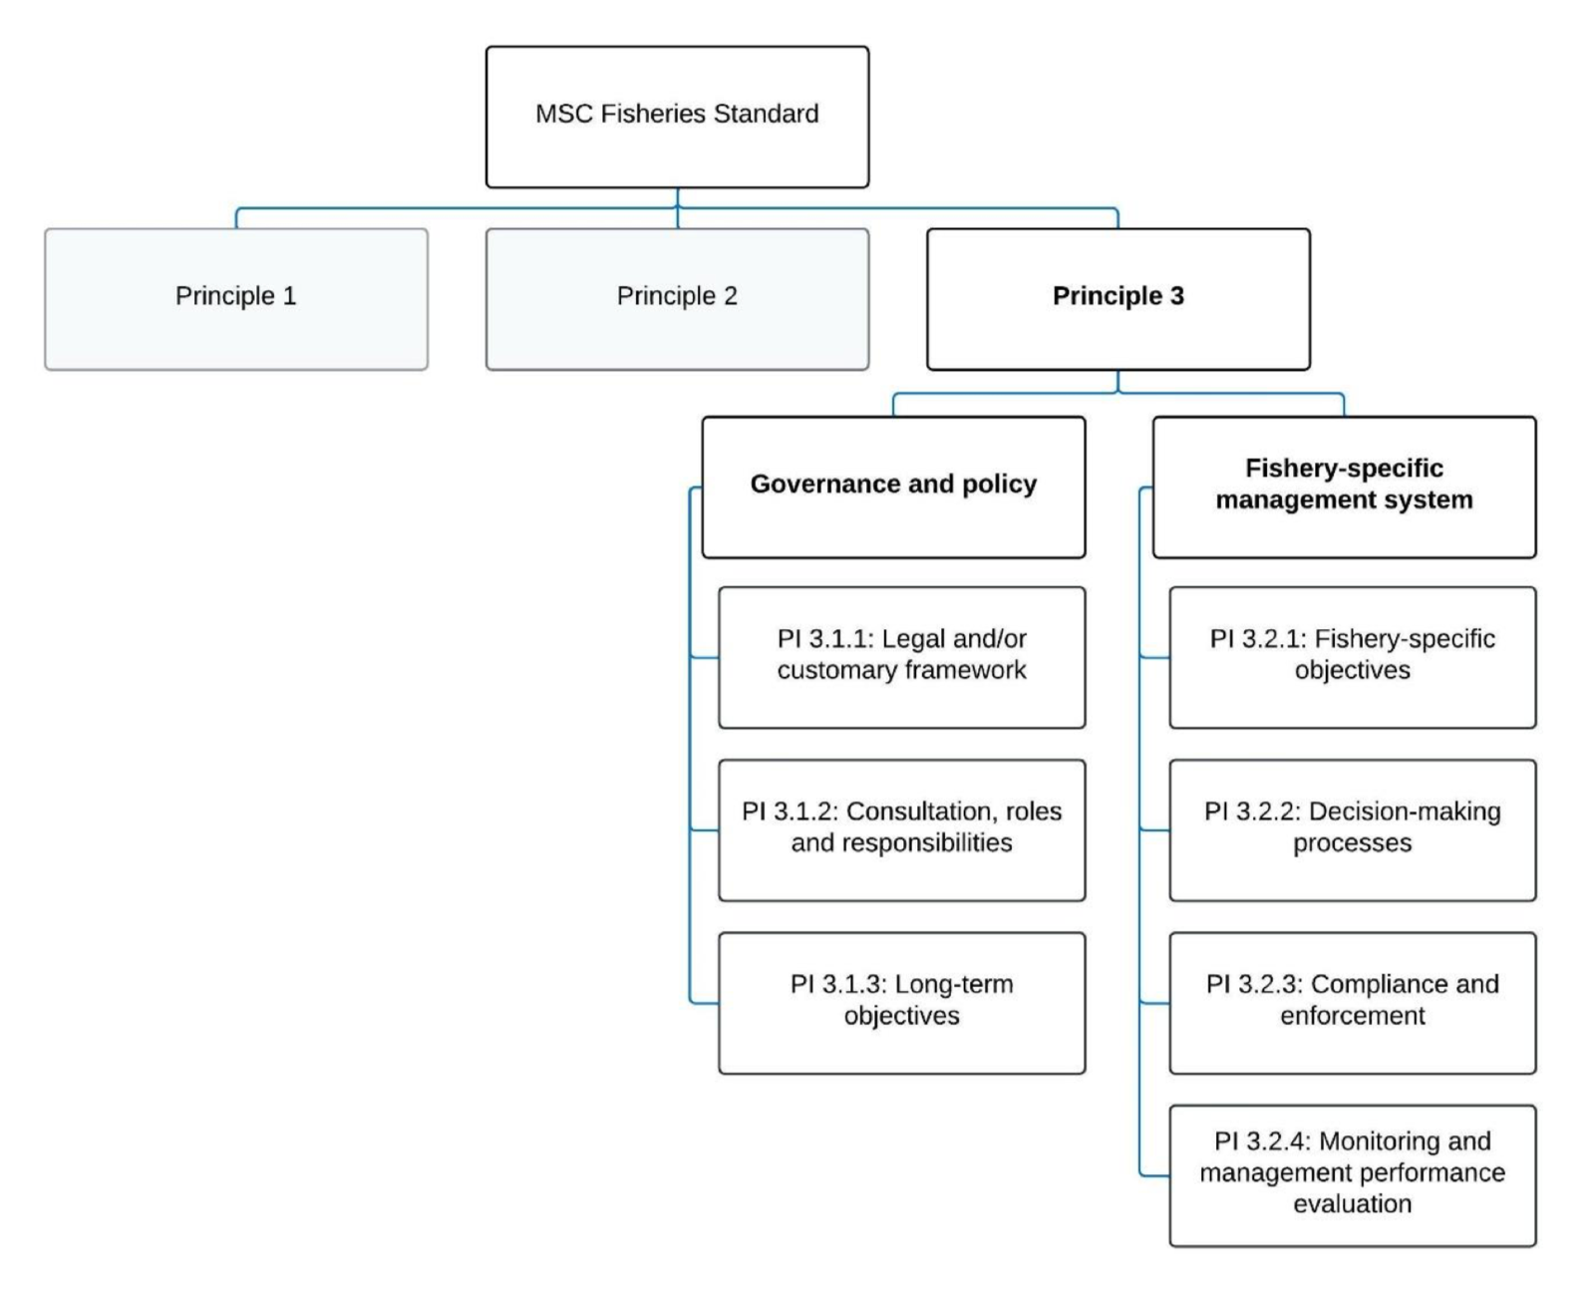
Figure 23. Decision tree for Principle 3 (MSC Fisheries Standard v3.)

4.3.2 Legal framework
Queensland's fisheries are regulated by these main pieces of legislation:
- The Fisheries Act 1994 sets out Fisheries Queensland's responsibilities for the economically viable, socially acceptable and ecologically sustainable development of Queensland's fisheries resources.
- The Fisheries (General) Regulation 2019 outlines general regulatory requirements relevant to the management and use of Queensland's fisheries resources. Section 3 provides useful advice on how to read and understand the regulations and declarations.
- The Fisheries (Commercial Fisheries) Regulation 2019 outlines the regulatory requirements that apply to Queensland’s commercial fisheries, including how activities are to be carried out.
- The Fisheries Declaration 2019 outlines restrictions on particular fishing activities across all sectors. Schedule 1 outlines regulated waters that apply in Queensland. Schedule 2 outlines the regulated fish declarations (size, possession and form requirements etc.) that apply to commercial and recreational fishers in Queensland.
- The Fisheries (Quota) Declaration 2019 outlines the quota entitlements for particular commercial fisheries, including the commercial catch limits.
The main purpose of the Fisheries Act is to “provide for the use, conservation and enhancement of the community’s fisheries resources and fish habitats in a way that seeks to apply and balance the principles of ecologically sustainable development; and promote ecologically sustainable development.”

The Fisheries Act 1994 (FA) and Fisheries (Commercial Fisheries) Regulation 2019 provide the formal legislative and administrative framework for all fisheries management in Queensland. The FA contains explicit objectives including the application of the principles of ecologically sustainable development. These objectives are consistent with national regulatory requirements including the Environmental Protection and Biodiversity Conservation Act 1999 (administered by the Australian Government).

The ECOTF is also subject to a range of provisions outlined in non-fisheries specific legislation surrounding marine parks (e.g., Marine Parks Act 2004 (Qld), Great Barrier Reef Marine Park Zoning Plan 2003 (Commonwealth) and the Great Barrier Reef Marine Park (GBRMP) Act 1975 (administered by the GBR Marine Park Authority). In addition, as part of the Wildlife Trade operation approval under the EPBC Act, one of the conditions requires the Queensland Department of Agriculture and Fisheries (DAF) to work with the GBRMP authority to develop a total effort cap for trawl operations within the GBR World Heritage Area.

4.3.3 Fishery specific management

The ECOTF area is defined by the Fisheries (Commercial Fisheries) Regulation 2019. The structure of the ECOTF is presented as 3.1.2 above. The single management unit for this harvest strategy is from Cape York to latitude 18 degrees . The fishery area is defined in Schedule 8 of the Fisheries (Commercial Fisheries) Regulation 2019 (Figure 1). The northern trawl region relies heavily on transhipment (mother shipping) services due to the remoteness of fishing locations. Fuel and product transport are key services provided by mother ships to allow vessels to remain at sea for longer periods and avoid the high fuel costs of steaming between their home port of Cairns and the fishing grounds.

As at March 2024, there were 406 active licences in the ECOTF including 364 T1 symbols.

The main management methods are:
- Limited entry: restrictions on the number and size of boats which can operate in the fishery
- Boat size restriction is 20 m for T1 fishery symbols
- 120 hull unit (hull volume) limit
- Engine capacity restrictions;
- Gear restrictions: vessel length, net headrope length and mesh restrictions apply depending on the areas of operation.
- Licence holders only have a certain number of nights they can fish each year in the form of tradeable effort units. The number of units required to operate a vessel for a single day depends on the hull units (hull volume) of the vessel. The number of units was capped at 2001 levels outside the GBRMP and at reducing levels within the GBRMP.
- Numerous and extensive permanent area closures apply to the fishery, particularly in waters of the GBR World Heritage Area.
- Seasonal/temporal closures.
- Mandatory use of TEDs and BRDs.
- A range of by-product harvesting protection arrangements.
- Logbooks for both the retained catch and ETP species (previously termed Species of Conservation Interest, surveillance by fisheries enforcement officers (the Queensland Boating and Fisheries Patrol), remote tracking of otter effort and compliance of fishing operations through mandatory satellite-based vessel monitoring system.
- Size of trawl nets is also limited to control effort in the fishery, and designs are prescribed to mitigate impacts of trawl gear on the seabed, and reduce by-catch and protected species interactions.

The different types of closures may overlap with each other and may also overlap with GBRMP closures.

4.3.4 Consultation, roles and responsibilities

Fisheries Queensland

Improving engagement with stakeholders is a key reform area of the Queensland Sustainable Fisheries Strategy: 2017–2027, and is fundamental to successfully implementing the strategy and ensuring sustainable fisheries. QDAF have an online “engagement hub” to communicate to clients and stakeholders.
The role of Fisheries Queensland is to:
- provide direction for working groups in the form of a work program
- arrange meeting times and provide logistical support for meetings
- prepare and distribute meeting materials to support the effective operation of the working group
- provide information and data to support the work of the working group
- provide a point of communication between the working group, other working groups and the Sustainable Fisheries Expert Panel in accordance with each terms of reference
- maintain communication with the working group members at least every three months.
Decision-making powers are enshrined within the Queensland fisheries legislation. In order to implement the harvest strategy, it was endorsed by the Deputy Director-General (DDG) (Fisheries and Forestry) in accordance with delegated powers under Part 2, Division 1 (Harvest Strategies) of the Fisheries Act 1994 and finally approved by the Minister responsible for fisheries in accordance with Section 16 of the same FA. When developing the harvest strategy, information collected through stakeholder consultation, and advice from expert panels and working groups was considered.

Sustainable Fisheries Expert Panel
A key action of the Sustainable Fisheries Strategy is to support evidence-based fisheries management through a sustainable fisheries expert panel. In July 2017, the Sustainable Fisheries Expert Panel was established with members in the areas of fish biology, stock assessment, fisheries management, social and economic science, and marine ecology. Further information on how the SFEP was chosen is available online, along with biographies of each member and communiques of meetings. The purpose of the Panel is to provide independent expert advice to the Minister responsible for fisheries and Fisheries Queensland on best practice fisheries management and implementation of the Sustainable Fisheries Strategy. The expert panel is advisory only. It is not a decision-making body. The expert panel will review key outputs from the working groups, such as harvest strategies (Figure 24).

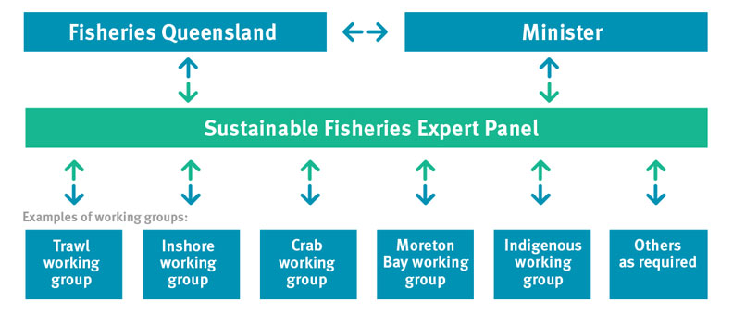
Figure 24. Flow diagram illustrating the process of review, consultation and consideration of information and advice prior to, and post, decision making (Source, Fisheries Queensland

Trawl Working group

The Trawl Working Group includes a wide range of stakeholders from the scientific community, management agencies, conservation groups and the commercial and recreational fishing sectors.
- To assist with the review of the management framework, including management options and fishing rules, and the development of harvest strategies consistent with the Sustainable Fisheries Strategy 2017-2027, the Queensland Harvest Strategy Policy and the Fisheries Act 1994.
- To provide general advice to Fisheries Queensland on any operational matters, emerging issues and general management of Queensland’s east coast, Moreton Bay, stout whiting and beam trawl fisheries.

4.3.5 Compliance and enforcement
A Compliance Risk Assessment and Strategy is in place to assist the Queensland Boating and Fisheries Patrol (QBFP) to deliver compliance operational plans across Queensland. The strategy is available at:
- https://www.daf.qld.gov.au/__data/assets/pdf_file/0018/284112/fisheries-compliance- qld.pdf
An interactive overview describing key elements of the QDAF monitoring program is available at:
- https://www.daf.qld.gov.au/business-priorities/fisheries/monitoring-compliance/interactive-map
As a part of the Compliance Strategy, compliance risk assessments are conducted to develop the state fisheries compliance plan and regional fisheries operational plans. The key outcome is to maximise voluntary compliance.
During 2023–24, there were 248 inspections were carried out on the east coast commercial net fishing vessel inspections. There were 91 offences for east coast commercial fishers resulting in a compliance rate of 76.6%. There is no data available on the compliance rate in the northern region only.

4.3.6 Queensland Evaluation and management reviews
There are several mechanisms in place for monitoring and evaluating the performance of various aspects of the management system of the ECOTF, including:
- The trawl fishery working group reviews harvest strategy decision rules, implementation of WTO conditions, stock assessment processes and other management proposals.
- The fishery is subject to an assessment against the Australian Government’s Guidelines for the Ecologically Sustainable Management of Fisheries under the EPBC Act is generally completed every three years (most recently in 2021).
- Assessments of target and important byproduct are conducted every 1–3 years through the SAFS process, although SAFS has been delayed, and the stock assessments are summarised on the QDAF website stock assessment program.

Principle 3 References:

Department Agriculture, Water and the Environment. (2021). Assessment of the Queensland East Coast Otter Trawl Fishery. Canberra: Department of Agriculture, Water and Environment. https://www.dcceew.gov.au/sites/default/files/documents/qld-east-coast-otter-trawl-assessment-2021.pdf

Butler, I. A. Roelofs & M. Kangas (2020) Banana Prawns 2020 Status of Australian Fish Stocks. FRDC, Canberra, Australia. Available at: https://www.fish.gov.au/report/272-BANANA-PRAWNS-2020# Access 22 March 2024.
Zeller, B., 2017. Submission for the reassessment of the Queensland East Coast Otter Trawl Fishery Part 13 Accreditation and Wildlife Trade Operation approval under the Environment Protection and Biodiversity and Conservation Act 1999 A report prepared by the Queensland De. Brisbane, Queensland.

Principle 3 Performance Indicator scores and rationales

Government and Policy

PI 3.1.1 – Legal and/or customary framework
PI 3.1.1 |  | The management system exists within an appropriate and effective legal and/or customary framework which ensures that it:  - Is capable of delivering sustainability in the UoA(s);  - Observes the legal rights created explicitly or established by custom of people dependent on fishing for food or livelihood; and  - Incorporates an appropriate dispute resolution framework
Scoring issue |  | SG 60 | SG 80 | SG 100
a | Compatibility of laws or standards with effective management
a | Guide post | There is an effective national legal system and a framework for cooperation with other parties, where necessary, to deliver management outcomes consistent with MSC Principles 1 and 2. | There is an effective national legal system and organised and effective cooperation with other parties, where necessary, to deliver management outcomes consistent with MSC Principles 1 and 2. | There is an effective national legal system and binding procedures governing cooperation with other parties that deliver management outcomes consistent with MSC Principles 1 and 2.
a | Met? | Yes | Yes | Not scored
Rationale |  | The ECOTF is managed in accordance with the objectives of the Fisheries Act 1994 and subordinate legislation including the Fisheries (General) Regulation 2019, Schedule 2 of Fisheries (Commercial Fisheries) Regulation 2019, Fisheries Declaration 2019; and Fisheries Quota Declaration 2019.  The Trawl Fishery Working Group also provides advice on aspects of fisheries management. SG 60 and SG 80 are met.
b | Resolution of disputes
b | Guide post | The management system incorporates or is subject by law to a mechanism for the resolution of legal disputes arising within the system. | The management system incorporates or is subject by law to a transparent mechanism for the resolution of legal disputes which is considered to be effective in dealing with most issues and that is appropriate to the context of the UoA. | The management system incorporates or is subject by law to a transparent mechanism for the resolution of legal disputes, which is appropriate to the context of the fishery and has been tested and proven to be effective.
b | Met? | Yes | Yes | Not scored
Rationale |  | Within the Fisheries Act 1994, there is a transparent mechanism that provides for an internal review of a decision made by the Department of Agriculture and Fisheries; specifically, Section 196(1) of the FA is the provision for appeal.  Any person who has been given an information notice relating to the appeal decision can apply for a review of a decision under the FA. SG 60 and SG 80 are met.
c | Respect for rights
c | Guide post | The management system has a mechanism to generally respect the legal rights created explicitly or established by custom of people dependent on fishing for food or livelihood in a manner consistent with the objectives of MSC Principles 1 and 2. | The management system has a mechanism to observe the legal rights created explicitly or established by custom of people dependent on fishing for food or livelihood in a manner consistent with the objectives of MSC Principles 1 and 2. | The management system has a mechanism to formally commit to the legal rights created explicitly or established by custom of people dependent on fishing for food and livelihood in a manner consistent with the objectives of MSC Principles 1 and 2.
c | Met? | Yes | Yes | Not scored
Rationale |  | The rights of customary fishers are recognised by the Section 14 exemption in the Fisheries Act that allows for an “Aborigine or Torres Strait Islander” to take fish for “the purpose of satisfying a personal, domestic or non-commercial communal need”.  In Queensland, the Fisheries Act 1994 defines traditional fishing as:  - the taking, using or keeping of the fisheries resources is for the purpose of satisfying a personal, domestic or non-commercial communal need of Aboriginal or Torres Strait Islander people, and  - it is carried out in accordance with the particular traditional laws and customs of native title holders or Traditional Owners of the area being fished, and  - those Aboriginal or Torres Strait Islander people, by their laws and customs, have a connection with the land or waters.  This definition is consistent with the federal Native Title Act 1993. It recognises that traditional fishing may vary from group to group, and that traditional ways of fishing evolve over time and may include modern methods and materials. SG 60 and SG 80 are met.

Draft scoring range | ≥80
Information gap indicator

PI 3.1.2 – Consultation, roles, and responsibilities
PI 3.1.2 |  | The management system has effective consultation processes that are open to interested and affected parties. The roles and responsibilities of organisations and individuals who are involved in the management process are clear and understood by all relevant parties
Scoring issue |  | SG 60 | SG 80 | SG 100
a | Roles and responsibilities
a | Guide post | Organisations and individuals involved in the management process have been identified. Functions, roles, and responsibilities are generally understood. | Organisations and individuals involved in the management process have been identified. Functions, roles, and responsibilities are explicitly defined and well understood for key areas of responsibility and interaction. | Organisations and individuals involved in the management process have been identified. Functions, roles, and responsibilities are explicitly defined and well understood for all areas of responsibility and interaction.
a | Met? | Yes | Yes | Not scored
Rationale |  | The roles and responsibilities of organisations and individuals who are involved in the management process are clear and understood by all relevant parties and are summarised in the Harvest Strategy Policy (QDAF, 2021). There are several available examples of evidence that the stakeholders have been identified and engaged in management amendments. In 2017 the fishery underwent a major review and reform; an example of that stakeholder engagement during major amendments is available https://qsia.com.au/wp-content/uploads/2018/03/Trawl-Discussion-Paper.pdf  - The functions of the Minister and powers of the Chief Executive are explicit in the Fisheries Act 1994.  - The role and functions of QDAF and the Fisheries portfolio are explicitly defined in QDAFs Annual Report  - The roles of the Sustainable Fisheries Expert Panel and the trawl working group members are clearly documented in the Queensland Sustainable Fisheries Strategy (DAF 2017).  SG 60 and SG 80 are met.
b | Consultation processes
b | Guide post | The management system includes consultation processes that obtain relevant information from the main affected parties, including local knowledge, to inform the management system. | The management system includes consultation processes that regularly seek and accept relevant information, including local knowledge. The management system demonstrates consideration of the information obtained. | The management system includes consultation processes that regularly seek and accept relevant information, including local knowledge. The management system demonstrates consideration of the information and explains how it is used or not used.
b | Met? | Yes | Yes | Not scored
Rationale |  | QDAF has a Stakeholder Engagement Charter that stipulates how to engage stakeholders.  Furthermore, a key objective of the Sustainable Fisheries Strategy is to improve stakeholder engagement and support evidence-based fisheries management through the use of a sustainable fisheries expert panel.  To improve engagement with stakeholders, QDAF:  - consult with the sustainable fisheries expert panel and trawl fishery working group on a regular basis, and publicly publish the meeting communiques online;  - has a specific webpage for consultations so all stakeholders can access opportunities to provide input;  - publishes the Catch news e-newsletter to include fisheries information for all stakeholders;  - publish a Commercial fishing update e-newsletter to keep commercial fishers informed of the latest fisheries management information.  Public consultation is also available for the application for export approval (wildlife trade operation). SG 60 and SG 80 are met.
c | Participation
c | Guide post |  | The consultation process provides opportunity for all interested and affected parties to be involved. | The consultation process provides opportunity and encouragement for all interested and affected parties to be involved, and facilitates their effective engagement.
c | Met? |  | Yes | Not scored
Rationale |  | QDAF has a Stakeholder Engagement Charter that stipulated how to be inclusive, transparent and respectful with stakeholder engagement. The Working Group charter outlines the responsivities and participation requirements.  Workshops are regularly held to discuss the Sustainable Fisheries Strategy, the harvest strategy for the Northern Trawl Fishery and Scallop assessments:  - 16–17 May 2022 in Cairns.  - 19 October 2021 online  - 31 Jan- 1 Feb 2019 in Townsville  During the meetings, industry members raised concerns regarding potential for effort shift etc. The consultation processes that are in place for the ECOTF and across fisheries in Queensland provide opportunity for all interested parties and affected parties to be involved; SG80 is met.

Draft scoring range | ≥80
Information gap indicator

PI 3.1.3 – Long term objectives
PI 3.1.3 |  | The management policy has clear long-term objectives to guide decision-making that are consistent with the MSC Fisheries Standard, and incorporates the precautionary approach
Scoring issue |  | SG 60 | SG 80 | SG 100
a | Objectives
a | Guide post | Long-term objectives to guide decision-making, consistent with the MSC Fisheries Standard and the precautionary approach, are implicit within management policy. | Clear long-term objectives that guide decision-making, consistent with the MSC Fisheries Standard and the precautionary approach, are explicit within management policy. | Clear long-term objectives that guide decision-making, consistent with the MSC Fisheries Standard and the precautionary approach, are explicit within and required by management policy.
a | Met? | Yes | Yes | Not scored
Rationale |  | Clear long-term objectives for the ECOTF are articulated in the broadest of terms in the Fisheries Act. Guidance for decision making are contained in Division 2 of the Fisheries Act 1994 with reference to precautionary approach being underlined:  “The main purpose of this Act is to provide for the use, conservation and enhancement of the community’s fisheries resources and fish habitats in a way that seeks to—  (1) (a) apply and balance the principles of ecologically sustainable development; and  (b) promote ecologically sustainable development.  (2) In balancing the principles, each principle is to be given the relative emphasis appropriate in the circumstances, having regard to ensuring access to the fisheries resources is allocated in a way that maximises the potential economic, social and cultural benefits to the community.  (3) Despite the main purpose of this Act, a further purpose of this Act is to reduce the possibility of shark attacks on humans in coastal waters of the State adjacent to coastal beaches used for bathing.  (4) Subsections (1) and (3) do not limit the purposes of this Act.  (5) In this section—  ecologically sustainable development means using, conserving and enhancing the community’s fisheries resources and fish habitats so that—  (a) the ecological processes on which life depends are maintained; and  (b) the total quality of life, both now and in the future, can be improved.  precautionary principle means the principle that, if there is a threat of serious or irreversible environmental damage, lack of scientific certainty should not be used as a reason to postpone measures to prevent environment degradation, or possible environmental degradation, because of the threat.  Principles of ecologically sustainable development mean the following principles—  (a) enhancing individual and community wellbeing through economic development that safeguards the wellbeing of future generations;  (b) providing fairness within and between generations;  (c) protecting biological diversity, ecological processes and life-support systems;  (d) in making decisions, effectively integrating fairness and short and long-term economic, environmental and social considerations;  (e) considering the global dimension of environmental impacts of actions and policies;  (f) considering the need to maintain and enhance competition, in an environmentally sound way;  (g) considering the need to develop a strong, growing and diversified economy that can enhance the capacity for environmental protection;  (h) that decisions and actions should provide for broad community involvement on issues affecting them;  (i) the precautionary principle.”  Given that the objectives relate to pursuing ecologically sustainable development and reference the use of, and define, the precautionary approach SG 60 is met. The Act also goes further to state how the purposes of the Act will primarily be achieved at the broad level. The objectives articulated under GBRMPA legislation are clear and do include explicit reference to the precautionary principle. There are clear long-term objectives that guide decision making consistent with MSC standard. Therefore, SG80 is met.

Draft scoring range | ≥80
Information gap indicator

Fishery Specific Management Systems

PI 3.2.1 – Fishery-specific objectives
PI 3.2.1 |  | The fishery-specific management system has clear, specific objectives designed to achieve the outcomes expressed by MSC Principles 1 and 2
Scoring issue |  | SG 60 | SG 80 | SG 100
a | Objectives
a | Guide post | Objectives, which are broadly consistent with achieving the outcomes expressed by MSC Principles 1 and 2, are implicit within the fishery-specific management system. | Short and long-term objectives, which are consistent with achieving the outcomes expressed by MSC Principles 1 and 2, are explicit within the fishery-specific management system. | Well-defined and measurable short- and long-term objectives, which are demonstrably consistent with achieving the outcomes expressed by MSC Principles 1 and 2, are explicit within the fishery-specific management system.
a | Met? | Yes | No | Not scored
Rationale |  | The objective of the harvest strategy that relates to the ECOTF (northern) is to manage the fishery in accordance with the objectives of the Fisheries Act 1994 and the Queensland Sustainable Fisheries Strategy: 2017–2027 (QDAF 2021). Fishery objectives set out the aspirations and operational direction for the management of the fishery in the long term.  The primary objective of the Northern trawl region is to maintain the target species at, or returned to, a target spawning biomass level that aims to maximise economic yield (MEY) for the fishery.  In pursuing the primary objective, the harvest strategy aims to:  - minimise and mitigate any unacceptable ecological risks arising from fishing-related activities;  - maximise economic performance of the commercial sector; and  - monitor the broader social and economic benefits of the fishery to the community.  With regard to objectives being consistent with achieving outcomes expressed in P1 and P2 of the MSC, the following indicators within the harvest strategy are relevant:  Principle 1 species (Tiger Prawns and Endeavour prawns):  - Only Tiger prawns are target (Tier 1) species for this fishery;  - Endeavour prawns are managed as a Tier 2 species in the Harvest Strategy. If a stock assessment with reference to target and limit reference points is unavailable, stock status is based on annual commercial logbook catches (2010–19). Catches outside of the defined range for two consecutive years would trigger a review, a stock assessment and the potential to introduce management triggers of trip/size limits or spatial/temporal closures.  Principle 2 interactions:  - Banana Prawn and MBB are also managed as a Tier 2 species although they are not taken in sufficient quantities to be assessed as a P2 species.  - For other byproduct species (Tier 3), there is management in place, but no Tier 3 species was taken in sufficient quantities to be assessed as a P2 species.  - Discard species are not monitored and there is no mention of such species in the HS.  - The harvest strategy aims to minimise and mitigate high ecological risks arising from fishing. If the ERA identifies that fishing impacts are considered to generate an unacceptable level of risk to an ecological component (includes non target species, ETPs and the broader ecosystem), a review is triggered to investigate the reason for the risk, and appropriate management action taken to reduce the risk to an acceptable level.  - If the Northern trawl region trawl footprint in any given year is greater than the 2019 effort footprint, a review will be undertaken to understand the reason for the increased effort footprint and identify appropriate management strategies to reduce the risk, including options that reduce the permitted area that can be trawled. If the review identifies sustainability is at risk, management action is required within two years.  In summary, defined and measurable short and long-term objectives, which are demonstrably consistent with achieving the outcomes expressed by MSC’s Principle 1 are implicit within the fishery’s management system achieving SG60. Whilst some components of Principle 2 (in-scope species and habitats) are within the harvest strategy, the assessment team was unable to find explicit long and short- term objectives for ETPs or discards and therefore SG 80 is not met.

Draft scoring range | 60–79
Information gap indicator

PI 3.2.2 – Decision-making processes
PI 3.2.2 |  | The fishery-specific management system includes effective decision-making processes that result in measures and strategies to achieve the objectives, and has an appropriate approach to actual disputes in the fishery
Scoring issue |  | SG 60 | SG 80 | SG 100
a | Decision-making processes
a | Guide post | There are some decision-making processes in place that result in measures and strategies to achieve the fishery-specific objectives. | There are established decision-making processes that result in measures and strategies to achieve the fishery-specific objectives.
a | Met? | Yes | Yes
Rationale |  | Decisions on the introduction of fisheries measures and strategies are informed through a range of information sources including QDAF, the Sustainable Fisheries Expert panel, other Government agencies, feedback from public consultation. In addition, the trawl fishery working group provides operational advice on the management of the trawl fishery in line with their terms of reference.  The Harvest Strategy Policy (QDAF, 2021) states that: “Harvest strategies provide a transparent decision-making framework for fisheries management, by Fisheries Queensland on behalf of the Queensland Government, to provide greater certainty for fishers, managers and other stakeholders.”  The ECOTF Northern harvest strategy (QDAF 2021e) stipulates the decision rules for commonly caught species (by Tier 1, 2 and 3) and ecological risks that are designed to ensure the fishery specific objectives are achieved. There are also processes in place that could be immediately triggered, such as the closure of trawl operations in certain region when an effort cap is reached; together, this meets SG 60 and SG 80.
b | Responsiveness of decision-making processes
b | Guide post | Decision-making processes respond to serious issues identified in relevant research, monitoring, evaluation, and consultation, in a transparent, timely and adaptive manner, and take some account of the wider implications of decisions. | Decision-making processes respond to serious and other important issues identified in relevant research, monitoring, evaluation, and consultation, in a transparent, timely, and adaptive manner, and take account of the wider implications of decisions. | Decision-making processes respond to all issues identified in relevant research, monitoring, evaluation, and consultation, in a transparent, timely, and adaptive manner, and take account of the wider implications of decisions.
b | Met? | Yes | Yes | Not scored
Rationale |  | The decision-making process for the ECOTF is consistent with those for the broader Queensland management system and responds to the specific harvest strategy, which respond to research, outcome evaluations and monitoring programs. Specific and relevant issues are evaluated through the Trawl Working Group. SG 60 is met.  It is important to note that the issues identified in the ERA and WTO application have differing levels of being addressed, and some recommendations remain outstanding. There are time-based conditions that have been place on the current WTO approval. SG 80 is met as the decision-making processes of the ECOTF clearly responded to the most serious issues first (i.e., scallop closures outside of the UoA area). The HS is due for a review/update in 2026.
c | Use of precautionary approach
c | Guide post |  | Decision-making processes use the precautionary approach and are based on best available information.
c | Met? |  | Yes
Rationale |  | The precautionary approach is explicit in the Fisheries Act 1994 and at the broader overarching legislative instruments, there is also evidence of the fishery specific decision-making processes use the precautionary approach within the harvest strategy for the northern trawl region.  Both the 2017–27 Sustainable Fisheries Strategy and Harvest Strategy Policy stipulate the use of precaution. For example, the use of default proxies for B_{MEY} and B_{MSY} (60% and 40% of unfished biomass respectively), provides a clear and consistent approach for setting target reference points in the absence of species or stock specific data (e.g. economic information).  The provides information on decision rules for each commonly retained species (Tier 1–3), although there is very little information on the use of precaution for the management of discarded species outside of the ERA.  Pears et al. (2012) conducted a thorough assessment of the fishery, including the area of the UoA. During the refined ERA (Dedini et al. 2023) only SOCI (Species of Conservation Interest) including ETP species and elasmobranches were assessed with additional precaution to flag the potential need of future management attention. SG 80 is met.
d | Accountability and transparency of management system and decision-making process
d | Guide post | Some information on the fishery’s performance and management action is generally available on request to stakeholders. | Information on the fishery’s performance and management action is available on request, and explanations are provided for any actions or lack of action associated with findings and relevant recommendations emerging from research, monitoring, evaluation, and review activity. | Formal reporting to all interested stakeholders provides comprehensive information on the fishery’s performance and management actions and describes how the management system responded to findings and relevant recommendations emerging from research, monitoring, evaluation, and review activity.
d | Met? | Yes | Yes | Not scored
Rationale |  | QDAF’s Annual report 2022–23 provides information on their performance against defined objectives (outlined in the Strategic plan 2021–25 (refreshed for 2022)).  The Harvest Strategy Policy (QDAF, 2021) and North Harvest Strategy (QDAF, 2021e) contain monitoring and performance indicators and provided the basis for incorporating relevant recommendations emerging from research, monitoring, evaluation and review activity. The UoA harvest strategy is in place for a period of five years (2021–2026), after which time it will be fully reviewed in accordance with the Fisheries Act 1994. The harvest strategy may also be subject to further review and amendment as appropriate within the five-year period if any of the following circumstances arise:  - there is new information that substantially changes the status of a fishery, leading to improved estimates of indicators relative to reference points  - drivers external to management of the fishery increase the risk to fish stock/s  - it is clear the strategy is not working effectively and the intent of the harvest strategy policy is not being met.  There are several formal reporting mechanisms available to all interested stakeholders that provides comprehensive information on stock status, compliance activities, management changes, explanations for lack of actions, and industry projects/initiatives underway; SG 60 and SG 80 are met.
e | Approach to disputes
e | Guide post | Although the management authority or fishery may be subject to continuing court challenges, it is not indicating a disrespect or defiance of the law by repeatedly violating the same law or regulation necessary for the sustainability of the fishery. | The management system or UoA is attempting to comply in a timely fashion with judicial decisions arising from any legal challenges. | The management system or UoA acts proactively to avoid legal disputes or rapidly implements judicial decisions arising from legal challenges.
e | Met? | Yes | Yes | Not scored
Rationale |  | The consultation and advisory processes ensure that the management system in each sub fishery acts proactively to avoid legal disputes.  Queensland Civil and Administrative Tribunal (QCAT) is able to review decisions from the Department of Agriculture and Fisheries in the use, conservation and enhancement of the community’s fisheries resources and fish habitats. There are no legal challenges known to the assessment team. SG 60 and 80 is met.

Draft scoring range | ≥80
Information gap indicator

PI 3.2.3 – Compliance and enforcement
PI 3.2.3 |  | Monitoring, control, and surveillance (MCS) mechanisms ensure the management measures in the UoA are enforced and complied with
Scoring issue |  | SG 60 | SG 80 | SG 100
a | MCS system
a | Guide post | Monitoring, control and surveillance mechanisms exist, and are implemented in the fishery and there is a reasonable expectation that they are effective. | A monitoring, control and surveillance system has been implemented in the fishery and has demonstrated an ability to enforce relevant management measures, strategies and/or rules. | A comprehensive monitoring, control and surveillance system has been implemented in the fishery and has demonstrated a consistent ability to enforce relevant management measures, strategies and/or rules.
a | Met? | Yes | Yes | Not scored
Rationale |  | A Compliance Risk Assessment and Strategy is in place to assist the Queensland Boating and Fisheries Patrol (QBFP) to deliver compliance operational plans across Queensland.  QDAF has undertaken a post implementation impact analysis statement (PI-IAS) of the vessel tracking regulations contained within Chapter 4, Part 1 of the Fisheries (General) Regulation 2019. The PI-IAS considered the impacts of the vessel tracking regulation since it was introduced and any recommendations for the regulation looking forward.  Data collected from vessel tracking is used by QBFP to observe in real time the commercial fishing fleet (identified down to an individual fishing vessel) in order to:  - monitor compliance with closures  - monitor real-time movement of vessels for at sea and landing inspections  - manage compliance of reporting obligations such as logbooks.  Overall, it has been reported by QBFP that data from vessel tracking has enabled QBFP to improve its compliance activities in line with its risk-based compliance approach.  During 2010, compliance rates for the entire ECOTF was 85% and the main offences relate to operation in regulated waters and TED/BRD use. In 2023–24 compliance rate for the ECOTF was 76.6% of the 248 inspections.  Compliance activities include on-water inspections, verification of catch and effort reported in logbooks, and checks of ETP species logbooks. There are also port inspections of gear. Fleet composition is well understood and sufficient data are collected to support the harvest strategy including vessel details, VMS data, fishing effort (hours and distribution), and vessel power of the fleet.  With regard to monitoring, there are catch records for the key species for all important sources of fishing mortality Furthermore, a new electronic monitoring project is in a trial phase for the ECOTF, although there is no data on number of UoA vessels signed up to use the QDAF e-monitoring gear. SG 80 is met.
b | Sanctions
b | Guide post | Sanctions to deal with non-compliance exist and there is some evidence that they are applied. | Sanctions to deal with non-compliance exist, are consistently applied and thought to provide effective deterrence. | Sanctions to deal with non-compliance exist, are consistently applied and demonstrably provide effective deterrence.
b | Met? | Yes | Yes | Not scored
Rationale |  | The sanctions applied for breaches of regulations operate on a sliding scale including a warning, issuing a Fisheries Infringement Notice caution (an on-the-spot fine with no further official penalty), a range of fines, and court appearances for more severe breaches that may lead to confiscation of catches and equipment. Therefore, SG80 is met.
c | Compliance (information)
c | Guide post | Fishers are generally thought to comply with the management system for the fishery under assessment, including, when required, providing information of importance to the effective management of the fishery. | Some evidence exists to demonstrate fishers comply with the management system under assessment, including, when required, providing information of importance to the effective management of the fishery. | There is a high degree of confidence that fishers comply with the management system under assessment, including, providing information of importance to the effective management of the fishery.
c | Met? | Yes | Yes | Not scored
Rationale |  | Some evidence exists to demonstrate fishers comply with the previous management system, including, when required, providing information of importance to the effective management of the fishery. Zeller, (2017) stated: “From 2013-16 compliance with ECOTF management arrangements has been high. From 2013 to present, 927 otter trawl vessel inspections were conducted. A total of 273 offences were detected. This translates to an average management regime compliance rate of 86%. In order of decreasing prevalence, the type of offences committed requiring either an official caution or infringement notice with financial penalty ranged from contravening a condition of an authority (includes BRD and TED non-compliance), failing to keep or provide information as required (includes failure to keep logbooks and submit logbook returns), contravention of regulated waters (includes fishing within closure areas or periods), and possession of regulated species or undersized catch. More serious offences that led to prosecution made up only a small percentage of total offences. Most were for failing to keep or provide information as required, possession of regulated species or undersized catch and contravention of regulated waters.”  The UoA management system under assessment includes the 2021 harvest strategy; quarterly compliance reports are produced for all fisheries by QDAF although data is not separated by location/fishery. SG80 is met.
d | Compliance (outcome)
d | Guide post |  | There is no evidence of systematic non-compliance
d | Met? |  | No
Rationale |  | With the data made available it is difficult to determine is systematic non-compliance is evident in the UoA. Whilst the team is unaware of any evidence of systematic non-compliance in the Northern sub-fishery compliance data is not divided by region. Whilst the 91 ECOTF offences are categorised, there is no assessment of how they relate to past offences. Further data is required, SG 80 is not met.

Draft scoring range | 60-79
Information gap indicator | Compliance data for fleet, number of inspections, number of sanctions, cases of re-offending etc.

PI 3.2.4 – Monitoring and management performance evaluation
PI 3.2.4 |  | There is a system for monitoring and evaluating the performance of the fishery-specific management system against its objectives. There is effective and timely review of the fishery-specific management system
Scoring issue |  | SG 60 | SG 80 | SG 100
a | Evaluation coverage
a | Guide post | There are mechanisms in place to evaluate some parts of the fishery-specific management system. | There are mechanisms in place to evaluate key parts of the fishery-specific management system. | There are mechanisms in place to evaluate all parts of the fishery-specific management system.
a | Met? | Yes | Yes | Not scored
Rationale |  | There are mechanisms in place to evaluate key parts of the fishery-specific management system (harvest strategy), through working groups, expert fisheries panel, research, compliance and monitoring. In 2016, QDAF underwent a major review regarding legislative instruments, decision-making framework, harvest strategies, data and information, consultation and compliance (QDAF, 2016). Reform strategies to the ECOTF were specifically discussed (QDAF, 2018) and significant amendments were implemented as a result of those evaluations.  This Sustainable Fisheries Strategy 2017–2027 is reviewed regularly (5 years) to ensure it is effectively delivering the vision for sustainable fisheries management in Queensland and ensure the targets and actions are being successfully implemented. The latest progress report was published in 2022 and provides a summary of deliverables being on track for completion by 2027. SG 60 and SG 80 are met.
b | Internal and/or external review
b | Guide post | The fishery-specific management system is subject to occasional internal review. | The fishery-specific management system is subject to regular internal and occasional external review. | The fishery-specific management system is subject to regular internal and external review.
b | Met? | Yes | Yes | Not scored
Rationale |  | The fishery-specific management system is subject to regular internal and occasional external review, through working groups and expert fisheries panel. Further, the expert panel has the ability to acquire external review of components of the ECTOF management system for advice. Example include the external review, advice and stakeholder engagement for the ECOTF harvest strategies (QDAF, 2021b), including the northern HS. Therefore, SG60 is met.  The fishery is also assessed externally every three years to permit export under the Environment Protection and Biodiversity Conservation Act 1999 (Wildlife Trade Operations); the fishery’s current export approval expires in December 2024 (DAWE 2021). SG80 is met.

Draft scoring range | ≥80
Information gap indicator

Template information, copyright and disclaimer

The Marine Stewardship Council’s ‘MSC Pre-Assessment Reporting Template v3.3’ and its content is copyright of “Marine Stewardship Council” - © “Marine Stewardship Council” 2022. All rights reserved.

A controlled document list of MSC program documents is available on the MSC website (https://www.msc.org/for-business/certification-bodies/supporting-documents).

This MSC pre-assessment has been undertaken using publicly available material generated primarily through web-searches and from confidential fishery data provided by the Client or data formally requested from the Queensland Department of Agriculture and Fisheries . Source material used to justify scoring is referenced. It is not impossible that additional material exists (particularly that held internally by the management and scientific agencies responsible for the management of the fishery) that could influence the justification and scores.

Assessor Disclaimer: All reasonable efforts have been taken to ensure the quality of this report, the authors do not warrant that the information is free from errors or omissions. The authors do not accept any form of liability, be it contractual, tortuous or otherwise, for the contents of this report or for any consequences arising from its use or any reliance placed upon it. This information is intended explicitly for the use by the Client and their chosen partners for the assessment of the defined UoA using the MSC Fisheries Standard v3. The author does not provide permission under any circumstances for the information presented in this report to be made publicly available to third parties without the written consent from the Client.

List of Tables
Table 1: Fisheries program documents versions 5
Table 2: Units of Assessment (UoA) 6
Table 3. Summary of Principle level scores for UoAs 3 & 4, ECOTF Northern Zone. 8
Table 4. UoA 3 Tiger Prawn Performance Indicator level draft scores and comments for those that scored < 80 8
Table 5. UoA 4 Endeavour Prawn Performance Indicator level draft scores and comments for those that scored < 80 9
Table 6. Logbook catch data for Tiger Prawn and Endeavour Prawn from the ECOTF, UoA = Northern region. 19
Table 7. History of Prawn management in Queensland (Lovett et al. 2023). 23
Table 8. Summary of model outcomes for all endeavour prawn scenarios—B₂₀₂₁ % is the most likely biomass in 2021 relative to unfished in 1968 with the 95 % credible interval (CI) (Fox et al. 2023b). 26
Table 9. Target (Tier 1), secondary (Tier 2) and permitted species as outlined in the regional East Coast Otter Trawl Fishery (ECOTF) harvest strategies 2 All five regional harvest strategies can be accessed at: https://www.daf.qld.gov.au/business-priorities/fisheries/sustainable/harvest-strategy (Source: Dedini et al. 2023b). 49
Table 10. Reported annual retained catch (t) from the northern region of the ECOTF by year (Source: QDAF FDR- 663) ETP species in italics with asterisks and species that make up ≥5% of retained catch in bold and highlighted. (Yellow = P1 species, Orange = P2 main species Blue = P2 minor species) 52
Table 11. Retained and discard species categorisation into components for this assessment. Discard species specific to the Northern region are unknown, and as such, discard species that were identified as high or precautionary high risk in the 2012 (Pears et al. 2012) and/or 2023 (Dedini et al. 2023). ERAs or those ETP species listed in ETP logbooks are listed here. Saucer Scallop are discarded with mandatory reporting in logbooks. (Yellow = P1; Orange = P2 Main; Blue = P2 minor; Green = ETP species) 54
Table 12. Annual sawfish interactions with the ECOTF as reported in ETP logbooks (Figure 4) and recent interaction data made publicly available . 58
Table 13. Reported Sea snake interaction and life status recorded by logbooks in the north sub-fishery and entire ECOTF by year 64
Table 14. Risk assessment of marine habitats (ordered according to 2009 risk levels) (source: (Morison and Pears, 2012)). 69

https://www.federalregister.gov/documents/2021/04/30/2021-09077/bureau-of-oceans-and-international-environmental-and-scientific-affairs-annual-certification-of
https://www.business.qld.gov.au/industries/farms-fishing-forestry/fisheries/monitoring-reporting/requirements/logbooks
https://www.daf.qld.gov.au/business-priorities/fisheries/sustainable/fishery-working-groups/trawl-working-group/communiques/communique-27-28-november-2023
https://www.dcceew.gov.au/sites/default/files/documents/qld-east-coast-otter-trawl-assessment-2021.pdf
https://www.data.qld.gov.au/dataset/quarterly-reports-species-of-conservation-interest-soci-interactions-from-2006
https://www.cms.int/sites/default/files/document/MOS1_Inf_5_6_Report_from_Australia_0.pdf
https://www.dcceew.gov.au/sites/default/files/documents/sawfish-river-sharks-multispecies-recovery-plan.pdf
https://www.environment.gov.au/cgi-bin/sprat/public/publicspecies.pl?taxon_id=68448
https://www.nespmarine.edu.au/system/files/Feutry%20et%20al_A12_Theme%202_M18_Anoxypristis%20cuspidata%20population%20structure_1.pdf
https://fisheries.msc.org/en/fisheries/australia-northern-prawn/@@assessments
https://www.researchgate.net/publication/377496999_Anoxypristis_cuspidata_The_IUCN_Red_List_of_Threatened_Species_2023_eT39389A58304073
https://www.nespmarine.edu.au/system/files/Feutry%20et%20al_A12_Theme%202_M18_Anoxypristis%20cuspidata%20population%20structure_1.pdf
https://www.fao.org/3/I0725E/i0725e.pdf
Vulnerable Marine Environments (VMEs) were assessed in early versions of the MSC Standard, and they are now considered “more sensitive habitats” (SA3.11.3.1).
https://www.amsa.gov.au/international-requirements-fishing-gear-marking-and-reporting/reporting-lost-or-discharged-fishing
https://daf.engagementhub.com.au/onboard-camera-trial
https://daf.engagementhub.com.au/onboard-camera-trial
https://daf.engagementhub.com.au/onboard-camera-trial
https://elibrary.gbrmpa.gov.au/jspui/retrieve/62d985cf-79b1-4615-b80a-9b43c8b517f3/gbrmpa-VA-SeaSnakes-11-7-12.pdf
https://www.iucnredlist.org/species/176734/7292879
https://www.iucnredlist.org/species/132475824/83766285
https://www.iucnredlist.org/species/176746/132780885
https://www.iucnredlist.org/species/176716/134229775
https://www.iucnredlist.org/species/176761/7299189
https://www.iucnredlist.org/species/176756/7298218
https://www.fao.org/3/I0725E/i0725e.pdf
When a sawfish does encounter a net, the morphology of their rostrum increases the probability of an entanglement.
https://www.amsa.gov.au/international-requirements-fishing-gear-marking-and-reporting/reporting-lost-or-discharged-fishing
Vulnerable Marine Environments (VMEs) were assessed in early versions of the MSC Standard, and they are now considered “more sensitive habitats” (SA3.11.3.1).
Vulnerable Marine Environments (VMEs) were assessed in early versions of the MSC Standard, and they are now considered “more sensitive habitats” (SA3.11.3.1).
https://www.amsa.gov.au/international-requirements-fishing-gear-marking-and-reporting/reporting-lost-or-discharged-fishing
https://fishnet.fisheries.qld.gov.au/Content/Public/FisherySymbols.aspx
https://www.daf.qld.gov.au/__data/assets/pdf_file/0020/63803/GoC-inshoreFF-ASR-09.pdf
https://www.daf.qld.gov.au/business-priorities/fisheries/sustainable/reviews-surveys-consultations
https://www.daf.qld.gov.au/__data/assets/pdf_file/0005/66938/ASR_ECOTF2011.pdf
https://www.publications.qld.gov.au/dataset/queensland-sustainable-fisheries-strategy/resource/e4fb3d01-d6c1-4bc3-b9f8-cdda16750ada

