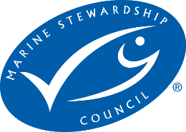

Tiger Prawns (Brown, Penaeus esculentus; Grooved, P. semisulcatus; Black, P. monodon) & Endeavour Prawns (Blue, Metapenaeus endeavouri; Red, Metapenaeus ensis)

{Moreton Bay Bugs, Red-spot King Prawns and Banana Prawns}

Central Zone: East Coast Otter Trawl Fishery, Queensland Australia

Pre-Assessment Report

Assessor | Peter Trott, FishListic Pty Ltd
Fishery client | Queensland Seafood Industry Association Inc (QSIA)
Assessment type | Pre-assessment
Date | 7 June 2024 (EP 4 June 2025)
Report type | Draft Pre-assessment v3 MSC Fisheries Standard

Contents

Glossary 4
Executive summary 5
Report details 6
Aims and constraints of the pre-assessment 6
Version details 6
1. Units of Assessment and Units of Certification 6
2. Pre-assessment outcomes 9
2.1 Overview 9
2.2 Recommendations 9
2.3 Summary of potential conditions by Principle 10
2.4 Summary of Performance Indicator level scores 11
3. Background 17
3.1.1 Legislation 17
3.1.2 Fishery boundaries 18
3.1.3 Gear specifications 20
3.1.4 Fleet composition 23
3.1.5 Monitoring 23
3.1.6 Seasonal/temporal closures 23
3.1.7 Spatial closures 25
3.1.7 Effort caps 26
4. Pre-assessment 27
4.1. Principle 1 27
4.1.1. Background 27
4.1.2 Catch profiles 27
Tiger prawns 27
Moreton Bay Bugs 28
Red-spot king prawns 32
Banana Prawns 33
4.1.3 UoA species 35
Tiger prawns 35
Moreton Bay Bug 38
Red-spot King prawns 42
Banana Prawn 43
4.2 Principle 1 References 52
Principle 1 – Performance Indicator scores and rationales 56
4.2. Principle 2 79
4.2.1. Background 79
4.2.2 Designating species 79
4.2.3 In-scope species 87
4.2.4 ETP/OOS species 91
4.2.5 Habitats 98
4.2.6 Ecosystems 107
Principle 2 References: 108
Principle 2 Performance Indicator scores and rationales 114
4.3 Principle 3 149
4.3.1 Background 149
4.3.2 Legal framework 149
4.3.3 Fishery specific management 150
4.3.4 Consultation, roles and responsibilities 151
Principle 3 References: 153
Principle 3 Performance Indicator scores and rationales 154
Template information, copyright and disclaimer 169
List of Tables 169

Glossary

B_{MSY} | Biomass at Maximum Sustainable Yield
CSIRO | Commonwealth Scientific and Industrial Research Organisation
CITES | Convention on International Trade in Endangered Species
CMS | Convention on Migratory Species
CoC | Chain of Custody certification
CPUE | Catch per unit of effort
EEZ | Exclusive Economic Zone
EP | Endeavour Prawn
ETP | Endangered, Threatened or Protected (species)
F | Fishing mortality rate
FMSY | Fishing mortality rate at Maximum Sustainable Yield
FRDC | Fisheries Research and Development Corporation
FAO | Food and Agriculture Organisation of the United Nations
FCR | Fisheries Certification Requirements (MSC)
HCR | Harvest Control Rule
HS | Harvest Strategy
HMS | Highly Migratory Species
IUCN | International Union for the Conservation of Nature
IUU | Illegal, Unregulated and Unreported
LRP | Limit Reference Point
MSE | Management Strategy Evaluation
MSC | Marine Stewardship Council
MEY | Maximum Economic Yield
MSE | Management Strategy Evaluation
MSY | Maximum Sustainable Yield
NPOA | National Plan of Action
NGO | Non Governmental Organisation
OOS | Out of Scope (species)
PI | Performance Indicator (MSC)
PRI | Point of recruitment impairment (MSC)
PSA | Productivity Susceptibility Analysis
QDAF | Queensland Department of Agriculture and Fisheries
RBF | Risk Based Framework (MSC)
SICA | Scale Intensity Consequence Analysis
SG | Scoring Guidepost (MSC)
TRP | Target Reference Point (B_{target}; F_{target})
TAC | Total Allowable Catch
TACE | Total Allowable Commercial Effort
UoA | Unit of Assessment (MSC)
UoC | Unit of Certification (MSC)
VMS | Vessel Monitoring System

Executive summary

This report contains the results of a Marine Stewardship Council (MSC) pre-assessment of the Units of Assessment (UoA): Tiger prawns, Moreton Bay Bugs, Red-spot King prawns, Banana Prawns and Endeavour Prawn, Queensland East Coast Otter Trawl Fishery, Central region.
In June 2024, a pre-assessment was undertaken by consultation of FishListic Pty Ltd for the client Queensland Seafood Industry Association (QSIA), an additional Unit of Assessment (UoA) was added in June 2025. To our knowledge, this is at least the second time that this fishery has undergone a pre-assessment against the MSC Standard, and this is the first pre-assessment using the updated MSC Fisheries Standard. This pre-assessment was conducted primarily through robust desktop-based analysis, drawing on data and information directly from fishery sources, QDAF sources, scientific literature, and third-party expertise and experience. This information was used to assess the UoA against the MSC Fisheries Standard and Guidance V3.0 using a modified MSC pre-assessment template. Supporting the pre-assessment was the MSC Certification Processes and Guidance. It should be noted that site visits were not conducted but some stakeholder communications were possible to be conducted as part of this pre-assessment process.
At present, the UoAs failed to meet the MSC Fisheries Standard. There are six Performance Indicators that did not meet the SG 60 benchmark. A full list of the recommendations to meet the SG 80 bench mark for each scoring issue has been provided, although at a high level, the current shortfalls/deficiencies in the UoA might be rectified when/with:
- The harvest strategy that was implemented in 2021 has not yet been tested; it will take time to demonstrate its effectiveness following the new stock assessments.
- Further information is required on the level of discarding and survivability of Saucer Scallops taken incidentally whilst the fishery is closes to retaining this species. There is no formal recovery plan for Saucer Scallop. The impact of the UoA through discards on the rebuilding of Saucer Scallop needs direct investigation.
- There is no formal discard/bycatch workplan for the fishery. There is no consistent, ongoing recording or monitoring of bycatch and discards.
- WKP is taken at a greater proportion of the catch now that Scallops are no longer retained. WKP is not mentioned in the harvest strategy.
- There is no data yet available for fishery independent monitoring or reporting for validation of fishery dependent information e.g., monitoring of catch composition, ETP reporting, habitat impacts. An electronic monitoring program has only recently been implemented. Information on desired or current up-take by fishers in the central fleet is required. Furthermore, the monitoring of discards is not listed as an objective of e-monitoring .
- Two listed pipehorse species are permitted to be retained under an exemption; neither species ranked as high risk in the 2023 ERA for the central region, although they are protected federally, catches are relatively high (compared to other regions) and there is no stock status data available. Whilst trip limits are in place, there is no information on how the trip limit of 50 individuals was calculated, if the trigger has ever been reached, and if discards are reported in ETP logbooks? Stock structure or status of these pipehorse species remains unknown, and the impact of removing thousands of pipehorses each year is uncertain
- Compliance data for the UoA is not publicly available and as such it is unclear if there is systematic non-compliance.

Report details

Aims and constraints of the pre-assessment

The aim of this project was to undertake a confidential pre-assessment against the MSC Fisheries Standard version 3.0 to identify the main strengths and weaknesses of the 13 fishery units of assessment, and the extent to which the fishery is consistent with the MSC Fisheries Standard; this is UoA 5‘Tiger prawns, UoA 6 Endeavour Prawn UoA 7 Redspot King Prawns UoA 8 Banana Prawn and UoA 13 Moreton Bay Bugs, from Queensland East Coast Otter Trawl Fishery (ECOTF) Central zone’. NB: the EP UoA was added in June 2025, and as such the P1 assessment was conducted under the latest MSC FS (version 3.1) and it was renumbered as UoA 6.

The outcomes of this pre-assessment report shall lead to the development of a Fisheries Improvement Project and action plan to improve the environmental sustainability credentials of the fishery. This project was restricted to commercial ECOTF fisheries only.

This pre-assessment has been constrained to some extent by issues with access to data. Specifically, an inability to accurately identify effort and catch associated with the UoA, including the regional breakdown of catch that might also be an issue at full assessment.

This report is a pre-assessment and does not attempt to duplicate a full assessment against the MSC Fisheries Standard. A full assessment involves a group of assessment team members and public consultation stages that are not included in a pre-assessment. A pre-assessment provides a provisional assessment based on information provided by the client. This pre-assessment did not use the new ERF tool to ensure the accuracy and trueness of data supplied by the client.

This pre-assessment report is for five UoAs from the same Central fishery management zone of the ECOTF (UoAs 5–8, 13). The entire project included the assessment of numerous species from various zones of the ECOTF and Torres Strait region.

Version details

Table 1: Fisheries program documents versions
Document/Assessment Tree | Version number/Type
MSC Fisheries Certification Process (Guidance) | Version 3.0 (26/10/22, effective 01/05/23)
MSC Fisheries Standard | Version 3.0
Assessment tree | Default
MSC General Certification Requirements | Version 2.5
MSC Reporting Template | Version 1.3
MSC Pre-Assessment Reporting Template | Version 3.3

Units of Assessment and Units of Certification

The project included 11 UoA from various zones within the ECOTF and Torre Strait Prawn Fishery. This is the assessment report for UoA 5 Tiger prawns; UoA 6 Endeavour prawns; UoA 7 Red-spot King prawns, UoA 8 Banana Prawn, UoA 13 Moreton Bay Bugs from the central zone of the ECOTF.

Fishers operating in the central zone of the East Coast Otter Trawl Fishery have no conviction listed for a serious crime, shark-finning violation or forced/child labour.

Table 2: Units of Assessment (UoA)
UoA 5 | Description
Target Stock | Tiger Prawn  - Brown, Penaeus esculentus;  - Grooved, P. semisulcatus;  - Black, P. monodon.
Geographical area | Central Zone, Queensland (ECOTF)
Fishing gear type(s) and, if relevant, vessel type(s) | Triple/Quad Demersal Otter Trawl
Client group | Queensland Seafood Industry Association
Other eligible fishers
Justification for choosing the Unit of Assessment | This UoA separated from the other 7 UoAs as the fishery operated in a different zone, with a different level of interaction and harvest strategy. This UoA was separated from UoA 6–8,13 as they are different species.

UoA 6 | Description
Target Stock | Endeavour Prawn
Geographical area | Central Zone, Queensland ECOTF
Fishing gear type(s) and, if relevant, vessel type(s) | Triple/Quad Demersal Otter Trawl
Client group | Queensland Seafood Industry Association
Other eligible fishers
Justification for choosing the Unit of Assessment | This UoA separated from the other 7 UoAs as the fishery operated in a different zone, with a different level of interaction and harvest strategy. This UoA was separated from UoA 5, 7, 8 and 13 as they are different species.

UoA 7 | Description
Target Stock | Redspot King Prawn (Penaeus longistylus)
Geographical area | Central Zone, Queensland (ECOTF)
Fishing gear type(s) and, if relevant, vessel type(s) | Triple/Quad Demersal Otter Trawl
Client group | Queensland Seafood Industry Association
Other eligible fishers
Justification for choosing the Unit of Assessment | This UoA separated from the other 7 UoAs as the fishery operated in a different zone, with a different level of interaction and harvest strategy. This UoA was separated from UoA 5,6,8 & 13 as they are different species.

UoA 8 | Description
Target Stock | Banana Prawns  - white banana prawn (Penaeus merguiensis) and  - red-legged banana prawn (Penaeus indicus).
Geographical area | Central Zone, Queensland ECOTF
Fishing gear type(s) and, if relevant, vessel type(s) | Triple/Quad Demersal Otter Trawl
Client group | Queensland Seafood Industry Association
Other eligible fishers
Justification for choosing the Unit of Assessment | This UoA separated from the other 7 UoAs as the fishery operated in a different zone, with a different level of interaction and harvest strategy. This UoA was separated from UoA 5–7 and 13 as they are different species.

UoA 13 | Description
Target Stock | Moreton Bay Bugs  - Thenus australiensis (reef or sand bug)  - Thenus parindicus (mud bug)
Geographical area | Central Zone, Queensland (ECOTF)
Fishing gear type(s) and, if relevant, vessel type(s) | Triple/Quad Demersal Otter Trawl
Client group | Queensland Seafood Industry Association
Other eligible fishers
Justification for choosing the Unit of Assessment | This UoA separated from the other 7 UoAs as the fishery operated in a different zone, with a different level of interaction and harvest strategy. This UoA was separated from UoA 5– 8 as they are different species.

Pre-assessment outcomes

2.1 Overview
Based on the current information made available to the assessment, as well as the current management regime that is in place, the UoA would fail to meet the MSC Fisheries Standard v 3.0.

2.2 Recommendations
At this stage, it is advised that the UoA enter into a Fisheries Improvement Project (FIP) before undergoing a full MSC assessment; to address the shortfalls identified above, the following is recommended:
Principle 1
Harvest Strategy
    - b) Provide evidence that the harvest strategy is achieving its objectives for Tiger prawn, Red-spot King Prawn, Moreton Bay bug, Endeavour prawns and banana prawns.

Principle 2
In- scope species
    - a) Provide sufficient information to accurately determine the main in-scope species are above PRI or if below PRI that the UoA does not hinder their recovery/rebuilding;
2.1.2 a) Implement a partial strategy measures that are expected to maintain (or that do not hinder the rebuilding) of main in-scope species (i.e., include main discard species and WKP in the harvest strategy)
    - b) Provide some evidence that the partial strategy is achieving the objectives for main in-scope species (i.e., discard species), such evidence should be based on the UoA and the species involved.

2.1.2 c) Implement a periodically review (≤ 5 years) of alternative measures to minimise UoA- related mortality of unwanted discard species.
2.1.3 a) Obtain adequate information to estimate the impact of the UoA on the stock status of main in-scope species (i.e., WKP and discard species) with a high degree of accuracy.
2.1.3 c) Ensure that the information for main in-scope species (i.e., discard species) is adequate to support a partial management strategy.
ETP species
2.2.1 a) Provide evidence of the direct effects of the UoA on Pipehorse and if impacts are likely to hinder recovery of this ETP species;
2.2.2 a) Implement a strategy that is expected to minimise UoA-related mortality of ETP species
2.2.3 a) Ensure adequate information is used to i) estimate the impact of the UoA on pipehorses and Sea snakes and ii) estimate whether the UoA may threaten these ETP species recovery with a high degree of accuracy.
2.2.3 b) Ensure adequate information is available to support an ETP management strategy that includes the measurement of trends to evaluate the effectiveness of measures in place to minimise mortality.
Habitats
2.3.1 a) Provide evidence that the UoA is highly unlikely to reduce structure and function of ‘less sensitive’ habitats to a point where there would be serious or irreversible harm.
2.3.1 b) Provide evidence that the UoA is highly unlikely to reduce structure and function of ‘more sensitive’ habitats to a point where there would be serious or irreversible harm.
Ecosystems
2.4.2 a) Implement a partial strategy that is expected to ensure that the UoA is highly unlikely to disrupt the key elements of the underlying ecosystem structure and function to a point where there would be serious of irreversible harm.
2.4.2 b) Provide some evidence that the partial strategy is achieving the objectives; such evidence should be based on the UoA and the ecosystem involved.
2.4.3 d) Ensure that monitoring collects adequate data to detect any increase in risk level to the ecosystem and main impacts of the UoA on key ecosystem elements.

Principle 3

Fishery specific management

3.2.1 a) Ensure that the fishery-specific management system has explicit short and long term objectives that are consistent with achieving the outcomes of MSC Principle 1 and Principle 2

3.3.3 d) Ensure that the UoA management measures are enforced and complied with by providing evidence of compliance and ruling out systematic non-compliance.

2.3 Summary of potential conditions by Principle

Table 3. Summary of Principle level scores for UoAs 5–8, ECOTF Central Zone.
UoA 5 Tiger Prawns
Principle of the Fisheries Standard | Number of PIs with draft scoring range < 60 | Number of PIs with draft scoring ranges 60–79
Principle 1 – Stock status | 0/5 | 1/5
Principle 2 – Minimising environmental impacts | 6/12 | 2/12
Principle 3 – Effective management | 0/7 | 2/7
UoA 6 Endeavour Prawn
Principle of the Fisheries Standard | Number of PIs with draft scoring range < 60 | Number of PIs with draft scoring ranges 60–79
Principle 1 – Stock status | 0/5 | 1/5
Principle 2 – Minimising environmental impacts | 6/12 | 2/12
Principle 3 – Effective management | 0/7 | 2/7
UoA 7 Redspot King prawns
Principle of the Fisheries Standard | Number of PIs with draft scoring range < 60 | Number of PIs with draft scoring ranges 60–79
Principle 1 – Stock status | 0/5 | 1/5
Principle 2 – Minimising environmental impacts | 6/12 | 2/12
Principle 3 – Effective management | 0/7 | 2/7
UoA 8 Banana Prawn
Principle of the Fisheries Standard | Number of PIs with draft scoring range < 60 | Number of PIs with draft scoring ranges 60–79
Principle 1 – Stock status | 0/5 | 4/5
Principle 2 – Minimising environmental impacts | 6/12 | 2/12
Principle 3 – Effective management | 0/7 | 2/7
UoA 13 Moreton Bay Bugs
Principle of the Fisheries Standard | Number of PIs with draft scoring range < 60 | Number of PIs with draft scoring ranges 60–79
Principle 1 – Stock status | 0/5 | 1/5
Principle 2 – Minimising environmental impacts | 6/12 | 2/12
Principle 3 – Effective management | 0/7 | 2/7

Summary of Performance Indicator level scores

Table 4. Tiger Prawn UoA 5 Performance Indicator level draft scores and comments for those that scored < 80

Principle 1 | 1.1.1 – Stock status | ≥80
Principle 1 | 1.1.2 – Stock rebuilding. Not applicable
Principle 1 | 1.2.1 – Harvest Strategy | 60-79 | HS was implemented in 2021 and no evidence yet that meeting objectives
Principle 1 | 1.2.2 – Harvest control rules and tools | ≥80
Principle 1 | 1.2.3 – Information and monitoring | ≥80
Principle 1 | 1.2.4 – Assessment of stock status | ≥80
Principle 2 | 2.1.1 – In-scope species outcome | <60 | Discard species stock levels unknown.
Principle 2 | 2.1.2 – In-scope species management strategy | <60 | WKP falls outside of the Central HS. Significant volume of discards. Discards remain unmonitored. Stock status of discards is unknown. No specific measures in place for species identified as high risk in ERA
Principle 2 | 2.1.3 –In-scope species information | <60 | Discard species composition is understood but monitoring is poor. No biomass information available and catch records do not include discards.
Principle 2 | 2.2.1 – ETP/OOS species outcome | <60 | Pipehorses are a listed ETP species and retained by the UoA (within set limits). No population estimates available. Unclear if trip limits biologically derived or effective.
Principle 2 | 2.2.2 – ETP/OOS species management strategy | <60 | No ETP species management strategy in place although there are measures for mitigating interactions (TEDs, BRDs). Duncker's Pipehorse is a listed ETP species and retained by the UoA (within set limits). However, there is no information of the set limit of 50 animals per trip minimise UoA-related mortality as logbook data is presented by volume (kg) not frequency.
Principle 2 | 2.2.3 – ETP/OOS species information | <60 | ERAs are available although data sets are limited for Pipehorse. Biological data, catch compositions and interactions rates are required.
Principle 2 | 2.3.1 – Habitats outcome | ≥80
Principle 2 | 2.3.2 – Habitats management strategy | ≥80
Principle 2 | 2.3.3 – Habitats information | ≥80
Principle 2 | 2.4.1 – Ecosystem outcome | ≥80
Principle 2 | 2.4.2 – Ecosystem management strategy | 60-79 | There are no measures in place specific to the smaller elasmobranchs caught by the fishery (even with BRDs and TEDs). Recording and reporting such interactions does not occur outside of research projects.
Principle 2 | 2.4.3 – Ecosystem information | 60-79 | Discard species interaction data missing. Several species ranked high risk in ERAs and no further attempts to collect/verify biological, species composition or interaction data has been made. Some survivability data is available.
Principle 3 | 3.1.1 – Legal and/or customary framework | ≥80
Principle 3 | 3.1.2 – Consultation, roles, and responsibilities | ≥80
Principle 3 | 3.1.3 – Long term objectives | ≥80
Principle 3 | 3.2.1 – Fishery-specific objectives | 60-79 | Explicit long and short-term objectives for ETPs (including retained pipehorse) absent.
Principle 3 | 3.2.2 – Decision-making processes | ≥80
Principle 3 | 3.2.3 –Compliance and enforcement | 60-79 | Evidence is required regarding compliance levels and the number of sanctions to decipher if that are acting as effective deterrent.
Principle 3 | 3.2.4 – Monitoring and management performance evaluation | ≥80

Table 5. Endeavour Prawn UoA 6 Summary of Performance Indicator level draft scores and comments for those that scored < 80

Principle 1 | 1.1.1 – Stock status | ≥80
Principle 1 | 1.1.2 – Stock rebuilding. Not applicable
Principle 1 | 1.2.1 – Harvest Strategy | 60-79 | HS was implemented in 2021 and no evidence yet that meeting objectives
Principle 1 | 1.2.2 – Harvest control rules and tools | ≥80
Principle 1 | 1.2.3 – Information and monitoring | ≥80
Principle 1 | 1.2.4 – Assessment of stock status | ≥80
Principle 2 | 2.1.1 – In-scope species outcome | <60 | Discard species stock levels unknown.
Principle 2 | 2.1.2 – In-scope species management strategy | <60 | WKP falls outside of the Central HS. Significant volume of discards. Discards remain unmonitored. Stock status of discards is unknown. No specific measures in place for species identified as high risk in ERA
Principle 2 | 2.1.3 –In-scope species information | <60 | Discard species composition is understood but monitoring is poor. No biomass information available and catch records do not include discards.
Principle 2 | 2.2.1 – ETP/OOS species outcome | <60 | Pipehorses are a listed ETP species and retained by the UoA (within set limits). No population estimates available. Unclear if trip limits biologically derived or effective.
Principle 2 | 2.2.2 – ETP/OOS species management strategy | <60 | No ETP species management strategy in place although there are measures for mitigating interactions (TEDs, BRDs). Duncker's Pipehorse is a listed ETP species and retained by the UoA (within set limits). However, there is no information of the set limit of 50 animals per trip minimise UoA-related mortality as logbook data is presented by volume (kg) not frequency.
Principle 2 | 2.2.3 – ETP/OOS species information | <60 | ERAs are available although data sets are limited for Pipehorse. Biological data, catch compositions and interactions rates are required.
Principle 2 | 2.3.1 – Habitats outcome | ≥80
Principle 2 | 2.3.2 – Habitats management strategy | ≥80
Principle 2 | 2.3.3 – Habitats information | ≥80
Principle 2 | 2.4.1 – Ecosystem outcome | ≥80
Principle 2 | 2.4.2 – Ecosystem management strategy | 60-79 | There are no measures in place specific to the smaller elasmobranchs caught by the fishery (even with BRDs and TEDs). Recording and reporting such interactions does not occur outside of research projects.
Principle 2 | 2.4.3 – Ecosystem information | 60-79 | Discard species interaction data missing. Several species ranked high risk in ERAs and no further attempts to collect/verify biological, species composition or interaction data has been made. Some survivability data is available.
Principle 3 | 3.1.1 – Legal and/or customary framework | ≥80
Principle 3 | 3.1.2 – Consultation, roles, and responsibilities | ≥80
Principle 3 | 3.1.3 – Long term objectives | ≥80
Principle 3 | 3.2.1 – Fishery-specific objectives | 60-79 | Explicit long and short-term objectives for ETPs (including retained pipehorse) absent.
Principle 3 | 3.2.2 – Decision-making processes | ≥80
Principle 3 | 3.2.3 –Compliance and enforcement | 60-79 | Evidence is required regarding compliance levels and the number of sanctions to decipher if that are acting as effective deterrent.
Principle 3 | 3.2.4 – Monitoring and management performance evaluation | ≥80

Table 6. Redspot King Prawn UoA 7 Summary of Performance Indicator level draft scores and comments for those that scored < 80
Principle 1 | 1.1.1 – Stock status | ≥80
Principle 1 | 1.1.2 – Stock rebuilding. Not applicable
Principle 1 | 1.2.1 – Harvest Strategy | 60-79 | HS was implemented in 2021 and no evidence yet that meeting objectives
Principle 1 | 1.2.2 – Harvest control rules and tools | ≥80
Principle 1 | 1.2.3 – Information and monitoring | ≥80
Principle 1 | 1.2.4 – Assessment of stock status | ≥80
Principle 2 | 2.1.1 – In-scope species outcome | <60 | Discard species stock levels unknown.
Principle 2 | 2.1.2 – In-scope species management strategy | <60 | WKP falls outside of the Central HS. Significant volume of discards. Discards remain unmonitored. Stock status of discards is unknown. No specific measures in place for species identified as high risk in ERA
Principle 2 | 2.1.3 –In-scope species information | <60 | Discard species composition is understood but monitoring is poor. No biomass information available and catch records do not include discards.
Principle 2 | 2.2.1 – ETP/OOS species outcome | <60 | Pipehorses are a listed ETP species and retained by the UoA (within set limits). No population estimates available. Unclear if trip limits biologically derived or effective.
Principle 2 | 2.2.2 – ETP/OOS species management strategy | <60 | No ETP species management strategy in place although there are measures for mitigating interactions (TEDs, BRDs). Duncker's Pipehorse is a listed ETP species and retained by the UoA (within set limits). However, there is no information of the set limit of 50 animals per trip minimise UoA-related mortality as logbook data is presented by volume (kg) not frequency.
Principle 2 | 2.2.3 – ETP/OOS species information | <60 | ERAs are available although data sets are limited for Pipehorse. Biological data, catch compositions and interactions rates are required.
Principle 2 | 2.3.1 – Habitats outcome | ≥80
Principle 2 | 2.3.2 – Habitats management strategy | ≥80
Principle 2 | 2.3.3 – Habitats information | ≥80
Principle 2 | 2.4.1 – Ecosystem outcome | ≥80
Principle 2 | 2.4.2 – Ecosystem management strategy | 60-79 | There are no measures in place specific to the smaller elasmobranchs caught by the fishery (even with BRDs and TEDs). Recording and reporting such interactions does not occur outside of research projects.
Principle 2 | 2.4.3 – Ecosystem information | 60-79 | Discard species interaction data missing. Several species ranked high risk in ERAs and no further attempts to collect/verify biological, species composition or interaction data has been made. Some survivability data is available.
Principle 3 | 3.1.1 – Legal and/or customary framework | ≥80
Principle 3 | 3.1.2 – Consultation, roles, and responsibilities | ≥80
Principle 3 | 3.1.3 – Long term objectives | ≥80
Principle 3 | 3.2.1 – Fishery-specific objectives | 60-79 | Explicit long and short-term objectives for ETPs (including retained pipehorse) absent.
Principle 3 | 3.2.2 – Decision-making processes | ≥80
Principle 3 | 3.2.3 –Compliance and enforcement | 60-79 | Evidence is required regarding compliance levels and the number of sanctions to decipher if that are acting as effective deterrent.
Principle 3 | 3.2.4 – Monitoring and management performance evaluation | ≥80

Table 7. Banana Prawn UoA 8 Summary of Performance Indicator level draft scores and comments for those that scored < 80

Principle 1 | 1.1.1 – Stock status | 60-79 | As biomass is not measured for white banana prawn, there is no way to directly measure the status of the stock. However, there is a long history of consistent catches across many generations of the stock for the UoA and much larger NPF, with no evidence to suggest that overfishing has occurred or is occurring but o MSY estimates available.
Principle 1 | 1.1.2 – Stock rebuilding. Not applicable
Principle 1 | 1.2.1 – Harvest Strategy | 60-79 | HS was implemented in 2021 and no evidence yet that meeting objectives
Principle 1 | 1.2.2 – Harvest control rules and tools | 60-79 | Where no stock assessment is available, the HCRs are based on monitoring catch relative to historical catch ranges for Tier 2 species. It is unclear if catches are monitored during the season or only at the end of each season
Principle 1 | 1.2.3 – Information and monitoring | ≥80
Principle 1 | 1.2.4 – Assessment of stock status | 60-79 | Current assessments of Banana Prawn in the UoA are based on the monitoring of the catch rates which is appropriate for the stock and the harvest strategy (SG 60 is met), although there is no information if monitoring is occurring prior, during or after the fishing season (SG 80 is not met).
Principle 2 | 2.1.1 – In-scope species outcome | <60 | Discard species stock levels unknown.
Principle 2 | 2.1.2 – In-scope species management strategy | <60 | WKP falls outside of the Central HS. Significant volume of discards. Discards remain unmonitored. Stock status of discards is unknown. No specific measures in place for species identified as high risk in ERA
Principle 2 | 2.1.3 –In-scope species information | <60 | Discard species composition is understood but monitoring is poor. No biomass information available and catch records do not include discards.
Principle 2 | 2.2.1 – ETP/OOS species outcome | <60 | Pipehorses are a listed ETP species and retained by the UoA (within set limits). No population estimates available. Unclear if trip limits biologically derived or effective.
Principle 2 | 2.2.2 – ETP/OOS species management strategy | <60 | No ETP species management strategy in place although there are measures for mitigating interactions (TEDs, BRDs). Duncker's Pipehorse is a listed ETP species and retained by the UoA (within set limits). However, there is no information of the set limit of 50 animals per trip minimise UoA-related mortality as logbook data is presented by volume (kg) not frequency.
Principle 2 | 2.2.3 – ETP/OOS species information | <60 | ERAs are available although data sets are limited for Pipehorse. Biological data, catch compositions and interactions rates are required.
Principle 2 | 2.3.1 – Habitats outcome | ≥80
Principle 2 | 2.3.2 – Habitats management strategy | ≥80
Principle 2 | 2.3.3 – Habitats information | ≥80
Principle 2 | 2.4.1 – Ecosystem outcome | ≥80
Principle 2 | 2.4.2 – Ecosystem management strategy | 60-79 | There are no measures in place specific to the smaller elasmobranchs caught by the fishery (even with BRDs and TEDs). Recording and reporting such interactions does not occur outside of research projects.
Principle 2 | 2.4.3 – Ecosystem information | 60-79 | Discard species interaction data missing. Several species ranked high risk in ERAs and no further attempts to collect/verify biological, species composition or interaction data has been made. Some survivability data is available.
Principle 3 | 3.1.1 – Legal and/or customary framework | ≥80
Principle 3 | 3.1.2 – Consultation, roles, and responsibilities | ≥80
Principle 3 | 3.1.3 – Long term objectives | ≥80
Principle 3 | 3.2.1 – Fishery-specific objectives | 60-79 | Explicit long and short-term objectives for ETPs (including retained pipehorse) absent.
Principle 3 | 3.2.2 – Decision-making processes | ≥80
Principle 3 | 3.2.3 –Compliance and enforcement | 60-79 | Evidence is required regarding compliance levels and the number of sanctions to decipher if that are acting as effective deterrent.
Principle 3 | 3.2.4 – Monitoring and management performance evaluation | ≥80

Table 8. Moreton Bay Bug UoA 13 Performance Indicator level draft scores and comments for those that scored < 80
Principle 1 | 1.1.1 – Stock status | ≥80
Principle 1 | 1.1.2 – Stock rebuilding. Not applicable
Principle 1 | 1.2.1 – Harvest Strategy | 60-79 | HS was implemented in 2021 and no evidence yet that meeting objectives
Principle 1 | 1.2.2 – Harvest control rules and tools | ≥80
Principle 1 | 1.2.3 – Information and monitoring | ≥80
Principle 1 | 1.2.4 – Assessment of stock status | ≥80
Principle 2 | 2.1.1 – In-scope species outcome | <60 | Discard species stock levels unknown.
Principle 2 | 2.1.2 – In-scope species management strategy | <60 | WKP falls outside of the Central HS. Significant volume of discards. Discards remain unmonitored. Stock status of discards is unknown. No specific measures in place for species identified as high risk in ERA
Principle 2 | 2.1.3 –In-scope species information | <60 | Discard species composition is understood but monitoring is poor. No biomass information available and catch records do not include discards.
Principle 2 | 2.2.1 – ETP/OOS species outcome | <60 | Pipehorses are a listed ETP species and retained by the UoA (within set limits). No population estimates available. Unclear if trip limits biologically derived or effective.
Principle 2 | 2.2.2 – ETP/OOS species management strategy | <60 | No ETP species management strategy in place although there are measures for mitigating interactions (TEDs, BRDs). Duncker's Pipehorse is a listed ETP species and retained by the UoA (within set limits). However, there is no information of the set limit of 50 animals per trip minimise UoA-related mortality as logbook data is presented by volume (kg) not frequency.
Principle 2 | 2.2.3 – ETP/OOS species information | <60 | ERAs are available although data sets are limited for Pipehorse. Biological data, catch compositions and interactions rates are required.
Principle 2 | 2.3.1 – Habitats outcome | ≥80
Principle 2 | 2.3.2 – Habitats management strategy | ≥80
Principle 2 | 2.3.3 – Habitats information | ≥80
Principle 2 | 2.4.1 – Ecosystem outcome | ≥80
Principle 2 | 2.4.2 – Ecosystem management strategy | 60-79 | There are no measures in place specific to the smaller elasmobranchs caught by the fishery (even with BRDs and TEDs). Recording and reporting such interactions does not occur outside of research projects.
Principle 2 | 2.4.3 – Ecosystem information | 60-79 | Discard species interaction data missing. Several species ranked high risk in ERAs and no further attempts to collect/verify biological, species composition or interaction data has been made. Some survivability data is available.
Principle 3 | 3.1.1 – Legal and/or customary framework | ≥80
Principle 3 | 3.1.2 – Consultation, roles, and responsibilities | ≥80
Principle 3 | 3.1.3 – Long term objectives | ≥80
Principle 3 | 3.2.1 – Fishery-specific objectives | 60-79 | Explicit long and short-term objectives for ETPs (including retained pipehorse) absent.
Principle 3 | 3.2.2 – Decision-making processes | ≥80
Principle 3 | 3.2.3 –Compliance and enforcement | 60-79 | Evidence is required regarding compliance levels and the number of sanctions to decipher if that are acting as effective deterrent.
Principle 3 | 3.2.4 – Monitoring and management performance evaluation | ≥80

Background

3.1.1 Legislation

Relevant fisheries legislation
- Fisheries Act 1994;
- Fisheries (General) Regulation 2019;
- Fisheries (Commercial Fisheries) Regulation 2019;
- Fisheries Declaration 2019;
- Fisheries Quota Declaration 2019.

Other relevant legislation
- Great Barrier Reef Marine Park Act 1975
- Great Barrier Reef Marine Park Regulations 2019
- Marine Parks Act 2004;
- Environment Protection and Biodiversity Conservation Act 1999;
- Environment Protection and Biodiversity Conservation Regulations 2000

An outline of fishing operations is available online at: https://www.business.qld.gov.au/industries/farms-fishing-forestry/fisheries/commercial/profile/trawl/east/operate

The management of the East Coast Otter Trawl Fishery is divided by region (Figures 1-3) using five harvest strategies. Each ECOTF harvest strategy, including central zone, is available at: https://www.daf.qld.gov.au/business- priorities/fisheries/sustainable/harvest-strategy

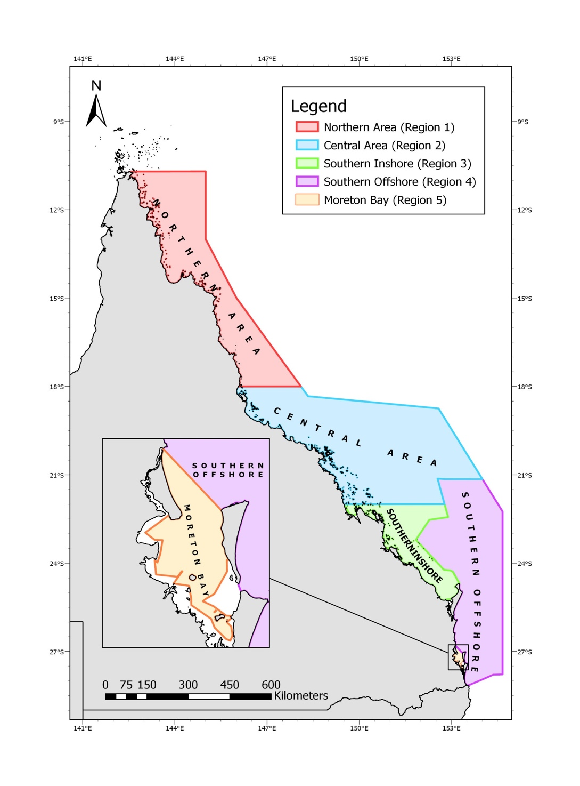
Figure 1. Management regions of the Queensland East Coast Otter Trawl Fishery (Source: QDAF)

3.1.2 Fishery boundaries

The ECOTF covers all tidal waters (excluding estuaries) east of longitude 142°31.89’E out to the East Coast Offshore Constitutional Settlement (OCS) Boundary between Cape York and the Queensland/New South Wales (NSW) border (Figure 1). The type of fishery symbol attached to a commercial fishing licence delimits the area that can be fished (Figure 2).
As part of the subdivision of the ECOTF, effort units and licence allocations are divided between the fishery management regions: 1) Northern, 2) Central, 3) Southern Inshore 4) Southern Offshore and 5) Moreton Bay.

Figure 3 maps the target species in each region. Effort units can only be used in the relevant management region.

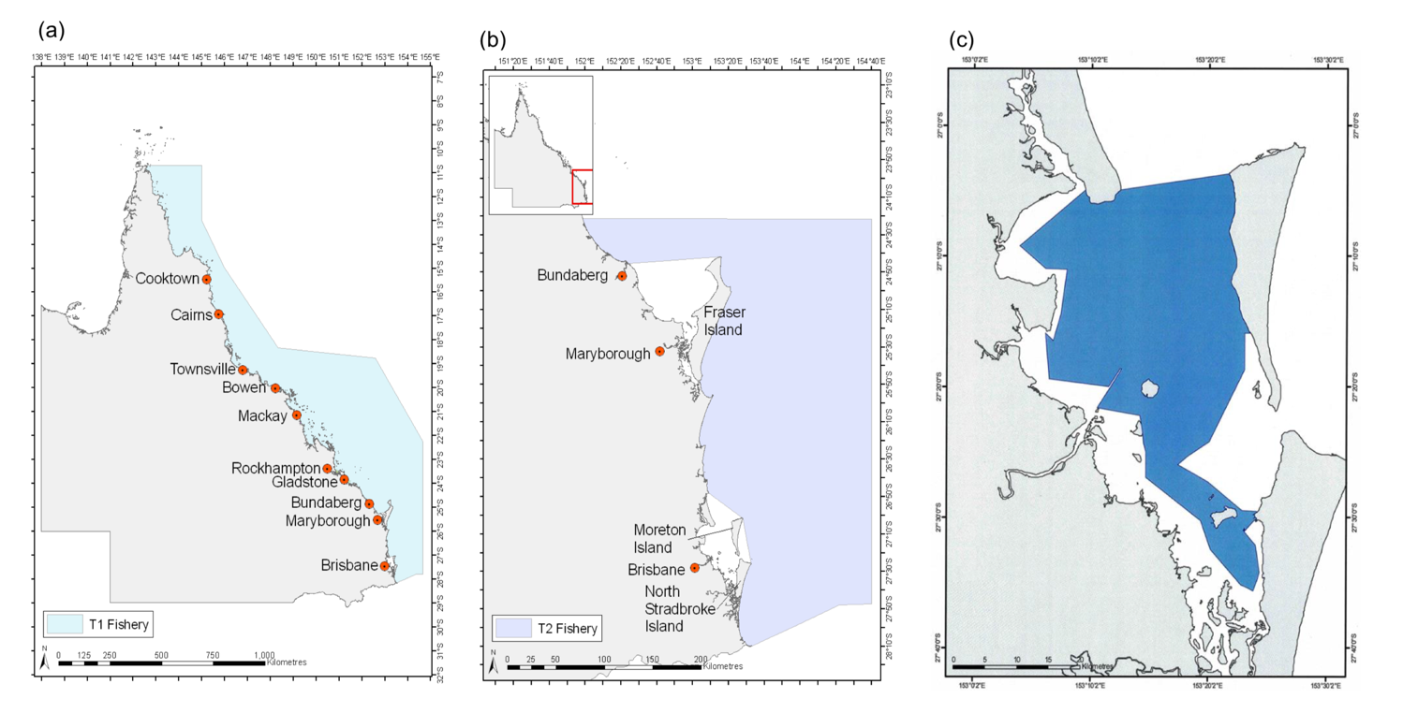
Figure 2. East Coast Otter Trawl Fishery (ECOTF) boundaries for a) the T1 fishery symbol, includes access to Moreton Bay if an operator holds an M1 fishery symbol, b) the T2 fishery symbol, excludes Moreton Bay and c) the boundary of the M1 and M2 fishery. (Source: Jacobsen et al., (2018))

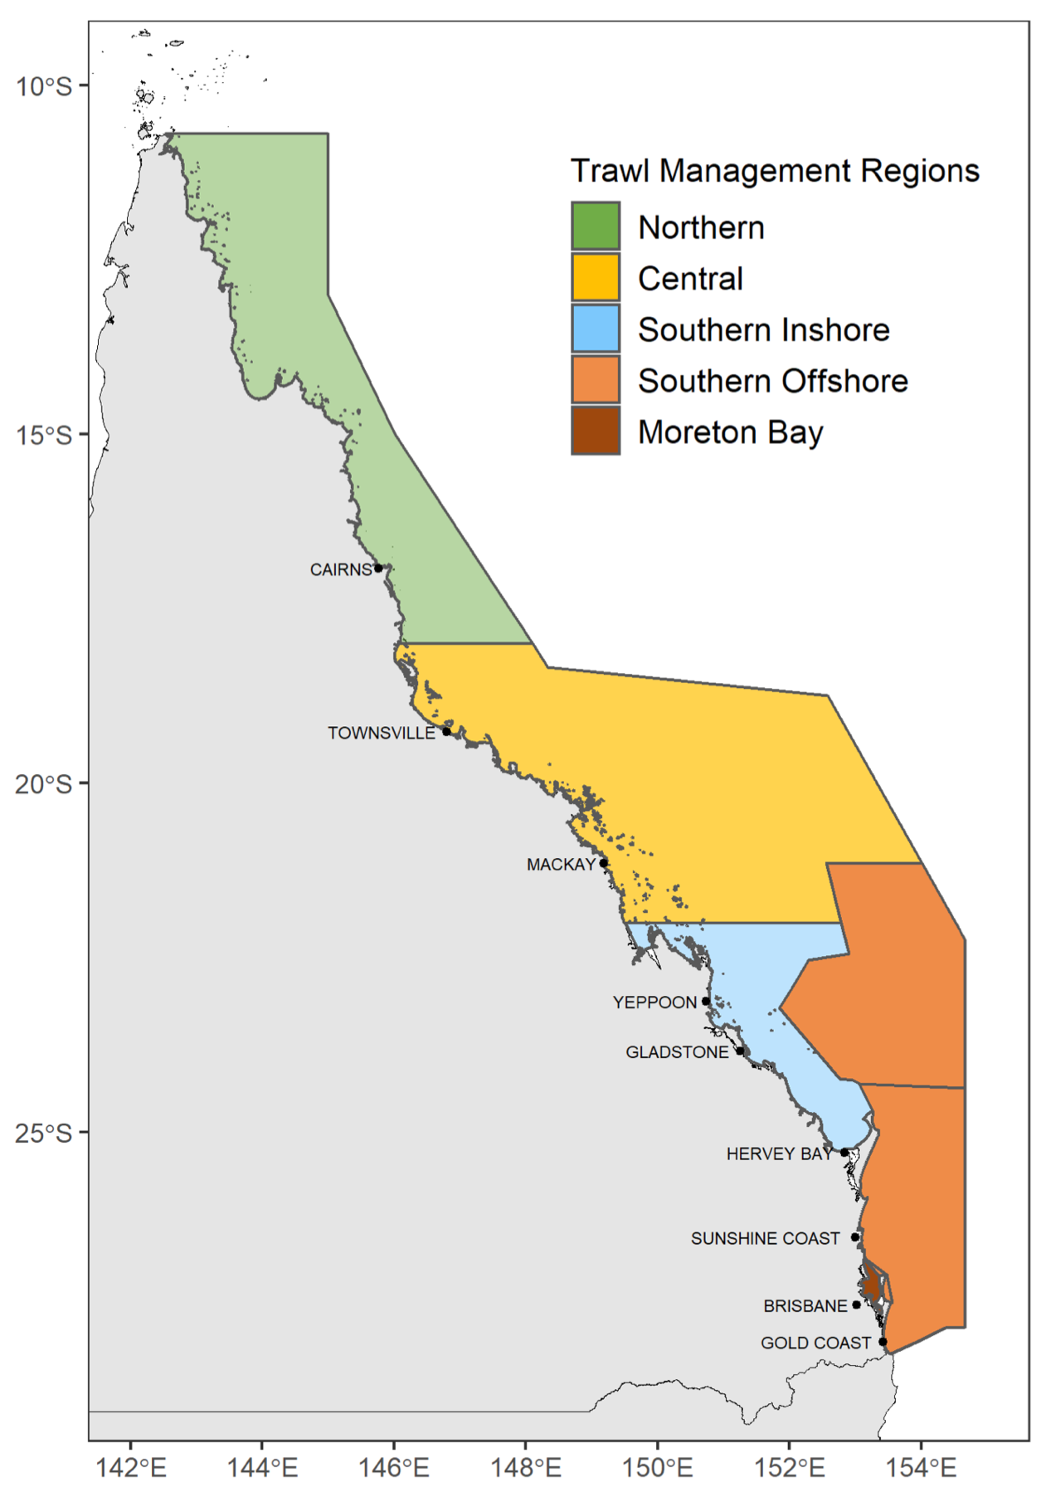
Figure 3. Illustrative map of the ECOTF trawl area, distinguishing the five different trawl regions (Wickens et al. 2023).

3.1.3 Gear specifications

The ECOTF uses demersal otter trawl gear to harvest prawns, scallops, bugs, squid, and several by-product species. The fleet uses trawl nets designed to operate on or near the seabed targeting these species mainly over muddy, sandy or silty habitats that are found away from coral reefs. Head-rope height varies according to target species, as does the detailed configuration of nets. Queensland east coast otter trawlers have traditionally used flat, rectangular ‘otter’ boards to spread their nets, but there is an increasing tendency to use more streamlined and smaller boards.

There are many net types used in the ‘central (e.g., double, triple, quad, five and beam); when taking MBB, the net design is the same as when targeting Scallops although prawn nets are different.

Quad net arrangements (four towed nets) are most frequently used in the fishery depending on the species targeted, fishing conditions and length of the net. Fishers report the net type used, and QDAF record net type effort data for each type (Figure 4).

Effort data was made available to the assessment team. In 2022, ‘Louvre’ and ‘Killfoil’ were the most common design, although there are various otter-board types and effort (days) fished with each type is reported, and recorded by QDAF and data was made available to the assessment team. The sheer force of water on the angled board forces each board sideways until the net is spread and held open. The otter trawl net has chains hung below the footrope to disturb the prawns as the net is towed along the seabed, making them jump into the mouth of the oncoming net. The type of ground gear (i.e., chain configuration) is reported by fishers, and recorded by QDAF; effort data for each ground gear type was made available to the assessment team and in 2022 the most common ground gear used in the Central region was ‘drop chain’ followed by ‘looped ground chain’.

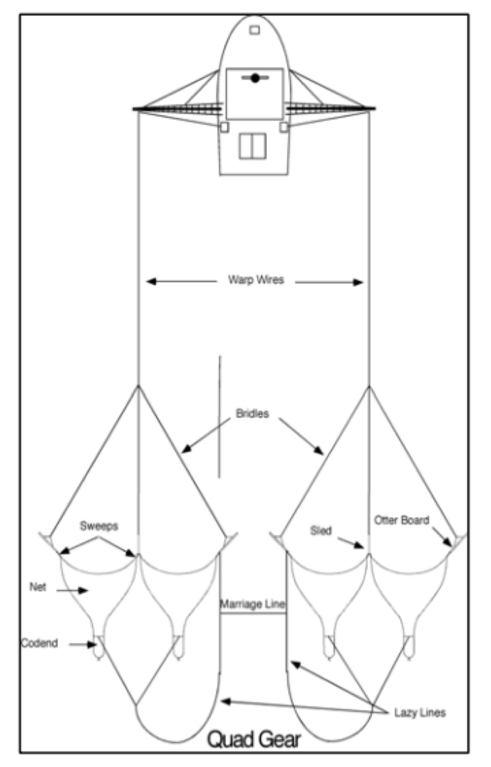
Figure 4: Illustration of Quad Gear otter board trawl in operation (Source; QDAF,2021)

Bycatch Reduction Devices and Turtle Exclusion Devices
In 1999, bycatch reduction devices (BRD)s became mandatory in the fishery. Under the Fisheries (Commercial Fisheries) Regulation 2019, commercial fishers operating in the east coast trawl fishery must install an approved BRD in each net used. There are five types of BRDs, with different features that were designed to exclude specific bycatch species.
Within the deepwater net area, the following BRDs are used:
- Square mesh codend specific for area
- Fisheye
- Bigeye
- Square mesh panel
In 2004, Turtle excluder devices (TEDs) became mandatory. A significant amount of research has been conducted on the ECOTF since the introduction of BRDs/TEDs, for example:
- Roy & Jebreen (2011) investigated the use of BRDs in the ECOTF and provide useful information on reductions in ETP and unwanted species interactions relative to target species catches.
- Courtney et al. (2010) quantified the species composition, catch rates and mortality rates of sea snakes caught incidentally by the ECOTF. They found data provided by fishers in the SOCI logbook had significantly under estimated the incidental catch and mortality of sea snakes imposed by the ECOTF. The project also tested different BRDs during a research charter and found that the fisheye BRD reduced the sea snake catch rate by 63% compared to a control net with no BRD, with no reduction in the catch rate of marketable prawns.
- Campbell (2022) provides a comprehensive overview of BRD and TED research in prawn trawls and investigated post trawl survival of batoid species from the ECOTF.
The use of TEDs is also a requirement of exporting prawns (shrimp) to the United States of America and the ECOTF is listed as registered fishery under that certification.

Fleet composition

As of July 2023, there were 365 T1 symbols and 16 T2 (concessional) symbols (Dedini & Jacobsen, 2023).

Monitoring
The commercial fisher in control of the fishing operation is responsible for meeting these reporting requirements.

Pre-trip notices
Commercial fishers must give a pre-trip notice before they commence a fishing operation, or if any details have changed since they last submitted a pre-trip notice.

Logbooks
Fishers are required to report retained species, effort and fishing location in daily logbooks(Figure 5); there is a note regarding ETP species interactions at the bottom of each logbook page. A further ETP species interaction logbook is also required to be completed (Figure 6). Fishers may use the eFisher app to submit logbooks and other fishery information such as: customise reporting; view licence and fishery symbol details; check quota use; manage vessel tracking units; report trip notices. There are guides and training versions of the App to ensure fishers are supported when using this means of logbook submission.

Fishing activities (location and intensity) are also monitored by VMS; Logbook maps are also available online. The fisher must report the interaction by submitting a protected animal interaction logbook (Figure 6) report within 24 hours (electronically) or 7 days (paper) after the fishing operation ends. If the interaction is with a marine mammal, the fisher must report the interaction to the Wildlife Hotline on 1300 264 625 within 24 hours. If the interaction is with a species listed, the fisher must also report the interaction to Fisheries Queensland on phone number and/or email provided within 48 hours after the fishing operation ends (unless reporting logbooks electronically).

Seasonal/temporal closures

For the Central zone, the fishing year starts on 1 March and concludes end of February the following year; the Central zone operates for 9.5 months per year.

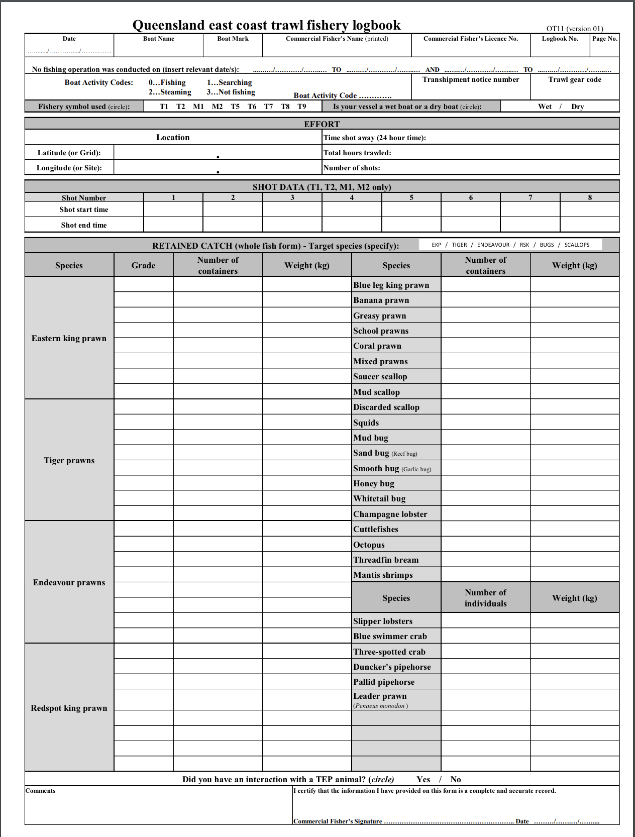
Figure 5. Commercial logbook for the ECOTF (Source: QDAF, 2024)
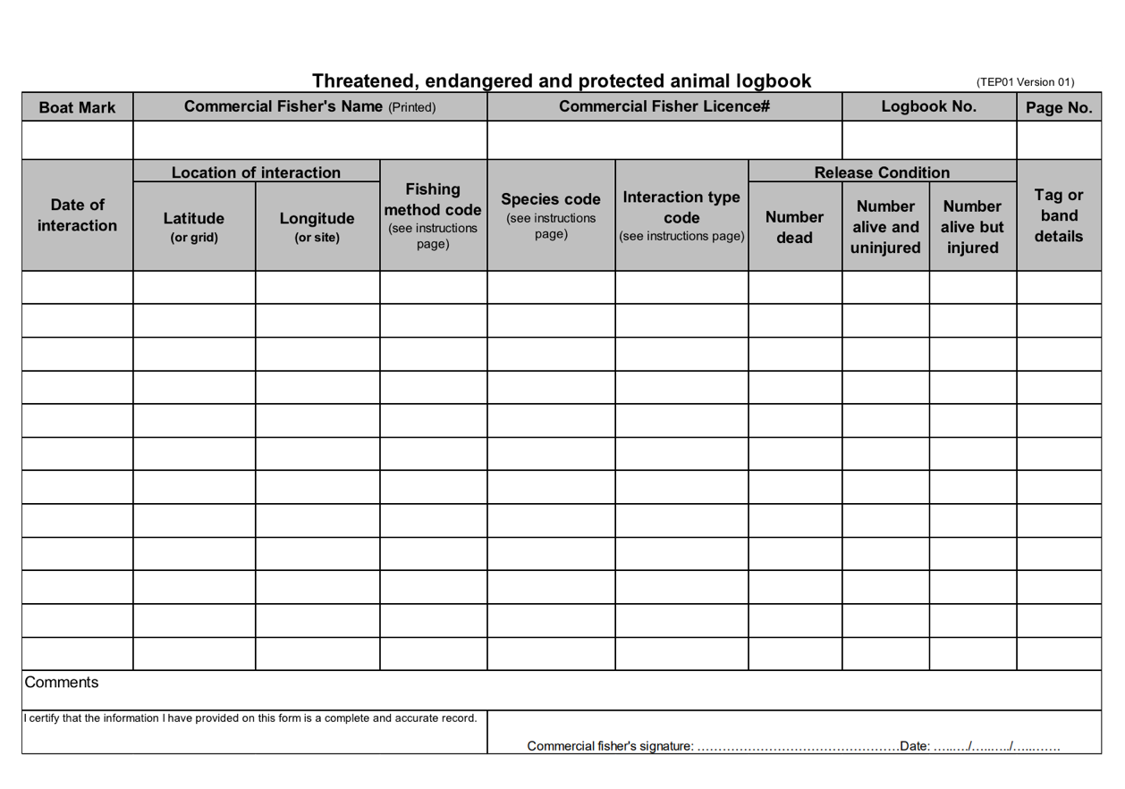
Figure 6. ETP interaction logbook for the ECOTF (Source: QDAF, 2024)

Spatial closures
Within the ECOTF there are both seasonal and permanent area closures, particularly in waters of the Great Barrier Reef World Heritage Area (Department of Agriculture and Fisheries, 2020). However, there are other closures in the area of operation of the central trawl region of the ECOTF fishery.
Lovett et al. (2023) provided a synopsis of the closed areas over time for the northern and central Tiger prawn fishery (Figure 7) that were identified for the purpose of stock assessment.

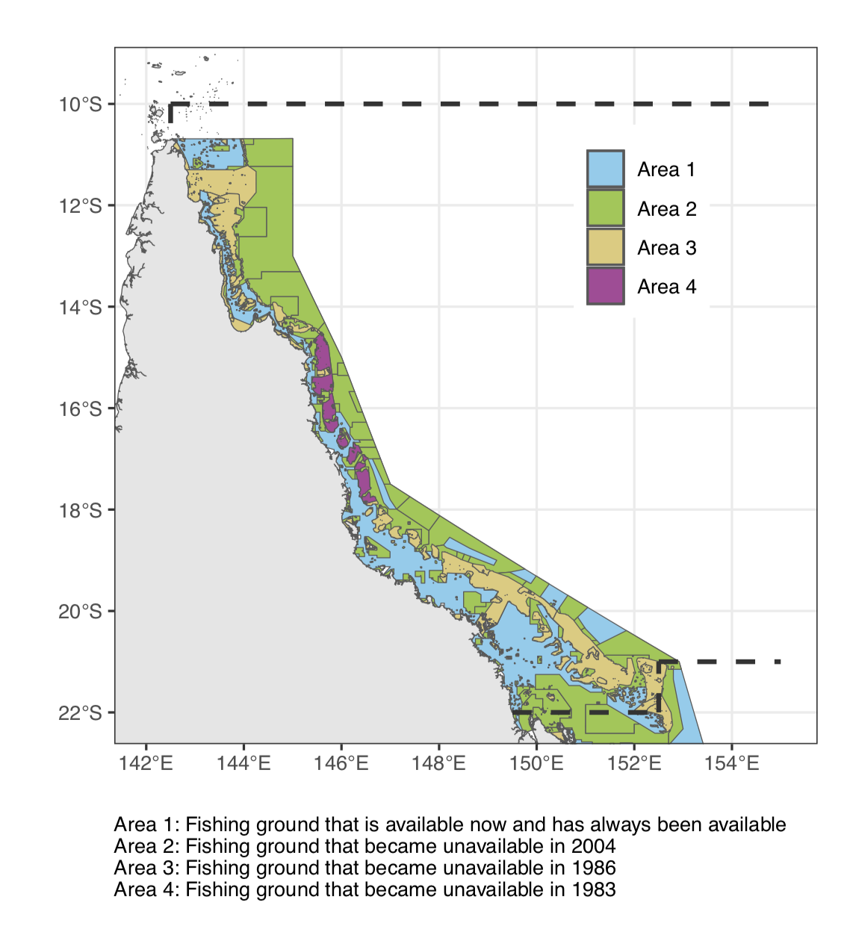
Figure 7. Assessment region defined by dashed lines—coloured fill represents changes through time of available trawling area within the defined assessment region

3.1.7 Effort caps
Effort unit entitlements for licence holders are renewed each year. Effort units can only be used in the relevant management region (e.g., they can not be transferred from southern inshore to central or vice versa).The central region effort cap for 2022–23 is set at 500 711 effort units. From 1 March 2023 to 21 February 2024, the effort cap for the central trawl region will be 318,584 effort units.
From 2024– 25 onwards, effort caps will be informed by stock assessments for tiger prawns, Moreton Bay bugs and red spot king prawns, and will provide recommendations around effort levels to achieve a target biomass of 60% of unfished levels (QDAF, 2022)

Pre-assessment

Principle 1

Background
The default Principal 1 decision tree (Figure 8) was used for this assessment.
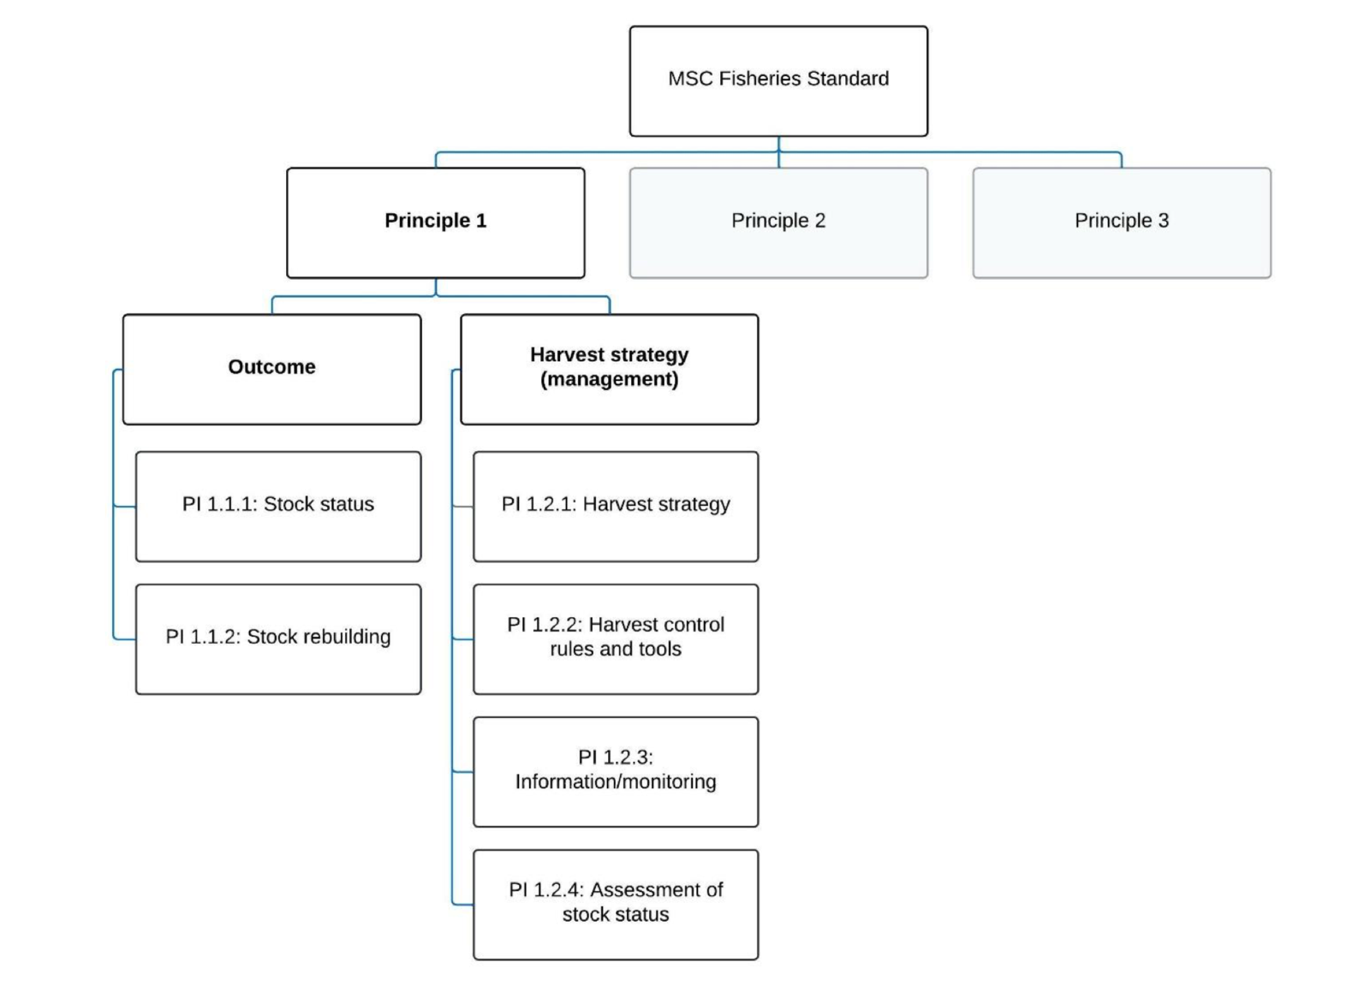
Figure 8. Decision tree for Principle 1 (MSC Fisheries Standard v3.)

4.1.2 Catch profiles

4.1.2.1 Catch history of each UoA

Tiger prawns

Tiger prawns is a collective term for two species: Brown tiger (Penaeus esculentus) and grooved tiger (P. semisulcatus). They are taken in the ECOTF within the Northern, Central and Moreton Bay Trawl regions. Tiger prawns are also a minor component of the southern offshore trawl region and rarely reported in the southern inshore catches (e.g., 350 kg in 2022 compared to total ECOTF of 1,051,646 kg).

Between 2017 and 2021, total retained catch of Tiger prawns averaged 1098 t per year (Figure 9). In the late 90s and early 2000s, there was a decreasing catch trend, and fishery adjustment (including substantial reductions in fleet size and total fishing effort) was evident in the reduced (yet stable) stable catches from 2006 to 2021. Recreational, Indigenous and charter harvests were non-existent or negligible for tiger prawns and were not included in the stock assessment (Lovett et al. 2023).

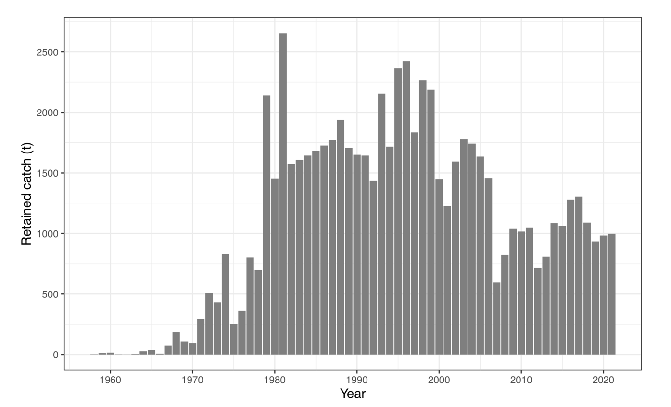
Figure 9. Annual estimated retained catch (tonnes) of Queensland’s east coast Tiger Prawn between 1958 and 2021 (Lovett et al. 2023)

Moreton Bay Bugs

Moreton Bay bugs’ is a collective term for two species: reef/sand bug (Thenus australiens) and mud bug (T. parindicus). It is taken in the ECOTF in various areas but was primarily taken in the southern inshore region whilst taking Ballot’s Saucer Scallops. Moreton Bay Bugs are also a very minor component of the (eastern king) prawn offshore sector of the ECOTF. Moreton Bay Bugs are more commonly taken north of 25° S (Wickens et al. 2023).

The 2020 total harvest was 466 tonnes, with 182 tonnes from the central trawl region (UoA) . In 2021 the total harvest of MBB, Sand Bug and Mud Bug was 545 tonnes (all zones; Figure 10), of which 162 t was taken in the Central Zone (UoA) and in 2022 a further 178 t was recorded as Sand Bug and 6.6 t was recorded as Mud Bug (184.6 t total for UoA area).

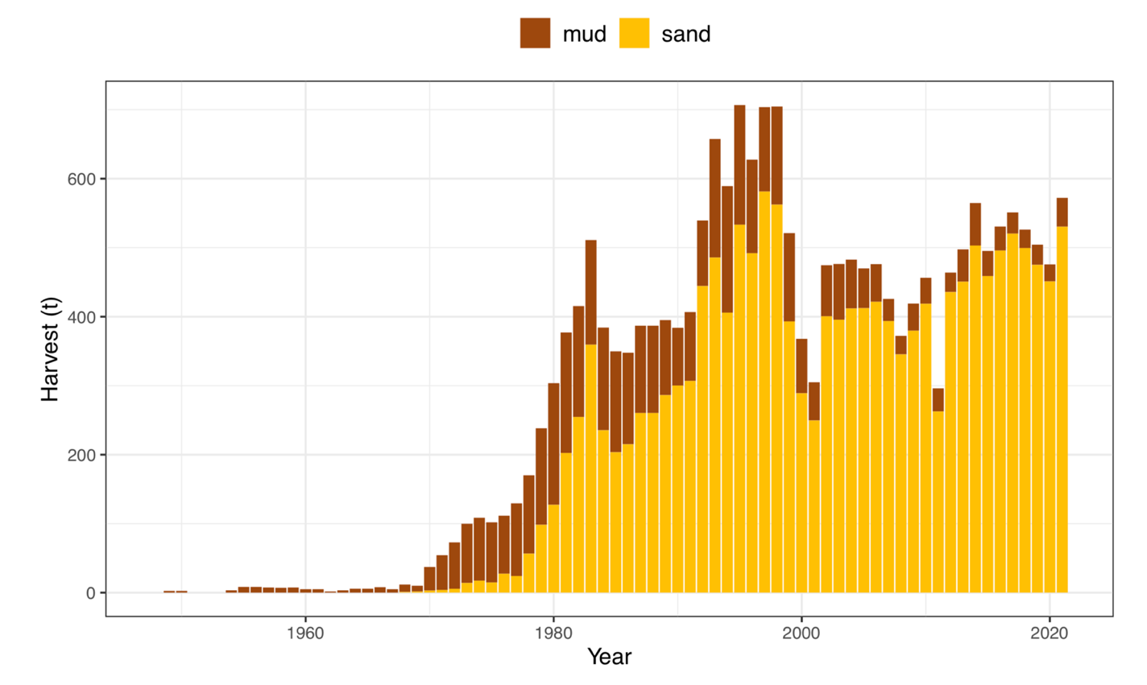
Figure 10. Annual MBB harvest in Queensland waters (Wickens et al. 2023)

Catch data supplied by QDAF presents MBB catches in 2019–2022 from 14 grids with the highest catch areas over this period being from J19, J20, K20, K21, L21 and M21 (Table 9).

Table 9. Moreton Bay Bug (sand mug and mud mug) catch from the central region by year and grid location (Further information on grid locations is available at https://www.business.qld.gov.au/industries/farms-fishing-forestry/fisheries/commercial/report/logbook/map
Grid code | Catch (t) of MBB by year
Grid code | 2020 | 2021 | 2022
I19 | 1889 | 1234 | 3446.5
I20 | 734.5 | 987.2 | 1141
J19 | 24940 | 15061.5 | 19120.6
J20 | 24903 | 17676 | 17982
J21 | 1461.5 | 1724.7 | 205
K20 | 66363.8 | 38829 | 50418
K21 | 14114.5 | 12618 | 6590
L20 | 4135 | 1160 | 2338
L21 | 32257 | 46651 | 48482
L22 | 3193 | 4622.66 | 1688.5
M21 | 8368 | 5211 | 11337
M22 | 5928.25 | 733.5 | 4436
M23 | 320 | 0 | 0
N23 | 92.1 | 0 | 0
N24 | 138.5 | 0 | 80.3
O22 | 378 | 355 | 0
O24 | 3636.75 | 4131 | 2285
O25 | 2542.5 | 1895 | 792
P23 | 1270 | 0 | 9399
P25 | 411 | 2338 | 0
Q24 | 4905 | 5884 | 4742
R25 | 0 | 901 | 0

Sand Bugs are taken by both prawn trawl and scallop trawl gear in the central region (Wickens et al. 2023). Figure 11 presents the catch pre/post 2004 (i.e., year of independent survey) separated by trawl gear type; catch rates have remained steady (Figure 12). In 2021 about half of the Sand Bug catch was taken by each gear type, although it should be noted that the region is currently closed to Saucer Scallop fishing and as such catches in 2022–2024 will be for prawn only.
In 2021, the management action for Scallops (Amendment Declaration) noted that “Urgent significant management action is required to protect and allow the recovery of saucer scallop stocks. The main policy objective of the Fisheries (Saucer Scallops) Amendment Declaration 2021 (the Amendment Declaration) is to prevent the take of saucer scallops in the southern inshore and central trawl regions. It is proposed that this closure would remain in place until scallop stocks have rebuilt to a 30 per cent biomass level.” As such, scallop gear is not being used in the UoA at present.

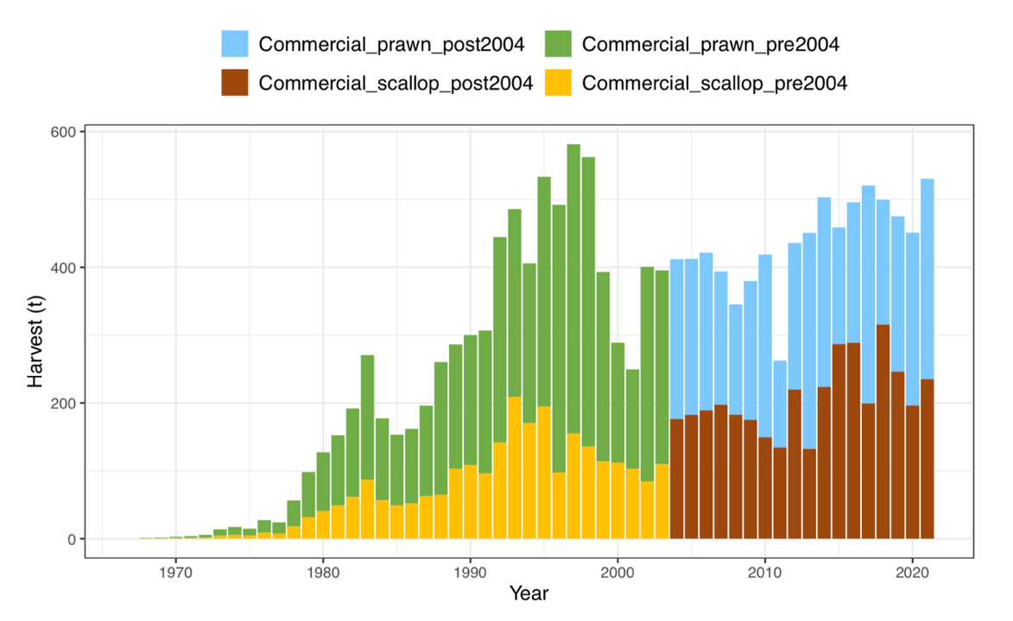
Figure 11. Annual estimated harvest (catch, t) for sand bugs from 1968 to 2021 illustrating the split between prawn trawl and scallop trawl gear. The data was split at 2004 in the stock assessment due to it being the year of an independent survey (Wickens et al. 2023).

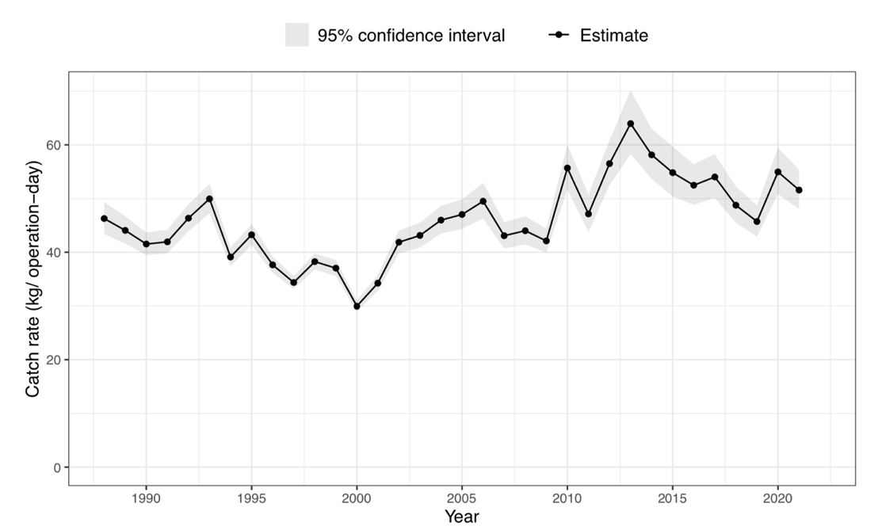
Figure 12. Annual catch rate (kg/day) for sand bugs from 1988 to 2021 (Wickens et al. 2023).

Mud Bugs are frequently trawled with tiger and endeavour prawns (Wickens et al. 2023). Catches have declined significantly since peaking in 1994 (Figure 13) although catch rates have remained steady with one noticeable increase in 2013 (Figure 14).

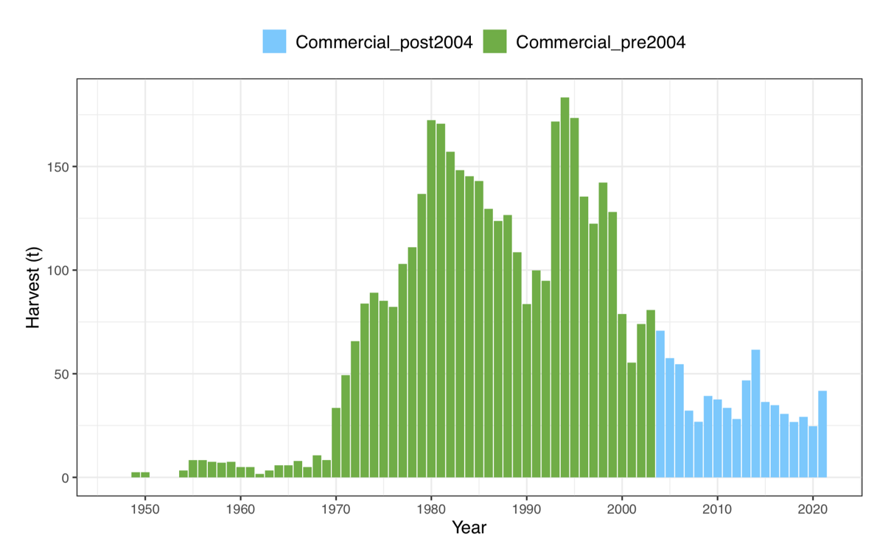
Figure 13. Annual estimated harvest (catch, t) for mud bugs from 1949 to 2021 illustrating the split at 2004 in the stock assessment due to it being the year of an independent survey (Wickens et al. 2023).

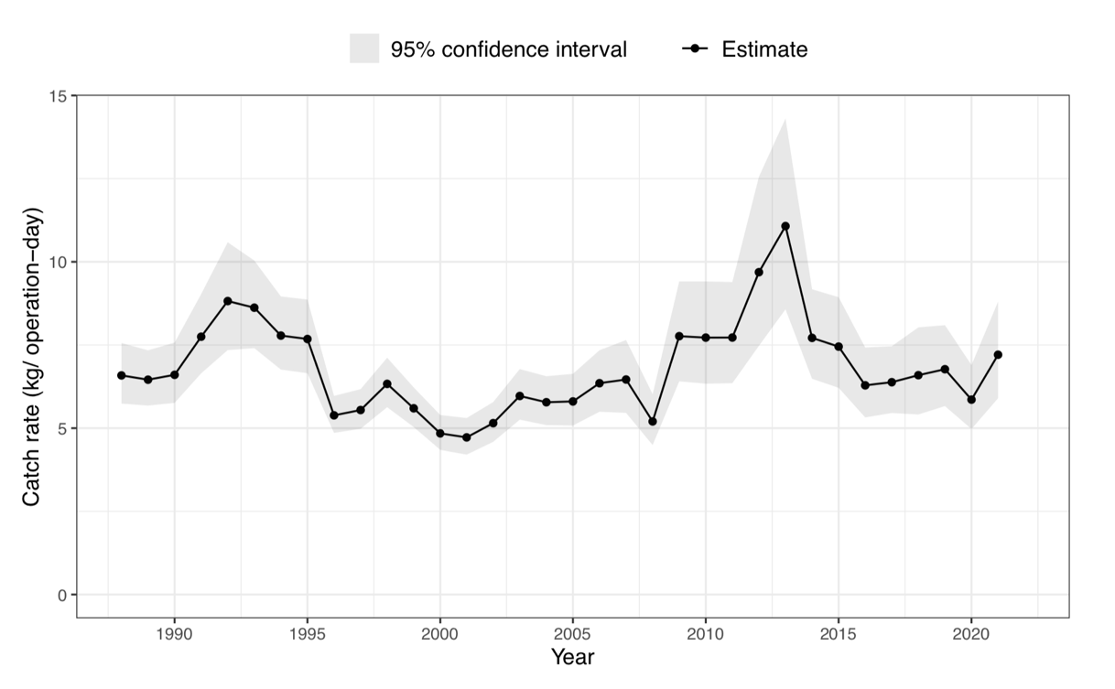
Figure 14. Annual catch rate (kg/day) for mud bugs from 1988 to 2021 (Wickens et al. 2023).

Red-spot king prawns
Since 1988, Red-spot King prawn commercial catch and effort data have been recorded in the Queensland logbooks.
The Central trawl region is the most common area that takes Red-spot King Prawns with very low catches in the southern inshore region. There was a decreasing catch trend in Red-spot king prawns through the 1990’s to the early 2000s (Figure 15). Fishery adjustment, including substantial reductions in fleet size and fishing effort, was reflected in relatively reduced but stable catches from around 2006. In 2022, 103 t of Red-spot king prawns were caught in the ECOTF, of which 81 t was taken by the Central Zone (Table 10). Recreational, Indigenous and charter harvests were non-existent or negligible for red spot king prawns and were not included in this assessment. Commercial catch rates for Red-spot king prawn through time suggest catch rates of about 100 kg/operation-day (Figure 16).

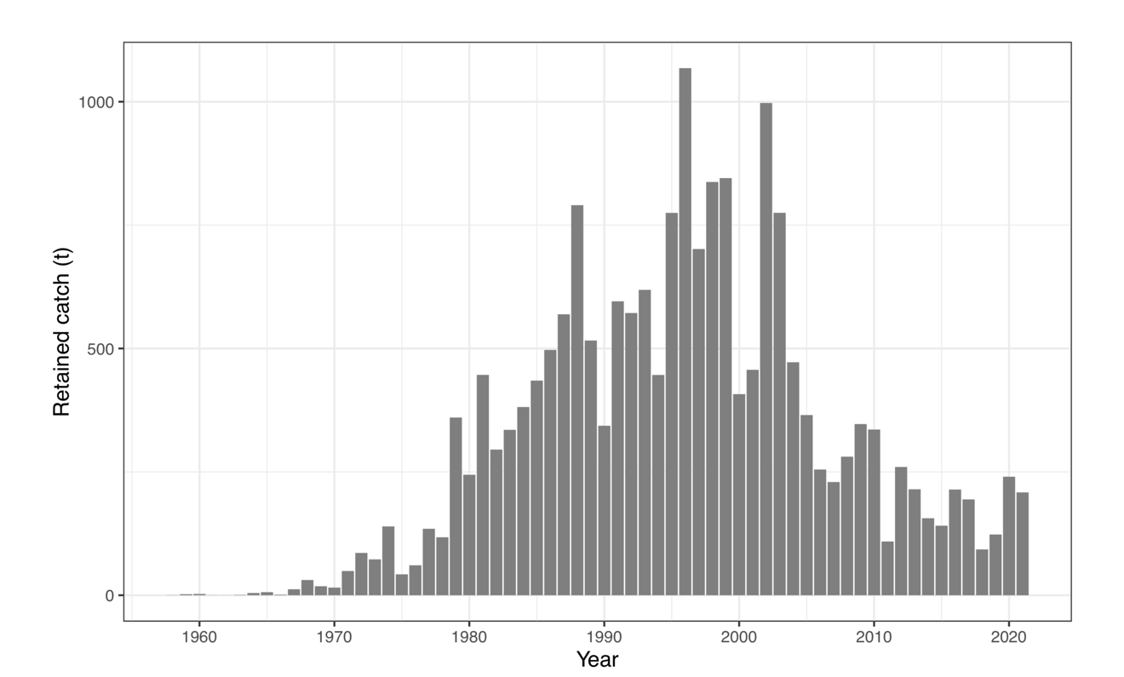
Figure 15. Annual estimated retained catch (tonnes) of Queensland’s east coast Red-spot King Prawn between 1958 and 2021 (Fox et al. 2023)

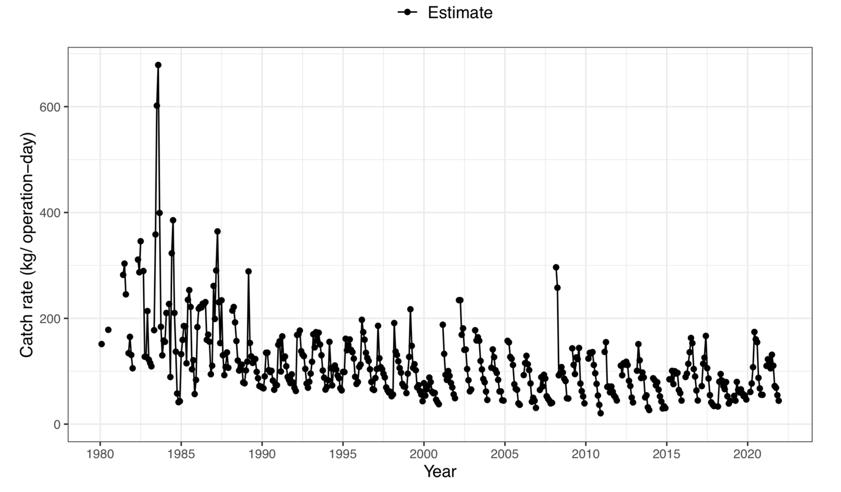
Figure 16. Monthly standardised catch rates relative to average kg per day for Queensland commercial red spot king prawns between 1980 and 2021 (Fox et al. 2023)

Banana Prawns

The vast majority of Banana Prawns are primarily taken in the Northern Prawn Fishery (Figure 17) (NB the NPF is MSC Certified). In 2022, 4029 t of banana prawn was taken by the NPF. In the same year, the total harvest of Banana Prawns from the ECOTF was 208 t, of which 21.5 t was from the Central Zone (i.e., the UoA )). Catch data supplied by QDAF presents Banana Prawn catches in 2019–2022 from four grids with the majority of the catch coming from grids O24 (75.4 t) and N24 (62.9 t) over the 4 years.

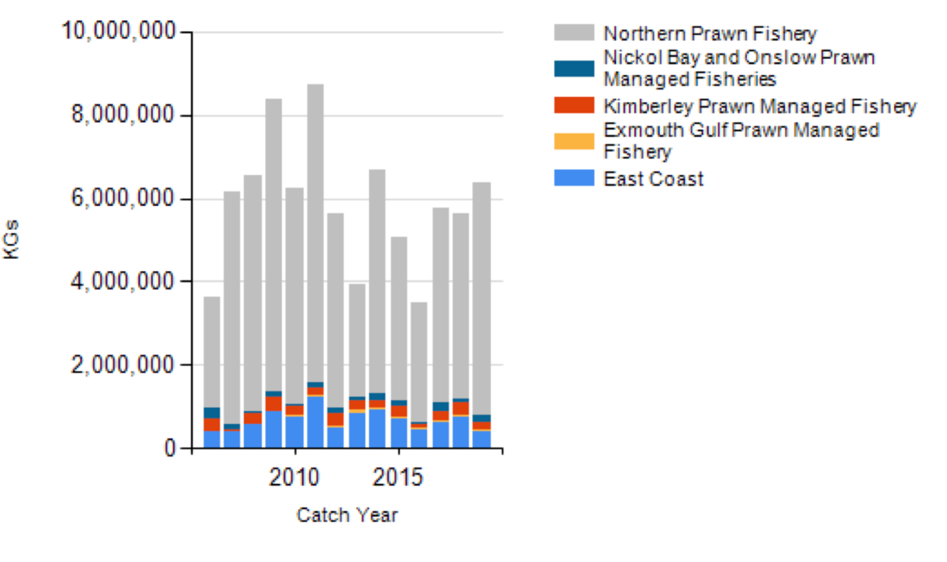
Figure 17. Annual Banana prawn harvest 2006–2019 by fishery (Source: Butler et al. 2020)

Endeavour Prawns

Catches and Harvest strategy

Most of the endeavour prawn harvest of the ECOTF comes from the Cape York Peninsula waters from north of Cairns, where the adults tend to inhabit inshore reef lagoons (QDAF, 2021a). In 2022, the northern region of the ECOTF took 74% of the total retained catch (Table 10), whilst the central region took 45 t and the Moreton Bay region took 19 t. Over the past five years (2017–21), the total retained mean catch of Endeavour Prawn was 395 t per year (Figure 18); the mean catch for the two most recent years: 2021–22 for the Central Zone was 58 t. Endeavour prawns are managed as a Tier 2 species within the Harvest Strategy (Figure 22; QDAF, 2021d). The harvest control rules for this species are:
- Commercial catch will be monitored to assess changes in fishing mortality.
- Annual commercial catch triggers (10–50 t) are used to assess changes in fishing mortality when compared to historic catch levels (2010 to 2019)

The relevant breakout rule for this species is: “if a biomass estimate is available through a stock assessment for secondary or by-product species that indicates a reduction in fishing mortality is required to achieve Btarg or avoid Blim, then management action must be taken (e.g. trip limits, size limits or spatial/temporal closures) to pursue the fishery objectives.”

The mean annual catch (58 t) is currently outside the commercial range listed in the HS (10–50 t). However, the HS stated that “a review is to be undertaken to understand the reason for the increased harvest, assess the risks and ensure catch of a species does not increase more than 20% above the upper catch range.” It is unclear if a review was triggered; however, the 2023 stock assessment found the biomass to be above B_{target}.

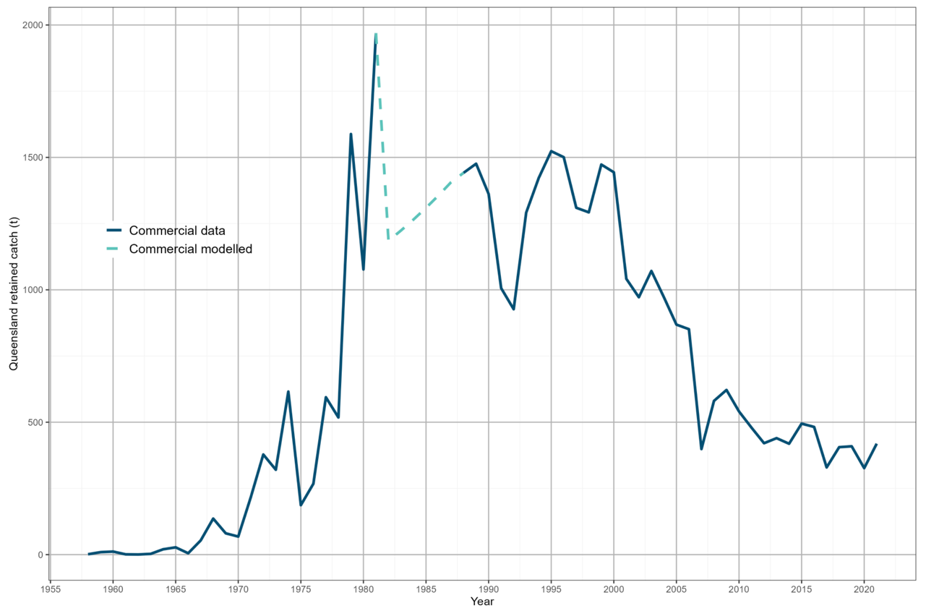

Figure 18. Endeavour prawn retained used in the stock assessment (Fox et al. 2023).

4.1.2.2 Catch data of each UoA species

Table 10. Logbook catch data for Tiger Prawn, Endeavour Prawn, Red-spot King, Banana Prawn and Moreton Bay Bug from the ECOTF, UoA = Central region. Note: From 2021 Moreton Bay Bug data was separated by species Mud Bug or Sand Bug. Sand bug dominates (>95%) the MBB catch from the central zone.
Catch Data | 2019 | 2020 | 2021 | 2022
ECOTF Tiger prawn catch (t) | 1075 | 1227 | 1097 | 1052
UoA Tiger prawn catch (t) | 324 | 482 | 351 | 289
ECOTF Endeavour Prawn catch (t) | 447 | 361 | 452 | 296
UoA Endeavour Prawn catch (t) | 63.03 | 63.26 | 75.80 | 45.65
ECOTF Red-spot King Prawn catch (t) | 115 | 209 | 201 | 103
UoA Red-spot King Prawn catch (t) | 110 | 207 | 187 | 81
ECOTF Banana Prawn catch (t) | 305 | 382 | 99 | 208
UoA Banana Prawn catch (t) | 245 | 146 | 50 | 22
ECOTF MBB catch (t) | 501 | 466 | 545 | 541
UoA MBB catch (t) | 182 | 202 | 162 | 184

4.1.3 UoA species

Tiger prawns

Distribution & stock structure
Brown tiger prawns are endemic to tropical and subtropical waters of Australia, while grooved tiger prawns have a wider Indo–West Pacific distribution. Both species occur along the coastline of northern Australia from Shark Bay in Western Australia to the eastern coast of northern New South Wales (Somers 1987; Ward et al. 2006).
Migratory behaviour differs between the species with the grooved tiger prawn displaying more mobile behaviour of regular movements from the inshore feeding grounds to spawn in offshore waters; Brown tiger prawns are more sedentary in nature (Dichmont et al. 2001; Venables et al. 2004). Subsequently, the susceptibility of each species to capture also differs throughout the coastline regions (Lovett et al. 2023).

Life history
Both Brown and Grooved Tiger prawns have an approximate life cycle of 2 years (Dichmont et al. 2006; Somers et al. 1991).
Spawning activity peaks in January–March and August –October each year with females spawning in offshore waters < 50 m deep (Turnbull et al. 2007). About two weeks after spawning, post-larvae settle on inshore sea-grass nursery beds within an estuary (Turnbull et al. 2007) and stay for about three months in these nursery grounds. Young juveniles migrate back to offshore waters, and reach maturity at approximately six months of age or 32–39 mm carapace length (CL) (Somers 1987; Turnbull et al. 2007). The maximum observed size is 44 mm CL for Brown females, 35 mm CL for Brown males, 52 mm CL for Grooved females and 38 mm CL for Grooved male prawns.

Stock assessment

Logbook records do not specify if catch is comprised of Penaeus esculentus, P. semisulcatus or a mix of both species, and as such Tiger prawns are modelled collectively although Lovett et al. (2023) found that a final overall proportion was calculated, resulting in 58% Brown Tigers and 42% Grooved Tigers.

Lovett et al. (2023) updated the stock assessment for Tiger prawns from the east coast of Queensland. Tiger prawns were previously assessed at the sector level (northern and southern sectors, split at 16◦ S) by Wang (2015) and at the management region level by Helidoniotis (2021), using a weekly delay-difference model.

The latest assessment (Lovett et al. 2023) used a one-sex monthly delay-difference population model, fitted to catch rates. An age-structured model Stock Synthesis model was also trialled; however, this did not lead to outcomes that were considered plausible by the assessment team and was therefore deemed an unsuitable method to assess tiger prawns for the east coast of Queensland at this time.

Stock status

In 2021, the stock level of Tiger Prawns was estimated to be 79% of unfished biomass (70–89% range across the 95% credible interval) (Figure 18; Lovett et al. 2023). Lovett et al. (2023) noted that whilst the stock is currently above the TRP, biomass was declining. Helidoniotis (2021) estimated the stock was at around 49–50% of unfished levels in 2019 for the central and northern trawl management regions combined.

The difference in final biomass predictions between Helidoniotis (2021) of 50% unfished biomass for central and Lovett et al. (2023) was explored thoroughly via a bridging analysis presented at ‘Appendix E Bridging Analysis’ within Lovett et al. (2023).

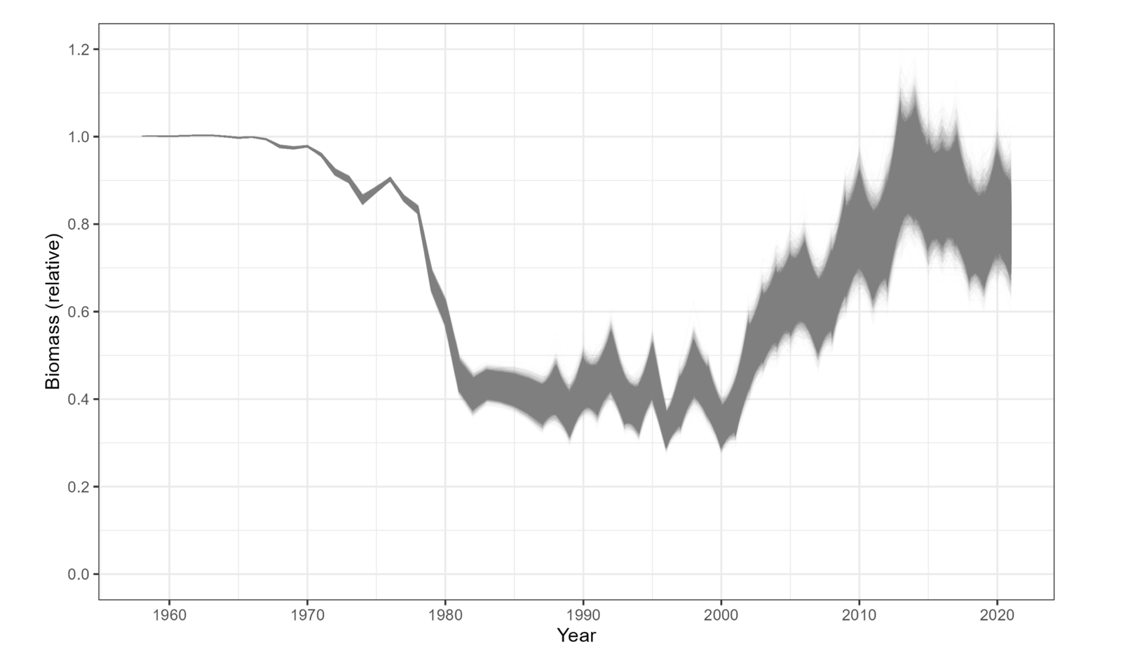
Figure 19. Predicted biomass trajectory relative to unfished for tiger prawns, from 1958 to 2021—grey lines represent individual MCMC samples (Source: Lovett et al. 2023).
Table 11. History of Prawn management in Queensland (Lovett et al. 2023).
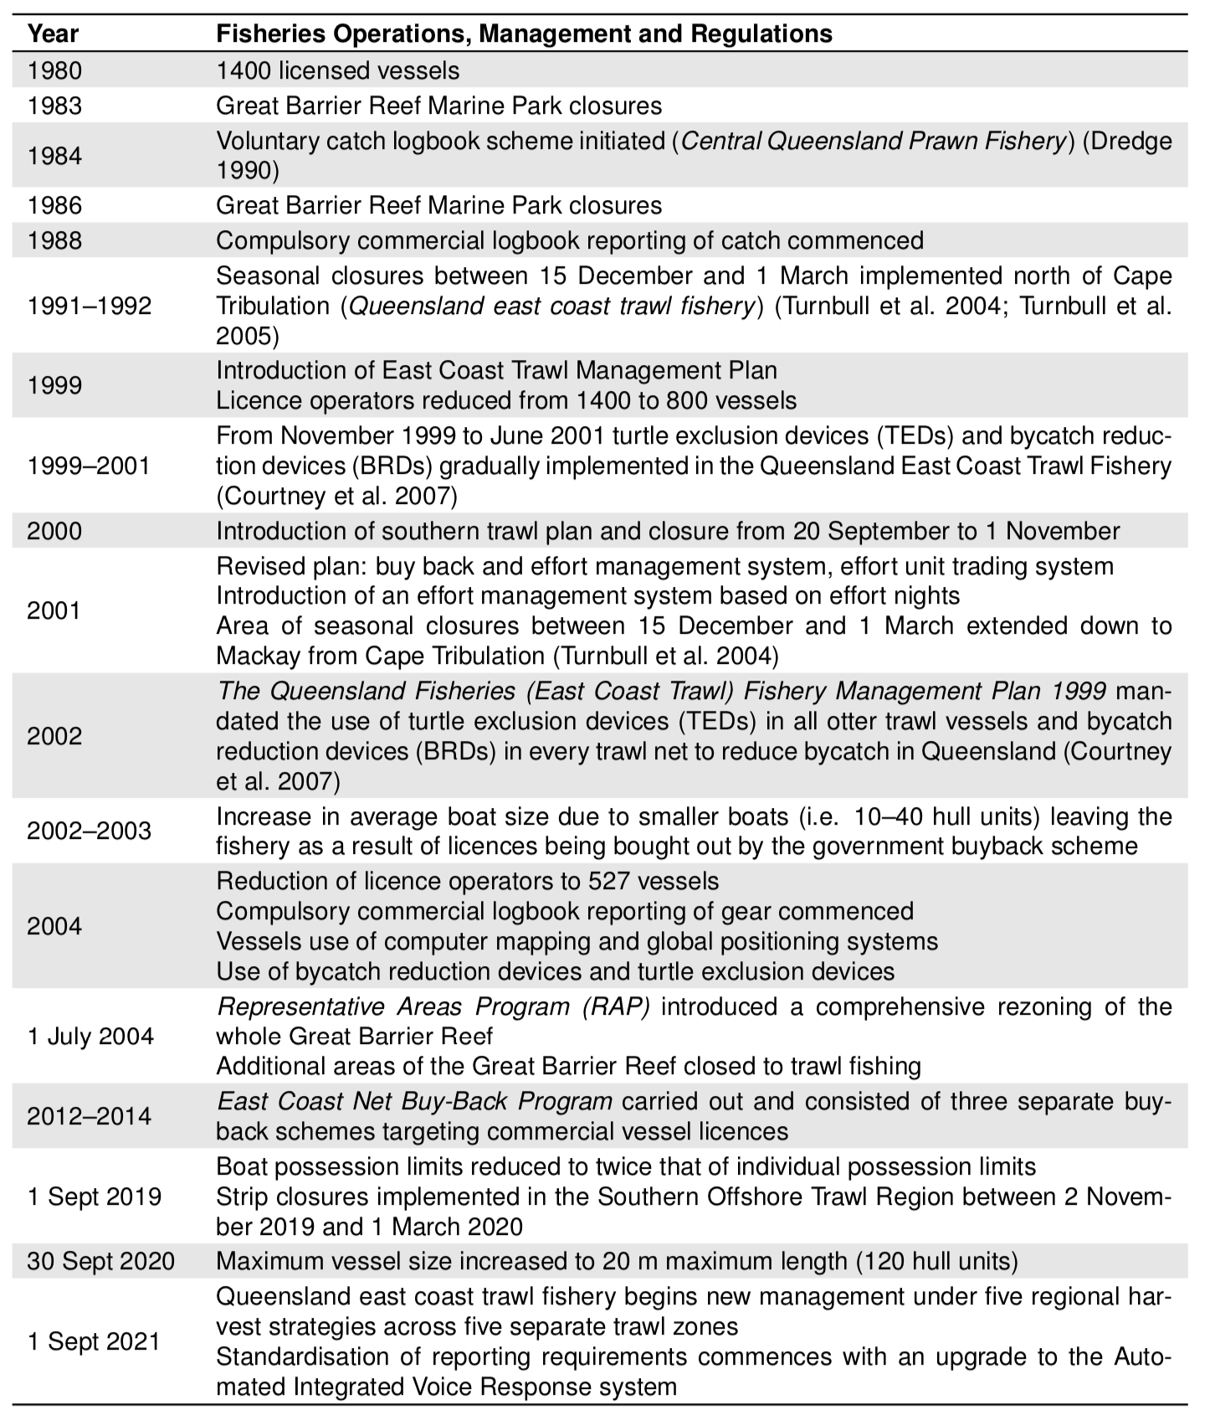

Moreton Bay Bug

Distribution & stock structure
Moreton Bay bugs are distributed throughout tropical and subtropical coastal waters of Australia from northern New South Wales to Shark Bay in Western Australia. The Moreton Bay bug population on the east coast of Queensland is comprised of two species—Thenus australiensis, also known as the sand or reef bug, and Thenus parindicus, also known as the mud bug. Mud bugs and sand bugs may be difficult to identify but can be distinguished by their legs and colouration. Mud bugs have striped legs whilst sand bugs have speckled legs and a red/brown colouration. Moreton Bay bugs are often confused with the sympatric species’ Balmain bugs I. brucei and I. alticrenatus. The key physical difference between the species is the location of the eyes; the eyes of the MBBs are on the outer edge of the carapace compared to centrally positioned eyes of Balmain bugs.

In Queensland, T. parindicus generally prefer shallow inshore waters between 10 and 30 m with sediment particle sizes of 0.125–0.25 mm, whilst T. australiensis generally prefer deeper waters between 40 and 50 m with particle sizes of 0.25–0.5 mm (Jones 1993). There is a paucity of studies of the movement of Thenus spp. in Queensland (Wickens et al. 2023). Jones (1993) hypothesized the ground gear ‘tickler chain’ was likely sufficient to disturb the top few centimetres of the benthos where inactive individuals were buried, exposing T. australiensis and T. parindicus from within the sediment to the trawl net following. Wickens et al. (2023) presented the distribution of catches (Figure 20).

McMillion et al. (2024) used genome complexity reduction-based sequencing to characterise high-quality Single Nucleotide Polymorphisms (SNPs) to evaluate MBB population structure among three management zones of the ECOTF. Post-filtering, a total of 3,031 SNPs were used to infer no genetic differences among locations indicating strong genetic population connectivity. The observed genetic population connectivity likely results from the relatively long pelagic larval duration that would support extensive larval dispersal and population mixing.
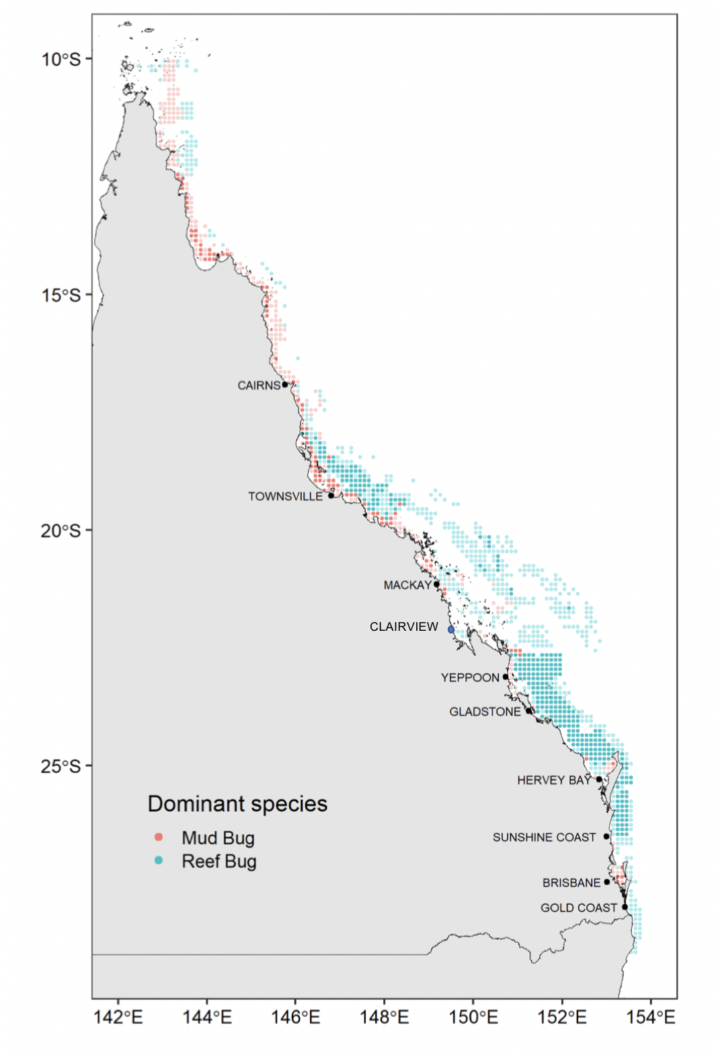
Figure 20. Distribution of MBB noting catches of the dominant MBB species (adapted from Wickens et al. 2023): Reef Bug aka Sand bug (Thenus australiensis) and Mud Bug (T. parindicus). Note: Sand Bug (aqua) is the dominant species of MBB in the inshore southern region (approximately Clairview south to Hervey Bay, see Figure 3 above for fishery boundaries)

Life history

- Sand bug females reach 50% maturity at 82 mm carapace width (CW) or 59 mm carapace length (CL).
- Mud bug females reach 50% maturity at 75 mm carapace width or 53 mm carapace length.
- Both species spawn year-round with spawning peaks during the period between spring and mid-summer.

Stock assessment
Wickens et al. (2023) produced the first stock assessment conducted on Queensland Moreton Bay bugs.

The stock assessment included input data through to December 2021. All assessment inputs and outputs were referenced on a calendar year basis (that is, ‘2021’ means January 2021–December 2021).
For all stocks analysed, the assessment used a one-sex monthly delay-difference population model,
fitted to catch rates. Age-structured models were also trialled; however, these did not lead to outcomes that were considered plausible by the project team.

For sand bugs, the data from 1968 to 2021 comprised of commercial catch and effort (1988—2021), historical commercial catch (1968–1981, 1974–1987), fishery independent survey data (2017-2021) and licence numbers (1968–2003).

For mud bugs, the data from 1948 to 2021 comprised of commercial catch and effort (1988-–2021), historical commercial catch (1948–1981, 1974–1987) and licence numbers (1968–2003). The model split the fishery into two fleets to account for the rezoning of the Great Barrier Reef (GBR) in 2004—one for the commercial sector pre-July 2004, and one for commercial sector post-July 2004.

The stock assessment was guided by a project team consisting of scientists, managers, and industry representatives.
Thirteen model scenarios were run for the sand bug stock, covering a range of modelling assumptions and sensitivity tests. All scenarios were optimised using Markov chain Monte Carlo (MCMC) to better explore the robustness of the models. Project team preferred scenario results suggested that the sand bug stock experienced a decline in the period 1968 to 2000 to reach 67% of unfished biomass. The biomass has been generally increasing since, and in 2021 the stock level was estimated to be 78% (63—94% range across the 95% credible interval) of the unfished biomass.
Thirteen model scenarios were run for the mud bug stock, covering a range of modelling assumptions and sensitivity tests. Seven scenarios had convergence problems, or diagnostics that indicated issues. The non-target nature of the fishery combined with fishery-dependent catch rates being the primary data set for model tuning makes assessment difficult. The status of the mud bug stock is undefined. The general trajectory across the thirteen scenarios shows the biomass experienced a decline from the period of 1968 until the mid 1980s, then slowly recovered since that time.

The main assumptions underlying the model by Wickens et al. include:
- The fishery began from an unfished state in 1968 for sand bugs and 1948 for mud bugs.
- Sand and mud bugs swim freely and mix rapidly within the bounds of each stock, so that the different fleets compete for the same sand and mud bugs rather than targeting different sub-populations.
- Genetic stocks along Queensland’s east coast are reproductively isolated from one another.
- The proportion of mature sand and mud bugs depends on size and not age.
- The proportion of mature sand and mud bugs vulnerable to fishing depends on size and not age.
- Growth occurs according to the von Bertalanffy growth curve.
- The instantaneous natural mortality rate does not depend on size, age, year or sex.
- Deterministic annual recruitment is a Beverton-Holt function of stock size.

Stock status

Wickens et al. (2023) stated that the biomass for 2021 was calculated to be 78% (63-94% CI) of unfished biomass, with a decreasing trend. MSY was estimated to be 636 t and B_{MSY} is 34% (Table 12). The same assessment for Mud Bug did not provide a biomass estimate due to the non-target nature of the fishery and insufficient data being available. Mud bugs are taken in association with Red-spot king prawns and Scallops whilst Sand bugs are taken in association with Tiger prawns, Endeavour and Banana prawns.

During the stock assessments (Wickens et al. 2023), the southern boundary of the sand bug assessment was at 26◦ S whilst the southern boundary of the mud bug assessment was at 28◦S.

Table 12. Indicators for MBB—target reference point for biomass is 60% (Wickens et al. 2023)
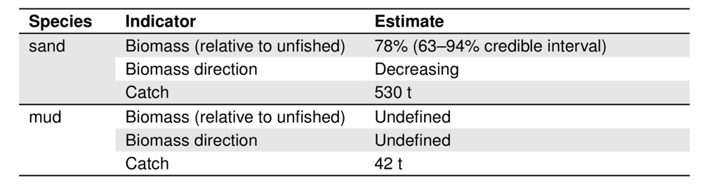
Zeller et al. (2016) noted that the minimum legal size limit of 75 mm carapace width (CW) lets Mud Bug have the opportunity to spawn prior to recruiting to the fishery. Post-capture survival of discards is high among Moreton Bay Bugs (Hill et al. 1998). Research has also shown that turtle excluder devices (TEDs) lower catch rates of legal sized Moreton Bay Bugs (greater than 75 mm CW) and 100 mm square-mesh codend bycatch reduction devices (BRDs) greatly lower incidental capture of undersize reef bug in the ECOTF (Courtney et al. 2008).

Retention of berried female bugs since 2010 is likely a factor in maintaining generally higher catches. However, Zeller et al (2016) conclude that the risk of overfishing is unlikely to be increasing under the current scenario of significant biomass protection within permanent GBRMP closures, size selectivity of TEDs and BRDs and a likely decline in fishing related mortality associated with declining fishing effort.
Wickens et al. (2023) summarised the management of MBB in Queensland (Table 13).
Table 13. History of Moreton Bay bug management in Queensland (Wickens et al. 2023).
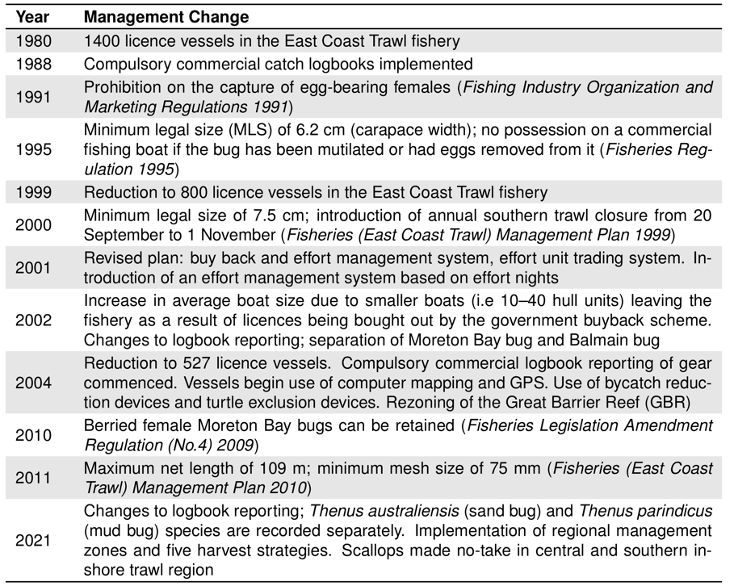

Red-spot King prawns

Distribution & stock structure

Red-spot King prawns (Melicertus longistylus, formerly known as Penaeus longistylus) are found in tropical waters of Australia from Shark Bay in Western Australia to near Yeppoon in Queensland. Red-spot King prawns generally occur along the eastern coastline of Queensland above 22◦S. Red-spot King prawns migrate between nursery areas within the Great Barrier Reef lagoons and deeper waters a short distance from the reef. However, the species is sedentary in nature and displays very little migratory behaviour once they have moved from nursery areas back to deeper waters(Dredge 1990).

Life history
Red-spot King Prawn live around two years and have a maximum observed size of 51 mm carapace length (CL) for females and 42 mm CL for males. Sexual maturity for females is reached at approximately 8 months of age and 33 mm CL (Fox et al. 2023).

Stock assessment

Fox et al. (2023) provided the first assessment of this species from east coast of Queensland. The assessment used a one-sex monthly delay-difference population model, fitted to catch rates. An age-structured model was also trialled. Twenty-four scenarios were run using a delay-difference model, covering a range of modelling assumptions and sensitivity tests. All scenarios were optimised using Markov chain Monte Carlo (MCMC) to better explore the robustness of the models. There was varying success across the 24 scenarios, with nine models achieving convergence that resulted in a wide range of final biomass estimates, and some non-converged scenarios had better model fit.

In southern Queensland, this species was assessed in 2015 (Wang et al. 2015) and estimated maximum sustainable yield (MSY) of 716 t from 1988–2013 catch data for the southern region.

Stock status
The stock level was reported as ‘undefined’ (Fox et al. 2023). Nine model scenarios converged, out of the 24 that were tested, predicting the current biomass (compared to unfished levels) for the stock to be 27–116%.

Banana Prawn
In Australia, Banana Prawns comprise two species, namely the white banana prawn (Penaeus merguiensis) and the red-legged banana prawn (Penaeus indicus). Both species are taken in Queensland, although only the white banana prawn (P. merguiensis) is listed as a Tier 2 species for the ECOTF central region sub-fishery (catch was 21.5 t in 2022).

Distribution & stock structure
Banana Prawns are very wide distribution and between the two species range longitudinally from Oceania (New Caledonia) in the east to eastern Africa in the west (Figure 21). Latitudinally, they occur from the Red Sea and South China Sea in the north to the mid-east and west coasts of Australia and the east coast of South Africa in the south (Vance and Roslisberg 2020).
Butler et al. (2021) stated that: “The biological stock structure of Banana Prawn is uncertain. There is some evidence that there may be separate biological stocks of White Banana Prawn within the Northern Prawn Fishery (Commonwealth); however, the boundaries of the biological stocks are unknown [Yearsley et al. 1999]. Banana prawn fisheries in Western Australia and Queensland are widely separated, but it is not known whether these are completely independent stocks [Tanimoto et al. 2006].”

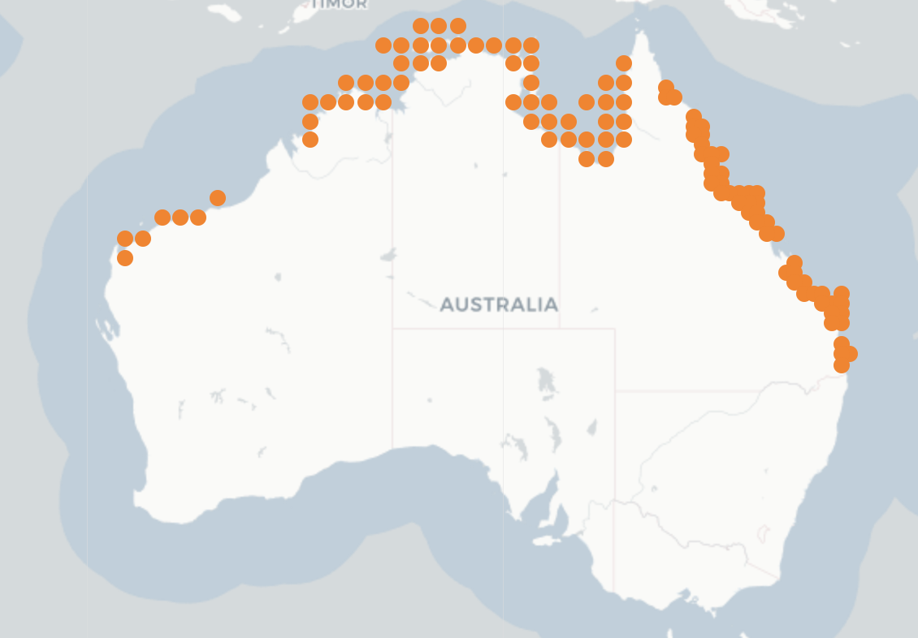
Figure 21. Distribution of Banana Prawn (Source: Butler et al. 2021)

Life history

Vance and Roslisberg (2020) reviewed the published literature across the species’ range and have compiled and synthesised what is known about the factors affecting recruitment dynamics.
Banana prawns are fecund, short-lived and have complicated requirements regarding life history: an offshore coastal spawning ground linked to a mangrove-lined estuarine nursery ground. Given these characteristics can be influenced heavily by variable environmental inputs, their recruitment to each life history stage is also variable, resulting in inter-generational and inter-annual variation in survival and population size. Commercial catch is therefore influenced by environmental changes and such dynamics vary in subtle ways between the two species and various important habitats (coastal seas, bays, estuaries, mangroves, channels, the land/sea interface, and river catchments). The annual catch is prone to relatively strong fluctuations due to these short lifecycles as well as their high sensitivity and responsiveness to environmental conditions, namely rainfall and subsequent riverine flows.

Stock assessment
A single fishery-level stock is also assumed for status determination purposes. There is no formal stock assessment for this stock and the latest assessment was conducted by Tanimoto et al. (2006) and is now outdated.

The environmentally driven, high variability of this resource means that developing a robust stock–recruitment relationship is difficult. This is because annual yields are largely dependent on annual recruitment and recruitment has a complex association with seasonal rainfall, oceanographic conditions and availability of food (van der Velde et al. 2021).

Banana prawn fishing mortality is primarily from the Northern Prawn Fishery (NPF). White banana prawns are mainly caught during the day on the eastern side of the Gulf of Carpentaria, whereas redleg banana prawns are caught day and night, mainly in Joseph Bonaparte Gulf (JBG). White banana prawns make up the bulk of the prawn catch in the NPF; In 2022, 3377 tonnes of white banana and 652 t of redleg banana were recorded compared to 207 t of banana prawns in the ECOTF, of which 22 t came from the UoA for the same period.
A banana prawn stock assessment was undertaken in 2006 examining regional catch rates of the potential eastern Australian sub-stock (Tanimoto et al. 2006). The results obtained indicated that exploitable biomass levels for banana prawns were about 50–70 per cent of virgin biomass, which was well above the level required for MSY or the PRI. Following that assessment, catches were higher than they were prior to the 2006 assessment and fishing power had increased but the species was still considered to be sustainably fished (QDAFF 2013, Larcombe et al. 2014). The ERAs found a low risk of overfishing at 2009 effort levels (Pears et al. 2012) and at 2017 levels (Jacobsen et al. 2018).
Whilst there is a Redleg banana prawn assessment (Plagányi et al. 2023) it was for the western area of the Northern Prawn Fishery only (i.e., Joseph Bonaparte Gulf) and is not relevant to this assessment.

Stock status
Butler et al. (2021) stated that: “A quantitative assessment of the East Coast (Queensland) management unit, based on catch and effort data from 1988–2004, estimated an average annual MSY estimate of 802 t [Tanimoto et al. 2006]. Total commercial catch of Banana Prawns since 2013 has stabilised at a level below the MSY estimate; at 442–785 t [QFISH 2020]. Total harvest in 2019 was at the lower end of this range at 449 t. The above evidence indicates that the biomass of the management unit is unlikely to be depleted and that recruitment is unlikely to be impaired.”

Butler et al. (2023) stated that: “There are currently no indices with which to measure the current versus historical biomass for white banana prawns. Consequently, there is no way to directly estimate the impacts of current fishing on that biomass relative to BLIM. Harvest rates for white banana prawn in the fishery are high (>90% of available biomass) in some years (Buckworth et al. 2013). The stock has so far been resilient to these levels of fishing pressure. Catch rate triggers also help stop fishing when catch rates become low because it becomes unprofitable. This provides a level of biological protection for the stock.”

Biomass is not measured in the white banana prawn fishery, so there is no way to directly measure the status of the stock. There is, however, a long history of consistent catches across many generations of the stock, with no evidence to suggest that overfishing has occurred or is occurring. Overfishing is therefore considered to be unlikely and the stock is classified as not subject to overfishing and not overfished (MRAG, 2023).

Endeavour Prawn

Distribution & stock structure

Endeavour prawns (Metapenaeus endeavouri and Metapenaeus ensis) are endemic to the tropical and subtropical waters of Australia and are widely distributed along the coastline of northern Australia from Shark Bay in Western Australia to the eastern coast of northern New South Wales (Figure 22).

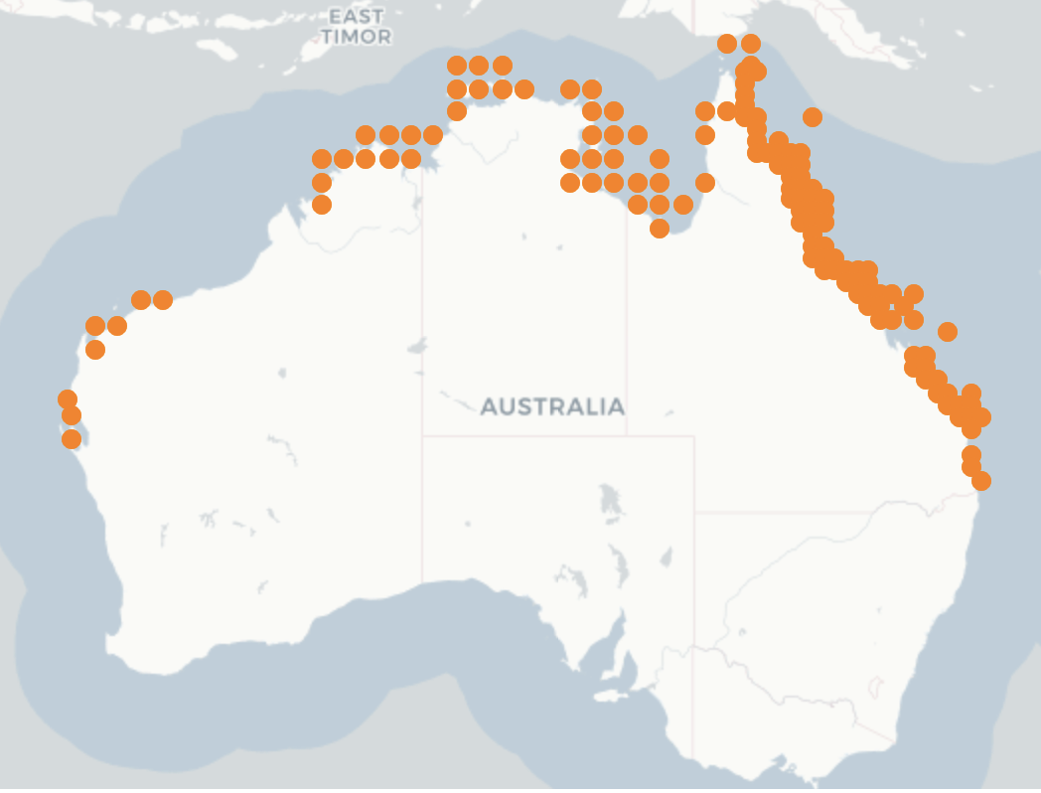
Figure 22. Distribution of Endeavour Prawns (Source: SAFS 2020)

Life history
Endeavour prawn is a species complex or Blue Endeavour and Red Endeavour prawns of similar sizes. Sexual maturity is months 24–26 mm CL.

Stock assessment
The most recent quantitative stock assessment on the biological stock was undertaken by Fox et al. (2023b). The assessment considered the spatial scope to be all east coast of Queensland using data to 2021. The assessment used a one-sex monthly delay-difference population model fitted to catch rates. An age-structured model was also trialled but there were no plausible outcomes from that model. Commercial catch rates were standardised to estimate an index of endeavour prawn abundance through time (Figure 28).
Endeavour prawns had previously been assessed at the sector level (northern and southern sectors, split at 16◦ S) by Wang (2015), using data from 1988 to 2013.

Stock status

Zeller et al. (2023) suggested the ECOTF Endeavour Prawn fishery was ‘sustainable’ and ‘not overfished’ based on the low fishing mortality relative to historical levels. Biomass declined between 1958 and 1997 to 34% of unfished biomass. In 2023, stock biomass was 69% (54–87%) of unfished biomass (Figure 23; Fox et al. 2023b).

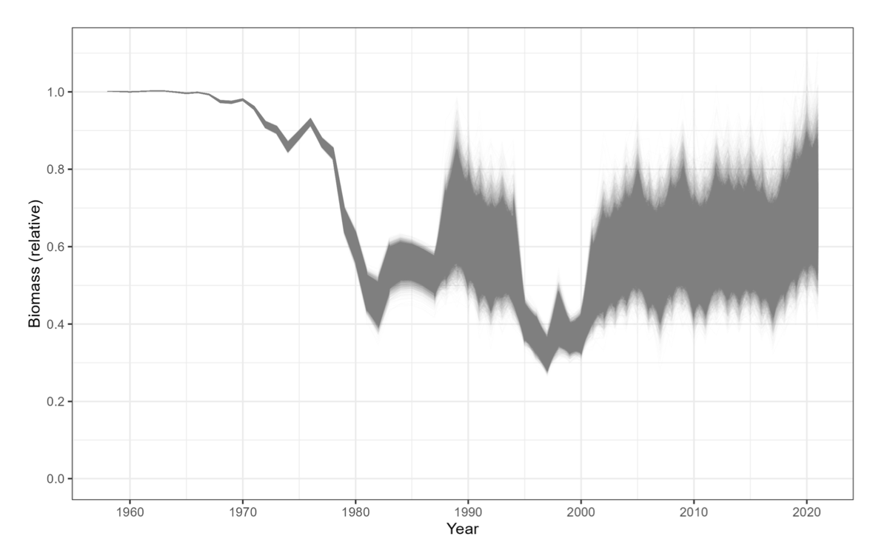
Figure 23. Predicted biomass trajectory relative to unfished for endeavour prawns, from 1958 to 2021—grey lines represent individual MCMC samples (Source: Fox et al. 2023b)

Table 14. Summary of model outcomes for all endeavour prawn scenarios—B₂₀₂₁ % is the most likely biomass in 2021 relative to unfished in 1968 with the 95 % credible interval (CI) (Fox et al. 2023b).
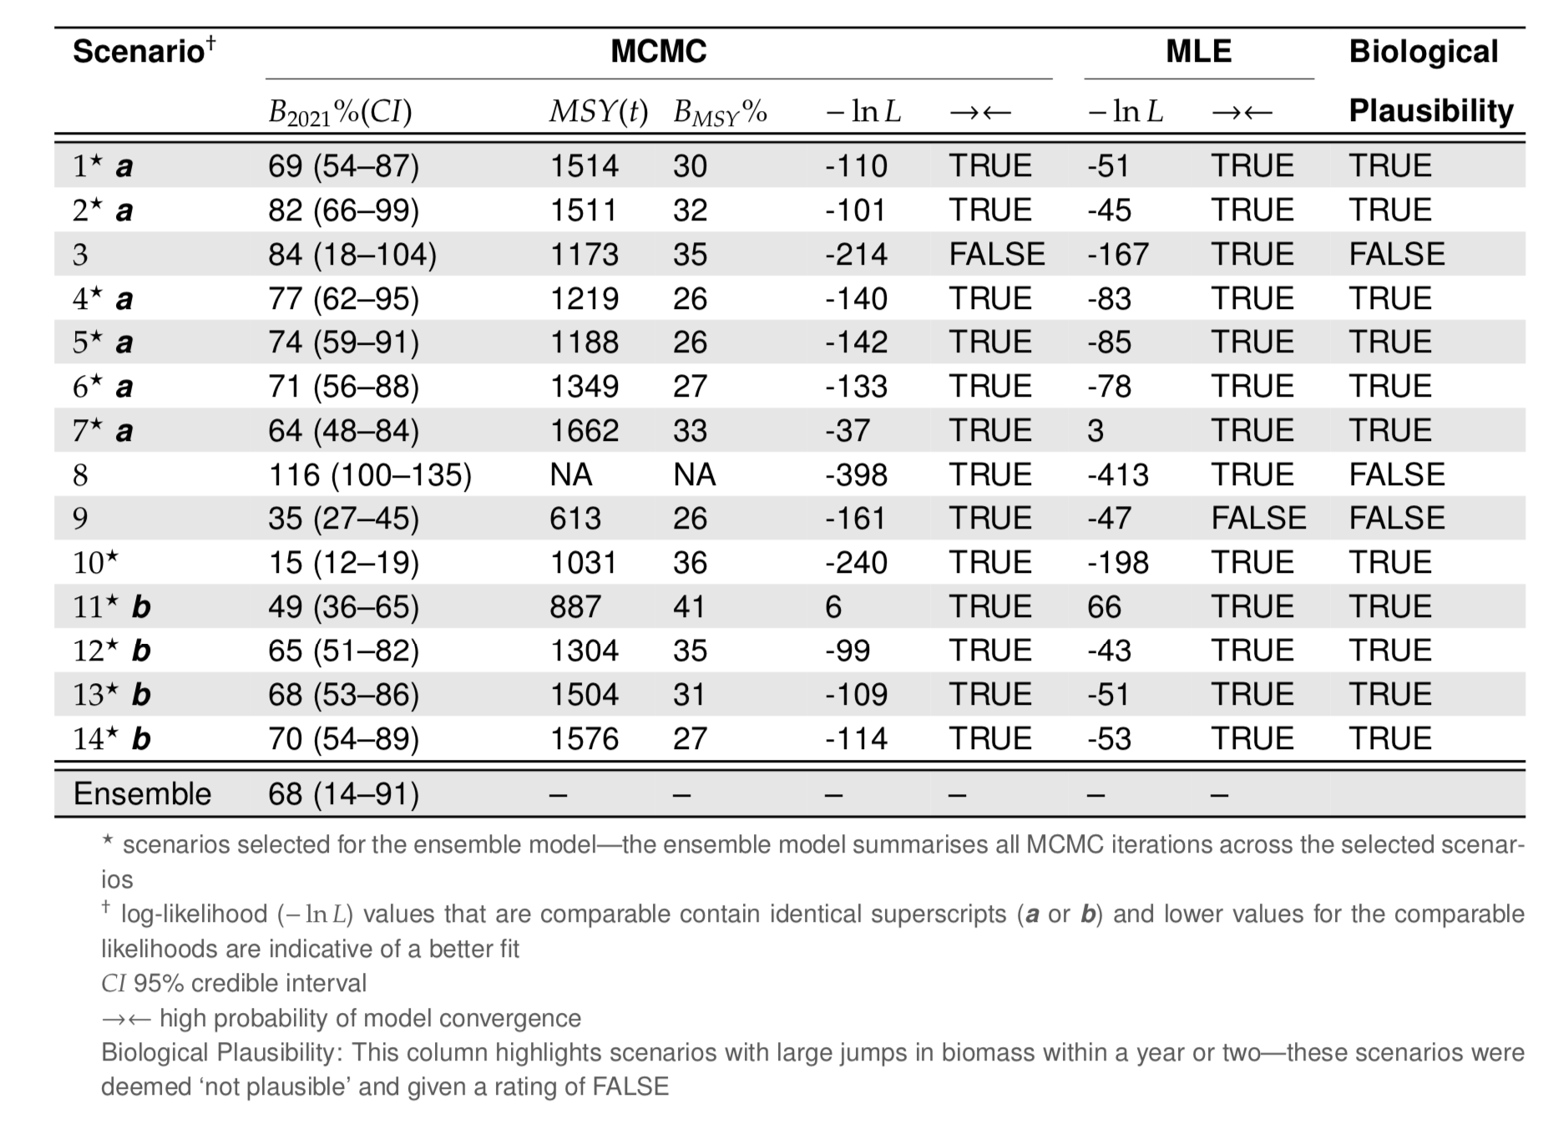

Harvest strategy

Tiger prawns
Brown and Grooved Tiger prawns are Tier 1 species managed collectively within the Central Trawl Region Harvest Strategy (QDAF, 2021d). There is a target reference point of 60% unfished spawning biomass and the limit reference point of 20% unfished spawning biomass. Harvest control rules (decision rules) are used to set total allowable commercial effort (TACE) (Figure 24).

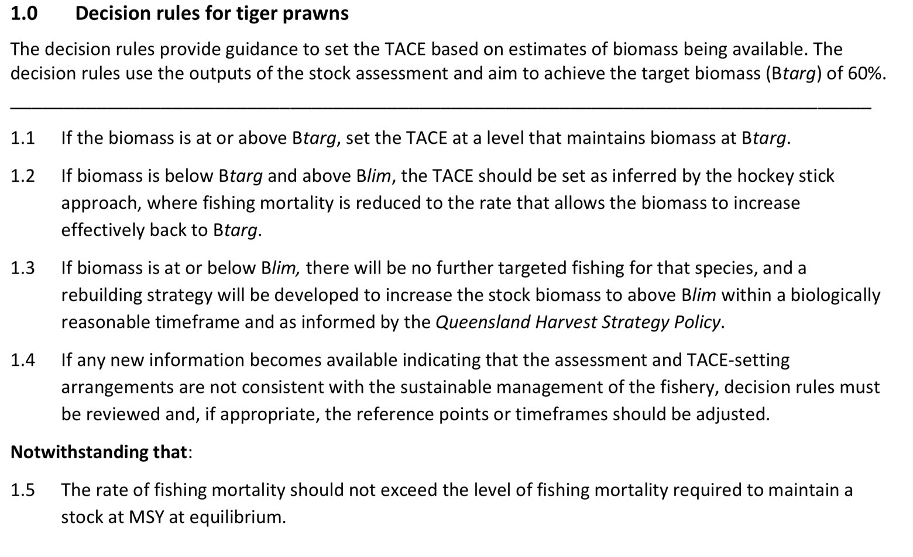
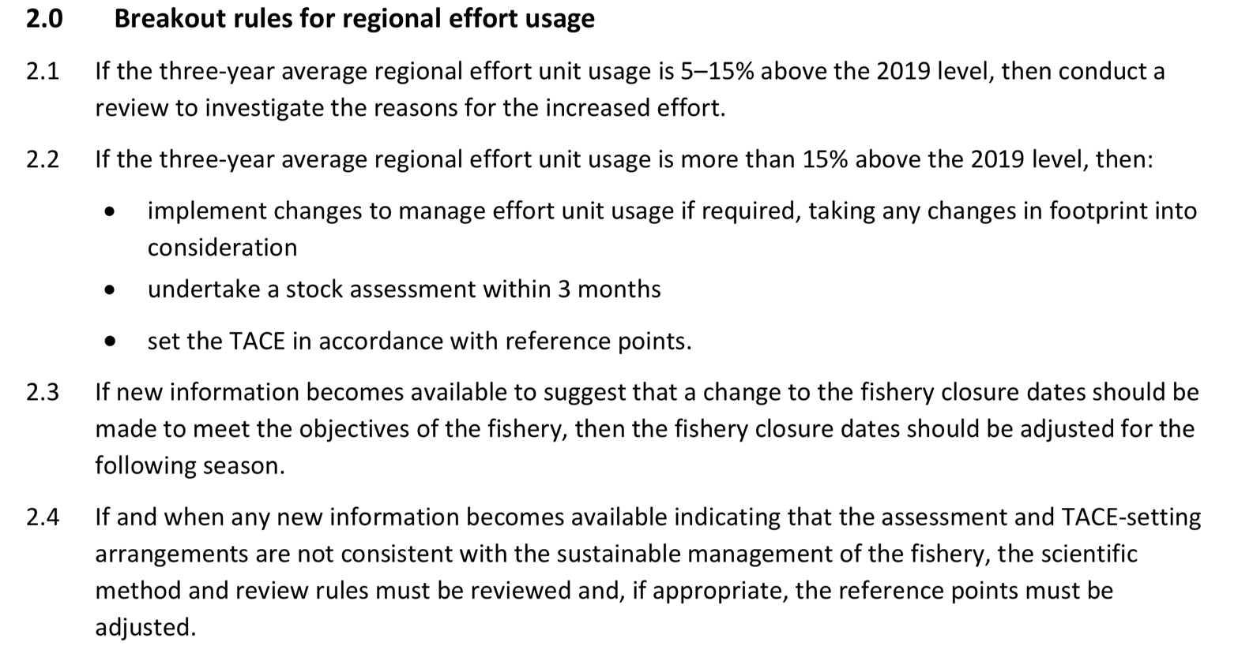
Figure 24. Harvest strategy decision rules for Tiger Prawns from Central Trawl Region of the ECOTF (QDAF, 2021d).

Red-spot King prawns
Red-spot King Prawns are a Tier 2 species within the Central Trawl Region HS (QDAF, 2021d) that are specifically mentioned in the decision rules or breakout rules (Figure 25). Catches outside of the 100-300 t range for two consecutive years would trigger a review, a stock assessment and the potential to introduce management triggers of trip/size limits or spatial/temporal closures. Catches of Red-spot King Prawns in the central trawl region (UoA) is presented in Table 10 above and in 2022 were 80.5 t and this is outside the historical range (total ECOTF catch was 102.7 t). Fox et al. (2023) conducted a stock assessment and the status is undefined although there is no indication that a reduction in fishing mortality is required.

Moreton Bay Bugs
MBB are a secondary (Tier 2) species within the Central Trawl Region Harvest Strategy (QDAF, 2021) with the target reference point of 60% unfished biomass and limit reference point of 20% unfished biomass. Prior to the release of the first stock assessment (Wickens et al. 2023), stock status was based on annual commercial logbook catches (2010–19) (Figure 25). Catches outside of the 100-300 t range for two consecutive years would trigger a review, a stock assessment and the potential to introduce management triggers of trip/size limits or spatial/temporal closures. Catches of Moreton Bay Bug in the central trawl region (UoA) is presented above and in 2022 were 184 t and of this, sand bug made up 178 t .

Endeavour prawns

Endeavour Prawns are a Tier 2 species within the Central Trawl Region HS (QDAF, 2021; Figure 25); SG 60 is met. The HS was implemented in 2022 with the harvest control rules for Endeavour prawn being:

- TRP = B_{target} = 60% of unfished biomass
- LRP = B_{limit} = 20% of unfished biomass
- In addition to stock assessments, commercial catch will be monitored to assess changes in fishing mortality. Annual commercial catch triggers (10–50 t) are used to assess changes in fishing mortality when compared to historic catch levels (2010 to 2019).
Catches have been monitored and retained catches have recently exceeded the trigger (average 58 t in 2021–22) indicating a change in fishing mortality. The most recent stock assessment (Fox et al. 2023b) used data to 2021 and estimated the stock was 69% of unfished biomass. Results of this assessment were discussed at the Trawl Working Group meeting in November 2023. Biomass is above the target reference point of 60% B₀ providing evidence that the measures are achieving the objectives; SG 80 is met.

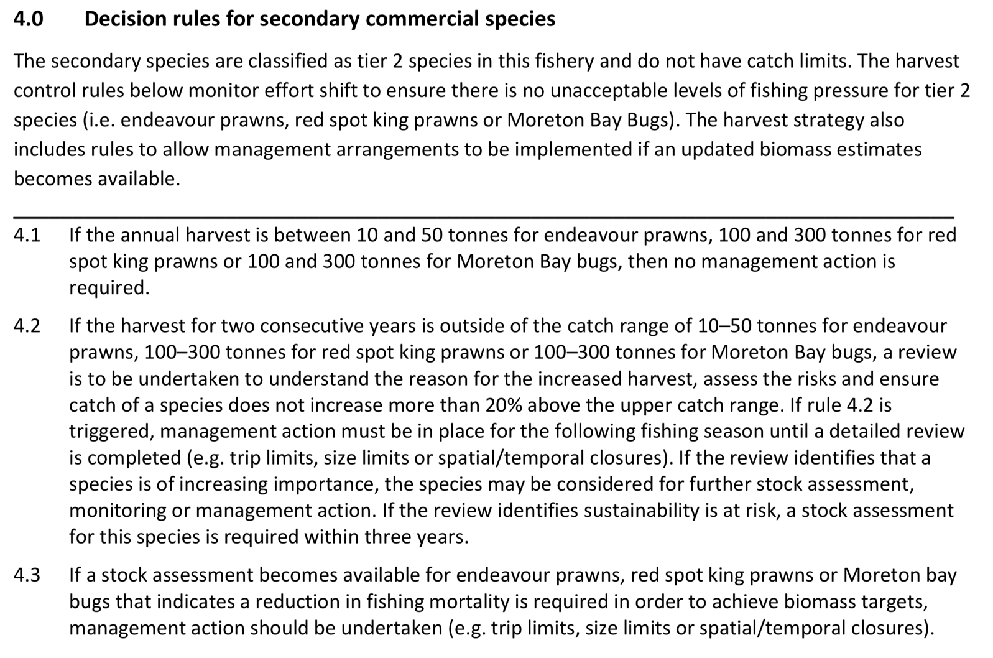
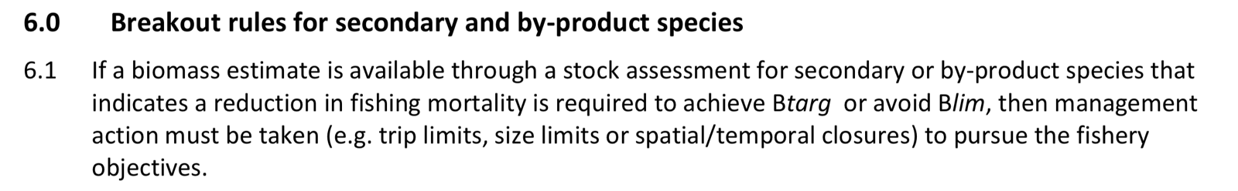
Figure 25. Secondary species Harvest strategy decision rules and breakout rules for Secondary/By-product species including Moreton Bay Bugs, Red-spot King Prawns and Banana Prawns from Central Trawl Region of the ECOTF (QDAF, 2021d).

Banana Prawns
Banana Prawns are also a Tier 2 species within the Central Trawl Region HS (QDAF, 2021d) although they are not specifically mentioned in the decision rules or breakout rules (Figure 25) as stock biomass is heavily influenced by environmental factors.

Other management arrangements

Management in Queensland applies a range of input controls including vessel entry limitations, boat- day/effort-unit allocations, vessel and gear size restrictions and spatial and temporal closures

Effort caps
- FishNet lists current the effort cap units, usage and dates.
Annual reset dates
Annual closures
Scallop area closure
- The Central trawl area is closed to taking scallops until a 30% scallop biomass level has been reached.
Other management methods include:
- Limited access through primary commercial fishing boat licences
- 20 m maximum vessel length
- hull unit (HU) limit of 120 HU
- gear restrictions such as net length and mesh size
- spatial and temporal closures

Fishery monitoring programs have changed since 2015. Courtney et al. (2014) provided a comprehensive of the fishery and the management pre-2015.

Evaluations of management measures

With regard to reviewing the harvest strategy, each harvest strategy will remain in place for a period of five years, after which time it will be fully reviewed in accordance with the Fisheries Act 1994. The harvest strategy may also be subject to further review and amendment as appropriate within the five-year period if any of the following circumstances arise:
- there is new information that substantially changes the status of a fishery, leading to improved estimates of indicators relative to reference points
- drivers external to management of the fishery increase the risk to fish stock/s
- it is clear the strategy is not working effectively and the intent of the harvest strategy policy is not being met.

Given the above, the 2021 Harvest Strategy is due for renewal in 2026.

4.2 Principle 1 References

Bessell-Browne, P., A. Prosser and A. Garland (2020). Pre-recruit abundance indices for eastern king prawn, blue swimmer crab and snapper in south eastern Queensland. Queensland Department of Agriculture and Fisheries.(QDAF) Available at https://era.daf.qld.gov.au/id/eprint/7441/1/Beam_trawl_survey_results%202020.pdf

Bio-inspecta (2023) Australia east coast king prawn fishery Marine Stewardship Council Public Certification Report 23 June 2023. Report available at https://fisheries.msc.org/en/fisheries/australia-east-coast-king-prawn/ accessed 1 February 2024.

Buckworth, Rik; Venables, Bill; Lawrence, Emma; Kompas, Tom; Pascoe, Sean; Chu, Long; Hill, Fiona; Hutton, Trevor; Rothlisberg, Peter. Incorporation of predictive models of banana prawn catch for MEY-based harvest strategy development for the Northern Prawn Fishery. Brisbane: CSIRO/ FRDC; 2014. csiro:EP137190. https://doi.org/10.4225/08/5953fcc5ad5Chan, JT (2015). Genetic analysis of the geographic structure of Australian eastern king prawns, Penaeus (Melicertus) plebejus, and implications for stock enhancement. PhD thesis. Sydney: University of NSW, 240 p.

Courtney, A., Campbell, M., Tonks, M., Roy, D., Gaddes, S., Haddy, J., Chilcott, K. (2014). Effects of bycatch reduction devices in Queensland’s (Australia) deepwater eastern king prawn (Melicertus plebejus) trawl fishery. Fisheries Research, 157, 113-123.

Courtney, A., Haddy, J., Campbell, M., Roy, D., Tonks, M., Gaddes, S., Kyne, P. (2007). Bycatch weight, composition and preliminary estimates of the impact of bycatch reduction devices in Queensland's trawl fishery. Canberra: Fisheries Research and Development Corporation, Project 2000/170. 307 pp. https://era.daf.qld.gov.au/id/eprint/3709/1/BycatchFinalReport2007-FullReport.pdf

Dedini, E., I. Jacobsen and J. Zieth (2023) East Coast Otter Trawl Fishery Ecological Risk Assessment Species of Conservation Concern. Technical Report. Fisheries Queensland, Department of Agriculture and Fisheries. Available at Accessed 15 Feb 2024.

Dedini E. and I. Jacobsen (2023) ECOTF Scoping Study. Fisheries Queensland, Department of Agriculture and Fisheries. Available at
https://era.daf.qld.gov.au/id/eprint/9572/1/East%20Coast%20Otter%20Trawl%20Fishery%20Scoping%20Study%20FINAL.pdf

Dichmont, C. M., A. R. Deng, A. E. Punt, W. Venables, and M. Haddon (2006). Management strategies for short-lived species: The case of Australia’s Northern Prawn Fishery: 1. Accounting for multiple species, spatial structure and implementation uncertainty when evaluating risk. Fisheries research 82.1-3: 204–220.

Dichmont, C., D. Die, A. Punt, W. Venables, J. Bishop, A. Deng, and Q. Dell (2001). Risk analysis and sustainability indicators for prawn stocks in the Northern Prawn Fishery. FRDC Project 1998/109. Hobart, Tasmania: CSIRO Marine Research; Fisheries Research and Development Corporation.

Fox, A. R., Lovett, R. A., Wickens, M. E. and Hillcoat, K. B. (2023) Stock assessment of Queensland east coast red spot king prawns (Melicertus longistylus), Australia, with data to December 2021. Technical Report. State of Queensland, Brisbane. Available at: https://era.daf.qld.gov.au/id/eprint/9561/ (Accessed 1 May 2024).

Fox, A. R., Lovett, R. A., Wickens, M. E. and Hillcoat, K.B. (2023b) Stock assessment of Queensland east coast endeavour prawns (Metapenaeus endeavouri and Metapenaeus ensis), Australia, with data to December 2021.Technical Report. State of Queensland, Brisbane.

Grech, A., & Coles, R. (2011). Interactions between a Trawl Fishery and Spatial Closures for Biodiversity Conservation in the Great Barrier Reef World Heritage Area, Australia. PloSOne, E 6(6): e21094., doi:10.1371/journal.pone.0021094. doi: doi:10.1371/journal.pone.0021094

Helidoniotis, F., O'Neill, M. F. and Taylor, M. (2020) Stock assessment of eastern king prawn (Melicertus plebejus). Technical Report. State of Queensland, Brisbane. Available at: https://era.daf.qld.gov.au/id/eprint/7826/

Helidoniotis, F. (2021). Stock assessment of Queensland east coast tiger prawns (Penaeus esculentus and Penaeus
semisulcatus). Brisbane, Queensland: Department of Agriculture and Fisheries.

Jacobsen, I., Zeller, B., Dunning, M., Garland, A., Courtney, T., & Jebreen, E. (2018). An ecological risk Assessment of the southern Queensland east coast otter trawl fishery and river and inshore beam trawl fishery. Brisbane: State of Queensland. Retrieved from https://www.daf.qld.gov.au/__data/assets/pdf_file/0004/1402672/Sth-QLD-Trawl-ERA- Final.pdf

Lloyd-Jones, LR, Wang, Y-G, Courtney, AJ, Prosser, AJ and Montgomery, SS (2012). Latitudinal and seasonal effects on growth of the Australian eastern king prawn (Melicertus plebejus), Canadian Journal of Fisheries and Aquatic Sciences, 69: 1525-1538.

Lovett, R. A., Fox, A. R., Wickens, M. E. and Hillcoat, K. B. (2023) Stock assessment of Queensland east coast tiger prawns (Penaeus esculentus and Penaeus semisulcatus), Australia, with data to December 2021. Technical Report. State of Queensland, Brisbane. Available at: https://era.daf.qld.gov.au/id/eprint/9560/ (accessed 3 May 2024)

McMillan, M.N., Brunjes, N., Williams, S.M. (2024). Broad-scale genetic population connectivity in the Moreton Bay Bug (Thenus australiensis) on Australia’s east coast. Hydrobiologia 851, 2347–2355 https://doi.org/10.1007/s10750-023-05460-8
https://link.springer.com/article/10.1007/s10750-023-05460-8

MRAG (2023) Australia Northern Prawn Fishery Public Certification Report July 2023 Second re-assessment Public report. MRAG Americas. Available at https://fisheries.msc.org/en/fisheries/australia-northern-prawn/@@assessments

O’Neill, MF, Leigh, GM, Wang, Y-G, Braccini, JM, and Ives, MC (2014). Linking spatial stock dynamics and economics: evaluation of indicators and fishery management for the travelling eastern king prawn (Melicertus plebejus), ICES Journal of Marine Science, 71(7): 1818-1834.

Pears, R., Morison, A., Jebreen, E., Dunning, M., Pitcher, C. C., Houlden, B., & Jacobsen, I. (2012). Ecological risk assessment of the East Coast Otter Trawl Fishery in the Great Barrier Reef Marine Park. Brisbane: Great Barrier Reef Marine Park Authority.

Plagányi, É, Deng, RA, Hutton, T, Kenyon, R, Lawrence, E, Upston, J & Eves, S (2020), ‘From past to future: understanding and accounting for recruitment variability of Australia’s redleg banana prawn (Penaeus indicus) fishery’, ICES Journal of Marine Science, vol. 78, no. 2, pp. 680–93.

Premachandra, H.K. & Becker, Alistair & Taylor, Matthew & Knibb, Wayne. (2022). Eastern king prawn Penaeus plebejus stock enhancement—Genetic evidence that hatchery bred prawns have survived in the wild after release. Frontiers in Genetics. 13. 10.3389/fgene.2022.975174.
QDAF(2020b). Queensland Fisheries Summary October 2020. Brisbane: State of Queensland. Department of Agriculture and Fisheries. https://www.publications.qld.gov.au/dataset/e7f0da0a-3904- 424b-ab48-a63bf7157823/resource/873e3106-5993-4efb-a3dc- 6b5dc1a1f2f0/fs_download/queensland-fisheries-summary-report.pdf
QDAF (2021a) Status report for reassessment and approval under protected species and export provisions of the Environment Protection and Biodiversity Conservation Act 1999 (EPBC Act) Queensland Department of Agriculture and Fisheries, State of Queensland. 85 pp. https://www.dcceew.gov.au/sites/default/files/env/consultations/e1ba225f-3edc-4f76-b93e-bb8cc69b0939/files/qld-east-coast-trawl-fishery-submission-2021.pdf

QDAF (2021b) Trawl fishery (southern offshore A and B regions) harvest strategy: 2021– 2026. Queensland Department of Agriculture and Fisheries, State of Queensland. 19 pp.

QDAF (2021c) Trawl fishery (southern inshore) harvest strategy: 2021– 2026. Queensland Department of Agriculture and Fisheries, State of Queensland. 19 pp.

QDAF (2021d) Trawl fishery (central) harvest strategy: 2021– 2026. Queensland Department of Agriculture and Fisheries, State of Queensland. 19 pp. https://www.publications.qld.gov.au/ckan-publications-attachments-prod/resources/b0d530dc-34ba-4dd7-9109-b79f3a785203/central-trawl-region-harvest-strategy.pdf?ETag=46f5f6a23c974621e5c8428a0cc56942

QDAF (2022) Queensland east coast otter trawl fishery. Consultation on proposed management actions. Discussion paper. Fisheries Queensland, State of Queensland. 22 pp.

Montgomery, S.S. (1990). Movements of juvenile eastern king prawns, Penaeus plebejus, and identification of stock along the east coast of Australia, Fisheries Research, 9: 189-208.

Montgomery, S.S. (1981) Tagging studies on juvenile eastern king prawns reveal record migration. Australian Fisheries 40(9), 13-14.

Roy, D., and E. Jebreen (2011) Extension of Fisheries Research and Development Corporation funded research results on improved bycatch reduction devices to the Queensland East Coast Otter Trawl Fishery. Report to the Fisheries Research and Development Corporation Project No. 2008/101 May 2011. Available at: https://era.daf.qld.gov.au/id/eprint/3903/1/FRDC_BRDs_Otter_Trawl_Fishery-Final_report.pdf

Ruello N. V. (1975). Geographical distribution, growth and breeding migration of the eastern Australian king prawn Penaeus plebejus hess. Mar. Freshw. Res. 26, 343–354.

Somers, I. (1987). Sediment type as a factor in the distribution of commercial prawn species in the
western Gulf of Carpentaria, Australia. In: Marine and Freshwater Research 38.1, pp. 133–149.

Somers, I. and G. Kirkwood (1991). Population ecology of the grooved tiger prawn, Penaeus semisulcatus, in the north-western Gulf of Carpentaria, Australia: growth, movement, age structure and infestation by the bopyrid para-
site Epipenaeon ingens. In: Marine and Freshwater Research 42.4, pp. 349–367.
Tanimoto, M, Courtney, AJ, O’Neil, MF and Leigh, GM 2006, Stock assessment of the Queensland (Australia) east coast banana prawn (Penaeus merguiensis), Queensland Department of Primary Industries and Fisheries, Brisbane.
Taylor, M. D and D, D Johnson (2020). Evaluation of adaptive spatial management in a multijurisdictional trawl fishery. In: Regional Studies in Marine Science, p. 101206. DOI:10.1016/j.rsma.2020.101206

Turnbull, C. T. and J. C. Atfield (2007). Fisheries long term monitoring program: summary of tiger and endeavour prawn survey results: 1998-2006. Brisbane, Queensland: Department of Primary Industries and Fisheries.

van der Velde TD, Venables WN, Crocos PJ, Edgar S, Evans F, Rothlisberg PC (2021) Seasonal, interannual and spatial variability in the reproductive dynamics of Penaeus merguiensis. Mar Ecol Prog Ser 658:117-133. https://doi.org/10.3354/meps13540

Vance, D.J and P. C. Rothlisberg (2020) Chapter One - The biology and ecology of the banana prawns: Penaeus merguiensis de Man and P. indicus H. Milne Edwards In: C. Sheppard (ed.) Advances in Marine Biology, Academic Press, 86(1):1-139,

Venables, W., R. Kenyon, J. Bishop, C. Dichmont, R. Deng, C. Burridge, B. Taylor, A. Donovan, S. Thomas, and S. Cheers (2006). Species Distribution and Catch Allocation: data and methods for the NPF, 2002-2004 Final Report. AFMA Project,(R01/1149). Australian Fisheries Management Agency, Canberra Australia.

Ward, R. D., J. R. Ovenden, J. R. S. Meadows, P. M. Grewe, and S. A. Lehnert (2006). Population genetic structure of the brown tiger prawn, Penaeus esculentus, in tropical northern Australia. Marine Biology 148(3): 599–607.

Wickens, M. E., Hillcoat, K. B., Lovett, R. A., Fox, A. R. and McMillan, M. N. (2023) Stock assessment of Moreton Bay bugs (Thenus australiensis and Thenus parindicus) in Queensland, Australia with data to December 2021. Technical Report. State of Queensland, Brisbane.

Zhou, Shijie., Rik C. Buckworth, Nick Ellis, Roy A. Deng, Sean Pascoe, Getting all information out of logbooks: estimating banana prawn fishable biomass, catchability, and fishing power increase, with a focus on natural mortality, ICES Journal of Marine Science, Volume 72, Issue 1, January 2015, Pages 54–61, https://doi.org/10.1093/icesjms/fsu013

Principle 1 – Performance Indicator scores and rationales

PI 1.1.1 – Stock status

PI 1.1.1 |  | The stock is at a level that maintains high productivity and has a low probability of recruitment overfishing
Scoring issue |  | SG 60 | SG 80 | SG 100
a | Stock status relative to recruitment impairment
a | Guidepost | It is likely that the stock is above the point of recruitment impairment (PRI). | It is highly likely that the stock is above the PRI. | There is a high degree of certainty that the stock is above the PRI.
a | Met? | Tiger prawn - Yes | Tiger prawn - Yes | Not scored
a | Met? | MBB - Yes | MBB - Yes | Not scored
a | Met? | Red-spot King - Yes | Red-spot King - Yes | Not scored
a | Met? | Banana Prawns - Yes | Banana Prawns - yes | Not scored
a | Met? | Endeavour Prawn- Yes | Endeavour Prawn- Yes | Not scored
Rationale |  | Tiger Prawn  Tiger prawns is a collective term for two species: Brown tiger (Penaeus esculentus) and grooved tiger (P. semisulcatus).  In 2021, the stock level of Tiger Prawns was estimated to be 79% of unfished biomass (70–89% range across the 95% credible interval) (Lovett et al. 2023). The point at which recruitment would become impaired is not explicitly determined, but the stock was above the B_{target} target reference point (60%). Estimated MSY is 1520 t and the catch in 2021 was 997 t (65% of MSY) leaving at B_{MSY} of 35%. SG 60 and SG 80 are met as the stock is highly likely to be above PRI.  Moreton Bay Bug  Two species make up MBB catches in the UoA area, although Sand Bugs are more commonly caught.  The most recent stock assessment (Wickens et al. 2023) estimated the biomass of Sand Bugs to be at 78% of unfished whereas the Mud Bug stock status was unable to be determined. Given that the catch in the central zone it dominated by Sand Bug, and Mud Bug make up a small (≤5%) proportion of the overall catch.  The point at which recruitment would become impaired is not explicitly determined, but the stock was above the B_{target} target reference point (60%) and the B_{MSY} of 34%. SG 60 and SG 80 are met as the stock is highly likely to be above PRI.  Red-spot King Prawn  The stock level was reported as ‘undefined’ (Fox et al. 2023).The historical catch from 2010–2019 is 100–300 t and the decision rules of the harvest strategy are based on catches staying within 20% of this historical catch. In the past four years, the total catch from the ECOTF has been between 103–209 t. The point at which recruitment would become impaired is not explicitly determined for this species and B_{MSY} is unknown. However, as catches are used as a performance indicator SG 60 and SG 80 are met as the stock is highly likely to be above PRI.  Banana Prawn  A banana prawn stock assessment was undertaken in 2006 examining regional catch rates of the potential eastern Australian sub-stock (Tanimoto et al. 2006). The results obtained indicated that exploitable biomass levels for banana prawns were about 50–70 per cent of virgin biomass, which was well above the level required for MSY or the PRI. Following that assessment, catches were higher than they were prior to the 2006 assessment and fishing power had increased but the species was still considered to be sustainably fished (QDAFF 2013, Larcombe et al. 2014). The ERAs found a low risk of overfishing at 2009 effort levels (Pears et al. 2012) and at 2017 levels (Jacobsen et al. 2018).  Banana prawns are taken in relatively high volumes by the Northern Prawn Fishery. The MSC certification report (NPF) that includes banana prawns (MRAG, 2023) noted that: “The stock assessment process for white banana prawns does not follow the traditional pattern for a prawn stock (e.g., for the tiger prawn species). Because of the inter-annual variability driven mainly by the environment, regular stock assessments have not been carried out, but the status of the stock is assessed through historic catch data and with reference to a proxy limit point. There has been extensive research on the causes of stock fluctuations, the most recent being that of Venables et al (2011) who modelled the effect of fishing effort and rainfall on the annual season catches in different areas of the NPF.” For redleg banana prawns, a stock assessment is only available for the Joseph Bonaparte Gulf sub-stock, with MRAG (2023) stating: “The 2022 assessment indicates that the stock is well above the proxy point of recruitment impairment.”  Butler et al. (2021) stated that: “… the biomass of the management unit is unlikely to be depleted and that recruitment is unlikely to be impaired.”  Endeavour Prawn  Zeller et al. (2023) suggested the ECOTF Endeavour Prawn fishery was ‘sustainable’ and ‘not overfished’ based on the low fishing mortality relative to historical levels. Biomass declined between 1958 and 1997 to 34% of unfished biomass. In 2023, stock biomass was 69% (54–87%) of unfished biomass (Fox et al. 2023b).

b | Stock status in relation to achievement of maximum sustainable yield (MSY)
b | Guidepost |  | The stock is at or fluctuating around a level consistent with MSY. | There is a high degree of certainty that the stock has been fluctuating around a level consistent with MSY or has been above this level over recent years.
b | Met? |  | Tiger prawn - Yes | Not scored
b | Met? |  | MBB - Yes | Not scored
b | Met? |  | Red-spot King - Yes | Not scored
b | Met? |  | Banana Prawn – No | Not scored
b | Met? |  | Endeavour prawn - Yes | Not scored
Rationale |  | Tiger prawn  Estimated MSY is 1520 t and the catch in 2021 was 997 t (65% of MSY) leaving at B_{MSY} of 35%. SG 80 is met as the stock is highly likely to be above MSY.  Moreton Bay Bugs  The Sand Bug stock was above the B_{target} target reference point (60%) and the B_{MSY} of 34%. Mud Bug MSY is not defined but the catch composition of MBB is predominately Sand Bugs. SG 80 are met as both stocks are highly likely to be at a level consistent with MSY.  Redspot King prawn  The most recent assessment (Lovett et al. 2023) found that the biomass is uncertain. Previously, Red-spot King Prawn maximum sustainable yield (MSY) was based on 1988–2013 data for the southern region to be 716 t (Wang et al. 2015). Total annual catches have not reached this level since this date (maximum 482 t). SG 80 are met as the stock is highly likely to be at a level consistent with MSY.  Banana Prawn  As biomass is not measured for white banana prawn, there is no way to directly measure the status of the stock. However, there is a long history of consistent catches across many generations of the stock for the UoA and much larger NPF, with no evidence to suggest that overfishing has occurred or is occurring. Overfishing is therefore considered to be unlikely and the stock is classified as not subject to overfishing and not overfished (MRAG, 2023).  Endeavour Prawn  In 2021, stock biomass was 69% (54–87%) of unfished biomass (Fox et al. 2023b). Previously, the maximum sustainable yield (MSY) for endeavour prawn was 865 tonnes for the northern sector (above 16°S), and 247 tonnes for the southern sector (between 22° S and 16°S). Fox et al. (2023b) treated endeavour prawns within the northern and central trawl management regions above 22°S as a “single stock” and the MSY was calculated to be 1514 tonnes. SG 80 are met as the stock is highly likely to be at a level consistent with MSY.

Draft scoring range | Tiger ≥80
Draft scoring range | MBB ≥80
Draft scoring range | Redspot King ≥80
Draft scoring range | Banana Prawn 60-79
 | Endeavour Prawn ≥80
Information gap indicator | Information sufficient to score PI

PI 1.2.1 – Harvest strategy
PI 1.2.1 |  |  | There is a robust and precautionary harvest strategy in place
Scoring issue |  |  | SG 60 | SG 80 |  | SG 100
a |  | Harvest strategy design
 |  | Guide post | The harvest strategy is expected to achieve stock management objectives reflected in PI 1.1.1/PI 1.1.1A SG80. | The harvest strategy is responsive to the state of the stock and the elements of the harvest strategy work together towards achieving stock management objectives reflected in PI 1.1.1/PI 1.1.1A SG80. |  | The harvest strategy is responsive to the state of the stock and is designed to achieve stock management objectives reflected in PI 1.1.1/PI 1.1.1A SG80.
 |  | Met? | Tiger prawn - Yes | Tiger prawn - Yes | Not scored
 |  | Met? | MBB -Yes | MBB - Yes
 |  | Met? | Redspot King - Yes | Redspot King - Yes
 |  | Met? | Banana prawn - Yes | Banana prawn - Yes
 |  | Met? | Endeavour Prawn - Yes | Endeavour Prawn - Yes
Rationale |  |  | A harvest strategy for the central zone of the ECOTF was approved and implemented in June 2021. The HS was designed in accordance with the 2021 Queensland harvest strategy policy. The HS includes managing the fisheries performance against key indicators through monitoring, stock assessment and explicit decision rules.  Tiger prawn are target (Tier 1) species whilst the four other species are ‘secondary species’ and are classified as tier 2 species with no catch limits. The harvest strategy includes decision rules (Figures 24–25) to allow management arrangements to be implemented if updated biomass estimates become available or if catches exceed historical commercial catches (2010–2019). As the level of exploitation changes outside of historic levels, species will be elevated to higher levels of monitoring, assessment and management.  With regard to being responsive, the HS outlines that the ‘central region harvest strategy workshop’ is held at least annually to discuss elements of the harvest strategy. Further information is presented in the relevant working group https://www.daf.qld.gov.au/business-priorities/fisheries/engagement/working-groups/current/trawl  The monitoring program requires a review of catch and effort data; adjustment of the annual commercial catch triggers are used to assess changes in fishing mortality when compared to historic catch levels; and bringing forward management decisions if needed. Both SG 60 and SG 80 are met
b | Harvest strategy evaluation
b | Guide post |  | The harvest strategy is likely to work based on prior experience or plausible argument. | The harvest strategy may not have been fully tested but evidence exists that it is achieving its objectives. |  | The performance of the harvest strategy has been fully evaluated and evidence exists to show that it is achieving its objectives including being clearly able to maintain stocks at target levels.
b | Met? |  | Tiger prawn - Yes | Tiger prawn - No |  | Not scored
 |  |  | MBB -Yes | MBB -No
 |  |  | Red-spot King - Yes | Red-spot King – No
 |  |  | Banana prawn - Yes | Banana prawn - No
 |  |  | Endeavour prawn - Yes | Endeavour prawn - No
Rationale |  |  | The Central HS was first adopted in 2021. There has been no formal MSE conducted. The HS contains pathways to ensure monitoring and stock assessments for Tier 1 (Tiger prawns) and Tier 2 (including MBB, Red-spot King prawns, Banana prawns and Endeavour prawns) if catches exceed historical ranges.  There has been a stock assessments since its release (Fox et al. 2023; Fox et al. 2023b; Lovett et al. 2023; Wickens et al. 2023;). However, Banana Prawn was last assessed in 2006 and no biomass estimate is available, as such commercial catches are monitored relative to historical levels.  The HS was designed in accordance with the Queensland HS Policy which was developed as a part of - the largest fisheries reform in Queensland's history.  The HS was developed for the central zone of the ECOTF with Tiger Prawn as the Tier 1 target species; MBB, Red-spot King, Banana and Endeavour Prawns are tier 2 byproduct species. There are pre-determined management actions necessary to achieve ecological, economic and/or social objectives. SG 60 is met for the four species.  The aim of the harvest strategy “is to manage fishing mortality through setting sustainable effort limits at a level that allows the stock to achieve its biomass targets. For all other retained species, effort triggers have been designed to monitor changes in fishing behaviour or stock trends, and hence optimising economic yield, while at the same time being precautionary in detecting changes in species composition within historic catch levels. Other management tools (e.g. size limits, spawning closures etc.) may also be used to support the sustainable management of stocks under this harvest strategy.”  For Tiger Prawn and MBB, harvest from all zones does not exceed MSY and an MSY estimated is unavailable for Red-spot King (Fox et al. 2023) or Banana Prawn. MSY estimates are available for Endeavour prawns. However, the new stock assessments used fishery data to 2021 (the year the HS was implemented) so there is no “evidence” that the HS is meeting the objective; SG 80 is not met.  For Banana Prawn, the HS is likely to work given the life history of this species, the size of the fishery and fact that the NPF harvest strategy for white banana prawns is also based on monitoring of commercial catches, is MSC certified and catches significantly more banana prawns than the UoA (>3377 t v. 103 t) SG 60 is met. Due to the clear variation in banana prawn recruitment due to environmental conditions (particularly wet season rainfall), the relationship between stock-recruitment is unclear (Buckworth et al. 2013). Analyses are also complicated by the highly variable CPUE data that result from the schooling behaviour of the species. As such, there is no formal quantitative stock assessment for banana prawns. The monitoring of catch-rates at regular intervals (6, 8, 10 weeks) is successfully used by the harvest strategy in the NPF although it is unclear if such regular catch-rate intervals are suitable for the UoA given the comparatively small size of the fishery and the extended fishing season compared to the NPF. SG 80 is not met.
c | Harvest strategy monitoring
c | Guide post |  | Monitoring is in place that is expected to determine whether the harvest strategy is working.
c | Met? |  | Yes
Rationale |  |  | Monitoring of the ECOTF includes the use of logbooks (compulsory) that include effort and catch data for all four UoA species. The Vessel Monitoring System is mandatory for all vessels; spatial management measures can be evaluated using location data. The Fisheries data validation plan was created in 2018 as one of the key actions under the Queensland Sustainable Fisheries Strategy: 2017-2027. It provides a framework for the collection and validation of more accurate fisheries information with specific action items. An update/review of the Data Validation Plan was conducted in 2023. As a part of the Plan, a program for electronic monitoring is currently being rolled-out. SG 60 is met for each UoA species
d | Harvest strategy review
d | Guidepost |  |  |  |  | The harvest strategy is periodically reviewed and improved as necessary.
d | Met? |  |  |  |  | Not scored
Rationale |  |  | Not scored
e | Shark finning
e | Guide post |  | There is a high degree of certainty that shark finning is not taking place. | It is highly likely that shark finning is not taking place. |  | There is a high degree of certainty that shark finning is not taking place.
e | Met? |  | NA | NA |  | NA
Rationale |  |  | Scoring issue need not be scored as sharks are not a P1 species.
f | Review of alternative measures
f | Guide post |  | There has been a review of the potential effectiveness and practicality of alternative measures to minimise UoA-related mortality of unwanted catch of the target stock. | There is a regular review of the potential effectiveness and practicality of alternative measures to minimise UoA-related mortality of unwanted catch of the target stock and they are implemented as appropriate. |  | There is a biennial review of the potential effectiveness and practicality of alternative measures to minimise UoA-related mortality of unwanted catch of the target stock, and they are implemented, as appropriate.
f | Met? |  | Yes | Yes |  | Not scored
Rationale |  |  | Whilst there is no precise estimate available for non-marketable catch of Tiger, MBB, Red-spot King, Banana Prawns and Endeavour Prawns (discards), discarding of these species is very rare. Rather than discarding these species, fishers sell soft and broken prawn product as “headless “when there are imperfections and damaged MBB are kept and boxed as “Soft ROC” (Run of Catch) and there is a market for this product. In addition, damaged banana prawns can be used as “bait prawn” . There is therefore no need for alternative measures as there is negligible “unwanted catch” (discards) of these five UoA species.

Draft scoring range | Tiger 60-79
 | MBB 60-79
 | Redspot King 60-79
 | Banana Prawn 60-79
 | Endeavour Prawn 60-79
Information gap indicator | There is sufficient information to score this PI.

PI 1.2.2 – Harvest control rules and tools

PI 1.2.2 |  |  | There are well-defined and effective HCRs in place
Scoring issue |  |  | SG 60 | SG 80 | SG 100
a |  | HCRs design and application
 |  | Guide post | Generally understood HCRs are in place or available that are expected to reduce the exploitation rate as the point of recruitment impairment (PRI) is approached. | Well defined HCRs are in place that ensure that the exploitation rate is reduced as the PRI is approached, are expected to keep the stock fluctuating around a target level consistent with (or above) MSY, or for key LTL species a level consistent with ecosystem needs. | The HCRs are expected to keep the stock fluctuating at or above a target level consistent with MSY, or another more appropriate level taking into account the ecological role of the stock, most of the time.
 |  |  | Tiger prawns - yes | Tiger prawns - yes
 |  |  | MBB: Yes | MBB: Yes
 |  | Met? | Red-spot King prawn- Yes | Red-spot King prawn- Yes | Not scored
 |  | Met? | Banana Prawns: Yes | Banana Prawns: No | Not scored
 |  | Met? | Endeavour Prawn - Yes | Endeavour Prawn - Yes | Not scored
Rationale |  |  | A Harvest Strategy for the Central region of the ECOTF with well defined HCRs (decision rules) was implemented in 2021 and is considered “in place”.  The HS for the central sub-fishery was developed with Tiger Prawns as the Tier 1 target species, there are also pre-determined management actions necessary to achieve ecological, economic and/or social objectives for tier 2 byproduct species (MBB, Red-spot King and Banana prawns). This ensures that the fishery operates at sustainable levels, as defined in Queensland’s Sustainable Fisheries Strategy 2017– 2027 (QDAF, 2017).  Tiger prawns:  Figure 21 outlines the decision rules for Tier 1 species. Harvest control rules (decision rules) are used to set total allowable commercial effort (TACE). A new stock assessment is available (Lovett et al. 2023) and it provided biomass estimates relative to reference points. The target reference point B_{targ} is 60% of the unfished biomass and the limit reference point B_{lim} is 20% of unfished biomass. Estimated MSY was 1520 t and the catch in 2021 was 997 t (65% of MSY) leaving at B_{MSY} of 35%. Break-out rules for this species are presented in Figure 24.  MBB: A new MBB stock assessment is available (Wickens et al. 2023) and provided a biomass estimate relative to reference points. The target reference point B_{targ} is 60% of the unfished biomass and the limit reference point B_{lim} is 20% of unfished biomass. Maximum Sustainable Yield (B_{MSY}) for MBB was defined at 34% of unfished biomass (Wickens et al. 2023). Decision rules for MBB (and other Tier 2 species) are based on historical catches (2010–2019) and presented at Figure 25.  Red-spot King Prawn:  A new stock assessment was conducted in 2023 (Fox et al. 2023) although it resulted in an undefined stock status relative to the biomass reference points. Historical catches are used to define decision rules when biomass estimates are unavailable. Decision rules for Red-spot King Prawns (and other Tier 2 species) are based on historical catches (2010–2019) and presented at Figure 25.  Banana Prawn: Where no stock assessment is available, the HCRs are based on monitoring catch relative to historical catch ranges for Tier 2 species. Monitoring occurs at the end of the fishing season.  Endeavour Prawn: The 2021 Harvest Strategy for this species defined TRP and LRP with an annual harvest level of 10–50 t not triggering further management attention. Decision rules are based on historical catches (2010–2019). There is a stock assessment available, and catches are monitored.  In summary, there are well-defined HCRs in place for Tiger, MBB, Red-spot King prawns and Endeavour Prawns from the Central region (SG 60 and 80 are met), but only generally understood HCRs are in place for Banana Prawns. For this species, biomass is heavily influenced by environmental factors rather than previous year catch data; SG 60 is met but SG 80 is not met unless there is evidence that within season monitoring/management is in place.
b | The robustness of HCRs to uncertainty
b | Guide post |  |  | The HCRs are likely to be robust to the main uncertainties. | The HCRs take account of a wide range of uncertainties including the ecological role of the stock, and there is evidence that the HCRs are robust to the main uncertainties.
b |  |  |  | Tiger prawns - yes | Not scored
b |  |  |  | MBB - yes | Not scored
b | Met? |  |  | Red-spot King prawns -yes | Not scored
b |  |  |  | Banana prawns - no | Not scored
b |  |  |  | Endeavour prawn - yes | Not scored
Rationale |  |  | The HCRs (termed ‘decision rules’ in the HS) that are in use are based on outcomes of the latest stock assessment relative to reference points (B_{targ}, B_{lim}, B_{MSY}). The application of decision rules relies on reliable stock assessments and/or knowledge of effort/catches relative to historical catches.  The stock assessments for Red-spot, Tiger and MBB (Fox et al. 2023; 2023b; Lovett et al. 2023; Wickens et al. 2023) examined many variables and identified the uncertainties including influences to recruitment/catches. However, for Banana Prawn, it is unlikely that the Tier 2 decision rules are likely to be “robust to the main uncertainties” as monitoring of catch and effort is not performed periodically through the fishing season. The life history of Banana Prawn and the strong influence of environmental conditions to recruitment means that overall catch rate from one year are unlikely to be impact the following years.  SG 80 is met for Tiger prawns, MBB, Red-spot King prawns and Endeavour prawns.
c | Evaluation of HCRs
c | Guide post |  | There is some evidence that tools used or available to implement HCRs are appropriate and effective in controlling exploitation. | Available evidence indicates that the tools in use are appropriate and effective in achieving the exploitation levels required under the HCRs. | Evidence clearly shows that the tools in use are effective in achieving the exploitation levels required under the HCRs.
c |  |  | Tiger prawns - yes | Tiger prawns - yes
c |  |  | MBB - yes | MBB - yes
c | Met? |  | Red-spot King - yes | Red-spot King - yes
c |  |  | Banana prawns - yes | Banana prawns - yes
c |  |  | Endeavour - yes | Endeavour - yes
Rationale |  |  | The 2021 Central HS outlines the tools in use. The HCRs (termed ‘decision rules’ in the HS) that are in use are based on outcomes of the latest stock assessment relative to reference points (B_{targ}, B_{lim}, B_{MSY}). The application of decision rules relies on reliable stock assessments and/or knowledge of effort/catches relative to historical catches; SG 60 is met.  For Tier 1 & Tier 2 species the tools in use include:  - monitoring of catch rates  - effort triggers  - catch triggers  - trip limits,  - size limits  - spatial/temporal closures  - requirement for stock assessment within three years  - Scallop seasons  - Scallop closures (based on biomass estimates).  Other management measures designed for Tier 1 species but would impact Tier 2 species include:  - limited access through primary commercial fishing licences  - 20 m maximum vessel length  - hull unit (HU) limit of 120 HU  - gear restrictions such as net length and mesh size  The 2023 stock assessments (Fox et al 2023; 2023b; Lovett et al. and Wickens et al.) provide evidence that the stock has not been subject to overfishing, with Tiger, MBB and Endeavour prawn stocks being above the 60% target threshold. Biomass of Red-spot King prawn was undefined in the latest assessment. However, there is some evidence that tools in use by the UoAs are effective in achieving the exploitation levels required by the decision rules as catches remain within the set limits. SG 80 is met for these species.  Banana Prawns: Whilst biomass is unknown, SG80 requirements are that the tools in use achieve exploitation levels required under the HCR. The tools used for Banana prawn are appropriate to the life history, environmental influences and size of the fishery relative to total fishing mortality of this species. SG 80 is met.

Draft scoring range | Tiger prawn: ≥80
Draft scoring range | MBB: ≥80
Draft scoring range | Red-spot King:≥80
Draft scoring range | Banana prawn: 60-79
 | Endeavour ≥80
Information gap indicator | There is sufficient information to score this PI.

PI 1.2.3 – Information and monitoring
PI 1.2.3 |  |  | Relevant information is collected to support the harvest strategy
Scoring issue |  |  | SG 60 | SG 80 | SG 100
a |  | Range of information
 |  | Guide post | Some relevant information related to stock structure, stock productivity, and fleet composition is available to support the harvest strategy. | Sufficient relevant information related to stock structure, stock productivity, fleet composition, and other data are available to support the harvest strategy. | A comprehensive range of information (on stock structure, stock productivity, fleet composition, stock abundance, UoA removals, and other information such as environmental information), including some that may not be directly related to the current harvest strategy, is available.
 |  | Met? | Tiger prawns - Yes | Tiger prawns - Yes | Not scored
 |  | Met? | MBB - Yes | MBB - Yes | Not scored
 |  | Met? | Red-spot King - Yes | Red-spot King - Yes | Not scored
 |  | Met? | Banana Prawn - Yes | Banana Prawn - Yes | Not scored
 |  | Met? | Endeavour - yes | Endeavour - Yes | Not scored
Rationale |  |  | Fleet composition – sufficient  As of May 2024, there were 355 T1 symbols and 15 T2 (concessional) symbols (Dedini & Jacobsen, 2023).  Tiger prawns  Stock structure & productivity –sufficient  Brown tiger prawns are endemic to tropical and subtropical waters of Australia, while grooved tiger prawns have a wider Indo–West Pacific distribution. The susceptibility of each species to capture differs throughout the coastline regions (Lovett et al. 2023). As migratory behaviour differs; the grooved tiger prawn displaying more mobile behaviour of regular movements from the inshore feeding grounds to spawn in offshore waters whereas the Brown tiger prawns are more sedentary in nature. Life history and recruitment is understood for both species.  Stock abundance – sufficient  Helidoniotis et al. (2021) provided an estimate of 50% unfished biomass for the central region Tiger prawns although the most recent update (Lovett et al. 2023) suggested that biomass was 79% of B₀ and declining.  UoA removals – sufficient  Logbook records do not specify if catch is comprised of Penaeus esculentus, P. semisulcatus or a mix of both species, and as such Tiger prawns are modelled collectively; Lovett et al. (2023) found that a final overall proportion was calculated, resulting in 58% Brown Tigers and 42% Grooved Tigers.  Tiger prawns are taken in the ECOTF within the Northern, Central and Moreton Bay Trawl regions. Tiger prawns are also a minor component of the southern offshore trawl region and rarely reported in the southern inshore catches (e.g., 350 kg in 2022 compared to total ECOTF of 1,051,646 kg). Table 10 presents the UoA catch relative to the ECOTF catch for the last four years.  SG60 and SG 80 are met for Tiger Prawns.  Moreton Bay Bugs  Stock structure & productivity –sufficient  McMillan et al. (2024) examined the stock structures in the ECOTF fishing zones. Wickens et al. (2023) provided information on productivity.  Stock abundance – sufficient  The life history of the species is sufficient and is used in the recent stock assessment (Wickens et al. 2023) to determine stock abundance relative to unfished levels. This first quantitative stock assessment on the single biological stock (McMillan et al. 2024) was undertaken by Wickens et al. (2023) using Sand Bug and Mud Bug data to 2021.  UoA removals – sufficient  MBB is taken by ECOTF. In 2021 the total harvest of MBB, Sand Bug and Mud Bug was 545 tonnes (all zones; Figure 10), of which 162 t was taken in the Central Zone (UoA). In 2021, catch records started to split the two species and by 2022, no MBB were reported in logbooks yet 178 t was recorded as Sand Bug and 7 t was recorded as Mud Bug (184 t total for UoA area).  - Sand Bugs are taken in association with trawls targeting Tiger Prawn, Endeavour prawns and Banana prawns.  - Mud Bugs are taken in association trawls targeting with Red-spot prawns and Saucer Scallops.  SG60 and SG 80 are met for MBB.  Red-spot King prawns  Stock structure & productivity –sufficient  Whilst the Biological Stock Structure of Redspot King Prawn is uncertain, Red-spot King prawns generally occur along the eastern coastline of Queensland above 22◦S. Red-spot King prawns migrate between nursery areas within the Great Barrier Reef lagoons and deeper waters a short distance from the reef. However, the species is sedentary in nature and displays very little migratory behaviour once they have moved from nursery areas back to deeper waters (Dredge 1990).  Stock abundance – sufficient  In the southern region, the estimated Red-spot King Prawn maximum sustainable yield (MSY) based on 1988–2013 data for the southern region was 716 t (Wang et al. 2015). An update for the east coast stock (Fox et al. 2023) could not estimate stock biomass accurately although total mortality is known and this is used to estimate stock status in accordance with the harvest strategy for Tier 2 species. Given the size of the fishery and catch size, knowledge of stock abundance is sufficient.  UoA removals – sufficient  In 2022, the total retained catch was 103 t of which 80 t was taken by the UoA. A very small quantity <1 t is taken by the Northern Prawn Fishery  SG60 and SG 80 are met for Red-spot King Prawns.  Banana Prawns  Stock structure & productivity –sufficient  There is sufficient information available on the productivity influences for banana prawns. The life history of the species is sufficient. Banana prawns are fecund, short-lived (<2 years) and have complicated requirements regarding life history: an offshore coastal spawning ground that is linked to a mangrove-lined estuarine nursery ground.  Stock abundance – sufficient  Banana prawns are fecund, short-lived (<2 years) and have complicated requirements regarding life history: an offshore coastal spawning ground that is linked to a mangrove-lined estuarine nursery ground. Biomass is not measured for white banana prawn, so there is no way to directly measure the status of the stock. However, there is a long history of consistent catches across many generations of the stock, with no evidence to suggest that overfishing has occurred or is occurring.  UoA removals – sufficient  Banana prawn fishing mortality is primarily from the Northern Prawn Fishery (NPF). White banana prawns are mainly caught during the day on the eastern side of the Gulf of Carpentaria, whereas redleg banana prawns are caught day and night, mainly in Joseph Bonaparte Gulf (JBG). White banana prawns make up the bulk of the prawn catch in the NPF; In 2022, 3377 tonnes of white banana and 652 t of redleg banana were recorded compared to 207 t of banana prawns in the ECOTF, of which 103 t is from the UoA for the same period.  SG60 and SG 80 are met for Banana Prawns.  Endeavour Prawn  Stock structure & productivity –sufficient  Stock abundance – sufficient  The life history of the species is sufficient and is used in the recent stock assessment (Fox 2023b) to determine stock abundance relative to unfished levels.  UoA removals – sufficient  Retained catch from each area number within grid numbers are collected by logbooks (Figure 5).  Endeavour prawns (Metapenaeus endeavouri and Metapenaeus ensis) are endemic to the tropical and subtropical waters of Australia and are widely distributed along the coastline of northern Australia from Shark Bay in Western Australia to the eastern coast of northern New South Wales (Figure 22).  Life history  Endeavour prawn is a species complex or Blue Endeavour and Red Endeavour prawns of similar sizes. Sexual maturity is months 24–26 mm CL.  Stock assessment  The most recent quantitative stock assessment on the biological stock was undertaken by Fox et al. (2023b). The assessment considered the spatial scope to be all east coast of Queensland using data to 2021. The assessment used a one-sex monthly delay-difference population model fitted to catch rates. An age-structured model was also trialled but there were no plausible outcomes from that model. Commercial catch rates were standardised to estimate an index of endeavour prawn abundance through time.  Endeavour prawns had previously been assessed at the sector level (northern and southern sectors, split at 16◦ S) by Wang (2015), using data from 1988 to 2013.  Stock status  Zeller et al. (2023) suggested the ECOTF Endeavour Prawn fishery was ‘sustainable’ and ‘not overfished’ based on the low fishing mortality relative to historical levels. Biomass declined between 1958 and 1997 to 34% of unfished biomass. In 2023, stock biomass was 69% (54–87%) of unfished biomass (Figure 28; Fox et al. 2023b).  SG60 and SG 80 are met for Endeavour prawns.
c | Monitoring
c | Guide post |  | Stock abundance and UoA removals are monitored and at least 1 indicator is available and monitored with sufficient frequency to support the harvest strategy. | Stock abundance and UoA removals are regularly monitored at a level of accuracy and coverage consistent with the harvest strategy, and 1 or more indicators are available and monitored with sufficient frequency to support the harvest strategy. | All information required by the harvest strategy is monitored with high frequency and a high degree of certainty, and there is a good understanding of the inherent uncertainties in the information (data) and the robustness of assessment and management in dealing with this uncertainty.
c | Met? |  | All UoAs - Yes | All UoAs - Yes | Not scored
Rationale |  |  | Logbooks: UoA removals are monitored by mandatory logbooks.  Commercial fishers are required to fill in a daily logbook that records what catch they land, where they caught their product, what fishing gear was used, and the time spent fishing. The logbook data is used to provide a comprehensive fisheries information system for managers, researchers and industry and ensure that the data meets the national standards for validation and coding, as developed by the Statistical Working Group of the Australian Fisheries Managers Forum (AFMF). The information provided in logbook returns is used for fisheries management and research purposes. A comprehensive and continuous series of catch and effort data from commercial fishers’ logbooks provides the basis for:  - scientific stock analysis when used in conjunction with other biological data (e.g. recruitment studies or effects of closures);  - economic analysis;  - descriptions of current fishing activity;  - short and long-term trends in the spatial and temporal distributions of fishing activity;  - responsible management and administration.  VMS: Commercial fishers are also required to use VMS, which reports the position and activity of their fishing vessels.  Since 2005 fishers have been required to complete a SOCI logbook for any interactions that occur whilst fishing.  Port sampling occurs, along with samples taken from suppliers and wholesalers.  Stock assessments:  For Tiger prawns, the most recent stock assessment was undertaken with data to 2021 (Lovett et al. 2023). The assessment is sufficient to support the decision rules as prescribed in the HS for the fishery thereby meeting SG 60.  For MBB the first stock assessment has been undertaken but results for Mud Bug were inconclusive (Wickens et al. 2023). The assessment was in 2023 using data to 2021. This is considered sufficient to support the available decision rules as described in the HS for the fishery. This meet SG 60 requirements.  For Red-spot King prawns, the most recent stock assessment for the east coast was conducted with data to 2021. Although the assessment was unable to produce a biomass estimate, catches are monitored relative to historical catches and is sufficient to support the decision rules as prescribed in the HS for the fishery thereby meeting SG 60.  Banana Prawn is a Tier 2 species in the HS, UoA removals and catch rates are regularly monitored at a level of accuracy and coverage consistent with the harvest strategy; SG 60 is met.  Endeavour Prawn is also a Tier 2 species in the HS with a recent stock assessment (Fox et al. 2023b). This is considered sufficient to support the available decision rules as prescribed in the 2021 HS. This species meets SG 60.  Monitoring is conducted and performed regularly at a level of accuracy and coverage that are consistent with the decision rules (HCR) within the Harvest Strategy SG 80 is met for all species.
d | Comprehensiveness of information
d | Guide post |  |  | There is good information on all other fishery removals from the stock.
d | Met? |  |  | All UoAs- Yes
Rationale |  |  | There are mandatory logbooks apply to all commercial fisheries that operate in the central fishery, and other regions/fisheries that take these species (e.g., NPF, French, 2023). Other mortality, including the recreational catch are known to be negligible. SG 80 is met for all five species.

Draft scoring range | All species: ≥80
Information gap indicator | There is sufficient information to score this PI.

PI 1.2.4 – Assessment of stock status

PI 1.2.4 |  |  | There is an assessment of the stock status
Scoring issue |  |  | SG 60 | SG 80 | SG 100
a |  | Appropriateness of assessment to stock under consideration
 |  | Guide post |  | The assessment is appropriate for the stock and for the harvest strategy. | The assessment takes into account the major features relevant to the biology of the species and the nature of the UoA.
 |  | Met? |  | Tiger prawns - yes | Not scored
 |  | Met? |  | MBB - Yes | Not scored
 |  | Met? |  | Red-spot King prawn- yes | Not scored
 |  | Met? |  | Banana Prawn - yes | Not scored
 |  | Met? |  | Endeavour Prawn - yes | Not scored
Rationale |  |  | Tiger prawns  Lovett et al. (2023) updated the stock assessment for Tiger prawns from the east coast of Queensland. Tiger prawns were previously assessed at the sector level (northern and southern sectors, split at 16◦ S) by Wang (2015) and at the management region level by Helidoniotis (2021), using a weekly delay-difference model.  The 2023 assessment (Lovett et al. 2023) used a one-sex monthly delay-difference population model, fitted to catch rates. An age-structured model Stock Synthesis model was also trialled; however, this did not lead to outcomes that were considered plausible by the assessment team and was therefore deemed an unsuitable method to assess tiger prawns for the east coast of Queensland at this time. SG 80 is met.  MBB  The MBB stock assessment was recently conducted (Wickens et al. 2023).  The stock assessment included input data through to December 2021. All assessment inputs and outputs were referenced on a calendar year basis (that is, ‘2021’ means January 2021–December 2021).  For all stocks analysed, the assessment used a one-sex monthly delay-difference population model, fitted to catch rates. Age-structured models were also trialled; however, these did not lead to outcomes that were considered plausible by the project team.  For sand bugs, the data from 1968 to 2021 comprised of commercial catch and effort (1988—2021), historical commercial catch (1968–1981, 1974–1987), fishery independent survey data (2017-2021) and licence numbers (1968–2003). Thirteen model scenarios were run for the sand bug stock, covering a range of modelling assumptions and sensitivity tests. All scenarios were optimised using Markov chain Monte Carlo (MCMC) to better explore the robustness of the models. Project team preferred scenario results suggested that the sand bug stock experienced a decline in the period 1968 to 2000 to reach 67% of unfished biomass. The biomass has been generally increasing since, and in 2021 the stock level was estimated to be 78% (63—94% range across the 95% credible interval) of the unfished biomass.  For mud bugs, the data from 1948 to 2021 comprised of commercial catch and effort (1988-–2021), historical commercial catch (1948–1981, 1974–1987) and licence numbers (1968–2003). The model split the fishery into two fleets to account for the rezoning of the Great Barrier Reef (GBR) in 2004—one for the commercial sector pre-July 2004, and one for commercial sector post-July 2004. Thirteen model scenarios were run for the mud bug stock, covering a range of modelling assumptions and sensitivity tests. Seven scenarios had convergence problems, or diagnostics that indicated issues. The non-target nature of the fishery combined with fishery-dependent catch rates being the primary data set for model tuning makes assessment difficult. The status of the mud bug stock is undefined. The general trajectory across the thirteen scenarios shows the biomass experienced a decline from the period of 1968 until the mid 1980s, then slowly recovered since that time.  The MBB stock assessment was guided by a project team consisting of scientists, managers, and industry representatives. This assessment is considered appropriate for the MBB stocks and the decision rules within the HS. SG 80 is met.  Red-spot King prawn.  Fox et al. (2023) provided the first assessment of this species from east coast of Queensland. The assessment used a one-sex monthly delay-difference population model, fitted to catch rates. An age-structured model was also trialled. Twenty-four scenarios were run using a delay-difference model, covering a range of modelling assumptions and sensitivity tests. All scenarios were optimised using Markov chain Monte Carlo (MCMC) to better explore the robustness of the models. There was varying success across the 24 scenarios, with nine models achieving convergence that resulted in a wide range of final biomass estimates, and some non-converged scenarios had better model fit. Whilst the outcome was unfavourable, the method was appropriate for this species and SG 80 is met.  Banana Prawn  A single fishery-level stock is also assumed for status determination purposes. There is no formal stock assessment for this stock and the latest assessment was conducted by Tanimoto et al. (2006) and is now outdated.  The environmentally driven, high variability of this resource means that developing a robust stock–recruitment relationship is difficult. This is because annual yields are largely dependent on annual recruitment and recruitment has a complex association with seasonal rainfall, oceanographic conditions and availability of food (van der Velde et al. 2021).  Zhou et al. (2015) used a method of population depletion analysis, and estimated the population and biological quantities for the white banana prawn (Penaeus merguiensis) in Australia's valuable Northern Prawn Fishery. Buckworth et al. (2014) noted that the short life cycle of P. merguiensis influences the opening of the NPF (around 1 April each year) and it closely follows their recruitment to the fishery. Therefore, factors affecting recruitment strength can only be measured up to February in the same year.  Assessment of Banana Prawn in the UoA is based on the monitoring of the catch rates which is appropriate for the stock and the harvest strategy (SG 80 is met), although there is no information if monitoring is occurring prior, during or after the fishing season.  Endeavour Prawn:  The most recent quantitative stock assessment on the biological stock was undertaken by Fox et al. (2023b). The assessment considered the spatial scope to be all east coast of Queensland using data to 2021. The assessment used a one-sex monthly delay-difference population model fitted to catch rates. An age-structured model was also trialled but there were no plausible outcomes from that model. Commercial catch rates were standardised to estimate an index of endeavour prawn abundance through time (Figure 18).  Endeavour prawns had previously been assessed at the sector level (northern and southern sectors, split at 16◦ S) by Wang (2015), using data from 1988 to 2013.
b | Assessment approach
b | Guide post |  | The assessment estimates stock status relative to generic reference points appropriate to the species category. | The assessment estimates stock status relative to reference points that are appropriate to the stock and can be estimated.
b | Met? |  | Tiger prawns - yes | Tiger prawns-yes
b |  |  | MBB - Yes | MBB - Yes
b |  |  | Red-spot King prawn - yes | Red-spot King prawn- Yes
b |  |  | Banana Prawn -Yes | Banana Prawn - No
 |  |  | Endeavour Prawn - yes | Endeavour Prawn - yes
Rationale |  |  | Tiger prawns  Tiger prawn were last assessed by Lovett et al. (2023). The assessment provided spawning biomass estimates relative to unfished levels; target and limit reference points are also linked to unfished spawning biomass levels. As a Tier 1 species in the HS, the target reference point was 60% unfished spawning biomass and the limit reference point was 20% unfished spawning biomass. Harvest control rules (decision rules) are used to set total allowable commercial effort (TACE). SG 60 and SG 80 are met.  MBB  The MBB target reference point B_{targ} is 60% of the unfished biomass and the limit reference point B_{lim} is 20% of unfished biomass. Maximum Sustainable Yield (B_{MSY}) for MBB was defined at 34% of unfished biomass (Wickens et al. 2023). This ensures that the fishery operates at sustainable levels, as defined in Queensland’s Sustainable Fisheries Strategy 2017– 2027 (QDAF, 2017).  The most recent stock assessment (Wickens et al. 2023) provided estimates of stock status relative to unfished levels and to MSY. It also provided estimates of fishing effort, adjusted for changes in fishing power of the fleet, that would meet sustainability and economic targets. SG 60 and SG 80 are met.  Red-spot King prawns  The latest assessment (Fox et al. 2023) aim was to “…. determine current stock biomass relative to an unfished state, and inform the management of the East Coast Otter Trawl Fishery.” As a Tier 2 species, the target reference point is 60% of unfished biomass and the limit reference point is 20% of unfished biomass. SG 60 and SG 80 are met.  Banana Prawn  An older assessment (Tanimoto et al. 2006) was based on catch and effort data from 1988–2004 and provided estimates of stock status relative to an average annual MSY estimate of 802 t. Catches in the UoA are less than this estimate. Current assessments of Banana Prawn in the UoA are based on the monitoring of the catch rates which is appropriate for the stock and the harvest strategy (SG 60 is met), although monitoring is not occurring prior or during the fishing season (SG 80 is not met).  Endeavour prawn  The stock assessment (Fox et al. 2023b) used data to 2021 and provides estimates relative to reference points and MSY. Performance indicator (biomass), TRP (60%) and LRP (20%) are defined in the HS. Catches in the UoA (average 62 t 2019–2022) are less than that calculated for MSY in the stock assessment. Furthermore, catches since the HS was implemented are within the catch limits (10–50 t). SG 60 and SG 80 are met.
c | Uncertainty in the assessment
c | Guide post |  | The assessment identifies major sources of uncertainty. | The assessment takes uncertainty into account. | The assessment evaluates stock status relative to reference points in a probabilistic way.
c | Met? |  | Tiger prawns - yes | Tiger prawn - yes | Not scored
c |  |  | MBB - yes | MBB - yes | Not scored
c |  |  | Redspot King Prawn-yes | Redspot King prawn - yes | Not scored
c |  |  | Banana prawns - yes | Banana prawns – no | Not scored
 |  |  | Endeavour prawn - | Endeavour prawn - yes | Not scored
Rationale |  |  | Tiger Prawns  The Tiger prawn stock assessment (Lovett et al. 2023) generated confidence intervals on all outputs. A Markov chain Monte Carlo (MCMC) was performed on ten scenarios  MCMC results were used to report biomass estimates with associated uncertainty. Scenarios that were examined estimated the changes in MSY and biomass with confidence intervals.  MBB  The MBB stock assessment (Wickens et al. 2023) generated confidence intervals on all outputs. For Sand Bugs, the biomass estimate was 78% with credible intervals of 63-94%. The Bayesian term ‘credible interval’ reflects that there is a 95% probability that the parameter or quantity is within that interval, conditional on the data and the model. Whilst a biomass estimate was not produced for Mud Bugs, 13 model scenarios were also run for the mud bug stock, covering a range of modelling assumptions and sensitivity tests. However, there is insufficient confidence in the optimised mud bug model results to gain information about the mud bug stock population trajectory.  Throughout the period of logbook data (i.e., 1988–2021) multiple management changes have occurred such as vessel buy backs, the rezoning of the Great Barrier Reef (GBR) and other spatial or temporal closures. In addition to these anthropogenic influences, many other factors such as environment and food availability are likely also at play. It is important to note these potential impacts on the resulting biomass. Wickens et al. (2021) identified and considered major sources of uncertainty, and allowed the evaluation of stock status relative to reference points in a probabilistic way. SG 60 and 80 are met.  Red-spot King prawn  The latest assessment (Fox et al. 2023) ran 24 scenarios to investigate model uncertainty and sensitivity to fixed paraments and model assumptions. The assessment team initially selected Scenario 1 as the preferred scenario, however upon completing further modelling work, they decided that selecting a preferred scenario would be inappropriate for this assessment, considering the instability in the results. SG 60 and 80 are met.  Banana Prawn  The degree of historical knowledge of the fishery, decision rules, and the level of monitoring account for uncertainty. There are tools that respond to changes in abundance of this stock. In this way it appropriately identifies uncertainty from year to year. SG60 is met. However, stock status is not evaluated relative to formal reference points and it is unclear if any ‘within season’ monitoring is occurring; SG 80 is not met  Endeavour prawn  The stock assessment (Fox et al. 2023b) generated confidence intervals on all outputs. The biomass estimate was 78% with credible intervals of 54-87%. The Bayesian term ‘credible interval’ reflects that there is a 95% probability that the parameter or quantity is within that interval, conditional on the data and the model. The assessment team initially selected 11 scenarios for the ensemble model; the ensemble model summarises all Markov chain Monte Carlo (MCMC) iterations across the selected scenarios. Eleven of the 14 sensitivity scenarios also resulted in biologically plausible biomass trajectories with a high probability of convergence. The project team decided that the MCMC optimisation method found a slightly better fit when compared to the Maximum Likelihood Estimation (MLE) method. Scenarios that were examined estimated the changes in MSY and biomass with confidence intervals  SG 60 and 80 are met.
d | Evaluation of assessment
d | Guide post |  |  |  | The assessment has been tested and shown to be robust. Alternative hypotheses and assessment approaches have been rigorously explored.
d | Met? |  |  |  | Not scored
Rationale |  |  | Not scored
e | Peer review of assessment
e | Guide post |  |  | The assessment of stock status is subject to peer review. | The assessment has been internally and externally peer reviewed.
e | Met? |  |  | Tiger prawn - yes | Not scored
e |  |  |  | MBB - yes | Not scored
e |  |  |  | Redspot King prawn - yes | Not scored
e |  |  |  | Banana prawn – no | Not scored
 |  |  |  | Endeavour prawn - yes | Not scored
Rationale |  |  | All recent stock assessments are easily assessable https://www.daf.qld.gov.au/business-priorities/fisheries/monitoring-research/data/stock-assessment-program  In Queensland, there is an internal peer-review process for stock assessments involving a stock assessment project team.  Tiger Prawns  The latest assessment (Lovett et al. 2023) was subject to a review team including members outside of Queensland Fisheries as outlined in the acknowledgement section of the stock assessment. SG 80 is met.  MBB  The MBB stock assessment (Wickens et al. 2023) was subject to review within the team as outlined in the acknowledgements although there is no evidence of external peer review SG 80 is met.  Red-spot King prawns  The latest assessment (Fox et al. 2023) was subject to a review team including members outside of Queensland Fisheries as outlined in the acknowledgement section of the stock assessment. SG 80 is met.  Banana Prawn  There is no recent stock assessment available for peer review. However, Fishery Status reports and Ecological Risk assessments (Jacobsen et al. 2018) are subject to peer review. The Sustainable Fishery Expert Panel is also available to review catch rate data used to monitor stock status, although there is no evidence of discussions relating to banana prawns. Annual status reports produced for the NPF are reviewed (Butler et al. 2023) but a review of the assessment for east coast prawn catch rates is not available SG 80 is not met.  Endeavour Prawn  The stock assessment (Fox et al. 2023b) was subject to a review team including members outside of Queensland Fisheries as outlined in the acknowledgement section of the stock assessment. SG 80 is met.

Draft scoring range | Tiger prawns: ≥80
Draft scoring range | MBB: ≥80
Draft scoring range | Red-spot King prawn: ≥80
Draft scoring range | Banana Prawn: 60-79
Draft scoring range | Endeavour Prawn: ≥80
Information gap indicator | There is sufficient information to score this PI.

Principle 2

Background

The default Principal 2 decision tree (Figure 23) was used for this assessment.

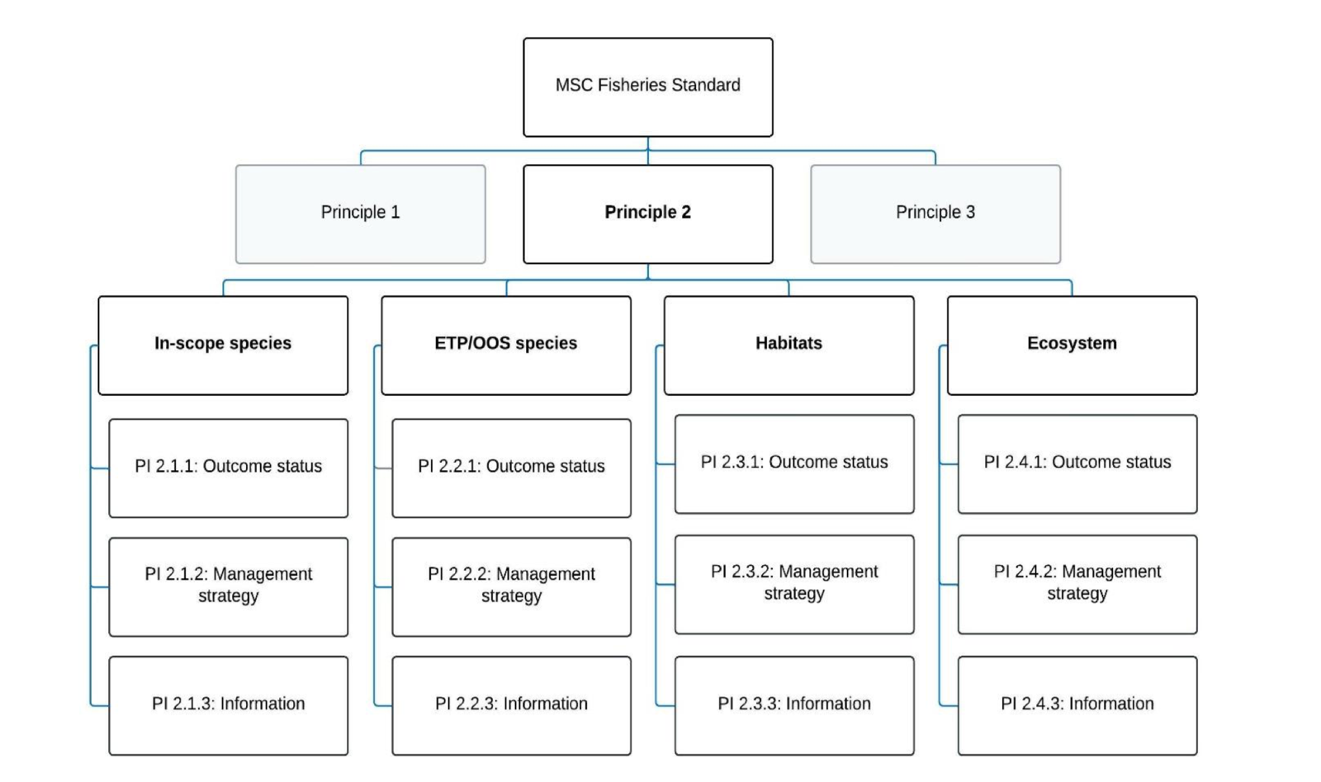
Figure 23. Decision tree for Principle 2 (MSC Fisheries Standard v3.)

4.2.2 Designating species

The MSC Standard v 3.0 outlines how to designate Principle 2 species. The Decision Tree (Figure 26) was used for each species listed in the QFish database (2016–2022) noting that Tiger prawns, MBB (Sand Bug/ Mud Bug), Red-spot King prawns, Endeavour Prawns and Banana Prawns were assessed at Principle 1. As discarding is considered to be significant in the ECOTF (Campbell et al. 2017), and logbooks do not quantify all discard species, this assessment also used published research data and ecological risk assessments (ERAs) to identify and quantify discard species for the central trawl region. Sand Bug is primarily taken when using prawn nets, whilst Mud Bugs are taken in operations targeting Saucer Scallops. Targeting of Saucer Scallop is currently closed although nets targeting scallops are used to take the UoA P1 species. Scallop discards volumes or number of baskets are recorded and data was made available to the assessment team.
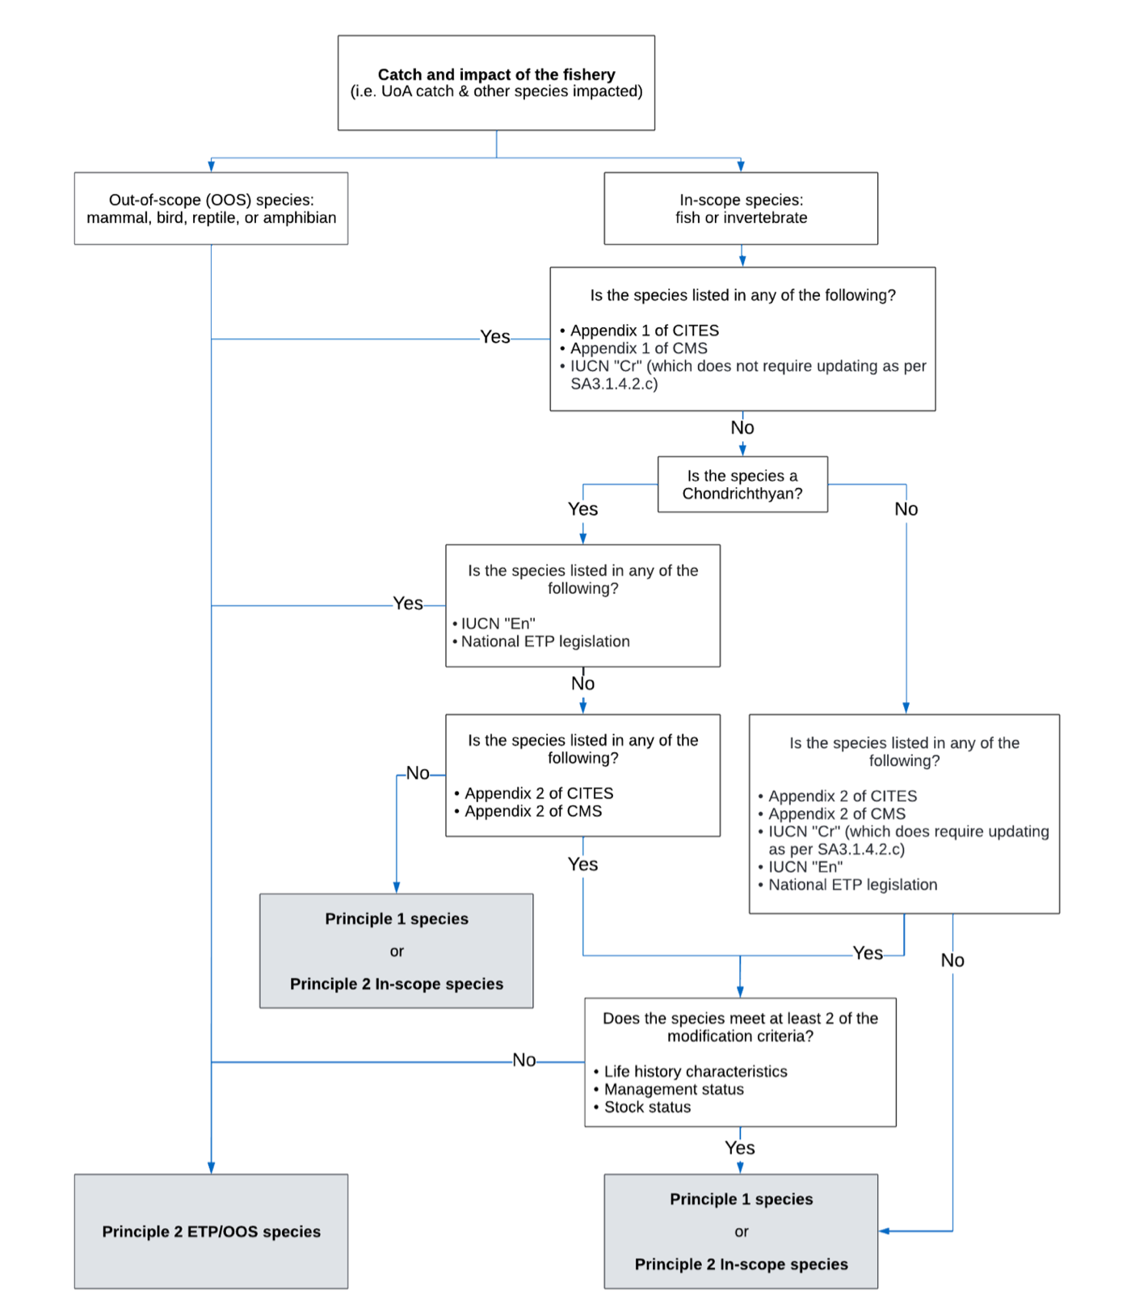
Figure 26. Decision tree for species categorisation from SA3 within the MSC Fisheries Standard v 3.0
The ECOTF is a large and complex fishery, encompassing multiple sub-sectors, across multiple bioregions and using slightly different gears and configurations of turtle exclusion devices (TEDs) and bycatch reduction devices (BRDs) in each sub-sector. As a result, the composition of other species taken in the fishery varies both spatially and temporally. Studies have shown that the fishery interacts with a large number of species, most of which occur very infrequently in trawls (e.g. Poiner et al., 1999; Courtney et al., 2007) and do not comprise a significant proportion of the total catch.

Permitted species and Species listed in logbooks
Table 15 outlines the target ad byproduct species of each sector of the ECOTF. The central sub-fishery primarily targets Brown and grooved tiger prawns (Penaeus esculentus and Penaeus semisulcatus) as the Tier 1 species (P1 species).

- Secondary (Tier 2) species also include:
  - Moreton Bay Bugs (P1 species)
  - Red-spot King Prawn (P1 species)
  - Banana prawns (P1 species)
  - Endeavour Prawns (Metapenaeus endeavouri) (P1 species)
  - Saucer Scallops (P2 species- although fishery closed and unlikely to be main in-scope species)

- Byproduct (Tier 3) species include:
  - Balmain Bugs (Ibacus chacei, I. brucei & I. alticrenatus)
  - Blue-swimmer crab (Portunus armatus)
  - Cuttlefish (Metasepia spp, Sepia spp),
  - Mantis shrimp (Family Squillidae),
  - Octopus (Octopus spp),
  - Pipefish (Solegnathus dunckeri, Solegnathus hardwickii),
  - Red champagne lobster (Linuparus trigonus),
  - Slipper lobster (Scyllarides spp),
  - Threadfin bream (Family Nemipteridae) and
  - Three-spotted crabs (Portunus sanguinolentus).

Table 15. Target (Tier 1), secondary (Tier 2) and permitted species as outlined in the regional East Coast Otter Trawl Fishery (ECOTF) harvest strategies 2 All five regional harvest strategies can be accessed at: https://www.daf.qld.gov.au/business-priorities/fisheries/sustainable/harvest-strategy. ²Unless otherwise specified, regional harvest strategies will classify permitted species as Tier 3 species/complexes. ³Stock classified as Depleted and is species classified as no-take as part of a broader stock rebuilding strategy (correct as of 1 July 2023). (Source: Dedini et al. 2023b)
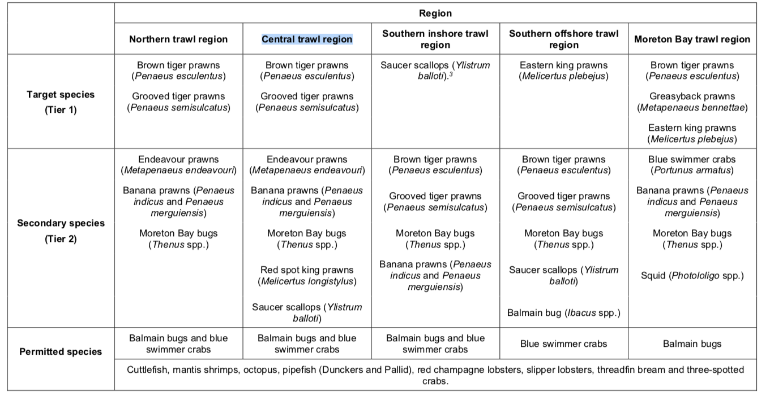

Ecological Risk Assessments
A common method for assessing data-poor species is via ecological risk assessments (ERAs). ERAs use a matrix of fishery impacts (catch, effort, discard rate, etc.) and resilience attributes (growth rate, discard survival, exclusion by TEDs, etc.) to determine the ecological risk posed species by the UoA.

In 2018, an ERA was published for the southern portion of the ECOTF (Jacobsen et al., 2018). However, as it was prepared in 2015 it was based on the management regime used up to 2015. Significant changes have been made to the management of Queensland fisheries since this time. In the 2018 ERA, the central zone was referred to as the “inshore tiger and endeavour prawn sector”. The risk assessment approach in the 2018 ERA did not take into consideration the changes to management or reform initiatives that have been implemented in the fishery since 2015. The earlier ERA (Pears et al. 2012), did not used a zone equivalent to the UoA, instead the “tiger and endeavour prawn” zone was assessed and this region stretched from Mackay Queensland to the Torres Strait (i.e., it includes the Northern, Central and some of the southern inshore zone Figure 3).

A recent ERA for the ECOTF (Dedini et al. 2023) was completed using a Productivity & Susceptibility Analysis (PSA) for species of conservation concern. As the PSA can over-estimate risk for some species (Zhou et al., 2016), the 2023 ERA also included a Residual Risk Analysis (RRA). The ERA prioritised assessments for non-target species. This ERA used the new zones of the ECOTF.

The entire ECOTF list was rationalised to 62 species consisting of six marine turtles, 13 sea snakes, nine syngnathids, 12 sharks and 22 batoids (Dedini et al. 2023). When the outputs of the PSA and RRA were taken into consideration, 12 species were categorised as being at high risk from fishing activities in the ECOTF. Of notable importance, nine of the 12 high-risk ratings were classified as ‘precautionary’ as they are more representative of the potential risk. As the ECOTF SOCC ERA is based at a whole-of-fishery level, ratings assigned to some species may not accurately account for variations at a management region level; it was advised that regional risk variations will be explored more in an additional risk assessment involving the ECOTF. The Trawl Fisheries Working Group met regularly and the minutes are publicly available. In November 2023, the communique stated that: “Fisheries Queensland provided an update on the Environmental Risk Assessment (ERA) for the East Coast Otter Trawl Fishery (ECOTF). Development of regional risk assessments are currently in the planning stages. Public consultation on the draft risk assessments for individual trawl regions is tentatively planned for early 2024 and the final version published in mid-end 2024”.

Five species were listed as high risk/precautionary high risk in the latest ECOTF ERA for SOCC (Dedini et al. 2023) and have the potential to interact with the central trawl fishery including:
- Colclough’s shark (Brachaelurus colcloughi) – High risk
- Green sawfish (Pristis zijsron) – High risk
- Eastern angel shark (Squatina albipunctata) – Precautionary high risk
- Blackspotted whipray (Maculabatis astra) – Precautionary high risk
- Brown whipray (Maculabatis toshi) – Precautionary high risk

Colclough's shark – Whilst there is a potential to interact with the UoA, Colclough’s shark is not strictly an ETP species and are caught in insufficient quantities to be assessed as an in-scope main species. Kyne et al. (2021) noted that “Currently it is known from <80 records, despite its distribution being well surveyed and researched. Given its apparent rarity and relatively restricted range, the population size is suspected to be <10,000 mature individuals, with an inferred continuing decline based on levels of fishing effort and habitat modification across its range, together with limited biological productivity. Therefore, Colclough’s Shark is assessed as Vulnerable. ” Kyne et al. (2021) listed this species as low threat from commercial bycatch. The SAFS report-card for this shark species is “depleted”. Dedini et al. (2023) noted that: “….interactions are largely undocumented. There has however been limited reports of the species being caught as bycatch in research projects quantifying otter trawl catch compositions (Courtney et al., 2007b; Kyne, 2008; Kyne et al., 2011a; Kyne et al., 2019a). Going forward, the level of information on B. colcloughi interactions is unlikely to improve unless there is a change in the EPBC Act conservation status or legislative protections. This highlights the need to prioritise this species for long-term monitoring under the Data Validation Program (Department of Agriculture and Fisheries, 2018a; Queensland Government, Undated-a).”

Wildlife Trade Operation Approval Application (EPBC Act)
In 2021, the ECOTF applied for WTO approval for export and was assessed under Part 13 of the EPBC Act. Eleven conditions were imposed on the fishery.

Bycatch/discard research
Research trawl data has been used to describe and quantify the bycatch in the ECOTF (Courtney, et al., 2007; 2008) in order to test the effectiveness of square mesh codend BRD (i.e., any reduction in bycatch rates in the fishery). There is no data specific to the central zone only. Courtney et al. (2007) and (2008) found that bycatch consisted of 224 taxa, including gurnards, flatheads, sandpaper fish, hermit and charybdid crabs, mantis shrimps, sea urchins, dragonets, snipefish, carids and lizardfish. Seven of these taxa comprised approximately 50% of the bycatch of which the following made up more than 5% of discards, by weight:
- Three-spined cardinalfish (Apogonops anomalus, 14.0%)
- Orange-freckled flathead (Ratabulus diversidens, 10.7%),
- Gurnard (Lepidotrigla argus, 8.7%),
- Orangemouth lizardfish (Saurida filamentosa, 5.9%),

Forty-five taxa accounted for 90% of the bycatch by weight however, 71% of taxa (159 species) were present in fewer than 10% of bycatch samples. Total bycatch rate in the fishery was significantly reduced (29%) using a combination of TED and 47.6 mm square mesh codend BRD. Catches of a number of species were reduced by > 80% (e.g., Graham’s conger, dumpling squid and stargaze cuttlefish). There was no significant reduction in the capture of elasmobranchs, which may in part be due to their low occurrence. In addition, codend type had little effect on bycatch assemblages, with assemblages more influenced by latitude and depth.

Wang, et al., (2020) estimated the weight of annual discards (i.e., bycatch) in the ECOTF by sector. The identification of bycatch species was not the subject of that study, although discards of <5000 t per year are reported in the central (Tiger/Endeavour prawn) sub-fishery in 2014 (Figure 25). Between 2007 and 2014, discards were about 5000 t per year. There is substantial evidence that BRDs significantly reduced discard rates, but their effect was inconsistent across sectors/regions (Courtney et al. 2007).

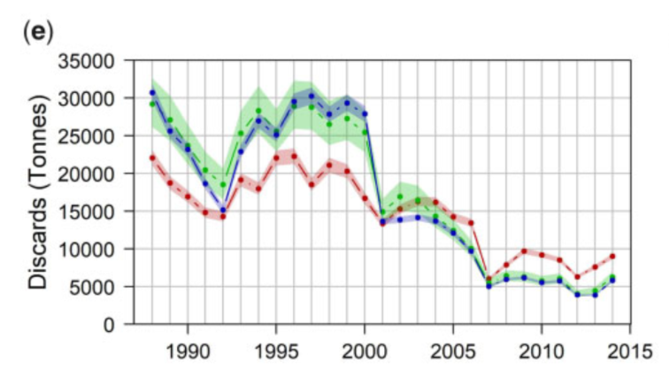
Figure 27. Annual discards in the ECOTF for operations targeting Tiger and Endeavour Prawns. Posterior means and 95% credible intervals from each of the three methods from January 1988 to December 2014. Means for various methods: the retained catch, effort, and swept area methods are red, green, and blue lines, respectively. (Wang et al. 2020)

Understanding post trawl survivability of discards is in its infancy, although Campbell et al. (2017) provided some estimates for the Common Stingaree and the Eastern Shovelnose Ray from prawn trawls. The mean PTS for female and male Common Stingarees was 33.5% and 17.3%, respectively, and 86.8% for Eastern Shovelnose Rays (both sexes combined).

Species designation

The annual retained catch is well understood (Table 10); the fishery has no trade in shark or shark-fins and as such, no shark is considered a main species (MSC SA 3.5.2.1c; Figure 28).

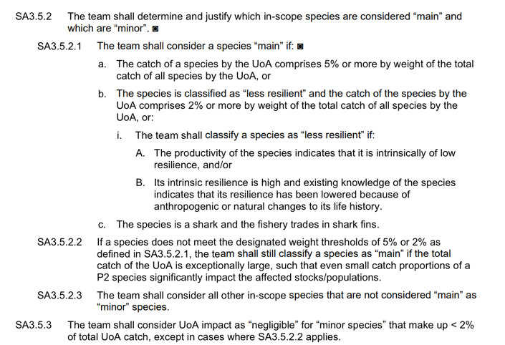
Figure 28. Default assessment tree guidance for definition of main and minor in-scope species

In 2022, the total retained catch for central was 714 tonnes although the total catch (including discards) is unknown. Wang et al. (2020) quantified discards by sector (i.e., target species) using data to 2015 (i.e., prior to the introduction of the HS); clear changes in discard quantities were evident following the introduction of BRDs and TEDs. However, Wang et al. found that: “Partitioning the fishery into sectors increased the amount of variation in discard rates”. Given that the sectors used in their analysis differ to the management areas now used in the ECOTF, and that multiple species are taken in the area that covers the Central trawl region, it is difficult to determine the level of discarding in the Central region with accuracy from Wang et al (2020). However, the Central HS lists Tiger Prawn as the Tier 1 species, and by using discard data from the Tiger prawn fishery (Wang et al. 2020) it is estimated that between 5,000 and 9,000 t was discarded in 2014 and the ratio of discard (kg) to retained (kg) was 4.5:1.0

The Central trawl zone remains closed for scallops and as such the Saucer scallop no longer make up ≥2–5% of the retained catch. Whilst the fishery does not retain scallops, they are still incidentally caught and discarded; recording discards for this species is required noting that no other discards have mandatory reporting. In 2022, 16 licences from the Central region reported scallop discards over 238 fishing days. Reporting included either weight or by the number of baskets/containers of an unknown weight. The Central trawl region (UoA) discarded 29.9 t plus 146.5 baskets/containers. A standard volume for the baskets/containers is unavailable for 2022 catches and as such the precise level of interaction with Saucer scallops remains unclear. However, French (2023) used basket volumes in the stock assessment and noted that meat-weight varied by month so basket weight was greater in January to March; the greatest weight was 7.5kg per basket. In order to estimate the total Scallop discards for 2022, the assessment team used this precautionary maximum volume of 7.5kg per basket; 146.5 baskets would equate to 1.01 t, meaning that a maximum of 33.5 t was discarded in 2022. If we use the approximate discard ratio of 4.5:1.0 for the Tiger prawn sector (Wang et al. 2020), then the total catch for the Central zone might have exceeded 3,200 t in 2022; in which case, Saucer scallop discards (30.91) made up about 1% of the estimated total catch. The MSC Guidance SA 3.5.2.1 outlines how to define a main species (see Figure 26) and stipulates that any species that makes up ≥2-5% of the total catch constitute a “main” species. Saucer Scallop does not meet this definition. However, SA3.5.2.2 is relevant for the overfished stock of Saucer Scallop as it states that a species may be designated as main if “even small catch proportions of a P2 species significantly impact the affected stocks/populations”. Saucer Scallop stock is depleted, with a 2022 estimated spawning biomass of 15% of unfished levels, with 95% confidence interval of 10– 25% (French, 2023). Campbell et al. (2010) examined the survivability of this species from the ECOTF following grading and reported high survival rate (83%). Given that the scallop fishery is closed, scallops are discarded with a high rate of survivability and scallops make up about 1% of total catch, Saucer Scallop is not assessed further.

Discard and interaction (SOCC) catch data is presented above from ERAs and research papers, and those retained species listed as main/minor in-scope species are presented in Table 16 and 17.

Table 16. Reported annual retained catch (t) from the central region of the ECOTF by year (Source: QDAF FDR- 663) ETP species in italics with asterisks and species that make up ≥5% of retained catch in bold and highlighted. Note the Scallop fishery is now closed and all retained catches from 2022 will be zero until biomass has rebuilt to 30% of unfished biomass.
Species | 2020 | 2021 | 2022
Bugs - Balmain | 3.2 | 0
Bugs - Moreton bay | 201.9 | 107.8 | 0
Bugs - mud |  | 1.4 | 6.6
Bugs - sand |  | 52.8 | 177.8
Butterfly bream - unspecified | 4.6 | 5.4 | 2.6
Crab - blue swimmer | 3.9 | 3.8 | 3.1
Cuttlefish | 4.7 | 9.3 | 8.1
Octopus - unspecified | 0.5 | 0.8 | 0.3
*Pipehorse - dunkers | 0.06 | 0.14 | 0.10
*Pipehorse - pallid | 0.08 | 0.09 | 0.02
Prawn - banana | 146.2 | 49.6 | 21.5
Prawn - blue leg king | 182.8 | 63.3 | 58.1
Prawn - coral | 3.6 | 5.2 | 2.8
Prawn - eastern king | 0.7 | 11.5 | 6.1
Prawn - endeavour | 61.4 | 72.8 | 44.5
Prawn - red |  | 0 | 0.1
Prawn - red spot king | 207.0 | 186.8 | 80.5
Prawn - tiger | 481.5 | 351.0 | 289.5
Prawn - unspecified |  | 0.1 | 5.9
Scallop - saucer | 8.7 | 3.8 | 0
Scallop - unspecified | 0 | 0.6 | 0.3
Squid - unspecified | 4.8 | 7.1 | 6.4
Grand Total | 1315.8 | 933.5 | 714.3

Table 17. Retained and discard species categorisation into components for the assessment. Discard levels are unknown for the Central region since closing to Saucer Scallops, and as such, discard species that were identified as high or precautionary high risk in the 2012 (Pears et al. 2012) and 2023 (Dedini et al. 2023) ERAs or those ETP species listed in ETP logbooks are listed here. Saucer Scallop are discarded and reported in logbooks.
Retained species | Species | Component
Retained species | Tiger prawns (Penaeus esculentus and P. semisulcatus) | UoA P1
Retained species | Moreton Bay Bugs (Thenus australiensis & T. parindicus) | UoA P1
Retained species | Red-spot King prawns | UoA P1
Retained species | Banana Prawns | UoA P1
Retained species | Endeavour Prawns | UoA P1
Retained species | Blue-legged (western) King Prawns | In-scope main
Retained species | Balmain Bugs (Ibacus chacei, I. brucei & I. alticrenatus) | In-scope minor
Retained species | Blue-swimmer crab (Portunus armatus) | In-scope minor
Retained species | Cuttlefish (Metasepia spp, Sepia spp) | In-scope minor
Retained species | Slipper lobster (Scyllarides spp) | In-scope minor
Retained species | Mantis shrimp (Family Squillidae) | In-scope minor
Retained species | Octopus (Octopus spp) | In-scope minor
Retained species | Red champagne lobster (Linuparus trigonus) | In-scope minor
Retained species | Slipper lobster (Scyllarides spp) | In-scope minor
Retained species | Threadfin bream (Family Nemipteridae) | In-scope minor
Retained species | Three-spotted crabs (Portunus sanguinolentus). | In-scope minor
Retained species | Pipefish (Solegnathus hardwickii, S. dunckeri,) | ETP
Discard species | Saucer Scallop (Ylistrum balloti) | In-scope minor
Discard species | Eastern Angel shark (Squatina albipunctata) | In-scope main
Discard species | Blackspotted Whipray (Himantura astra) | In-scope main
Discard species | Brown Whipray (M. toshi) | In-scope main
Discard species | Colclough’s shark (Brachaelurus colcloughi) | In-scope minor
Discard species | Green Sawfish (Pristis zijsron) | ETP
Discard species | Loggerhead turtle (Caretta caretta) | ETP
Discard species | Green Turtle (Chelonia mydas) | ETP
Discard species | Sea snakes (12 species) | ETP

4.2.3 In-scope species

Retained in- scope main species

Blue-legged King prawn (Western King Prawn)

Distribution and stock structure
Blue-legged King Prawn (Melicertus latisulatus) are more commonly called Western King Prawn. They are distributed throughout the Indo–West Pacific. In Australian waters it occurs in South Australia, Western Australia, Northern Territory, Queensland and down the east coast to northern New South Wales. With a preference for benthic habitat such as sand, sandy mud or gravel, the species inhabits shallow marine water to depths of around 90 m (MRAG, 2020). Habitat preference is linked to this species ability/need to bury itself to avoid predation (Tanner & Deakin 2001 cited in Kangas et al. 2015)).

No research has been conducted into Western King Prawn biological stock structure on the east coast of Queensland, and status is therefore reported at the management unit level. However, electrophoretic studies on western king prawns (Kangas et al. 2015) have demonstrated genetic differences among populations sampled in WA, the Gulf of Carpentaria and South Australia. Interestingly, the WA populations in Shark Bay and Exmouth Gulf have distinct adult and juvenile habitats with independent variations in recruitment and abundance and are treated as separate stocks for management purposes in WA.

Life history
Much of the life history information is based in South Australian (e.g., Hackett, 2017) or tropical Western Australia (MRAG 2020 and references within). The western king prawn is a fast-growing species and is highly fecund, reaching sexual maturity at six to nine months. The life cycle of western king prawns is generally 2–3 years. Western king prawns are nocturnal and highly sensitive to light, with their activity influenced by both lunar cycles and temperature (Penn 1980 cited in MRAG 2020). Western king prawns undertake a migration from nursery areas to deeper, more offshore waters to spawn.

Stock assessment
There is no stock assessment available for WKP from Queensland. However, catch rates are used to assess the stock relative to historical levels. WKP long-term nominal catch rates (1998–2017) were 31.0–58.3 kg per day. At 45.9 kg per day, nominal catch rates for 2019 were at the upper end of this range (QFISH 2020).

Stock status
Noell et al. (2020) used the results of the ERA (Pears et al. 2012) to suggest that “..biomass of this management unit is unlikely to be depleted and that recruitment is unlikely to be impaired.” Catch rates relative to historical catch rates and closed areas were also used to suggest that overfishing was not occurring. Within the 2017 application for export approval, the following was used as rationale that the stock is not overfished:

“• predictive biophysical modelling estimated a large proportion (41%) of the biomass within the GBRMP is protected from trawl fishing through permanent closures;
• there has been a substantial long term decline in catch, partly due to the introduction of closures within the GBRMP in 2004 and subsequent reduction in otter trawl effort;
• the number of licences reporting catch declined from an average of 154 in 2004–08 to an average of 100 in 2009-15;
• average effort declined by 39% between 2004-08 and 2009-15;
• 2013-15 annual catches and catch rates were marginally higher than the 2009-15 averages.”

No rationale was provided in the 2021 application for WTO approval. This species is taken by numerous other fisheries in Australia (Figure 30), and the larger fisheries have MSC certification (e.g., Spencer Gulf SA, Shark Bay WA etc.).

Catches and Harvest strategy
Retained catches are well understood in the ECOTF. Table 17 presents the catches of all species including Western King prawn in the UoA for 2019–22. Total catches for the entire ECOTF are presented in Table 18 below. The 2021 WTO application provided ECOTF catches for each species for 2010–2019, WKP catches for the entire ECOTF during that period were of 76–181 t. Total fishing mortality for the species can be estimated from retained catches across the eight fisheries, although stocks are likely to differ by region.

Table 18. Western King prawn retained catches (tonnes) by sector of the ECOTF for 2019–2022
 | Catch (t) per Year
ECOTF region | 2019 | 2020 | 2021 | 2022
Central Trawl Region | 85.876 | 182.759 | 63.347 | 58.1035
Moreton Bay Trawl Region | 1.678 | 0 | 0.472 | 1.543
Northern Trawl Region | 17.525 | 11.575 | 3.065 | 0.606
Southern Inshore Trawl Region | 4.8037 | 4.6915 | 2.8915 | 6.8875
Southern Offshore Trawl Region | 5.978 | 8.985 | 3.879 | 0
Grand Total | 115.8607 | 208.0105 | 73.6545 | 67.14

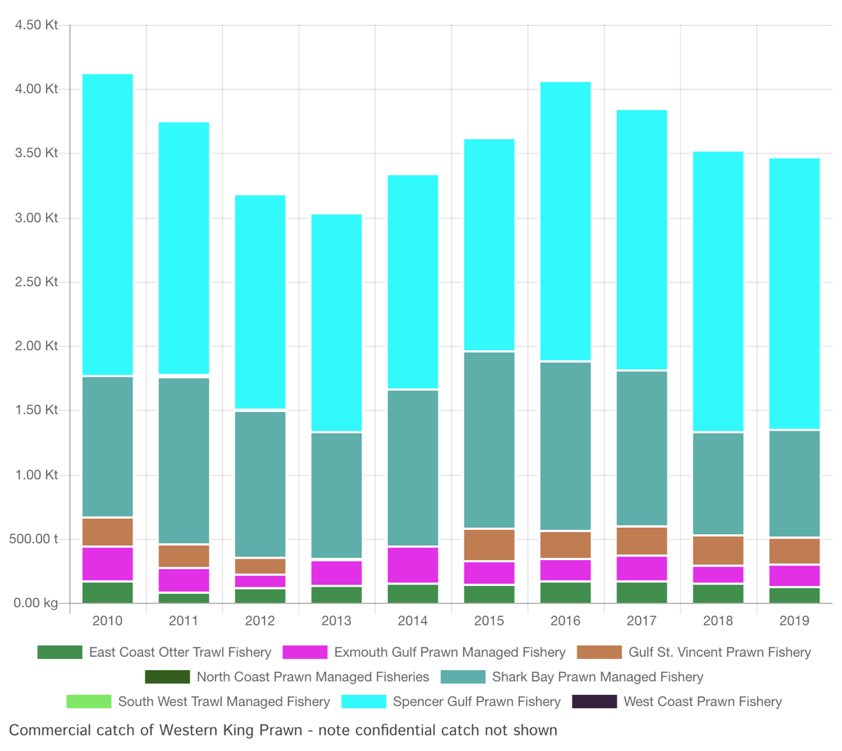
Figure 29. Commercial retained catch of Western King Prawn from 2010 to 2019 by nine Australian fisheries (Noell et al. 2020).

Discarded in- scope main species

There is no discard data specific to the central trawl, and fishing behaviour has changed in this region since the closing of the scallop fishery. Estimating main discard species is therefore based on the ERA (Pears et al. 2012) as the other ERAs are specific to the southern zone of the ECOTF (Jacobsen et al. 2018) or SOCC alone (Dedini et al. 2023a). Pears et al. was conducted prior new management measures and zonation. The 2012 ERA identified the following discard species as high risk in the northern part of the ECOTF:
- Yellowspot Goatfish Parupeneus indicus
- Grey-spotted Catshark Asymbolus analis
- Orange-spotted Catshark Asymbolus rubiginosus
- Sawtail Catshark Figaro boardmani
- Sydney Shark Dipturus australis
- Endeavour skate D. endeavouri
- Blacktip skate D. melanospilus
- Argus skate D. polyommata
- Australian Butterfly Ray Gymnura australis
- Eastern Shovelnose Ray Aptychotrema rostrate
- Blackspotted Whipray Himantura astra
- Blue-spotted Maskray Neotrygon kuhii
- Speckled Maskray N. picta
- Common Stingaree Trygonoptera testacea
- Sandyback Stingaree Urolophus bucculentus
- Kapala Stingaree U. kapalensis

The elasmobranchs were assessed again in the newest ERA (Dedini et al. 2023) that only examined the SOCC (i.e., ETP species and elasmobranchs) and two elasmobranchs were listed as ‘high risk’ in the central region:
- Colclough’s shark Brachaelurus colcloughi
- Green sawfish P. zijsron (reviewed further under ETP below)

A further 3 elasmobranchs were ranked as ‘precautionary high risk’ in the central zone :
- Eastern Angel shark Squatina albipunctata
- Blackspotted Whipray Himantura astra
- Brown Whipray M. toshi

From the above, five other species that were identified as in-scope main using research data and ERA outcomes. Stock status reference points are still unavailable for these species; any further assessment would require the RBF process to score in-scope main species that are discarded.

Minor in-scope species

Many other species are regularly discarded by the central sub-fishery, although studies have shown that the fishery interacts with a large number of species, most of which occur very infrequently in trawls (e.g. Poiner et al., 1999; Courtney et al., 2007) and do not comprise a significant proportion of the total catch. Given that this is a pre-assessment report and minor in-scope species are only assessed to reach SG 100 no further attention is given to this group of species.

Management of In-scope species

In March 2022, the harvest strategy for the central region was approved and implemented (QDAF, 2021d). It was developed in accordance with the Queensland harvest strategy policy to manage the harvest of trawl fishery resources within the central trawl region.

The HS includes decision rules for:
- Tier 1 (Tiger prawns – P1 species);
- Secondary (Tier 2) species (Endeavour Prawns, Banana Prawns; Red-spot Prawns; Endeavour Prawns, Moreton Bay Bugs – P1 species). Saucer Scallops is listed as a Tier 2 species although the fishery is currently closed;
- Byproduct (Tier 3) species (Balmain bugs; blue swimmer crabs; cuttlefish; mantis shrimps; octopus ; pipefish; red champagne lobsters; slipper lobsters; threadfin bream; three-spotted crabs).

Decision rules for the Tier 3 species are presented at Figure 30. Western King Prawns (blue-legged king prawns) are not subject to Tier 3 rules.
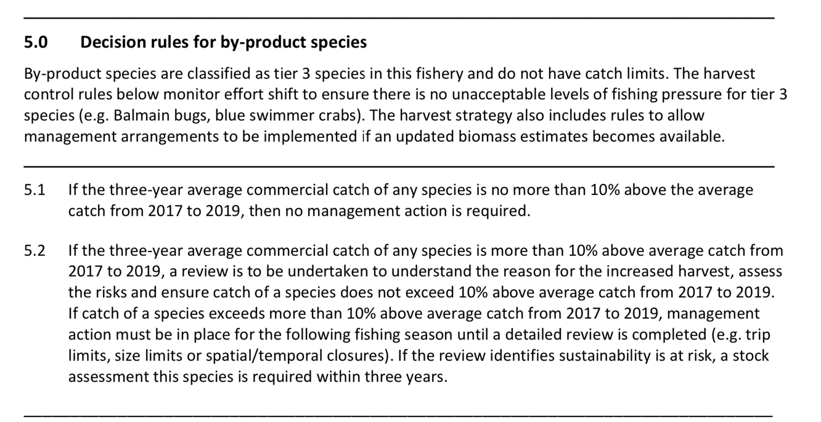

Figure 30. By-product species: Harvest strategy decision rules by-product species including from Central Trawl Region of the ECOTF (QDAF, 2021d).

Management of Discards

There are three basic approaches to minimising discards.
- The first approach is to avoid bycatch in the first instance. This is done through voluntary or compulsory closed seasons or closed waters to avoid catching fish or other species that will be discarded. This often includes closing water to fishing where there is a high likelihood of interactions.

- The second approach uses selective or alternative fishing equipment to reduce bycatch, by either preventing certain species from entering nets, or providing escape mechanisms for unwanted catch. In 2000, the Queensland government implemented significant management changes via the Fisheries (East Coast Trawl) Management Plan 1999, which reduced nominal effort in the fishery by about 50%. TEDs and BRDs were also introduced as part of the Trawl Plan. By 2002, all vessels operating in the ECOTF were required to have both a TED and at least one of seven prescribed BRDs installed in their nets.

TEDs and BRDs resulted in significant decreases in the number of discards produced in the ECOTF. For example, the use of an efficient TED and a square mesh codend BRD resulted in a 78% reduction of discards produced in the scallop sector in central Queensland or approximately 10,588 tonnes, annually. Further information on BRDs is presented above at Section 3.1.3.

- A third approach aims to create a value for bycatch that would otherwise be discarded, providing market incentives to retain more catch and discard less. Whilst this has been investigated in other Australian trawl fisheries, it has not been investigated for the ECOTF.

4.2.4 ETP/OOS species

Endangered, Threatened and/or Protected species (ETPs)
The MSC Standard v 3.0 outlines how to designate Principle 2 species, including determination of an ETP species (SA 3.1.4); noting that this has changed since the earlier MSC version to now include CITES/CMS Appendix II species.
Information on any listing with CITES or CMS is available at: https://www.speciesplus.net and the Australian database for listed species is at: https://www.environment.gov.au/cgi-bin/sprat/public/sprat.pl.
The Australian database also includes the IUCN Redlist ranking as required in the decision tree at Figure 24.
Commercial fishers operating in ECOTF are required to report all interactions with protected species using Queensland Fisheries approved logbooks (Figure 6) quarterly reports are prepared from this logbook data although there is no differentiation of the data for specific region or net type configuration (prawn/scallop). Accurate information must be available to monitor and manage the impacts of the UoA on protected species.
ECOTF logbook data reveal few interactions with species of conversation interest (SOCI). Interactions are defined as any physical contact with a protected species, including interactions with fishing gear and vessel collisions. Interaction data is made publicly available on the portal.
There is no break down by region, but the reported interactions from Q4 2022 to Q3 2023 for the east coast trawl (ECOTF) include:
- Sea snakes (1321 caught of which 133 dead/injured)
- Narrow sawfish (10 caught of which 3 dead/injured)
- Green turtle (4 caught, nil dead/injured)
- Loggerhead turtle (3 caught, nil dead/injured)
- Pipefish/seahorses (110 caught, nil dead/injured – presumably spp other than retained spp but uncertainty remains)
- Estuary stingray (1 caught, nil dead).
Not all SOCC reported in logbooks are ETPs (i.e., protected under national legislation and/or binding international agreements), particularly many sharks and rays. Additional information from the FRDC reports (Simpfendorfer et al. 2019) and International Plan of Action (Kyne et al. 2021) were included on stock status and risk assessment of sharks and rays. Pears et al., (2012) assessed the potential risk the ECOTF posed to Species of Conservation Concern (SOCC) including 6 species of turtles, 16 species of sea snakes, 6 species of seahorses and pipefish and 33 species of sharks and rays. Dedini et al. (2023) identified 19 shark/ray species that have the potential to interact with the central fishery. Of these the following were ranked as high risk (HR) or precautionary high risk (PHR):
- Colclough’s shark Brachaelurus colcloughi - HR
- Green sawfish P. zijsron - HR
- Eastern Angel shark Squatina albipunctata - PHR
- Blackspotted Whipray Himantura astra - PHR
- Brown Whipray M. toshi - PHR

A data request for ETP species interactions with a break-down between regions illustrated that the only ETP species reported for the central sub-fishery are sea snakes (undefined species) (Table 17).

CITES
The Convention on International Trade in Endangered Species of Wild Fauna and Flora (CITES) is an international agreement between governments that aims to ensure that the international trade in wildlife does not threaten wild populations of plants and animals. The 19th meeting of the Conference of the Parties to the CITES (CITES CoP19) was held from 14 to 25 November 2022 in Panama City, Panama. Amendments to the CITES Appendices, including new listings, enter into force for all parties 90 days after the meeting (i.e., 23 February 2023), unless a delayed implementation date is agreed. Australia implements CITES through its national environment law, the Environment Protection and Biodiversity Act 1999 (EPBC Act). The List of CITES Species included in the EPBC Act was to be amended by 23 February 2023 to ensure that any Australian imports and exports of the species newly listed under CITES may continue. Proposals to include hammerhead sharks (Sphyrnidae spp) and guitarfish (Rhinobatidae spp) in Appendix II to CITES were adopted and these listings became effective from 23 February 2023. Proposals to include requiem sharks (Carcharhinidae spp) in Appendix II were also adopted with “delayed listings”. The requiem shark listing will come into effect after a 12-month implementation delay on 25 November 2023.

CMS
The Convention on Migratory Species (CMS), also known as the Bonn Convention, is an environmental treaty of the United Nations that provides a global platform for the conservation and sustainable use of terrestrial, aquatic and avian migratory animals and their habitats.
Countries whose representatives have signed up to the CMS are known as ‘Parties to the CMS’. Australia became a Party of the CMS in 1991. All Parties to the CMS acknowledge the importance of acting to conserve migratory species. CMS has two Appendices. These Appendices list migratory species to which the Convention applies. The text of the Convention defines the basic obligations of the Contracting Parties towards species listed on Appendix I and Appendix II. These obligations are quite distinct for the two Appendices, and a migratory species can be listed in both Appendices at the same time, if the circumstances so warrant. Appendix I comprises migratory species that have been assessed as being in danger of extinction throughout all or a significant portion of their range. Appendix II covers migratory species that have an unfavourable conservation status and that require international agreements for their conservation and management. Appendices I and II may be amended at any meeting of the Conference of the Parties. An amendment to the Appendices shall enter into force for all Parties ninety days after the meeting of the Conference of the Parties. Those CMS listed species relevant to Australia are available at http://www.environment.gov.au/cgi-bin/sprat/public/publicshowmigratory.pl Species listed on CMS Appendices I and II are protected under the Environment Protection and Biodiversity Conservation Act 1999 (EPBC Act). Through listing the species as migratory under the EPBC Act, it becomes an offence to kill, injure, take, trade, keep or move the species in Commonwealth waters. In 2023, Australia produced a National report for migratory sharks and rays although there is no information on guitarfish/wedgefishes; these species shall be treated as ETP in this pre-assessment.

Green sawfish (Pristis zijsron)
Green Sawfish are Critically Endangered by the IUCN RedList. Further information on sawfish research projects is available at https://www.sharksandraysaustralia.com/research/. Green sawfish were once widely distributed in the Indian Ocean and off Indonesia and Australia although population declines due to overfishing have caused restrictions, e.g., once found south to Sydney, its east coast range has contracted to north Queensland (Kyne et al. 2021).
Green sawfish are very large, slender sawfish with a shark-like body. The maximum length recorded in Australian waters is 730 cm (Last & Stevens, 2009). Peverell (2009) examined the age (vertebral bands) of 18 green sawfish from the Gulf of Carpentaria. Average size at birth was 76 cm, and the average growth in the first year was 52 cm, and 33 cm in the second year. Longevity was estimated to be 53 years (based on a maximum size of 540 cm, the locally recorded maximum size). Based on the observations of a single post partum female, size and age at maturity was estimated at 380 cm and nine years. The size at maturity of males is unknown. The population structure of green sawfish has been assessed (Phillips et al., 2011; Phillips, 2012). Green sawfish are genetically structured in northern Australian waters with at least the assemblages from the west coast, the Gulf of Carpentaria and the east coast being genetically distinct, although precise population boundaries are unclear (Phillips et al., 2011; Phillips, 2012). The Recovery Plan (2015) outlines the known stock structure in Australian waters.

The ERA (Dedini et al. 2023) listed this species as high risk for the ECOTF as a whole. Range descriptions for the Green Sawfish (Pristis zijsron) are based on historical observations and suggest the species is found across a large expanse of the ECOTF. However, this information is considered (Dedini et al. 2023) to be outdated and it is hypothesised that the east coast P. zijsron distribution has contracted to north Queensland (Kyne et al., 2021). Based on this information, interactions with the ECOTF are more likely to occur in areas north of the Whitsundays (Harry et al., 2011) which is within the operational area of the central sub-fishery. In the ECOTF, nine P. zijsron interactions have been reported through the logbook program since 2006; three interactions were reported in 2018 and with further interactions since 2018 (Department of Agriculture and Fisheries, 2023). No interactions were recorded for the central region.
A recovery plan is available for Green Sawfish (combined with other Pristis sawfish and river sharks). There is little information on current population sizes or long-term rates of population change. The recovery plan does not include the Narrow Sawfish as it is not listed by the EPBC Act. The SPRAT profile for each species provides a comprehensive overview of the legal status, population status etc.
Under the CMS, all sawfish species are protected and Australia is a signatory country to the Memorandum of Understanding (MoU) Sharks. Under this agreement, recommended actions relevant to fisheries include:
- Enforce compliance with fisheries management regulations, landing and trade bans;
- Improve capacity in species identification through trainings and the dissemination of available ID guides;
- Identify effective approaches to reduce bycatch and improve survivorship of sawfishes such as:
  - gear modifications and fishing practices e.g., shot times and safe release handling guidelines
  - options for spatial management
  - post-release survivorship of sawfishes to inform improved handling and release protocols.
- Enhance or develop collection of fishery data (including landings, discards, size frequency, catch and effort).
The UoA met this agreement as follows:
- Fisheries regulations are strongly enforced by Queensland. Vessel Monitoring Systems (VMS) are used on all Queensland commercial fishing vessels to track their location, validate reported fishing activity, and enhance QDAF’s capacity to undertake vessel inspections.
- Sawfish are easily identified by their unique ‘saw’ or rostrum. The following guides are available to allow for correct species identification:
- Looking after protected species in Queensland – a guide to commercial fishers;
- Australia’s sawfish ID guide (SARA)

Marine turtles
Marine turtles are listed in Appendix I of CITES which prohibits international trade in specimens of these species. In Australia, it is illegal to kill, injure, take, trade, keep or move turtle species. Marine turtles are also listed in Appendix I of the CMS. CMS requirements for the signatory countries include prohibiting the taking of the species, with very restricted scope for exceptions; conserving and where appropriate restoring their habitats; preventing, removing or mitigating obstacles to their migration and controlling other factors that might endanger them. In Australia, marine turtles are EPBC listed as ‘vulnerable’ or ‘endangered’, marine and migratory. To meet the CMS and the EPBC requirements, an updated Recovery Plan for Marine Turtles in Australia 2017–2027 was developed (DEE, 2017).
The ERA (Dedini et al. 2023) listed marine turtles as medium or precautionary medium risk for the ECOTF as a whole. All six species are considered ‘central’ as a key risk region. The use of a Turtle Exclusion Device (TED) remains a pivotal component of the broader ECOTF management plan and has been an effective risk-mitigation strategy employed for marine turtles. Research from both Australia and elsewhere has shown that the combined use of a TED with a Bycatch Reduction Device (BRD) can reduce landing rates for marine turtles by 97–99% (e.g., Campbell et al., 2020). Publicly available interaction data reported that in 2021–22, four Marine Turtles interactions were reported with the entire ECOTF (three loggerhead (Caretta caretta) and one green turtle (Chelonia mydas)); ETP interaction data for 2014–2022 from the central region reported an interaction with two green and two loggerhead turtles, and all were reported to be released alive although one Loggerhead turtle was released injured in 2021.
The Action Plan requires that Australian fisheries management should be undertaken in accordance with the FAO Guidelines to Reduce Sea Turtle Mortality in Fishing Operations. The main requirements within the recovery plan relevant to domestic fisheries include:
- improving access and report of the most current bycatch information that will enhance the assessment of whether current fisheries interactions will impact on stock recovery.
- promotion and implementation of best practice and continued innovation of turtle bycatch mitigation.
The measures of success for the above actions include:
- domestic fisheries are compliant with fisheries legislation pertaining to bycatch;
- marine turtle species are accurately recorded in 90% of reported fishery interactions within Australia’s jurisdiction;
- marine turtle bycatch is reduced such that it does not impact stock recovery (DEE, 2017).

The ECOTF’s impact on marine turtles was reduced significantly with the introduction of TEDs and most turtles caught are released alive with mandatory reporting requirements. ECOTF Central trawl footprint is a very small fraction of marine turtle species distribution.

Sea snakes
There are at least 15 species of sea snakes recorded in the ECOTF catch prior to and after the implementation of bycatch reduction devices (Courtney et al. 2010; Courtney et al. 2014; Jacobsen et al. 2018). The latest ERA (Dedini et al. 2023) listed 12 sea snakes as low (1) and medium (11) risk for the central region. Of these 12 sea-snake species known to have an interaction with the central sub-fishery of these 11 were medium risk.

In 2022, 257 Sea snake interactions were reported with the entire ECOTF of which 3 were dead and two were injured, the remainder were released alive. Logbook data provided by QDAF suggests that sea snake interaction in the central region makes up a varying proportion of the total report interactions for the ECOTF each year (Table 19), although in 2020 more than half of all interactions came from this area. Note: the boundaries and names of the regions within the ECOTF have varied since 2019. In 2023, the total number of sea snake interactions for the entire ECOTF increased to a new peak of 1968 (509 dead/injured). Region specific data is not available for 2023.

Pears et al. (2012) stated that: “There is considerable overlap between the spatial distribution of some sea snake species and trawl fishing effort in the Great Barrier Reef Region. Most of the incidental trawl fishing mortality for sea snakes (Courtney et al. 2010), and therefore most of the risk, occurred in the central Queensland red-spot king prawn sector of the ECOTF.” The newer ERA (Dedini et al. 2023) noted that: “the absence of an effective mechanism to validate logbook data increases the risk of non-compliance e.g. the non-reporting of sea snake interactions and the submission of erroneous release-fate data.” When considering cumulative impacts of interactions with MSC certified fisheries, it is important to consider the Northern Prawn Fishery and its impacts on these species of sea snakes (Fry et al. 2021).

Table 19. Reported Sea snake interaction and life status recorded by logbooks in the central sub-fishery and entire ECOTF by year
YEAR | LIFE STATUS | Total  NUMBER OF INTERACTIONS | Central NUMBER OF INTERACTIONS | % of total reported interactions in the UoA
2019 | Alive | 508 | 26 | 4.8%
 | Injured | 1 | - | 4.8%
 | Dead | 23 | - | 4.8%
2020 | Alive | 1317 | 898 | 68.7%
 | Injured | 43 | 40 | 68.7%
 | Dead | 50 | 31 | 68.7%
2021 | Alive | 413 | 52 | 12.9%
 | Injured | 5 | 2 | 12.9%
 | Dead | 8 | 1 | 12.9%
2022 | Alive | 252 | 97 | 37.7%
 | Injured | 2 | - | 37.7%
 | Dead | 3 | - | 37.7%

Pipefish
In late 2001, syngnathids (pipefish and seahorse etc.) were included in the list of marine species under Part 13 of the EPBC Act. As a result of this listing, it is an offence to kill, injure, take or trade syngnathids and solenostomids in, or from, a Commonwealth area. However, for those caught in the ECOTF, their fate (discard/retention) will depend on its status within the fishery. Solegnathus dunckeri and S. hardwickii make up a high percentage of the ECOTF syngnathid catch (Connolly et al., 2001; Dodt, 2005). Under Part 2 of the Fisheries Declaration 2019, the take of ‘pipefish’ (S. dunckeri and S. hardwickii) is restricted by a combined trip limit of 50 individuals and both species must be discarded once this limit is reached. The latest ERA (Dedini et al. 2023) did not list Duncker’s Pipehorse (S. dunckeri) as high or medium risk for the Central region although five syngnathids were listed as medium risk.

Dodt (2005) reported that about 5,500–11,000 syngnathids are retained annually by the ECOTF and the average wet weight was < 60 grams. Whilst volumes may differ with the use of different BRD and TED combinations, in 2022, the central zone (UoA) retained 120 kg. It is unclear if operators are required to record discard numbers (or fates) for S. dunckeri and S. hardwickii in ETP logbooks. As post-trawl survivability of discarded pipefish is unknown, fishing-mortality rates for both species will also be higher than retained catches in logbook entries. In 2019–22, 1394 kg was recorded in logbooks (Table 20) of which 40% is caught and retained by the UoA. If the average Duncker’s pipehorse weighs 50 grams, the 120 kg reported in logbooks in 2022 is calculated to 2400 individuals in the UoA or 11,200 pipehorses in the last four years (2019–22); the total ECOTF take for 2019–22 is estimated to be 27,880 pipehorses. There is no information to ascertain if triggers of 50 per trip were ever reached in any sector of the ECOTF and if so, how often they were reached. The is no information on precise number of pipefish retained (only estimates based on average weight), or if limits are effective at reducing mortality (i.e., survivability of discarded pipehorses is unknown).

Table 20. Reported pipehorse retained (kg) by the ECOTF and the central trawl region sub-fishery by year. Pallid’s (Solegnathus hardwickii) and Duncker’s (S. dunckeri)
Year | Retained (kg) by pipehorse species |  | Total ECOTF retained (kg)
Year | Pallid’s | Duncker’s | Total ECOTF retained (kg)
2019 | 28 | 33 | 361
2020 | 79 | 65 | 285
2021 | 87 | 140 | 441
2022 | 21 | 104 | 308
Total | 215 | 343 | 1394

The remaining members of the Family Syngnathidae are all classified as no-take and are subject to mandatory reporting requirements through the TEPA logbook (Figure 6). Historical catch data for non-retainable syngnathids is limited, with less than 10 interactions reported through the logbook program over the last 10 years (Department of Agriculture and Fisheries, 2023).

Ghost nets

Ghost nets are defined as abandoned, lost or otherwise discarded fishing gear (ALDFG) in the marine environment and are a global problem. Fishing gear could be lost from vessels for a variety of reasons, including but not limited to stowed gear being washed overboard, gear being lost or abandoned during fishing operations and nets or net repairs being discarded whilst at sea (Richardson et al., 2018). Lost fishing gear (e.g. ground chains, trawl net) is likely to sink, with localised smothering effects on a small area of habitat where it lands, however trawl net will not generally continue ‘ghost’ fishing, and the level of lost or discarded fishing gear in the trawl industry is likely to be relatively low. Bio-inspecta (2023) noted that: “Gear loss in the fishery is low, with industry data reporting 3 boards, 3 skids and 4 nets lost between 2015-2019” although there is no further information if this is for that single UoA of the southern offshore EKP sub-fishery or for the entire ECOTF. Further information is needed regarding central region gear loss at sea and recycling/disposal facilities available at ports.

Pollution of the marine environment by ships, including fishing vessels, is strictly controlled by the International Convention for the Prevention of Pollution from Ships (known as MARPOL). With regard to legislation, the Australian Maritime Safety Authority also have legislative responsibility for marine pollution and providing safe navigation. States and Territories, including Queensland have complementary frameworks. With regard to the “Accidental loss or discharge of fishing gear”, fishing vessel operators are also required to record the discharge or loss of fishing gear in their garbage record book or ships log.

Habitats
The new MSC Standard classifieds habitats as 'More Sensitive' or 'Less Sensitive', based on the time it takes to recover from the impacts of fishing.
- More sensitive habitat: a habitat unable to recover to at least 80% of its unimpacted structure and function within 20 years if fishing were to cease entirely.
- Less sensitive habitat: a habitat able to recover to at least 80% of its unimpacted structure and function within 20 years if fishing were to cease entirely.
Detailed information is available on the habitat types of the GBRMP and the impacts of trawling on them (Pitcher et al., 2007; Jacobsen et al., 2018). The GBR Seabed Biodiversity project (AIMS, 2024) identified habitats contained within the GBR and defined their distribution and provided finer scale assessments of the species assemblages. This Project covered about 60% by area of the GBRMP (i.e. 210,000 km² out of a total 344,400 km²). About one-third of the GBRMP is below 200 metres, and there has been little investigation of these continental slope and deep oceanic habitats. The continental slope is a complex area composed of relic reefs, landslides, canyons and plateaux. The seabed project mapped nine habitat types (clusters) and assessed risks to each habitat cluster from trawling throughout the continental shelf of the GBR (Pitcher et al. 2007). The most relevant measure considered the distribution of trawl effort and identified that the nine habitat clusters varied in trawl exposure from 3 to 39%, with 39% considered a moderate level of risk. Various scenarios of management change were also examined from the peak effort for the fishery in the late 1990’s. It was determined that the reductions in trawl effort that occurred up until 2006 were sufficient that even the most vulnerable habitat types had demonstrated significant recovery.
The 2012 ERA (Pear et al. 2012) provided an overview of the ecological sub-components from Kenna and Kirkwood (2008) in the region (Figure 31) and assessed ten habitat types in detail. Nine habitat types were identified by the AIMS Seabed Biodiversity Project. These habitats were defined using a dataset of available biological and physical data plus video data characterising the seabed and biological structural types (e.g. seagrass, sponge garden). An additional habitat type was defined by this assessment. Habitat 10 covered an area of 14,056 square km located in the southern GBR Region between about 90 and 300 m depths (Figure 19 & Figure 20) and was outside of the area now referred to as Central zone. Fishing location is known, and in 2022, 85 grid locations were fished in the central sub-fishery of the ECOTF (Figure 3).
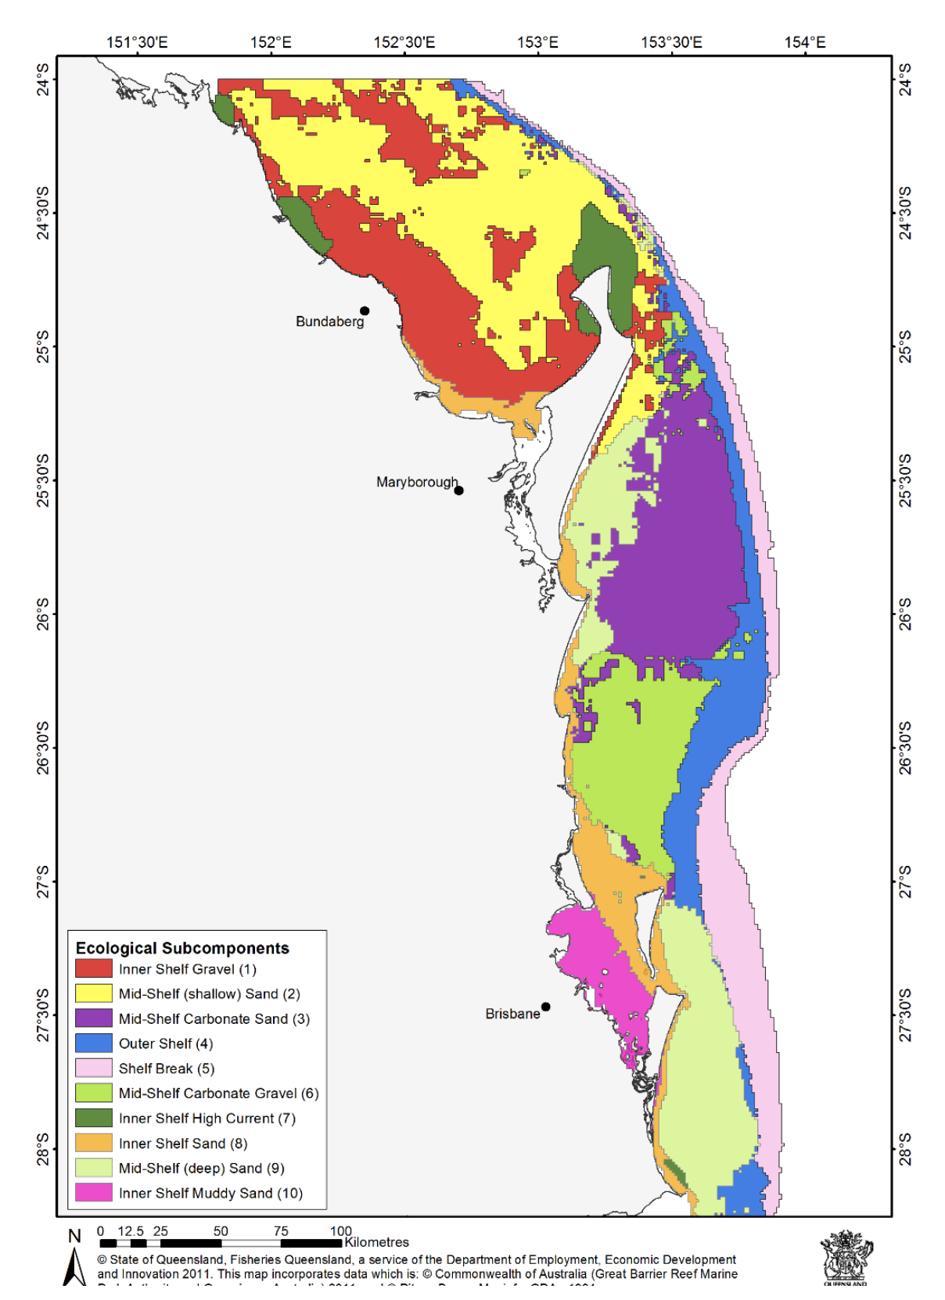
Figure 31. Map of biophysical parameter strata (surrogates) for seabed habitats in the Tweed-Moreton Bioregion (Source: Kenna & Kirkwood, 2008 as cited in Pears et al. 2012).
As an additional step in the ERA identification process, to ensure all potentially impacted habitats were considered, the assessment looked at additional areas in deeper waters of the Marine Park that are open to trawling but outside of the area covered by all 10 habitat types already identified for detailed assessment (i.e. at other areas where the otter trawl fishery is allowed to operate within the GBRMP not already covered by habitats 1 to 10). To do this, 2005 and 2009 otter trawl fishing effort for the region was overlaid on the habitats assessed (Figure 32). As the level of trawl effort was low, habitat type(s) in the area are likely to be at low or negligible risk from trawling, and were therefore not included in that detailed assessment. Other deepwater areas are likely to be occasionally fished, but at current very low effort levels in these habitats they are also likely to be at low or negligible risk from trawling.
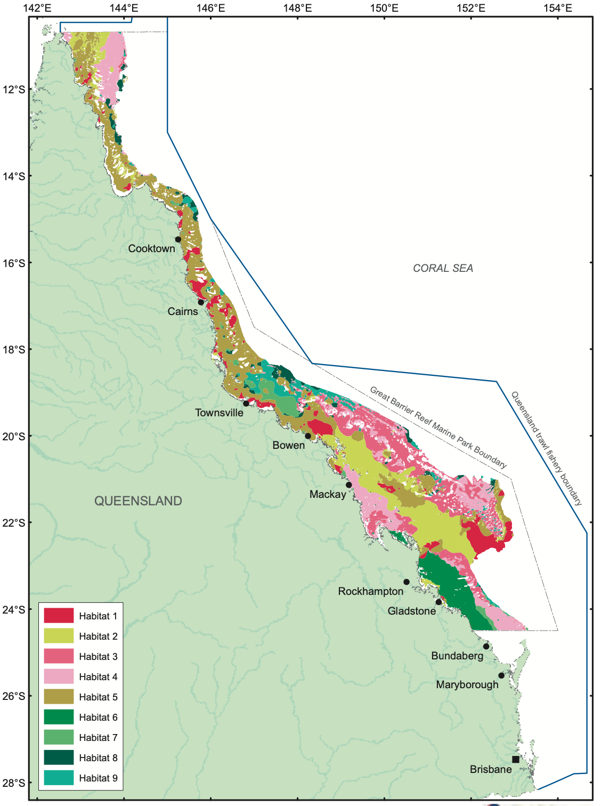
Figure 32. Map of predicted distribution of habitat types 1 to 9 in the Great Barrier Reef Marine Park (Source: (Pitcher et al., 2007))
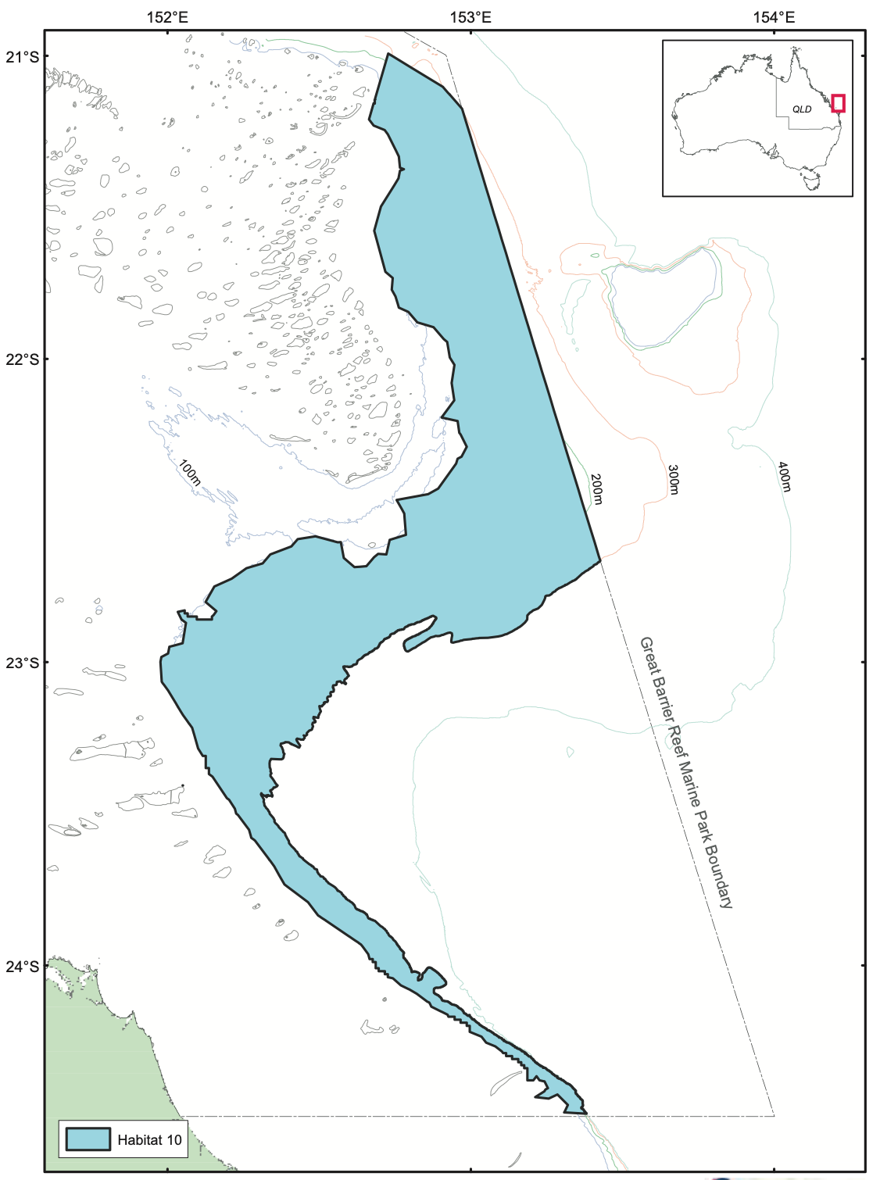
Figure 33. Map showing habitat 10 in the southern Great Barrier Reef Marine Park (Source: (Pitcher et al., 2007))
The habitat types were characterised as follows:
- Habitat 1 represents the most barren seabed type, almost entirely bare (making up about 20% of the habitat area) and bioturbated (>70%) with very little observed biogenic habitat. It is distributed in muddy areas of the inshore and mid-shelf, as well as the deep end of the Capricorn Channel.
- Habitat 2 is also very barren, with some bioturbation (about 20%), 60–70% bare seabed and very little epi-benthos or algae (<1%). It is distributed in muddy–sandy areas of the southern mid-shelf and far north.
- Habitat 3 has significant patches of whip gardens, sponge gardens, gorgonian gardens, alcyonarians, and algae separated by tracts of bare seabed (about 70%). This habitat may also include very small amounts of hard coral gardens, Halimeda and Caulerpa. It is distributed in low mud, higher current areas, primarily in the southern Great Barrier Reef.
- Habitat 4 is similar to habitat 3, but with more algae (about 16%). It also had Halimeda and seagrass. This habitat may also include very small amounts of live reef corals, hard coral gardens, alcyonarians and Caulerpa. Habitat 4 is distributed in low mud, high current areas with higher benthic irradiance, in both the southern and far northern Great Barrier Reef.
- Habitat 5 represents mostly bioturbated (about 40%) and bare seabed (about 40%) with a little algae and seagrass algal habitat and small amounts of whip, sponge and gorgonian gardens, live reef corals, hard coral gardens, Halimeda, alcyonarians and Caulerpa. It is distributed over much of the shelf in central and northern sections of the Great Barrier Reef.
- Habitat 6 represents seagrass (about 30%) and algal (about 10%) habitats with about 10 per cent bioturbated and about 35% bare seabed. May also include very small amounts of whip, sponge, and gorgonian gardens, alcyonarians, and Halimeda. It is distributed along much of the inner half of the shelf in the southern Capricorn section of the Great Barrier Reef.
- Habitat 7 represents patchy seagrass (about 30%) and algal (about 15%) habitat with about 40% bare seabed. It is distributed along the mid-shelf from Cape Upstart
to Innisfail. This habitat also has very small amounts of whip, sponge, and gorgonian gardens, Halimeda, flora (i.e. unidentified marine plants other than Halimeda and Caulerpa), and Caulerpa.
- Habitat 8 represents much of the Halimeda (> 40%) habitat, as well as some other algae (about 20%) and about 12% bare seabed. Other characteristics include small amounts of whip gardens, sponge gardens, seagrass, live reef corals, hard coral gardens, gorgonian gardens, flora (as above), Caulerpa, and bioturbation.
- Habitat 9 represents about 35% patchy algae (including some Halimeda) with about 15% bioturbation and about 35% bare seabed. Other characteristics include small amounts of whip gardens, sponge gardens, seagrass, live reef corals, hard coral gardens, gorgonian gardens, Caulerpa, and alcyonarians. Habitat 9 is distributed primarily in the outer-shelf offshore from Townsville.
- Habitat 10 is an additional habitat type to those defined above from the Seabed Biodiversity Project, and occurs in the southern Great Barrier Reef Marine Park between about 90 and 300 m depths. The area as defined includes part of two bioregions defined for the Great Barrier Reef Marine Park, namely the ‘X8 Southern Embayment’ bioregion (within that depth range) and the southern part of the ‘NU Terraces’ bioregion. Biological characteristics are largely unknown. The seabed sediments in this habitat are reported on Admiralty Charts as coral sand and shell, however this information would have been obtained from limited seabed sampling. There is no detailed knowledge about seabed habitats in the area.

The contact of trawl gear without capture was considered to pose an initial high risk of damage to habitats in the GBR Region. Trawl gear can cause direct physical damage to marine plants and animals on the seabed. Some other activities of the fishery may also impact on habitats; however, these were all assessed as posing a low initial risk. Trawl gear may impact on habitats by removing structural habitat elements such as sponges, which are subsequently discarded. Lost fishing gear (e.g. ground chains, trawl net) is likely to sink, with localised smothering effects on a small area of habitat where it lands, however trawl net will not generally continue ‘ghost’ fishing, and the level of lost or discarded fishing gear in the trawl industry is believed to be relatively low. Boat maintenance and emissions could potentially impact marine plants and animals by contaminating the water column and the seabed with toxic chemicals (e.g. fuel, oil or anti-fouling chemicals), however, the fleet size and amount of chemicals carried is relatively small compared with all shipping activity in the area, and most maintenance is carried out in port or on land. The ERA outcomes and level of overall risk posed by the fishery is presented in Tables 18–20. From Table 21, only habitat 10 was considered high risk in both 2005 and 2009, while habitats 3, 6, 7, 8, and 9 were intermediate-low risk and habitat types 1, 2, 4 and 5 considered low risk (Morison and Pears, 2012).
The assessment of a high risk of serious or irreversible damage within 20 years to habitat 10 was precautionary and partly reflects the lack of biological information for deepwater habitat(s) in the areas fished for eastern king prawns. The certainty in the assigned risk level was low. Risk prone fishery impact factors for habitat 10 arose from lack of spatial knowledge of the habitat, very high effort exposure from trawling (the exposed 53% of area was trawled an average of more than 2.1 times in 2009, contributing to a total indicator of 112% of area exposed to trawl effort), and limited protection under Marine Park zoning (only 13.8%), resulting in a high fishery impact profile.
Table 21. Risk assessment of marine habitats (ordered according to 2009 risk levels) (source: (Morison and Pears, 2012)).
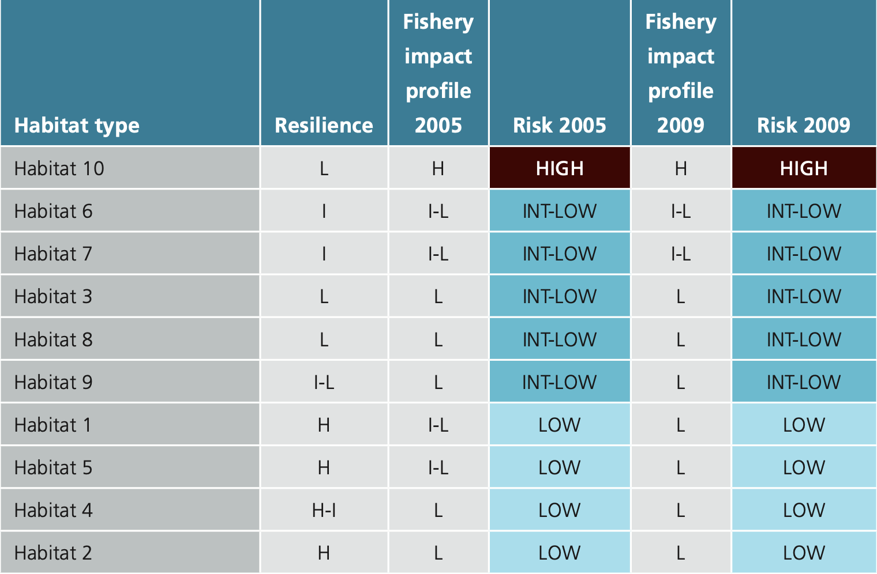
It is important to note that the various types of zones in the GBRMP consider the ecological impacts of different fishing methods, with around 33% of the Marine Park set aside as “no fishing” and a further 33% prohibiting trawling. Therefore, a total of over 66% of waters within the GBRMP are closed to the ECOTF. These zones contribute to the maintenance of ecosystem processes, resilience and biodiversity of the GBR ecosystem. Areas zoned as no-trawl areas are also important for the dependent communities of plants and animals that live there, including the fish stocks that depend on those communities. One habitat type has 20% and all the others had greater than 20% in zones closed to trawling. These protected areas act as a safeguard to ensure that marine habitats in the GBR will not be altered irreversibly by trawling. Additionally, the study confirmed that at least 20% of the 850 species analysed and the 16 species assemblages assessed were protected. Even though 34% of GBR waters are open to trawling, only 7% and 6% of the Marine Park and World Heritage Area were trawled more than once per year in 2005 and 2009, respectively.
The 2018 ERA (Jacobsen et al. 2018) assessed the southern part of the fishery, where there was considerable variability in the amount of available information on community structures, species assemblages, seabed substrata and epibenthic coverage within the sample area. It is important to consider that the 2018 southern region ERA assessment (Jacobsen et al. 2018) is outside the areas of the central zone (UoA); the most recent ERA that encompasses habitats in the central region was performed by Pears et al. (2012).
Detailed information is available on the habitat types of the GBRMP and the impacts of trawling on them (Pitcher et al. 2007) and VMS information provides fine scale information on fishing effort sufficient to detect any increase in risk. The nature, distribution and vulnerability of the main habitat types in the GBRMP are well studied and allow effective strategy to ensure the ECOTF does not reduce habitat structure and function to the point of serious or irreversible harm.

Habitat Management
There are several measures to manage habitat impacts for these UoAs that occur largely within the boundaries of the GBRMP:
- Spatial closures: Trawling is permanently excluded from 66 % of the GBRMP and approximately 42% of the total fishery area (Pears et al. 2012). Closures protect sensitive, representative habitats within the GBRMP, GBR Coastal MP and GSS MP.
- Effort reduction and cap: In the last two decades significant reductions in nominal effort have occurred for the fishery. An effort cap has been established to maintain the fishery at 5% less effort than 1996 levels.
- Gear restrictions: The size and power of vessels and the gear that they trawl with are restricted through legislation. Of particular importance for habitats is the restriction on the weight of chains.
- VMS: all vessels are required to use VMS to ensure compliance with spatial and temporal closures, and to make it easy for compliance officers to know where vessels are when undertaking compliance activity.
- Research: Substantial research activity to evaluate and manage the impacts of the fishery on habitats, particularly within the GBRMP (e.g. Poiner et al, 1999; Pitcher et al, 2007).
Closures within the GBRMP under the GBRMP Zoning Plan are designed to protect at least 20% of each bioregion in the marine park in no-take areas. While these measures in combination with more generic measures such as effort and gear limitations are probably sufficient to ensure that the UoA is unlikely to reduce structure and functions of habitats to the point where there would be serious or irreversible harm, there is insufficient information on the overlap of the fishery with habitats south of the GBRMP at this stage.
Closed areas, effort caps and gear restrictions are all effective management tools that are proven effective in management of habitat impacts, but only when coupled with an appropriate compliance program. The VMS is a critical and effective component of compliance to ensure adherence with closures and efficacy of compliance surveillance. Collectively, these measures form at least a partial strategy. The Seabed Biodiversity Project (Pitcher et al. 2007) provides compelling and objective evidence that the strategy is working to minimise the risk to habitats.

Marine Parks
The fishery operations partly within the Great Barrier Reef Marine Park, Great Sandy Marine Park and World Heritage Area. Zoning restricts trawling to the General Use (Light Blue) Zone in the Great Barrier Reef Marine Park. Zoning incorporates Queensland Government trawl closures in the Habitat Protection (Dark Blue) Zone. Trawling is restricted to the General Use Zone in the Marine Park and occurs in about 7% of the Marine Park area (Grech and Coles 2011).
The Central region of the ECOTF operates from 1 March – end of February but there are extensive seasonal and permanent area closures across the fishery, particularly in waters of the Great Barrier Reef World Heritage Area and Great Sandy MP (QDAF, 2021d). The benthic habitat of the Great Sandy Marine Park is well understood (Figure 35).
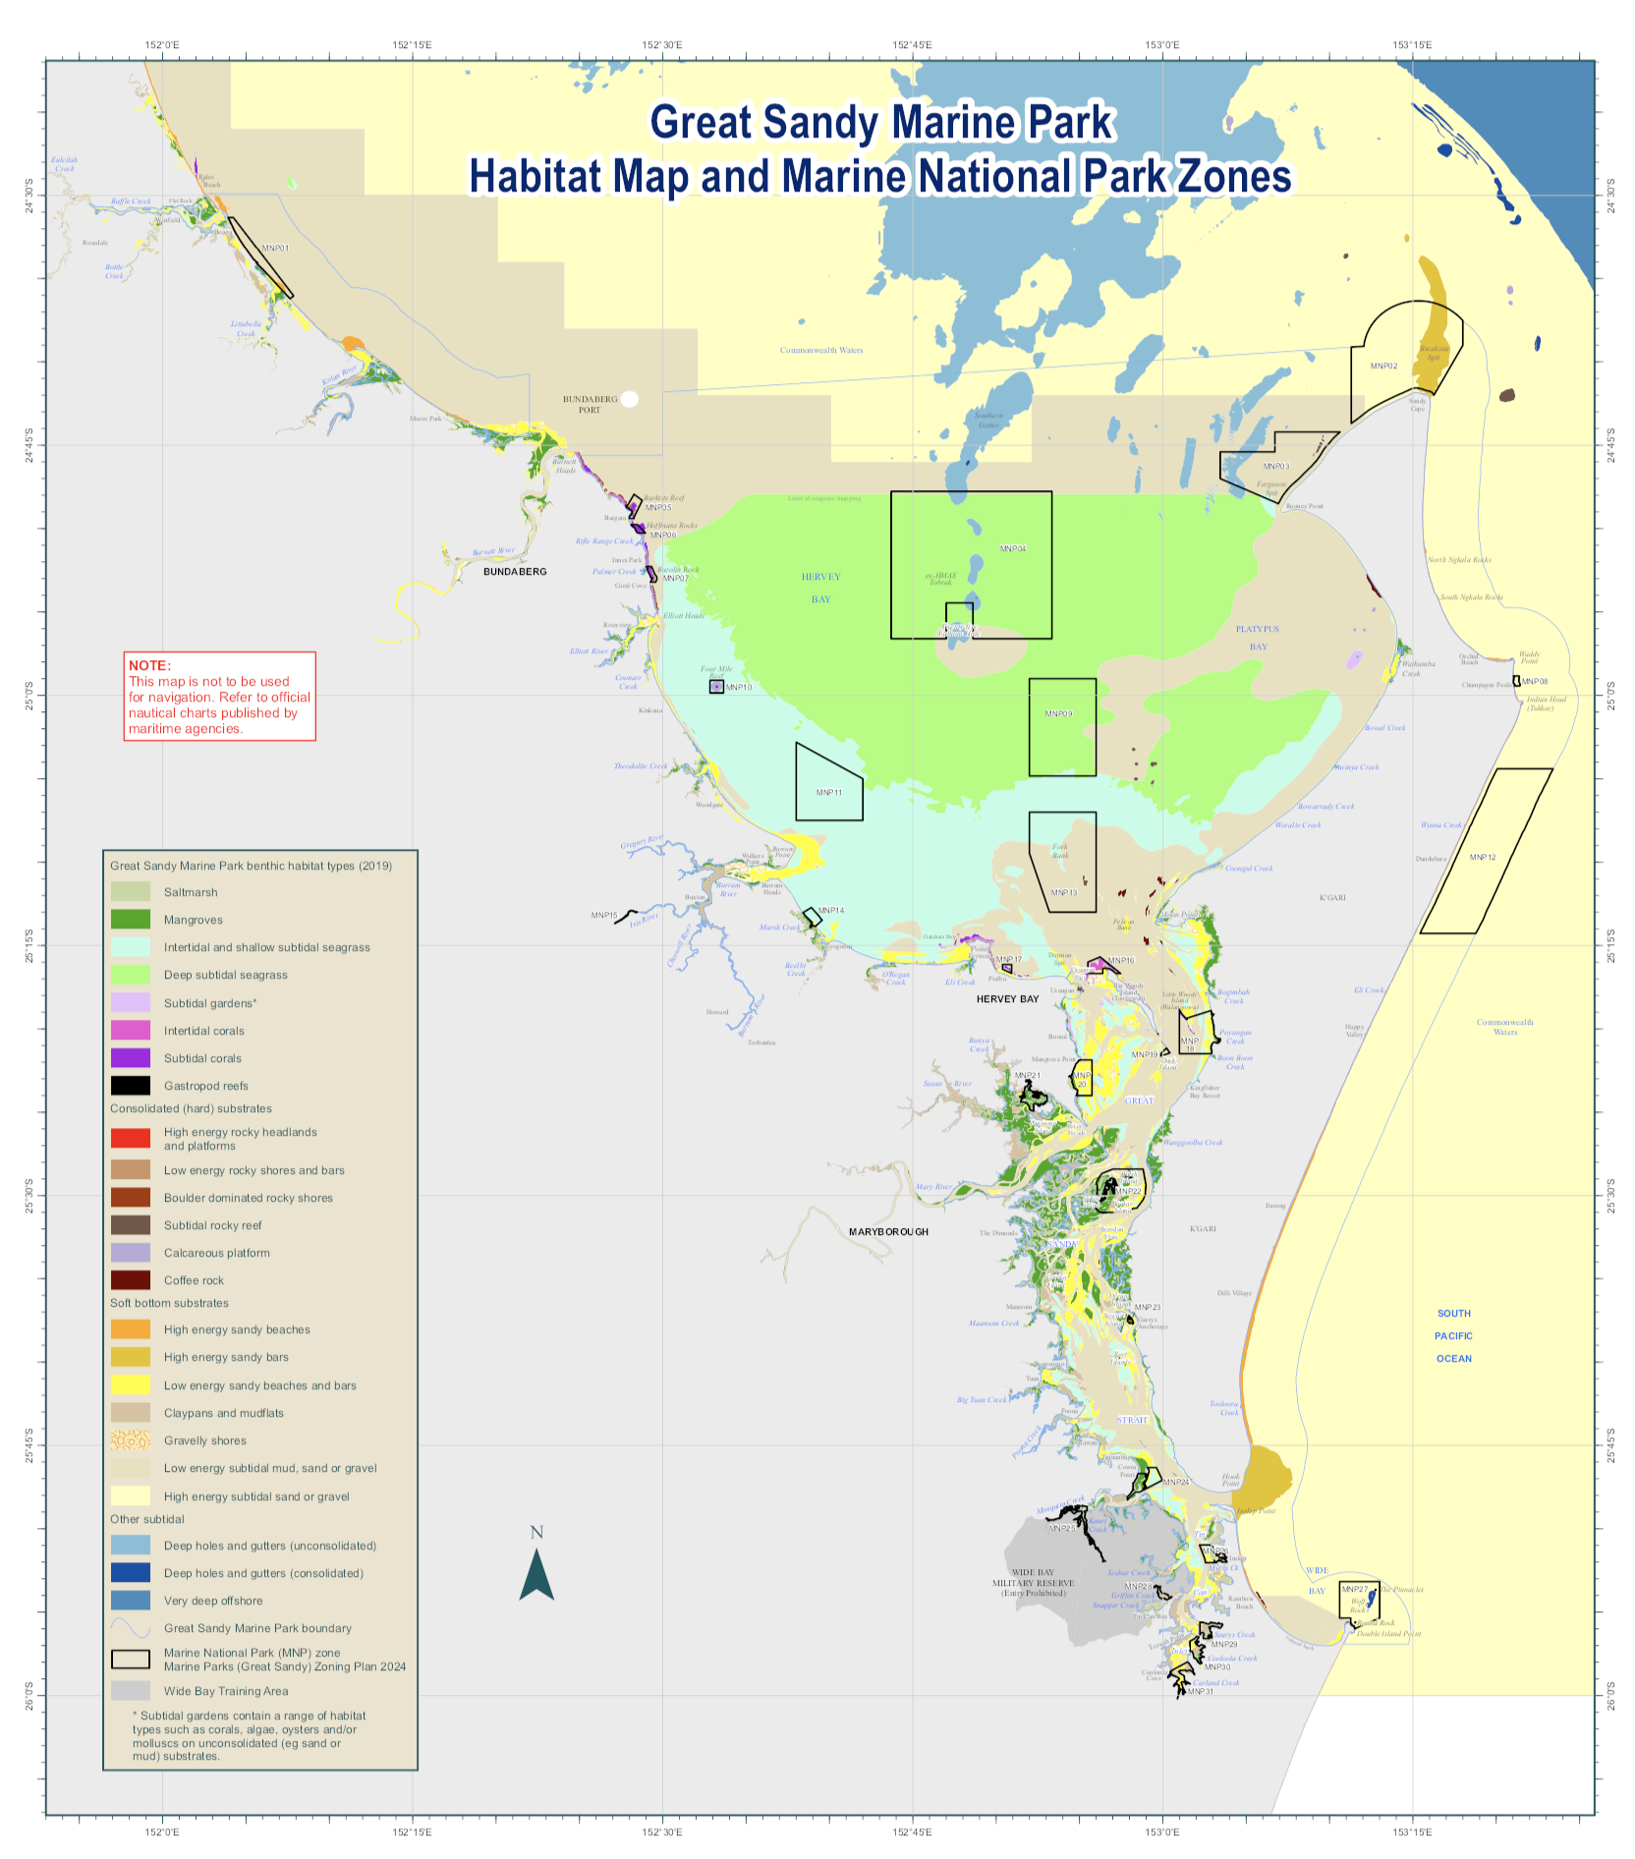
Figure 34. Map showing the benthic habitat types (2019) in the Great Sandy Marine Park (Source: Queensland Parks, 2024)
The ECOTF, like all fisheries operating in the Marine Park, are assessed against the Australian Government’s Guidelines for the Ecologically Sustainable Management of Fisheries and continued operation is approved under the EPBC Act. Closed areas were recently refined in the new Plan for the Great Sandy Marine Park as defined in Figure 36.

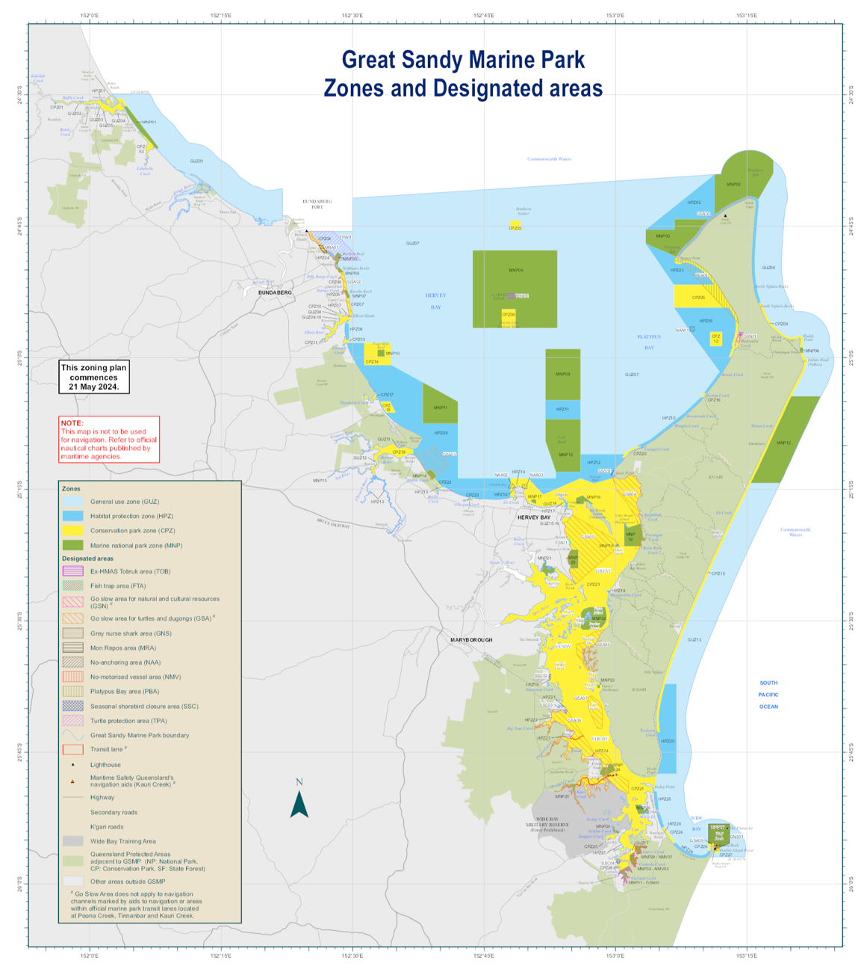
Figure 36. Marine parks and designated zones for the Great Sandy Marine Park (Source: Queensland Parks, 2024)

Ecosystems
Pitcher et al. (2007) provides an excellent basis for understanding the ecosystem and determining measures to assess changes in risk. The region south of the GBR has not been studied to the same level of detail, and additional information on the impact of bycatch reduction devices on ETP and individual species extends the work from the Seabed Biodiversity Project. Together this information is sufficient to assess changes in risk to the ecosystem. Pitcher et al. (2007) provide detailed assessments of the risk of trawling on the GBRMP habitats and associated species assemblages. They also examine the effects of changes in management over time (i.e., effort reductions). Jacobsen, et al., (2018) did not assess risk to the broader ecosystem while Pears, et al., (2012) assessed 14 ecosystem processes that had the potential to be impacted by trawling, all components were assessed as low risk.
The impacts of the ECOTF on the broader ecosystem within the GBRMP was part of the ecological risk assessment (Pears et al. 2012). This assessment considered impacts on specific ecosystem processes: particle feeding, primary production, herbivory, predation, bioturbation, detritivory, scavenging, symbiosis, reef building, competition, connectivity, and species introductions. It concluded that trawling posed a low risk to all these processes.

Pitcher et al. (2007) demonstrated that trawling impacts on habitats and their associated species assemblages were at sustainable levels, and were highly unlikely to be causing serious or irreversible effects to the ecosystem of the GBR. While similar studies have not been conducted in the region south of the GBR, similar reductions in effort have been observed in this region since the late 1990’s and therefore it is considered highly unlikely that the fishery is causing serious or irreversible harm to the ecosystem. Notably, there have been several quantitative studies on the impacts of trawl bycatch reduction devices in this region (Courtney et al. 2007) that provide additional confidence that these gear modifications further reduce the impact of trawling on individual species, species assemblages and ETPs.

Ecosystem Management
There are a number of management measures that comprise the management strategy for ecosystems.
- Spatial and temporal closures: Trawling is permanently excluded from 66.2% of the GBRMP and approximately 42% of the total ECOTF area (Pears et al. 2012). Substantial spatial closures outside of the GBR also exist, as well as some seasonal closures and daytime trawling bans.
- Effort reduction and cap: In the last two decades significant reductions in nominal effort have occurred for the fishery; an effort cap has been established to maintain the fishery at 5% less effort than 1996 levels.
- Bycatch reduction devices: The use of BRDs and TEDs of particular specifications is mandatory. These devices are particularly important for turtle and sawfish exclusion. Fish eye devices have been demonstrated to significantly reduce capture of sea-snakes and have been recently made mandatory in regions with the highest levels of sea-snake interaction.
- Logbook data collection of interactions: fishers are required by law to record interactions with ETP species. While it is likely these data are under-represented, they do provide a useful insight into potential changes in interactions levels with ETP species.
- Substantial research activity to evaluate and manage the impacts of the fishery on the ecosystem (e.g. Poiner et al, 1999; Pitcher et al, 2007).

Collectively these measures constitute at least a partial strategy which is expected to restrain impact of the UoA on the ecosystem.

The harvest strategies for each of the ECOTF fishing regions also contain a set of decision rules for minimising and mitigating high ecological risks arising from fishing related activities. All five regional harvest strategies have the same two rules, these are:
- If an ERA identifies fishing impacts that are considered to generate an undesirable level of risk to any secondary or bycatch species’ populations, (i.e. high risk) a review is triggered to investigate the reason for the increased risk. Appropriate management action should be taken to reduce the risk to an acceptable level.
- If the “Region” trawl footprint in any given year is greater than the 2019 footprint, then undertake a review to identify appropriate management strategies to reduce the risk including options that reduce the area trawled.

Principle 2 References:

Australian Institute of Marine Science (AIMS) (2024): Seabed biodiversity on the continental shelf of the Great Barrier Reef World Heritage Area (CRC-Reef Task Number: C1.1.2). Australian Institute of Marine Science (AIMS).dataset.
https://researchdata.edu.au/seabed-biodiversity-continental-number-c112/1376420

Bio-inspecta (2023) Australia east coast king prawn fishery Marine Stewardship Council Public Certification Report 23 June 2023. Report available at https://fisheries.msc.org/en/fisheries/australia-east-coast-king-prawn/ accessed 1 February 2024.

Braccini, J.M., O’Neill, M.F., Campbell, A.B., Leigh, G.M., Courtney, A.J., Walters, C., (2012). Fishing power and standardized catch rates: implications of missing vessel-characteristic data from the Australian eastern king prawn (Melicertus plebejus) fishery. Can. J. Fish. Aquat. Sci. 69, 797–809. https://doi.org/10.1139/f2012-023

Brewer, D., Heales, D., Milton, D., Dell, Q., Fry, G., Venables, B. & Jones, P. (2006). The impact of turtle excluder devices and bycatch reduction devices on diverse tropical marine communities in Australia's northern prawn trawl fishery. Fisheries Research 81, 176-188.

Campbell, M. J., Officer, R.A., Prosser, A.J., Lawrence, M.J., Drabsch, S.L. and Courtney, A. J. (2010) Survival of graded scallops Amusium balloti in Queensland's (Australia) trawl fishery. Journal of Shellfish Research, 29 (2):373-380. ISSN 0730-8000 Available at: https://era.daf.qld.gov.au/id/eprint/1806/

Campbell, M. J., Courtney, A. J., Wang, N., McLennan, M. F., and Zhou, S. (2017) Estimating the impacts of management changes on bycatch reduction and sustainability of high-risk bycatch species in the Queensland East Coast Otter Trawl Fishery: FRDC Final Report Project number 2015/014, Brisbane, Queensland. CC BY 3.0 Available at: https://era.daf.qld.gov.au/id/eprint/9354/1/Estimating%20impacts%20of%20management%20changes%20on%20bycatch%20reduction_2017_campbell.pdf

Campbell, M.J (2022) Assessing ecological risk posed to common rays by prawn trawling. PhD Thesis, James Cook University. Access to this file is available from: https://doi.org/10.25903/yphx%2Dyk52

Chan, JT (2015). Genetic analysis of the geographic structure of Australian eastern king prawns, Penaeus (Melicertus) plebejus, and implications for stock enhancement. PhD thesis. Sydney: University of NSW, 240 p.

Connolly, R. M., Cronin, E. R. & Thomas, B. E. (2001). Trawl Bycatch of Syngnathids in Queensland: Catch Rates, Distribution and Population Biology of Solegnathus Pipehorses (Seadragons). Gold Coast: School of Environmental and Applied Sciences, Griffith University.

Courtney, A., Campbell, M., Roy, D., Tonks, M., Chilcott, K., & Kyne, P. (2008). Round scallops and square meshes: a comparison of four codend types on the catch rates of target species and by- catch in the Queensland (Australia) saucer scallop (Amusium balloti) trawl fishery. Marine and Freshwater Research, 849–864 .

Courtney, A.J., M.J. Campbell, M.L. Tonks, D.P. Roy, S.W. Gaddes, J.A. Haddy, P.M. Kyne, D.G. Mayer, & K.E. Chilcott (2014)
Effects of bycatch reduction devices in Queensland's (Australia) deepwater eastern king prawn (Melicertus plebejus) trawl fishery,
Fisheries Research, 157: 113–123.

Courtney, A.J., Haddy, J.A., Campbell, M.J., Roy, D.P., Tonks, M.L., Gaddes, S.W., Chilcott, K.E., O'Neill, M.F., Brown, I.W., McLennan, M., Jebreen, J.E., van der Geest, C., Rose, C., Kistle, S., Turnbull, C.T., Kyne, P.M., Bennett, M.B. and Taylor, J. (2007) Bycatch weight, composition and preliminary estimates of the impact of bycatch reduction devices in Queensland's trawl fishery. Queensland.

Courtney, A.J., B.L. Schemel, R. Wallace, M.J. Campbell, D.G. Mayer and B. Young (2010) Reducing the impact of Queensland's trawl fisheries on protected sea snakes Report to the Fisheries Research and Development Corporation Project No. 2005/053, The State of Queensland, Department of Employment, Economic Development and Innovation, Department of Primary Industries and Fisheries. Brisbane, Queensland. pp: 307. https://era.daf.qld.gov.au/id/eprint/3709/1/BycatchFinalReport2007-FullReport.pdf

Courtney, A.J., C. M. Spillman, R. Lemos, J. Thomas , G. M. Leigh and A. B. Campbell. (2015) Physical oceanographic influences on Queensland reef fish and scallops Final Report FRDC 2013/020 December 2015 Available at: https://era.daf.qld.gov.au/id/eprint/5028/1/Final%20Report%202013-020%20Physical%20oceanographic%20influences%20on%20Queensland%20reef%20fish%20and%20scallops.pdf

Courtney, A.J., Tonks, M.L., Campbell, M.J., Roy, D.P., Gaddes, S.W., Kyne, P.M. and O'Neill, M.F. (2006) Quantifying the effects of bycatch reduction devices in Queensland's (Australia) shallow water eastern king prawn (Penaeus plebejus) trawl fishery. Fish Res. 80(2–3): 136–147 https://era.daf.qld.gov.au/id/eprint/752/

Courtney, A. J., Leigh, G. M., Yang, W.-H., Campbell, M. J. and McLennan, M. F. (2022) Estimating the natural mortality rate of saucer scallops (Ylistrum balloti) on the Queensland east coast from tag-recaptures. Fisheries Research, 250 . p. 106273. ISSN 0165-7836 https://era.daf.qld.gov.au/id/eprint/8571/

Dedini, E., I. Jacobsen and J. Zieth (2023) East Coast Otter Trawl Fishery Ecological Risk Assessment Species of Conservation Concern. Technical Report. Fisheries Queensland, Department of Agriculture and Fisheries. Available at Accessed 15 Feb 2024.

Dedini E. and I. Jacobsen (2023) ECOTF Scoping Study. Fisheries Queensland, Department of Agriculture and Fisheries. Available at
https://era.daf.qld.gov.au/id/eprint/9572/1/East%20Coast%20Otter%20Trawl%20Fishery%20Scoping%20Study%20FINAL.pdf

Department Agriculture, Water and the Environment. (2021). Assessment of the Queensland East Coast Otter Trawl Fishery. Canberra: Department of Agriculture, Water and Environment. https://www.dcceew.gov.au/sites/default/files/documents/qld-east-coast-otter-trawl-assessment-2021.pdf

Department of Employment, Economic Development and Innovation. (2012). Annual Status Report 2011 East Coast Otter Trawl Fishery. Brisbane: Department of Employment, Economic Development and Innovation. Retrieved from https://www.daf.qld.gov.au/__data/assets/pdf_file/0005/66938/ASR_ECOTF2011.pdf

Dodt, N. (2005). Fisheries Long Term Monitoring Program: Syngnathids in the East Coast Trawl Fishery: a review and trawl survey. Department of Primary Industries, Queensland. https://era.daf.qld.gov.au/id/eprint/6433/

Fox, A. R., Lovett, R. A., Wickens, M. E. and Hillcoat, K. B. (2023a) Stock assessment of Queensland east coast red spot king prawns (Melicertus longistylus), Australia, with data to December 2021. Technical Report. State of Queensland, Brisbane.

Fox, A. R., Lovett, R. A., Wickens, M. E. and Hillcoat, K.B. (2023b) Stock assessment of Queensland east coast endeavour prawns (Metapenaeus endeavouri and Metapenaeus ensis), Australia, with data to December 2021.Technical Report. State of Queensland, Brisbane.

French, S. M. (2023) Stock Assessment of Ballot's saucer scallop (Ylistrum balloti) in Queensland, Australia, with data to October 2022. Technical Report. State of Queensland, Brisbane. Available at: https://era.daf.qld.gov.au/id/eprint/9458/ Accessed 4 March 2024.

Fry, G., Laird, A. and Lawrence, E. (2021) Monitoring interactions with bycatch species using crew- member observer data collected in the Northern Prawn Fishery: 2017 – 2019. Final Report to AFMA; R2017/0835. June 2021. CSIRO, Australia. Pp. 236.

Grech, A., & Coles, R. (2011). Interactions between a Trawl Fishery and Spatial Closures for Biodiversity Conservation in the Great Barrier Reef World Heritage Area, Australia. PloSOne, E 6(6): e21094.,

Harry, A.V. (2011). Life histories of commercially important tropical sharks from the Great Barrier Reef World Heritage Area. PhD thesis. James Cook University, Queensland, Australia.

Helmke, S, Jebreen, E, McGilvray, J, O’Neill, M, Roelofs, A, Roy, D, Wortmann, J & Heaven, C, 2021. Stock assessment of Ballot’s saucer scallops (Ylistrum balloti) in Queensland, Australia.

Jacobsen, I., Zeller, B., Dunning., M., Garland., A., Courtney, T., Jebreen, E., 2018. An ecological risk Assessment of the southern Queensland east coast otter trawl fishery and river and inshore beam trawl fishery. Queensland Department of Agriculture and Fisheries, Queensland Australia. Available at: https://www.daf.qld.gov.au/__data/assets/pdf_file/0004/1402672/Sth-QLD-Trawl-ERA-Final.pdf

Kangas, MI, Sporer, EC, Hesp, SA, Travaille, KL, Brand-Gardner, SJ, Cavalli, P and Harry, AV (2015), Shark Bay Prawn Managed Fishery, Western Australian Marine Stewardship Council Report Series, 2: 294 pp.

Kangas M, Chandrapavan A, Wilkin Sand Caputi N (2022) Recovery trajectories and management responses for three scallop stocks over ten years following an extreme marine heatwave in Western Australia. Front. Clim. 4:104

Kenna, E. & Kirkwood, J. (2008). Seabed Biodiversity of the Tweed-Moreton Bioregion Phase 1. Unpublished Report to Burnett-Mary Regional Group. Project Number: PA0165, July 2008. Queensland Department of Primary Industries and Fisheries. 64 p.

Kyne, P.M., (2008). Chondrichthyans and the Queensland East Coast Trawl Fishery. University of Queensland, Australia.

Kyne, P., Courtney, A., Campbell, M., Chilcott, K., Gaddes, S., Turnbull, C., Van Der Geest, C. and Bennett, M. (2002) An overview of the elasmobranch bycatch of the Queensland East coast trawl fishery (Australia). Northwest Atlantic Fisheries Organisation NAFO SCR Document. 2(00): 97

Kyne, P.M., Heupel, M.R., White, W.T. and Simpfendorfer, C.A. (2021). The Action Plan for Australian Sharks and Rays 2021. National Environmental Science Program, Marine Biodiversity Hub, Hobart. Available at: https://www.nespmarine.edu.au/system/files/Shark_Action_Plan_FINAL_Sept7_2021_WEB_RGB.pdf

Last P.R. and Stevens J.D. (2009) Sharks and Rays of Australia. 2nd Ed. Australia: CSIRO Publishing, Hobart, Australia.

McPhee, DP. (2022a). Assessment of Bycatch in Vessels Operated by the Australian Ocean King Prawn Company in the Deepwater Prawn Trawl Fishery. Report for industry. Available on from Bio-Inspecta (2023) upon request.

McPhee, DP. (2022b). Characterisation of the Seabed in the Deepwater Eastern King Prawn Fishery Accessed by the Australian Ocean King Prawn Company. Report for industry. Available on from Bio-Inspecta (2023) upon request.

Morison, A.K., Pears, R.J., (2012). Assessment of the ecological vulnerability of the East Coast Otter Trawl Fishery to Climate Change. Great Barrier Reef Marine Park Authority Assessment_ecological_vulnerability_ECOTF_climate_change.pdf

O’Neill, M., Leigh, G., Wang, Y.-G., Braccini, J., Ives, M., (2014). Linking spatial stock dynamics and economics: evaluation of indicators and fishery management for the travelling eastern king prawn (Melicertus plebejus). ICES J. Mar. Sci. 71, 1818–34.

O'Neill, M. F., Yang, W.H., Wortmann, J., Courtney, A. J., Leigh, G. M., Campbell, M. J. and Filar, J. (2020) Stock predictions and population indicators for Australia's east coast saucer scallop fishery. Project Report. FRDC. https://era.daf.qld.gov.au/id/eprint/7444/

Pears, R.J., Morison, A.K., Jebreen, E.J., Dunning, M.C., Pitcher, C.R., Courtney, A.J., Houlden, B. and Jacobsen, I.P. (2012) Ecological risk assessment of the East Coast Otter Trawl Fishery in the Great Barrier Reef Marine Park: Technical report. Great Barrier Reef Marine Park Authority. Townsville, Queensland. pp: 263.
http://elibrary.gbrmpa.gov.au/jspui/bitstream/11017/1148/1/ECOTF_ERA_Technical_web.pdf

Peverell SC (2009) Sawfish (Pristidae) of the Gulf of Carpentaria, Queensland, Australia. MSc Dissertation, James Cook University, Townsville.

Pitcher, C.R., Doherty, P., Arnold, P., Hooper, J., Gribble, N., Bartlett, C., Browne, M., Campbell, N., Cannard, T., Cappo, M., Carini, G., Chalmers, S., Cheers, S., Chetwynd, D., Colefax, A., Coles, R., Cook, S., Davie, P., De’ath, G., Devereux, D., Done, B., Donovan, T., Ehr, G., 2007. Seabed biodiversity on the continental shelf of the Great Barrier Reef World Heritage Area, Australian Institute of Marine Science, CSIRO, Queensland Museum, Queensland Department of Primary Industries & CRC Reef Research Centre, task final report, CSIRO.

Pitcher, C.R., Ellis, N., Althaus, F., Williams, A., McLeod, I., Bustamante, R., Kenyon, R., Fuller, M., 2016. Implications of current spatial management measures for AFMA ERAs for habitats - FRDC Project No 2014/204, CSIRO Oceans & Atmosphere, Brisbane. https://doi.org/577.770994

Poiner, I. R., Glaister, J., Pitcher, C. R., Burridge, C., Wassenberg, T. J., Gribble, N., Hill, B. J., Blaber, S. J. M., Milton, D., Brewer, D. & Ellis, J. R. (1998). The environmental effects of prawn trawling in the far northern section of the Great Barrier Reef: 1991–96. Final Report to GBRMPA and FRDC. CSIRO Division of Marine Research – Queensland Department of Primary Industries Report. https://www.frdc.com.au/project/1993-096

QDAF (2021) Trawl fishery (southern inshore) harvest strategy: 2021–2026. Queensland Department of Agriculture and Fisheries, State of Queensland, Australia. Available at https://www.publications.qld.gov.au/ckan-publications-attachments-prod/resources/25136e07-b01d-4809-b27d-34f6c9b24976/southern-inshore-trawl-region-harvest-strategy.pdf?ETag=f72bdd36e470a5c00ad281623d45c048 Accessed 1 March 2024.

QDAF (2021b) Status report for reassessment and approval under protected species and export provisions of the Environment Protection and Biodiversity Conservation Act 1999 (EPBC Act) https://www.dcceew.gov.au/sites/default/files/env/consultations/e1ba225f-3edc-4f76-b93e-bb8cc69b0939/files/qld-east-coast-trawl-fishery-submission-2021.pdf

QDAF (2021c) Trawl fishery (southern offshore A and B regions) harvest strategy: 2021–2026. Queensland Department of Agriculture and Fisheries, State of Queensland, Australia. Available at https://www.publications.qld.gov.au/ckan-publications-attachments-prod/resources/b23ffab7-c4b0-4441-b4f4-0ef040208f2a/southern-offshore-trawl-region-harvest-strategy.pdf?ETag=84ba013db7f40f491c7f203f04e47556 Accessed 1 March 2024.
QDAF (2021d) Trawl fishery (central) harvest strategy: 2021–2026. Queensland Department of Agriculture and Fisheries, State of Queensland, Australia. Available at https://www.publications.qld.gov.au/ckan-publications-attachments-prod/resources/b0d530dc-34ba-4dd7-9109-b79f3a785203/central-trawl-region-harvest-strategy.pdf?ETag=46f5f6a23c974621e5c8428a0cc56942
QDAF (2022) Queensland fisheries summary report Fisheries catch and effort data https://www.daf.qld.gov.au/__data/assets/pdf_file/0004/1423831/queensland-fisheries-summary-report.pdf

Richards, R.G., A.T. Davidson, J. Meynecke, K. Beattie, V. Hernaman, T. Lynam, and I. E. van Putten (2015) Effects and mitigations of ocean acidification on wild and aquaculture scallop and prawn fisheries in Queensland, Australia, Fisheries Research, 161: 42–56.

Richardson, K., R. Gunn, C. Wilcox, B.D. Hardesty (2018) Understanding causes of gear loss provides a sound basis for fisheries management Marine Policy 96:278-84

Rigby, C.L., White, W.T. and Simpfendorfer, C.A. (2016) Deepwater chondrichthyan bycatch of the eastern king prawn fishery in the southern great barrier reef, Australia. PLoS ONE. 11(5): e0156036
Robins-Troeger, J.B. (1994) Evaluation of the Morrison soft turtle excluder device: prawn and bycatch variation in Moreton Bay, Queensland. Fisheries Research 19 (3), 205-217.
Robins-Troeger, J.B., Buckworth, R.C., and Dredge, M.C.L. (1995) Development of a trawl efficiency device (TED) for Australian prawn fisheries. II. Field evaluations of the AusTED. Fisheries Research 22 (1–2), 107-117.
Simpfendorfer, C., Chin, A., Rigby, C., Sherman, S., White, W. (2019) Shark futures: a report card for Australia’s sharks and rays’, Centre for Sustainable Tropical Fisheries and Aquaculture, James Cook University Available at: https://www.frdc.com.au/sites/default/files/products/2013-009-DLD.pdf

Wang, N. (2015). Sustainability and optimality in fisheries management. PhD thesis. The University of Queensland.

Wang, N., Courtney, A. J., Campbell, M. J., and Yang, W.-H. (2020) Quantifying long-term discards from Queensland’s (Australia) east Coast otter trawl fishery. ICES Journal of Marine Science, 77: 680–691. doi:10.1093/icesjms/fsz205 Available at: https://academic.oup.com/icesjms/article/77/2/680/5644309 Accessed 2 March 2024

Welch, David & Saunders, Thor & Robins, Julie & Harry, Alastair & Johnson, Johanna & Maynard, Jeffrey & Saunders, Richard & Pecl, Gretta & Sawynok, Bill & Tobin, Andrew. (2014). Implications of climate change impacts on fisheries resources of northern Australia. Part 1: Vulnerability assessment and adaptation. FRDC Project 2010/565

Wortmann, J. (2021). Stock Assessment of Ballot’s saucer scallop (Ylistrum balloti) in Queensland. Brisbane, Australia: Department of Agriculture and Fisheries. /https://era.daf.qld.gov.au/id/eprint/8091/

Wortmann, J. (2022). Stock Assessment of Ballot’s saucer scallop (Ylistrum balloti) in Queensland, Australia. Brisbane, Australia: Department of Agriculture and Fisheries. https://era.daf.qld.gov.au/id/eprint/8472/

Yang, W., Wortmann, J., Robins, J., Courtney, A., O'Neill, M., & Campbell, M. (2016). Quantitative assessment of the Queensland saucer scallop (Amusium balloti) fishery. Brisbane: Department of Agriculture and Fisheries. https://era.daf.qld.gov.au/id/eprint/5478/

Principle 2 Performance Indicator scores and rationales

In-scope Species

PI 2.1.1 – In-scope species outcome
PI 2.1.1 |  | The UoA aims to maintain in-scope species above the PRI and does not hinder recovery of in-scope species if they are below the PRI
Scoring issue |  | SG 60 | SG 80 | SG 100
a | Main in-scope species stock status
a | Guide post | Main in-scope species are likely to be above the PRI.  or  If the species is below the PRI, it is likely that the UoA does not hinder recovery and rebuilding. | Main in-scope species are highly likely to be above the PRI.  or  If the species is below the PRI, there is evidence of recovery, or it is highly likely that the UoA does not hinder recovery and rebuilding. | There is a high degree of certainty that main in-scope species are fluctuating around a level consistent with MSY.
a | Met? | WKP– yes | WKP – no | Not scored
a | Met? | Discard species – No | Discard species – No | Not scored
Rationale |  | On 1 November 2021, the Scallop fishery closed in the central region. As such, at the time of this assessment, Scallop is not considered a main in-scope species although further information is required to determine the level of scallop bycatch/discards exists and the survivability from the otter trawl gear following being discarded.  Western King Prawn (WKP)  There is no recent stock assessment and the point at which recruitment would become impaired has not been explicitly determined. Unlike other species, reference points are not used for this stock. Current catch rates are compared to historical catch ranges as a means of assessing stock status and the latest SAFS lists the species as not overfished.  SG 60 is met as WKP is likely to be above PRI, although without further information SG 80 is not met for WKP.  Discard species:  There is no stock status data available for the common discard species. ERA data provides an overview of the studies conducted in the ECOTF.  The latest (2021) WTO assessment requested the used of an indicator species for monitoring discards; an indicator species has not been chosen.  Version 3 of the MSC Fisheries Standard includes updates to the Risk-Based Framework to ensure it delivers precautionary and robust outcomes. The used of an RBF for each discard species is required.
b | Minor in-scope species stock status
b | Guide post |  |  | Minor in-scope species are highly likely to be above the PRI.  or  If below the PRI, there is evidence that the UoA does not hinder the recovery and rebuilding of minor in-scope species.
b | Met? |  |  | Not scored
Rationale

Draft scoring range | < 60
Information gap indicator | Western king prawn: stock structure in Queensland. No including in HS and as such no TRP are applicable.  Discards: Species composition of discards by volume/number is lacking.  RBF required for discard species that may make up more than 5% of the total catch.  Scallop: The fishery is closed to scallops although data on level of incidental catch of scallops discarded suggests that ## t is discarded from the UoA each year. Survivability of discards including scallops from the UoA needs to be further understood.  A formal recovery plan for scallops lacking. There is a lack of understanding if 8 years (2 generations) to meet biomass of 40% will be a part of formal recovery plan. Stock is below PRI, and clarification required to ensure incidental catches and discards in the UoA are not impacting rebuilding.

PI 2.1.2 – In-scope species management strategy
PI 2.1.2 |  |  | There is a strategy in place that is designed to maintain or to not hinder rebuilding of in-scope species
Scoring issue |  |  | SG 60 | SG 80 | SG 100
a |  | Management strategy in place
 |  | Guide post | There are measures in place for the UoA, if necessary, that are expected to maintain or to not hinder rebuilding of the main in-scope species at/to the in-scope species outcome SG60 level. | There is a partial strategy in place for the UoA, if necessary, that is expected to maintain or to not hinder rebuilding of the main in-scope species at/to the in-scope species outcome SG80 level.  or  Where in-scope species outcome fails to meet the SG80, a demonstrably effective strategy is in place between all MSC UoAs that categorise this species as main in-scope to ensure that they collectively do not hinder recovery and rebuilding. | There is a strategy in place for the UoA for managing main and minor in-scope species at the in-scope species outcome SG80 level.
 |  | Met | WKP – yes | WKP– no
 |  | Met | Discard species – no | Discard species – no
Rationale |  |  | Western King Prawn (WKP)  In 2022, 58 t of WKP was taken by the central trawl region (UoA) compared to 183 t in 2020. There are no species specific measures in place for the WKP and the ECOTF. However, measures aimed at other species would afford some protection to the WKP stock.  Measures in the UoA that would ensure WKP is at least the SG60 in 2.1.1 a (outcomes) include:  - Annual closures  - Pre-trip notices  Commercial fishers must give a pre-trip notice before they commence a fishing operation, or if any details have changed since they last submitted a pre-trip notice.  - Logbooks  Fishers are required to report retained species, effort and fishing location in daily logbooks;  - Spatial closures: Trawling is permanently excluded from 66 % of the GBRMP and approximately 42% of the total fishery area (Pears et al. 2012). Closures protect sensitive, representative habitats within the GBRMP, MBMP and GSS MP.  - Effort reduction and cap: In the last two decades significant reductions in nominal effort have occurred for the fishery. An effort cap has been established to maintain the fishery at 5% less effort than 1996 levels. FishNet lists current the effort cap units, usage and dates  - Gear restrictions: The size and power of vessels and the gear that they trawl with are restricted through legislation. Of particular importance for habitats is the restriction on the weight of chains.  - VMS: all vessels are required to use VMS to ensure compliance with spatial and temporal closures, and to make it easy for compliance officers to know where vessels are when undertaking compliance activity.  It is necessary to consider the term “if necessary” and the Guidance for this PI: “If the UoA has no, or negligible (see SA3.1.1.e) impact on this component, the team does not need to score scoring issue (a) for SG60 and SG80.” Although the UoA catch of WKP makes up a very small proportion of the total WKP catch (Figure 30), it was not considered “negligible” given that stock boundaries and structure remains unclear.  Given the above, WKP taken from the Central region fall outside the remit of ECOTF harvest strategies. As the fishery transitions away from Saucer Scallops (to allow rebuilding), it is reasonable to presume that WKP will play a significant part of the UoA in the future. As WKP from the Central region is not included in the harvest strategy, SG 80 is not met.  Discard species  The HS for the UoA does not mention discard species; instead it mentions retained species (Tier 1, Tier 2 and Tier 3 species) or those species identified as high risk in the ERA process. Reporting discards is not required (except Saucer Scallops) and independent monitoring is irregular (usually associated with testing gear modifications). The RBF process for commonly discarded species (as identified by the ERA etc.) will be required as there is no management in place. There is no formal discard/bycatch workplan for the fishery. SG 60 is not met.
b | Management strategy effectiveness
b | Guide post |  | The measures, if necessary, are considered likely to work for the main in-scope species, based on plausible argument. | There is some evidence that the measures/partial strategy, if necessary, is achieving the objectives for main in-scope species set out in scoring issue (a), based on some information directly about the UoA and/or species involved. | There is evidence that the partial strategy/strategy is achieving the objectives set out in scoring issue (a), based on information directly about the UoA and/or species involved.
b | Met? |  | WKP - yes | WKP – no
b |  |  | Discard species - no | Discard species – no
Rationale |  |  | Western King Prawn (EKP)  The general measures outlined at 2.2.1 (a) above are likely to work for WKP in the UoA as the bulk of WKP stock is outside of the fishing area; SG 60 is met. WKP taken from the central region are not covered by the HS and it is reasonable to presume that WKP will play a significant part of the UoA whilst Scallop target fishing is closed. Given there is no management measures for WKP in the central region SG 80 is not met.  Discard species  Given that discards make a high proportion of the total catch measures are necessary. BRDs are mandatory in the fishery. There are no other measures specific to discarding and there is no formal discard/bycatch workplan for the fishery. Measures aimed at other components of the fishery would incidentally reduce catches of some species (effort reductions, VMS, gear restrictions, use of BRDs, closures etc.) although there are no measures directly in place to monitor changes in species composition, abundance or impact to discard species SG 60 is not met.
c | Review of alternative measures
c | Guide post |  | There is a review of alternative measures to minimise UoA-related mortality of unwanted catch of main in-scope species | There is a review at least once every 5 years of alternative measures to minimise UoA-related mortality of unwanted catch of main in-scope species and they are implemented, as appropriate. | There is a review that happens every 2 years of alternative measures to minimise UoA-related mortality of unwanted catch of all in-scope species, and they are implemented, as appropriate.
c | Met? |  | WKP - yes | WKP – no | Not scored
c |  |  | Discard species -yes | Discard species – no | Not scored
Rationale |  |  | Western King Prawn (WKP)  The HS for the UoA does not mention WKP as a Tier 2 or Tier 3 species and the HS is set for formal review in 2026 in accordance with the Fisheries Act 1994. Whilst the is no precise estimate available for non-marketable catch of WKP in the central region, the discarding of prawns is rare as fishers also sell soft and broken product as “headless “when there are imperfections. SG 60 is met. Given the recent changes in the central sub-fishery (with the closure of the scallop sector), the trawl working group will review catch composition prior to the HS review due in 2026; SG 60 is met. Noell et al. (2020) provided the most recent stock status update for WKP and considered catch from the ECOTF. Stock assessments that inform management decisions are missing and there is no mention of alternative measures in the UoA fishery relevant to WKP; SG 80 is not met.  Discard species  There is substantial evidence that BRDs have reduced the proportion of discards taken by the ECOTF (Brewer et al. 2006; Courtney et al. 2014). There are no management measures in place for discards, although those in place for other components of the fishery would aid some discard species (e.g., VMS, gear restrictions, spatial and temporal closures etc.). Campbell et al. (2017) reviewed the ECOTF management changes (pre-Fishery Strategy) with respect to impact on bycatch species. One ERA (Dedini et al. 2023) has been conducted since the introduction of the HS (QDAF, 2021) although this primarily focused on ETP species. Campbell (2022) provides a comprehensive overview of BRD and TED research in prawn trawls and investigated post trawl survival of batoid species from the ECOTF. The use of electronic monitoring is being investigated by the fishery; alternative measures have been investigated and are the subject of ongoing discussions, as such SG 60 is met. The HS for the sub-fishery is due for renewal in 2026–27 (five years), although there is no requirement to include discard species in the updated HS; SG 80 is not met.
d | Shark finning
d | Guide post |  | There is a high degree of certainty that shark finning is not taking place.
d | Met? |  | Yes
Rationale |  |  | Sharks are not retained by the fishery and the fishery does not operate in shark fins. The possession of any shark products by fishers operating in the ECOTF was prohibited in 2001 and, since then, fishers have been required to return all chondrichthyans to the sea as quickly as practicable (Campbell, 2022). Compliance officers conduct in port and at sea inspections, and the electronic monitoring is being trialled for the fishery will provide additional confidence that are sharks are discarded whole. SG 60 is met.  The Evidence Requirement Framework is mandatory for this scoring issue.
e | Ghost gear management strategy
e | Guide post |  | There are measures in place for the UoA, if necessary, that are expected to minimise ghost gear and its impact on all in-scope species. | There is a partial strategy in place for the UoA, if necessary, that is expected to minimise ghost gear and its impact on all in-scope species. | There is a strategy in place for the UoA, if necessary, that is expected to minimise ghost gear and its impact on all in-scope species.
e | Met? |  | Yes | Yes | Not scored
Rationale |  |  | Some measures are in place that are expected to prevent or remediate gear loss in the UoA. Anecdotal information suggests that considerable effort is put into the immediate recovery of lost gears due to their high value, combined with improvements in navigation and gear marking technologies. However, it is apparent that some ECOTF nets are lost as Bio-inspecta (2023) noted that with regard to potential for gear loss that: “Gear loss in the fishery is low, with industry data reporting 3 boards, 3 skids and 4 nets lost between 2015-2019.”  Measures include:  - Marking and identification requirements  - Spatial closures;  - Use of VMS  - Effort limits;  - Gear design specifications;  - End of life fishing gear disposal facilities  - Gear loss reporting requirements.  The central sub-fishery of the ECOTF is not expected to make a significant contribution to the number of ghost nets although loss of fishing gear was broadly assessed in the ECOTF ERA as a potential risk for inshore habitats/ecosystems (i.e., the UoA). For trawl operations, loss of fishing gear has the greatest potential to impact the marine environment through physical damage to seabed assemblages, plants or microhabitats within the immediate area (Pears et al. 2012).  Pollution of the marine environment by ships, including fishing vessels, is strictly controlled by the International Convention for the Prevention of Pollution from Ships (known as MARPOL). Under MARPOL Annex V, vessel operators are currently required to report the loss or discharge of fishing gear that poses a significant threat to the marine environment or navigation. With regard to legislation, the Australian Maritime Safety Authority (AMSA) also have legislative responsibility for marine pollution and providing safe navigation. States and Territories, including Queensland have complementary frameworks. With regard to the “Accidental loss or discharge of fishing gear”, Fishing vessel operators are also required to record the discharge or loss of fishing gear in their garbage record book or ships log. Whilst there are no specific ECOTF management measures within Queensland’s legislation that are expected to minimise ghost gear and it’s impact on in-scope species, the MARPOL requirements together with the above measures are likely to be sufficient for SG 60 and SG 80 to be met.

Draft scoring range | <60
Information gap indicator | Discard species volume and composition data is missing for the central trawl region. Survivability estimates available for some species, but missing data on those species listed as high risk or main in-scope.

PI 2.1.3 – In-scope species information
PI 2.1.3 |  |  | Information is adequate to determine the impact of the UoA on in-scope species and the effectiveness of management measures or strategies in place
Scoring issue |  |  | SG 60 | SG 80 | SG 100
a |  | Information adequacy for assessment of impact on main in-scope species
 |  | Guide post | Information is adequate to broadly understand the impact of the UoA on the stock status of main in-scope species. | Information is adequate to estimate the impact of the UoA on the stock status of main in-scope species with a high degree of accuracy. | Information is adequate to estimate the impact of the UoA on the stock status of main in-scope species with a very high degree of accuracy.
 |  | Met? | WKP - yes | WKP - yes
 |  | Met? | Discard species - no | Discard species - no
Rationale |  |  | Western King Prawn (WKP)  The impact of the UoA on WKP is sufficient. Catches are recorded although this data is not used in stock assessments, catches are reported on SAFS (Noell et al. 2020). SG 60 and SG 80 are met.  Discard species  It is well acknowledged and understood that the ECOTF catches many other species that are discarded. Discards generated by the ECOTF have been widely researched (e.g. Courtney et al., 2008; Courtney et al., 2014; Courtney et al., 2006; Wang et al., 2020; Campbell 2022).  It is not mandatory to record discards (except Scallops) and the use of electronic monitoring is currently in a trial period. Qualitative information is available on species composition from research projects and ERAs.  ERAs provide information on those species most at risk for ECOTF as a whole and future ERAs are likely to be differentiated by region. Two qualitative ERAs have been used to assess the population status of species caught by penaeid trawls in Queensland.  Pears et al. (2012) assessed the risk posed to a number of species groups and habitats by the QECOTF within the Great Barrier Reef Marine Park; 11 chondrichthyan species ranked as high risk based on high levels of interaction with the fishery, poor or very poor post-release survival, and ineffective TEDs.  Jacobsen et al. (2018) found that ECOTF posed a high risk to 15 chondrichthyans species in the area south of the GBRMP for similar reasons as Pears et al, although Jacobsen et al. (2018) was not based on the central region operations. The latest ERA relevant to the central region was Dedini et al. (2023) and they noted that: “Data deficiencies were most prevalent in risk assessments involving the syngnathids, batoids and sharks; particularly for maximum age, age at sexual maturity and fecundity” As such, the ERA used precaution during the PSA.  Rigorous at-sea testing of BRDs/TEDs has demonstrated that the devices were effective in reducing overall bycatch but ineffective for the two most common chondrichthyans caught: Eastern Shovelnose Ray (Aptychotrema rostrata) and Common Stingaree (Trygonoptera testacea) (Courtney et al., 2006; 2008; Campbell et al. 2017; Campbell 2022). Post-trawl survivability (PTS) has also been investigated for these species (Campbell 2022).  Whilst a number of monitoring programs collect information on the ECOTF including fishery dependent catch and effort logbooks, processor returns and VMS. Only retained species are recorded in the fishery dependent logbook. Qualitative data on byproduct, bycatch and discards (and ETP interactions) specific to the ECOTF as a whole is the subject of a current e-monitoring trial. Such information would allow the determination of risk with a high degree of accuracy; SG 60 is not currently met.
b | Information adequacy for assessment of impact on minor in-scope species
b | Guide post |  |  |  | Information is adequate to estimate the impact of the UoA on the stock status of minor in-scope species with a high degree of accuracy.
b | Met? |  |  |  | Not scored
Rationale |  |  | Not scored
c | Information adequacy for management strategy
c | Guide post |  | Information is adequate to support measures to manage main in-scope species. | Information is adequate to support a partial strategy to manage main in-scope species. | Information is adequate to support a strategy to manage all in-scope species and evaluate with a high degree of certainty whether the strategy is achieving its objective.
 |  |  | Western King Prawn - yes | Western King prawn - no | Not scored
 |  |  | Discard species - yes | Discard species- no
Rationale |  |  | A number of monitoring programs collect information on the ECOTF including fishery dependent catch and effort logbooks, processor returns and VMS. Only retained species are recorded in the fishery dependent logbook. Qualitative data on byproduct, bycatch and discards (and ETP interactions) specific to the ECOTF as a whole is the subject of a current e-monitoring trial ; past ERAs also summarise information on species that interact with the fishery, although the most recent ERA for the central region that involves discards was Pears et al. 2012  At SG 80, information must be adequate to support a “partial strategy” including the ability to detect any changes in risk level to main in-scope species, however since the termination of the observer program in 2012, there has been no fishery independent monitoring of retained species and no recording of discards, except by targeted research programs (Courtney, et al., 2007; 2014) until the installation of cameras and review/verification of fishery data. Given that the program is not yet established (i.e. no data is available), information is not yet adequate to support any partial strategy to manage main in-scope species and SG 80 is not met.

Draft scoring range | <60
Information gap indicator | With regard to discard species, information is inadequate to broadly understand the impact of the UoA on the stock status.

Endangered, Threatened and Protected Species (or Out of Scope Species)

PI 2.2.1 – ETP/OOS species outcome
PI 2.2.1 |  | The direct effects of the UoA do not hinder recovery of the ETP/OOS unit to favourable conservation status
Scoring issue |  | SG 60 | SG 80 | SG 100
a | Direct effects
a | Guide  post | The direct effects of the UoA are unlikely to hinder recovery of the ETP/OOS unit to favourable conservation status. | The direct effects of the UoA are highly unlikely to hinder recovery of the ETP/OOS unit to favourable conservation status. | There is a high degree of certainty that the direct effects of the UoA do not hinder recovery of the ETP/OOS unit to favourable conservation status.
 | Met? | pipehorse – no | pipehorse – no | Not scored?
 |  | Sea snakes - yes | Sea snakes - yes | Not scored?
 |  | Turtles - yes | Turtles - yes | Not scored?
Rationale |  | There is no break down of ETP species caught in logbooks by region, but the reported interactions from Q4 2022 to Q3 2023 for the east coast trawl (ECOTF) include:  - Sea snakes (1321 caught of which 133 dead/injured) - assessed below  - Narrow sawfish (10 caught of which 3 dead/injured) – outside of range, not assessed.  - Green turtle (4 caught, nil dead/injured) – assessed below  - Loggerhead turtle (3 caught, nil dead/injured) - assessed below  - Pipefish/seahorses (110 caught, nil dead/injured – assessed below  - Estuary stingray (1 caught, nil dead) – not an ETP species, not assessed  Pears, et al., (2012) assessed the potential risk the entire ECOTF posed to Species of Conservation Concern (SOCC) including 6 species of turtles, 16 species of sea snakes, 6 species of seahorses and pipefish and 33 species of sharks and rays. The updated ERA for the entire ECOTF (Dedini et al. 2023) was completed using a Productivity & Susceptibility Analysis (PSA). This ERA assessed risk by region. The ERA prioritised assessments for non-target species, specifically species of conservation concerns (SOCC). The entire ECOTF list was rationalised to 62 species consisting of six marine turtles, 13 sea snakes, nine syngnathids, 12 sharks and 22 batoids. When the outputs of the ERA were taken into consideration, 12 species were categorised as being at high risk from fishing activities in the ECOTF. Of notable importance, nine of the 12 high-risk ratings were classified as ‘precautionary’ as they are more representative of the potential risk (all nine were sharks/rays and there is no obligation to report interactions in logbooks).  When considering the UoA central region only, the following species were listed as HR or Precautionary HR in the Dedinit et al. ERA:  - Colclough’s shark Brachaelurus colcloughi  - Green sawfish P. zijsron  - Eastern Angel shark Squatina albipunctata  - Blackspotted Whipray Himantura astra  - Brown Whipray M. toshi  Of these only the Green sawfish is an ETP species. For the other species, stock status reference points are unavailable; any further assessment would require the RBF process to score in-scope main species that are discarded  Green sawfish was listed as HR in the Dedini et al. ERA although it is highly unlikely to interact with UoA given retracted range of this species. This species is not assessed further.  Pipefish  Although all syngnathids are protected species, there is an exemption to permit the taking of two syngnathid species. The take of S. dunckeri (and S. hardwickii) is restricted by a combined trip limit of 50 individuals and both species must be discarded once this limit is reached (no information if trip limit has ever been met).  There is a known to interaction with the UoA and pipehorse are listed as a Tier 3 species in the harvest strategy. Although all syngnathids are protected species, there is an exemption to permit the taking of two syngnathid species. The take of S. dunckeri and S. hardwickii is restricted by a combined trip limit of 50 individuals and both species must be discarded once this limit is reached. Unlikel other regions of the ECOTF, the latest ERA (Dedini et al. 2023) did not list Duncker’s Pipehorse (S. dunckeri) as high or medium risk for the Central region; five other syngnathids were listed as medium risk, including Pallids (S. harwickii). However, retained and reported catches of Duncker’s are greater than Pallid’s as presented in Table 20. If the average pipehorse weighs 50 grams, the 120 kg reported in logbooks in 2022 correlates to 2400 individuals in the UoA or 11,200 pipehorses in the last four years (2019–22); the total ECOTF take for 2019–22 is estimated to be 27,880 pipehorses. The Central region UoA took 40% of the pipefish reported in ECOTF logbooks.  Sea snakes  No species of sea snake is currently listed as threatened under Queensland or Australian legislation, but all species of sea snakes are considered a 'listed marine species' under the Environment Protection and Biodiversity Conservation Act 1999 and are 'protected species' under the Nature Conservation Act 1992 and the Great Barrier Reef Marine Park Act 1975.  Twelve species of sea-snake have known interaction with the central sub-fishery of these 11 were medium risk and one was low risk. The IUCN RedList ranking for each of the Medium risk species are listed below:  In 2022, 257 Sea snake interactions were reported with the entire ECOTF of which 3 were dead and two were injured, the remainder were released alive (Table 19).  Logbook data provided by QDAF suggests that sea snake interaction in the central region makes up a large proportion of the total report interactions for the ECOTF (Table 19), with 44% of the total reported sea snake interaction occurring in the Central region. In the four years of 2019–22, 2625 sea snakes were reported from the entire ECOTF of which 94 were deceased. In 2023, the total number of seasnake interactions for the entire ECOTF increased to a new peak of 1968 (509 dead/injured). Region specific data is not available for 2023. In the Central region, sea snake interactions peaked in 2020 to 969 compared to <100 in other recent years.  The ERA (Dedini et al. 2023) noted that: “In the ECOTF, the length of the interaction will have a considerable impact on the chance of a sea snake surviving the event. For individuals that are able to escape through a BRD, the long-term consequences of the interaction will be minimal. Risk levels will be notably higher for individuals that cannot escape through a BRD and are retained within the codend of the net. In the ECOTF, logbook data indicates that between three and 30 per cent of landed sea snakes die due to drowning or injuries sustained during the fishing event (Department of Agriculture and Fisheries, 2023).¹⁸ Without a mechanism to validate TEPA data, it is difficult to assess the accuracy of these reports.” Whilst species identification is not reported in logbooks, there are reports by species during research projects quantifying otter trawl catch compositions and effectiveness of BRDs and TEDs (Courtney et al. 2014). Campbell et al. (2018) noted that substantial resources have been expended in trialling technologies that mitigate the incidental capture of species of conservation concern by commercial prawn trawlers.  The ERA (Dedini et al. 2023) noted that: “the absence of an effective mechanism to validate logbook data increases the risk of non-compliance e.g. the non-reporting of sea snake interactions and the submission of erroneous release-fate data.” It is important to note that e-monitoring has recently been initated in the fishery. When considering cumulative impacts of interactions with MSC certified fisheries, it is important to consider the Northern Prawn Fishery and its impacts on these species of sea snakes (Fry et al. 2021). Seasnakes are subject to the threat abatement plan that lead to the introduction of BRDs on all prawn trawlers in Australian waters, including the ECOTF. SG 60 and 80 are met.  Marine turtles  The latest ERA (Dedini et al. 2023) listed marine turtles as medium or precautionary medium risk for the ECOTF as a whole. Six species considered ‘central’ as a medium or precautional medium risk region. Research has shown that the combined use of a TED with a Bycatch Reduction Device (BRD) dramatically reduces landing rates for marine turtles. In 2021–22, publicly available interaction data reported four Marine Turtles interactions for the entire ECOTF (three loggerhead (Caretta caretta) and one green turtle (Chelonia mydas)) of which one was injured and three were released alive. Of these interactions, central region logbook data reported one loggerhead turtle in 2021 (released injured) and one green turtle (released alive) in 2021. In Australia, marine turtles are EPBC listed as ‘vulnerable’ or ‘endangered’, marine and migratory. To meet the CMS and the EPBC requirements, an updated Recovery Plan for Marine Turtles in Australia 2017–2027 was developed (DEE, 2017). The Action Plan requires that Australian fisheries management should be undertaken in accordance with the FAO Guidelines to Reduce Sea Turtle Mortality in Fishing Operations. The main requirements within the recovery plan relevant to domestic fisheries include:  - improving access and report of the most current bycatch information that will enhance the assessment of whether current fisheries interactions will impact on stock recovery.  - promotion and implementation of best practice and continued innovation of turtle bycatch mitigation.  The measures of success for the above actions include:  - domestic fisheries are compliant with fisheries legislation pertaining to bycatch;  - marine turtle species are accurately recorded in 90% of reported fishery interactions within Australia’s jurisdiction;  - marine turtle bycatch is reduced such that it does not impact stock recovery (DEE, 2017).  The ECOTF’s impact on marine turtles was reduced significantly with the introduction of TEDs and most turtles caught are released alive with mandatory reporting requirements. ECOTF Central trawl footprint is a very small fraction of marine turtle species distribution.  SG 60 and 80 are met.  In summary, the UoA is likely to have some, albeit limited, spatial overlap with ETPs, and the compulsory use of BRDs and TEDs are known to reduce interactions with ETPs. There is limited understanding of pipefish stock status and if the limits that are set in management are biologically recommended. Therefore, given the above, the assessment team concluded the direct effects of the UoA are highly likely to not hinder recovery of green sawfish, marine turtles and sea snakes and SG 60 and 80 are met, although without information on pipefish localised depletions and stock structure and status, SG 60 is not met for pipefish.
  Species | IUCN RedList listing & Date
  Elegant sea snake (Hydrophis elegans) | Least Concern 2009.
  Reef Shallows sea snake (Aipysurus duboisii) | Least Concern 2009 .
  Olive sea snake (A. laevis) | Least Concern 2018.
  Spine-bellied sea snake (H. curtus) | Least Concern 2018.
  Beaked sea snake (H. zweifeli) | Data deficient 2009 .
  Spectacled sea snake (Hydrophis kingii) | Least Concernn 2009
  Olive-headed sea snake (Hydrophis major ) | Least Concern 2009
  Small-headed sea snake (H. macdowelli) | Least Concernt 2009
  Spotted sea snake (H. ocellatus) | Least Conern 2009
  Horned Sea snake (H. peronii) | Least Concern 2009
  Beaked Sea snake (H. zweifeli) | Data deficient 2009
  Stokes’ Sea snake (H. stokesii) | Least Concern 2009

Draft scoring range | < 60
Information gap indicator | - No requirement to record shark interactions;  - Trip limit for pipehorse yet there is no data reported by frequency (i.e., only retained weight data is available and its unclear if there is a requirement to record pipehorse in SOCC logbook after trip limit (50) have been reached).  - There is little information available on total annual catch (discards), only retained catch on QFish.

PI 2.2.2 – ETP/OOS species management strategy
PI 2.2.2 |  |  | The UoA has precautionary management strategies in place designed to:  - Ensure that incidental catches of the ETP/OOS unit are minimised and where possible eliminated  - Ensure that the UoA does not hinder recovery to Favourable Conservation Status.
Scoring issue |  |  | SG 60 | SG 80 | SG 100
a |  | Management strategy in place
 |  | Guide post | There are measures in place, if necessary, that are expected to minimise the UoA-related mortality of the ETP/OOS unit and achieve the ETP/OOS outcome SG80 level of performance. | There is a strategy in place, if necessary, that is expected to minimise the UoA-related mortality of the ETP/OOS unit and achieve the ETP/OOS outcome SG80 level of performance. | There is a comprehensive strategy in place that is expected to minimise the UoA-related mortality of the ETP/OOS unit and achieve the ETP outcome SG80 level of performance.
 |  | Met? | Sea snakes - yes | Sea snakes - no | Not scored
 |  | Met? | Marine turtles - yes | Marine turtles - no | Not scored
 |  | Met? | Pipefish- no | Pipefish - no | Not scored
Rationale |  |  | Under the Fisheries (Commercial Fisheries) Regulation 2019, commercial fishers are required to have on board, make entries, and submit an ETP animal interaction logbook for all interactions with protected species (Figure 6).  At present, the management of interactions of each ETP species/group is not compiled under one ECOTF management strategy. However, QDAF have developed such strategies for other fisheries (e.g., ECIFF ETP Management Strategy) that clearly outlines the responsibilities and management responses following interactions.  Fisheries Declaration 2019 sets out the mandatory use of BRDs and TEDs of particular specifications. These devices are particularly important for turtle and sawfish exclusion, and recently fish-eye devices were regulated to reduce the capture of sea-snakes.  Pipefish: The ECOTF is unique in that it permits the take of a known ETP species protected by Federal legislation. In late 2001, syngnathids and solenostomids were included in the list of marine species under Part 13 of the EPBC Act. As a result of this listing, it is an offence to kill, injure, take or trade syngnathids and solenostomids in, or from, a Commonwealth area. However, two pipefish species (Solegnathus dunckeri and S. hardwickii) are considered Tier 3 species’ in the ECOTF and are managed under the same Harvest Strategy used for target and byproduct species. Pipefish are also managed under Part 2 of the Fisheries Declaration 2019 that outlines a possession limit of 50 per trip. The assessment team was unable to find background information to decipher if the value of 50 was derived from biological based recommendations. Further, there is no reporting requirement to publicly report these species by number, making it difficult to ascertain if the triggers are ever reached, and if so, how often. Obligations about the reporting of discarded pipefish in ETP logbooks remains unclear.  Sea snakes: There are measures in place that have shown to minimise sea snake mortality. The implementation of BRDs dramatically reduced the catch of sea-snakes (Pears et al. 2012; Jacobsen et al. 2018) and they are now mandated in the fishery. Species are not identified in logbooks.  Marine turtles: The ECOTF’s impact on marine turtles was reduced significantly with the introduction of TEDs and most turtles caught are released alive. ECOTF Central sub-fishery trawl footprint is a very small fraction of marine turtle species distribution. Furthermore, there are ongoing efforts to understand how the interactions with the prawn trawl gear occur and find alternative measures to minimize the impact on ETPs.  In summary, there are measures in place that are expected to ensure the UoA does not hinder the recovery of ETP species. This is evidenced through the specific and direct development and implementation of BRDs and TEDs in the fishery to manage ETP interactions, along with the general measures of the fishery through temporal and spatial closures, gear design, and effort restrictions. Therefore, SG60 is met. However, there are no specific ETP strategies in place for ETPs, therefore SG80 in not met.
b | Management strategy effectiveness
b | Guide post |  |  | Evidence indicates that the measures, strategy or comprehensive strategy have reduced or minimised the mortality of the ETP/OOS unit.
b | Met? |  |  | Yes – sea snakes
b |  |  |  | Yes – marine turtles
b |  |  |  | No – Pipefish
Rationale |  |  | There are a number of management measures for ETP species.  - Spatial closures: Trawling is permanently excluded from 66.2% of the GBRMP and approximately 42% of the total fishery area (Pears et al. 2012).  - Effort reduction and cap: In the last two decades significant reductions in nominal effort have occurred for the fishery. Also an effort cap has been established to maintain the fishery at 5% less effort than 1996 levels.  - Bycatch reduction devices: Fisheries Declaration 2019 sets out the mandatory use of BRDs and TEDs of particular specifications. These devices are particularly important for turtle and sawfish exclusion, and recently fish-eye devices were regulated to reduce the capture of sea-snakes.  - Monitoring, including the use of logbook data: fishers are required by law to record interactions with ETP species.  Collectively these measures could be expected to ensure the UoA does not hinder recovery of ETP species if implemented effectively. The main weakness in the existing arrangements is the absence of ongoing independent monitoring of ETP interactions, particularly in the context of weaknesses in fishery logbook reporting, which limits the capacity of the management agency to monitor the effectiveness of the measures and means that existing arrangements could not be considered a strategy.  Several studies have demonstrated that TEDs are an effective tool in significantly reducing capture of turtles and elasmobranchs including sawfish (e.g. Courtney et al. 2007; Courtney et al. 2014). Similarly, research has demonstrated that fish-eye devices and square mesh cod-ends reduce mortality of sea-snakes in the red-spot king prawn fishery (Braccini et al., 2012). While it has been demonstrated that fish-eye devices reduce sea-snake interactions significantly, it is unclear if these reductions are sufficient enough to prevent population declines. At present, there is a lack of ongoing independent monitoring of sea snake interactions, and this undermines the capacity of QDAF to assess the effectiveness of new gear requirements. The electronic monitoring project will provide additional verification data.  The exclusion capabilities of TEDs for turtles, sharks and rays is well understood (e.g. (Kyne, et al. 2007)). There is an objective basis for confidence that the measures will work, based on information directly about the fishery and/or the species involved.  SG 80 is met for Sea snakes and Marine Turtles although pipe horses are still being caught in significant volumes and there is no evidence that the trip limit is being effective; SG 80 is not met for Pipe horses.
c | Review of alternative measures to minimise mortality of the ETP/OOS unit
c | Guide post |  |  | There is a review at least once every 5 years of the alternative measures to minimise UoA-related mortality of the ETP/OOS unit and they are implemented as appropriate for the ETP/OOS unit. | There is a review that happens every 2 years of alternative measures to minimise UoA- related mortality of the ETP/OOS unit, and they are implemented, as appropriate for the ETP/OOS unit.
c | Met? |  |  | Yes | Not scored
Rationale |  |  | Considerable research effort has been undertaken to develop bycatch reduction technologies and turtle excluder devices that have proven to substantially reduce the risks to other species as well (e.g. Courtney et al. 2007; Courtney et al. 2010). Importantly, QDAF has acted to ensure implementation through legislation. There is a regular review of the potential effectiveness of these devices annually using the daily catch logbooks (Figure 5) and SOCI logbooks (Figure 6) completed by fishers, ongoing monitoring and compliance programs. Each BRD functions differently and each has different features which help to exclude different types of bycatch species.  The fishing industry works with government to research the most efficient BRDs to use on trawlers. As a result of scientific research there is a requirement to use BRDs (see Schedule 2 Fisheries (Commercial Fisheries) Regulation 2019). There is clear evidence that alternative measures are continually considered in working group meetings. For example, on Day 1 of November meeting “Members discussed the flow on benefits of independent onboard monitoring, including the need for improved education and training of protected species identification and reporting for skippers and crew.”). As such, there is some evidence that alternative measures are discussed, reviewed and implemented, as necessary. SG 80 is met.
d | Shark finning
d | Guide post |  | There is a high degree of certainty that shark finning is not taking place.
d | Met? |  | Yes
Rationale |  |  | Sharks and ray are caught and discarded whole as bycatch in the ECOTF. Sharks and rays are not reported in ETP logbooks but there is considerable research data available on the level of interactions (e.g., Campbell 2022; Kyne et al. 2002; Rigby et al. 2016) and the impact has been assessed in the latest ERA (Dedini et al. 2023).  The possession of any shark products by fishers operating in the ECOTF was prohibited in 2001 and, since then, fishers have been required to return all chondrichthyans to the sea as quickly as practicable (Campbell, 2022). Compliance officers conduct in port and at sea inspections, and the electronic monitoring is being trialled for the fishery will provide additional confidence that are sharks are discarded whole.  Use of the ‘Evidence Requirement Framework’ is mandatory for this scoring issue.
e | Ghost gear management strategy
e | Guide post |  | There are measures in place, if necessary, for the UoA that are expected to minimise ghost gear and its impact on the ETP/OOS unit. | There is a partial strategy in place for the UoA, if necessary, that is expected to minimise ghost gear and its impact on the ETP/OOS unit. | There is a strategy in place for the UoA, if necessary, that is expected to minimise ghost gear and its impact on the ETP/OOS unit.
e | Met? |  | Yes | Yes | Not scored
Rationale |  |  | Some measures are in place that are expected to prevent or remediate gear loss in the UoA. Anecdotal information suggests that considerable effort is put into the immediate recovery of lost gears due to their high value, combined with improvements in navigation and gear marking technologies. However, it is apparent that some trawl nets are lost with Bio-inspecta (2023) noting that with regard to potential for gear loss in either the whole ECOTF or UoC (it is unclear which) that: “Gear loss in the fishery is low, with industry data reporting 3 boards, 3 skids and 4 nets lost between 2015-2019.”  Measures include:  - Marking and identification requirements  - Spatial closures;  - Use of VMS  - Effort limits;  - Gear design specifications;  - End of life fishing gear disposal facilities  - Gear loss reporting requirements.  The central sub-fishery of the ECOTF is not expected to make a significant contribution to the number of ghost nets although loss of fishing gear was broadly assessed in the ECOTF ERA as a potential risk for inshore habitats/ecosystems (i.e., the UoA). For trawl operations, loss of fishing gear has the greatest potential to impact the marine environment through physical damage to seabed assemblages, plants or microhabitats within the immediate area (Pears et al. 2012).  Pollution of the marine environment by ships, including fishing vessels, is strictly controlled by the International Convention for the Prevention of Pollution from Ships (known as MARPOL). Under MARPOL Annex V, vessel operators are currently required to report the loss or discharge of fishing gear that poses a significant threat to the marine environment or navigation. With regard to legislation, the Australian Maritime Safety Authority (AMSA) also have legislative responsibility for marine pollution and providing safe navigation. States and Territories, including Queensland have complementary frameworks. With regard to the “Accidental loss or discharge of fishing gear”, Fishing vessel operators are also required to record the discharge or loss of fishing gear in their garbage record book or ships log. Whilst there are no specific ECOTF management measures within Queensland’s legislation that are expected to minimise ghost gear and it’s impact on in-scope species, the MARPOL requirements together with the above measures are likely to be sufficient for SG 60 and SG 80 to be met.

Draft scoring range | < 60
Information gap indicator | - Pipehorse reporting obligations  - Lack of ETP management strategy

PI 2.2.3 – ETP/OOS species information
PI 2.2.3 |  |  | Information is adequate to determine the impact of the UoA on the ETP/OOS unit and the effectiveness of management measures or strategies in place
Scoring issue |  |  | SG 60 | SG 80 | SG 100
a |  | Information adequacy for assessment of impacts
 |  | Guide post | Information is adequate to broadly understand the impact of the UoA on the ETP/OOS unit. | Information is adequate to estimate the impact of the UoA on the ETP/OOS unit, and to estimate whether the UoA may be a threat to its recovery, with a high degree of accuracy. | Information is adequate to estimate the impact of the UoA on the ETP/OOS unit, and to estimate whether the UoA may be a threat to its recovery, with a very high degree of accuracy.
 |  | Met? | Pipefish - no | Pipefish - no | Not scored
 |  | Met? | Sea snakes - yes | Sea snakes - no | Not scored
 |  | Met? | Marine turtles - yes | Marine turtles - yes | Not scored
Rationale |  |  | ERAs  For the Central region the most relevant ERA is Pears, et al., (2012) which assessed the potential risk the ECOTF posed to Species of Conservation Concern (SOCC) including 6 species of turtles, 16 species of sea snakes, 6 species of seahorses and pipefish and 33 species of sharks and rays. Dedini et al. (2023) provided an updated ERA for the ECOTF by region for ETP species (plus elasmobranchs). Not all SOCC reported in logbooks are ETPs (i.e., protected under national legislation and/or binding international agreements), particularly many sharks and rays. Additional information from the FRDC reports (Simpfendorfer et al. 2019) and International Plan of Action (Kyne et al. 2021) were included on stock status and risk assessment of sharks and rays.  Pipefish  Duncker’s Pipefish ranked low risk in the latest ERA (Dedini et al. 2023) although a significant proportion of the ECOTF catch is taken from the Central region. Pallid’s pipehorse and other syngnathids ranked as medium risk.Tthere is a paucity of population status data available , especially for the two species permitted to be retained. Dodt (2005) examined syngnathids catches in the ECOTF although accurate catch data for the UoA is missing and there is no understanding of the obligations by operators to report discarded interactions of this species (retained catches are reported in logbooks). There is no data on post trawl survivability for this species. SG 60 is not met.  Sea snakes  Courtney et al. (2010) evaluated the impact on sea snakes. Dedini et al. (2023) noted that with the absence of an effective mechanism to validate logbook data there is an increase to the risk of non-compliance. The example provided was the non-reporting of sea snake interactions and the submission of erroneous release-fate data. Omissions and erroneous fate data, combined with catch data uncertainty makes it more difficult to assess the interaction/encounterability potential and reduces the accuracy of mortality rate estimates. Species are rarely identified as fishers generally discard ETPs as quickly as possible to allow for greater chance of survival. Life status is reported by remains unverified; SG 60 is met although SG 80 is not met.  Marine turtles  The ECOTF’s impact on marine turtles was reduced significantly with the introduction of TEDs and most turtles that are caught are released alive. ECOTF central region trawl footprint is a small fraction of marine turtle species distribution. Furthermore, there are ongoing efforts to understand how the interactions with the prawn trawl gear occur and find alternative measures to minimize the impact on ETPs. SG 60 and SG 80 are met.
b | Information adequacy for management strategy
b | Guide post |  | Information is adequate to support measures to manage impacts on the ETP/OOS unit. | Information is adequate to support a strategy to manage impacts on the ETP/OOS unit, and to measure trends to evaluate the effectiveness of the measures to minimise mortality. | Information is adequate to support a comprehensive strategy to manage impacts on the ETP/OOS unit, and to evaluate the effectiveness of the measures to minimise mortality with a high degree of certainty.
b | Met? |  | No | No | Not scored
Rationale |  |  | There is no specific ETP management strategy for the ECOTF like other Queensland fisheries (e.g., Protected Species management strategy for the east coast inshore Fishery).  In the ECOTF, there are measures in place to manage impacts (see 2.2.2), although the ECOTF is a unique fishery as it permits the retention of pipefish that are protected under Federal legislation. Catches are reported in logbooks (and discards reported in ETP since 2023, although species is unspecified). It remains unclear how the 50 animal trigger for pipefish were developed and given discard data is not recorded there is no understanding on the true level of interaction with these species. There is sufficient information to support an ETP strategy for sea snakes and marine turtles, and new/future e-monitoring data will further substantiate data . However, further information is required on pipefish and SG 60 is not met. Once data is available from the new project (2023-009) funded by the FRDC regarding ETP species interaction monitoring and mitigation in the ECOTF, this SI will need to be reassessed.

Draft scoring range | < 60
Information gap indicator

Habitats

PI 2.3.1 – Habitats outcome
PI 2.3.1 |  |  | The UoA does not cause serious or irreversible harm to habitat structure and function, considered on the basis of the area covered by the governance body(ies) responsible for fisheries management in the area(s) where the UoA operates
Scoring issue |  |  | SG 60 | SG 80 | SG 100
a |  | Less sensitive habitats
 |  | Guide post | The UoA is unlikely to reduce structure and function of less sensitive habitats to a point where there would be serious or irreversible harm. | The UoA is highly unlikely to reduce structure and function of less sensitive habitats to a point where there would be serious or irreversible harm. | There is evidence that the UoA is highly unlikely to reduce structure and function of less sensitive habitats to a point where there would be serious or irreversible harm.
 |  | Met? | Yes | Yes | Not scored
Rationale |  |  | The new MSC Standard classifieds habitats as 'More Sensitive' or 'Less Sensitive', based on the time it takes to recover from the impacts of fishing.  - Less sensitive habitat: a habitat able to recover to at least 80% of its unimpacted structure and function within 20 years if fishing were to cease entirely.  Information is available on the habitat types of the GBRMP and the impacts of trawling (Pitcher et al., 2007; Jacobsen et al., 2018). The GBR Seabed Biodiversity project (AIMS, 2024) identified habitats contained within the GBR and defined their distribution and provided finer scale assessments of the species assemblages. It was determined that the reductions in trawl effort that occurred up until 2006 were sufficient that even the most vulnerable habitat types had demonstrated significant recovery.  The ECOTF operations are principally focussed over benthic habitats of sand, silt, and mud as this is the preferred habitat for EKP (DEEDI, 2012). In general, vessels do not use heavy impacting trawl gear and the use of trawl spikes, ploughs and rippers are prohibited (QDAF, 2021).  Pears et al. (2012) assessed habitats in the ECOTF area and provided comprehensive information on benthic habitats prdivided into ten habitats; only Habitat 10 was ranked as high risk. There is sufficient information to evaluate the impact the fishery has on the habitats encountered by the UoAs and, and the MSC Benthic Impacts Tool will be required to assess less sensitive habitats further; SG 80 is met.
b | More sensitive habitats
b | Guide post |  | The UoA is unlikely to reduce structure and function of more sensitive habitats to a point where there would be serious or irreversible harm. | The UoA is highly unlikely to reduce structure and function of more sensitive habitats to a point where there would be serious or irreversible harm. | There is evidence that the UoA is highly unlikely to reduce structure and function of more sensitive habitats to a point where there would be serious or irreversible harm.
b | Met? |  | Yes | Yes | Not scored
Rationale |  |  | The new MSC Standard classified habitats as 'More Sensitive' or 'Less Sensitive', based on the time it takes to recover from the impacts of fishing.  - More sensitive habitat: a habitat unable to recover to at least 80% of its unimpacted structure and function within 20 years if fishing were to cease entirely.  Detailed information is available on the habitat types of the GBRMP and Great Sandy Marine Park and the impacts of trawling on them (Pitcher et al., 2007; Jacobsen et al., 2018).  Pears et al (2012) noted that for the entire ECOTF: “Several of the shelf habitat types that are trawled in the Great Barrier Reef Region had a relatively high resilience to trawling, and these tend to be predominantly muddy, sandy or silty habitats where prawns are abundant. Although the resilience of other shelf habitat types was lower, their exposure to trawling was low to very low, and they had high levels of protection under the zoning. Hence, all of the shelf habitat types (habitats 1 to 9) had relatively low fishery impact profiles leading to low or intermediate-low risks.”  The GBR Seabed Biodiversity project (AIMS, 2024) identified habitats contained within the GBR and defined their distribution and provided finer scale assessments of the species assemblages. The seabed sediments in the habitat of the UoA are reported as inner-shelf gravel, mid-shelf gravel and mid-shelf carbonate (Table 21). It is likely that this information would have been obtained from limited seabed sampling and there is no detailed knowledge about seabed habitats in the area.  Trawling is permanently excluded from 66% of the GBRMP and approximately 42% of the total fishery area (Pears et al. 2012). Closures aim to protect sensitive, representative habitats within the marine parks (Figures 34 & 35).  Based on the information provided, the UoA is unlikely to reduce structure and function of the more sensitive habitats to a point where there would be serious or irreversible harm. Therefore, meeting SG60. Pears et al. (2012) assessed habitats in the ECOTF area and provided comprehensive information on benthic habitats provided into ten habitats; only Habitat 10 was ranked as high risk. Habitat 10 covered an area of 14,056 square km located in the southern GBR Region between about 90 and 300 m depths (Figure 33 & Figure 34) and was outside of the area now referred to as Central zone. The UoA’s fishing location is known, and in 2022, 85 grid locations were fished in the central sub-fishery of the ECOTF (Figure 1). The MSC Benthic Impacts Tool is available to assess more sensitive habitats further if required; SG 80 is met.

Draft scoring range | ≥80
Information gap indicator | Without evidence to evaluate the impact the fishery has on the habitats encountered and, and the MSC Benthic Impacts Tool will be required to assess more sensitive habitats further.

PI 2.3.2 – Habitats management strategy
PI 2.3.2 |  |  | There is a strategy in place that is designed to ensure the UoA does not pose a risk of serious or irreversible harm to the habitats
Scoring issue |  |  | SG 60 | SG 80 | SG 100
a |  | Management strategy in place
 |  | Guide post | There are measures in place, if necessary, that are expected to achieve the habitat outcome SG80 level. | There is a partial strategy in place, if necessary, that is expected to achieve the habitat outcome SG80 level or above. | There is a strategy in place for managing the impact of all MSC UoAs/non-MSC fisheries on habitats.
 |  | Met? | Yes | Yes | Not scored
Rationale |  |  | There are a number of measures in place that are expected to achieve habitat outcome SG 80 at 2.3.1 above. They include:  - Limited entry;  - Effort reduction and cap: In the last two decades significant reductions in nominal effort have occurred for the fishery. Also an effort cap has been established to maintain the fishery at 5% less effort than 1996 levels;  - Gear and mesh restrictions. The size and power of vessels and the gear that they trawl with are restricted through legislation. Of particular importance for habitats is the restriction on the weight of chains;  - Line (strip) fishing to reduce trawl footprint;  - Spatial and temporal closures. Trawling is permanently excluded from 66% of the GBRMP and approximately 42% of the total fishery area (Pears et al. 2012). Closures protect sensitive, representative habitats within the GBRMP, MBMP and GSS MP;  - VMS for real-time effort management and compliance with spatial management. All vessels are required to use VMS to ensure compliance with spatial and temporal closures, and to make it easy for compliance officers to know where vessels are when undertaking compliance activity;  - Substantial research activity to evaluate and manage the impacts of the fishery on habitats, particularly within the GBRMP and Great Sandy Marine Park;  - ERA to assess the risk the fishery poses to benthic habitats. The risk to benthic habitats has also been assessed through ERAs, which identified several benthic habitats as intermediate or high risk (see Pears, et al., 2012; Jacobsen, et al., 2018) although scores were precautionary due to data deficiencies;  - The assessment of the ECOTF against the EPBC Act also highlighted the need to address risk to habitats identified as being at or above intermediate risk from the impacts of fishing (Department Agriculture, Water and the Environment, 2021) with an FRDC project ‘Habitat ecological risk assessment for eco-regions with high trawl footprints, in southern Queensland and northern NSW’ currently underway to fill information gaps on benthic habitats for future ERAs.  Collectively, these measures could form a partial strategy. Any new information on trends in the overall level and spatial distribution of trawl effort in the context of habitats within the ECOTF should continue to be evaluated in future ERA assessments. Closed areas, effort caps and gear restrictions are all effective management tools that are proven effective in management of habitat impacts, but only when coupled with an appropriate compliance program. The VMS is a critical and effective component of compliance to ensure adherence with closures and efficacy of compliance surveillance.  The Central HS includes an indicator specifically for habitats based on maintaining the trawl footprint below the 2019 effort footprint with the following decision rule:  “If the central trawl region effort footprint in any given year is greater than the 2019 effort footprint, a review will be undertaken to understand the reason for the increased effort footprint and identify appropriate management strategies to reduce the risk, including options that reduce the permitted area that can be trawled. If the review identifies sustainability is at risk, management action is required within two years.”  There are several temporal and spatial closures within the footprint of the UoA; Therefore, there is a partial strategy in place, if necessary, that is expected to achieve the Habitat Outcome 80 level of performance or above and SG 60 and 80 are met.
b | Management strategy effectiveness
b | Guide post |  | The measures, if necessary, are considered likely to work, based on plausible argument. | There is some evidence that the measures/partial strategy, if necessary, is achieving the objectives set out in SI (a), based on information directly about the UoA and/or habitats involved. | There is evidence that the partial strategy/strategy is achieving the objectives set out in SI (a), based on information directly about the UoA and/or habitats involved.
b | Met? |  | Yes | Yes | Not scored
Rationale |  |  | The primary management measure for the ECOTF is Individual Effort Units and a total allowable effort cap for the region (QDAF 2021) which combined with spatial and temporal closures act to constrain fishing effort.  There were substantial reductions in the number of licensed trawlers, effort and catch have occurred since the now superseded Fisheries (East Coast Trawl) Management Plan and re-zoning of the GBRMP in 2004 (Courtney, et al., 2014) with less than half the area zoned available to the ECOTF, and only 48% of the available fishing time is used (Grech & Coles, 2011).  In order to monitor compliance with both spatial/temporal closures and regional effort caps, VMS is compulsory on all vessels. There is a high level of compliance with the management regime (QDAF, 2021b).  Therefore, there is some evidence that the measures/partial strategy will work, based on information directly about the UoA and/or habitats involved and SG 60 and 80 are met.
c | Compliance with management requirements and other MSC UoAs’/non-MSC fisheries’ measures to protect more sensitive habitats
c | Guide post |  | Information is adequate to broadly understand compliance in the UoA with management requirements to protect more sensitive habitats. | Information is adequate to determine, with a high degree of accuracy, compliance in the UoA with both its management requirements and protection measures afforded to more sensitive habitats by other MSC UoAs/non-MSC fisheries, where relevant. | Information is adequate to determine, with a very high degree of accuracy, compliance in the UoA with both its management requirements and with protection measures afforded to more sensitive habitats by other MSC UoAs/ non-MSC fisheries, where relevant.
c | Met? |  | Yes | Yes | Not scored
Rationale |  |  | In order to monitor compliance with both spatial/temporal closures and regional effort caps, VMS is compulsory on all vessels. There is a high level of compliance with the management regime (QDAF, 2021).  Compliance checks are conducted in port and at sea and checks are made on the use of BRDs and other management requirements (e.g., gear types). The average BRD compliance rate for the ECOTF fleet in 2013–2016 was 95% while average management regime compliance was 86% (QDAF, 2021).  Consideration of other fisheries in the UoA area is required to avoid the possibility of cumulative impact as the MSC FS v3 states that scoring issue (c) needs to be scored if:  “… a. The UoA impacts a “more” sensitive habitat, and/or b. Another MSC UoA or non-MSC fishery, where relevant, impacts a “more” sensitive habitat within the UoA’s “managed area””  Whilst there is an MSC certified EKP sub-fishery operating in ECOTF (Bio-inspecta, 2023); it operates as a component within the southern offshore EKP fishery which is southeast to the UoA being assessed here. There is some quantitative evidence available, (i.e., VMS and fishery footprint) that demonstrates that the UoA complies with both its management requirements and with protection measures afforded to more sensitive habitats (VMEs) by other MSC UoAs/non-MSC fisheries (i.e., closures within the broader marine parks) where relevant. SG 60 and SG 80 are met.
d | Ghost gear management strategy
d | Guide post |  | There are measures in place, if necessary, for the UoA that are expected to minimise ghost gear and its impact on all habitats. | There is a partial strategy in place for the UoA, if necessary, that is expected to minimise ghost gear and its impact on all habitats. | There is a strategy in place for the UoA, if necessary, that is expected to minimise ghost gear and its impact on all habitats.
d | Met? |  | Yes | Yes | Not scored
Rationale |  |  | The Central trawl region of the ECOTF is not expected to make a significant contribution to the number of ghost nets although the loss of fishing gear was only broadly assessed in the ECOTF ERA as a potential risk for inshore habitats/ecosystems. For trawl operations, loss of fishing gear has the greatest potential to impact the marine environment through physical damage to seabed assemblages, plants or microhabitats within the immediate area (Jacobsen et al. 2018). Gear loss in the fishery is likely to be very low and retrieval is the first option if gear is damaged or lost.  The central sub-fishery of the ECOTF is not expected to make a significant contribution to the number of ghost nets although loss of fishing gear was broadly assessed in the ECOTF ERA as a potential risk for inshore habitats/ecosystems (i.e., the UoA). For trawl operations, loss of fishing gear has the greatest potential to impact the marine environment through physical damage to seabed assemblages, plants or microhabitats within the immediate area (Pears et al. 2012).  Pollution of the marine environment by ships, including fishing vessels, is strictly controlled by the International Convention for the Prevention of Pollution from Ships (known as MARPOL). Under MARPOL Annex V, vessel operators are currently required to report the loss or discharge of fishing gear that poses a significant threat to the marine environment or navigation. With regard to legislation, the Australian Maritime Safety Authority (AMSA) also have legislative responsibility for marine pollution and providing safe navigation. States and Territories, including Queensland have complementary frameworks. With regard to the “Accidental loss or discharge of fishing gear”, Fishing vessel operators are also required to record the discharge or loss of fishing gear in their garbage record book or ships log. Whilst there are no specific ECOTF management measures within Queensland’s legislation that are expected to minimise ghost gear and it’s impact on in-scope species, the MARPOL requirements together with the above measures are likely to be sufficient for SG 60 and SG 80 to be met.

Draft scoring range | >80
Information gap indicator

PI 2.3.3 – Habitats information
PI 2.3.3 |  |  | Information is adequate to determine the impact of the UoA on habitats, including changes in the risk posed by the UoA over time
Scoring issue |  |  | SG 60 | SG 80 | SG 100
a |  | Information quality
 |  | Guide post | The types and distribution of habitats are broadly understood. | The nature, distribution, and vulnerability of habitats in the UoA area are known at a level of detail relevant to the scale and intensity of the UoA. | The distribution of  The distribution of habitats is known over their range, with particular attention given to the occurrence of vulnerable habitats. habitats is known over their range, with particular attention to the occurrence of vulnerable habitats.
 |  | Met? | Yes | Yes | Not scored
Rationale |  |  | In MSC FS version 3, the RBF for habitats is replaced with a Benthic Impact Tool which will require a significant level of information to assess PI 3.2.1.  The types of habitat that the fishery interacts with is well understood based on locations from logbook returns, VMS and the habitat types within the GBRMP and Great Sandy MP areas having been well characterised and mapped over several decades). Earlier ERA’s considered habitats (Pears et al. 2012; Jacobsen et al. 2018) ranked the risk as intermediate to high risk. Pears et al. (2012) is more relevant to the Central trawl region than Jacobsen et al. (2018). Pears et al. noted that “Several of the shelf habitat types that are trawled in the Great Barrier Reef Region had a relatively high resilience to trawling, and these tend to be predominantly muddy, sandy or silty habitats where prawns are abundant. Although the resilience of other shelf habitat types was lower, their exposure to trawling was low to very low, and they had high levels of protection under the zoning. Hence, all of the shelf habitat types (habitats 1 to 9) had relatively low fishery impact profiles leading to low or intermediate-low risks.”  In summary, the types and distribution of habitats in the fishing area are broadly understood and SG 60 is met. The scale and effort of the fishery is known and understood relative to the available trawl area. Whilst additional information is available for the Marine Parks areas is available, the southern region outside of marine parks is less researched although vulnerability is understood; SG 80 is met.
b | Information adequacy for assessment of impacts
b | Guide post |  | Information is adequate to broadly understand the impacts of gear use on habitats. | Information is adequate to estimate the impacts of the UoA on habitats with a high degree of accuracy. | Information is adequate to estimate the impacts of the UoA on habitats with a very high degree of accuracy.
b | Met? |  | Yes | Yes | Not scored
Rationale |  |  | Two ERAs (Pears, et al., 2012; Jacobsen, et al., 2018) and habitat mapping (Pitcher, et al., 2018) that used environmental variables as surrogates for benthic habitats provide a broad understanding of the main habitat types in the ECOTF; For the Central region, only Pears et al. (2012) is relevant and SG 60 is met. There is a lack of specific information on the distribution of marine benthic assemblages e.g., sponge, seagrass and corals (Pears, et al., 2012; Jacobsen, et al., 2018; Pitcher, et al., 2018). Dedini et al. 2023 noted that: “While marine habitats and species assemblages have been considered in previous assessments (Pears et al., 2012a; Pears et al., 2012b; Jacobsen et al., 2015), information levels for these two ecological components (e.g. Habitat 10) have shown little improvement. Some of these deficiencies are now being actively addressed as part of a broader survey being undertaken by the Commonwealth Scientific and Industrial Research Organisation (CSIRO). This program has yet to progress to a point where the outputs would support the inclusion of either ecological component in Phase 1 of the ECOTF ERA update.”  At present information in the central region is adequate to estimate the impacts of the UoA with a high degree of accuracy; SG 80 is met.
c | Monitoring
c | Guide post |  |  | Adequate information continues to be collected to detect any increase in risk to habitats. | Changes in habitat distributions over time are measured.
c | Met? |  |  | Yes | Not scored
Rationale |  |  | The harvest strategy includes a habitat performance indicator based on maintaining the trawl footprint below the 2019 effort with the following decision rule:  “If the central trawl region effort footprint in any given year is greater than the 2019 effort footprint, a review will be undertaken to understand the reason for the increased effort footprint and identify appropriate management strategies to reduce the risk, including options that reduce the permitted area that can be trawled. If the review identifies sustainability is at risk, management action is required within two years.”  The UoA collects effort and location data via logbooks and VMS. Heat maps of fishing effort are not available for the UoA and would allow for monitoring the impact of fishing on the benthic environment and detecting changes in risk.  In 2022, a research project was initiated (FRDC Project 2020-26) that will assess the habitat ecological risk for eco-regions with high trawl footprints in southern Queensland and northern NSW commenced; it is due for completion in 2025. The project also aims to collect bycatch data and information on the distribution and abundance of habitats and sensitive habitat-forming benthos across trawl grounds in the region, including the area of operation of the UoA. SG 80 is met

Draft scoring range | ≥80
Information gap indicator

Ecosystems

PI 2.4.1 – Ecosystem outcome
PI 2.4.1 |  | The UoA does not cause serious or irreversible harm to the key elements underlying ecosystem structure and function
Scoring issue |  | SG 60 | SG 80 | SG 100
a | Ecosystem status
a | Guide post | The UoA is unlikely to disrupt the key elements underlying ecosystem structure and function to a point where there would be serious or irreversible harm. | The UoA is highly unlikely to disrupt the key elements underlying ecosystem structure and function to a point where there would be serious or irreversible harm. | There is evidence that the UoA is highly unlikely to disrupt the key elements underlying ecosystem structure and function to a point where there would be serious or irreversible harm.
a | Met? | Yes | Yes | Not scored
Rationale |  | Information on the impact of the ECOTF since introducing bycatch reduction devices on TEP and individual species (e.g., Rigby et al. 2016) expands the work from AIMS Seabed Biodiversity Project. Pitcher et al. (2007) provided an excellent foundation for understanding the ecosystem and determining measures to assess changes in risk. Combined with the ERAs (Pears et al. 2012; Jacobsen et al. 2018), there is sufficient information to assess changes in risk to the ecosystem. Pitcher et al. (2007) also examined the consequences of differing management measures over time (i.e., effort reductions). Furthermore, the latest ERA (Dedeni et al. 2023) assessed the impacts of the fishery on species of conservation concern, including ETP species, shark and rays etc.  Discards are not reported in logbooks. Campbell et al. (2017) examined the discards of the entire ECOTF following the mandatory implementation of TEDs and BRDs. Wang, et al., (2019) estimated the weight of annual discards (i.e., discards and bycatch) in the ECOTF by sector (target species rather than region) using three different methods; retained catch, effort and swept area. Unfortunately, there was a lack of observations available in the Red-spot fishery (that primarily operates in the central zone).  Shark and ray bycatch remains a significant issue in the fishery as a whole although they are not caught in sufficient quantities (>2% of catch) to be assessed as a main in-scope species. Whilst bycatch declined dramatically with the introduction of TEDs and BRDs, the catch of small elasmobranchs was not altered as they are small enough to pass through the devices. The post-trawl survivability of some batoid species has been studied (Campbell et al. 2017; Campbell, 2022).  Some studies have indicated that the fishery poses some level of risk to species but a low risk to the ecosystem structure and function (Pears et al. 2012). The UoA is highly unlikely to disrupt the key elements underlying ecosystem structure and function to a point where there would be a serious or irreversible harm. Therefore, SG80 in met.

Draft scoring range | ≥80
Information gap indicator | Information sufficient to score PI

PI 2.4.2 – Ecosystem management strategy
PI 2.4.2 |  | There are measures in place to ensure the UoA does not pose a risk of serious or irreversible harm to ecosystem structure and function
Scoring issue |  | SG 60 | SG 80 | SG 100
a | Management strategy in place
a | Guide post | There are measures in place, if necessary, which considers the potential impacts of the UoA on the key elements underlying ecosystem structure and function. | There is a partial strategy in place, if necessary, that is expected to achieve the Ecosystem outcome SG80 level. | There is a strategy in place for managing the impact of the UoA on the key elements underlying ecosystem structure and function.
a | Met? | Yes | No | Not scored
Rationale |  | For Principle 1 species (Tiger prawns, Moreton Bay Bugs, Red-spot Prawns, Endeavour Prawns and Banana prawns), the primary management method is Individual Effort Units and a total allowable effort cap by region.  Scallops are also managed as Tier 2 species; although the area is currently closed to Scallop fishing discarding is reported to be 31 t in 2022. Whilst there are some measures in place to allow the rebuilding of scallop stocks in 8 years (i.e., 2029), there is no formal recovery plan in place for Scallop as required by:  - Queensland Sustainable Fishery Strategy 2017–2027 when stock fall below 20% unfished biomass;  - The WTO approval that conditioned export approval to the implementation of recovery plan by June 2022.  There are some measures for Target species that are likely to work but there is evidence that they might not be effectively applied. Saucer Scallop is likely to be assessed as a minor species with low catches, mandatory monitoring and high level of discard survivability.  In addition to the species listed in the HS, the central region operations also retain a significant proportion of Western King Prawn (Blue-legged King prawn); this species is not managed under the HS, although measures designed to manage other species would consequently afford protection to WKP and SG 60 is met.  For ETP species, Pitcher et al. (2007), Pears et al. (2012) and Dedini et al., (2023) together provide evidence that the measures are likely to work and indeed that they are being implemented successfully. The BRD research specific to the ECOTF provides increased confidence that the impact of the fishery on other species and ETPs is minimised. Studies provide some confidence and evidence that these measures are being implemented successfully. There is no Protected Species Management Strategy for the ECOTF like the East Coast Inshore Fishery.  For discards, there are no other measures specific to discarding and there is no formal discard/bycatch workplan for the fishery. Measures aimed at other components of the fishery would incidentally reduce catches of some species (effort reductions, VMS, gear restrictions, use of BRDs, closures etc.) although there are no measures directly in place to monitor changes in species composition, abundance or impact to discard species. Impacts remain on small elasmobranchs (Rigby et al. 2016) and survivability of discards is a new area of research (Campbell 2022).  With regard to habitat impacts, there are substantial spatial closures associated with Marine Parks. Closures were designed to protect a representative sample of habitats within the park. Closures within the GBRMP under the GBRMP Zoning Plan are designed to protect at least 20% of each bioregion in the marine park in no-take areas.  Collectively these measures are expected to restrain the impact of the UoAs on the ecosystem. Therefore, SG60 is met. There are no measures in place specific to WKP or discards, and without the ongoing recording of discards and observer program (personnel or electronic) it is difficult to ascertain in the measures in place are not disrupting discard species to a point where there would be serious or irreversible harm. SG 80 is not met.
b | Management strategy effectiveness
b | Guide post | The measures, if necessary, are considered likely to work, based on plausible argument. | There is some evidence that the measures/partial strategy, if necessary, is achieving the objectives set out in scoring issue (a), based on some information directly about the UoA and/or the ecosystem involved. | There is evidence that the partial strategy/strategy is achieving the objectives set out in scoring issue (a) based on information directly about the UoA and/or ecosystem involved.
b | Met? | Yes | No | Not scored
Rationale |  | Measures include:  - Spatial and temporal closures with VMS monitoring  - Limited entry  - Limited effort  - Gear and mesh restrictions  - Use of Bycatch reduction devices.  - Monitoring and data collection (logbooks, VMS, surveys etc.).  - Substantial research activity to evaluate and manage the impacts of the fishery on the ecosystem (e.g. Campbell et al., 2018; Hobday et al., 2011; Pitcher et al., 2007)  - Ecological risk assessments.  - Fishery Strategy which prioritises the use of harvest strategies to ensure stock remain above the target reference point.  The is a harvest strategy is the primary tool used to manage the fishery. The HS includes regional effort cap for target and byproduct species, and if triggered, closes the fishery to trawling. The HS also includes objectives to ensure that the trawl footprint remains below the 2019 footprint, and has legislated area specific BRDs to addressing some of the high and intermediate risks identified in ERA process (QDAF 2021).  Collectively these measures may assist in ensuring that the UoA does not hinder the key elements underlying ecosystem structure and function. For example, the mandatory use of BRDs and TEDs has been are effective with a 29% reduction in bycatch rates (Courtney, et al., 2014). Wang, et al., (2019) estimated the weight of annual discards (i.e., bycatch) in the ECOTF by target species sector; SG 60 is met. However, there are still weaknesses including:  - the measures for overfished scallop recovery,  - WKP stocks status is unknown,  - discard species monitoring and mitigation, and  - effectiveness of 50 kg trip limits for two ETP species (pipehorses); SG 80 is not met.

Draft scoring range | 60-79
Information gap indicator

PI 2.4.3 – Ecosystem information
PI 2.4.3 |  | There is adequate knowledge of the ecosystem and the main impacts of the UoA on key ecosystem elements
Scoring issue |  | SG 60 | SG 80 | SG 100
a | Information quality
a | Guide post | Information is adequate to identify the key elements of the ecosystem. | Information is adequate to broadly understand the key elements of the ecosystem.
a | Met? | Yes | Yes
Rationale |  | Information is adequate to broadly understand the key elements of the ecosystem (see Grech and Coles, 2011; Hogan, 2009; Jacobsen et al., 2018; Morison and Pears, 2012; Pears et al. 2012; Pitcher et al., 2007).  SG 60 and SG 80 is met.
b | Investigation of UoA impacts
b | Guide post | Main impacts of the UoA on the key ecosystem elements can be inferred from existing information | Main impacts of the UoA on the key elements of the ecosystem have been investigated in detail. | Main interactions between the UoA and the key ecosystem elements have been investigated in detail.
b | Met? | Yes | No | Not scored
Rationale |  | The main impacts of the UoA on the key ecosystem elements can be inferred from existing information, and some have been investigated in detail (Grech and Coles, 2011; Hogan, 2009; Jacobsen et al., 2018; Morison and Pears, 2012; Pitcher et al., 2007; Wang et al. 2019); SG 60 is met. Whilst there is research on the small elasmobranch interactions in the ECOTF (Rigby et al. 2016; Campbell 2022), more detailed information is required to investigate the impact posed to ecosystem functions now that some survivability data is available (e.g., Campbell 2022).
c | Understanding of component functions
c | Guide post |  | The main functions of the components in the ecosystem are known. | The impacts of the UoA on the components are identified and the main functions of these components in the ecosystem are understood.
c | Met? |  | Yes | Not scored
Rationale |  | The main functions of the components (i.e., P1 target species, in-scope main species and ETP species and habitats) in the ecosystem are known (Grech and Coles, 2011; Hogan, 2009; Jacobsen et al., 2018; Morison and Pears, 2012; Pears et al. 2012; Pitcher et al., 2007). SG 80 is met.
d | Monitoring
d | Guide post |  | Adequate data continue to be collected to detect any increase in risk level. | Information is adequate to support the development of strategies to manage ecosystem impacts.
d | Met? |  | No | Not scored
Rationale |  | ERAs have been conducted on the ECOTF that have assessed a suite of physical, chemical, ecological and other process that are important to the functioning of the GBR (Pears, et al., 201; Jacobsen et al. 2018; Dedini et al 2023).  All vessels in the fishery are required to have vessel monitoring system (VMS) installed and operational to verify fishing effort reported in the ECOTF logbooks VMS is used to draw down effort unit quotas in real time, with logbooks (QDAF, 2021).  All retained catch is recorded in the fishery dependent logbooks (Figure 5), or ETP logbooks (Figure 6). Although there is no ongoing fishery independent monitoring program in place, there is a new trial electronic monitoring project may be used to assess discard species in the future, at present the objective of the project is the verification of logbook (retained and ETP) data.  Bycatch and discards have been quantified by previous studies (Courtney, et al., 2007; Courtney, et al., 2014; Rigby, et al., 2016; Wang et al. 2020) although the ongoing reporting of discards is not currently required.  Some information about habitats, and vulnerability in the area of operation is known (Pitcher, et al., 2018; Pears et al. 2012).  In summary, data continues to be collected for the ECOTF including the central trawl sector. Ongoing information collected includes retain species, ETP species interactions, and VMS. There is a paucity of ongoing data collection for discard species composition, volume changes over time and survivability of discards. SG 80 is not currently met although this SI will need to be revisited if/when e-monitoring data becomes available.

Draft scoring range | 60-79
Information gap indicator

4.3 Principle 3

4.3.1 Background
The default Principal 3 decision tree (Figure 36) was used for this assessment.

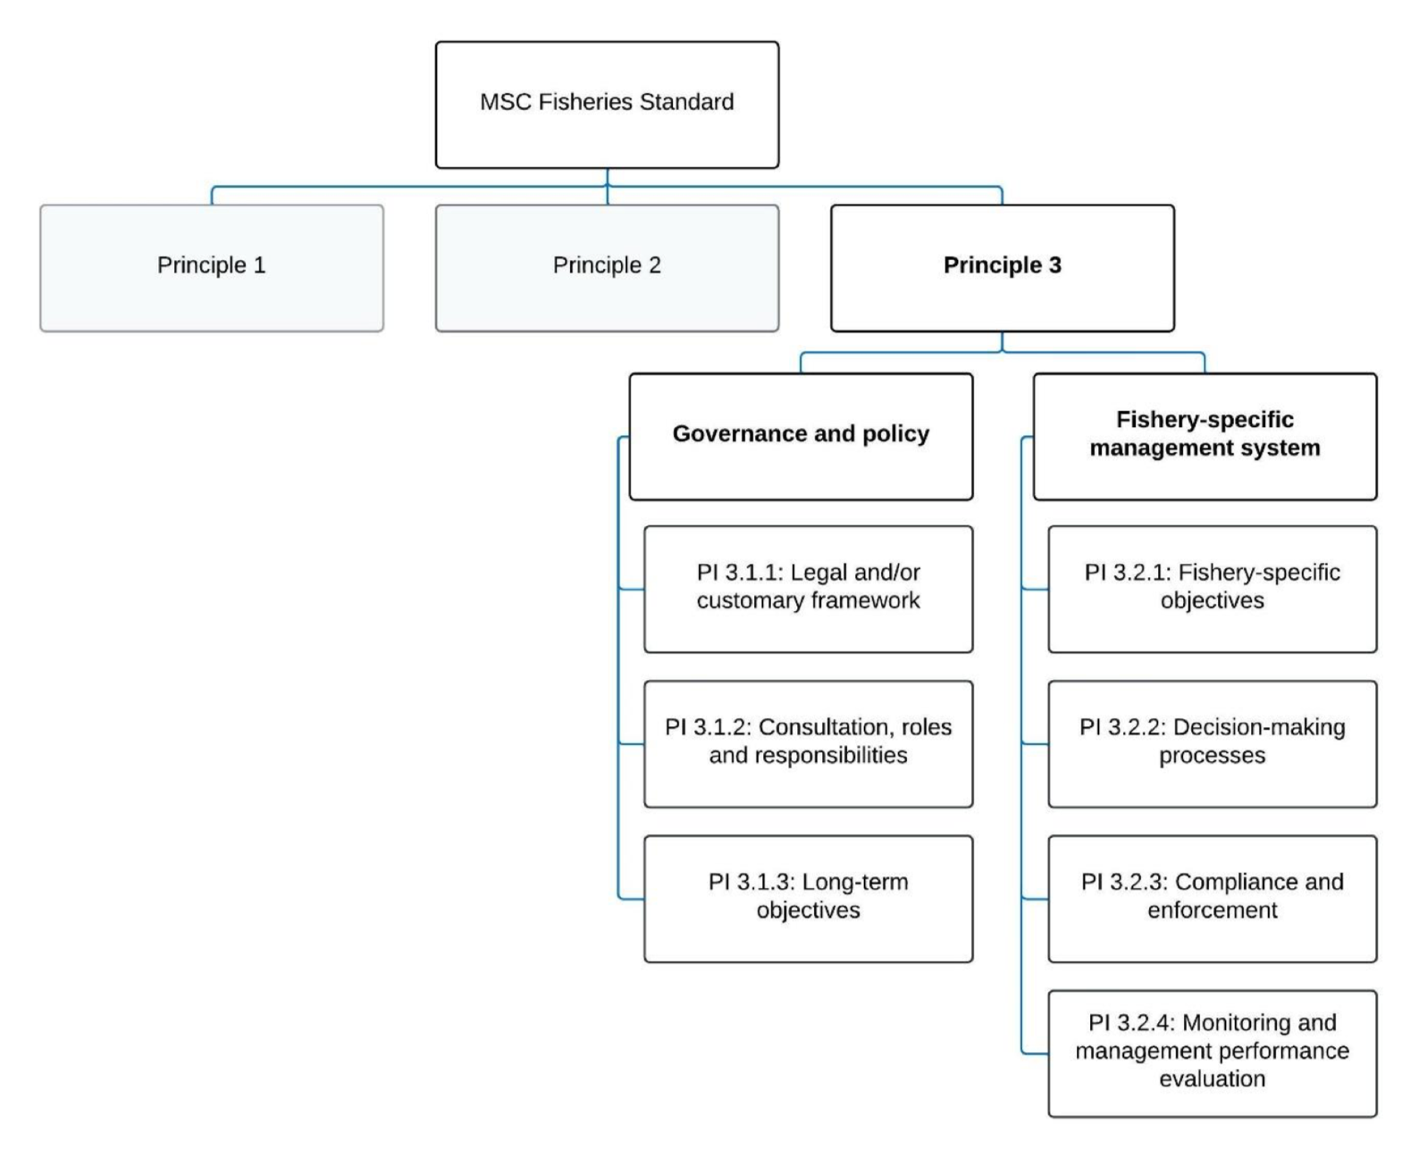
Figure 36. Decision tree for Principle 3 (MSC Fisheries Standard v3.)

4.3.2 Legal framework
Queensland's fisheries are regulated by these main pieces of legislation:
- The Fisheries Act 1994 sets out Fisheries Queensland's responsibilities for the economically viable, socially acceptable and ecologically sustainable development of Queensland's fisheries resources.
- The Fisheries (General) Regulation 2019 outlines general regulatory requirements relevant to the management and use of Queensland's fisheries resources. Section 3 provides useful advice on how to read and understand the regulations and declarations.
- The Fisheries (Commercial Fisheries) Regulation 2019 outlines the regulatory requirements that apply to Queensland’s commercial fisheries, including how activities are to be carried out.
- The Fisheries Declaration 2019 outlines restrictions on particular fishing activities across all sectors. Schedule 1 outlines regulated waters that apply in Queensland. Schedule 2 outlines the regulated fish declarations (size, possession and form requirements etc.) that apply to commercial and recreational fishers in Queensland.
- The Fisheries (Quota) Declaration 2019 outlines the quota entitlements for particular commercial fisheries, including the commercial catch limits.
The main purpose of the Fisheries Act is to “provide for the use, conservation and enhancement of the community’s fisheries resources and fish habitats in a way that seeks to apply and balance the principles of ecologically sustainable development; and promote ecologically sustainable development.”

The Fisheries Act 1994 (FA) and Fisheries (Commercial Fisheries) Regulation 2019 provide the formal legislative and administrative framework for all fisheries management in Queensland. The FA contains explicit objectives including the application of the principles of ecologically sustainable development. These objectives are consistent with national regulatory requirements including the Environmental Protection and Biodiversity Conservation Act 1999 (administered by the Australian Government).

The ECOTF is also subject to a range of provisions outlined in non-fisheries specific legislation surrounding marine parks (e.g., Marine Parks Act 2004 (Qld), Great Barrier Reef Marine Park Zoning Plan 2003 (Commonwealth) and the Great Barrier Reef Marine Park (GBRMP) Act 1975 (administered by the GBR Marine Park Authority). In addition, as part of the Wildlife Trade operation approval under the EPBC Act, one of the conditions requires the Queensland Department of Agriculture and Fisheries (DAF) to work with the GBRMP authority to develop a total effort cap for trawl operations within the GBR World Heritage Area.

4.3.3 Fishery specific management

The ECOTF area is defined by the Fisheries (Commercial Fisheries) Regulation 2019. The structure of the ECOTF is presented as 3.1.2 above. The single management unit for this harvest strategy is from latitude 22 degrees south down to the southern end of Hervey Bay, excluding the eastern king prawn fishing grounds. The fishery area is defined in Schedule 8 of the Fisheries (Commercial Fisheries) Regulation 2019 (Figure 1).

As at March 2024, there were 406 active licences in the ECOTF including 364 T1 symbols and 16 T2 symbols.

The main management methods are:
- Limited entry: restrictions on the number and size of boats which can operate in the fishery
- Boat size restriction is 20 m for T1, T2 fishery symbols
- 120 hull unit (hull volume) limit
- Engine capacity restrictions;
- Gear restrictions: vessel length, net headrope length and mesh restrictions apply depending on the areas of operation.
- Licence holders only have a certain number of nights they can fish each year in the form of tradeable effort units. The number of units required to operate a vessel for a single day depends on the hull units (hull volume) of the vessel. The number of units was capped at 2001 levels outside the GBRMP and at reducing levels within the GBRMP.
- Numerous and extensive permanent area closures apply to the fishery, particularly in waters of the GBR World Heritage Area, and GSS and MB Marine Parks.
- Seasonal closures (mainly for economic reasons) in place during summer and autumn north of 22°S latitude and during spring and summer south of this latitude.
- Daytime and weekend closures apply to trawling in estuaries and some inshore areas (e.g. Moreton Bay) to reduce any interactions with recreational users.
- Daylight closures (e.g. 6 am to 6 pm), such as those applying to the far northern area and to the scallop grounds, designed to limit effort and reduce by-catch.
- Mandatory use of TEDs and BRDs.
- A range of by-product harvesting protection arrangements.
- Logbooks for both the retained catch and ETP species (previously termed Species of Conservation Interest, surveillance by fisheries enforcement officers (the Queensland Boating and Fisheries Patrol), remote tracking of otter effort and compliance of fishing operations through mandatory satellite-based vessel monitoring system.
- Size of trawl nets is also limited to control effort in the fishery, and designs are prescribed to mitigate impacts of trawl gear on the seabed, and reduce by-catch and protected species interactions.

The different types of closures may overlap with each other and may also overlap with GBRMP closures.

4.3.4 Consultation, roles and responsibilities

Fisheries Queensland

Improving engagement with stakeholders is a key reform area of the Queensland Sustainable Fisheries Strategy: 2017–2027, and is fundamental to successfully implementing the strategy and ensuring sustainable fisheries. QDAF have an online “engagement hub” to communicate to clients and stakeholders.
The role of Fisheries Queensland is to:
- provide direction for working groups in the form of a work program
- arrange meeting times and provide logistical support for meetings
- prepare and distribute meeting materials to support the effective operation of the working group
- provide information and data to support the work of the working group
- provide a point of communication between the working group, other working groups and the Sustainable Fisheries Expert Panel in accordance with each terms of reference
- maintain communication with the working group members at least every three months.
Decision-making powers are enshrined within the Queensland fisheries legislation. In order to implement the harvest strategy, it was endorsed by the Deputy Director-General (DDG) (Fisheries and Forestry) in accordance with delegated powers under Part 2, Division 1 (Harvest Strategies) of the Fisheries Act 1994 and finally approved by the Minister responsible for fisheries in accordance with Section 16 of the same FA. When developing the harvest strategy, information collected through stakeholder consultation, and advice from expert panels and working groups was considered.

Sustainable Fisheries Expert Panel
A key action of the Sustainable Fisheries Strategy is to support evidence-based fisheries management through a sustainable fisheries expert panel. In July 2017, the Sustainable Fisheries Expert Panel was established with members in the areas of fish biology, stock assessment, fisheries management, social and economic science, and marine ecology. Further information on how the SFEP was chosen is available online, along with biographies of each member and communiques of meetings. The purpose of the Panel is to provide independent expert advice to the Minister responsible for fisheries and Fisheries Queensland on best practice fisheries management and implementation of the Sustainable Fisheries Strategy. The expert panel is advisory only. It is not a decision-making body. The expert panel will review key outputs from the working groups, such as harvest strategies (Figure 37).

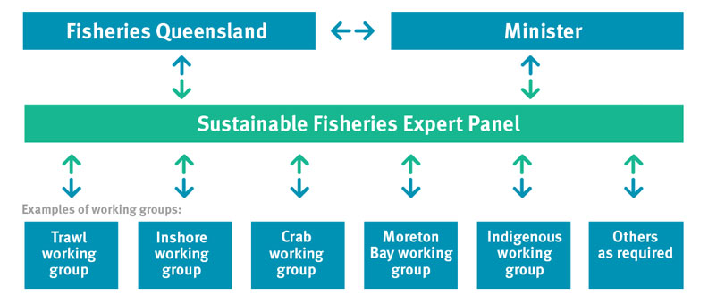
Figure 37. Flow diagram illustrating the process of review, consultation and consideration of information and advice prior to, and post, decision making (Source, Fisheries Queensland

Trawl Working group

The Trawl Working Group includes a wide range of stakeholders from the scientific community, management agencies, conservation groups and the commercial and recreational fishing sectors.
- To assist with the review of the management framework, including management options and fishing rules, and the development of harvest strategies consistent with the Sustainable Fisheries Strategy 2017-2027, the Queensland Harvest Strategy Policy and the Fisheries Act 1994.
- To provide general advice to Fisheries Queensland on any operational matters, emerging issues and general management of Queensland’s east coast, Moreton Bay, stout whiting and beam trawl fisheries.

4.3.5 Compliance and enforcement
A Compliance Risk Assessment and Strategy is in place to assist the Queensland Boating and Fisheries Patrol (QBFP) to deliver compliance operational plans across Queensland. The strategy is available at:
- https://www.daf.qld.gov.au/__data/assets/pdf_file/0018/284112/fisheries-compliance- qld.pdf
An interactive overview describing key elements of the QDAF monitoring program is available at:
- https://www.daf.qld.gov.au/business-priorities/fisheries/monitoring-compliance/interactive-map
As a part of the Compliance Strategy, compliance risk assessments are conducted to develop the state fisheries compliance plan and regional fisheries operational plans. The key outcome is to maximise voluntary compliance.
From July 2023 to 14 May 2024, 248 inspections were carried out. There were 91 offences reported for commercial fishers resulting in a compliance rate of 76.6%, and that was for failing to submit logbooks on time.

4.3.6 Queensland Evaluation and management reviews
There are several mechanisms in place for monitoring and evaluating the performance of various aspects of the management system of the ECOTF, including:
- The trawl fishery working group reviews harvest strategy decision rules, implementation of WTO conditions, stock assessment processes and other management proposals.
- The fishery is subject to an assessment against the Australian Government’s Guidelines for the Ecologically Sustainable Management of Fisheries under the EPBC Act is generally completed every three years (most recently in 2021).
- Assessments of target and important byproduct are conducted every 1–3 years through the SAFS process, although SAFS has been delayed, and the stock assessments are summarised on the QDAF website stock assessment program.

Principle 3 References:

Department Agriculture, Water and the Environment. (2021). Assessment of the Queensland East Coast Otter Trawl Fishery. Canberra: Department of Agriculture, Water and Environment. https://www.dcceew.gov.au/sites/default/files/documents/qld-east-coast-otter-trawl-assessment-2021.pdf

Butler, I. A. Roelofs & M. Kangas (2020) Banana Prawns 2020 Status of Australian Fish Stocks. FRDC, Canberra, Australia. Available at: https://www.fish.gov.au/report/272-BANANA-PRAWNS-2020# Access 22 March 2024.
Zeller, B., 2017. Submission for the reassessment of the Queensland East Coast Otter Trawl Fishery Part 13 Accreditation and Wildlife Trade Operation approval under the Environment Protection and Biodiversity and Conservation Act 1999 A report prepared by the Queensland De. Brisbane, Queensland.

Principle 3 Performance Indicator scores and rationales

Government and Policy

PI 3.1.1 – Legal and/or customary framework
PI 3.1.1 |  | The management system exists within an appropriate and effective legal and/or customary framework which ensures that it:  - Is capable of delivering sustainability in the UoA(s);  - Observes the legal rights created explicitly or established by custom of people dependent on fishing for food or livelihood; and  - Incorporates an appropriate dispute resolution framework
Scoring issue |  | SG 60 | SG 80 | SG 100
a | Compatibility of laws or standards with effective management
a | Guide post | There is an effective national legal system and a framework for cooperation with other parties, where necessary, to deliver management outcomes consistent with MSC Principles 1 and 2. | There is an effective national legal system and organised and effective cooperation with other parties, where necessary, to deliver management outcomes consistent with MSC Principles 1 and 2. | There is an effective national legal system and binding procedures governing cooperation with other parties that deliver management outcomes consistent with MSC Principles 1 and 2.
a | Met? | Yes | Yes | Not scored
Rationale |  | The ECOTF is managed in accordance with the objectives of the Fisheries Act 1994 and subordinate legislation including the Fisheries (General) Regulation 2019, Schedule 2 of Fisheries (Commercial Fisheries) Regulation 2019, Fisheries Declaration 2019; and Fisheries Quota Declaration 2019.  The Trawl Fishery Working Group also provides advice on aspects of fisheries management. SG 60 and SG 80 are met.
b | Resolution of disputes
b | Guide post | The management system incorporates or is subject by law to a mechanism for the resolution of legal disputes arising within the system. | The management system incorporates or is subject by law to a transparent mechanism for the resolution of legal disputes which is considered to be effective in dealing with most issues and that is appropriate to the context of the UoA. | The management system incorporates or is subject by law to a transparent mechanism for the resolution of legal disputes, which is appropriate to the context of the fishery and has been tested and proven to be effective.
b | Met? | Yes | Yes | Not scored
Rationale |  | Within the Fisheries Act 1994, there is a transparent mechanism that provides for an internal review of a decision made by the Department of Agriculture and Fisheries; specifically, Section 196(1) of the FA is the provision for appeal.  Any person who has been given an information notice relating to the appeal decision can apply for a review of a decision under the FA. Bio-inspecta (2023) provided further evidence of the effectiveness of the mechanism for the EKP sub-fishery of the ECOTF. SG 60 and SG 80 are met.
c | Respect for rights
c | Guide post | The management system has a mechanism to generally respect the legal rights created explicitly or established by custom of people dependent on fishing for food or livelihood in a manner consistent with the objectives of MSC Principles 1 and 2. | The management system has a mechanism to observe the legal rights created explicitly or established by custom of people dependent on fishing for food or livelihood in a manner consistent with the objectives of MSC Principles 1 and 2. | The management system has a mechanism to formally commit to the legal rights created explicitly or established by custom of people dependent on fishing for food and livelihood in a manner consistent with the objectives of MSC Principles 1 and 2.
c | Met? | Yes | Yes | Not scored
Rationale |  | The rights of customary fishers are recognised by the Section 14 exemption in the Fisheries Act that allows for an “Aborigine or Torres Strait Islander” to take fish for “the purpose of satisfying a personal, domestic or non-commercial communal need”.  In Queensland, the Fisheries Act 1994 defines traditional fishing as:  - the taking, using or keeping of the fisheries resources is for the purpose of satisfying a personal, domestic or non-commercial communal need of Aboriginal or Torres Strait Islander people, and  - it is carried out in accordance with the particular traditional laws and customs of native title holders or Traditional Owners of the area being fished, and  - those Aboriginal or Torres Strait Islander people, by their laws and customs, have a connection with the land or waters.  This definition is consistent with the federal Native Title Act 1993. It recognises that traditional fishing may vary from group to group, and that traditional ways of fishing evolve over time and may include modern methods and materials. SG 60 and SG 80 are met.

Draft scoring range | ≥80
Information gap indicator

PI 3.1.2 – Consultation, roles, and responsibilities
PI 3.1.2 |  | The management system has effective consultation processes that are open to interested and affected parties. The roles and responsibilities of organisations and individuals who are involved in the management process are clear and understood by all relevant parties
Scoring issue |  | SG 60 | SG 80 | SG 100
a | Roles and responsibilities
a | Guide post | Organisations and individuals involved in the management process have been identified. Functions, roles, and responsibilities are generally understood. | Organisations and individuals involved in the management process have been identified. Functions, roles, and responsibilities are explicitly defined and well understood for key areas of responsibility and interaction. | Organisations and individuals involved in the management process have been identified. Functions, roles, and responsibilities are explicitly defined and well understood for all areas of responsibility and interaction.
a | Met? | Yes | Yes | Not scored
Rationale |  | The roles and responsibilities of organisations and individuals who are involved in the management process are clear and understood by all relevant parties and are summarised in the Harvest Strategy Policy (QDAF, 2021). There are several available examples of evidence that the stakeholders have been identified and engaged in management amendments. In 2017 the fishery underwent a major review and reform; an example of that stakeholder engagement during major amendments is available https://qsia.com.au/wp-content/uploads/2018/03/Trawl-Discussion-Paper.pdf  - The functions of the Minister and powers of the Chief Executive are explicit in the Fisheries Act 1994.  - The role and functions of QDAF and the Fisheries portfolio are explicitly defined in QDAFs Annual Report  - The roles of the Sustainable Fisheries Expert Panel and the trawl working group members are clearly documented in the Queensland Sustainable Fisheries Strategy (DAF 2017).  SG 60 and SG 80 are met.
b | Consultation processes
b | Guide post | The management system includes consultation processes that obtain relevant information from the main affected parties, including local knowledge, to inform the management system. | The management system includes consultation processes that regularly seek and accept relevant information, including local knowledge. The management system demonstrates consideration of the information obtained. | The management system includes consultation processes that regularly seek and accept relevant information, including local knowledge. The management system demonstrates consideration of the information and explains how it is used or not used.
b | Met? | Yes | Yes | Not scored
Rationale |  | QDAF has a Stakeholder Engagement Charter that stipulates how to engage stakeholders.  Furthermore, a key objective of the Sustainable Fisheries Strategy is to improve stakeholder engagement and support evidence-based fisheries management through the use of a sustainable fisheries expert panel.  To improve engagement with stakeholders, QDAF:  - consult with the sustainable fisheries expert panel and trawl fishery working group on a regular basis, and publicly publish the meeting communiques online;  - has a specific webpage for consultations so all stakeholders can access opportunities to provide input;  - publishes the Catch news e-newsletter to include fisheries information for all stakeholders;  - publish a Commercial fishing update e-newsletter to keep commercial fishers informed of the latest fisheries management information.  Public consultation is also available for the application for export approval (wildlife trade operation). SG 60 and SG 80 are met.
c | Participation
c | Guide post |  | The consultation process provides opportunity for all interested and affected parties to be involved. | The consultation process provides opportunity and encouragement for all interested and affected parties to be involved, and facilitates their effective engagement.
c | Met? |  | Yes | Not scored
Rationale |  | QDAF has a Stakeholder Engagement Charter that stipulated how to be inclusive, transparent and respectful with stakeholder engagement. The Working Group charter outlines the responsivities and participation requirements.  Workshops are regularly held to discuss the Sustainable Fisheries Strategy, the harvest strategy for the Central Trawl Fishery and Scallop assessments:  - 16–17 May 2022 in Cairns.  - 19 October 2021 online  - 31 Jan- 1 Feb 2019 in Townsville  During the meetings, industry members raised concerns regarding potential for effort shift etc. The consultation processes that are in place for the ECOTF and across fisheries in Queensland provide opportunity for all interested parties and affected parties to be involved; SG80 is met.

Draft scoring range | ≥80
Information gap indicator

PI 3.1.3 – Long term objectives
PI 3.1.3 |  | The management policy has clear long-term objectives to guide decision-making that are consistent with the MSC Fisheries Standard, and incorporates the precautionary approach
Scoring issue |  | SG 60 | SG 80 | SG 100
a | Objectives
a | Guide post | Long-term objectives to guide decision-making, consistent with the MSC Fisheries Standard and the precautionary approach, are implicit within management policy. | Clear long-term objectives that guide decision-making, consistent with the MSC Fisheries Standard and the precautionary approach, are explicit within management policy. | Clear long-term objectives that guide decision-making, consistent with the MSC Fisheries Standard and the precautionary approach, are explicit within and required by management policy.
a | Met? | Yes | Yes | Not scored
Rationale |  | Clear long-term objectives for the ECOTF are articulated in the broadest of terms in the Fisheries Act. Guidance for decision making are contained in Division 2 of the Fisheries Act 1994 with reference to precautionary approach being underlined:  “The main purpose of this Act is to provide for the use, conservation and enhancement of the community’s fisheries resources and fish habitats in a way that seeks to—  (1) (a) apply and balance the principles of ecologically sustainable development; and  (b) promote ecologically sustainable development.  (2) In balancing the principles, each principle is to be given the relative emphasis appropriate in the circumstances, having regard to ensuring access to the fisheries resources is allocated in a way that maximises the potential economic, social and cultural benefits to the community.  (3) Despite the main purpose of this Act, a further purpose of this Act is to reduce the possibility of shark attacks on humans in coastal waters of the State adjacent to coastal beaches used for bathing.  (4) Subsections (1) and (3) do not limit the purposes of this Act.  (5) In this section—  ecologically sustainable development means using, conserving and enhancing the community’s fisheries resources and fish habitats so that—  (a) the ecological processes on which life depends are maintained; and  (b) the total quality of life, both now and in the future, can be improved.  precautionary principle means the principle that, if there is a threat of serious or irreversible environmental damage, lack of scientific certainty should not be used as a reason to postpone measures to prevent environment degradation, or possible environmental degradation, because of the threat.  Principles of ecologically sustainable development mean the following principles—  (a) enhancing individual and community wellbeing through economic development that safeguards the wellbeing of future generations;  (b) providing fairness within and between generations;  (c) protecting biological diversity, ecological processes and life-support systems;  (d) in making decisions, effectively integrating fairness and short and long-term economic, environmental and social considerations;  (e) considering the global dimension of environmental impacts of actions and policies;  (f) considering the need to maintain and enhance competition, in an environmentally sound way;  (g) considering the need to develop a strong, growing and diversified economy that can enhance the capacity for environmental protection;  (h) that decisions and actions should provide for broad community involvement on issues affecting them;  (i) the precautionary principle.”  Given that the objectives relate to pursuing ecologically sustainable development and reference the use of, and define, the precautionary approach SG 60 is met. The Act also goes further to state how the purposes of the Act will primarily be achieved at the broad level. The objectives articulated under GBRMPA legislation are clear and do include explicit reference to the precautionary principle. There are clear long-term objectives that guide decision making consistent with MSC standard. Therefore, SG80 is met.

Draft scoring range | ≥80
Information gap indicator

Fishery Specific Management Systems

PI 3.2.1 – Fishery-specific objectives
PI 3.2.1 |  | The fishery-specific management system has clear, specific objectives designed to achieve the outcomes expressed by MSC Principles 1 and 2
Scoring issue |  | SG 60 | SG 80 | SG 100
a | Objectives
a | Guide post | Objectives, which are broadly consistent with achieving the outcomes expressed by MSC Principles 1 and 2, are implicit within the fishery-specific management system. | Short and long-term objectives, which are consistent with achieving the outcomes expressed by MSC Principles 1 and 2, are explicit within the fishery-specific management system. | Well-defined and measurable short- and long-term objectives, which are demonstrably consistent with achieving the outcomes expressed by MSC Principles 1 and 2, are explicit within the fishery-specific management system.
a | Met? | Yes | No | Not scored
Rationale |  | The objective of the harvest strategy that relates to the ECOTF (central) is to manage the fishery in accordance with the objectives of the Fisheries Act 1994 and the Queensland Sustainable Fisheries Strategy: 2017–2027 (QDAF 2021). Fishery objectives set out the aspirations and operational direction for the management of the fishery in the long term.  The primary objective of the Central trawl region is to maintain the target species at, or returned to, a target spawning biomass level that aims to maximise economic yield (MEY) for the fishery.  In pursuing the primary objective, the harvest strategy aims to:  - minimise and mitigate any unacceptable ecological risks arising from fishing-related activities;  - maximise economic performance of the commercial sector; and  - monitor the broader social and economic benefits of the fishery to the community.  With regard to objectives being consistent with achieving outcomes expressed in P1 and P2 of the MSC, the following indicators within the harvest strategy are relevant:  Principle 1 species (Tiger Prawns, MBB, Red-spot King prawns and Banana prawns):  - Only Tiger prawns are target (Tier 1) species for this fishery;  - Other P1 species are managed as a Tier 2 species in the Harvest Strategy. If a stock assessment with reference to target and limit reference points is unavailable, stock status is based on annual commercial logbook catches (2010–19). Catches outside of the defined range for two consecutive years would trigger a review, a stock assessment and the potential to introduce management triggers of trip/size limits or spatial/temporal closures.  Principle 2 interactions:  - Saucer scallop is a Tier 2 species although the Scallop fishery currently closed until biomass reaches ≥30% unfished biomass. Does not meet the definition of Main species given low catch rates (all discarded) and survivability of discards.  - For other byproduct species (Tier 3), if the three-year average harvest of any species is no more than 10% above the average catch from 2017–2019, then no management action is required.  - Western King Prawn (Blue-legged Kings) are not managed by the HS yet catches make up more than 5% of the total retained catch. Species composition of the Central fishery (UoA) has changed following the closure of the Scallop component and as such WKP now make up a significant proportion of the UoA.  - The harvest strategy aims to minimise and mitigate high ecological risks arising from fishing. If the ERA identifies that fishing impacts are considered to generate an unacceptable level of risk to an ecological component (includes non target species, ETPs and the broader ecosystem), a review is triggered to investigate the reason for the risk, and appropriate management action taken to reduce the risk to an acceptable level.  - If the Central trawl region trawl footprint in any given year is greater than the 2019 effort footprint, a review will be undertaken to understand the reason for the increased effort footprint and identify appropriate management strategies to reduce the risk, including options that reduce the permitted area that can be trawled. If the review identifies sustainability is at risk, management action is required within two years.  Additional measures are in place with regard to the pipehorse (an ETP species that can be retained). Under Part 2 of the Fisheries Declaration 2019, the take of ‘pipefish’ (S. dunckeri and S. hardwickii) is restricted by a combined trip limit of 50 individuals and both species must be discarded once this limit is reached.  In summary, defined and measurable short and long-term objectives, which are demonstrably consistent with achieving the outcomes expressed by MSC’s Principle 1 are implicit within the fishery’s management system achieving SG60. Whilst some components of Principle 2 (in-scope species and habitats) are within the harvest strategy, the assessment team was unable to find explicit long and short- term objectives for ETPs (including pipe horses) or discards and therefore SG 80 is not met.

Draft scoring range | 60–79
Information gap indicator

PI 3.2.2 – Decision-making processes
PI 3.2.2 |  | The fishery-specific management system includes effective decision-making processes that result in measures and strategies to achieve the objectives, and has an appropriate approach to actual disputes in the fishery
Scoring issue |  | SG 60 | SG 80 | SG 100
a | Decision-making processes
a | Guide post | There are some decision-making processes in place that result in measures and strategies to achieve the fishery-specific objectives. | There are established decision-making processes that result in measures and strategies to achieve the fishery-specific objectives.
a | Met? | Yes | Yes
Rationale |  | Decisions on the introduction of fisheries measures and strategies are informed through a range of information sources including QDAF, the Sustainable Fisheries Expert panel, other Government agencies, feedback from public consultation. In addition, the trawl fishery working group provides operational advice on the management of the trawl fishery in line with their terms of reference.  The Harvest Strategy Policy (QDAF, 2021) states that: “Harvest strategies provide a transparent decision-making framework for fisheries management, by Fisheries Queensland on behalf of the Queensland Government, to provide greater certainty for fishers, managers and other stakeholders.”  The ECOTF Central harvest strategy stipulates the decision rules for commonly caught species (by Tier 1, 2 and 3) and ecological risks that are designed to ensure the fishery specific objectives are achieved. There are also processes in place that could be immediately triggered, such as the closure of trawl operations in certain region when an effort cap is reached; together, this meets SG 60 and SG 80.
b | Responsiveness of decision-making processes
b | Guide post | Decision-making processes respond to serious issues identified in relevant research, monitoring, evaluation, and consultation, in a transparent, timely and adaptive manner, and take some account of the wider implications of decisions. | Decision-making processes respond to serious and other important issues identified in relevant research, monitoring, evaluation, and consultation, in a transparent, timely, and adaptive manner, and take account of the wider implications of decisions. | Decision-making processes respond to all issues identified in relevant research, monitoring, evaluation, and consultation, in a transparent, timely, and adaptive manner, and take account of the wider implications of decisions.
b | Met? | Yes | Yes | Not scored
Rationale |  | The decision-making process for the ECOTF is consistent with those for the broader Queensland management system and responds to the specific harvest strategy, which respond to research, outcome evaluations and monitoring programs. Specific and relevant issues are evaluated through the Trawl Working Group. SG 60 is met. However, the Central HS was implemented in 2021 and in that time there has been evidence responsiveness of decision rules being triggered for Scallops. It is important to note that the issues identified in the ERA and WTO application (e.g., primarily scallop stock status and interactions) have differing levels of being addressed, and some recommendations remain outstanding. SG 80 is met as this fishery has clearly responded to the most serious issues first; other issues will need a response in the short-medium term now that Scallop stock assessments have been conducted. The HS is due for a review/update in 2026.
c | Use of precautionary approach
c | Guide post |  | Decision-making processes use the precautionary approach and are based on best available information.
c | Met? |  | Yes
Rationale |  | The precautionary approach is explicit in the Fisheries Act 1994 and at the broader overarching legislative instruments, there is also evidence of the fishery specific decision-making processes use the precautionary approach within the harvest strategy for the central trawl region.  Both the 2017–27 Sustainable Fisheries Strategy and Harvest Strategy Policy stipulate the use of precaution. For example, the use of default proxies for B_{MEY} and B_{MSY} (60% and 40% of unfished biomass respectively), provides a clear and consistent approach for setting target reference points in the absence of species or stock specific data (e.g. economic information).  The Harvest Strategy for the Central Region provides information on decision rules for each commonly retained species (Tier 1–3), although there is very little information on the use of precaution for the management of discarded species outside of the ERA.  Pears et al. (2012) conducted a thorough assessment of the fishery, including the area of the UoA. During the refined ERA (Dedini et al. 2023) only SOCI (Species of Conservation Interest) were assessed with additional precaution to flag the potential need of future management attention. SG 80 is met.
d | Accountability and transparency of management system and decision-making process
d | Guide post | Some information on the fishery’s performance and management action is generally available on request to stakeholders. | Information on the fishery’s performance and management action is available on request, and explanations are provided for any actions or lack of action associated with findings and relevant recommendations emerging from research, monitoring, evaluation, and review activity. | Formal reporting to all interested stakeholders provides comprehensive information on the fishery’s performance and management actions and describes how the management system responded to findings and relevant recommendations emerging from research, monitoring, evaluation, and review activity.
d | Met? | Yes | Yes | Not scored
Rationale |  | QDAF’s Annual report 2022–23 provides information on their performance against defined objectives (outlined in the Strategic plan 2021–25 (refreshed for 2022)).  The Harvest Strategy Policy (QDAF, 2021) and Central Harvest Strategy (QDAF, 2021c) contain monitoring and performance indicators and provided the basis for incorporating relevant recommendations emerging from research, monitoring, evaluation and review activity. The UoA harvest strategy is in place for a period of five years (2021–2026), after which time it will be fully reviewed in accordance with the Fisheries Act 1994. The harvest strategy may also be subject to further review and amendment as appropriate within the five-year period if any of the following circumstances arise:  - there is new information that substantially changes the status of a fishery, leading to improved estimates of indicators relative to reference points  - drivers external to management of the fishery increase the risk to fish stock/s  - it is clear the strategy is not working effectively and the intent of the harvest strategy policy is not being met.  There are several formal reporting mechanisms available to all interested stakeholders that provides comprehensive information on stock status, compliance activities, management changes, explanations for lack of actions, and industry projects/initiatives underway; SG 60 and SG 80 are met.
e | Approach to disputes
e | Guide post | Although the management authority or fishery may be subject to continuing court challenges, it is not indicating a disrespect or defiance of the law by repeatedly violating the same law or regulation necessary for the sustainability of the fishery. | The management system or UoA is attempting to comply in a timely fashion with judicial decisions arising from any legal challenges. | The management system or UoA acts proactively to avoid legal disputes or rapidly implements judicial decisions arising from legal challenges.
e | Met? | Yes | Yes | Not scored
Rationale |  | The consultation and advisory processes ensure that the management system in each sub fishery acts proactively to avoid legal disputes.  Queensland Civil and Administrative Tribunal (QCAT) is able to review decisions from the Department of Agriculture and Fisheries in the use, conservation and enhancement of the community’s fisheries resources and fish habitats. There are no legal challenges known to the assessment team. SG 60 and 80 is met.

Draft scoring range | ≥80
Information gap indicator

PI 3.2.3 – Compliance and enforcement
PI 3.2.3 |  | Monitoring, control, and surveillance (MCS) mechanisms ensure the management measures in the UoA are enforced and complied with
Scoring issue |  | SG 60 | SG 80 | SG 100
a | MCS system
a | Guide post | Monitoring, control and surveillance mechanisms exist, and are implemented in the fishery and there is a reasonable expectation that they are effective. | A monitoring, control and surveillance system has been implemented in the fishery and has demonstrated an ability to enforce relevant management measures, strategies and/or rules. | A comprehensive monitoring, control and surveillance system has been implemented in the fishery and has demonstrated a consistent ability to enforce relevant management measures, strategies and/or rules.
a | Met? | Yes | Yes | Not scored
Rationale |  | A Compliance Risk Assessment and Strategy is in place to assist the Queensland Boating and Fisheries Patrol (QBFP) to deliver compliance operational plans across Queensland.  QDAF has undertaken a post implementation impact analysis statement (PI-IAS) of the vessel tracking regulations contained within Chapter 4, Part 1 of the Fisheries (General) Regulation 2019. The PI-IAS considered the impacts of the vessel tracking regulation since it was introduced and any recommendations for the regulation looking forward.  Data collected from vessel tracking is used by QBFP to observe in real time the commercial fishing fleet (identified down to an individual fishing vessel) in order to:  - monitor compliance with closures  - monitor real-time movement of vessels for at sea and landing inspections  - manage compliance of reporting obligations such as logbooks.  Overall, it has been reported by QBFP that data from vessel tracking has enabled QBFP to improve its compliance activities in line with its risk-based compliance approach.  During 2010, compliance rates for the entire ECOTF was 85% (less in Moreton Bay). The main offences relate to operation in regulated waters and TED/BRD use.  Compliance activities include on-water inspections, verification of catch and effort reported in logbooks, and checks of ETP species logbooks. There are also port inspections of gear. Fleet composition is well understood and sufficient data are collected to support the harvest strategy including vessel details, VMS data, fishing effort (hours and distribution), and vessel power of the fleet.  With regard to monitoring, there are catch records for the key species for all important sources of fishing mortality Furthermore, a new electronic monitoring project is in a trial phase for the ECOTF, although there is no data on number of UoA vessels signed up to use the QDAF e-monitoring gear. SG 80 is met.
b | Sanctions
b | Guide post | Sanctions to deal with non-compliance exist and there is some evidence that they are applied. | Sanctions to deal with non-compliance exist, are consistently applied and thought to provide effective deterrence. | Sanctions to deal with non-compliance exist, are consistently applied and demonstrably provide effective deterrence.
b | Met? | Yes | Yes | Not scored
Rationale |  | The sanctions applied for breaches of regulations operate on a sliding scale including a warning, issuing a Fisheries Infringement Notice caution (an on-the-spot fine with no further official penalty), a range of fines, and court appearances for more severe breaches that may lead to confiscation of catches and equipment. Therefore, SG80 is met.
c | Compliance (information)
c | Guide post | Fishers are generally thought to comply with the management system for the fishery under assessment, including, when required, providing information of importance to the effective management of the fishery. | Some evidence exists to demonstrate fishers comply with the management system under assessment, including, when required, providing information of importance to the effective management of the fishery. | There is a high degree of confidence that fishers comply with the management system under assessment, including, providing information of importance to the effective management of the fishery.
c | Met? | Yes | Yes | Not scored
Rationale |  | Some evidence exists to demonstrate fishers comply with the previous management system, including, when required, providing information of importance to the effective management of the fishery. Zeller, (2017) stated: “From 2013-16 compliance with ECOTF management arrangements has been high. From 2013 to present, 927 otter trawl vessel inspections were conducted. A total of 273 offences were detected. This translates to an average management regime compliance rate of 86%. In order of decreasing prevalence, the type of offences committed requiring either an official caution or infringement notice with financial penalty ranged from contravening a condition of an authority (includes BRD and TED non-compliance), failing to keep or provide information as required (includes failure to keep logbooks and submit logbook returns), contravention of regulated waters (includes fishing within closure areas or periods), and possession of regulated species or undersized catch. More serious offences that led to prosecution made up only a small percentage of total offences. Most were for failing to keep or provide information as required, possession of regulated species or undersized catch and contravention of regulated waters.”  The UoA management system under assessment includes the 2021 harvest strategy; quarterly compliance reports are produced for all fisheries by QDAF although data is not separated by location/fishery. SG80 is met.
d | Compliance (outcome)
d | Guide post |  | There is no evidence of systematic non-compliance
d | Met? |  | No
Rationale |  | Whilst the team is unaware of any evidence of systematic non-compliance in the Central sub-fishery, Bio-inspecta (2023) reported compliance data for the small fleet (10 vessels) of the EKP southern offshore sub-fishery; (i.e., a small component of the ECOTF EKP sub-fishery) – “Compliance data on the client’s fleet shows that fourteen sanctions have been applied in the last six years. Where offences were detected, sanctions in the form of Fishery Infringement Notices and cautions were applied and nearly all of these were against individuals. Compared to the number of inspections (43) that occurred, the number of offences detected and sanctions applied is low which demonstrates that sanctions are an effective deterrent.”  From the above, it is unclear if “systematic non-compliance” has occurred as it is unknown if several offences were identified upon each inspection over the 6 years. The above example could imply that 32% of inspections resulted in one offence per inspection (i.e., likely systematic non-compliance), or that in one inspection there were many of the 14 sanctions and nothing/few at any other time (i.e., not systematic non-compliance). Furthermore, there is limited information on the type of offences other than they were “against individuals” and without information on prevalence of re-offending there is no evidence that sanctions are an effective deterrent; Further data is required, SG 80 is not met.

Draft scoring range | 60-79
Information gap indicator | Compliance data for fleet, number of inspections, number of sanctions, cases of re-offending etc.

PI 3.2.4 – Monitoring and management performance evaluation
PI 3.2.4 |  | There is a system for monitoring and evaluating the performance of the fishery-specific management system against its objectives. There is effective and timely review of the fishery-specific management system
Scoring issue |  | SG 60 | SG 80 | SG 100
a | Evaluation coverage
a | Guide post | There are mechanisms in place to evaluate some parts of the fishery-specific management system. | There are mechanisms in place to evaluate key parts of the fishery-specific management system. | There are mechanisms in place to evaluate all parts of the fishery-specific management system.
a | Met? | Yes | Yes | Not scored
Rationale |  | There are mechanisms in place to evaluate key parts of the fishery-specific management system (harvest strategy), through working groups, expert fisheries panel, research, compliance and monitoring. In 2016, QDAF underwent a major review regarding legislative instruments, decision-making framework, harvest strategies, data and information, consultation and compliance (QDAF, 2016). Reform strategies to the ECOTF were specifically discussed (QDAF, 2018) and significant amendments were implemented as a result of those evaluations.  This Sustainable Fisheries Strategy 2017–2027 is reviewed regularly (5 years) to ensure it is effectively delivering the vision for sustainable fisheries management in Queensland and ensure the targets and actions are being successfully implemented. The latest progress report was published in 2022 and provides a summary of deliverables being on track for completion by 2027. SG 60 and SG 80 are met.
b | Internal and/or external review
b | Guide post | The fishery-specific management system is subject to occasional internal review. | The fishery-specific management system is subject to regular internal and occasional external review. | The fishery-specific management system is subject to regular internal and external review.
b | Met? | Yes | Yes | Not scored
Rationale |  | The fishery-specific management system is subject to regular internal and occasional external review, through working groups and expert fisheries panel. Further, the expert panel has the ability to acquire external review of components of the ECTOF management system for advice. Example include the external review, advice and stakeholder engagement for the ECOTF harvest strategies (QDAF, 2021b), including the HS for the Central trawl region. Therefore, SG60 is met.  The fishery is also assessed externally every three years to permit export under the Environment Protection and Biodiversity Conservation Act 1999 (Wildlife Trade Operations); the fishery’s current export approval expires in December 2024 (DAWE 2021). SG80 is met.

Draft scoring range | ≥80
Information gap indicator

Template information, copyright and disclaimer

The Marine Stewardship Council’s ‘MSC Pre-Assessment Reporting Template v3.3’ and its content is copyright of “Marine Stewardship Council” - © “Marine Stewardship Council” 2022. All rights reserved.

A controlled document list of MSC program documents is available on the MSC website (https://www.msc.org/for-business/certification-bodies/supporting-documents).

This MSC pre-assessment has been undertaken using publicly available material generated primarily through web-searches and from confidential fishery data provided by the Client or data formally requested from the Queensland Department of Agriculture and Fisheries . Source material used to justify scoring is referenced. It is not impossible that additional material exists (particularly that held internally by the management and scientific agencies responsible for the management of the fishery) that could influence the justification and scores.

Assessor Disclaimer: All reasonable efforts have been taken to ensure the quality of this report, the authors do not warrant that the information is free from errors or omissions. The authors do not accept any form of liability, be it contractual, tortuous or otherwise, for the contents of this report or for any consequences arising from its use or any reliance placed upon it. This information is intended explicitly for the use by the Client and their chosen partners for the assessment of the defined UoA using the MSC Fisheries Standard v3. The author does not provide permission under any circumstances for the information presented in this report to be made publicly available to third parties without the written consent from the Client.

List of Tables
Table 1: Fisheries program documents versions 5
Table 2: Units of Assessment (UoA) 6
Table 3. Summary of Principle level scores for UoAs 5–8, ECOTF Central Zone. 9
Table 4. Tiger Prawn UoA 5 Performance Indicator level draft scores and comments for those that scored < 80 10
Table 5. Endeavour Prawn UoA 6 Summary of Performance Indicator level draft scores and comments for those that scored < 80 11
Table 6. Redspot King Prawn UoA 7 Summary of Performance Indicator level draft scores and comments for those that scored < 80 12
Table 7. Banana Prawn UoA 8 Summary of Performance Indicator level draft scores and comments for those that scored < 80 13
Table 8. Moreton Bay Bug UoA 13 Performance Indicator level draft scores and comments for those that scored < 80 14
Table 9. Moreton Bay Bug (sand mug and mud mug) catch from the central region by year and grid location (Further information on grid locations is available at https://www.business.qld.gov.au/industries/farms-fishing-forestry/fisheries/commercial/report/logbook/map 29
Table 10. Logbook catch data for Tiger Prawn, Moreton Bay Bug, Red-spot King, Banana Prawn and Endeavour Prawn from the ECOTF, UoA = Central region. Note: From 2021 Moreton Bay Bug data was separated by species Mud Bug or Sand Bug. Sand bug dominates (>95%) the MBB catch from the central zone. 35
Table 11. History of Prawn management in Queensland (Lovett et al. 2023). 37
Table 12. Indicators for MBB—target reference point for biomass is 60% (Wickens et al. 2023) 41
Table 13. History of Moreton Bay bug management in Queensland (Wickens et al. 2023). 41
Table 14. Summary of model outcomes for all endeavour prawn scenarios—B₂₀₂₁ % is the most likely biomass in 2021 relative to unfished in 1968 with the 95 % credible interval (CI) (Fox et al. 2023b). 46
Table 15. Target (Tier 1), secondary (Tier 2) and permitted species as outlined in the regional East Coast Otter Trawl Fishery (ECOTF) harvest strategies 2 All five regional harvest strategies can be accessed at: https://www.daf.qld.gov.au/business-priorities/fisheries/sustainable/harvest-strategy. ²Unless otherwise specified, regional harvest strategies will classify permitted species as Tier 3 species/complexes. ³Stock classified as Depleted and is species classified as no-take as part of a broader stock rebuilding strategy (correct as of 1 July 2023). (Source: Dedini et al. 2023b) 81
Table 16. Reported annual retained catch (t) from the central region of the ECOTF by year (Source: QDAF FDR- 663) ETP species in italics with asterisks and species that make up ≥5% of retained catch in bold and highlighted. Note the Scallop fishery is now closed and all retained catches from 2022 will be zero until biomass has rebuilt to 30% of unfished biomass. 85
Table 17. Retained and discard species categorisation into components for the assessment. Discard levels are unknown for the Central region since closing to Saucer Scallops, and as such, discard species that were identified as high or precautionary high risk in the 2012 (Pears et al. 2012) and 2023 (Dedini et al. 2023) ERAs or those ETP species listed in ETP logbooks are listed here. Saucer Scallop are discarded and reported in logbooks. 87
Table 18. Western King prawn retained catches (tonnes) by sector of the ECOTF for 2019–2022 89
Table 19. Reported Sea snake interaction and life status recorded by logbooks in the central sub-fishery and entire ECOTF by year 96
Table 20. Reported pipehorse retained (kg) by the ECOTF and the central trawl region sub-fishery by year. Pallid’s (Solegnathus hardwickii) and Duncker’s (S. dunckeri) 97
Table 21. Risk assessment of marine habitats (ordered according to 2009 risk levels) (source: (Morison and Pears, 2012)). 103

The nomenclature of white banana prawn varies across reports, although the Standard Fish Name for this species is Panaeus merguiensis not Fenneropenaeus merguiensis.
https://www.federalregister.gov/documents/2021/04/30/2021-09077/bureau-of-oceans-and-international-environmental-and-scientific-affairs-annual-certification-of
Fishery Declaration 2019 Schedule 2 Part 2 https://www.legislation.qld.gov.au/view/whole/html/inforce/current/sl-2019-0076
The nomenclature of white banana prawn varies across reports, although the Standard Fish Name for this species is Panaeus merguiensis not Fenneropenaeus merguiensis.
https://www.afma.gov.au/sites/default/files/2023-02/Northern%20Prawn%20Fishery%20Harvest%20Strategy.pdf
https://www.fish.gov.au/report/291-Redspot-King-Prawn-2020
https://www.business.qld.gov.au/industries/farms-fishing-forestry/fisheries/monitoring-reporting/requirements/logbooks
https://www.daf.qld.gov.au/business-priorities/fisheries/sustainable/fishery-working-groups/trawl-working-group/communiques/communique-27-28-november-2023
https://www.dcceew.gov.au/sites/default/files/documents/qld-east-coast-otter-trawl-assessment-2021.pdf
https://www.dcceew.gov.au/sites/default/files/env/pages/9fe831d8-19fc-4b5e-90cb-3f4a3c5ad995/files/assessment-2017.pdf
https://www.dcceew.gov.au/sites/default/files/env/consultations/e1ba225f-3edc-4f76-b93e-bb8cc69b0939/files/qld-east-coast-trawl-fishery-submission-2021.pdf
https://www.data.qld.gov.au/dataset/quarterly-reports-species-of-conservation-interest-soci-interactions-from-2006
https://www.cms.int/sites/default/files/document/MOS1_Inf_5_6_Report_from_Australia_0.pdf
https://www.dcceew.gov.au/sites/default/files/documents/sawfish-river-sharks-multispecies-recovery-plan.pdf
https://www.fao.org/3/I0725E/i0725e.pdf
Vulnerable Marine Environments (VMEs) were assessed in early versions of the MSC Standard, and they are now considered “more sensitive habitats” (SA3.11.3.1).
“In determining whether an impact is “negligible”, the team shall consider the relevant requirements of each component.”
https://www.amsa.gov.au/international-requirements-fishing-gear-marking-and-reporting/reporting-lost-or-discharged-fishing
https://daf.engagementhub.com.au/onboard-camera-trial
https://daf.engagementhub.com.au/onboard-camera-trial
https://daf.engagementhub.com.au/onboard-camera-trial
https://elibrary.gbrmpa.gov.au/jspui/retrieve/62d985cf-79b1-4615-b80a-9b43c8b517f3/gbrmpa-VA-SeaSnakes-11-7-12.pdf
https://www.iucnredlist.org/species/176734/7292879
https://www.iucnredlist.org/species/176748/7296594
https://www.iucnredlist.org/species/132475824/83766285
https://www.iucnredlist.org/species/176746/132780885
https://www.iucnredlist.org/species/176716/134229775
https://www.iucnredlist.org/species/176761/7299189
https://www.iucnredlist.org/species/176729/7292011
https://www.iucnredlist.org/species/176745/7295853
https://www.iucnredlist.org/species/176727/7291730
https://www.iucnredlist.org/species/176756/7298218
https://www.iucnredlist.org/species/176716/134229775
https://www.iucnredlist.org/species/176708/136257093
https://www.fao.org/3/I0725E/i0725e.pdf
https://www.amsa.gov.au/international-requirements-fishing-gear-marking-and-reporting/reporting-lost-or-discharged-fishing
Vulnerable Marine Environments (VMEs) were assessed in early versions of the MSC Standard, and they are now considered “more sensitive habitats” (SA3.11.3.1).
Vulnerable Marine Environments (VMEs) were assessed in early versions of the MSC Standard, and they are now considered “more sensitive habitats” (SA3.11.3.1).
https://www.amsa.gov.au/international-requirements-fishing-gear-marking-and-reporting/reporting-lost-or-discharged-fishing
https://fishnet.fisheries.qld.gov.au/Content/Public/FisherySymbols.aspx
https://www.daf.qld.gov.au/business-priorities/fisheries/sustainable/reviews-surveys-consultations
https://www.daf.qld.gov.au/__data/assets/pdf_file/0005/66938/ASR_ECOTF2011.pdf
https://www.publications.qld.gov.au/dataset/queensland-sustainable-fisheries-strategy/resource/e4fb3d01-d6c1-4bc3-b9f8-cdda16750ada

