Indian Ocean Swordfish-Longline

Fishery Improvement Project (FIP) Workplan

Introduction
This report contains detailed information about areas needing improvement in the performance of the longline fishery for swordfish in the Indian Ocean for vessels flying Malaysia’s flag. The project will contribute to areas that scored preliminarily <80 in a 2021 re-assessment of the fishery.
The fishery was assessed with the methodology in the MSC publication, “Working Towards MSC Certification: a practical guide for fisheries improving sustainability”, then checked in May 2021 for conformity to the Environmental Rapid Assessment methodology by FisheryProgress.org. Areas for improvement for all areas scoring below MSC’s passing score of 80 were based on the MSC scoring guidepost requirements and the actions recommended in the MSC guide, “Working Towards MSC Certification: a practical guide for fisheries improving sustainability”. Specific details for each indicator are provided in the “Environmental Rapid Assessment” and the project scoping document.

Table 1: Workplan Overview
Workplan Version and Date | 2022-2023, v.3
Start date (expected) | End date (anticipated month/year)
January 1 2022 | December 2026
FIP Lead (organization/individual responsible for Action Plan) | Improvements recommended by (meeting/group that supported the development)
Jochanan Liew, Fong Hsiang Enterprises | Fong Hsiang, SYM-PAC International, Sustainability Incubator
FIP Coordinator (organization/individual responsible for reporting on FisheryProgress) | Workplan developed by (consultant or person)
Katrina Nakamura, PhD | Katrina Nakamura, PhD

Acronyms

IOTC | Indian Ocean Tuna Commission
FAO | Food and Agriculture Organization of the United Nations
FIP | Fishery Improvement Project
MSC | Marine Stewardship Council

Unit of Assessment(s)

Table 2. Unit(s) of Assessment (UoA)
UoA 1 | Description
Target species (common and scientific name) | Swordfish, Xiphias gladius
Stock | Indian Ocean
Geographical area | Indian Ocean High seas
Fishing method or gear type | Longline
Fishing fleet or group of vessels, or individuals fishing operators pursuing stock | 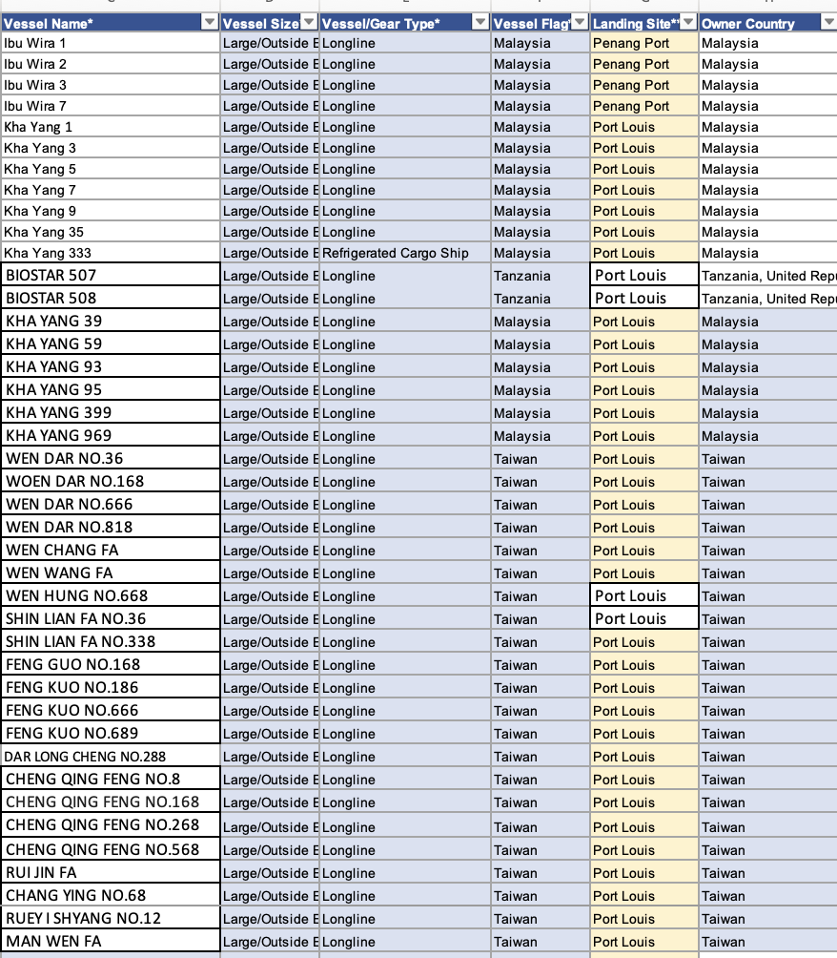

FIP Actions

The FIP goals in the table below need to be achieved to raise the performance of the fishery to meet the ‘pass’ level of the MSC standard. Of these, five of seven are built into current FIP Actions. (Note to Reader: the goals are referenced to the recommendations in “Working Towards MSC Certification: a practical guide for fisheries improving sustainability” MSC 2016).

Principles and indicators where the fishery does not yet appear to “pass” the MSC Standard in 2024 |  |  | Preliminary score | FIP goals for this indicator per MSC guidance
ETP species | 2.3.1 | ETP species outcome | <60 | - Determine the level of indirect impact of the fishery on the identified ETP species. Determine whether the information basis is sufficient to draw confident and robust conclusions. (2.3.1, MSC 2016:197)   established for long-standing FIP vessels, implementing for new vessels
ETP species | 2.3.2 | ETP species management | 60-79 | Implement new measures and strategies, so that, where possible, these are binding and develop monitoring protocols to incentivize compliance. (2.3.2, MSC 2016:214)  established for long-standing FIP vessels, implementing for new vessels
ETP species | 2.3.3 | ETP species information | 60-79 | Consider the potential to engage vessel crews in the collection of ETP management information. This could include training on ETP species identifications and the recording of interactions, via logs and onboard manuals. Engage more widely in regional efforts to collect information and manage impacts on ETP species. (2.3.3, MSC 2016:226)  established for long-standing FIP vessels, implementing for new vessels
Ecosystem | 2.5.1 | Ecosystem outcome | 60-79 | Give consideration to the ecosystem role of the target species and the wider ecosystem impacts (both direct and indirect) in the setting of fishing opportunities. (2.5.1, MSC 2016:266)  First half has been done not yet the latter half.
Ecosystem | 2.5.3 | Ecosystem information | 60-79 | Consider the potential for unintended or indirect ecosystem impacts of the fishery and ensure that on-going research and data collection are adequate to identify these changes. (2.5.3, MSC 2016:302)  established for long-standing FIP vessels, implementing for new vessels

Table 3. Performance Indicator Action Plan Table for 2024-2025 Actions
Action Number and Name  (One sentence description) | Impact of fishery on ETP Species and ecosystem
Action Goals  (One sentence that describe the result of the action) | Improve the fishery’s management of ETP species and its ecosystem impacts.  The FIP will support the fishery to implement the following RFMO measures by December 2026:  Fisheries bycatch of Sharks: Options for Mitigation , IOTC-2024-WPEB20(DP)-INF07  Effects of leader material on catches of shallow pelagic longline fisheries in the southwest Indian Ocean , IOTC-2024-WPEB20(DP)-INF09.  IOTC Resolution 23/06 On the Conservation of Cetaceans.  Vessels shall report all incidents to the relevant authority of the flag State, with the following information:  i. the species (if known);  ii. the number of individuals;  iii. a short description of the interaction, including details of how and why the interaction occurred and the gear type;  iv. the location of the encirclement or entanglement (if occurred);  v. the steps taken to ensure safe release (if encirclement or entanglement occurred);  vi. an assessment of the life status of the animal on release, including whether the cetacean was released alive but subsequently died.  IOTC Resolution 23/07 On Reducing the Incidental Bycatch of Seabirds in Longline Fisheries.  In the area south of 25 degrees South latitude, all longline vessels shall use at least two of the three mitigation measures of (1) night setting with minimum deck lighting, (2) tori lines, or (3) line weighting, or alternatively, use hook-shielding devices as a stand-alone measure.
Action Description  (Brief summary of the steps involved in the action and importance of the action in achieving the FIP objectives) | FIP vessels are recording incidental interactions with sea birds, turtles, rays, sharks and non-targe species feeding from the baited hooks on the longline gear (non-retained species). FIP vessel operators and crew received educational materials (courtesy of USA-NOAA) for practicing safe handling and release.
Action Rationale | The FIP will help improve the fishery’s standing relative to the MSC indicator for endangered, threatened and protected species and the pelagic ecosystem, 2.3.1, 2.3.2, 2.3.3, 2.5.1, 2.5.3).
Expected Completion Date | December 2026
Priority  (Based on the implementers criteria: e.g., lowest scoring issues are high priority or actions that are necessary to complete before beginning other actions are high priority) | High
Estimated Cost  (An estimate of the budget needed to complete the action) | US$30,000 borne by vessel operators and US$25,000 by Fong Hsiang/SYM PAC for vessel instructions, research, tallying, analysis.
Responsible Parties  (List of participants) | Vessels in the FIP with support from their buyer, Fong Hsiang, the US importer SYMPAC, and the US retailer, Sprouts Farmers Markets.
MSC PI(s) Addressed by the Action | 2.3.1 ETP Species outcome  2.3.2 ETP species management  2.3.3 ETP species information  2.5.1 Ecosystem outcome  2.5.3 Ecosystem information

FIP Actions | Tasks/ Milestones | Responsible (lead) | Responsible (supporting role) | Starting date | Expected completion date | Evidence of completion / results
Record incidental species interactions with longline gear, educate and improve safe handling and release of ETP species feeding on baited hooks, implement RFMO CMMs for ETP and swordfish | FIP vessels are regularly capturing data on incidental interactions of ETP species and overfished/overfishing species of marlin and blue sharks | Jochanan Liew, Jayden Chen, | Fong Hsiang | November 2020 | December 2026 | Incidental interactions matrix
 | Compile data and research to learn the level of fishing impact, (a) direct and (b) indirect, and (c) the ecosystem role of swordfish. | Sustainability Incubator | Fong Hsiang, SYM PAC | December 2021 | December 2026 | Regular reporting on FP.org

Future Planning
- FIP Actions for 2.5.2 Ecosystem Management and for Management Performance Evaluation are anticipated in a workplan due to be developed in early 2025.
- FIP Actions for 3.2.4 (Management Performance Evaluation) are anticipated in a workplan due to be developed in early 2025

