Morocco anchovy fishery

Three-Year Audit Report
Version 1.2, September 2021

FIP Information

Target species scientific name and common name | Engraulis encrasicolus, European anchovy
Fishery location | FAO Fishing Area 34, Eastern Central  Morocco EEZ, Atlantic North and Centre (A + B) management zones (Figure 1)  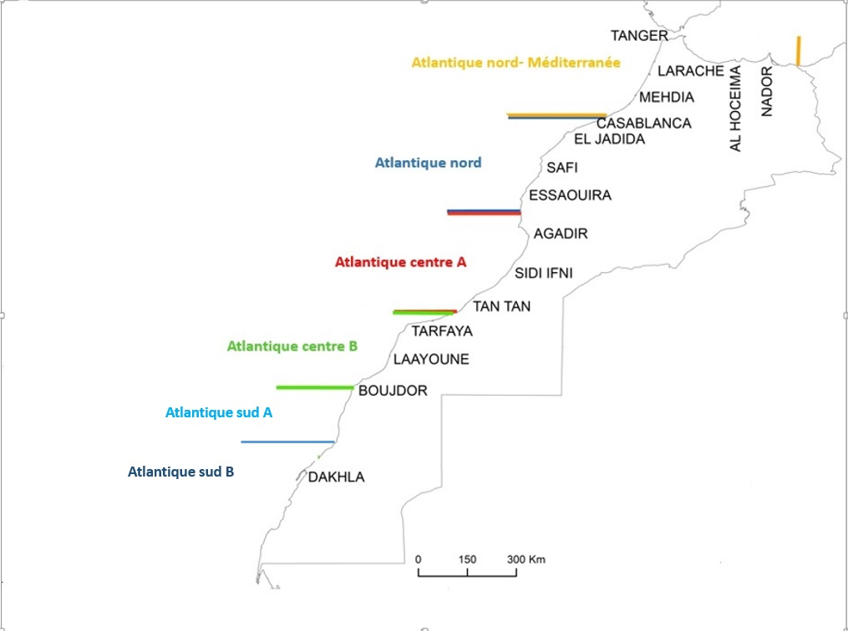  Figure 1. Map of Morocco Atlantic fishing management zones since 2022.
Gear type(s) | Purse seine
Estimated FIP Landings (weight in tons) | 2020: 49,846 t  2021: 48,127 t
Vessel type(s) and size(s) | Coastal fleet composed of Moroccan purse seiners (Figure 2)  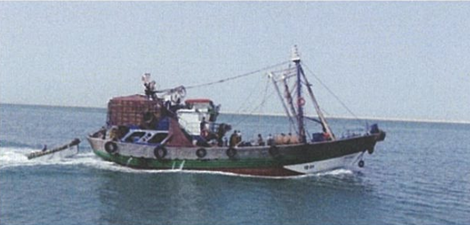  Figure 2. Coastal purse seiner. Source : INRH 2019.  Fishing vessels average gross tonnage per zone is presented in Table 1.
  Table 1. Fishing vessels average gross tonnage per management zone. Source: DPM
  Management zone | Average gross tonnage
  Mediterranean – Atlantic North | 79
  Atlantic North | 80
  Atlantic Centre A | 94
  Atlantic Centre B | 106
Number of vessels | The number of active fishing vessels per management zone 2022 was provided by the Département des Pêches Maritimes (Table 2).  * The DPM advised that fishing vessels operating in the Mediterranean-Atlantic North management zone are allowed moving between the Mediterranean and the Atlantic North waters (given that this management unit extends from the eastern border in the Mediterranean to the north of Casablanca in the Atlantic). This mobility is not allowed between the management zones.
  Table 2. Number of fishing vessels per management zone. Source: DPM
  Management zone | Number of vessels
  Mediterranean – Atlantic North* | 147
  Atlantic North | 106
  Sub-total for the Mediterranean - Atlantic North and Atlantic North | 253
  Atlantic Centre A | 138
  Atlantic Centre B | 195
  Sub-total for the Atlantic Centre | 333
  TOTAL | 586
Management authority | Ministère de l’Agriculture, de la Pêche Maritime, du Développement Rural et des Eaux et Forêts – Département des Pêches Maritimes (DPM)
Auditor name(s) | Géraldine Criquet
Auditor Organization/Affiliation | Global Trust Certification / NSF
Date of report completion | 8 July 2022

Stakeholder Consultation & Meetings
As per the FisheryProgress FIP Three-year Audit Guidelines, the three-year audit is required to be conducted. However, this three-year audit was conducted remotely due to the short timeline between the contract signing and the deadline for completing the report and also due to the on-going covid-related difficulties to travel from and to France (where the auditor is based) to and from Morocco.

Name | Affiliation |  | Date and Subjects Discussed
Jo Gascoigne | Fisheries consultant / FIP Coordinator |  | Wednesday 22 June 2022  • History of the FIP  • Role of the FIP coordinator  • Most-up-to date FIP work plan  • INRH’s project on anchovy stock assessment modelling and development of HCR  • Data collection on artisanal fleet related actions completed  • Organisation of remote meetings with stakeholders
Lamia Znagui | Fédération Nationale des Industries de Transformation et de Valorisation des Produits de la Pêche (FENIP) |  | Tuesday 28 June 2022  • Objectives of the FIP Three-Year Audit  • History of the FIP and FENIP’s role  • Lamia Znagui’s responsibilities and role as a FIP coordinator  • INRH’s project on anchovy stock modelling and development of HCR  • Current review of the small pelagic management plan  • Data collection on artisanal fleet
Omar Kharmaz | Ministère de l’Agriculture, de la Pêche Maritime, du Développement Rural et des Eaux et Forêts |  | Wednesday 29 June 2022  • Objectives of the FIP Three-Year Audit  • History of the FIP and the Ministry’s role  • Objectives of the FIP  • INRH’s project on anchovy stock modelling and development of HCR  • Landings reporting requirements for the artisanal fleet  • “Plan d’aménagement” detailed by fleet type  • Description of the enforcement and surveillance mechanism  • Measures facilitating access to the resource for the artisanal fleet  • Impact of covid on the FIP: delay
Jilali Bensbai | Institut National de Recherche Halieutique (INRH) |  | Friday 01 July 2022  • Objectives of the FIP Three-Year Audit  • INRH’s role  • Anchovy stock monitoring and assessment  • INRH’s project on anchovy stock assessment modelling and development of HCR  • Landings reporting requirements for the artisanal fleet: The case of the study carried out by INRH  • “Management Measures target all small pelagic species”, HCR in place but not formalized and well-defined  • Most recent stock assessment report  • Impact of covid on the FIP: delay  • Recommendation for improving the FIP process
Leila Radi | La Monégasque USA | Unimer | Friday 01 July 2022  • Objectives of the FIP Three-Year Audit  • Description of Unimer’s activities  • Role of Unimer in the FIP  • Importance of the certification for European and US markets  • Funding issues for the INRH’s project on anchovy stock modelling and development of HCR  • Impact of covid on the FIP: delay; concerns regarding the impacts of this delay on the FIP progress  • Recommendation for improving the FIP process
David Bataller | La Monégasque UK | Unimer
Najat El Monfaloti | Ministère de l’Agriculture, de la Pêche Maritime, du Développement Rural et des Eaux et Forêts - Direction des Pêches Maritimes |  | Friday 01 July 2022  • Objectives of the FIP Three-Year Audit  • Role of the DPM in fisheries management  • Role of the DPM in the FIP  • Current review of the small pelagic management plan  • Description of the fisheries management system consultation processes and how artisanal fleet is included
Lamia Znagui | Fédération Nationale des Industries de Transformation et de Valorisation des Produits de la Pêche (FENIP) |  | Monday 04 July 2022  • Wrap-up meeting  • Recommendations for the FIP

Summary of Findings and Recommendations
The objectives of this Three-Year audits are to:
- Evaluate the progress of the FIP
- Assess the current performance of the fishery against the MSC Fisheries Standard in regard to the progress (update PI score)
- If necessary, provide recommendations for improvement

The FIP has made very good progress in regard to Actions 3 & 4. These actions were extensively discussed during the FIP steering group meeting held in March 2021. The representatives of the Ministry confirmed that artisanal fishers are required to report their catches and that a restructuring plan for artisanal fishing is being discussed with representatives of the artisanal fleet, particularly concerning the small pelagic fishery. Landings data for the 2018-2020 period were provided and showed that the artisanal landings accounted for 0.16% of anchovy total landings in 2020. Stakeholders met during the 3-Year remote audit mentioned that the catch of anchovy is opportunistic and that landings from the artisanal fishery are not significant. Landings data were provided by the DPM, landings from the artisanal fishery accounted for only 0.03% to 0.16% of anchovy total landings for the 2018-2021 period. Measures exist to facilitate the access of the artisanal fishery to the resources. The Direction de Contrôle confirmed that monitoring, control and surveillance mechanisms exist for all segments including the artisanal fishery and all species including anchovy, and also that no infraction has been recorded in 2021 for the artisanal fishery for anchovy.
- Actions 3 & 4 are now closed (Table 3) and related PIs have been rescored to ≥80 / Actions 3 & 4 sont maintenant clôturées (Table 3) et les IPs en lien avec ces Actions ont été renotés à ≥80.

FIP work related to Action 1 has been significantly delayed. The FIP steering group meetings were held in March 2021 and June 2022 during which options for reference points and work required to improve the stock assessment model have been discussed with the INRH. During the June 2022 FIP meeting, INRH has presented a project for developing a more sophisticated stock assessment model to provide more robust reference points for the anchovy stock. During the 3-year remote audit, the INRH advised that stages 1-4 (data collection and modelling) would likely take 1 year (at least) and stage 5 (proposed management measures and HCR) would require an additional 6 months (at least). However, budget for this project is yet to be secured, and it has not started yet. Therefore, it is unlikely that this action will be completed by March 2023.
Given that Action 2 depends on the completion of Action 1, it is significantly delayed too.

- Progress on Actions 1 & 2 is determined to be behind target (Table 3) and the score for the related PIs remains 60-79 / Les progrès sur les Actions 1 &2 sont en retard sur le calendrier actuel et la note des IPs en lien avec ces Actions demeure 60-79.

Table 3. Summary of Action Progress for the Morocco anchovy FIP.
Action name | Performance Indicators | Expected completion date | Status at Three-year Audit
1. Evaluate options for defining additional reference points for the Atlantic anchovy stock to support MSC requirements | 1.1.1 Stock status  1.2.1 Harvest strategy  1.2.2 Harvest Control Rules & Tools | March 2023 | Behind target
2. Well-defined HCR | 1.2.2 Harvest Control Rules & Tools | March 2023 | Behind target
3. Artisanal landings of anchovy – as it relates to Principle 1 | 1.2.3 Information/Monitoring | December 2022 | On-target - Completed
4. Artisanal landings of anchovy – as it relates to Principle 3 | 3.1.1 Legal and/or customary framework  3.2.3 Compliance & Enforcement | March 2023 | Ahead of target - Completed

I would like to highlight the fact that since 2020 the FIP has been operating against a background of covid restrictions. This has hindered the FIP activities, particularly for Actions 1 & 2. The progress of the FIP over the last three years should be seen in that context.

Recommendations / Recommandations
Below are some recommendations received from stakeholders, which the FIP could consider.
- In light of the delayed in progressing on Actions 1 & 2, a realistic revised timeline should be discussed and agreed, and clearly communicated to the FIP participants. Au vue du retard pris sur les Actions 1 & 2, un calendrier révisé réaliste devrait être discuté et adopté, et clairement communiqué à tous les participants du FIP.
- Unimer raised concerns regarding the lack of involvement of fishing industry in the FIP which could impair the progression of the FIP. The auditor recommends the FIP and its objectives to be presented to the fishing industry and representative(s) of the industry to be invited to FIP meetings. Le groupe Unimer a fait part de sa préoccupation concernant le manque de participation de l’industrie dans le FIP, ce qui pourrait réduire la progression du FIP. L’auditrice recommande que le FIP et ses objectifs sont présentés à l’industrie et que leur(s) représentant(s) soient invité(s) aux réunions du FIP.
- Some participants mentioned their confusion regarding the role of the FENIP FIP Coordinator (Lamia Znagui) and the Fisheries Consultant/ FIP Coordinator (Jo Gascoigne). The auditor recommends clarifying roles. Certains participants ont fait part de leur confusion concernant le rôle de la Coordinatrice du FIP de la FENIP (Lamia Znagui) et de la Consultante Coordinatrice du FIP (Jo Gascoigne). L’auditrice recommande de clarifier le rôle de chacune.
- Due to covid related restrictions, all FIP meetings have been held remotely. The auditor recommends that next meeting(s) to be held in-person if possible. A cause des restrictions liées à l’épidémie de la covid 19, toutes les réunions du FIP se sont déroulées à distance. L’auditrice recommande que la (les) prochaine(s) réunion (s) se fasse(nt) en personne.

Summary of MSC Performance Indicator Scores
The PIs for which Actions have been drafted and implemented are identified in bold.

Principle | Component | Performance Indicator |  | Previous Score 2021 | Current Score 2022 | Rationale or Key Points
1 | Outcome | 1.1.1 | Stock status | ≥80 | ≥80 | The most recent stock assessment report was published in 2020 (INRH, 2020). It concluded that the Atlantic North and Atlantic Centre anchovy stock is not fully exploited (data used until 2019) (Table 4). This is an improvement from the previous year where anchovy stock was fully exploited. This improvement in the anchovy status is confirmed by an increase in the biomass recorded during the 2019 fall survey compared to the same period in 2018.  Table 4. Anchovy stock status in the Atlantic North and Atlantic Centre zones. Source: INRH 2020.  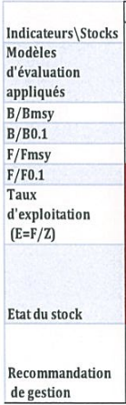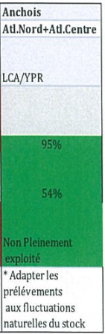  Therefore, it is determined that SG80a & b are still met, and the score remains at ≥80.
1 | Outcome | 1.1.2 | Stock rebuilding | NA | NA
1 | Management | 1.2.1 | Harvest Strategy | 60-79 | 60-79 | The harvest strategy consists of a set of management regulations which aim at controlling the fishing effort in the small pelagic fishery. The most recent stock assessment report published concludes that the Atlantic North and Atlantic Centre anchovy stock is neither overexploited nor fully exploited, suggesting that the harvest strategy is generally working.  The INRH’s 2020 stock assessment report recommends removals from the anchovy stock to be adapted to the annual fluctuations of the stocks. In June 2022, INRH has presented a project for developing a more sophisticated stock assessment model to provide more robust reference points for the anchovy stock and proposing anchovy-specific management measures (Actions 1 & 2).  However, a harvest strategy that is specifically responsive to the state of the anchovy stock is yet to be defined and implemented.  The score remains 60-79.
1 | Management | 1.2.2 | Harvest control rules and tools | 60-79 | 60-79 | Generally understood HCRs are available. The tools used appears to be effective, the Atlantic North and Atlantic Centre anchovy stock is not fully exploited (2019 situation).  In June 2022, INRH has presented a project for developing a more sophisticated stock assessment model and more robust reference points for the anchovy stock and proposing anchovy-specific management measures and HCR (Actions 1 & 2).  However, well-defined HCR are yet to be in place.  The score remains 60-79.
1 | Management | 1.2.3 | Information and monitoring | ≥80 | ≥80 | This PI was scored at 60-79 in the pre-assessment due to concerns over unquantified (or less well quantified) removals from the artisanal fishery.  Stakeholders met during the remote audit mentioned that the catch of anchovy is opportunistic and that landings from the artisanal fishery are not significant. Landings data were provided by the DPM (Table 5, Figure 3). Landings from the artisanal fishery accounted for only 0.03% to 0.16% of anchovy total landings for the 2018-2021 period.  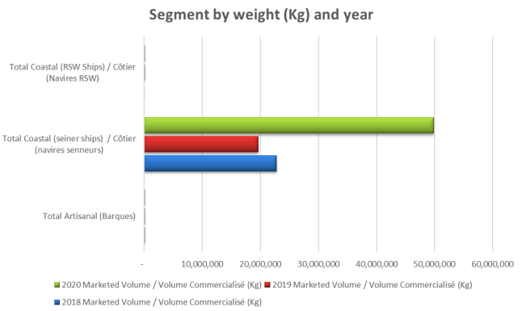  Figure 3. Weight (kg) of anchovy landings by segment for the 2018-2020 period. Source: provided by the DPM in July 2022.  Fishers are required to declare landings at landings sites/ports. The Direction de Contrôle confirmed that monitoring, control and surveillance mechanisms exist for all segments including the artisanal fishery and all species including anchovy. Enforcement activities occur as follows:  • control in landings ports, fishing sites and “halles au poisson”  • at-sea control through VMS  • at-sea control by authorities  Based on the above evidence, it is concluded that the anchovy landings from the artisanal fishery is well quantified. Therefore, there is good information on all other fishery removals from the stock, SG80c is now met.
  Table 5. Anchovy landings (kg) from the artisanal fishery. Source: DPM
  Year | 2018 | 2019 | 2020 | 2021
  Landings from artisanal fishery | 10,950 | 8,490 | 78,882 | 12,823
  % of anchovy total landings | 0.05% | 0.04% | 0.16% | 0.03%
1 | Management | 1.2.4 | Assessment of stock status | ≥80 | ≥80 | No change since pre-assessment
2 | Primary species | 2.1.1 | Outcome | ≥80 | ≥80 | No change since pre-assessment
2 | Primary species | 2.1.2 | Management strategy | ≥80 | ≥80 | No change since pre-assessment
2 | Primary species | 2.1.3 | Information | ≥80 | ≥80 | No change since pre-assessment
2 | Secondary species | 2.2.1 | Outcome | ≥80 | ≥80 | No change since pre-assessment
2 | Secondary species | 2.2.2 | Management strategy | ≥80 | ≥80 | No change since pre-assessment
2 | Secondary species | 2.2.3 | Information | ≥80 | ≥80 | No change since pre-assessment
2 | ETP species | 2.3.1 | Outcome | ≥80 | ≥80 | No change since pre-assessment
2 | ETP species | 2.3.2 | Management strategy | ≥80 | ≥80 | No change since pre-assessment
2 | ETP species | 2.3.3 | Information | ≥80 | ≥80 | No change since pre-assessment
2 | Habitats | 2.4.1 | Outcome | ≥80 | ≥80 | No change since pre-assessment
2 | Habitats | 2.4.2 | Management strategy | ≥80 | ≥80 | No change since pre-assessment
2 | Habitats | 2.4.3 | Information | ≥80 | ≥80 | No change since pre-assessment
2 | Ecosystem | 2.5.1 | Outcome | ≥80 | ≥80 | No change since pre-assessment
2 | Ecosystem | 2.5.2 | Management strategy | ≥80 | ≥80 | No change since pre-assessment
2 | Ecosystem | 2.5.3 | Information | ≥80 | ≥80 | No change since pre-assessment
3 | Governance and Policy | 3.1.1 | Legal and customary framework | 60-79 | ≥80 | This PI was scored at 60-79 in the pre-assessment due to concerns over whether or not anchovy landings by the artisanal fishery is significant and whether or not measures are in place in the management system to respect the rights of the artisanal fishers.  Stakeholders met during the remote audit mentioned that the catch of anchovy is opportunistic and that landings from the artisanal fishery are not significant. Landings data were provided by the DPM (Table 5, Figure 3). Landings from the artisanal fishery accounted for only 0.03% to 0.16% of anchovy total landings for the 2018-2021 period.  Measures exist to facilitate the access of the artisanal fishery to the resources. Some fishing zones are closed to other segments. There are numerous “Point de Débarquement Aménagé (PDA)” and “Villages de Pêche (VDP) ” along the Morocco coastline (Figure 4), these sites are equipped and are for the use of the artisanal fishers exclusively.  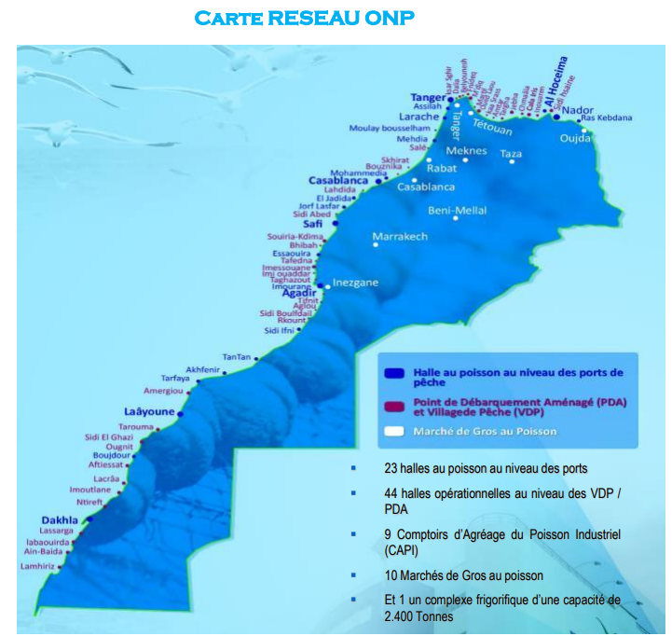  Figure 4. Map of the ONP network showing “halles au poisson”, equipped landing sites (PDA) and fishing villages (Villages de Pêche, VDP). Source: DPM.  Based on the above evidence, it is concluded that the issue identified in the pre-assessment is addressed, and therefore, SG80c is now met.
3 | Governance and Policy | 3.1.2 | Consultation, roles and responsibilities | ≥80 | ≥80
3 | Governance and Policy | 3.1.3 | Long term objectives | ≥80 | ≥80
3 | Fishery specific management system | 3.2.1 | Fishery specific objectives | ≥80 | ≥80
3 | Fishery specific management system | 3.2.2 | Decision making processes | ≥80 | ≥80
3 | Fishery specific management system | 3.2.3 | Compliance and enforcement | ≥80 | ≥80 | This PI was scored at 60-79 in the pre-assessment due to concerns over unquantified (or les well quantified) removals from the artisanal fishery and whether or not there is an enforcement issue.  Stakeholders met during the remote audit mentioned that the catch of anchovy is opportunistic and that landings from the artisanal fishery are not significant. Landings data were provided by the DPM (Table 5, Figure 3). Landings from the artisanal fishery accounted for only 0.03% to 0.16% of anchovy total landings for the 2018-2021 period.  Fishers are required to declare landings at landings sites/ports. The Direction de Contrôle confirmed that monitoring, control and surveillance mechanisms exist for all segments including the artisanal fishery and all species including anchovy. Enforcement activities occur as follows:  • control in landings ports, fishing sites and “halles au poisson”  • at-sea control through VMS  • at-sea control by authorities  Direction de Contrôle confirmed that no infraction has been recorded in 2021 for the artisanal fishery for anchovy.  Based on the above evidence, it is concluded that enforcement activities cover the artisanal fishery and that there is no evidence of systematic non-compliance, SG80 is now met.
3 | Fishery specific management system | 3.2.4 | Management performance evaluation | ≥80 | ≥80

Environmental Workplan Results

Result | Related Action on FisheryProgress | Related MSC Performance Indicator | Explanation
Convening a workshop with INRH to discuss options for reference points and the resources required to address them | Action 1 - Evaluate options for defining additional reference points for the Atlantic anchovy stock to support MSC requirements | 1.1.1 Stock status  1.2.1 Harvest strategy  1.2.2 Harvest Control Rules & Tools | The FIP steering group meetings were held in March 2021 and June 2022 during which option for reference points and work required to improve the stock assessment model have been discussed with the INRH.  During the June 2022 meeting, INRH has presented a project for developing a more sophisticated stock assessment model to provide more robust reference points for the anchovy stock. INRH explained the difficulties in establishing robust reference points and developing HCRs for this stock due to the fact that i) the stock naturally fluctuates because of the nature of the species and its high dependence on environmental factors; and ii) the fishery is opportunistic.  The project is to be stand-alone, distinct from INRH’s routine responsibilities and work, thus will require additional resources. It has 5 stages as follows (Figure 5):  - Field work: size-sampling, biological sampling and other biological data collection, at Larache and Agadir but with the potential to be flexible depending on landing sites for anchovy, which can vary.  - Laboratory analysis: preparation of otoliths and aging, with validation, data input and quality control, preparation of size/age keys.  - Preparatory working group: review of all data sets (biological, fisheries, survey, oceanographic).  - Modelling: development of several suitable models (VPA, JABBA and/or other), stock assessment, reference points and projections. External peer review is required.  - Recommendations: immediate management measures, HCR and any other management recommendations. External peer review is required.  During the 3-year remote audit, the INRH advised that stages 1-4 would likely  take 1 year (at least) and stage 5 would require an additional 6 months (at least).  INRH also presented an estimation of cost for the project. Although, FENIP confirmed that they will contribute to the costs, the total budget is yet to be available and the project has not started yet.  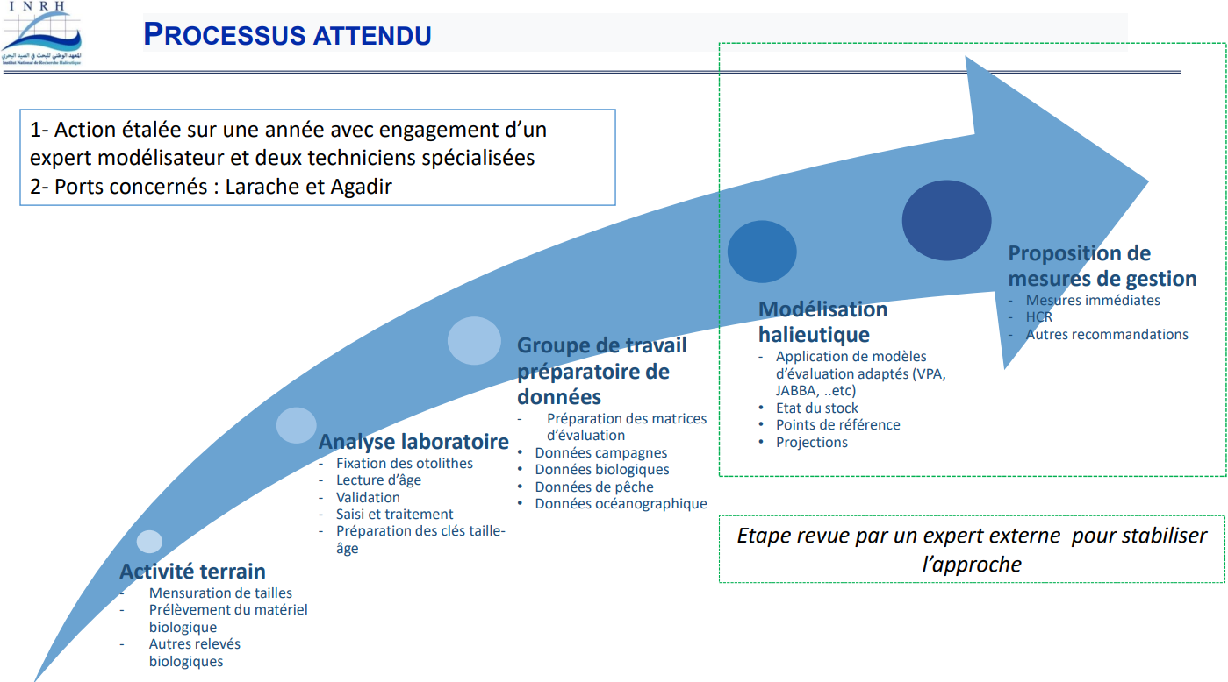  Figure 5. INRH’s proposed project for the development of a stock assessment model for the anchovy stock and of management measures and HCR.
Working with INRH and ONP to evaluate based on existing data whether the issue of artisanal landings remains; i) significant; and ii) unquantified. | Action 3 - Artisanal landings of anchovy – as it relates to Principle 1 | 1.2.3 Information/Monitoring | This action was extensively discussed during the FIP steering group meeting held in March 2021. The representatives of the Ministry confirmed that the artisanal fishery is subject to management measures and that artisanal fishers are required to report their catches. Landings data for the 2018-2020 period were provided and showed that the artisanal landings accounted for 0.16% of anchovy total landings in 2020.  Stakeholders met during the remote 3-year audit mentioned that the catch of anchovy is opportunistic and that landings from the artisanal fishery are not significant. Landings data were provided by the DPM (Table 5, Figure 3). Landings from the artisanal fishery accounted for only 0.03% to 0.16% of anchovy total landings for the 2018-2021 period.  Fishers are required to declare landings at landings sites/ports. The Direction de Contrôle confirmed that monitoring, control and surveillance mechanisms exist for all segments including the artisanal fishery and all species including anchovy. Enforcement activities occur as follows:  • control in landings ports, fishing sites and “halles au poisson”  • at-sea control through VMS  • at-sea control by authorities
Working with INRH and ONP to evaluate based on existing data whether the issue of artisanal landings remains; i) significant; and ii) unquantified. | Action 4 - Artisanal landings of anchovy – as it relates to Principle 3 | 3.1.1 Legal and/or customary framework  3.2.3 Compliance & Enforcement | This action was extensively discussed during the FIP steering group meeting held in March 2021. The representatives of the Ministry confirmed that the artisanal fishery is subject to management measures and that artisanal fishers are required to report their catches. Landings data for the 2018-2020 period were provided and showed that the artisanal landings accounted for 0.16% of anchovy total landings in 2020.  Stakeholders met during the remote 3-year audit mentioned that the catch of anchovy is opportunistic and that landings from the artisanal fishery are not significant. Landings data were provided by the DPM (Table 5, Figure 3). Landings from the artisanal fishery accounted for only 0.03% to 0.16% of anchovy total landings for the 2018-2021 period.  Fishers are required to declare landings at landings sites/ports. The Direction de Contrôle confirmed that monitoring, control and surveillance mechanisms exist for all segments including the artisanal fishery and all species including anchovy. Enforcement activities occur as follows:  • control in landings ports, fishing sites and “halles au poisson”  • at-sea control through VMS  • at-sea control by authorities  Direction de Contrôle confirmed that no infraction has been recorded in 2021 for the artisanal fishery for anchovy.
Evaluating whether the lack of data relates to non-compliance

Supporting References
FAO. 2018. Report of the FAO Working Group on the Assessment of Small Pelagic Fish off Northwest Africa. Nouadhibou, Mauritania, 22–27 May 2017. Rapport du Groupe de travail de la FAO sur l’évaluation des petits pélagiques au large de l’Afrique nord-occidentale. Nouadhibou, Mauritanie, 22-27 mai 2017. FAO Fisheries and Aquaculture Report/FAO Rapport sur les pêches et l’aquaculture No. 1221. Rome.

Rapport annuel de l’état des stocks et des pêcheries marocaines au Maroc 2019 ; Depmt. Des Pêches, Institut National de Recherche Halieutique, INRH, Casablanca (Morocco). 2019. – ISSN : 2509-1727.

Statistiques de débarquements de l’anchois par segment et port (2018-2021) provided by the Ministère de l’Agriculture, de la Pêche Maritime, du Développement Rural et des Eaux et Forêts.

Power Point presentation made by the Institut National de Recherche Halieutique (INRH) during a FIP meeting held on 17 June 2022 – Financement du Projet Modélisation de l’anchois et proposition d’HCR adapté.

Carte Réseau ONP

Key Traceability – Morocco anchovy FIP – Annual Review – March 2021

Minutes of the 12 March 2021 meeting of the Morocco anchovy FIP Steering Committee

Minutes of FIP meeting held on the 17 June 2022

